William Scott (1703620)
Module: ADAD5001. Lecturer: Robert Jones. Date: 9/5/2019
A Personal Investigation into Live Performance, Digital Sound and Analogue Sound

Over the years live music has changed from acoustic sound production to amplified electronic and digital
It has changed from acoustic sing arounds and ceilidhs to include rock, pop and discos.
The current situation has seen a fall in the number of professional and semi-professional live performances in pubs and clubs and a return to free amateur, informal get togethers making it difficult for artists to make a living.
I shall be investigating the reasons for the decline in financial return for live entertainment (specifically music), the narrow choices of styles of music and what can be done to expand the range, cash return and opportunities afforded live performers in small venues.
As I have been performing in the local pub scene for the past 19 years, I shall investigate from personal experience and support my assertions with research.
There is anecdotal evidence published by organisations such as the Small Venue Trust. (2017)
The UK Live Music Census report, (Webster, et al., 2018) is the first, according to The Guardian, (2018) that is both quantitative and qualitative.

There is a dichotomy between evidence regarding the facilitating of live entertainment and the closure of small venues. On the one hand, according to The Music Venue Trust ‘’between 2007 and 2015, 35% of venues in the UK closed down’’. (The Music Venue Trust, 2017)
On the other hand, however, PRS for Music research, published by the Musicians Union (N.D.) among others, shows ‘’that bars putting on live music see an increase in ‘wet sales’ of 44% over the weekend, peaking at 60% on Friday and Saturday nights, and are on average three times less likely to close.’’
For both sets of figures to be correct it is unlikely the venues and bars fall into the same category. The ‘’venues’’ referred to by the MVT must include small theatre type locations as opposed to ‘’bars’’ mentioned in the PRS report.

It seems clear from the massive array of online music available and the contribution made to the UK economy by the music industry, that music, is as popular as ever. Maybe more so. It is certainly more accessible due to the use of mobile devices. This has been at the expense of high street shops selling hard copy recordings which are rapidly disappearing
‘’Between 2004 and 2006, a quarter of independent record shops in Britain shut, according to figures from the Entertainment Retailers Association’’. (Thoughtshift 2017)
Even shops selling musical instruments are becoming a rare breed. Nevertheless, according to UK Music (2018), music is still a major contributor to the UK economy worth overall £3.5 billion
What then, is the problem? Bars with music events see 44% to 60% increase of wet sales and are less likely to close.
Could it be there are underlying circumstances that support the longevity and sustainability of businesses facilitating live music?
It is possible that the people running such businesses are more conscientious and put more effort in to attracting customers. Live music being just one tool in a range implemented to create a popular and atmospheric experience.
The busiest bar I have attended in many years is The Live Lounge in Cardiff. It combines low cost drinks with high quality entertainment in a smart, safe environment (If the number of security staff is anything to go by).
Somehow the Live Lounge manages to keep prices down which I believe contributes significantly to its popularity. A belief confirmed by the findings in a paper by Christopher Snowdon,(2014) Director of Lifestyle Economics at the IEA who blames the rise in home-based entertainment, cheap supermarket alcoholic drinks, he said ‘’Taxation, regulation and the recent decline in disposable incomes are the leading causes of the decimation of the UK pub industry since 2006, responsible for around 6,000 pub closures. The smoking ban and the alcohol duty escalator are particularly culpable.’’

Live music has been intimately tied into the pub trade.
Its decline means showcases and opportunities for entertainers to hone their skills are much reduced. TV talent shows give a window of minutes to a lucky few.
This is a great shame and is damaging to the ecology of live music.
The British music scene has made a significant contribution, not only to culture, but to the UK economy as well. The emphasis on, and route to success, even modest success, has changed. The days of transit vans full of Wanna-Be rock stars on the motorways are over.
The Culture of Live Performance
The narrow choices of styles of music and what can be done to expand the range and encourage larger audiences.
Online, there seems to be an infinite array of choice available. This does not seem to be replicated in the real world. Having seen the loss of so many pubs and, by virtue of that fact, potential venues, I shall look at the responsibility of entertainers to ‘’draw a crowd’’, what they have done to keep their performances new, fresh and interesting.
Drawing a crowd is a contentious issue between pub managers and entertainers.
Although entertainers prefer a substantial audience it is not possible or reasonable for them to expect friends and family to attend every gig. And even if they did, they would be unlikely to fill the till of the bar. Therefore, if the venue wants to profit from hiring entertainers it needs to build a reputation as ‘the place to be’. It needs to hire the right acts to attract a local crowd and take on a share of promotion for any events it puts on. Any audience members from further afield would be a welcome bonus.
The act must play its part in raising awareness of its existence. It needs to plan a marketing strategy. Like any business they need to find and make known their unique selling point, recognising the requirements of the audience. Are people there to listen, talk to each other, dance?
The act must find a balance between familiarity and novelty. Over-familiarity becomes boring, excessively novel is distracting and hard to listen to.
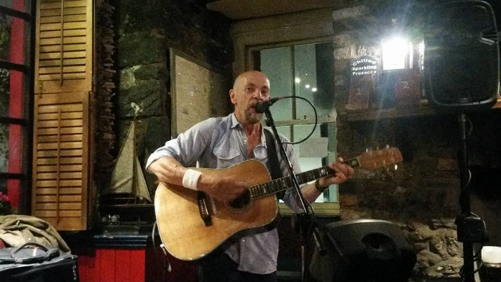
At present I think live music in pubs is overly familiar. I think we’ve followed the path trodden so many times before. One rock band or guitar vocalist is almost indistinguishable from another. Generic backing tracks, easily downloaded from the internet for solo artists, remove the need for thought or innovation.
Individual abilities and quality of sound may vary but the format and song selections are often more or less identical and as a result predictable.
What can be done to address this dull conformity?
If it is addressed and overcome will it contribute to larger audiences and a lift in the fortunes of the venues and performers?
It is in all our interests to solve these issues. Not only from innovative, artistic and cultural, point of view but economically too.

One of the main restrictions for all concerned in starting this process is budget. Balancing cost against return.
Developing new and exciting shows is time consuming and expensive.

It is curious, though I think he was referring to ''the industry’’ as a whole, that
Will Page, (2010) Chief Economist PRS for Music said "The UK live music industry continues to exceed expectations, especially during an economic downturn …. It’s fascinating to consider that events-based industries such as live music have succeeded in growing their overall pie, whilst so much of the digital media debate is about cannibalisation."
The statement concurs with the findings of the first census of live music ‘’Investigations showed that live music contributes significant sums of money to local economies: £78.8m annually in Glasgow equating to an estimated 2,450 full-time equivalent jobs; £43.3m in Newcastle-Gateshead (1,620); and £10.5m in Oxford (350). The study recommended that local authorities “recognise small and medium music venues as key sites of artist and audience development and as cultural and community assets.” (Webster et al., 2018)
But contrasts with the findings of the same report regarding musicians themselves which states,
‘’The report also highlighted the difficulty of making a living as a musician in Britain: 68% said stagnating pay made it difficult to earn a viable income, with the figure rising to 80% for those identifying as professional musicians; 66% reported working unpaid for “exposure” that they believe had no positive effect on their career.’’ (Webster et al., 2018)
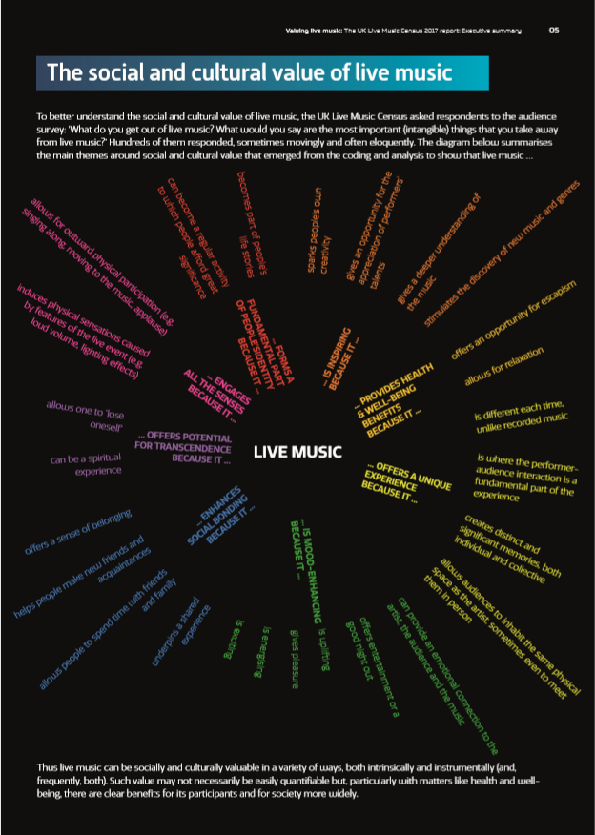
(Webster et al., 2018)
Most performers start from a point of undercutting competition, at least at the beginning of their time in the industry. This is counterproductive. There are always beginners coming through the pipeline. As a result, the fees are constantly in a depressed state. The closure of potential venues means a smaller market. The declining clientele in pubs equates to a lower amount available for paid entertainment which in turn reduces the incentive for artists to continue performing long term. The knock-on effect is there are fewer and fewer experienced acts prepared to continue and the novices take their place with the associated naive attitude to fees, narrower skill set and, unless they are very fortunate, limits to the quality and availability of equipment.
In general, bands have larger audiences than solo acts. Bands tend to have a bigger, fuller, sound and are more exciting than solos. But bands tend to cost more due to the number of people involved and the equipment required. Combining the sound and excitement of a band with minimal equipment and personnel would be a good compromise. This approach was recognised by Tom Bailey when he changed The Thompson Twins from a seven piece band to three piece. As a result of obtaining a synthesiser the need for so many band members was eliminated allowing an increased income share for those remaining.
He said in a 1983 interview ‘’ When we reformed the band, we were making a statement. We weren’t going to be a rock ‘n’ roll band, we weren’t going to have a guitar. We were going to move on...… Right now, technology is what’s important, and that’s what our music tries to reflect.” (Thomas 2017)
Now, in 2019, with the advances in computing and technology his statement is still relevant and makes this a thrilling time to be making music.
The sonic possibilities afforded to a two or three-piece outfit now are almost unlimited. These possibilities do not appear to have been explored by current artists and practitioners.
My question is can electronic dance music/techno be integrated with rock and pop? Can live musicians form a band with DJs? Of course, the answer is ‘’yes’’ but would it be a feasible proposition for small venues? Would EDM/Rock hybrids entice a larger audience without alienating existing customers? Would it fall between two stools?

In the world of EDM, according to an article by Connor Jones, (2016)
‘’ The number of artists embracing the live performance has substantially risen over the last year or so’’
There seems little evidence that rock bands, at least on a local level, are embracing the use of recorded sounds and samples or making significant use of technology.
Most of these hybrid outfits referred to in the Magnetic article, such as Nero, Porter Robinson and The Glitch Mob are DJs that have introduced live vocals to their performances rather than bands incorporating DJs to their line-up or building an EDM/Rock show from the ground up.
The 60’s onwards saw the use of synthesisers in rock bands such as Hawkwind, Roxy Music, Pink Floyd etc., which were eventually, via New Romantic and electro-pop bands, The Thompson Twins, Pet Shop Boys, Depeche Mode, etc., linked into and were superseded by, discos and Electronic Dance Music.
At this point in time there seems to have been a divergence between electronic music and rock.
It’s common practice for live performers, solo, duo or band to use backing tracks but rarer to use the computer and associated software as an instrument.
Several bands seem to have forged a connection between electronic and jazz but not so much with rock
Floating Points present outstanding jazz musicianship combined with synth and DJ/technology skills. (KEXP 2016)
My interest is not necessarily to come up with something entirely new but to build upon the work of previous artists with a particular interest in 80’s electro-pop bands and apply a layer of live, analogue instrumentation, with a rock feel.
Having searched the internet there does not seem to be an awful of this type of electro rock. Of the few examples I have found Depeche Mode’s I Feel You @ Live O2 Wireless Festival (Kottak 2006) and Gary Newman- Cars- Live@Sonisphere (FestoTV 2014)
are good indicators of the genre. But these are big name bands on large stages.
What makes live performance special?
The answers to this question are its unique selling points.
Atmosphere, changes to each performance, each strum of the guitar, each beat of the drum is individual capturing the feel and creating a ‘vibe’.
Performers can do things live that are impossible to recreate in a studio.
The size of the sound. The volume, the connection between the audience and the act.
Digital Technology
I want to re-imagine the pub gig.
This is a still from a piece I made as an experiment around 2017. (The video link is below)
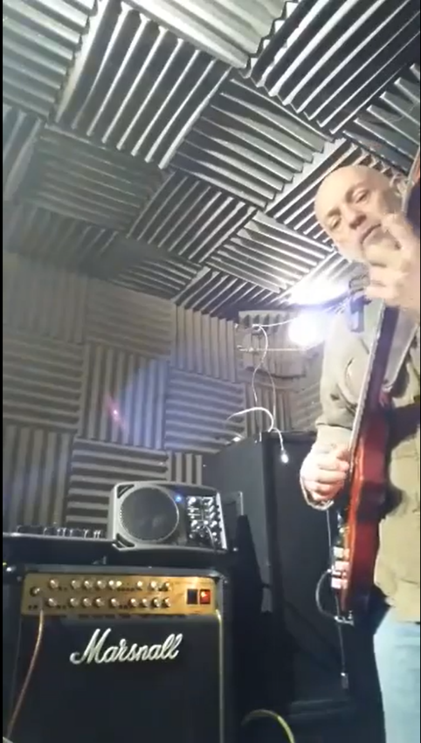
The song is my own interpretation of Shape of My Heart by Sting from the 1997 album Ten Summoners Tales. Although this was not a public performance, it was all played live, recorded on my mobile phone and gives an impression of the direction I would like to explore. There was nothing pre-recorded and nothing added or edited post recording. I used an electric guitar I made and fitted with 2 magnetic humbucker pickups and a Roland GK3 midi pickup.
The midi pickup output was sent to a Roland GR55 guitar synthesiser which I used to create the strings, bass and resonator guitar sounds. The magnetic pickup signal output was sent unaffected through the GR55.
From the GR55 all the sounds were fed to a Boss RC 300 looper.
The synthesised sounds went from the looper to a Mackie SRM 150 mini monitor shown in the picture on top of the Marshall.
The magnetic pickup sounds went from the looper to the Marshall 6101 amplifier shown in the picture. (Scott 2017)
How far can this be taken?
On top of the facilities afforded by computers, software, vsts, synths and other pieces of technology I want take advantage of, an aspect that can be used live, is the very fact that pubs are relatively small. This opens the opportunity to implement spatial audio.
It may be possible to place wireless speakers around a venue and send sounds to different parts of the room. For most people this would be a new experience. Very few people have home audio systems that are capable of spatial audio even if they can find any spatial audio recordings.
5.1 surround sound is commonly used for films and for good reason. It immerses the viewer in the movie. What if a similar immersive experience can be used at a small venue?
Spatial audio adds an exciting new dimension to music.
On a practical, health and safety level, wireless speakers minimise the need for wires and cables trailing through audience areas. If the speakers are battery powered, they require no leads at all.
There are questions to investigate regarding the practicalities of wireless, such as risk of interference to the signal, latency and reliability of the connection.
Nevertheless, it’s a possibility I would like to explore.
Pub gigs do not feature high on the list of cultural events in the way opera does in London. They do not receive the respect, plaudits or funding. But they are part of our cultural heritage, our musical education and a significant contributor to our local and national economy. I would like to explore ways of enhancing the experience of the small venue.
‘’ Smaller spaces for live music therefore perform a key role within the overall live music ecology in terms of both attendance and performance. With this in mind, we recommend that any local authority cultural policy recognises the economic and cultural value of live music and live music venues to the local region, and that planning and economic policies take account of the actual and potential contribution of live music.’’
(Webster 2018)

Reference List
FestoTV (2014) Gary Newman- Cars- Live@Sonisphere [Video] Available a: https://www.bing.com/videos/search?q=Gary+Numan+Today&&view=detail&mid=F902EB7672489A7FD493F902EB7672489A7FD493&&FORM=VRDGAR (Accessed:19/4/2019)

Jones, C. (2016) A Live Performance Revolution is Taking Over Electronic Music. Available at: https://www.magneticmag.com/2016/06/live-performance-revolution-taking-over-electronic-music/ (Accessed 23/4/2019)

KEXP 2016 Floating Points - Full Performance (Live on KEXP) [Video] https://www.youtube.com/watch? v=yYqu5NdFMf8&fbclid=IwAR3a5pQV3tgWbCdkUjtZN_5qfuLfsw0T8y9VpioZQY2OJPAMywsBj95U8eo (Accessed:23/4/2019)

Kottack, G. (2010) Depeche Mode’s I Feel You @ Live O2 Wireless Festival 2006 [Video] Available at: https://www.bing.com/videos/search?q=depeche+mode%e2%80%99s+i+feel+you+%40+live+o2+wireless+festival+2006&view=detail&mid=3CEA1BC8F4E9E8CD90623CEA1BC8F4E9E8CD9062&FORM=VIRE (Accessed 19/4/2019)
Page, W. (2010) Live music continues to outperform recorded. Available at: https://www.prsformusic.com/press/2010/live-music-continues-to-outperform-recorded (Accessed 6/5/2019)

Scott, W. (2017) Shape of my Heart. [Video] https://www.facebook.com/will.scott.54/videos/vb.100000348435290/1635437706477828/?type=3 (Accessed 8/5/2019)

Snowdon, C. (2014) Closing Time. Who’s Killing the British Pub. Available at: https://www.iea.org.uk/sites/default/files/publications/files/Briefing_Closing%20time_web.pdf (Accessed 26/4/2019)

The Music Venue Trust (2017) A Manifesto for Music Venues. [Website] Available at: http://musicvenuetrust.com/2017/05/a-manifesto-for-music-venues-2017/
(Accessed 21.03.2019)

The Musicians Union (N.D.) Grassroots, Music Venues & Pubs Available at: https://www.musiciansunion.org.uk/Home/Advice/Playing-Live/Gigs-and-Live-Entertainments/Grassroots-and-Pubs (Accessed 21.03.2019)

Thomas, B. (2017) You say you want a “Revolution”: Thompson Twins and 1986’s “most requested videos” Available at: http://nightflight.com/you-say-you-want-a-revolution-thompson-twins-and-1986s-most-requested-videos/ (Accessed 28/4/2019)

Thouhtshift (2017) Music and Musical Instrument Trends and Statistics. Available at: https://www.thoughtshift.co.uk/music-and-musical-instrument-retail-trends-and-statistics/ (Accessed 26/4/2010)

UK Music (2018) True Value of Music to the Uk Economy Revealed. Available at: https://www.ukmusic.org/news/true-value-of-music-industry-to-uk-economy-revealed (Accessed 23/4/2019)

Webster, E. Brennan, M. Behr, A. Cloonan, M. Ansell, J. (2018) UK Live Music Census. Available at: http://uklivemusiccensus.org/wp-content/uploads/2018/03/UK-Live-Music-Census-2017-executive-summary.pdf (Accessed 6/5/2019)

Bibliography
Ableton (2014) 4DSOUND: A New Dimension | Ableton [Video]
Available at: https://www.youtube.com/watch?v=WvM-SxrMv6s&feature=youtu.be (Accessed 3/5/2019)

AntiProtonBoy (2012) What the Future Sounded Like (2006) [Video] Available at:
https://youtu.be/8KkW8Ul7Q1I (Accessed 20/4/2019)

Ableton (2014) 4DSOUND: A New Dimension | Ableton [Video]
Available at: https://www.youtube.com/watch?v=WvM-SxrMv6s&feature=youtu.be (Accessed 3/5/2019)

archivesnz (2013) Artists Prepare - Chris Cree Brown (1980) [Video] Available at: https://www.youtube.com/watch?v=umy4uAVfdfw (Accessed 19/4/2019)

Computer Music (Computer Music) (2013) How should you perform your electronic music live? [Website] Available at: https://www.musicradar.com/news/tech/how-should-you-perform-your-electronic-music-live-575226 (Accessed 23/4/2019)

Conte, J. (2014) This Band Just Finished A 28 Day Tour And Made How Much?! [Blog] Available at:https://www.digitalmusicnews.com/2014/11/25/band-just-finished-28-day-tour-made-much/ (Accessed 6/5/2019)

MusicRadar Team (Future Music) (2018) The 15 best live electronic acts in the world right now. [Website]
Available at: https://www.musicradar.com/news/the-15-best-live-electronic-acts-in-the-world-right-now Electronic Music History Documentary (1980) (Accessed: 16/4/2019)

Romer, C. (2019) One in three think classical music must drop ‘elitist’ traditions [Website] Available at: https://www.artsprofessional.co.uk/news/one-three-think-classical-music-must-drop-elitist-traditions (Accessed 23/4/2019)

