CRISTIAN CUPCEA
1916875@student.uwtsd.ac.uk
BMSW4001_LON
LECTURE:JOANNA WALSH
GROUP 3
INTRODUCTION
The speedy increase of community, the companies are also competitions between them, are patrons want for the qualify employers are not only but pay attention to their employability skills. To win their competitors, patrons want to graduate who have a lot of abilities to bring to the work environment, and need the workers with multi-skilled to many separate position in company, (Foster,1998, p.4) , to graduates who want to join in the workforce must have the potential needed by patrons. To making ourselves more ambitious in the future job, first we should find out what employability skills the patron want from you . They need to learn a good skills and do the personal SWOT analysis and make an plan to improve you future.
SKILLS DEFINITON
A skills is the learned ability to improve you tine on the minimum of time, energy or both, in other word the abilities that you have. Skills can often be divided into general-domain and specific-domain skills. For example, in the work domain the skills would included team work and leadership, time management, self-motivation and other skills. People need a lot of skills to contribute to a economy
The skills sought by the employer can be divided into two categories: hard skills and soft skills. Hard skills vary from one field of activity to another, however, soft skills are applicable in most industries, regardless of the level of experience, both seniors and students and graduates. Those who have these soft skills prove a better performance at work and are more likely to follow a successful career path. This is why companies want to recruit candidates who have such competencies, and we encourage you to identify and develop them.
and industry. Example of skills:
The ability to use knowledge effectively and readily
Skills or coordination especially in the execution
A learned power of doing something competently
DECISION MAKING SKILLS
Decision-making capacity, identifying how value can be added to the activity carried out, growth opportunities in the company and making the right decisions in situation of major importance are characteristic that define a potential candidate.
ORGANIZATION SKILLS
Organization skills are crucial for many work experience. For working in the kitchen of you local fast food to managing a office, a sense of organization show that you have a clarity and strategic ability to a successful organization. The following are important organization skills you should list in you resume.
SOFT SKILLS
To work in a reputable company and continue to perform at work, you need a whole arsenal of technical skills. A dentist must know how to eliminate a caries, a construction engineer must have a least and idea of what the resistance structure of a building means, accountants must have a certificate that give then the right to sing the balance payments. The soft skills help you to acquire over the professional media and get out of the mode. They do not depend on the specifics of your profession, how well you know your job, but more how to stand out, what kind of attitude you have, what are you social skills and how they help you, have a good contact whit another. Even if the soft skills open the door for you, your human skills will help you to advance in you career.
Therefore, it is a bit contradictory that while companies highlight the importance of developing hard, professional skills, they are not interested in investing in the development of soft skills.
Negotiation ability is a soft skill sought today, but which will be given a significant import in the future because companies are looking for people who can easily manage productive relationships, to produce consistent results. This contributes to the good development of the activities carried out, as well as of the business.
HARD SKILLS
It is that skill pack that you have acquired over time. Whether you learned them from school. From course and consider boring at college or from various type of trainings, hard skills define you experience and how suitable are far a certain job. For example, if you want to work in digital marketing, you must master SEO marketing, know how to build a social media strategy and elements related to ADS. Thus, you become aware of what you like to do and what skills you have when you to choose a job. Open up to new opportunities challenges and keep this phrase in mine when thinking about hard skills .
TEAMWORK SKILLS
Today’s is not enough to have the individual skill working ability, more jobs need a group of people to complete something together. Work in teams can speed up the progress of to create a better idea of the company. Employees in a team must possess skills related to the execution of both tasks individually and in the group, because they is important butter its’ to achieve performance. Experts say that effective functioning depends on everyone’s abilities, they say focusing on capacity members to know how to work in a team that requires more knowledge.
Example: active listening ability, receptivity to what others say and the ability to ask question.
Social vigilance awareness of the reaction of other and understanding the way they behave.
Patience and tolerance to acceptance of criticism and calm resolution of frustration.
COMMUNICATION SKILLS
Communication skills is effective communication helps to develop the quality of relationships with other, so that people who know how to communicate, can easily deal with conflicts and can bring positive results for the company and the team they belong to .
Example: Adapting your communication style to your audience
Active listening: active listening means paying attention to the person who is speaking to you
EMPLOYABILITY SKILLS
Employability skills is a word that can be used in different context and whit a different meanings. In this course we are discussing employability in relate to higher education, it is a set of skills understanding a personal attributes to chosen a successful occupation, which benefits, the work place, the economy and community . Employability skills are often referred to as employment skills, soft skills and foundation skills. I think employability is not just about a finding a better job, it is about a set of skills and attributes that will enable to a successful working life
This skill included : team work skills, planning and organising, communication, problem solving and some skills overlap whit one another. People who can identify, evaluate and control their own emotions, but can also read the people around them have great chances to change their status from candidates to employees. Developing the ability to relate to others, to be able to understand why they react differently should become a priority for employees. Each of us has such skills, but it is important to have the courage to highlight them in front of employers. You have more skills than you think, and at top employers you have the chance to prove you potential in front of more companies, which have over thousand jobs.
ACADEMIC SKILLS
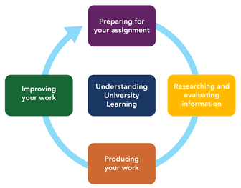
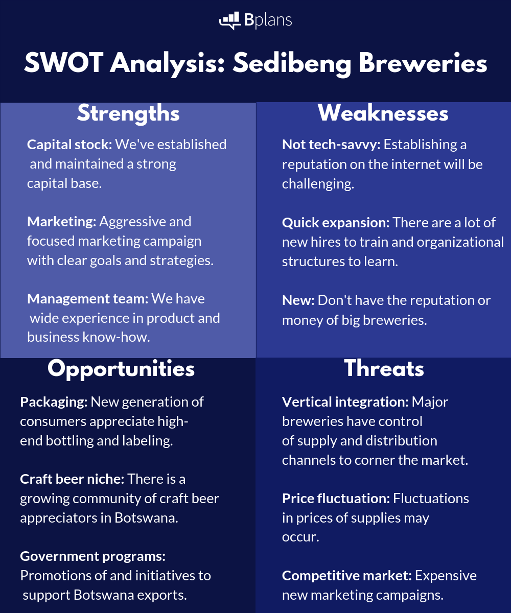
Academic skill are all about you learn in your life , starting for school and finish to college, it help to learn effective at university and developing the study skills and research method to success future.
Developing good academic skills will help you achieve the success academic potential. All of skills you will learn during your studies are transferable to your future job to help you offer leave a university. The academic skills based within the library, study skills and digital capabilities expert who help you to develop essential skills what you need for the future.
I have a good team work and organizing skills. I have a great mark in ability to communication and listening. In the group work I can build on ideas whit other members and as team leader I usually will make plans to allocate tasks to the group members to make sure everyone enjoys. I am a good self management, I can management my time well and usually I will write down. But I have no employment experience , even the part-time job experience. I am weak in problem solving, when I face problems usually I can not see all side of them an can not provide good solution of them. My communication skills are weak whit other.
I want to open my own business because the business is the way of the earth: buying, selling, shopping, promoting , discounting all business activities and involved every day, I have broad range of interests. I am a forward thinking individual who has driven ambitions and ability, all of which are traits that are vital fir effective business developing. I have decided to continuing my university study to create my construction business. I think that the world business is full of exciting challengers and I am more than happy to face them. I am also very delightful to share the knowledge that I already have in the field with other business partner in the work. This way covers all care aspects of business and gives an excellent foundation on which to build a successful career in business construction. I am an exceptional motivated and driven person .
I want to pursues a career in administration ( project manager, or manager of tourism or trade companies), establishing the most important job for me. My life style is a routine for now, my priority ( learning ) with opposition much higher than otherwise. For now I am studying the university of business and management, following the degree, so that you will promote the highest cycle of education. I want to reach a stable social position, in the administrative field, which I can master enough to be able to live modestly. During this year, I attended the project manager course, and in February-March I will also obtain a diploma. What could help me achieve my goals in graduating from university. The remuneration for me is important, and I want an income of at least 5000 pounds per month. What could prevent my career plan is my low ability tot deal with the stressful situation a manager is subjected to and the lock of jobs in the field in question. These can be overcame by experience, by work, but also by the politics of the country , which we hope will encourage more the administrative field, or discourage, so that the good one stand out and thus be sure that the desired field is the ring one, to achieves these goals by working, and not starting directly from a function. Thus my path to career will be safer. I instead to do all this in next five years, (three of university), finishing my studies and for the next two years I became a manager or at least an assistant manager.

