Management group assignment report
Group members
-Dewi
-Morgan
-Jake
-Ben
Introduction
The project our group is working on is the imeche advanced automotive design challenge. The basis for this challenge is to work as a group and independently research and tests methods in which to utilise in the creation and operation of an autonomous vehicle fit to fulfil the challenge task: Start on a target with a precision marker over the centre of the target, move forward to a small wall and once having touched the wall the vehicle should reverse back to a separate target. This will be done through a mixture of motors, sensors and programming in order to fulfil the task cheaply and appropriately.

Group roles
In our group we have 5 members and so have split the workload 5 ways. The specifics for each persons work differs week to week. Initially for the first 2 weeks each person solely focussed on research in separate areas, see below for initial individual research.
- Maxwell-
-Types of sensors
-pros and cons of different types of sensors
-Which sensors we could reasonable use
-The price of the industry standard sensors
-the voltage requirement of the industry standard sensors

- Dewi-
-Of the past winners of the challenge: what works and doesn’t work
-General winner design
-Previous victor analysis
-The collation of the above data

- Morgan-
-Different types of power source
-What types of power source are reasonable
-Price of industry standard parts
-Capacity and voltage output of industry standard parts
-The environmental impact of the different types of power source
-The required connection types for each power source

- Jake-
-Previously used materials for successful builds
-Best places to source different types of materials
-The properties of the most used materials
-Making a list of suggest materials and why
-Manufacture methods best for specific parts
-Materials costs

- Ben-
-Research into different types of propulsion methods
-Power requirements of the industry standard propulsion solutions
-Pros and cons for the different types of propulsion methods

In terms of the skills and traits required for the above roles, overall the most important are being able to analysis large amounts of data and then collate that in a form which can then be easily access and understood by the other team members. Other important traits include strict timekeeping so that all members are able to progress their specific operation using the required data gathered by other researchers.
The workload is being allocated based off of peoples interests and specific traits. Look below for an explanation of peoples strengths and how that is being used to allocate them appropriate work.
-Maxwell
I really enjoy coding and as programming is a large part of this challenge I’ve been allocated researching and learning how to operate an Arduino. This not only allows me to focus singularly on something but also because programming is more of a learnt skill and less of a collation of data it is harder to split this work over multiple people.
-Dewi
Dewi has more academic experience and so will head the general research as well as time keep people as they work. He’s also taken on a large CAD aspect of the role as he has lots of experience in this field.
-Morgan
Morgan is studying Energy and environmental engineering and so placing him in charge of your power sourcing area of the project means his particular skills and knowledge base will enable us to better meet efficient energy needs as well as be as environmentally friendly as possible whilst making the best result possible. Morgan is a great team player who is able to accept a complex workload with no complaint and always will publish his results succinctly and promptly.
-Jake
Jake is also a great team player, even with a limited knowledge base in certain areas he doesn’t shy away from accepting a heavy workload which he can then break down into useful and ongoing information. Not only is he in charge of an integral part of the research of our project but he is also in charge of acquiring any components or materials or heading the manufacture in house of said parts. This is because he has a lot of hands on mechanical experience and so can be trusted to do quality assurance for the project.
-Ben
Ben also study energy and environmental engineering and so he is working with morgan from the other side of the fence so to say, he is looking at motors and alternative propulsion systems. This may seem unrelated but he needs to find the most accurate and efficient method of propulsion in order to minimise mileage required so the smallest possible batteries can be used and thus he can limit the environmental impact of the overall project. Ben is better at talking about his knowledge base and research then collating the data but this just means that for the best results having him sat next to you as you work is incredibly useful as his knowledge of a lot of the areas is worth hearing and would be hard to condense into words on a page in a rather limited time frame.

My tasks (in greater depth)
-Research types of sensors that can be connected to an Arduino (1)
-Compare the sensors and create a table showing the differences and contextual benefits and drawbacks in a simple to understand diagram (2)
-Use logic and research to figure out which sensors can remove from the list as they are unfit for the required purpose (3)
-Do research into the price of the sensor from a few different suppliers, not for the final price of acquisition but to compare against the other sensors as the prices I find would be different to the eventual price we would pay which would be determined by Jake as he is in charge of acquisition of materials and components. (4)
-Figure out the voltage requirement of each type of sensor and collate the data into a simple table so either morgan or a different team member can reference this when deciding which sensors are more efficient to run and if a certain sensor would require a higher voltage battery. (5)
Moving on from the sensors aspect which was the original work I was set I would move onto the following tasks
-Research Arduinos and collate the useful data for the team to reference, such as voltage and power requirements or special requirements for the chassis design (6)
-Research programming with Arduinos using their proprietary language which is similar to C/C++ (7)
-Research linking the motors and batteries to the Arduino (8)
-Research linking the sensors to the Arduino (9)
-Program a system to take data from the sensors and control the propulsion device intelligently (10)
Below is a table for my detailed tasks
Task | Hours required to perform task | Equipment required | Notable comments
1 | 1 | Research materials (internet and library books)
2 | 0.5 | Research materials (internet and library books)
3 | 0.5 | Research materials (internet and library books)
4 | 0.5 | Research materials (internet and library books)
5 | 0.5 | Research materials (internet and library books)
6 | 1 | Research materials (internet and library books)
7 | 3 | Research materials (internet and library books)  +  An Arduino | Here will begin the part of the project involving the Arduino, as no one as used one before I will be learning about them from scratch including the programming element. As programming is a skill the hours to perform this task could very well be significantly longer if trouble arises because we will be very inexperienced in trouble shooting at this stage
8 | 2 | Research materials (internet and library books)  +  An Arduino  +  A motor | This task will not only involve lots of programming but will also probably include a fair bit of wiring which I will be receiving assistance from Morgan and Jake
9 | 3 | Research materials (internet and library books)  +  An Arduino  +  A sensor | This task will not only involve lots of programming but will also probably include a fair bit of wiring which I will be receiving assistance from Morgan and Jake
10 | 4 | Research materials (internet and library books)  +  An Arduino + A motor + A Sensor  +  A prototype model of the project | This task will not only involve lots of programming but will also probably include a fair bit of wiring which I will be receiving assistance from Morgan and Jake

In terms of personal date guidelines for work, below will be listed dates at which I will be attempting to meet with my work properly completed to a high and sufficient standard to the group document or physical work.

Project start – 14/11/23
Sensor research start – 15/11/23
Sensor research finish – 27/11/23
Arduino to be ordered – 4/12/23
Arduino research start – 4/12/23
Arduino Practise start – 11/12/23
First prototype test – 15/12/23
Final design plan - 5/1/24
Final design assembly - 27/1/24
Programming the Arduino for the finished bot – 12/02/24
Imeche challenge day – 20/03/24
Project 1 end – 20/03/24

The gateway for the sensor finish date is having a set of data collated into tables, short easy to understand writings and diagrams so that anyone can quickly look at the work done and reference it for either parts of the project, the goal is to end up so that no one needs to do research in this area external of our collated data document

Areas of concern
Within my area of the project I have quite a daunting task ahead of my being solely responsible for the coding side of the challenge. This will require lots of research, testing and time. My concern in this area is that I might struggle to fulfil the goals of our robot in terms of accuracy in a limited time slot. A reasonable way to mitigate this is to set myself realistic time goals for each part of the coding and try my best to meet them. If I don’t I know I’m behind schedule and within the university I will attempt to find someone with a strong knowledge base in coding with Arduinos and ask for their help. I only wish to do this as a last resort and receive help for each goal instead of the entire project as I wish to build up my own skill and knowledge base so when difficulties arise my team members know I can be approached to solve the issue rather than the person I find for assistance.
Another concern I have about a potential problem is that if there are shipping delays for the Arduino there will be only so much practise and research I can get done and every day late the arrival is, another day is lost of practise and this increases the risk of buggy and inaccurate code. In terms of potential solutions I believe I could find a virtual Arduino online from a learning resource and practice using an entirely virtual model or contact the university robotics group and inquire about whether they have an Arduino on hand which I could borrow for practise.

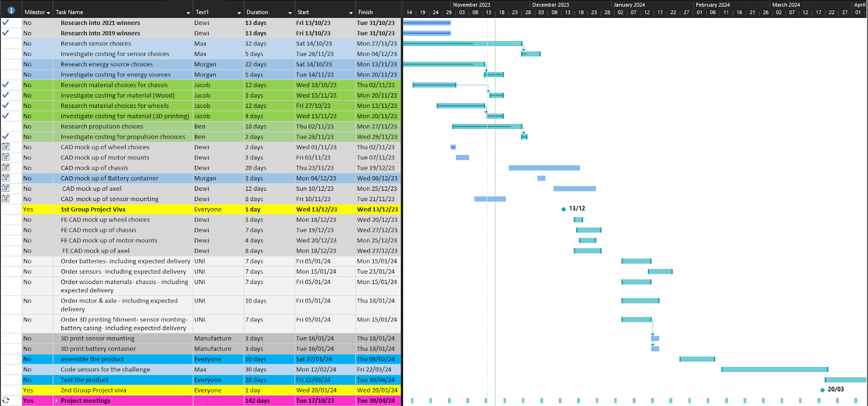
Group Gantt Chart
e

