Managing Enterprise in the 21st Century (BMSW4006)
Business plan report /group report
Maria Alexandra Mihai-2030294
Angelika Woloncewicz- 2030158
Daniel Adrian Vasile – 2030031
Keti Veselinova-2030287
Lecture name: Zainab Atta
Table of content
•Introduction ….2
• Market Analysis and Marketing Plan ….. 3-4-
•Operations and Management plan ………5-6-7
• Conclusion ……8
• References….9
Introduction.
Bella fashion Year 1 Fashion Introduction to the fashion Industry report In this report I am going give an introduction to the fashion industry by introducing several different areas of the industry. I aim to develop a critical perspective of organizations within the fashion industry, To introduce organizational behavior, structures, roles, and how the production process works. I am going to examine Industry dynamics and their relationship to other sectors and examine the industry in the context of broader, cultural, social, economic and technological factors. Designers usually work in one of three main fields- Bella, designer, ready-to-wear, or high street fashion. They may also specialise in various types of clothing- Underwear, Sports wear, swimwear, knitwear or theatrical costume. The majority work in clothing, but some specialise in hats and other accessories. Bella Fashion involves designing garments for individual consumers, who pay for individual clothes. They attend the designer's workroom to have clothes fitted that are made to measure. Most designers also design ready-to-wear clothes. These can be produced in relatively small numbers and sold under the designer's label. Mass-market work involves designing clothes and accessories where price is a major factor for items selling in large quantities though shops. Most fashion designers work as part of a team for wholesale companies who will either retail their products direct or sell them though fashion fairs and shows. Ranges are designed and produced by wholesale manufacturers who sell them to retailers for resale.
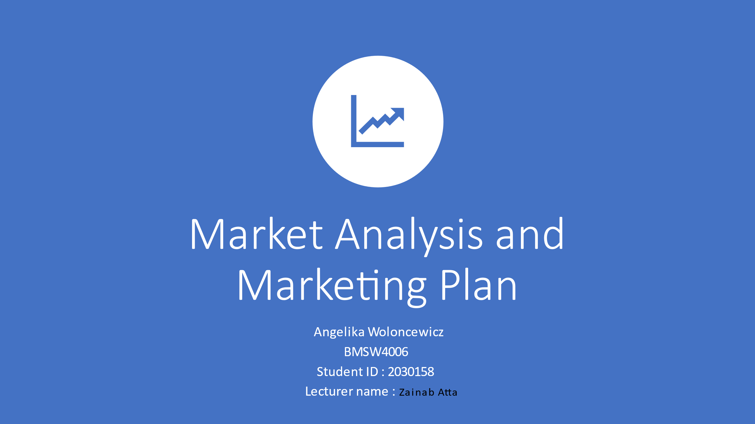
Market Analysis and Marketing Plan
To start our group report out now I will go and talk about my part of the group report which is
{market Analysis and marketing plan},
This is a plan made out of a table chart I have created and in the chart I have what the public would ask us as a business, what the business would be about , and we would answer them as a business in other types of ways , our business very much adapt to the way the system pf living works now with the pandemic everything has changed, and because of lock down a lot of business are now struggling to keep open their businesses, even when the restrictions, in allot of employees are sacked just because they are newer you have to leave because of the law of 6 only allot of business had to pull string to meet ends
www.bloomberg.com/graphics/2020-us-bankruptcies-coronavirus/ here if have a look on the website where it explains how the pandemic and lockdown put a lot of business in the spot, how much pressure all business were in, some even closed up.
That’s why we as a business have put down that we will become an online store for the time being if we make good enough product sell and hide some money aside and one day open a store, but for the time being we will stay selling our products online, there are a view examples the same as what we present like the online store called ASOS the difference between our business and ASOS company they sell products from other brands ASOS | Online Shopping for the Latest Clothes & Fashion like Tommy Hilfiger, Gucci, Armani , etc … they also sell their own but like my business, we have come up with the plan to start our business with our own clothing line, and maybe than start selling other clothing lines, but that idea is for the future now our main motive is to successfully fill full our goal which is to open up our business and start selling our own clothing line, this business is a private business our prices come in different ranges depending on the clothes the prices start from £10 on words, we sell boots heals and accessories such as earrings bags and scarfs,
Depending on the time frame but as we see and know it for now it will be the items I have listed and also coats and jumper’s shirts and jeans, tops, our clothing line are from age group 17-60 only for woman shopping obviously a man can buy from our online store, but the clothes select are for women, young adults.

Going back to our questions and answers as you can see the questions were asked by the public and our business answered the questions best as we could, there were different type of questions asked, our main goal is to make all our shoppers happy and fill full their needs and leave them happy with our products, we are not wanting to make our business similar to other business we are making it unique, yes of course there are many other business with the same selling meaning clothing lines yes we know a lot of business have the same but we are going to try and make it the best online shopping site you bought something from save your money costs not that expensive, making it worth your time and money the quality of the clothes are very good , as we probably all went through it buying from big business like EBAY www.ebay.co.uk/itm/265295362256?chn=ps&var=565154085260&norover=1&mkevt=1&mkrid=7101533165274578&mkcid=2&itemid=565154085260_265 not so expensive but the material quality is not as good as we would expect from a big business like EBAY , Amazon or , Wish.
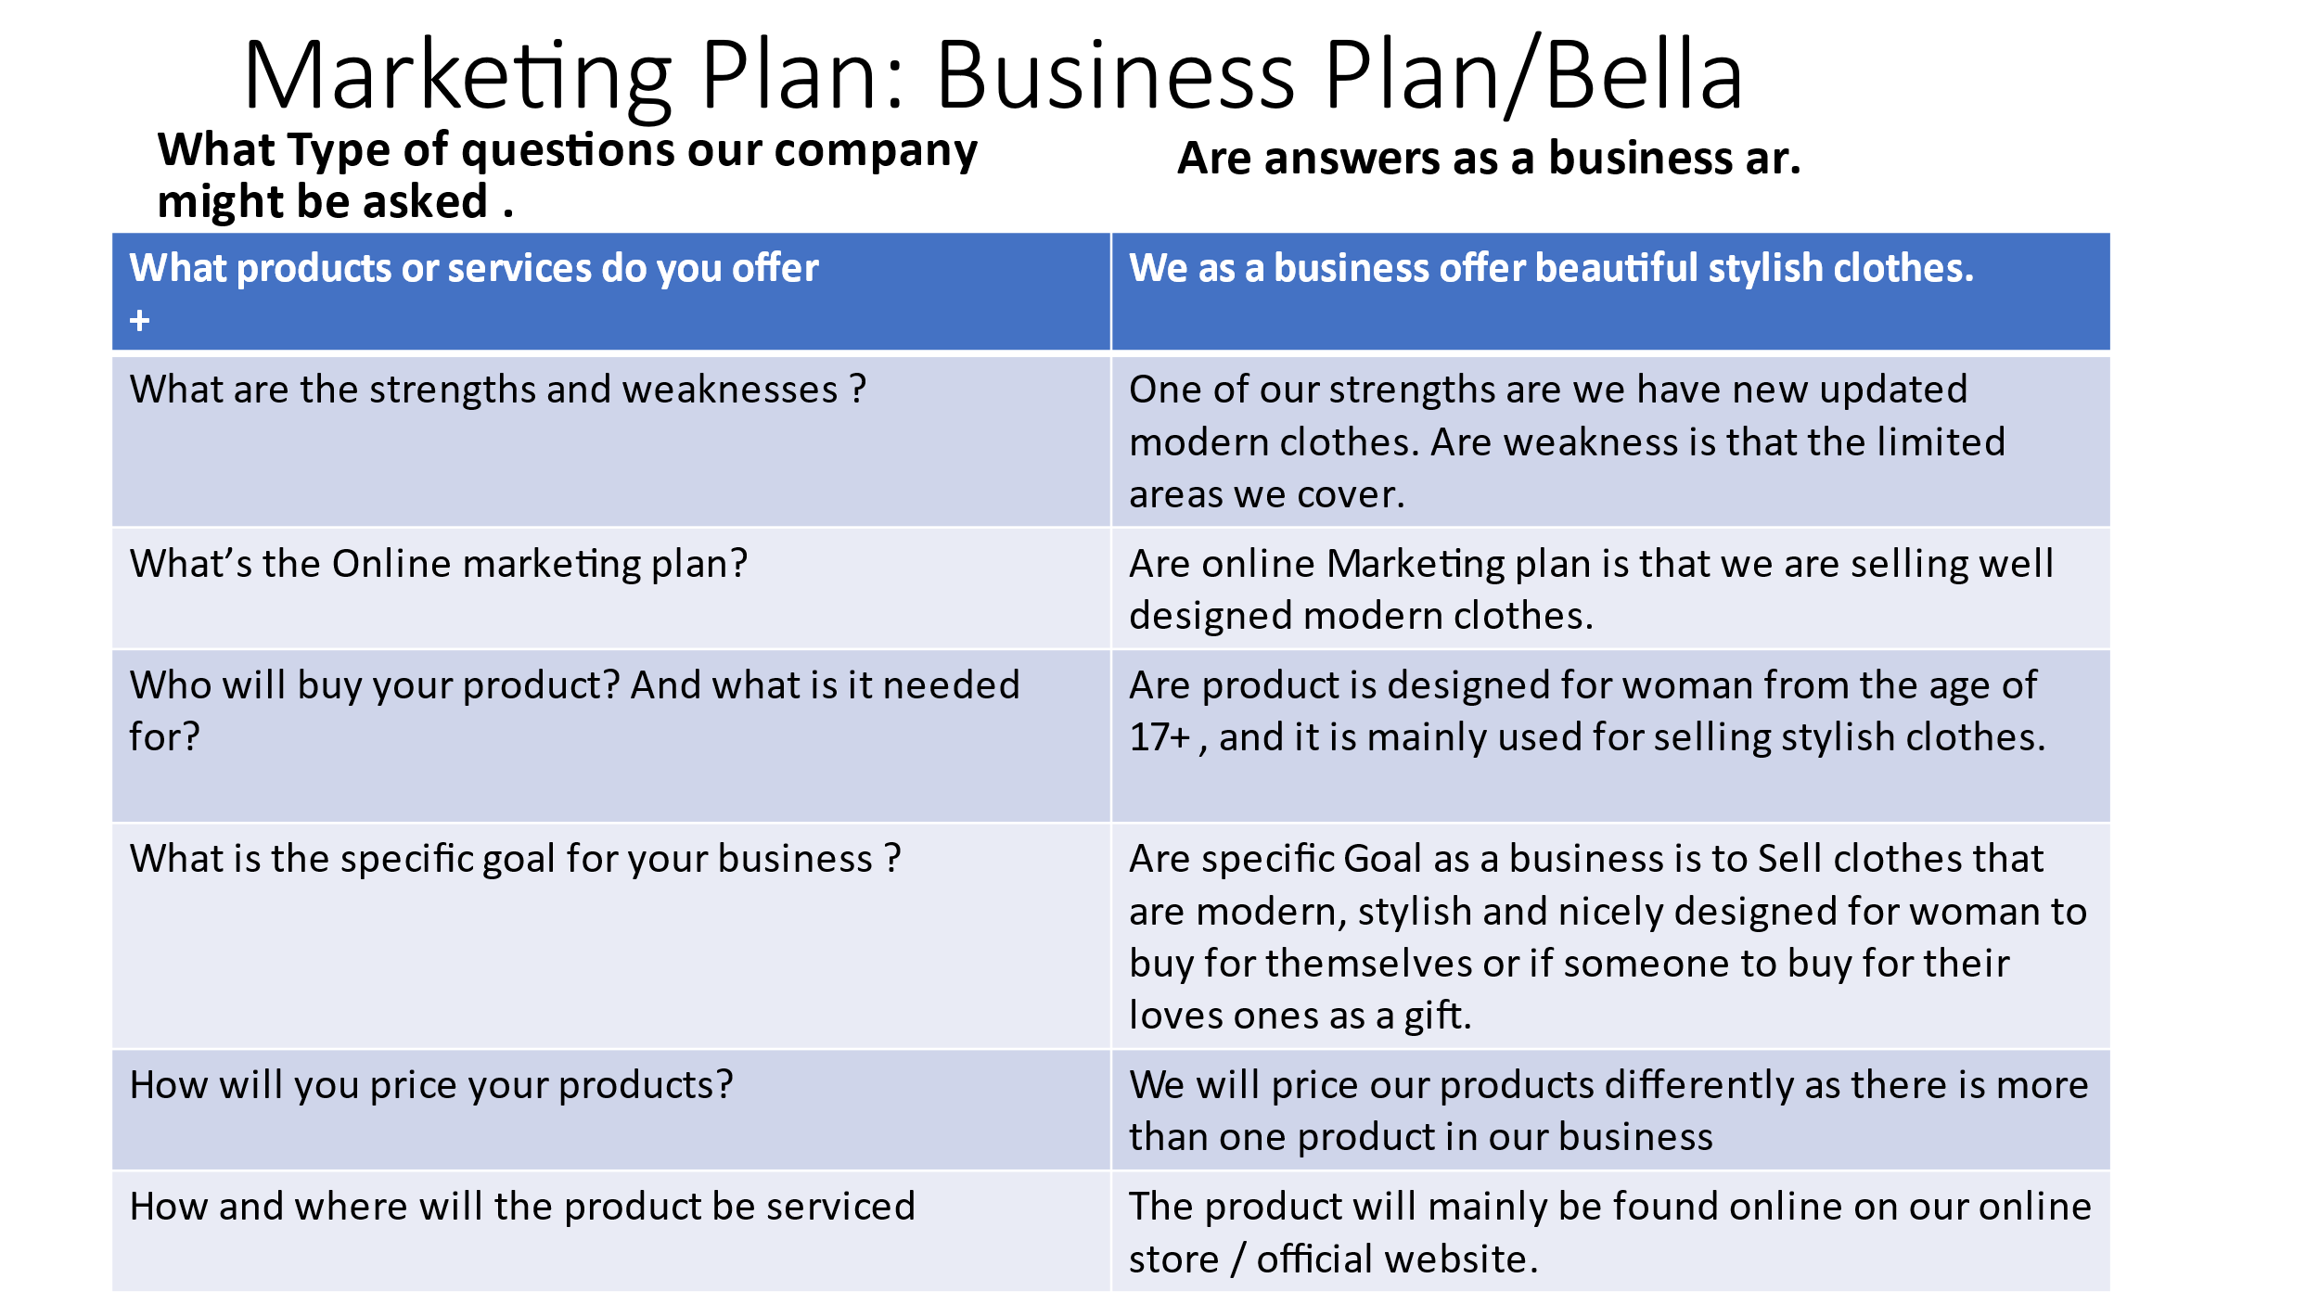
That is why we are trying our best to advertise our business as best as we can, No we are not trying to win over the whole of UK but we are trying to show all our customers why its best to buy from our online stores, like I mentioned before if our productivity goes up everything goes well we will open up a store and if that goes well we will open our stores in different areas in the UK, it is not such an easy process and it will not be a 2 minute job it take weeks of planning and organising how the business will be structured what will the business based for and where as a private business we are based at home we work from home as it is a online store we don’t have a lot of employers as we currently need 5 workers, one for ordering the products, one with for the banking and looks after profits , one for updating the online store, other workers to send off the packages, our packages are delivered by www.myhermes.co.uk , www.dpdlocal-online.co.uk and of course we got the www.postoffice.co.uk , the delivery prices are all different.

Also to include in my business report our business only delivers to the UK, as we are starting from where we are based yes we are thinking to deliver to other country but as for the time being we are only selling and delivering to the UK, as for Brexit parcels are delayed so we don’t want to have any problems with our customers, we are planning to send out of the UK but we are waiting for everything to calm down before we start any action. So, to put your thoughts at ease, our plan for the future is to add more products and change the prices and add more delivery address and countries to our business so we become world range
More products | Better prices | Location change for orders
We also have a plan to open up a store(s) but that will be only based in the UK, but the online store will be continually online for people all around the world.
Open up a walk-in store

More better materials more exclusive clothing line and better prices that will not let you down.
The point of opening this business is to help people buy what they need with better quality and better prices because of this pandemic world-wide it has been a problem with stores staying opened and people only have access to essential shops or online shopping which can be very tricky because it might cost £20 but there is a delivery fee that marks the cost up to £30 or higher. There were so many times I would want to wear something nice but don’t have a good store to pop in to and the online stores don’t really have good quality, so I came up with the idea and asked around got the right permission to open up a online store, called up a few places that can help me with the materials and getting the right quality for each and every item we sell, we don’t want to spend £30 pound on a piece of clothing and turn around after a few months and its not in good shape or the colour changes of the material itself changes.
Best website to gather the right tools to creating a online business for me personally was
( Wix.com, Inc © 2006 – 2021) Sell Online with Wix eCommerce | Wix.com
It helps you and gives you the right tools to create the perfect online store shows you what to do and what not to do.
But before we could do anything we had to be assessed by the law we had to show our structured plan for the business, show what places we will be getting our materials from, show our banker the person who looks after all the money. Because of course every business needs it. No business is quite perfect, but by trying to create the most unique business you are showing other people that if you could active it they can active it too, if you put your mind too it anything is possible. On our official website you can click on contact us and information about our products and our business, you can even chat to us live on the website, if you have any questions or need to send back any items if they were to small or anything else we have a delivery address and all you need to tell us why you are sending back the item so that is why we have given the option for customers to be aloud to chat to us online, and tell us about the issue, of course you will be refunded, but if you don’t want a refund you can by anything else to the price that you spend on the other item.
But before you do wish to by anything else for the price you spend in our online store, first the item will have to be returned then you will get an email with the steps asking if you would like the full refund or would like to credit that and by something else, our best is in the mind of our customers, happy customers happy business.
Thank you sincerely for reading through my part of the business plan and by writing this report I am trying to show you why this business is a brilliant idea, it is very hard now a days with all this viruses I my self am to scared to go into a shop where 3 years ago I would go in without being scared of catching something, but if you ask me personally, illness were always here it is just not always they get to the point where half of the globe are so ill so have passed away tragically due to COVID-19, so we cannot get scared but what we can do is , wear a mask, get boosted and stay 2 meters apart and stay safe , clean your hands, and be careful when in any place and it is best if you don’t have big gatherings, especially in cold autumn, winter times when the illness comes out more like any normal flu usually comes in cold weather,
Here is some information on how to keep safe during this sadly times, also explains about working from home, or working out from home and best ways to keep yourself and your family safe.
- Coronavirus » Safe working for all NHS staff through COVID-19 (england.nhs.uk)
Philosophy and product development
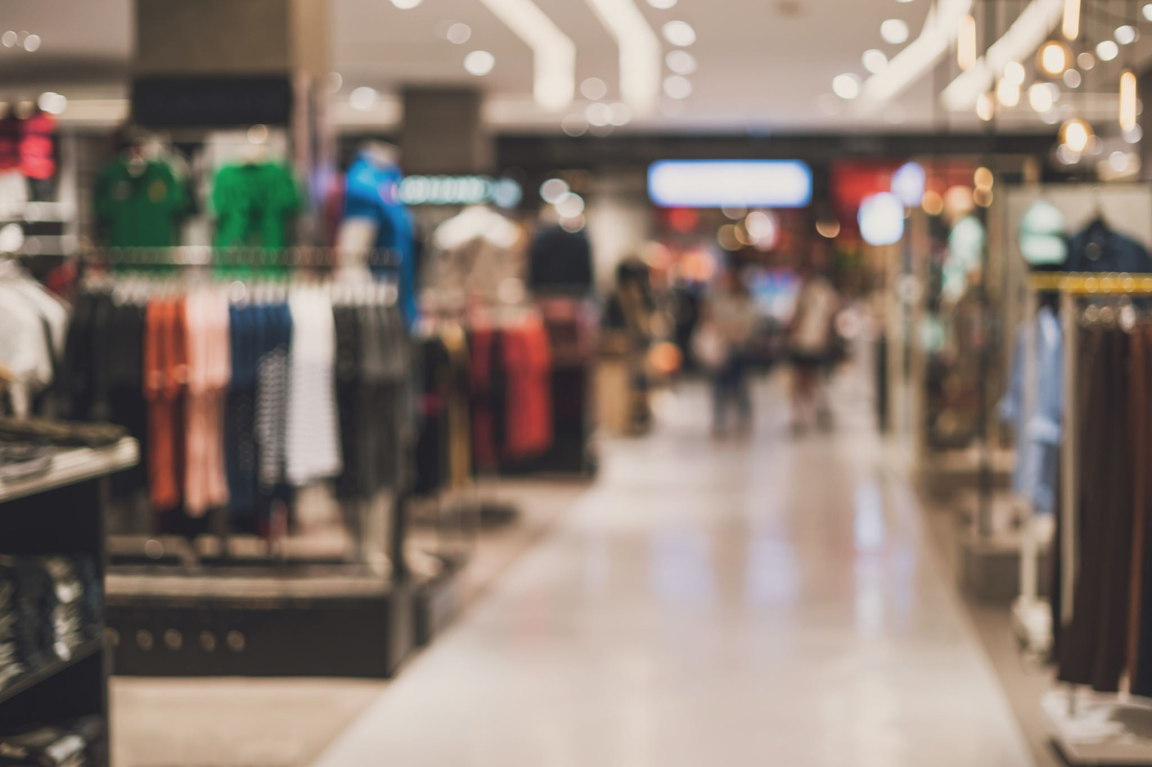
The fundamental business strategy of our organisation is to combine great and adequate customer service with high-quality, fashionable items. We will make shopping fun for our consumers. Bella's objective is to provide attractive apparel for ladies. Our goal is to develop our firm as an industry pioneer and to create a boutique brand name that will become associated with high quality.
● We are actively assembling our collection via collaboration with many clothes
wholesalers, garment manufacturers and fashion designers.
● Additionally, we are coordinating with the relevant authorities to ensure that
all necessary permissions and occupational licences are obtained.
● Additionally, we will utilize the money to acquire products and equipment.
Prior to Bella’s big debut.
● We will arrange multiple online and in-person events and kick of promotions
with strong advertising.
- Online Strategy.
Bella will create an online shop to sell our items, since the Internet has become a need for living and retail commerce. We've registered the domain name Bellafashion.co.uk and will begin building the site on the Wix platform. These systems enable us to swiftly construct an online shop and handle all parts of it, including the creation of shipping labels, payment processing, and inventory management. Additionally, customers will be able to make wish lists for things they intend to buy in the future. By establishing an online presence, we will be able to grow our email marketing list and send frequent promotions to clients, including new product announcements, discounts, and specials.
Operations.
Bella will operate seven days a week, twenty-four hours a day, as an online retail firm. Monday through Friday, from 10 a.m. to 8 p.m., live customer assistance will be accessible. We will extend live shop hours throughout the Christmas season and special events. At this time, the retail shop will occupy about two-thirds of the available area in the structure. The remainder of the room will be used for inventory and administrative reasons. Along with the two full-time co-owners, we plan to recruit three part-time staff to assist with customer service.
Organisational Structure and Leadership.
We will have a modest crew since we are a tiny firm. Both co-owners will take leadership positions within the business and will be accountable for daily operations, marketing activities, purchasing items and inventory management, as well as any other administrative responsibilities. A modest sales crew will support the co-owners in obtaining sales, serving clients, and regular storage facilities upkeep.

- Conclusion.
Bella has made significant progress over the years to provide consumers with better online shopping and will continue to do so in the coming years. With the rapid growth of products and brands, people are speculating that online shopping will overtake in-store shopping. Although this has been the case in some areas, there is still a demand for shops in market areas where the consumer feels more comfortable seeing and touching the product being purchased. However, the availability of online shopping has created a more educated consumer who can shop with relative ease without having to spend a lot of time. In return, online shopping has opened the door to many small retailers who would never have a business if they had to bear the high cost of owning a store. In the end, it was a win-win situation for both consumers and sellers.
Referencess list.
ASOS | Online Shopping for the Latest Clothes & Fashion
- www.bloomberg.com/graphics/2020-us-bankruptcies-coronavirus/
- Coronavirus » Safe working for all NHS staff through COVID-19 (england.nhs.uk)
- www.dpdlocal-online.co.uk
- www.ebay.co.uk/itm/265295362256?chn=ps&var=565154085260&norover=1&mkevt=1&mkrid=7101533165274578&mkcid=2&itemid=565154085260_265
- www.myhermes.co.uk
- www.postoffice.co.uk
- Sell Online with Wix eCommerce | Wix.com ( Wix.com, Inc © 2006 – 2021)
” operation and management plan”. Available online: https://www.ideasforleaders.com/ideas/fast-fashion-retailing-–-transforming-operations-management (Accessed: 14th December 2021)
“Organizational structure and leadership”. Available online: https://www.npaonline.org/sites/default/files/PDFs/Organizational%20and%20Leadership%20Structure.pdf (Accesed:14th December 2021)

The fundamental business strategy of our organisation is to combine great and adequate customer service with high-quality, fashionable items. We will make shopping fun for our consumers. Bella's objective is to provide attractive apparel for ladies. Our goal is to develop our firm as an industry pioneer and to create a boutique brand name that

