Name: Mavish Iyshia
Student ID:2236706
Component 1- Coursework: Portfolio ACCA4026_BIRM
Lecturer: Osman Elgawi
Date Of Submission:25.03.2026

Contents
Introduction 2
Section1 2
Wix 2
The advantages are indicated below 3
Shopify 4
Section 2 6
Mind map Description 6
Creation of Mind mapping 7
Section 3 8
Office software solutions for businesses/organisations 8
Practical testing of Excel Functions 14
Pivot Table in Excel 14
Section 4 16
Online Communication 16
Online Collaboration 17
Reference 24

Introduction
Software solutions are crucial for modern businesses, boosting effective productivity and enhancing daily workflow. Throughout this assignment, I will explore a broad spectrum of software applications that contribute towards working environments.

Task 1 outlines the two e-commerce website builders, Wix and Shopify. Task 2 clarifies the importance of mind-mapping with a practical example. Task 3 explores four of my chosen MS software’s Microsoft Word, Excel, PowerPoint and Access with practical examples. Task 4 examines one communication and one collaboration tool. I will demonstrate my awareness across my assignment on how software solutions and applications strengthen businesses' day-to-day operations.

Section 1

Section1
[1] E-commerce builders are software developers that help assist businesses to establish and maintain online services. My objective from this task is to outline two website builders with a specific focus on e-commerce functionality. I have decided to research both Wix and Shopify. I will be discussing the strengths and limitations of my chosen platforms.

Wix
To begin with, I will share my insights into a well-recognised website builder known as Wix. Wix is utilised by businesses/organisations in producing professional websites, this website builder has many benefits which help assist businesses in accomplishing goals and aims. Moreover, [2] you do not require experience to use Wix as it is amazingly easy to operate in creating a tailored website. You can make alterations within the website without the use of coding; this is fantastic for businesses with limited experience in using this specific experience.

The advantages are indicated below:
- Beginner- friendly
- Drag and Drop system
- Safe and secure
- SSL certificates-the information and data shared between yourself and guests will stay protected due to it being encrypted, which promotes a high standard of security
- Custom build
- Able to sell products directly from the site
- Excellent marketing opportunities
- Use of different languages and translation options tailored to people around the world
- Customer assistance provided

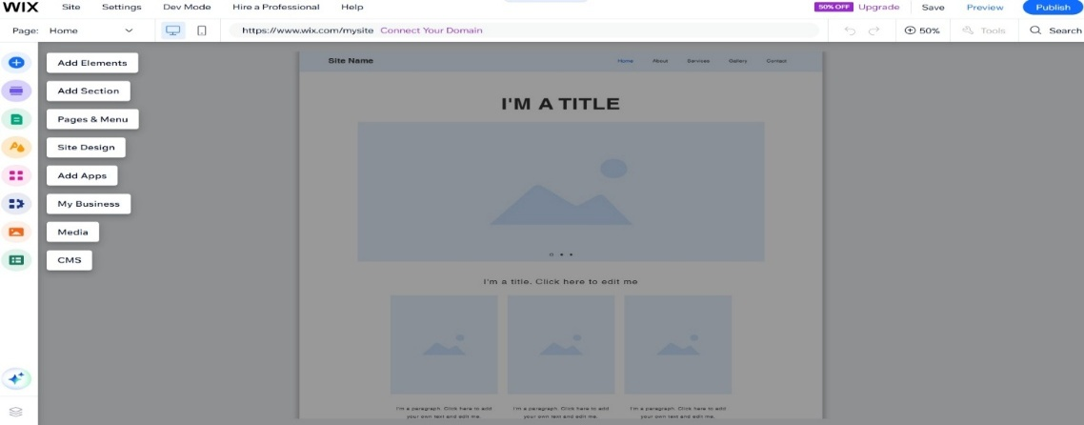
Figure 1 Screenshot of the Wix's Website Builder's homepage and the available features/tools.

Limitations are as follows:

- Lock in system- after you have decided on your preferred template and conduct your website, unfortunately you are unable to change to a different template without starting over
- Wix is a good choice for small businesses, unfortunately becomes a challenge for users who require more customisation due to the restrictions
- The time of loading will decrease due to the number of videos and images used

Shopify
Another popular platform is known as Shopify [3] Shopify is a cloud-based e-commerce builder, it is predominantly built as an online selling service as well as face- to- face. From the build in features businesses can operate efficiently managing daily tasks such as, transactions/profits gains, controlling stock, order dispatch and monitoring of sale data. Shopify assists businesses in progression and expansion of their online recognition.

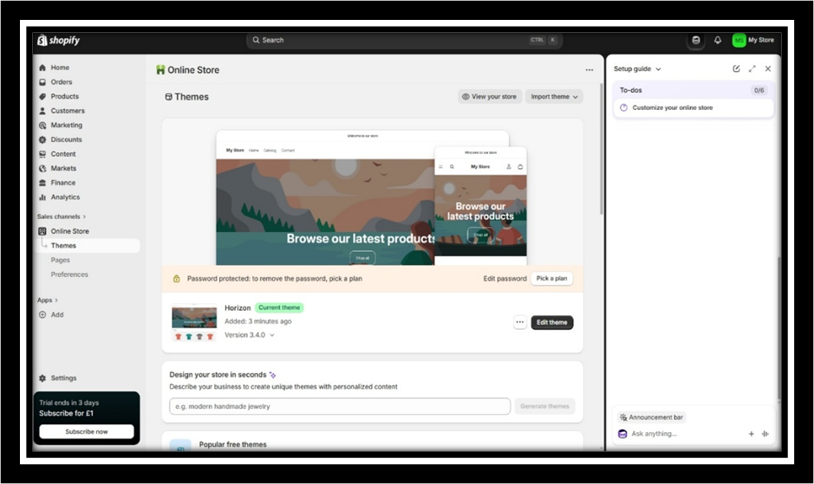
Figure 2- Screenshot of the Shopifys homepage.

The benefits are indicated below:

- A user-friendly visual editor assisting you to project at a higher level of speed
- The use of setup wizard helps suppliers
- Can sell the products/items on different social media platforms such as, Tik Tok, Instagram, Facebook, Amazon and eBay
- Rapid implementation service- users could go live within a short time frame
- Building apps or adding functionality without the use of traditional coding
- 24hr assistance is available

The Disadvantages are as follows:

- Ongoing charges and in-app fees
- If needing themes that are different from those which are provided, then further applications are required.
- Third-party apps are required, which minimises the overall performance

Shopify vs Wix
Table 1 Comparison table of Shopify and Wix.
Evaluation Standards | Shopify | Wix
Role | Online selling platform | Multi- purpose website builder
Usability | Fair | Beginner friendly
Scalability | High in scalability | Limited in scalability
Cost spectrum | Higher in price | Lower in price
Targeted at | Growing online merchants | Small businesses/organisations
The table above demonstrates the differences between the two website builders, Shopify and Wix especially when it comes to the scalability, cost and targeted at. A new or smaller business would benefit more by utilizing Wix due to it being budget-friendly and easier to navigate. However, a business that is well-established and working towards scaling up, using Shopify is the way forward due to the more advanced features provided. To conclude, it all depends on the users’ requirements and what they wish to attain. Shopify is aimed at bigger businesses whereas Wix is an easy option for smaller businesses who focus on simplicity when it comes to design and use. Overall, I believe from the findings Shopify is more influential and stronger in terms of expansion, however Wix is powerful when it comes to simplicity.

Section 2

Section 2

Mind map Description


A mind map is a visual representation to highlight ideas, thoughts, and theories. The purpose of mind mapping is it’s a visual method that arranges content in a hierarchical form. The advantage of this is that it promotes a higher level of understanding, which leads to valuable decisions being made. [4] It all started in the year 1974, Tony Buzan a teacher and TV personality took part in a show known as Use your head. He introduced a new type of visual tool which resembled a bright tree. Indicating the prime talking point in the middle, and then links are connected around the middle , all relating back to the discussion point.
For example, if the subject is about healthy lifestyle, then that will be positioned into a box in the middle and then branches will be made around the box with the ideas which are relatable. Ideas such as the following may be discussed and used, diet, getting active, quitting smoking, decreasing consumption of alcohol, drinking and monitoring of water and many more. Mind maps can be created by using the following MindMeister, Coogle, Canva, Mural, Miro and XMind. MindMeister claims making mind maps can be produced together as a team through collaboration [5]
Businesses implement the use of mind mapping to support them to break down problematic operations into a much simpler form, the purpose of this action is to obtain a smoother business/organisation daily functionality. This is a powerful source to promote within businesses; due to the amazing differences it makes. Looking back, I applied this methodology within my workplace with the aim to assist me in attaining what I needed to achieve. I used this function to support me towards a particular situation that required further development, through team meetings it provided members of staff to collaborate and put their voice across. From this we were able to resolve the situation in a professional manner attaining positive outcomes. Mind mapping simply encourages ideas, planning and team working standards. [6] The use of mind maps assists users to remember the information gathered at a longer duration. Research demonstrates utilizing mind maps rather than writing down note’s, individuals can hold onto the information at a much better level.

The benefits are indicated below:
- Simplifies complicated concepts
- Communicating/interacting within the team helps to pick up various ideas around the talking point
- Enhances decision making
- Effective problem solving
- Increases the level of productivity, performance, innovation and progression.
- Less time-consuming
- Clear and Concise
- Achievement of set goals and objectives
- Aids with organisational skills
- Businesses can look over the options and make wise decisions
- Support in absorbing information more effectively

After thorough research, I have obtained meaningful findings on the importance of applying mind mapping. I understand this method increases the chances of solving implications, as the process enforces a clearer perspective. There are countless advantages that drive growth and development in all areas, playing a positive role in strengthening performance and achieving desired goals and aims at a much faster pace.

My chosen career is cybersecurity. I believe that in this field, it’s paramount to put this methodology into practice, as it will make complex material easier to understand. I understand cybersecurity involves dangers/threats, data, layered systems, and processes. Using mind mapping would help me gain a much better understanding.

Creation of Mind mapping

The mind map below displays the different Cybersecurity software’s; each individual software has their own roles and duties in protecting corporate infrastructure and data. For example, Endpoint Detection and Response
(EDR) it’s a real time detection software tracking unsuspicious occurrences.

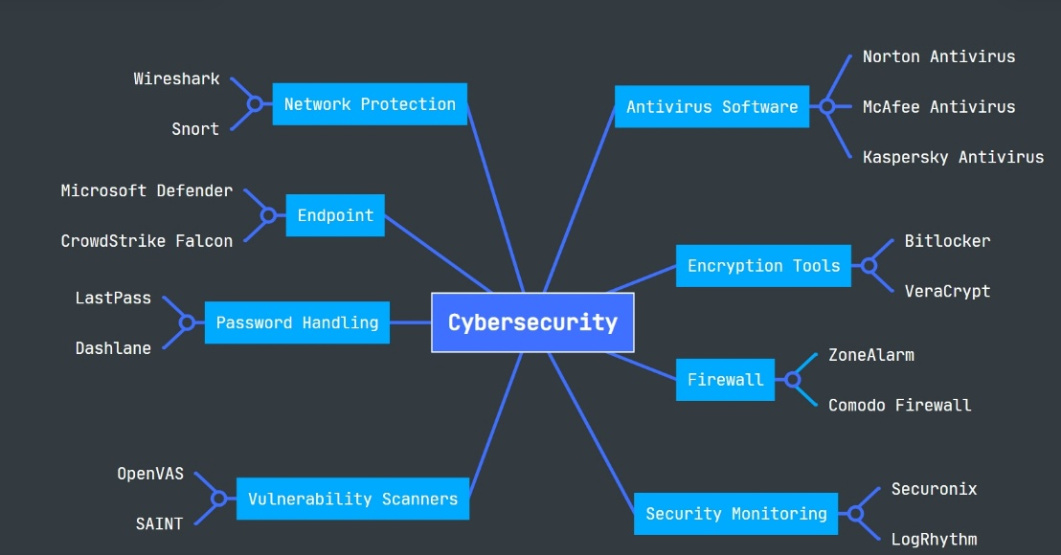
Figure 3 Screenshot of mind map of software’s in Cybersecurity

Section 3

Section 3

Office software solutions for businesses/organisations
In this report, I critically analyse the key components, strengths and limitations of the four office platforms Microsoft Word, Microsoft PowerPoint, Microsoft Excel and Microsoft Access, along with the impact each has on operational efficiency, data and collaboration. Office software applications serve as the foundation for overall operational efficiency, workflow, performance and daily tasks. On the other hand, I will outline the possible limitations and the negative effects that it may cause within businesses/organisations. Effectiveness is boosted when each software is combined, as their integrated functionalities aid communication, data/file sharing and efficiency within corporate operations.


To begin with, I will be discussing about a popular software known as Microsoft Word. [7] Microsoft Word is a typical application which is used for professional purposes creating documents, forms, reports and for all work-related means.

Figure 4- Screenshot of mail merge letter
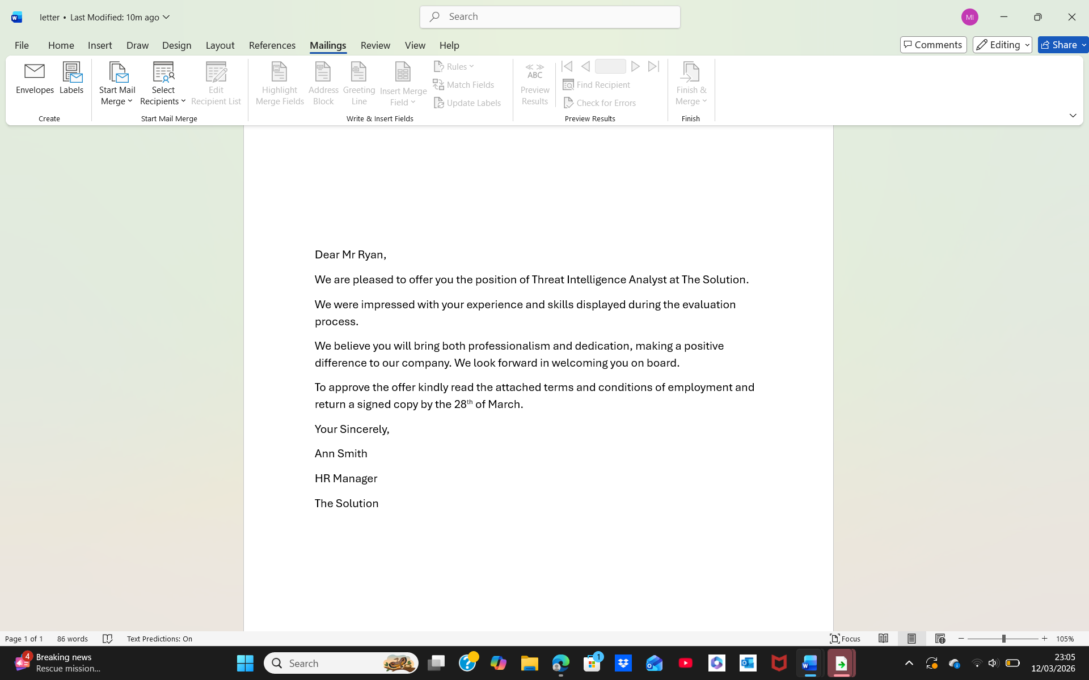
I created a personalised letter using the mail merge feature within Microsoft Word. I found the process intuitive and simple to carry out.

There are many benefits such as the following:
- Businesses can produce documentations at a professional standard.
- There are built in useful features, which can help with incorrect spellings and grammar
- Easy to gain access and use daily
- Beginner and user friendly easy to learn even for individuals with no or less knowledge in how to use this software
- Able to amend by the features and tools which are provided
- Formulated templates are available reducing time spent to create them yourself

On the other hand, there are also many limitations of this software such as:

- It is not ideal to input data as Microsoft Word is known for text. It is better to used Excel when one needs to input data.
- Smaller businesses may struggle to gain access to the full use of Microsoft Word, as it comes at a cost.
- If Microsoft Word is not being utilised appropriately, then there is a possible chance that confidential documents may be duplicated or disclosed
- Folders that may contain large quantity of images can unfortunately, slow the software down
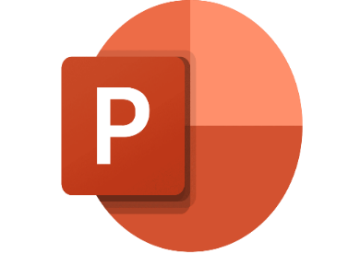
Secondly, another popular software is MS power point. Businesses use this software to assist them to both conduct and deliver presentations. [8] MS power point is a great way to express ideas through slideshows utilizing all the tools provided in a professional form.

Power point promotes businesses to compose engaging and captivating visual presentations, grabbing individuals’ attention for overall business improvements and development in mind.

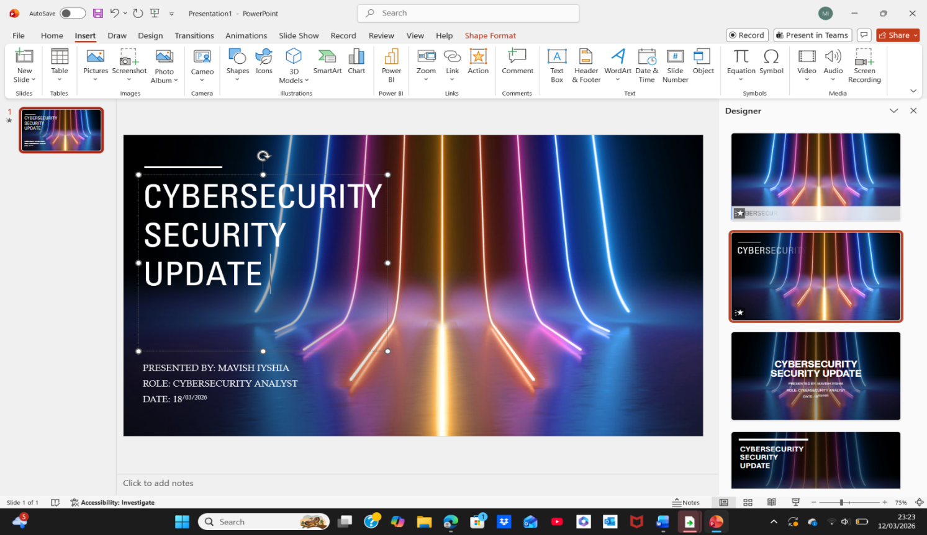
Figure 5- Screenshot of a slideshow created in Microsoft PowerPoint.
I opened PowerPoint to create a slide show as shown above. I used the designer tab, and a range of designs appeared. I then pressed onto the design that I found the most appealing. I opted for white bold font for the writing (Cybersecurity Security Update). I found the process straightforward and easy to use.

The benefits are indicated below:

- It is useful for individuals who find visualising information easier than other ways
- Presenting ideas in a stimulating way
- Making complex theories into simpler formation
- Utilising several features to make the presentations the way you want them
- Able to add pictures, videos and audio within the presentations
- Ready-to-use templates that save a good deal of time
- Data can be displayed via charts and bullet point format
- Helps Businesses with meeting

The limitations are the following:

- In some cases, imperative information can be missed when presenting the information of complex topics
- On the day of conducting the presentation technical faults could occur
- Individuals who are not familiar with this software, may take time getting the hang of using all the features correctly
- Designing slide shows to perfection may be time consuming

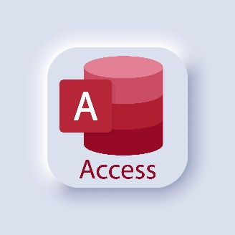
Moving on, I will be discussing MS Access software. [9] mentions businesses today depend strongly on databases, handling client’s information and inventory. This software boosts towards preparation, sorting and examining information from data.
This software is a program designed to support individuals with managing data in a smooth way, businesses can use this software to place data from statistics and figures found into tables clearly. Using MS Access can strengthen the chances of resolving operational complications which they may face.

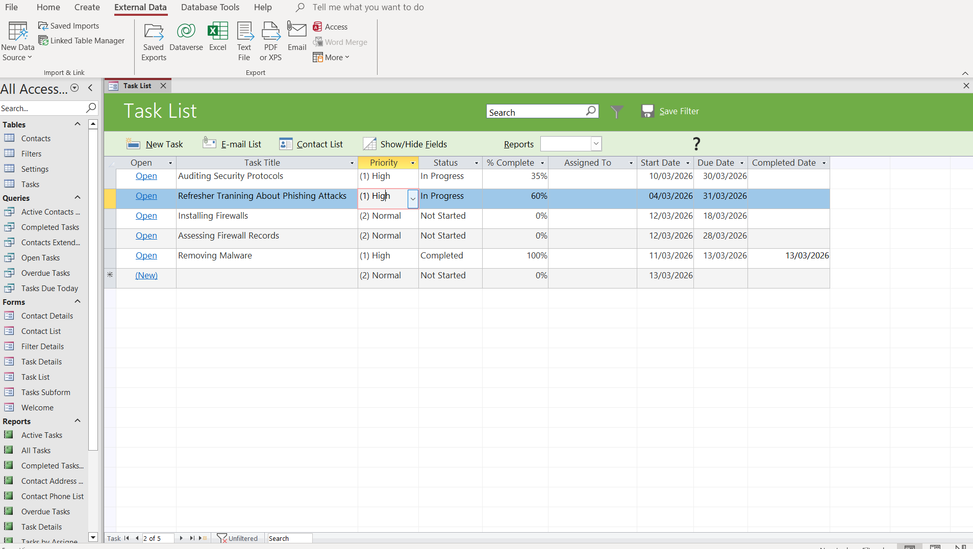
Figure 6 Screenshot of a Cybersecurity task list I formulated.
I developed a task list in Microsoft Access to help arrange and oversee required tasks. At first, it did take me time to get the hang of using the features, however then became more confident and was able to complete the spreadsheet with success.
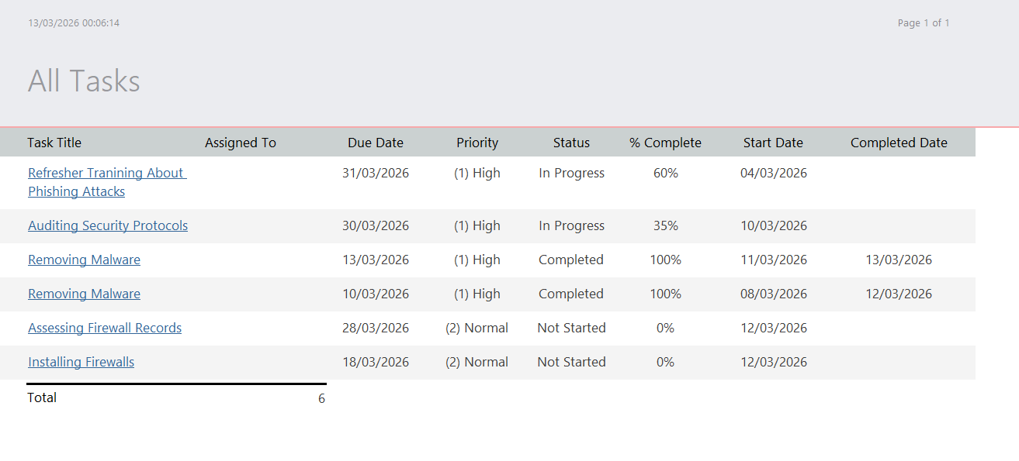
Figure 7 Screenshot displaying in-depth information for each listed task.

The benefits are as follows:
- Easy to use and learn for beginners
- Data from other software, such as Excel, Word or PowerPoint, can be easily imported and exported between the two
- Cost-effective
- Built-in features to assist towards databases
- Ideal for small to medium-sized businesses
- High level of security protecting sensitive information

The disadvantages are the following:
- The speed of the software may decrease immensely when the amount of data increases
- The level of software performance drops when too many people use it
- Microsoft Access at the same time
- Restricted to 2GB storage space
- Reduced cloud performance
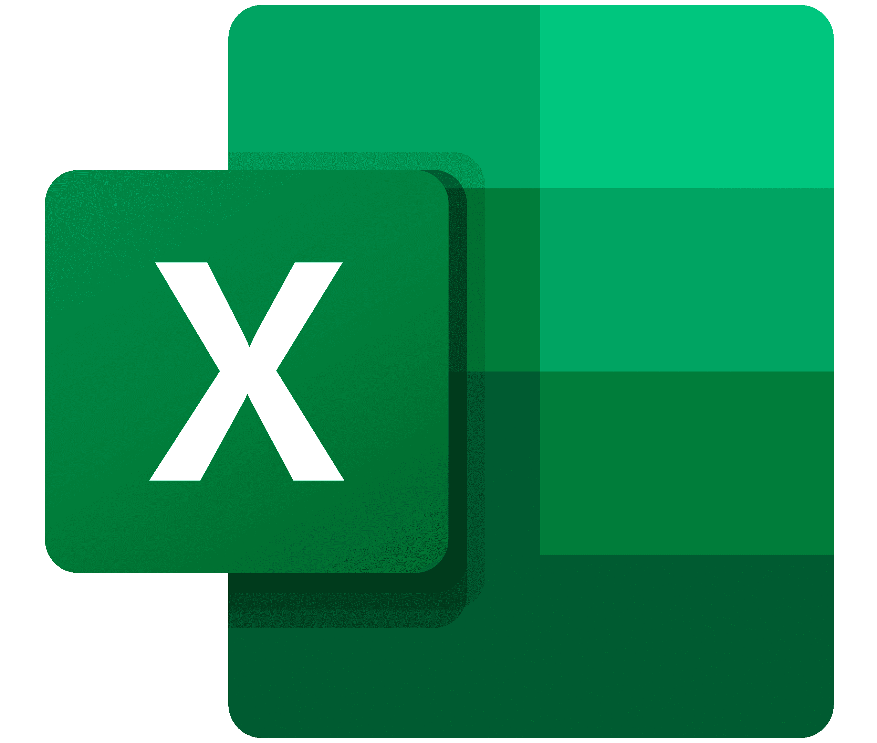
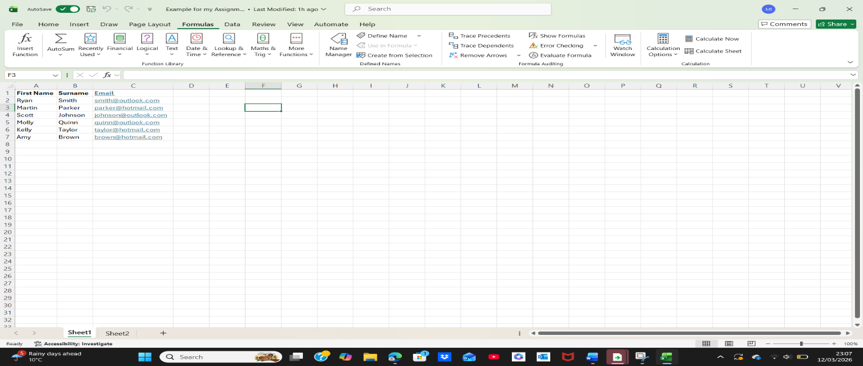
Finally, Excel is a spreadsheet software which is beneficial for businesses to save, sort out and evaluate accumulated data. Microsoft Excel is extensively utilized to help assist businesses to classify information by leveraging Excels build in tools and functionalities such as, data analysis tables, graphs/charts and formulas. [10] These influences towards decision-making from inspecting collected information from data. Businesses can improve their functionality by monitoring their financial situations, such as being aware of outgoing expenses and incoming profits. Having a sense of control is vital for businesses to prosper and develop positive
Figure 8 Screenshot of practical example highlighting employees’ information
I created a spreadsheet in Excel listing employees’ details such as first name, surname and email address. I found this easy, as I have experience using Excel spreadsheets when I worked as a administrator.

The advantages are stated below:
- Helps with time management.
- Cost-effective
- Easy to access
- Influences organisation by placing collected data within tables
- Individuals can remove and arrange data with ease
- Both graphs and charts can be easily used

The limitations are the following:
- Can be hard to use the software, especially for individuals with no experience
- Errors can occur easily
- The speed may drop due to the quantity of data
- Less security due to limited features which protect sensitive information
- Hidden fees

To conclude, throughout my research, I have gained knowledge that all Microsoft Office Applications, such as Word, PowerPoint, Excel and Access, are paramount in their own unique way with specific strengths and qualities,which bring their own benefits to overall business/organisation functionality. This plays a high level of role towards reaching positive outcomes linked to productivity, performance and strong daily operations. Each one of the Microsoft Office Applications are customised with certain intentions in mind, having the same focus to produce success and positive development and progression.

Microsoft Word is used extensively by businesses and organisations in creating professionally written documentation. Microsoft Excel is constructive when dealing with data. Microsoft PowerPoint assists professionals in presenting ideas and concepts in a visual method. Microsoft Access offers a systematic approach towards controlling and managing data more easily.
There also come the limitations with each individual software mentioned. Some Microsoft Office Programs have strengths in particular aspects where another software is weaker in that same area and vice versa.

Practical Testing of Excel Functions
I have tested two features.

Practical Testing of Excel Functions.

I have tested two features Pivot and IF
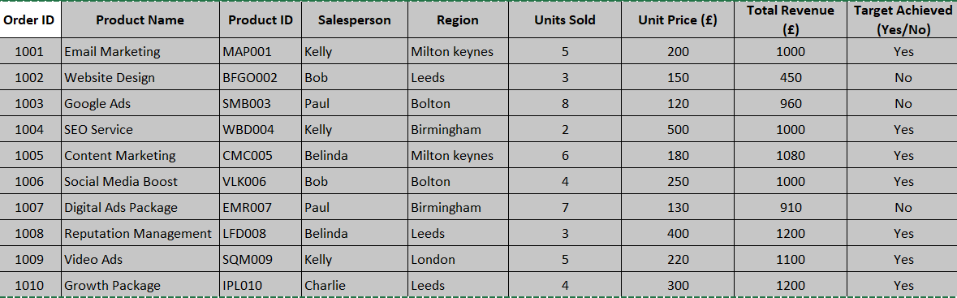
Figure 9- Screenshot data used for Pivot table in Excel

Pivot Table in Excel

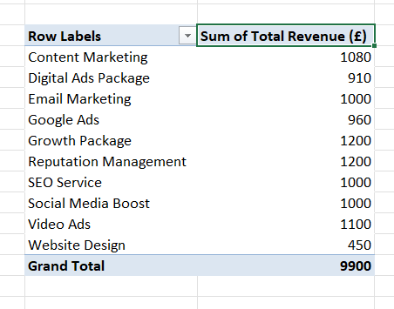
Figure 10- Screenshot of results

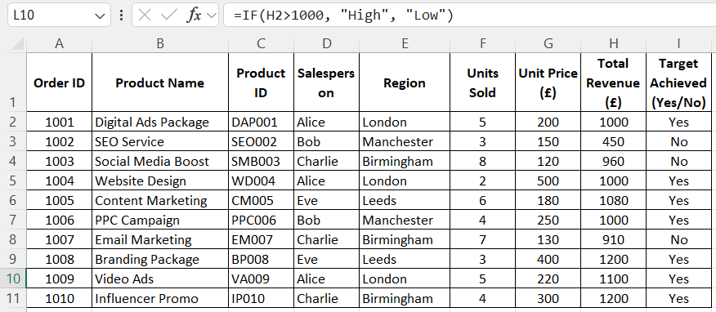
Figure 11- Data sample used for IF function in Excel
Order ID | Total Revenue £ | IF Result
1001 | 1000 | High
1002 | 450 | Low
1003 | 960 | Low
1004 | 1000 | High
1005 | 1080 | High
1006 | 1000 | High
1007 | 910 | High
1008 | 1200 | High
1009 | 1100 | High
1010 | 1200 | High

Figure 12- Results received

Section 4

Section 4

Online Communication

Businesses today depend hugely on digital communication and collaboration platforms. In this task, I will be breaking down one contemporary communication and one online collaboration. There are several positive advantages of using both platforms which facilitate businesses daily such as, agility, advancement, productively and success. Using the tools and applications efficiently can result in greater level of business aims and goals to be met.

Throughout this task I will critically analyse Zoom as a communication application and Microsoft Teams as a collaboration application. I will be reviewing the main features as well as the strong and weak aspects of each platform. I have tested both software’s myself to compare both tools, attaching evidence to display how modern businesses benefit from both systems.


To begin with, I will be discussing a recognised contemporary communication software known as Zoom. [11] Professionals turn to Zoom to enhance and grow the following, customer network, earnings and overall operation.
Zoom is a cloud-based web conferencing system which is a useful system, that provides businesses to run smoothly and seamlessly. It’s a powerful platform to communicate and collaborate with others at ease, supporting both hybrid and remote work, it is a perfect software to connect with other professionals.
The features of this software are the following:

- Aids with hybrid and remote working environment
- Connects with teams around the world
- Less time consuming
- Improves teamwork and collaboration
- Ideal for webinar
- Better development through shared knowledge/ideas
- Promotes better standard of training
- Good with decision making
- Meets the needs for small and large quantity of teams
- Has tools like phone, whiteboard, private chat, reactions and screen sharing
- High standard of video quality and noise reduction


Finally, I will address one online contemporary collaboration known as Microsoft Teams. [12] When it comes to teamwork, Microsoft Teams helps businesses by bringing everything required in one place. The main aim of this online contemporary collaboration is to communicate more efficiently. Microsoft Teams helps businesses and organisations stay connected through online meetings, sharing applications and files.

The key features are indicated below:
- Both video and audio calls are available
- Interact individually or as a team
- Online meetings
- File sharing
- Having control of tasks
- Works well alongside with Microsoft 365 applications
- High standard of security is in force.

Online Collaboration
Communication and collaboration applications are utilised worldwide in aiding professionals to work and interact together online. In this task I will be testing one communication and one collaboration software. I have attached several screenshots to show evidence of myself testing both Zoom and Microsoft Teams.

Communication Application.
Application: Zoom
The feature tested: The process of joining a video meeting and using the different tools provided.
In this practical test, I opened Zoom and opted for the test audio and video option, which allowed
Figure 13- Screenshot above shows Wix's homepage and the available features.
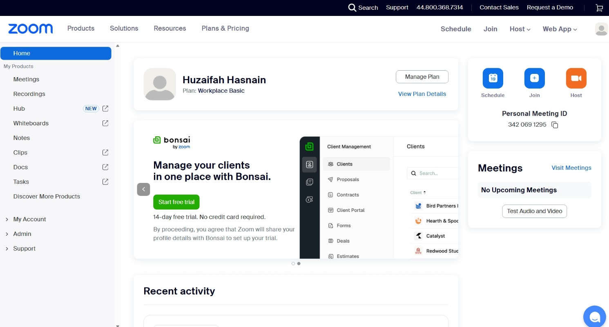
me to explore the application without launching a real Zoom meeting.

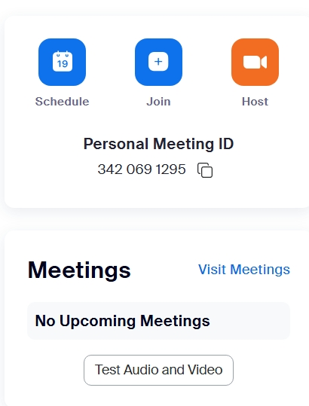

Figure 14- Screenshot of meeting options to Schedule, Join or Host. I opted for the Test audio and Video.



Figure 15- Screenshot of the above page will be visible. You can then indicate your name and press onto the join button.

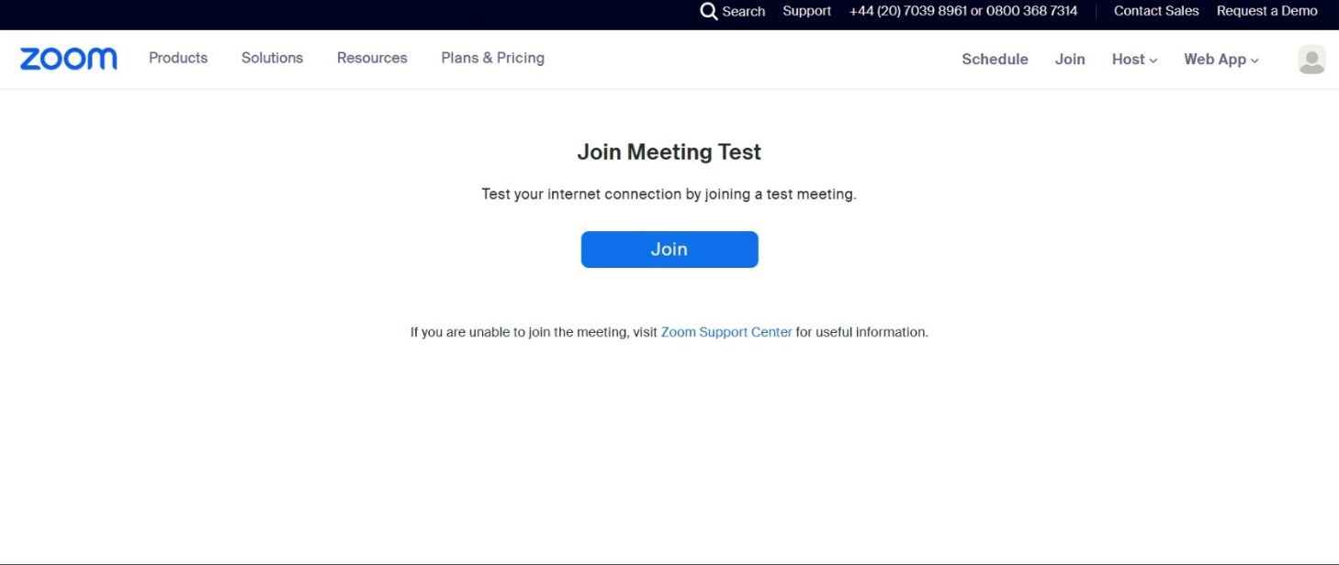
Figure 16- Screenshot of the above screen will appear. I pressed onto the Join button

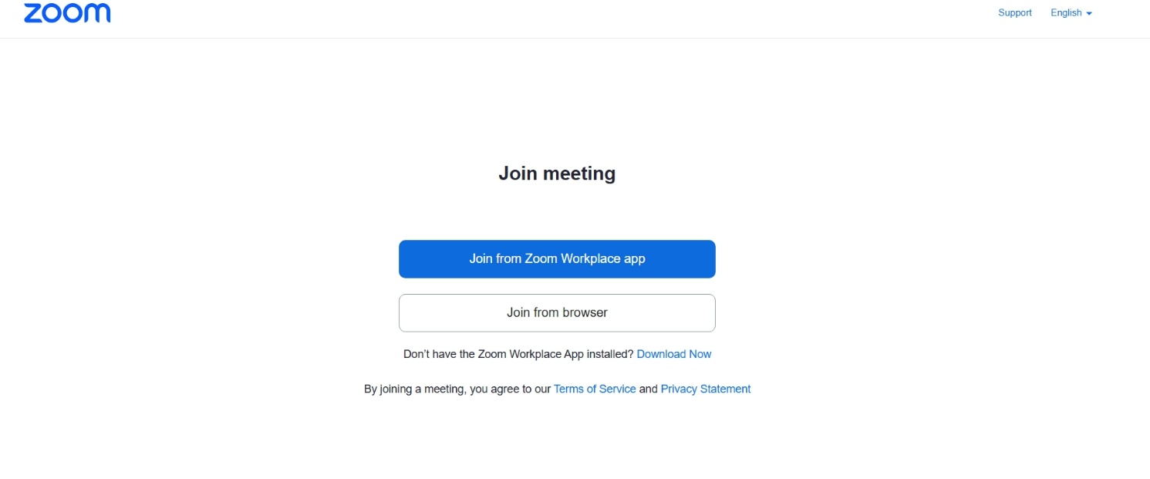
Figure 17- I pressed onto the Join from Zoom Workplace app


Figure 18- Zoom meeting in process. There are many features that you are able to use, such as participants, chat, reactions, share screen and other options.

Collaboration Application.
Application: Microsoft Teams
The feature tested: Sending a file to a participant

In this practical test I opened Microsoft Teams and decided to send a file to another participant. I selected the participant from the drop-down list and pressed onto the right induvial, then I attached the chosen file and pressed onto the send icon. From this it provided me with an opportunity to examine and experiment with how to send files successfully.

Figure 19- Screenshot of Shopifys’ homepage
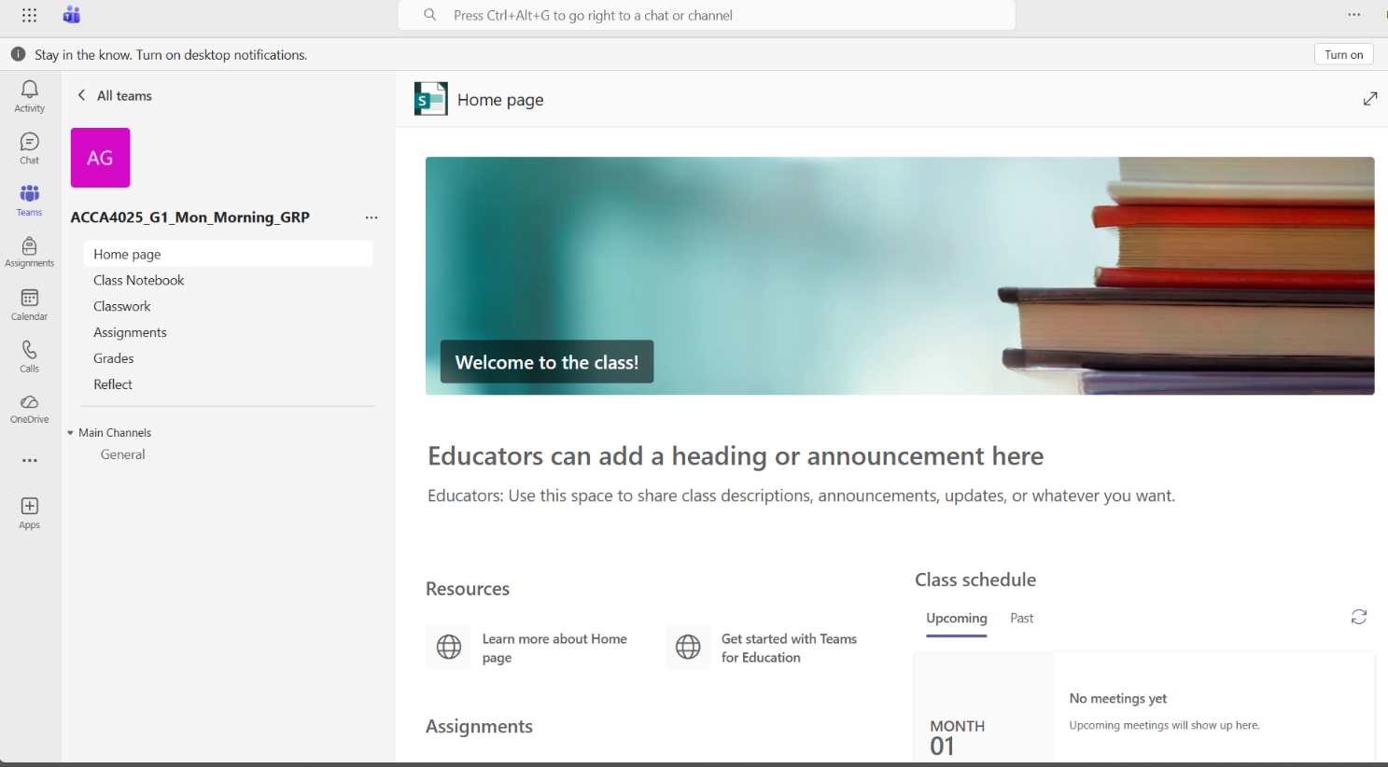

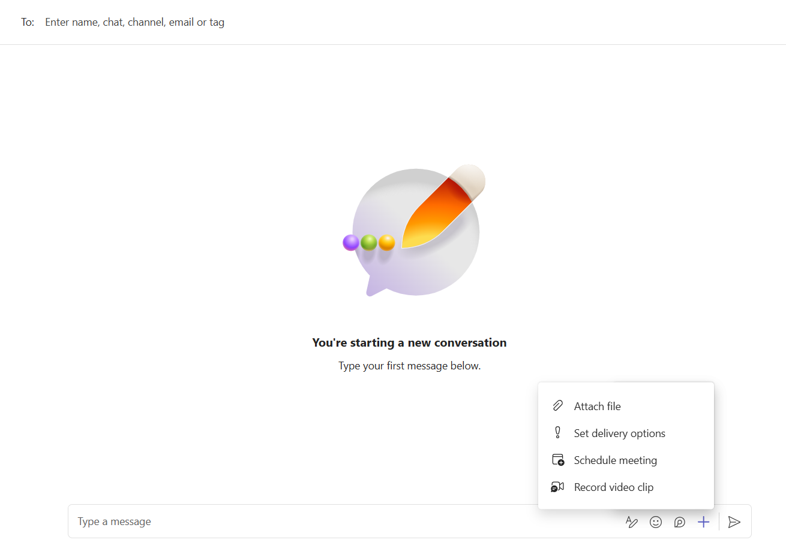
Figure 20- I searched for the contact I wanted to send the file to and clicked on the attach file button
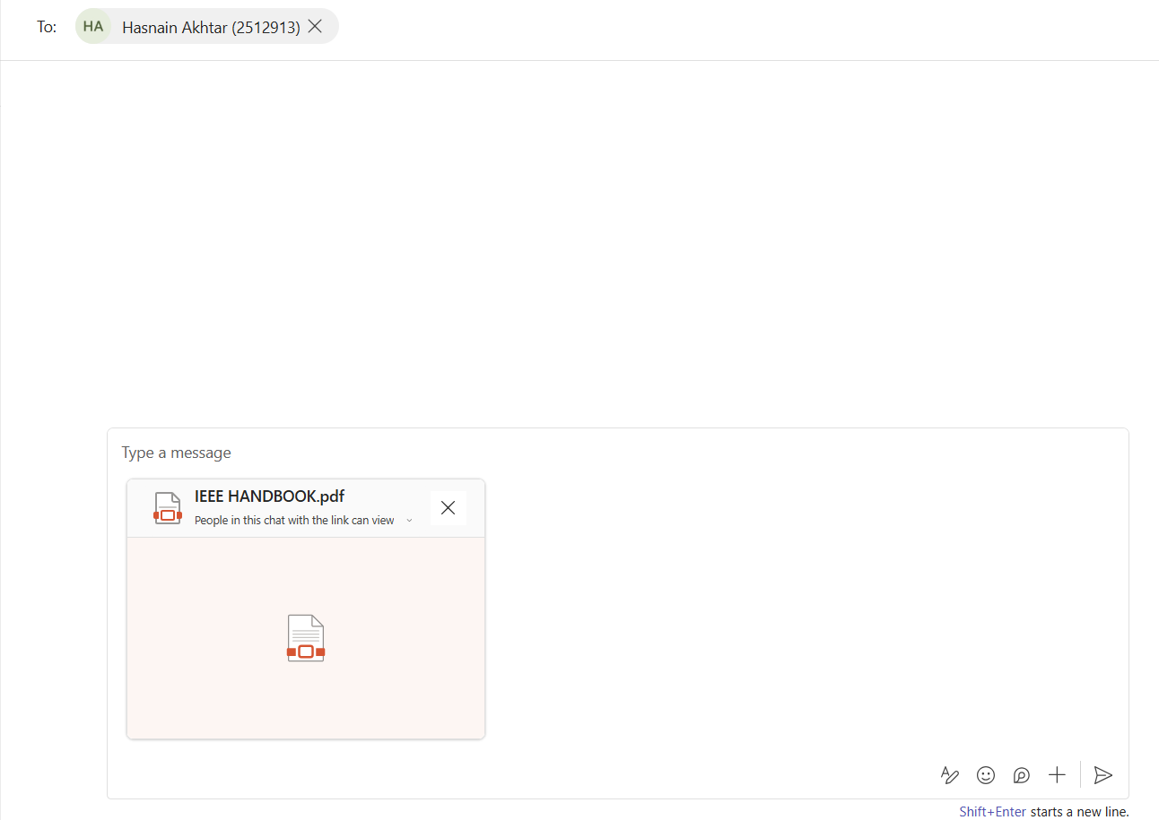
Figure 21- I selected the correct file and clicked onto the arrow button (send)

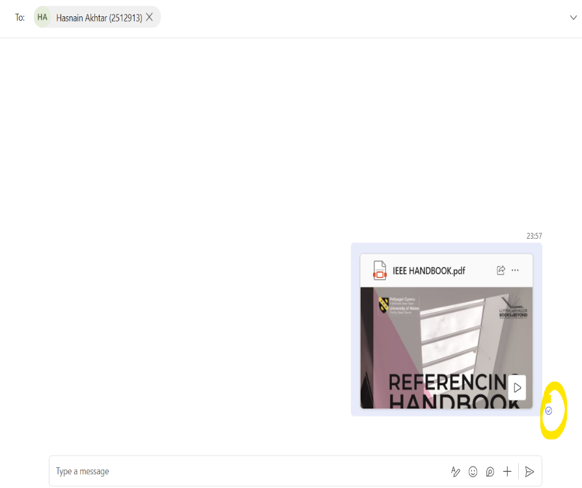
Figure 22- The screenshot above shows the message has been sent successfully.
/In this task, I had the opportunity to put both communication and collaboration tool into practice. I gained a better understanding of the difference between the two, zoom (communication), you are able to interact with others in real-time and share information at a faster pace, whereas Microsoft Teams (collaboration) you can share files and develop content with other team members. From the practical engagement, I found both platforms useful, and I am aware that both are beneficial for businesses/organisations.

To summarise, modern businesses rely on digital tools and software to enhance productivity, information transmission and managerial decision-making. The applications include e-commerce website builders, mind-mapping, office applications, and communication and collaboration systems. Each tool plays a specific role in different aspects of business functionality, such as online presence, breaking down complex ideas, managing data and team collaboration.

From the findings, I have gained deeper insight into the [13] importance of businesses utilising the tools, as they provide numerous advantages, boosting the overall operational standards in this fast-changing digital business world. It is essential to make sure you are aware of how the business benefits from this.

References

Reference

[1] Q. Malloy, “Benefits of E-commerce For Customers and Businesses | CloudTalk,” CloudTalk, Jan. 22, 2019. https://www.cloudtalk.io/blog/benefits-of-e-commerce-for-customers-and-businesses/
[2] J. Novak, “Wix Review 2022: Features, Pros & Cons,” Forbes Advisor, Mar. 22, 2022. https://www.forbes.com/advisor/business/software/wix-review/
[3] D. Winter, “What is Shopify and How Does it Work? (2022),” Shopify, Oct. 06, 2023. https://www.shopify.com/uk/blog/what-is-shopify
[4] G. Guthrie, “8 science-backed benefits of mind mapping,” Nulab, Jun. 09, 2021. https://nulab.com/learn/strategy-and-planning/8-science-backed-benefits-of-mind-mapping/
[5] MeisterLabs, “MindMeister,” MindMeister, 2019. https://www.mindmeister.com/
[6] A. Athuraliya and Creately, “What is a Mind Map? Definition, Uses, Benefits, & Examples,” Creately, Sep. 24, 2024. https://creately.com/guides/what-is-a-mind-map/
[7] Jennifer Post, “5 Random Things You Can Create in a Microsoft Word Document,” business.com, Dec. 08, 2017. https://www.business.com/articles/5-random-things-you-can-create-in-a-microsoft-word-document/
[8] J. Wilson, “What is Microsoft PowerPoint Used For in the Workplace? (The Benefits Revealed),” Tooling Ant, Sep. 14, 2023. https://toolingant.com/what-is-microsoft-powerpoint-used-for-in-the-workplace/
[9] “9 Benefits of using Microsoft Access,” Popular Tech World, Feb. 28, 2025. https://populartechworld.com/9-benefits-of-using-microsoft-access/
[10] GeeksforGeeks, “Importance of Microsoft Excel in the Workplace (With RealWorld Examples),” GeeksforGeeks, Feb. 21, 2025. https://www.geeksforgeeks.org/excel/importance-of-microsoft-excel-in-workplace/
[11] B. Cananzi, “5 Reasons Why Zoom Will Benefit Your Small Business,” Zoom, Jan. 31, 2025. https://www.zoom.com/en/blog/zoom-video-communications-small-business-benefits/
[12] R. Charnock, “7 Benefits of Using Microsoft Teams for Business,” Centric Consulting, Apr. 05, 2024. https://centricconsulting.com/blog/remote-work-how-microsoft-teams-can-keep-your-business-running/
(13) “The 8 genuine benefits of digital business strategies,” www.imd.org, Aug. 17, 2022. https://www.imd.org/blog/strategy/digital-business-strategies/

