University of Wales Trinity Saint David
Wales Institute of Science & Art
Engineering Academic Discipline

Energy In a Flywheel
Motor Vehicle Engineering Science (ACHA4036)
Motorsports Engineering With Foundation Year

Hassan Khan
2502126
03 / 2026

Contents
1 Contents 2
2 Introduction 1
2.1 Aim 1
2.2 Background 1
3 Experimental Procedure 1
3.1 Resources 1
3.2 Setup 2
3.3 Method 2
4 Results 4
5 Analysis 4
5.1 Data Tables 4
5.2 Calculating data 5
5.3 Finding a gradient 6
5.4 PE loss 7
5.5 Difference in KE 8
6 Conclusion 8
7 Evaluation 9
8 Further Work 9
9 References 9

Introduction

Aim
This experiment was conducted to determine the energy stored in a flywheel by dropping a range of masses from 100-500 grams and measuring the time taken for each to fall and rise, along with the maximum height each mass reached on the ascent.

Background
A notable example of this principle being applied in motorsport is regenerative braking systems, they utilise the same principles of energy in a flywheel to convert the kinetic energy from braking into electrical energy via magnetic induction. This energy can then be deployed later in the lap to provide an advantage for the driver.

Experimental Procedure

Resources
To conduct the experiment, specific instruments were provided and set up accordingly. A set of nominal details (in bold italics) were provided to use later in calculations. The range includes:
- A flywheel (mass=330g) (Inertia=3.862x10⁻⁴Kgm²)
- A pully block (Inertia=0.834x10⁻⁴Kgm²)
- A cord (radius=0.0065m) (Circumference=πx0.013m)
- A 300 mm rule
- A pegboard
- A hanger for placing masses on (10g)
- Masses (10g each, up to 500g)
- Two smartphones

Setup
To setup the experiment, the flywheel was attached to the pulley block, the system was screwed onto the pegboard. The cord which came pre-attached to the pulley block was tied onto the hanger. The rule was then set up, allowing for a 280mm drop for the hanger and its associated masses.
Additionally, two phones were used to record the experiment. One phone was used as a timer and enabled recording of the time to fall and rise, and the second phone used its high-speed camera to get accurate height recordings.

Figure 1: An image showing the experiment setup and the guide used as reference.

Method
Masses were set up on the pulley sequentially from 100-500g. For the first mass, 90g were added to account for the mass of the pulley itself (10g, with 90g totalled 100g). Once the correct mass was set, the camera operator and timer operator confirmed they were ready, and the third person responsible for winding up the pulley would set it to the 280mm mark on the rule. They would count down from three, at which point both operators would begin recording the moment the mass began to fall – up to the point at which the mass ascended to its second height. This was then repeated three times, allowing an average for both the height and time to be made ensuring accuracy in results.
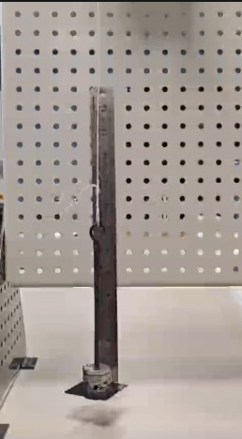
Figure 2.1, figure 2.2 and figure 2.3: Figure 2.1 shows the system before release (stage 1), figure 2.2 shows the system at its lowest, bottoming out (stage 2) and Figure 2.3 shows the system as its ascended to its second height (stage 3)

Results
The raw data collected from the methodology. (See figure 3) 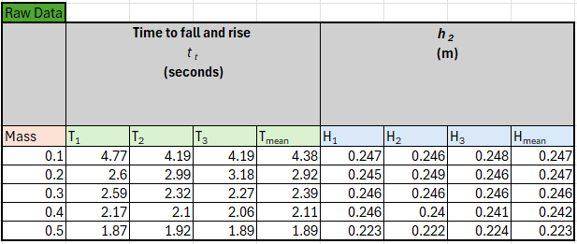
Figure 3: A table showing the raw data collected from the experiment and the averages calculated from the data.

Analysis

Data Tables
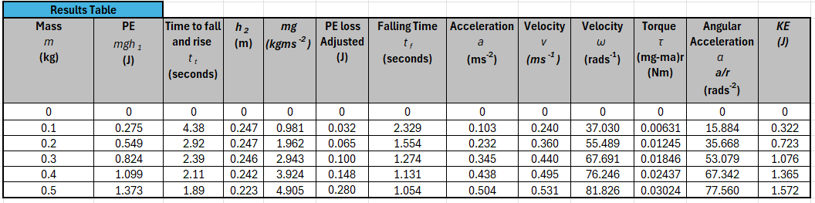
Figure 4.1: Results table includes new data calculated from the raw data. 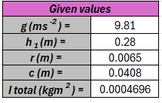
Figure 4.2: A data of given values provided by the guidance book.

Calculating data
Figure 4.1 is calculated using the data found and context provided by the guidance books’s given values in Figure 4.2. Mass (m),time (t_{t}) and height (h₂) were found during the experiment.
Weight (mg) was calculated from mass (m) multiplied by the gravitational constant 9.81ms⁻². The weight (mg) was used to calculate the potential energy (mgh₁) at stage 1(figure 2.1) by multiplying it by height (h₁). Additionally, weight (mg) was also used to calculate the potential energy lost throughout the system, the formula PE_{loss} = mg(h₁-h₂) was used to find the wasted potential energy as the mass goes through stages 1 through 3 (figures 2.1, 2.2 and 2.3).
To find the acceleration (a) and velocity (v), the falling time (t_{f}) is required, that being the time between stage 1 and 2 (figures 2.1 and 2.2). This is found through a ratio where the total time throughout the system (t_{t}) is multiplied by the ratio of $\frac{h_{1}}{h_{1}+h_{2}}$ , giving us an equation for t_{f} = t_{t}×$\frac{h_{1}}{h_{1}+h_{2}}$ . Calculating the maximum acceleration (a) at stage 2 (figure 2.2) where the mass has fallen through a distance of height (h₁) requires it to be divided by the square of time (t_{f}). This provides the formula for acceleration, $a=\frac{2h_{1}}{t_{f}^{2}}$, using this we can find the maximum linear velocity (v) during descent between stage 1 and 2 (figure 2.1 and 2.2) by multiplying the acceleration (a) by time (t_{f}). Furthermore, the angular velocity (ω) around the permiter of the pulley can be found with the linear velocity due to them being directly connected to each other. Thus, angular velocity (ω) is a product of $\frac{2πv}{c}$ where velocity (v) is converted to angular velocity (ω) by $2πv$ and divided by circumference (c). Similar to angular velocity (ω), angular acceleration (α) is found by dividing acceleration (a) by the pulley radius (r).
Force in the cord of the flywheel at any point in time (figure 2.1,2.2 and 2.3) is equal to the difference between the force due to the acceleration (ma) and the force due to gravity (mg). Under the assumption that the cord does not stretch, we can use τ = (mg-ma)r to find the torque (τ ) in the cord.
Finding the kinetic energy (KE) stored in the rotation of the pulley during descent requires the total nominal Inertia (I) from the system. The torque (τ ) due to angular acceleration (α) in the system is resisted by the moment of interia (I) and then stored in rotation as kinetic energy (KE). This results in a familiar looking equation in $KE=\frac{1}{2}I×ω^{2}$, giving us the kinetic energy stored as rotation.

Finding a gradient
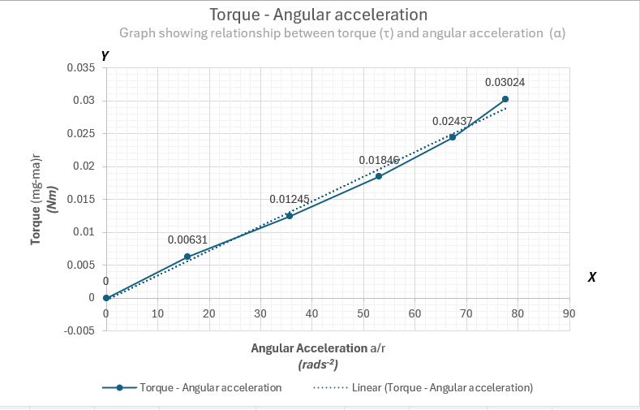
Figure 5.1: A graph showing the relationship of torque (τ) against angular acceleration (α).
With the data from the results table (figure 4.1) a relationship between torque (τ) against angular acceleration (α) can be seen. This can be applied to find a gradient with y=mx + c. The gradient will show us what the average inertia (I_{t}) of the flywheel is and how it compares to the nominal values provided.

Figure 5.2: A table showing the gradient found with functions provided by excel.
Using the =SLOPE function in excel, the average linear gradient for the graph can be determined. This gave a value for inertia (I_{t}), that value being 0.000375 kgm². The nominal inertia (I_{f}) of the flywheel was 0.0003862 kgm². The difference isn’t much and can be calculated with a simple percentage formula $\frac{I_{t}}{I_{f}}×100$, giving 97.1%.

PE loss
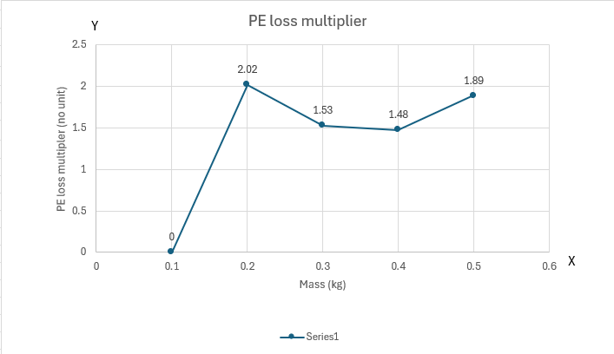
Figure 6.1: A graph showing the multiplier for mass against PE loss.
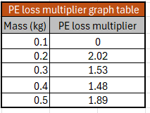
Figure 6.2: Accompanying graph figure 6.1.
The PE_{loss} is a multiplier calculated by dividing the PE_{loss} of the subsequent mass by the previous mass. To find the PE_{loss} multiplier of 0.2 kg, divide PE_{loss} at 0.2 by the PE loss at 0.1kg.

Difference in KE
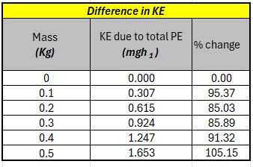
Figure 7: A table showing the difference in KE
KE due to total PE is calculated by adding PE and PE_{loss} . The % change is then calculated by dividing the KE due to total PE by the KE due to inertia multiplied by 100.

Conclusion
One thing that was made clear with this experiment was the difference between the nominal value for inertia (I_{f}) in the flywheel and the average linear inertia (I_{t}). It was 2.9% off the nominal (I_{f}), meaning some inertia was lost in the experiment. This could be a result of unaccounted friction in the bearing reducing the measured acceleration of the flywheel therefore causing a loss in torque and giving a lower value for the linear inertia (I_{t}).
The PE_{loss} multiplier shows no consistent trend across the range of masses. This suggests that the PE_{loss} in the system is not directly proportional to mass. The inconsistency is likely a result of variability in height and timing across the experiment along with friction losses in the cord likely increasing with mass. This, however, isn’t verifiable with the data gathered and is a theory.
For the KE due to the total PE, the % change is inconsistent across the range of masses. This suggests systematic losses such as friction and cord mass. One issue is the 0.5kg result, which is theoretically impossible. This suggests an error made during the measuring process of the experiment, likely an error for the h₂ measurement.

Evaluation
Averaging data across three runs helped reduce anomalous results and diluted any human errors. Additionally, recording with a timer and camera helped accuracy, however being limited to 60fps still isn’t an ideal way to accurately measure height. The mass of the bearings and cord mass remain unaccounted for and likely result in errors seen in results.

Further Work
Given unlimited time and money, making the experiment as accurate as possible would require much better equipment. A specialty high speed camera to record the time and height. A motor in place of the bearings inside the flywheel to accurately release the mass. Connecting that to a timer can then accurately starting the stopwatch, and electronic contacts on the rule and mass hanger can result in accurate timings. Accounting for friction and mass of the cord will improve accuracy drastically too.

References
Book: TecQuipment, (2012) Potential and Kinetic Energy kit ES9.

