

Strategic Management - LCMB7003
Assessment Component: Individual Report
Strategic Expansion Plan for Greggs plc: Entering the German Bakery-to-Go Market
Name of Student: Samuel Kirvej
Student ID: 2120449

Table of Contents
Executive Summary 4
1 Introduction 5
2 Selection of Greggs Organisation and Target Market 6
2.1 Overview of Greggs plc 6
2.2 Rationale for International Expansion 6
2.3 Market Selection: Why Germany? 7
2.4 Strategic Justification 8
2.5 Market Segmentation, Targeting and Positioning (STP Framework) 9
2.5.1 Segmentation 9
2.5.2 Targeting 10
2.5.3 Positioning 10
3 Comprehensive Strategic Analysis 11
3.1 Macro-Environmental Analysis – PESTLE Framework 11
3.1.1 Political Factors 12
3.1.2 Economic Factors 12
3.1.3 Sociocultural Factors 13
3.1.4 Technological Factors 14
3.1.5 Legal Factors 14
3.1.6 Environmental Factors 15
3.2 Industry and Competitive Analysis – Porter’s Five Forces 16
3.2.1 Threat of New Entrants 16
3.2.2 Bargaining Power of Suppliers 17
3.2.3 Bargaining Power of Buyers 17
3.2.4 Threat of Substitutes 17
3.2.5 Rivalry among Existing Competitors 17
3.3 Internal Environment – VRIO Analysis 18
3.4 Country Competitiveness – Porter’s Diamond Model 19
3.4.1 Factor Conditions 20
3.4.2 Demand Conditions 20
3.4.3 Related and Supporting Industries 20
3.4.4 Firm Strategy, Structure and Rivalry 20
3.5 SWOT Summary 21
4 Conclusion 22
References 24

Executive Summary
This report examines a strategic growth plan of Greggs plc, the leading bakery and food to go retailer company in the United Kingdom with an aim of venturing into the German market. Greggs has more than 2,500 stores around the country and a solid cost-leadership model. It pursues international diversification due to a domestic growth trend that is going flat. German market with an estimated worth of around 18 billion Euros per annum is an attractive target owing to the fixed bakery culture, stability in the macroeconomy and the growing consumer need to consume economical, portable and environmentally friendly food products. The complex strategic analysis based on the PESTLE, Porters Five Forces, VRIO, and Porters Diamond models demonstrates the presence of favourable macroeconomic conditions, a developed infrastructure, and a rather large urban professional population, whereas the competition intensity and the increasing labour cost can be regarded as the risk factors. The prescribed action is based on a market-development approach which will see Greggs as a value-based, sustainable British bakery-to-go brand. A Balanced Scorecard, which is an integration of financial, customer, operational, and sustainability measures, will be used to monitor performance. The expected results are brand differentiation, market-share increase and DAC region scalability. The main threats include the regulatory complexity and cultural adaptation, which require a proactive localisation and strong local partnerships.

Introduction
In the modern and fast changing world of global business, the world has forced business enterprises to develop strategic agility to maintain growth/competitive advantage. Founded in 1939 in Newcastle upon Tyne, Greggs plc has risen to become the leading bakery and food-to-go retailer in the United Kingdom, and it has over 2,500 stores across the country (Greggs plc, 2024). It has its success pegged in integrated supply chain, cost leadership and a reputation of affordability and high quality of bakery products. However, as the UK market moves towards maturity and domestic growth opportunities start to become saturated, Greggs faces the strategic challenge of seeking new areas of growth outside of its core business (Greggs plc, 2025). Expanding internationally is thus the next right move by the company.
In addition to this, market potential and mitigation of strategic risks in the post Brexit environment are present in expansion to continental Europe (CBI – Ministry of Foreign Affairs, 2025). Germany with an estimated sum of about 18billion euro per year, is the biggest bakery and convenience food market in Europe. High economy of the country, density of the urban area and coffee culture are in line with the strengths of Greggs on affordability, convenience, and operational efficiency. Furthermore, the consumer trends that prefer sustainable and on-the-go meals create a favourable environment to the entry of Greggs (BMEL, 2024). In the industry, other sources like IBISWorld and the Financial Times highlight that the bakery industry in Germany is dynamic but fragmented thus providing room to institute new formats and value-based brands.

Selection of Greggs Organisation and Target Market

Overview of Greggs plc
Greggs plc is the United Kingdom retailing leader of bakery and on-the-go food retailer, established in 1939 and with over 2,500 stores across the country (Greggs plc, 2025). Its menu includes savoury pastries, sandwiches, salads and drinks, which are attractive to value-conscious clients who value convenience and freshness in their meals. The supply chain of Greggs is vertically integrated which gives it the control over the production and distribution which guarantees quality and cost-effectiveness. This is the basis of its cost-leadership approach as well as its operational consistency. Online innovation enhances the competitiveness of Greggs, the loyalty app allows repeat buyers and also provides the company with data about their behaviour based on which to market. Consumer habit shifts represented in 2023 make digital transactions about 13% of the overall sales (Reuters, 2024). The revenues have exceeded over a billion pounds but still the firm is financially strong even with the inflationary factors. Its brand also encompasses sustainability by sourcing ethically, minimising wastes, and a Net 0 2040 promise.

Rationale for International Expansion
The domestic market of Greggs is mature and it is a strategic requirement to expand internationally. The lack of space to develop the UK market is a reason to seek foreign markets to develop new sources of revenue and no longer rely on the domestic market (Financial Times, 2024). In the line with the Market Development strategy developed by Ansoff, Greggs plans to transfer the current competencies to new geographical locations. The trends of consumers also serve as an additional indication of expansion opportunities, busy workers are more willing to consume rapid, nutritious, and cheap food, and online ordering became a norm throughout Europe. The efficient model of the service and mobile application at Greggs is highly adapted to these behaviours (Greggs plc, 2024). The post-Brexit uncertainties are also reduced through international diversification. The figure 1 shows other similar brands like Costa Coffee and Pret A Manager, have been able to expand abroad by adjusting to the local tastes and prove that British food to go brands can compete effectively in Europe.
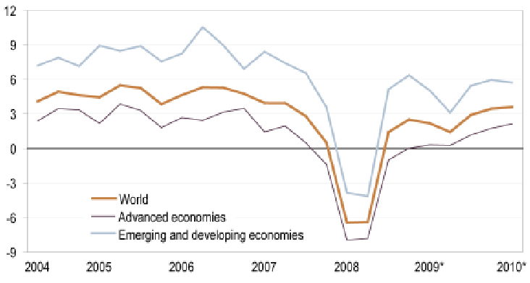
Figure 1 Global Gross Domestic Product (GDP) Growth Quarter-over-quarter percentage change
Source: Melecky and Macháček (2010)

Market Selection: Why Germany?
Germany is the most strategically opportune point of entry as it has a large market base, macroeconomically stable, and cultural fit with the product, and is estimated at around 18 billion euros of annual turnover, thus it is the largest bakery market in Europe (World Bakers, 2023). The high disposable income of the people, the established culture of coffee, and the fast urbanisation process all support the success of the fast-service model of Greggs. German consumers have a dualistic taste to both quality and affordability qualities, which are closely related to the core competencies at Greggs.
Moreover, the country has a history of a long tradition of bakery practises, which creates a sense of familiarity with the product category of Greggs, but there is a clear disconnect between high-end artisanal bakery products and low-cost products at the supermarket (Verband Deutscher Großbackereien, 2024). Therefore, Greggs stands at a good position to fill this middle market segment at affordable prices with fresh products. The strength of the logistics networks of Germany allows distributing product all over the country, and strategic partnerships with on-demand delivery systems like Lieferando or Uber Eats may speed up the expansion into the market. Lastly, the operational risk is reduced due to the stable regulatory environment and a ready access to skilled labour force compared to the more volatile emerging markets.

Strategic Justification
The growth of Greggs can be oriented along the Matrix by Ansoff as a Market Development strategy, where the already existing products are implemented in a new market. The cost-effectiveness and good brand image of the company have a basis to compete with chains like BackWerk and Kamps, which mainly concentrate on price (Kamps, 2025). Competitive advantage can be developed through differentiation based on digital interaction and quality across the board. The venture also provides a small first-mover market in the niche of the British bakery-to-go. The effectiveness of Pret A Manager in Paris shows that the international consumers are ready to react positively to the unique Britain brands. Nevertheless, Greggs will have to modify tastes, prices, and store architecture in accordance with the domestic tastes (Verband Deutscher Großbäckereien, 2024). German labour rates and regulations would limit margins hence a joint venture or franchise arrangement would reduce such a financial risk whilst ensuring market familiarity. In general, Germany has got growth opportunities and moderate risks, though operations have to be efficiently localised.

Market Segmentation, Targeting and Positioning (STP Framework)
It is certain that applying the STP framework clarifies Greggs’ market focus in Germany.
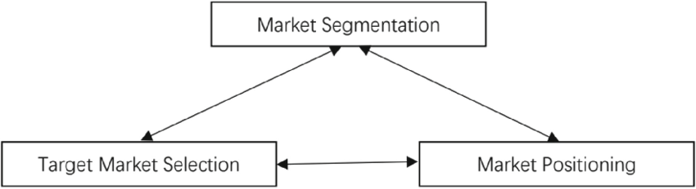
Figure 2 STP theory
Source: Li (2024)

Segmentation
The demographic, geographic, psychographic, and behavioural segmentation is possible in the market (Kumar et al., 2025). The core clientele includes 18-45 years old professionals and students in the large cities like Berlin, Munich, and Hamburg. They are characterised by a lack of time, value orientation and growing sustainability awareness. In terms of behaviour, they have a liking towards low-cost breakfast and lunches and often rely on mobile ordering applications. The popularity of fast value-oriented service demonstrated by BackWerk in train stations can be adopted by Greggs (BackWerk, 2025).
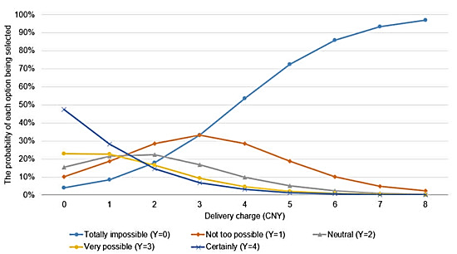
Figure 3 The selection probability of each result as the delivery charge changes.
Source: Wu et al. (2022)

Targeting
The main audience of Greggs is professionals and commuters in the city, who need fast and regular food (Greggs plc, 2024). The secondary audience is the students and young adults who utilise online platforms and react to loyalty programmes. This would strike a balance between the in-store and online demand, following a similar approach in the UK of Greggs combining high-street stores with click-and-collect and delivery.

Positioning
Greggs has to position itself as a low-price and yet high-quality bakery cafe which is going to serve freshly made food-to-go with a mix of the British convenience and local flavour (Greggs plc, 2024). Its price, quality, and ethical sourcing are expressed in its value proposition in form of fast, fresh, and fair. Greggs would have a niche in Germany between low-end chains like BackWerk and high-end cafes like Starbucks ( Food Drink Europe, 2024). Localisation of menus, for example, pretzels sandwiches or rye-based, and a clear sustainability communication will enhance differentiation and cultural relevancy.

Comprehensive Strategic Analysis
This part is a critical analysis of the strategic environment that affects the expansion of Greggs plc into Germany in terms of the PESTLE, Porters five forces, VRIO, and Porters diamond frameworks. They jointly determine those external opportunities, internal strengths, and competitive challenges. Each framework has its own contribution but has to be implemented dynamically since the food retail sector is evolving at a very fast rate and therefore what was applicable a few years ago may not be applicable today.

Macro-Environmental Analysis – PESTLE Framework
PESTLE model analyses the political, economic, sociocultural, technological, legal and environmental factors that influence entry of Greggs into the market. It provides a systematic summary but it is restrained by its lack of dynamism and only gives a picture as opposed to a glimpse into the future..
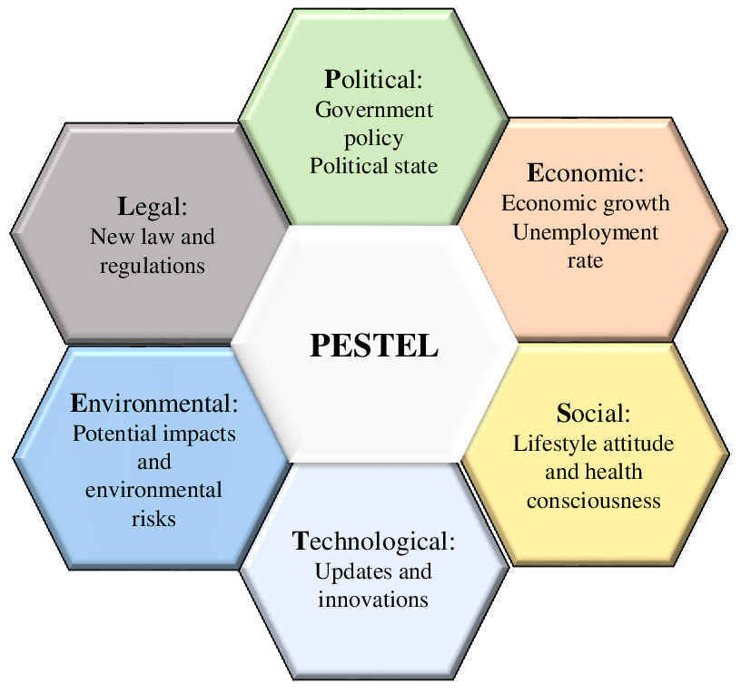
Figure 4 The PESTEL analysis framework
Source: Sansa (2020)

Political Factors
The government in Germany is stable and the country is in the EU, which makes the business environment low-risk (BMAS, 2024). The UK, EU Trade and Cooperation Agreement permits tariff-free trade with the added responsibility of more paperwork in terms of custom. Germany is ranked in the top ten countries in the world by the OECD in terms of political stability, which will give Greggs a lot of confidence in entering the market (Maddren, 2024). But the changing EU food labelling and labour regulations can drive up the cost of compliance, which will demand local legal knowledge.

Economic Factors
Germany is the largest economy in Europe contributing about 24% of the gross domestic product of the European Union (USDA Foreign Agricultural Service, 2024). Demand in the convenience foods market is strong given the bakery industry in the country dominated by 18 billion Euros. However, Greggs may lose its cost-leadership margins due to the high city rent prices and labour expense (BMAS 2025). The efficiency-oriented model of the firm has to, therefore, balance between the affordability and profitability.

Sociocultural Factors
The German cafe culture and the emphasis on bakery products produced freshly are in line with the Greggs brand ethos (European Coffee Federation, 2024). However, the consumers are mostly concerned with quality and local authenticity in the event of price. The percentage of vegetarians in Germany is around 10%, indicating there could be interest in vegan and balanced product lines of Greggs (BMEL, 2024). Greggs will have to localise its recipes, reinforce freshness and promote health and ethical values to become successful. The pie chart provided shows that grass and leaves (46%) and crop residues (19%) make up the majority of livestock feed in the world, with grains (8%) and other edible substances (1%) contributing a minor portion, meaning that most livestock feed is non-edible to humans.
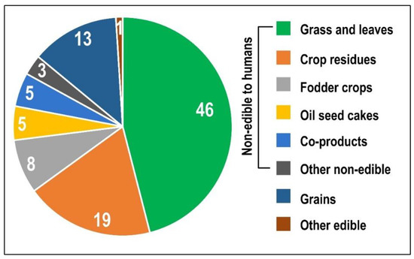
Figure 5 Distribution (%) of global livestock feed dry matter intake
Source: Dorgbetor et al. (2022)

Technological Factors
Greggs can rely on technology-based strategy as it is highly adopted in digital. In Germany, more than 90% of people have smartphones, and apps like Lieferando are the leaders in online delivery of food (Bitkom, 2023). The mobile application and the loyalty system that Greggs has developed can also be used, as they need to be in agreement with GDPR. The use of the delivery options through the local applications could expand the coverage and convenience, thus emulating the successful digital experience of the firm in the UK (Bitkom, 2023).

Legal Factors
Germany has a strict labour, food safety, and franchising law. The German Labour Code imposes more minimum wages and sets the number of working hours, which influences the work of stores (Minimum Wage Commission, 2023). It will be necessary to comply with the EU General Food Law and open franchising conditions. The figure 6 represents the employment rate in Germany in 2001 2016 on the overall, males and females. The total employment was steady (ranging between 25 and 30%) with a higher percentage of males employed than the females. There is a slight downturn at 2008-2009, which coincides with the world financial crisis, after which there is a slow recovery.
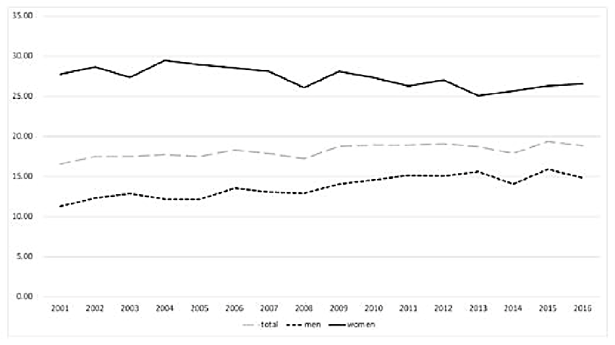
Figure 6 Employment rate in Germany (%), 2001-17
Source: Weishaupt (2021)

Environmental Factors
The German Packaging Act deems recycling and sustainability. The Net Zero 2040 target and recyclable packaging of Greggs fits the requirements of the country (Greggs plc, 2025). A brand image can be enhanced by proving to be environmental-responsible and being non-responsible means reputational risks.

Industry and Competitive Analysis – Porter’s Five Forces
This model identifies competition forces in Germany bakery-to-go market. Even though it provides structural insights, it presupposes the competition being static and the underrepresentation of the dynamic power of digital platforms (Bitkom, 2023).
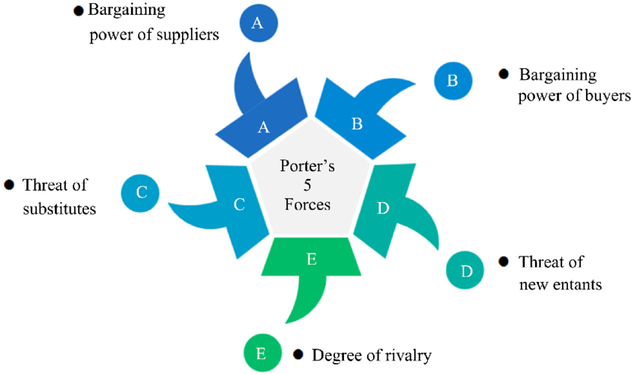
Figure 7 Porter's five forces model
Source: Mao (2023)

Threat of New Entrants
It is found that there are moderate barriers to entry. The high set up costs are accompanied by low brand loyalty in the value segment. The success of BackWerk franchise proves the willingness of the market to scalable chains (BackWerk, 2025). The fact that Greggs is capital strong and its operations are vertically integrated minimises the risks of entry.

Bargaining Power of Suppliers
The power of suppliers is low due to the integrated supply chain of Greggs and the possible local sourcing (USDA Foreign Agricultural Service, 2024). However, the price of raw material and energy is unstable. The input risks can be reduced by keeping costs in cheque and forming local alliances.

Bargaining Power of Buyers
The consumers are powerful in the sense that they are price sensitive and quality conscious. The number of options of bakery is high, so the switching costs are low (World Bakers, 2023). Buyer power can be mitigated by the use of loyalty programmes and product differentiation which has been illustrated by Starbucks capacity to charge its customers premiums in order to get a consistent quality.

Threat of Substitutes
Supermarkets, cafes, and in-store bakeries represent a high threat of substitution (Amin et al., 2025). The proposition made by Greggs competes with the coffee shops of Lidl and McCafes. In response to this, Greggs should emphasise speed, freshness and ethical sourcing as the points of differentiation.

Rivalry among Existing Competitors
Competition is also high and there are other brands like BackWerk, Kamps, and Le Crobag. The level of price competition has been the norm and thus restrained the margins (Saha et al., 2022). The process of differentiation of Greggs according to the British bakery-to-go identity and sustainability branding can give Greggs a clear positioning, but permanent innovation will be essential.

Internal Environment – VRIO Analysis
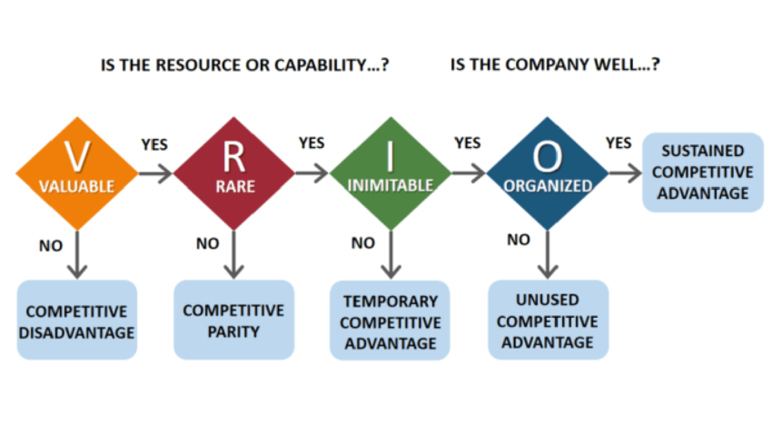
Figure 8 The VRIO framework
Source: Mazikana (2023)
The vertically integrated logistics and digital systems of Greggs produce sustainable cost and service benefits (Greggs plc, 2024). Nevertheless, it has not yet been able to transfer its brand equity to the international market, which requires new positioning and local involvement.
Table 1 VRIO Analysis
Resource/Capability | Valuable | Rare | Inimitable | Organised | Competitive Implication
Integrated supply chain | Yes | Yes | Yes | Yes | Sustainable advantage
Brand reputation (value-for-money) | Yes | Yes | No | Yes | Temporary advantage
Product innovation (vegan range) | Yes | No | No | Yes | Competitive parity
Digital platform (Greggs App) | Yes | Yes | Yes | Yes | Sustainable advantage

Country Competitiveness – Porter’s Diamond Model
The Porters Diamond will help in evaluating the level of national competitiveness of Germany to the bakery industry (USDA Foreign Agricultural Service, 2024).
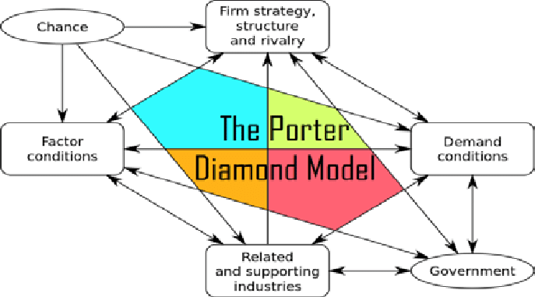
Figure 9 The Porter Diamond Model
Source: Bhaskar et al. (2019)

Factor Conditions
The high infrastructure and skilled labour of Germany facilitate effective logistics. But increased wages and strict labour regulations put pressure on the cost of Greggs value-based model (Minimum Wage Commission, 2023).

Demand Conditions
Demand of convenience and sustainable food is driven by sophisticated, health-conscious consumers. This is in line with vegan products that Greggs already has but it increases pressure on consistent innovation (European Coffee Federation, 2024).

Related and Supporting Industries
The local supply-chain is sufficiently resilient, and stable food-tech, logistic, and packaging are presented to provide collaboration opportunities to improve both the sustainability and compliance of the local supply-chain (Central Agency Packaging Register, 2025).

Firm Strategy, Structure and Rivalry
Innovation and efficiency are the two main factors that German companies compete on and not just on price. This environment will be able to motivate Greggs to persist in improving operations performance and be more responsive to the market trends (Verband Deutscher Großbäckereien, 2024).

SWOT Summary
The SWOT synthesis demonstrates that Greggs has excellent operational fundamentals and brand reputation but needs to change its product, pricing, and communication policies to suit the local tastes to succeed in a competitive market (Greggs plc, 2025).
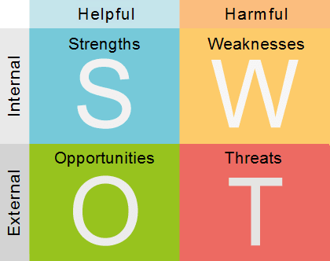
Figure 10 SWOT analysis
Source: Bhaskar et al. (2019)
Table 2 SWOT Analysis
Strengths | Weaknesses | Opportunities | Threats
1. Vertically integrated supply chain ensuring cost control and product consistency. | 1. No established presence or brand recognition in the German market. | 1. Access to Europe’s largest bakery sector worth approximately €18 billion annually. | 1. Intense rivalry from established German chains such as BackWerk, Kamps, and Le Crobag.
2. Strong UK brand reputation for value, convenience, and ethical operations. | 2. Limited understanding of local consumer preferences and cultural tastes. | 2. High digital adoption enabling app-based sales and loyalty engagement. | 2. Rising labour and energy costs reducing operational margins.
3. Advanced digital infrastructure (Greggs App, click and collect) supporting operational efficiency. | 3. Dependence on UK-centric menu and pricing strategy requiring localisation. | 3. Growing demand for healthier and sustainable food options aligning with Greggs’ CSR goals. | 3. Complex EU labour, food, and packaging regulations increasing compliance costs.

Strategy Development and Formulation

Strategic Objectives
The strategic objectives of Gregg’s to make expansion in the German market will be:
- To establish almost 20-25 bakery-to-go outlets of Gregg’s in all the larger cities of Germany in the first 3 years which can be by 2028. It will help in expanding the business in other areas in short time.
- To gain a greater level of brand recognition of almost 50% awareness within the selected target market in Germany in the first 3 years. It will help in increasing more sales in the new industry.
- To make successful achievement of repeating customer rate of 75% by year 3 by building effective brand loyalty and driving the sustained sales growth in the new market. It will help in attracting larger base of customers towards new brand.
- To achieve break-even profitability in 4 years that will be end of 2029 in all over the German outlets. It will help in gaining successful position in the new competitive market.
- To gain almost 30-40% of the product menu to the significant local tastes with the preferences in the market entry. It will ensure the cultural fit and related customer acceptance.

Market Entry Strategy
In the new German market, Gregg’s needs implication of the joint venture and pursuing franchising for the creation of local bakery chain. Therefore, the application of Dunning’s Eclectic Paradigm seems effective. The theory defines effective choices of entry mode with three significant advantages such as ownership, location development, and internalisation (Singh and Sudha,, 2024). Gregg’s implicates ownership advantage due to the stronger UK brand and provision of efficient bakery products. Whereas; for the local partner, it will offer several location advantages such as use of market knowledge, management of existing customer base, and consideration of the operational infrastructure. Internalisation benefits occur due to the controlling management of brand standards and leveraging partners towards local adaptation (Semenova and Semenov, 2023).
Moreover, there is a comparison of the Greenfield investments which needs 45-50% higher initial capital and greater setup times for new entry. In addition to this, on the financial aspect, the franchising allows stability to the royalty revenues. There must be 5-7% increases in the turnover with reducing the upfront costs of Gregg’s. It needs alignment with targets for the management of break even in the first four years. The business selects leading regions like Berlin and Munich, where sales of food retail exceed by €30 billion annually and the bakery-to-go products capture almost 12-24% of overall market share (Statista, 2025).

Competitive Strategy – Porter’s Generic Strategies
Gregg’s needs adaptation to a hybrid competitive strategy which combined cost leadership and differentiation from the model of Porter’s Generic Strategies. The implementation of cost leadership is associated with the management of supply chain services and automation technology (Rögner et al., 2021). For Gregg’s, it will be applied to make reduction in the production and logistics costs by almost 15-20% which enables competitive management of prices in the price-sensitive bakery industry of Germany. The efficiency will be helpful for Gregg’s to achieve the strategic objective as the successful bakery-to-go brand in the new market to prioritise value by the consumers. The application of differentiation seems in managing product innovation (Pietrangeli et al., 2023).
The introduction of new brand in the German-preferred like pretzels, the use of rye-based sandwiches, and introduction of the vegan pastries which will address the increasing demand for plant-based services of almost 10% in the German market. Additionally, the ethical sourcing and sustainability commitments of Gregg’s will allow differentiation of the brand in the German consumers. There are almost 75% of environmentally responsible companies who are already existing in the market (Report Linker, 2025). Therefore, the technology-driven aspects and use of digital customer engagement will help in reducing the waste by 20% for the improvements in the loyalty.

Strategic Positioning – SAF Model (Suitability, Acceptability, Feasibility)
Gregg’s applied strategic approach with the help of SAF framework. It ensures alignment of the company goals with the market realities. There is a suitability of stronger aspects where the strategy directly correlates with the mission of the company (Nakatani, 2024). Gregg’s offers efficiency of the effective food accessible to all eth consumers. There is an estimation of €5 billion for the products in the market which is growing at 3.5% annually in Germany (Fortune Business Insights, 2025). The product value proposition is affordable which offers high-quality bakery products for meeting the demands of local consumer towards fulfilment of convenience and overall quality (Mehdi et al., 2022).
Moreoer, there must be adaptation of local menus for making increases in the product relevance and enhancement in the suitability for the achievement of competitive cultural context. The acceptability imposes some risk which are mitigated by culturally aligned use of the products and local management in the market entry. The estimation showed that the German market forecasts the achievable brand management of 50% by year within the targeted marketing. Feasibility is offered by Gregg’s to maintain strong financial performance which can be £1.2 billion revenue in the UK as shown in the year 2024 (Novonesis, 2024). There is an operational expertise in the management of expansion and successful franchising.

Risk Assessment and Mitigation
Risk Category | Description | Likelihood | Impact | Risk Rating | Mitigation Strategy | Responsible Party
The slowdown in the economic values. | There is a reduction of the consumer spending which impacts directly on the sales growth. | Moderate | High | High | The company must focus on offering affordable pricing. It needs monitoring of the economic indicators. There musts be maintenance of the flexible cost structure in the industry. | Marketing and Finance Department.
Unfamiliarity of the brand. | There is a consideration of lower initial brand awareness with possible level of acceptance. | High | Moderate | High | There are some definite partner to manage the local brands. There must be implementation of digital marketing and promotional activities which develop effective cultural adaptation of the products. | Sales, Marketing and Local Partners in Germany.
Regulatory compliances in the brand expansion. | There are some complex items and food to develop safety and labour laws. | Moderate | High | High | There must be engagement in the local legal advisors. It needs efficiency in providing the staff training. There must be regular audits for ensuring the compliances. | Legal and Operations Managers.
Cultural differences in the market. | There are some definite misalignments of product delivery with the offering with tastes in the German market. | Low | Moderate | Moderate | There must be extensive management of the local consumer research. The brand should offer adapt menu and service policies for the targeted customers. | Product Development and Marketing Departments.
Supply chain errors and challenges. | There are some delays in the local suppliers which are seen in the features of logistics. | Moderate | Moderate | Moderate | There must be development of multiple sourcing policies. It needs maintenance of leading stock. There must be real-time management for supply chain monitoring system. | Operations and Supply Chain Teams.
Competitive pressure in the market. | There is an aggressive competition considering the local bakeries in the new market. | High | Moderate | High | There must be differentiation of the process using ethical sourcing and implication of unique product offerings. The competitive pricing strategy will also be helpful for the brand. | Strategy and Marketing Departments.

Performance Evaluation Framework

Designing of a Balanced Scorecard (BSC)
Perspectives | Strategic Objective | KPIs | Targets and Measures
Financial Aspects | To make achievement of profitability in four years. | There are some Return on Investment (ROI) and Revenue per store. | The estimation of €1.3 million for the average revenue per outlet.
Customer Management | To create stronger management of brand awareness. | The use of Customer Satisfaction (CSAT), The use of Repeat purchase rate. | There should be 75%+ repeat in the rates of purchase.
Internal Process Evaluation | To provide efficient supply and definite operational policies. | There are some waste reduction percentage. There is delivery and restock time. | There are less than 5% waste in the timeline of 24-hour restocks.
Learning and Growth Abilities | To explore effective policies for the local workforce development. | The management of employee training hours and consideration of employee retention rate | There must be 42 hours training annually to make increases in 80% of overall rate of retention.

Critical Evaluation
The Balanced Scorecard (BSC) determines that the Gregg’s should measure and manage the possibilities of the strategic objectives in different perspectives. It allows provision of a definite framework for tracking the progress and gain successful market entry in the competitive market of Germany (Lederwascher, 2022). The financial perspective defined about the clear setting of the targeted system which needs €1.3 million average revenue in each outlets (Market Research Future, 2025). It makes alignment with the break-even goal in the first four years with ensuring about the resource allocation efficiently and increases in the overall profitability. There is a measurable KPIs such as ROI and revenue per store to offer quantifiable indicators for the senior management to make monitoring of the system in the timely financial courses (Hübner, 2024).
The customer orientation is a significant pillar which develops the KPIs to manage customer satisfaction and make repetition of the purchase rate (Guiné and Florença, 2024). There is a targeting of 75%+ repeat purchase rate which reflects on the Gregg’s emphasis towards fulfilment of the brand loyalty and market penetration system. Goryńska-Goldmann et al. (2021) stated that the metrics allows effectiveness of the product adaptation, service quality management, and development of the marketing strategies. The integration of the customer feedback to the framework is effective for Gregg’s to make continuous development and improvements in the consumer experience. It seems essential for the Germany’s competitive bakery sector to manage brand recognition and lowering the brand trust for the expectations to be fulfilled (Gmoser et al., 2021).
There is an internal process perspective for addressing the operational efficiency which critical for the development of the cost leadership. Therefore, the reduction in the waste to below 5% is associated with the maintenance of a 24-hour restock system in the cycle (Fernandez‐Pan et al., 2023). It seems reducing the supply chain disruptions and losing the product freshness in the system. There is an increases in the margins and overall customer satisfaction. The KPIs allows management of Gregg’s operational capabilities to develop the ability and replicate the UK supply chain efficiencies for the German context. Dossa et al. (2023) illustrated that it directly impacts on the cost control and service reliability management which seem essential for the maintenance of the sustainable competitive advantages in the market.
The aspects of learning and growth must need effective development that allows support of the long-term sustainability and operational management system. There is an increase of 80% employee retention rate in the era of 42 hours of training demonstration. It seems committed to manage a skilled and motivated local workforce which is aligned with the overall values and operational standards of Gregg’s in the competitive market. The investment is associated with the management of reduction in the human capital and consideration of the overall costs of turnover (Bordel et al., 2022). It determines the maintenance of the consistent service quality, which is effective for the development of franchise-based expansion and ensuring efficiency in the brand promise to be applied on all the outlets.
The BSC offers effective clarity for the balancing of the financial and non-financial aspects. It is linking with the possible strategic objectives with some of the limitations based on the sustainability. The use of Triple Bottom Line (TBL) model seems in integrating the environmental and social impacts that impact on the financial results, whereas; the traditional BSC allows primarily measurement of the internal and market-facing factors that are considered indirect allocation of the broader sustainability goals (Babor et al., 2022). Thus, the services of Gregg’s needs effective management of the operational and workforce metrics for the capturing of the social dimensions. There is a differences in the environmental metrics like consideration of the carbon emissions and use of the sustainable sourcing which are absent and can make emerging regulatory system for the market expectations in Germany and the services in the EU.

Conclusion
It is concluded that the expansion to Germany as contained in the proposal by Greggs is a rational and well-timed move in the long-term development plan of the company. The choice is supported by strong internal strengths including its vertically integrated supply chain, model of cost-efficiency and a long-standing reputation of cheap quality. These strengths are highly congruent with the design of the bakery-to-go industry in Germany that brings together a high consumer demand with the rising focus on convenience, health, and sustainability. A macro-environment, competitive forces and industry analysis of Germany positively supports the appeal of the market although in a very competitive environment which will require a close adjustment. Three key success factors come up in order to succeed. To start with, establishing local collaboration with suppliers, logisticians, and online delivery services will provide an opportunity to integrate operations and be cost-effective.
Secondly, the brand localisation will be necessary to appeal to German consumers, it means changing the menu items, the interior design, as well as the advertising messages to meet the local preferences yet preserve Greggs value-oriented brand image. Third, integrating sustainability into the packaging, sourcing, and operations will enhance the impression of the firm in a market where the environmental consciousness will be the final determinant in buying behaviours. The expansion can be strategically placed in the Market Development model of Ansoff and will be expansion of existing products into a new region with low product risk and high growth potential. Through considered immigration, Greggs will be able to gain a competitive presence in Germany, and thus establishing a pathway towards a gradual presence in the broader DACH region (Germany, Austria and Switzerland). This incremental strategy balances out opportunity and control, which make sure that both the international expansion of Greggs is both strategically viable and operationally sustainable.

References
Amin, M. D., Badruddoza, S., and McCluskey, J. J. (2025) Substitutes or complements? The effect of opening a food store on customer visits to neighborhood food stores. American Journal of Agricultural Economics. Available at: https://onlinelibrary.wiley.com/doi/pdf/10.1111/ajae.12556
Babor, M., Pedersen, L., Kidmose, U., Paquet-Durand, O. and Hitzmann, B., (2022). Application of non-dominated sorting genetic algorithm (NSGA-II) to increase the efficiency of bakery production: A case study. Processes, 10(8), p.1623.
BackWerk (2025) Franchise information (web), BackWerk / Valora. Available at: https://www.back-werk.de/de/franchise (Accessed 5 November 2025)
Bhaskar, M.P., Pawar, S. and Hole, Y. (2019) The Porter Diamond Model (Álvarez et al., 2011) [online image]. ResearchGate, January. Available at: https://www.researchgate.net/figure/The-Porter-Diamond-Model-Alvarez-et-al-2011_fig3_348351396 (Accessed: 5 November 2025)
Bitkom (2023) Die Zukunft der Consumer Technology 2023 (PDF), Bitkom e. V., Berlin. Available at: https://www.bitkom.org/sites/main/files/2023-08/bitkom-studie-die-zukunft-der-consumer-technology-2023.pdf (Accessed 5 November 2025)
BMAS (2025) Der Mindestlohn – Informationsflyer (Deutsch) (web), BMAS, Berlin. Available at: https://www.bmas.de/DE/Service/Publikationen/Broschueren/a640d-mindestlohn-flyer-deutsch.html (Accessed 5 November 2025)
BMEL (2024) Ernährungsreport 2024: Tabellenband (PDF), BMEL, Berlin. Available at: https://www.bmleh.de/SharedDocs/Downloads/DE/_Ernaehrung/forsa-ernaehrungsreport-2024-tabellen.pdf (Accessed 5 November 2025)
Bordel, B., Alcarria, R., de la Torre, G., Carretero, I. and Robles, T., (2022), February. Increasing the efficiency and workers wellbeing in the European bakery industry: An industry 4.0 case study. In International Conference on Information Technology & Systems (pp. 646-658). Cham: Springer International Publishing.
CBI – Ministry of Foreign Affairs (Netherlands) (2025) What is the demand for coffee on the European market? (PDF), The Hague. Available at: https://www.cbi.eu/sites/default/files/pdf/research/577.pdf (Accessed 5 November 2025)
Central Agency Packaging Register (ZSVR) (2025) Guideline Catalogue to the German Packaging Act (VerpackG) (PDF), Stiftung Zentrale Stelle Verpackungsregister, Osnabrück. Available at: https://www.verpackungsregister.org/fileadmin/files/Katalog/Guideline_catalogue.pdf (Accessed 5 November 2025)
Dorgbetor, I.K., Ondrasek, G., Kutnjak, H. and Mikuš, O. (2022) ‘What If the World Went Vegan? A Review of the Impact on Natural Resources, Climate Change, and Economies’, Agriculture, 12(10), 1518. Available at: https://doi.org/10.3390/agriculture12101518 (Accessed: 5 November 2025)
DOSSA, S., DRAGOMIR, C., BIRTA, I., ARGYELAN, C. and RIVIȘ, A., (2023). The use of moringa oleifera as value-added ingredient in bakery industry. Scientific Papers. Series D. Animal Science, 66(2).
European Coffee Federation (2024) European Coffee Report 2023/2024 (PDF), ECF, Brussels. Available at: https://www.ecf-coffee.org/wp-content/uploads/2024/07/European-Coffee-Report-2023-2024.pdf (Accessed 5 November 2025)
Federal Ministry of Labour and Social Affairs (BMAS) (2024) The minimum wage (web), BMAS, Berlin. Available at: https://www.bmas.de/EN/Services/Publications/a640e-mindestlohn-flyer-2023-english.html (Accessed 5 November 2025)
Fernandez‐Pan, I., Ibañez, F.C., Virseda, P., Arozarena, I. and Beriain, M.J., (2023). Stabilization and valorization of tomato byproduct: A case study for the bakery industry. Journal of Food Science, 88(11), pp.4483-4494.
Financial Times (2024) ‘Greggs forecasts sales to double by 2026’, Financial Times, 5 March. Available at: https://www.ft.com/content/9090049f-0368-41b3-943b-25c8e833d54e (Accessed 5 November 2025)
FoodDrinkEurope (2024) Data and Trends of the EU Food and Drink Industry 2024 (PDF), FoodDrinkEurope, Brussels. Available at: https://www.fooddrinkeurope.eu/wp-content/uploads/2025/01/FoodDrinkEurope-Data-Trends-2024.pdf (Accessed 5 November 2025)
Fortune Business Insights, (2025). Bakery Products Market. [Online] Available at: https://www.fortunebusinessinsights.com/industry-reports/bakery-products-market-101472 [Accessed 10 October 2025].
Gmoser, R., Lennartsson, P.R. and Taherzadeh, M.J., (2021). From surplus bread to burger using filamentous fungi at bakeries: Techno-economical evaluation. Cleaner Environmental Systems, 2, p.100020.
Goryńska-Goldmann, E., Gazdecki, M. and Rejman, K., (2021). Benefits and Limitations of Methods of Measuring Food Losses and Their Economic and Non-Economic Significance—The Case of Bakery and Confectionery Industry. Environ. Nat. Resour. J, 32, pp.20-28.
Greggs plc (2024) Annual Report and Accounts 2023, Greggs plc, Newcastle upon Tyne. Available at: https://a.storyblok.com/f/162306/x/6191f7066b/greggs-annual-report-and-accounts-2023.pdf (Accessed 5 November 2025)
Greggs plc (2025) Annual Report and Accounts 2024 (FCA filing, PDF), Financial Conduct Authority archive. Available at: https://data.fca.org.uk/artefacts/NSM/Portal/NI-000118042/NI-000118042.pdf (Accessed 5 November 2025)
Guiné, R.P. and Florença, S.G., (2024). Development and characterisation of functional bakery products. Physchem, 4(3), pp.234-257.
Hübner, D.S., (2024). Case study on sustainability as an influencing factor on the purchasing behaviour of bakery consumers-Consumption behaviour of baked goods among the urban population in Germany. Springer International Publishing.
Kamps (2025) Brand overview (web), Groupe Le Duff / Kamps, Düsseldorf. Available at: https://en.groupeleduff.com/enseignes/kamps (Accessed 5 November 2025)
Kumar, P., Kashyap, S., Mandal, D. K., and Dhar, S. (2025) The Shift From Demographics to Psychographics: New Era in Market Segmentation. In Multiple-Criteria Decision-Making (MCDM) Techniques and Statistics in Marketing (pp. 547-568) IGI Global Scientific Publishing. Available at: https://www.igi-global.com/chapter/the-shift-from-demographics-to-psychographics/372414
Lederwascher, K.M., (2022). Field Lab on Internationalisation-The Case of Bakery Goods in Germany (Master's thesis, Universidade NOVA de Lisboa (Portugal)). Springer International Publishing.
Li, K. (2024) “STP theory (drafted by author)” [online image]. In: Li K., “Analysis of the Marketing Strategy of HEYTEA” [article]. Available at: https://www.researchgate.net/figure/STP-theory-drafted-by-author_fig1_368979292 (Accessed: 5 November 2025)
Maddren, E. (2024) The Foodservice Landscape in Germany (PDF), NZTE Market Research, November 2024. Available at: https://assets.ctfassets.net/pn8wbiqtnzw9/pYLNDZOn9rZxkM6vOidhF/efd115ceb4b601afa74b83488f123521/Foodservice_in_Germany_-_Nov_24_update.pdf (Accessed 5 November 2025)
Mao, N. (2023) “Porter’s five forces model of enterprises” [online image]. Available at: https://www.researchgate.net/figure/Porters-five-forces-model-of-enterprises_fig1_375864278 (Accessed: 5 November 2025)
Market Research Future, (2025). Germany Bakery Products Market. [Online] Available at: https://www.marketresearchfuture.com/reports/germany-bakery-products-market-46412 [Accessed 5 October 2025].
Mazikana, A.T. (2023) “The VRIO framework (Source: Chapman 2018)” [online image]. Available at: https://www.researchgate.net/figure/The-VRIO-framework-Source-Chapman-2018_fig1_376076598 (Accessed: 5 November 2025)
Mehdi, M.M., Rakshit, S., Sarma, T.R., Joshi, M. and Nille, N., (2022). Entrepreneurship and innovation in the bakery industry: A case study of Ganesh Bakery. FIIB Business Review, 11(1), pp.30-35.
Melecky, A. and Macháček, M. (2010) Global Gross Domestic Product (GDP) Growth: Quarter-over-quarter percentage change [online image]. Uploaded at ResearchGate. Source: IMF World Economic Outlook Update, July 2009. Available at: https://www.researchgate.net/figure/Global-Gross-Domestic-Product-GDP-Growth-Quarter-over-quarter-percentage-change_fig1_227636658 (Accessed: 5 November 2025)
Minimum Wage Commission (Mindestlohnkommission) (2023) Evolution of the minimum wage (web), MLK, Berlin. Available at: https://www.mindestlohn-kommission.de/en/Information-on-the-minimum-wage/Evolution-of-the-minimum-wage (Accessed 5 November 2025)
Nakatani, R., (2024). Food companies' productivity dynamics: Exploring the role of intangible assets. Agribusiness, 40(1), pp.185-226.
Novonesis, (2024). The time for baking biosolutions is now.. [Online] Available at: https://www.novonesis.com/en/biosolutions/food-and-beverages/baking/newsletter?utm_source=google&utm_medium=cpc&utm_campaign=ba_gl_lead_newsletter&utm_content=ge_defensivesem&utm_term=baking%20industry%20trends&gad_source=1&gad_campaignid=23218763996&gbra [Accessed 2 October 2025].
Pietrangeli, R., Eriksson, M., Strotmann, C., Cicatiello, C., Nasso, M., Fanelli, L., Melaragni, L. and Blasi, E., (2023). Quantification and economic assessment of surplus bread in Italian small-scale bakeries: An explorative study. Waste Management, 169, pp.301-309.
Report Linker, (2025). Germany Bakery Market Report- Q4 2024. [Online] Available at: https://www.reportlinker.com/dlp/301afc577640d30633dae1e86bec9fc4 [Accessed 10 October 2025].
Rögner, N.S., Mall, V. and Steinhaus, M., (2021). Odour-active compounds in liquid malt extracts for the baking industry. European Food Research and Technology, 247(5), pp.1263-1275.
Saha, S., Banaszak, Z., Bocewicz, G., and Nielsen, I. E. (2022) Pricing and quality competition for substitutable green products with a common retailer. Operational Research, 22(4), 3713-3746. Available at: https://link.springer.com/article/10.1007/s12351-021-00656-z
Sansa, M. (2020) “2: The PESTEL analysis framework” [online image]. In: Sansa, M. A new model to improve the life cycle of products since early design phase. Available at: https://www.researchgate.net/figure/The-PESTEL-analysis-framework_fig11_353729691 (Accessed: 5 November 2025)
Semenova, E.I. and Semenov, A.V., (2023). Impact of bakery innovation on business resilience growth. In Baking business sustainability through life cycle management (pp. 241-259). Cham: Springer International Publishing.
Singh, N. and Sudha, M.L., (2024). Natural food flavours: a healthier alternative for bakery industry—a review. Journal of food science and technology, 61(4), pp.642-650.
Statista, (2025). Bread & Cereal Products - Germany. [Online] Available at: https://www.statista.com/outlook/cmo/food/bread-cereal-products/germany?srsltid=AfmBOooyirOJojBDMWOEQgdHJYCY0y2IRVbwfvYwNkEZoDswrgqIGY0V [Accessed 15 October 2025].
USDA Foreign Agricultural Service (2024) Germany: Food Processing Ingredients Annual (GM2024-0003) (PDF), FAS Berlin. Available at: https://apps.fas.usda.gov/newgainapi/api/Report/DownloadReportByFileName?fileName=Food+Processing+Ingredients+Annual_Berlin_Germany_GM2024-0003.pdf (Accessed 5 November 2025)
Verband Deutscher Großbäckereien (2024) Backwarenbranche: Daten and Fakten 2023 (PDF), Düsseldorf. Available at: https://www.grossbaecker.de/wp-content/uploads/backwarenbranche-daten-fakten-2023-verband-grossbaecker.pdf (Accessed 5 November 2025)
Weishaupt, T. (2021) Employment rate in Germany (%) 2001-17 [online image]. In: Minimum wage(s) in Germany: origins, enforcement, effects. Available at: https://www.researchgate.net/figure/Employment-rate-in-Germany-2001-17_fig1_356648618 (Accessed: 5 November 2025)
World Bakers (2023) ‘The German bakery market, between inflation and convenience’, World Bakers, 18 October. Available at: https://www.worldbakers.com/the-german-bakery-market-between-inflation-and-convenience/ (Accessed 5 November 2025)
Wu, Y., Lu, Y. and Huang, S. (2022) ‘Impacts of delivery charge on the possibility of consumers using online food delivery’, Sustainability, 14(3), 1795. Available at: https://doi.org/10.3390/su14031795 (Accessed: 5 November 2025)

