Problem Solving and Decision Making
BMSK4014

Student Name: | Shanice Hodgson
Student Number: | 2238725
Module No: | BMSK4014
Module Name: | Problem Solving and Decision Making

Statement of Confirmation of Authenticity
By the act of making this submission, the student declares that this is the work of the student named above. The work has not, in whole or in part, been knowingly presented elsewhere for assessment, or where assessment has been built on a previous assessment, this has been identified. Where materials have been used from other sources it has been properly acknowledged. If this statement is untrue, the student acknowledges that an assessment offence has been committed.
Attention is drawn to plagiarism and unfair practice policies of both the University and the ILM.

“The activity of problem solving is essentially the same as the activity of understanding [44]. Regardless of whether the implementation of a solution is successful, an organization refines its understanding of its environment, increases its absorptive capacity [9] and improves its ability to react appropriately to future stimuli by attempting to solve a problem. Indeed, failure to arrive at a successful solution may be essential to effective learning and adaptation over time [54].” Gray, May 2001.
Introduction
Define a complex problem in the workplace, including its scope and impact.
Complex problems require the collaborative integration of multiple differing perspectives (Rothaizer, 2021), therefore, to solve my problem I will be identifying a solution by applying a range of tools offering multiple perspectives.
In this assignment I will discuss a complex problem in my workplace, how I as the business owner will deal with the problems, and I will explain how I concluded the best option for my business.

- Nature
I am a self-employed nail technician, I rent a chair in a busy salon in Swansea. The nature of the problem is that I have had 3 clients not show up to their appointments in a week in my business. This is a regular occurrence and can massively impact my working week. As it is a regular occurrence, I will need to implement something to limit the amount of people not attending their appointments and myself loosing income weekly.
- Scope
The people that are affected by these no shows are myself, the owners of the salon I rent my chair from, my family, my sons childminder, other existing clients, my parents, and energy suppliers.
- Impact
I am affected by these 3 clients not showing up to their appointments because I have income on 3 appointments averaging at £35 per appointment. In total for those 3 appointments, I have lost £105 just from that week. If 3 clients do not show up to their appointments every week that is 12 missed appointments for the month, if that continues throughout every month of the year that would be a loss of £5,040 in total for those missed appointments.
The owners of the salon I rent my chair off are also affected because if I do not get paid then that will in turn mean I cannot afford to pay my rent for that week.
My family are affected by my clients not showing up to their appointments because I have budgeted money for the week, with the loss of such a high amount it could mean I cannot afford to pay for my daughter's dance lessons that month as I would have had to prioritise my money for other things. That would mean my daughter could lose her space in dance which will mean she will miss time with friends. My husband will also be affected by the no shows as I will be at a loss with money, which will mean I will not be able to pay my bills for that month which will then mean me having to rely on my husband to lend me money to cover my half of the house bills or food shopping. Also borrowing money from him that month will mean I will be owing my husband money which will put me at a financial disadvantage going forward.
Another person that would be affected by the no shows would be my son's childminder because I would not have needed to put him into childcare that day, which in turn would mean I would lose extra money as I would have to pay money for her to have my son that day.
Other people that would be affected by this would be my existing clients as they can be waiting for an appointment, some clients might have a special event, holiday or are just unable to book in for their regular maintenance appointments that I cannot fit them in for and they would have to go elsewhere.

Brainstorming
Brainstorming is a technique that can provide a range of solutions to the identified problem, which can then be analysed and used to help inform the decision-making process.
“Brainstorming is a group problem-solving method that involves the spontaneous contribution of creative ideas and solutions. This technique requires intensive, freewheeling discussion in which every member of the group is encouraged to think aloud and suggest as many ideas as possible based on their diverse knowledge.” (Whatis.com, 2023).
By using a range of brainstorming techniques on how I can try to resolve the 3 clients not showing up to their appointments a week. I can find what is best for my complex problem. Different brainstorming techniques are mind mapping or flowcharts. I have decided to use a flowchart for my complex problem.
“A flowchart is a picture of the separate steps of a process in sequential order. It is a generic tool that can be adapted for a wide variety of purposes, and can be used to describe various processes, such as a manufacturing process, an administrative or service process, or a project plan.” (ASQ, 2023).

Propose a range of alternative solutions to the problem
The alternative solutions I concluded were;
- Sending appointment reminders to each client the night before their appointments.
- Investing in an online booking system which the client can go on and make their own appointments, when doing so they will input their contact numbers and details to pay a deposit to hold their appointments.
Using a decision-making technique, evaluate a range of solutions to identify the most appropriate option

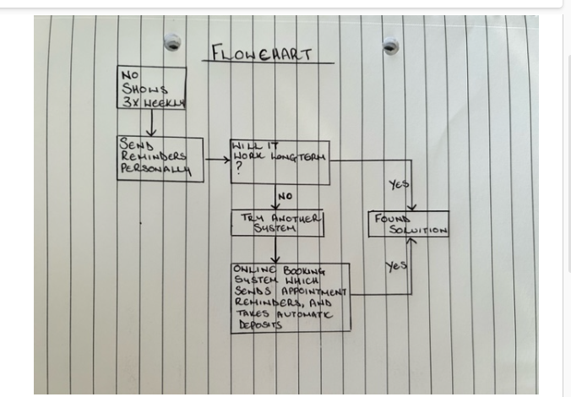

Summary

With this flowchart I have worked out that for my business and the amount of no shows I am getting I produced 2 solutions.
  - Solution 1 – the first solution I thought of was to send all individual clients a reminder for their appointment the day before. This I find will not work long term because running a business on my own, admin, accounts, being full time mum to two children, a wife, and running a home takes all my available time. Some days I can have 7 clients booked in and be working until late, I will not have enough time to then send clients reminders the day before their appointments.
  - Solution 2 – the second solution I concluded was that I investigate having an online booking system which will send automatic text reminders the day before client's appointments, and online booking systems also take automatic deposits from the clients which can mean that if they do not cancel in enough time they will lose that deposit and will have to pay 50% of the cost if they wish to book another appointment in future. I concluded that this solution would be the best for my business going forward as it saves time for myself that I can put elsewhere in my business or at home.

I have then considered Root Cause Analysis to identify the underlying cause of my problem, and this will help me find a potential solution. The analysis should look at how the root cause could be prevented in the future. Root cause analysis is a comprehensive approach, met with holistic methods that will result in an actionable analysis. (Tableau, 2022)
“Cause and effect refers to the relationship between events or actions where one event, the cause, leads to another event, the effect.” James Prior

For this section I chose between the 5 whys and a Cause-and-effect diagram.
The 5 Whys method allows uncovering the root cause of a problem by simply asking "Why" five times. This interrogative technique is one of the most effective tools for root cause analysis (Kanbanize, 2023).

5 Whys
I am having clients constantly not attend their appointments weekly.
Why am I having no shows?
Because clients have not let me know that they cannot attend.
Why can they not attend?
Because they could be unable to afford their appointments.
Why can they no longer afford their appointment?
Because they could have run out of money.
Why have they run out of money?
Because they could have had to pay their bills and will mean they are unable to afford luxury appointments.
Why can they not afford luxury appointments?
Because of the cost-of-living crisis.
Check clients are doing okay, and possibly give a small discount.

Cause and effect analysis helps you to think through the causes of a problem thoroughly, including its root causes. It is only by identifying the main causes that you can permanently remove the problem, or reduce the delay (NHS, 2023)

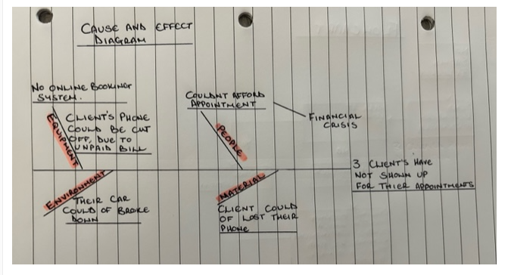
In this Cause-and-Effect diagram I have concluded solutions that would be the possible reasons as to why clients are unable to attend their appointments.
- People; could be unable to afford their appointments, because of the financial crisis which will mean them having to give up luxury treatments. Due to the financial crisis people can feel ashamed of their situation and would prefer to not share any information about what they are dealing with.
- Material; the client could have lost their phone before their appointment which then they would be unable to contact myself to inform they are unable to attend.
- Equipment; no online booking system for clients to book their appointments online so they will not get message reminders for their appointments.
Client's phone could be cut off due to not being able to pay their contract.
- Environment; the client's car could have broken down on the way to their appointment.

Grid Analysis

“Grid analysis (also known as Decision Matrix, Pugh Decision Matrix, Weighted Scorecard and others) is a framework for evaluating ideas and making decisions which uses a set of weighted criteria to rank the ideas.”
Below I will attach my grid analysis I produced to decide on the best solution for clients not turning up for their nail appointments.

Factors: | Cost | Reliability | Speed | User Friendly | Total
Weights: | 3 | 5 | 4 | 5
Online booking system | 12  4 | 15  3 | 16  4 | 15  3 | 58  14
Deposits when booking the appointment | 15  5 | 15  3 | 12  3 | 20  4 | 62  15
Automatic message reminders | 12  4 | 12  4 | 16  4 | 25  5 | 65  17
Low to high: 1 – 5
I have chosen the 4 factors;
Cost – as it is important for not only me but clients, if they are paying a deposit when booking some clients might be unhappy with paying an extra fee towards an app.
Reliability – my clients will need a reliable source of information on what they will be using to book their appointments as some clients are elderly women and might not feel confident or comfortable putting their details online.
Speed – as I book all appointments through my diary in my own time which can take me a few days as home and work life can get in the way, speed is very important to me and I appreciate that clients do not have the time to wait for me to reply so they can book online that same day.
User friendly – highlighting above as I have some elderly ladies in with me so I must weigh up the pros of how difficult it would be for them to use.
I have chosen the weights from lowest to highest, 1 – 5, 5 being the most positive.
“The main benefit of using Grid Analysis for decision making and idea evaluation is to make the process more objective. By using a concrete set of criteria with distinct weights, the decision-maker can inject a certain amount of rationality in the process and, subsequently, more easily justify their decision to others if needed.”
Summary
In the Grid Analysis I created above using factors and weights the best solution to my clients not showing up to their appointments weekly would be to use message reminders, these would be sent the day before their appointments to their emails and mobile phones. If possible, having an online booking system app which all clients can download onto their phones, or they can use online which can make it more accessible for them to book and cancel their appointments with enough notice for the nail technician. With an online booking system clients must input their best form of contact and they will receive a confirmation message once the appointment deposit has been paid.

Cost Analysis

“Generally speaking, cost-benefit analysis involves tallying up all costs of a project or decision and subtracting that amount from the total projected benefits of the project or decision. (Sometimes, this value is represented as a ratio.)” Tim Stobierski, 2019.
For my cost analysis, I searched for online booking system apps which were reliable to work with, there was also a signup fee included which will be in the total cost.

 | Year 1 | Year 2 | Year 3 | Total
Cost of app | £360 | £360 | £360 | £1,080
Signup fee | £40 | 0.00 | 0.00 | £40
Total cost | £400 | £360 | £360 | £1,120

In this chart the online booking system I have used will be an app which all clients can access to book appointments, with this app they will have to pay a 50% deposit off their appointment to secure their booking, with the deposit that will mean if clients do not show up to their appointments the amount will be transferred and unable to refund or move it over to another appointment which then covers some of my costs for that day. The cost of the app will be paid every year which covers all aspects of the app, there will also be a signup fee which I will pay for the first year of starting.
Benefit Analysis
“Before building a new plant or taking on a new project, prudent managers conduct a cost-benefit analysis to evaluate all the potential costs and revenues that a company might generate from the project. The outcome of the analysis will determine whether the project is financially feasible or if the company should pursue another project.” Adam Hayes, 2023.
In this benefit analysis I will total up the amount no shows over the 3-year period that would be reduced by having the app and then total up the cost of the booking app and will summarise the benefit of using the app for my business.

 | Year 1 | Year 2 | Year 3 | Total
Clients turning up to their appointment | £5,040 | £5,040 | £5,040 | £15,120
Equipment | £260 | £260 | £260 | £780
Total Benefit | £5,300 | £5,300 | £5,300 | £15,900

Summary
3 no shows a week averaging at £35 per appointment equals the amount of £105 a week, averaging £420 a month, and then averaging with around 144 clients a year not attending their appointments that is a total of £5,040 a year. In conclusion for all clients to use an online booking app which sends message reminders I will have an extra yearly income of £5,040, which will then give me an extra income over 3 years of £15,900.

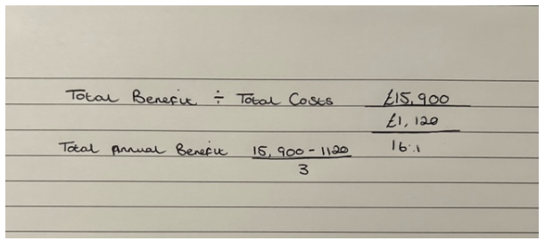
Net annual benefit:
Year 1 - £5,300 - £400 = £4,900
Year 2 - £5,300 - £360 = £4,940
Year 3 - £5,300 - £360 = £4,940

Gantt Chart
“A Gantt chart is a project management tool assisting in the planning and scheduling of projects of all sizes; they are particularly useful for visualising projects. A Gantt chart is defined as a graphical representation of activity against time; it helps project professionals monitor progress.” August 2023.
I will use a Gantt Chart to decide when I will apply various aspects of releasing the app, from research, to implementing the app for the clients to access to book their appointments.
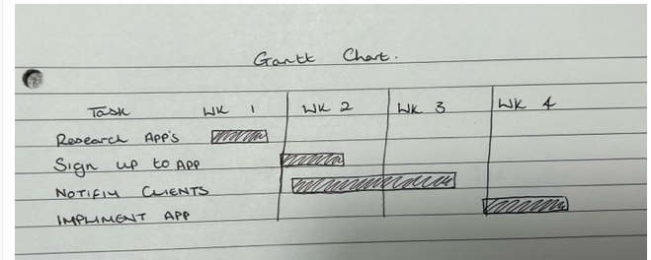
In this process I used the Gantt Chart to help me indicate which times would be best to start the app for my clients from week to week.
- Researching apps; researching apps will not take much longer than the first week. Once finding the perfect app that will work well with clients, I will then start the sign-up process.
- Sign up to app; signing up to the app will happen through week two. I will pay the signing up fee, clients will not be required to pay a sign-up fee.
- Notify clients; clients will need to be notified that I will be using an online booking system to now book their appointments. That will normally need to be done between the weeks of two and three.
- Implement app; links for the app will then be posted on my Instagram and all clients will get a link sent to them to book their appointments, that will be done through the week of week 4.
Stakeholder Analysis
“A stakeholder is a party that has an interest in a company and can either affect or be affected by the business. The primary stakeholders in a typical corporation are its investors, employees, customers, and suppliers.” (Fernando, 2023)
The stakeholders of my business would be;
Myself, as with clients unable to attend their appointments I will be at a loss with income.
All my clients because they are waiting for appointments and people not attending means I could have offered other clients the appointment.
The owners of the salon, as without a steady income for the week I will struggle to not only pay my bills, but unable to pay the rent in the salon.
Monitors
I will be using the Gantt Chart to monitor the implementation of the solutions.

Conclusion
To conclude my problem of having multiple clients not attending their appointments weekly I will be using an online booking system for clients to book their appointments, all clients will have to pay a 50% deposit when booking to secure their appointments, and all clients must put contact information into the booking system to have appointment reminders the day before their appointments.
I will use the Gantt Chart to implement the solution to my problem, making sure it is cost affective for myself, clients, family, and business.

References

A problem-solving perspective on knowledge management practices. Peter H Gray. Decision Support Systems Volume 31, Issue 1, May 2001, Pages 87-102.
- Tech target, Whatis.com. By Corinne Bernstein. August 2023.
- ASQ, Learn about quality. What is a flowchart? August 2023.
- DoTefl, Cause and Effect: Definition, Meaning and Examples. James Prior, April 22, 2023.
- Rationalize.io, Decision Matrix, MCDA and Grid Analysis tool, Using Grid Analysis for Idea Evaluation. August 2023.
- Rationalize.io, Decision Matrix, MCDA and Grid Analysis tool, Using Grid Analysis for Idea Evaluation. August 2023.
- Harvard business school online. How to do a cost-benefit analysis & why is it important. Tim Stobierski, 05 September 2019.
- What Is Cost-Benefit Analysis, How Is it Used, What Are its Pros and Cons? Investopedia. By Adam Hayes, March 28, 2023.
- What is a Gantt chart? | Definition & Examples | APM, August 2023.
- Rothaizer J M, 2021, How to Best Approach Complex Problems, https://www.forbes.com/sites/forbescoachescouncil/2021/10/25/how-to-best-approach-complex-problems/?sh=55d0b9bb6760, accessed 29/8/2021
- Tableau. (2022). Root Cause Analysis Explained: Definition, Examples, and Methods. https://www.tableau.com/. https://www.tableau.com/learn/articles/root-cause-analysis, accessed 29/8/2023
- Kanbanize, 2023, 5 Whys: The Ultimate Root Cause Analysis Tool, https://kanbanize.com/lean-management/improvement/5-whys-analysis-tool, accessed 29/8/2023
- NHS, 2023, Cause and Effect Diagram (Fish Bone), https://qi.elft.nhs.uk/resource/cause-and-effect-diagram-fish-bone/, accessed 29/8/2023
- What Are Stakeholders: Definition, Types, and Examples, https://www.investopedia.com/terms/s/stakeholder.asp#:~:text=A%20stakeholder%20is%20a%20party,employees%2C%20customers%2C%20and%20suppliers, Jason Fernando, March 07, 2023.

