DATA HANDLING & BUSINESS INTELLIGENCE

Konstantina Malamova 2020492
BA Business Management Level 5 Term 2 Group 1

TABLE OF CONTENTS
Part 1 3
Part 2 12
2.1 12
2.2 13
2.3 14
2.4 14
2.5 17
2.6 18
Reference list 20

ASSESSMENT COMPONENT 2

Part 1
In this part the data analysis can be presented according to the provided data which is Superstore data. In addition, from the analysis of the respective dataset, this analysis project will critically evaluate the superstore’s overall profits or decline in sales over the respective fiscal years of 2012, 2011, 2010, and 2009. For the analysis of the dataset Microsoft Excel software has been used where first the data has been shortlisted and after shortlisted it starts analysing the superstore data with respect to sales and profits or loss over the fiscal years. For the analysis of the superstore dataset main two Excel functionality has been used. One is Lookup and another one is Pivot table. The main purpose of using LookUP functionality in EXCEL is to find out a specific column or row from the respective dataset as well as also search for the value from a similar place in the dataset’s column or row. Pivot table has been also used as the functionality in EXCEL to critically and fastly gist the vast amounts of information. However, the application of the pivot table is used to measure the numerical data in brief as well as answer some “unanticipated questions” with respect to the data. From the analysis of the superstore data, it will critically discuss the profits of the superstore and sales of the superstore.

Row Labels | Sum of Sales | Sum of Profit
293 | 244.57 | 46.71
Mar | 244.57 | 46.71
868 | 2948.66 | 228.92
Oct | 2948.66 | 228.92
933 | 80.61 | -4.72
Apr | 80.61 | -4.72
1540 | 80.9 | 5.76
Jun | 80.9 | 5.76
3232 | 42.66 | -11.83
Oct | 42.66 | -11.83
3524 | 427.32 | 52.35
Mar | 427.32 | 52.35
Grand Total | 3824.72 | 317.19
Table 1: pivot table of sales and profit data in the fiscal year 2012
(Source: self-created in Microsoft Excel)
In the fiscal year 2012 the superstore sold different kinds of products. In March the superstore sold their product at a value of 244.57 whereas in the month of October the superstore sold their products at a value of 2948.66. This is a matter of fact, based on their sold items and analysis of the data it can be concluded that the super store’s overall sales value is actually greater as compared to the super store’s profit value. With the help of this analysis and with the help of the pivot table outcome it can be stated that the superstore faced declines in sales which means the superstore faced the loss or failed to earn profits.
The identification of graphical presentation can be provided based on the fiscal year, 2012. From this analysis it can be stated that the sum of sales is high in the month, October for the fiscal year, 2012 for the product ID 868. This range is about 3400. The sum of sales is mostly lower in the month, October for the product ID, 3232. The sum of profit is high in fiscal year, 2012 in the month, October, for the product that was high in sales. In the month, March, for the product ID 293, the sum of sales is 244.57. For this same product and month the sum of profit is 46.71. In this year in April, the sum of profit is negative. In the month, June, the sum of profit is very low. The value for sum of profit in the month, June is 5.76.
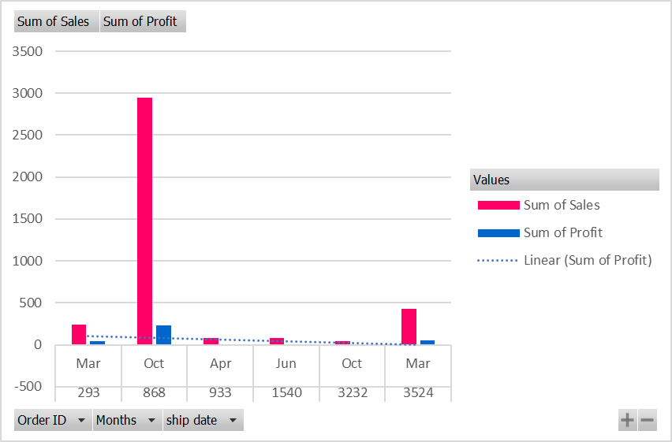
Figure 1: Graphical presentation of the fiscal year 2012
(Source: self-created in Microsoft Excel)

Row Labels | Sum of Profit | Sum of Sales
483 | 1198.97 | 4965.7595
Dec | 1198.97 | 4965.7595
1702 | 4.9 | 67.24
Jul | 4.9 | 67.24
2277 | 67.34 | 1690.64
Mar | 67.34 | 1690.64
2532 | -157.92 | 852.074
Nov | -157.92 | 852.074
Grand Total | 1113.29 | 7575.7135
Table 2: pivot table of sales and profit data in the fiscal year 2011
(Source: self-created in Microsoft Excel)
In the fiscal year 2011 the superstore sold different kinds of products. In December the superstore sold their product at a value of 4965.75 whereas in the month of March the superstore sold their products at a value of 1690.64 and in the month of November the superstore sold their products at a value of 852.074. From the above pivot table analysis, it can also be stated that in the fiscal year 2011 the superstore actually sold their products highest in the month of December whereas on the other hand in the month of July the superstore sold very fewer amounts of products. Additionally, in the months of November and March, the superstore sold average amounts of products.

The identification of graphical presentation can be provided based on the fiscal year, 2011. The sum of sales is high in the month December within the fiscal year, 2011. This value is 4965.7595. The sum of profit is also high in this month of this fiscal year. This value is 1198.87. The sum of profit is lower in the month, july. This value is 4.9 for the order ID 1702. This sum of sales in this month, July is 67.24. In the month, March the value for sum of sales is 1690.64 and the value of sum of profit is 67.34. The value for the sum of sales is 852.074. In this month the sum of profit is in the negative.
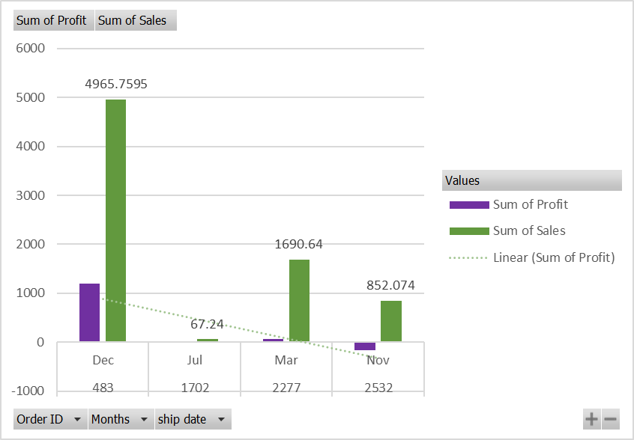
Figure 2: Graphical presentation of the fiscal year 2011
(Source: self-created in Microsoft Excel)
Row Labels | Sum of Sales | Sum of Profit | Sum of Order ID
Mar | 6900.13 | 552.97 | 7906
Aug | 820.284 | -180.2 | 3908
Nov | 16962.83 | 2740.69 | 121816
Grand Total | 24683.244 | 3113.46 | 133630
Table 3: pivot table of sales and profit data in the fiscal year 2010
(Source: self-created in Microsoft Excel)
In the fiscal year 2010, the superstore faced financial losses just because of their product sales amounts. In the fiscal year 2010, the superstore was unable to sell different kinds of products which simply push the store into losses. In November the superstore sold their product at a value of 16962.83 whereas in the month of March the superstore sold their products at a value of 6900.13 and in the month of August the superstore sold their products at a value of 820.284. From the above pivot table analysis, it can also be stated that in the fiscal year 2011 the superstore actually sold their products highest in the month of November whereas on the other hand in the month of August the superstore sold very fewer amounts of products. Additionally, in the month of March, the superstore sold average amounts of products.
The identification of graphical presentation can be provided based on the fiscal year, 2010. The sum of order ID is high in the month, November within the fiscal year, 2010. This value is 121816. The sum of profit is also high in this same month, November of this fiscal year. This value is 2740.69. The sum of profit is absent in the month, August. This value is -180.2 for the order ID 3908. The sum of sales in this month, August is 820.284. In the month, March, the value for sum of sales is 6900.13 and the value of sum of profit is 552.97. The value for the Order ID is 7906.
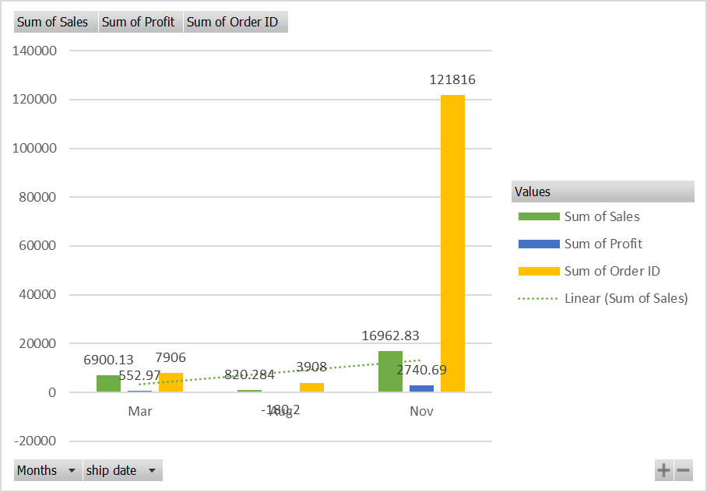
Figure 3: Graphical presentation of the fiscal year 2010
(Source: self-created in Microsoft Excel)

Row Labels | Sum of Sales | Sum of Profit
2791 | 1522.92 | 356.82
Oct | 1522.92 | 356.82
4612 | 55.45 | 21.42
Jun | 55.45 | 21.42
4676 | 221.8 | 85.68
Jun | 221.8 | 85.68
10499 | 121.73 | -69.07
Nov | 121.73 | -69.07
10535 | 243.46 | -138.14
Nov | 243.46 | -138.14
10789 | 121.73 | -69.07
Nov | 121.73 | -69.07
Grand Total | 2287.09 | 187.64
Table 4: pivot table of sales and profit data in the fiscal year 2009
(Source: self-created in Microsoft Excel)
In the fiscal year 2009 the superstore faced financial losses just because of not only their products sales amounts but also for being unable to earn profits. In the fiscal year 2009, the superstore was unable to sell different kinds of products which simply pushed the store into losses. In the month of October, the superstore sold their product at a value of 1522.92 whereas in the month of June the superstore sold their products at a value of 55.45, 221.8 respectively based on the product variation, and in the month of November, the superstore sold their products at a value of 121.73, 243.46 respectively based on the product variation. From the above pivot table analysis, it can also be stated that in the fiscal year 2009 the superstore actually sold their products highest in the month of October whereas on the other hand in the month of June and November the superstore sold very fewer amounts of products and due to this unable to gain profits.
The identification of graphical presentation can be provided based on the fiscal year, 2009. The sum of sales is high in the month, of October. Its value is 1522.92. In this month, the sum of profit value is 356.82. In the month, of June, the value for the sum of sales is 55.45 and the value for the sum of sales is 21.42 for the order number 4612. In the month, June for the order ID, 4676, the value for sum of sales is 221.80 and the value for sum of profit is 85.68. In the month, November, the value for sum of sales is 121.73 and the sum of profit value is negative, which is -69.07. In this same month for the product ID 10535, the value for sum of sales is 243.46 and the sum of profit value is -138.14. In this same month for the product ID 10789 the value for sum of sales is 121.73 and the value for sum of profit is negative.

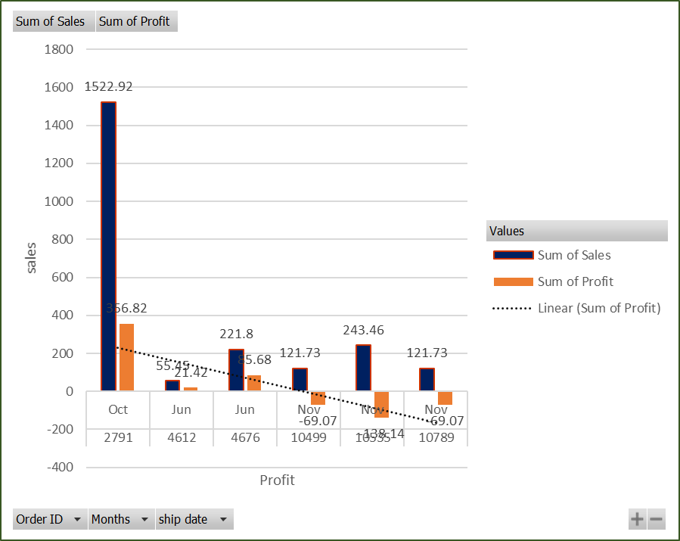
Figure 3: Graphical presentation of the fiscal year 2009
(Source: self-created in Microsoft Excel)

Part 2
In this part the data analysis can be presented according to the provided data in Ice_cream_csv datasets and Ice_cream.xls. From the analysis of the dataset, the identification of numbers of students who like the ice cream with vanilla flavour can be identified. The numbers of the male and female students in this provided data set can also be identified. These findings can be provided by the presentation of the bar diagram and pie chart in this report. Through the graphical representation the data analysis will be provided. It will evaluate the means and medians, for the students who like strawberry flavour and chocolate flavour of ice cream. The value of K-means will also be analysed for the provided data.

2.1
The analysis is done in the SPSS platform. From this analysis the numbers of the students who like vanilla flavour are identified. From this it is identified that the numbers of the students are 13 who like the vanilla flavour. The vanilla ice cream is identified as 1 in the table. And the male students are identified as “0”, female students are identified as “1”. From this it can be stated that within 13 numbers of students, 8 students are male like this vanilla flavour and another 5 students are female. In the table below, the identification of students through cross tabulation is provided.

students * ice_cream Cross Tabulation
Count
 |  | ice_cream |  |  | Total
 |  | 1 | 2 | 3 | Total
students | 0 | 8 | 3 | 4 | 15
students | 1 | 5 | 7 | 8 | 20
Total |  | 13 | 10 | 12 | 35

Table 5: Students and ice cream Cross Tabulation
(Source: Self-created in SPSS)

The identification of the data can be provided in the form of graphical presentation that can be provided below.
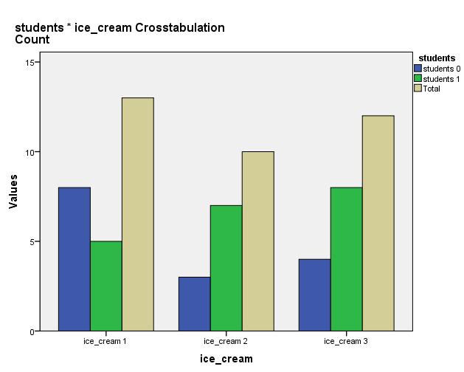
Figure: Cross tabulation of ice cream vs. Students
(Source: Self-created in SPSS)

2.2
From the analysis of the data the total numbers of the students can be identified that is 35. Within these students, 15 students are male and 20 students are female. The numbers of students can be provided
Table 6: Gender of students with different numbers
Gender of students
Count
 |  | ice_cream |  |  | Total
 |  | 1 | 2 | 3 | Total
students | 0 | 8 | 3 | 4 | 15
students | 1 | 5 | 7 | 8 | 20
Total |  | 13 | 10 | 12 | 35

(Source: Self-created in SPSS)

2.3
The mean and median value for the participant, like strawberry and chocolate flavor can be evaluated by the analysis of the data.
Table 7: Mean and median of students who like chocolate flavor and strawberry flavor
Report
Students
ice_cream | Mean | Std. Deviation | Median
1 | .38 | .506 | .00
2 | .70 | .483 | 1.00
3 | .67 | .492 | 1.00
Total | .57 | .502 | 1.00

(Source: Self-created in SPSS)
From the presentation of the above table the identification of mean and median value is possible. Ice cream “2” represents chocolate flavor and ice cream “3” represents strawberry flavor. From the analyzed table it can be stated that for the participants who like strawberry flavor, the mean value is 0.67 and 1.0 is the median value For the participants who like chocolate flavor, the mean value is 0.70 and 1.0 is the median value.

2.4
By the use of the dataset, Ice_cream_csv in the SPSS format the identification of K-means can be possible. The K-means clustering can be provided by the analysis of the provided data. The initial cluster centers can be provided below in the form of a graph.
Table 8: Initial Cluster Centers
Initial Cluster Centers
 | Cluster
 | 1 | 2
Z score(students) | -1.13809 | .85356
Z score(video) | -1.52916 | 1.47762
Z score(puzzle) | -1.91086 | 1.66288
(Source: Self-created in SPSS)
For the K-means of clustering, in cluster 1, the value for students is -1.13809 and in cluster 2 this K-means value for students is .85356. This K-means for clustering in cluster 1, the value for video is -1.52916 and in cluster 2 this K-means value for video is 1.47762. This value for clustering in cluster 1, for the puzzle, is -1.91086 and in cluster 2 this K-means value for the puzzle is 1.66288. The final cluster center can be provided in the table below.
Table 9: Final Cluster Centers
Final Cluster Centers
 | Cluster
 | 1 | 2
Zscore(students) | -.26674 | .22462
Zscore(video) | -.75867 | .63888
Zscore(puzzle) | -.73025 | .61494
(Source: Self-created in SPSS)
From this table, it can be stated that for the final cluster this value for students is -.26674 for cluster 1 and the value for students is .22462 for cluster 2. The value for video is -.75867 for cluster 1 and the value for video is .63888 for cluster 2. The value for the puzzle is -.73025 for cluster 1 and the value for the puzzle is .61494 for cluster 2. The final cluster can be provided in the form of the pie chart to discuss the data.
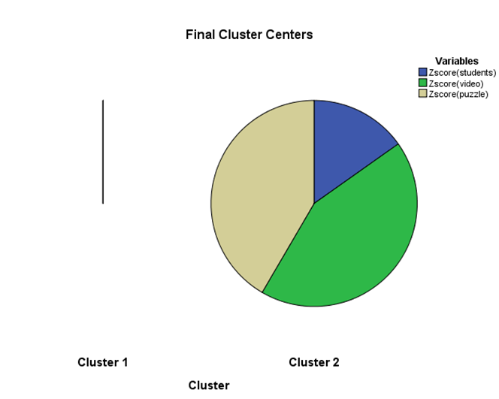
Figure: Graphical analysis for Final Cluster Centers
(Source: Self-created in SPSS)
The numbers of the cases for each cluster can be stated and this can be provided in the form of a table.
Table 10: Number of Cases in each Cluster
Number of Cases in each Cluster
Cluster | 1 | 16.000
Cluster | 2 | 19.000
Valid |  | 35.000
Missing |  | .000
(Source: Self-created in SPSS)
The numbers for each cluster are 16 for cluster 1 and the number is 19 for cluster 2. From this, it can be stated that the valid cluster number is 35.00. The missing numbers of clusters are not present in the analyzed data.
From the analysis of the data, the ANOVA can be provided for the analysis of statistical methods that can be provided in the form of a table.
Table 11: ANOVA test
ANOVA
 | Cluster |  | Error |  | F | Sig.
 | Mean Square | df | Mean Square | df | F | Sig.
Z Score(students) | 2.097 | 1 | .967 | 33 | 2.169 | .150
Z Score(video) | 16.965 | 1 | .516 | 33 | 32.863 | .000
Z Score(puzzle) | 15.717 | 1 | .554 | 33 | 28.369 | .000
(Source: Self-created in SPSS)
From this, it can be stated that statistical significance is present in the puzzle and in the video. The students are not statistically significant. From this, it can be stated that within the cluster programming, the students cannot impact.

2.5
The data mining method can be used in the business. For this use, real-world examples can be banking and retail. For example, data mining is employed by institutions to properly assess risk exposures. It is often used to analyze purchases, card payments, purchase histories, and client financial documents in credit scores and other sophisticated anti-fraud programs (iberdrola.com, 2022). Banks can also use data mining to discover something about individual online interests or behaviors in order to maximize the impact on business marketing initiatives, examine the success of business units, or monitor compliance requirements duties. Supermarkets analyze collaborative purchase habits to detect product linkages. Data mining may help determine which deals are the most popular among clients and enhance sales just at the checkout line.
The text mining method is required for cybercrime prevention. With the rising measure of cybercrimes, for example, information breaks, and cyberbullying, among others, consolidating network safety programming with text mining capacities could assist organizations with recognizing undesirable action (analyticsinsight.net, 2022). Text mining devices may likewise perceive terms that are in many cases involved on the web for tormenting, compromising, or other negative demonstrations.

2.6
Advantages of Excel
- The code can be automated by excel
- All tools are present for data analysis
Drawbacks of Excel
- “Advanced pricing rules” management is difficult
- Human error can be present
Advantages of SPSS
- It is useful for both “quantitative” and “qualitative” data analysis (surveysparrow.com, 2022).
- Much effort is not required to begin by this software
Drawbacks of SPSS
- Large datasets cannot be analyzed
- this functionality is limited

Reference list
Journals
Ahmi, A., Elbardan, H. and Ali, R.H.R.M., 2019, January. Bibliometric analysis of published literature on industry 4.0. In 2019 International Conference on Electronics, Information, and Communication (ICEIC) (pp. 1-6). IEEE.
Aldrich, J.O., 2018. Using IBM SPSS statistics: An interactive hands-on approach. Sage Publications.
Bansal, A. and Srivastava, S., 2018. Tools used in data analysis: A comparative study. International Journal of Recent Research, 5(1), pp.15-18.
Bansal, A. and Srivastava, S., 2018. Tools used in data analysis: A comparative study. International Journal of Recent Research, 5(1), pp.15-18.
Bennett, R., Alberti, G., Çibik, A., Eremenko, T., Formosa, S., Formosa‐Pace, J., Jiménez‐Buedo, M., Lynch, K., Salazar, L. and Ubeda, P., 2022. Bringing about the data revolution in development: What data skills do aspiring development professionals need?. Journal of International Development.
Cheng, C., Gilmore, T.J., Lougen, C. and Stovall, C., 2018, November. Statistical analysis, data visualization, and business intelligence tools for electronic resources in academic libraries. In What’s Past Is Prologue: Charleston Conference Proceedings 2017.
Gould, S.J., 2019, May. Bespoke Data Visualization using R and ggplot2. In Extended Abstracts of the 2019 CHI Conference on Human Factors in Computing Systems (pp. 1-4).
Islam, M., 2020. Data Analysis: Types, Process, Methods, Techniques and Tools. International Journal on Data Science and Technology, 6(10).
Istikomah, E., 2021. The Increasing Self-Efficacy and Self-Regulated through GeoGebra Based Teaching Reviewed from Initial Mathematical Ability (IMA) Level. International Journal of Instruction, 14(1), pp.587-598.
Lemenkova, P., 2019. Numerical data modelling and classification in marine geology by the SPSS statistics. International Journal of Engineering Technologies IJET, 5(2), pp.90-99.
Lu, J., 2018, September. Data science in the business environment: skills analytics for curriculum development. In International Conference on Machine Learning, Optimization, and Data Science (pp. 116-128). Springer, Cham.
Lu, J., 2020. Data analytics research-informed teaching in a digital technologies curriculum. INFORMS Transactions on Education, 20(2), pp.57-72.
Lu, J., 2020. Data analytics research-informed teaching in a digital technologies curriculum. INFORMS Transactions on Education, 20(2), pp.57-72.
Lunsford, D.L. and Phillips, P.P., 2018. Tools used by organizations to support human capital analytics. Performance Improvement, 57(3), pp.6-15.
Majeed, S., Uzair, M., Qamar, U. and Farooq, A., 2020, November. Social Network Analysis Visualization Tools: A Comparative Review. In 2020 IEEE 23rd International Multitopic Conference (INMIC) (pp. 1-6). IEEE.
Monsen, K.A., 2018. Exploratory data analysis. In Intervention Effectiveness Research: Quality Improvement and Program Evaluation (pp. 77-85). Springer, Cham.
Okagbue, H.I., Oguntunde, P.E., Obasi, E.C. and Akhmetshin, E.M., 2021. Trends and usage pattern of SPSS and Minitab Software in Scientific research. In Journal of Physics: Conference Series (Vol. 1734, No. 1, p. 012017). IOP Publishing.
Ozgur, C., Booth, D. and Alam, P., 2019. Analytics Software Languages for Problem Solving. Engineering and Technology Quarterly Reviews, 2(2).
Rahmany, M., Zin, A.M. and Sundararajan, E.A., 2020. Comparing Tools Provided By Python And R For Exploratory Data Analysis. IJISCS Int. J. Inf. Syst. Comput. Sci, 4(3).
Rahmany, M., Zin, A.M. and Sundararajan, E.A., 2020. Comparing Tools Provided By Python And R For Exploratory Data Analysis. IJISCS Int. J. Inf. Syst. Comput. Sci, 4(3).
Website
iberdrola.com (2022). Discover how data mining will predict our behavior. Available at: https://www.iberdrola.com/innovation/data-mining-definition-examples-and-applications [Accessed on: 25/08/2022]
analyticsinsight.net (2022). TEXT MINING: BEST REAL-WORLD APPLICATIONS IN USE TODAY. Available at: https://www.analyticsinsight.net/text-mining-best-real-world-applications-use-today/ [Accessed on: 25/08/2022]
surveysparrow.com (2022). Advantages of Using SPSS. Available at: https://surveysparrow.com/blog/what-is-spss/ [Accessed on: 25/08/2022]

