E-Portfolio Evidence Of Learning
Student Name: Soabia Rafiq
Student ID: 2015530
Module Code: BMHP5015_BIRM
Lecturer’s Name: Tayo Korede

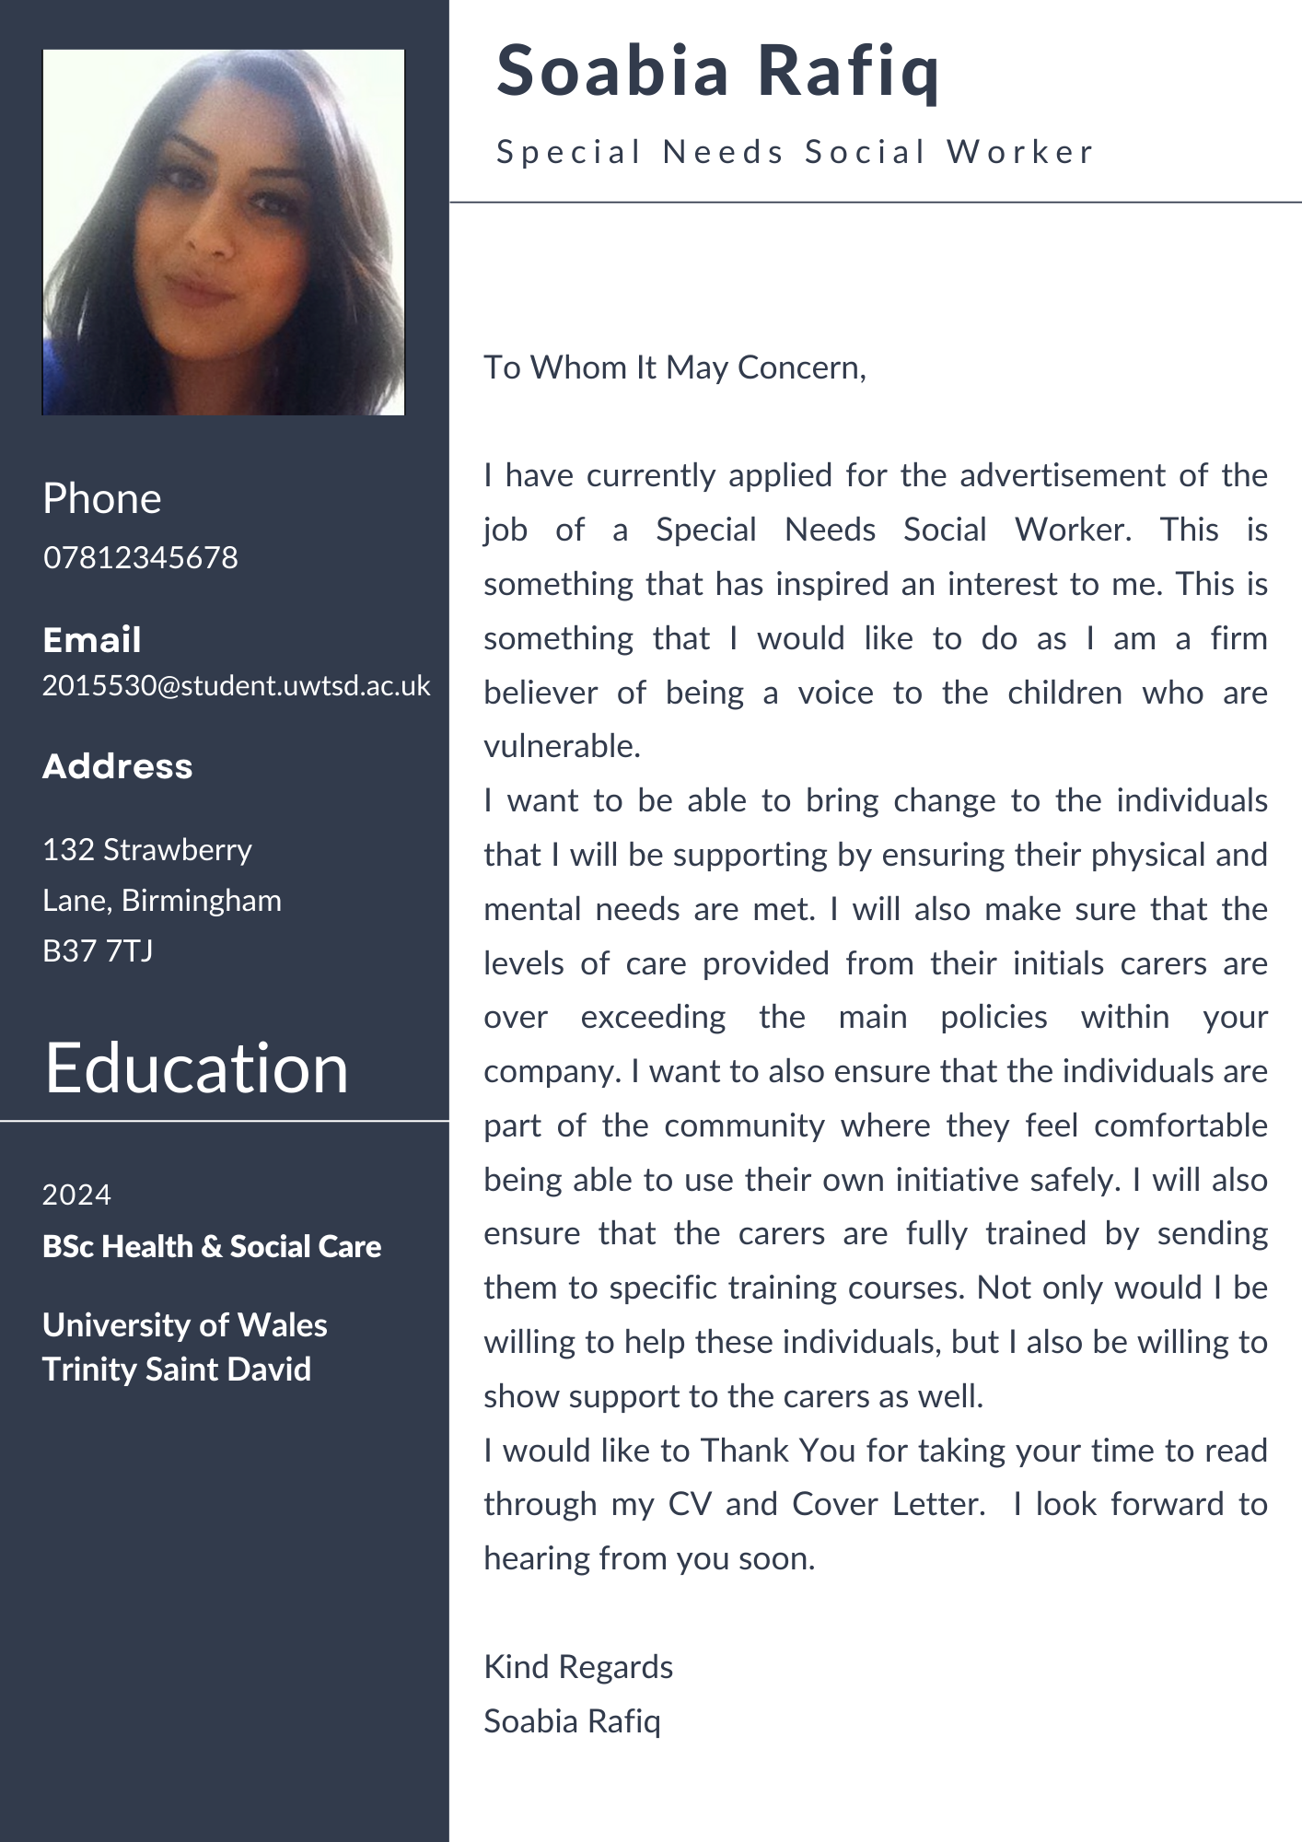
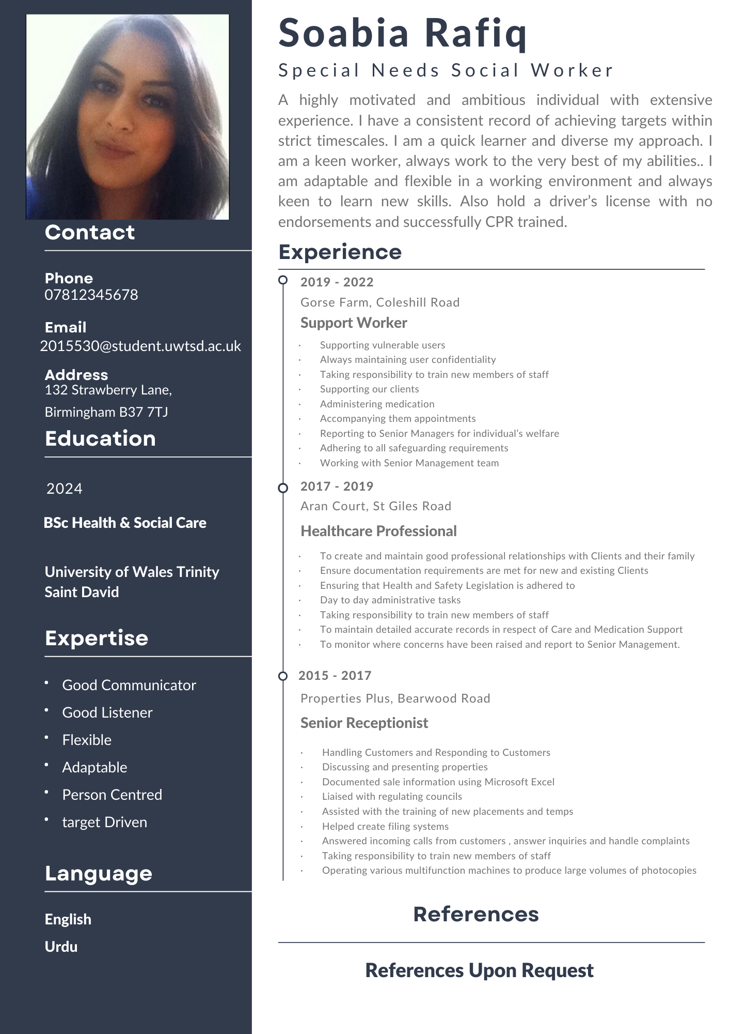

Pitch

