Task 1: Locating Sources
Identify and locate three different sources (a report, a journal article, and a website) related to the question
“What employability skills do business graduates need to succeed in the modern workplace?”
Show how you used keywords, search terms, and Boolean operators to find them, and explain how you know which type of source each one is and why it is appropriate for the research question.

Source Type & Why It Is Appropriate | URL/DOI | What search engine did you use? Google/Online Library/Library AI Assistant | Keywords/Boolean Operators Used
Journal | ISSN: 1097-6671 | Library | Employability skills, success, modern workplace

Task 2: Evaluating Information (CRAAP Test)
Your colleague has forwarded you a source from a peer reviewed journal, and they are not sure whether it is appropriate to use and has asked for your help. Your task is to evaluate the source by using the CRAAP Test to assess its appropriateness.
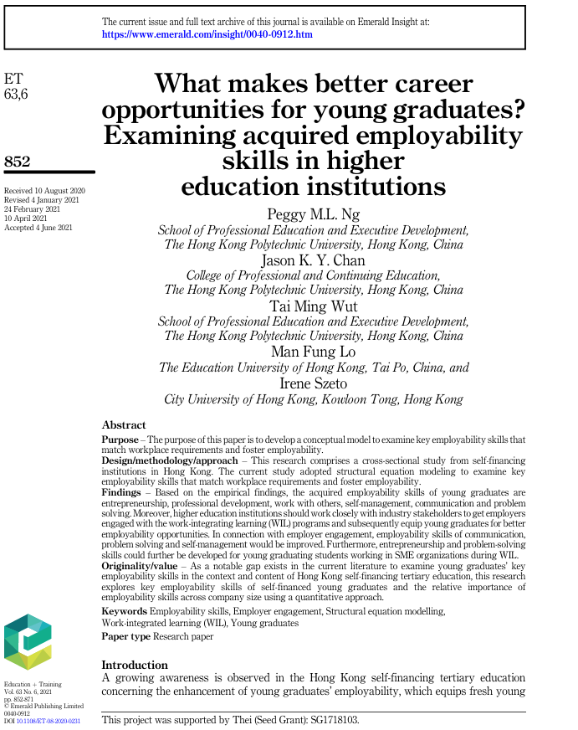

CRAAP Test
Currency | This journal was published in 2020 so is reasonably recent some workplace requirements have improved over the years
Relevance | This journal is related to the topic of research and uses some of the key words
Authority | The authors are professional education directors
Accuracy | This research is conducted by several professional lectures and education executives
Purpose | This purpose is tors Journal is to are what makes better opportunities for young grads

Task 3: Source Analysis
Your manager has provided you with a short extract from a source and has asked you to analyse the source by Identifying one strength, one weakness, and providing a brief explanation of the strength and weakness identified.
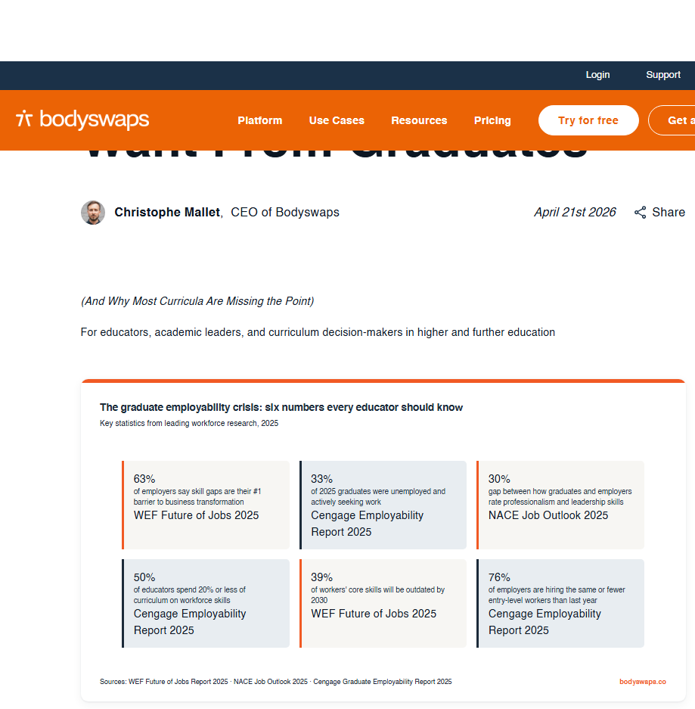
.

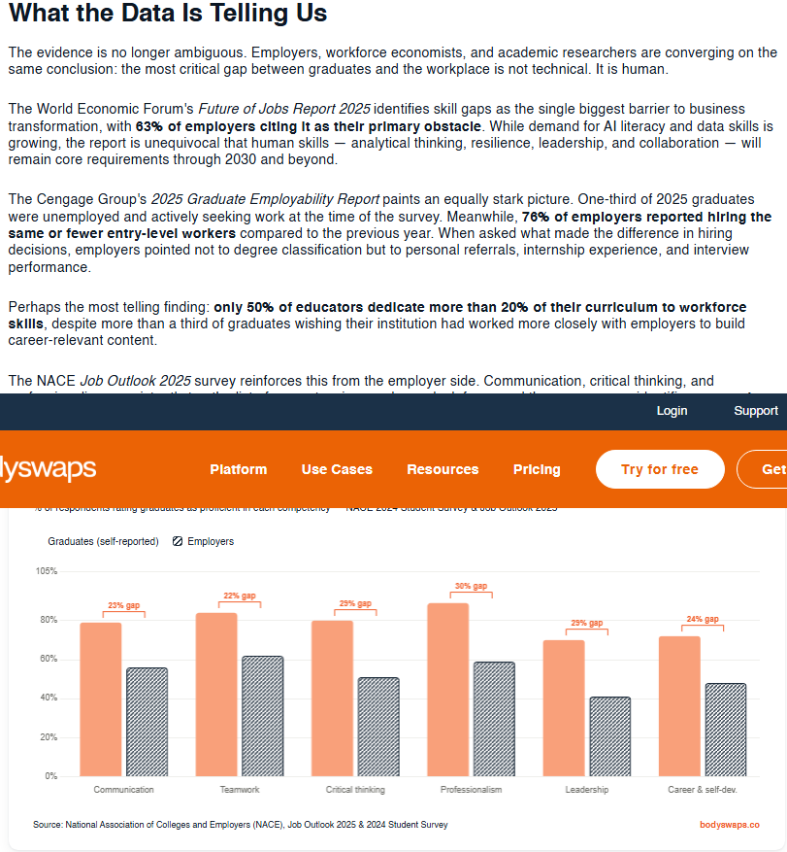

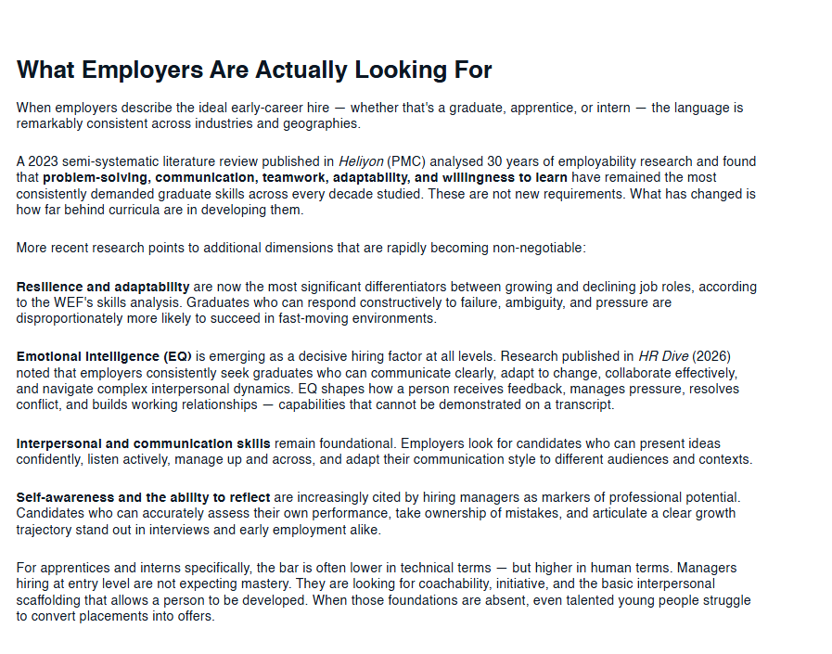

Please click the link, if you wish to read the article online.
What Employers Actually Want From Graduates

Strength of the Source:

This source used research from graduates and collected statistics to increase credibility of the source

Weakness of the Source:

The weakness is its published by Webster which represents the universities based towards promoting education

