Module Title: Effective Team Work and communication
Module Code: BMSW4002
Name: Faisal Mahmood

Contents
1. Introduction 3
2. Models of Communication 4
2.1 Shannon and Weaver 4
2.2 Schramm Model 5
Difference between Schramm and Shannon's Model 6
2.3 Berlo Communication Model 6
3.0 Communication Skills 8
3.1 Verbal Skills 8
3.2 Non-Verbal Skills 9
Case study: A day with the Chief 9
3.3 Listening Skills 9
Case study: Max the multi Tasker 9
Advantages of technology in communication 10
Disadvantages of technology in communication 11
5.0 Conclusion 12
6.0 References 13

1. Introduction
Communication is a word which indicates several factors exchanging feelings, and it defines interactions among people in different ways. The primary object of communication is to exchange messages between a sender and receiver via a medium, and its response method is to provide feedback to several people. Communication is a medium which helps a person share experiences and needs and allows building relationships with another person. The most important advantages are it helps to express feelings, and thoughts, pass information and connect people. In this report, communication models, Shannon and weaver, Schramm, and Berlo models, and several communication barriers will be demonstrated. Besides communication skills such as verbal and nonverbal and listening skills will be focused. Finally, the advantages and disadvantages of technology in communication will be elaborated broadly to realize the real scenario of communication.

2. Models of Communication
Three communication models define some specific communication tools closely connected with communication. Every single Model of communication bears a different role illustrates communication. Although all three communication theories have unique characteristics, they represent communication methods, and those theories will help to identify the overall communication process. All three models reflect fresh perspectives on numerous communication-related topics, which aids in the development of an efficient communication system (Salmon & Young, 2018). Three models are given below to understand communication issues perfectly:
- Transmission
- Interaction
- Transaction
All three models represented new ideas and thoughts on various aspects of communication theory, and they help to make a detailed plan for an effective communication system.

2.1 Shannon and Weaver
Shannon and weaver's model mainly focuses on five core points which are the primary components of the theory. This communication theory model consists of five elements as a source of information. The theory identifies a number of variables, including the person who creates the message, the person who transfers it, the person who encrypts the message into signals, the transmitting channel, which signals are received for transmission, the receiver point, which decodes the message from the signal, and the location where the message is received (Lawrence, 2018). The Shannon and Weaver Model of Communication is a mathematical theory of communication that explains how human communication may be divided into the following six essential elements.
- The sender,
- the encoder
- The channel
- Scream
- a decoder
- The receiver.

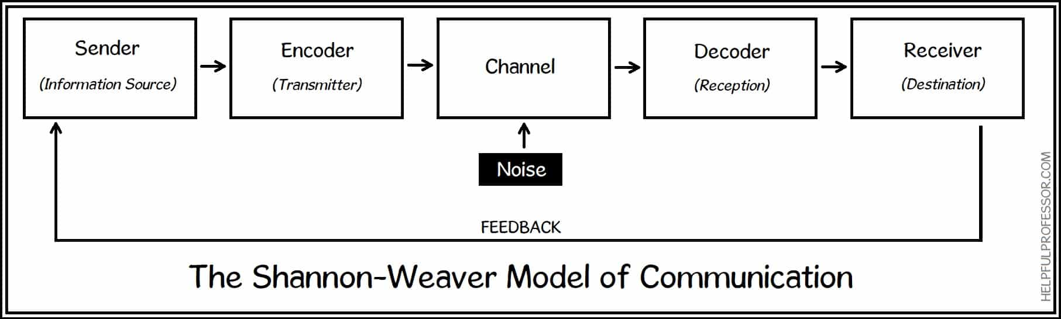
Figure 01: Shannon and weaver model of communication (Source: Chris DREW, 2022)
Case Study on Shannon and Weaver Theory
The conversation between Maria and Pedro Shannon and the weaver case study showed some ideas to understand better all the issues they faced during their conversation. The broken conversation is the main reason for the misunderstanding between Maria and Pedro. The case study suggests that Maria is a message transmitter and Pedro is a receiver. In that case, an encoded message transmitted by Maria Pedro could not decode that message, creating confusion between them (Yan, 2014). Avoid such misunderstanding during the conversation; it is essential to ensure a proper message transmission channel.
My workplace experience examples
I have gone through a similar experience in my workplace which Maria and Pedro, respectively, faced. I called a colleague to share my feeling about my new locket, and he heard about Rocket which directly connected with Shannon and weaver's theory.

2.2 Schramm Model
Schramm Communication model is a cyclical model of communication which contains all Fundamental rules of the communication system. A traditional approach that clarifies communication better is represented by the Schramm Communication Model. It is also used to analyse how two people communicate when they discuss ideas, opinions, and attitudes. The cyclical communication model, commonly referred to as Schramm's theory, is founded on the idea that communication is a two-way street. Consequently, there must be a sender and a recipient. The message itself and at least one additional element is both part of the Model. The typical mode of communication involves a wasteful receiver and sender (O'Donnell & Schramm, 2021).

Difference between Schramm and Shannon's Model
The difference between Schramm's and Shannon's theories that elaborated below to understand both the theory better. The Shannon-Weaver communication model, which defines how information is transported from a sender to a receiver, includes fundamental components such a source, encoder, medium, decoder, receiver, and noise. On the other hand, Schramm's theory is. Model is a model which describes both the sender and the receiver engaging simultaneously.
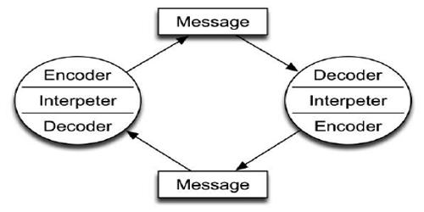
Figure 02: Schramm Communication Model (Source: QS Study.com, 2019).

2.3 Berlo Communication Model
The SMCR Communication model by Berlo expresses the nature of communication in order to define it in its simplest form. The key component of this theory, Sender, Message, Channel, and Receiver, denotes its fundamental composition. The many elements that make up the fundamental operation of the communication system are likewise described by Berlo's communication model (Zelizer, 2015). Four essential elements of Berlo's model of Communication have been discussed below.
- Sender who sends a message
- Message
- Proper Channel
- A Receiver who receives a message
Difference between Shannon-Weaver and Berlo model
The difference between the Shannon-Weaver models is that the Shannon-Weaver model is useful for technical communication (not caring about the message and its human perception). On the other hand, Berlo’s SMCR model is helpful for human communication (not caring about encoding, decoding, noise/errors, and feedback)
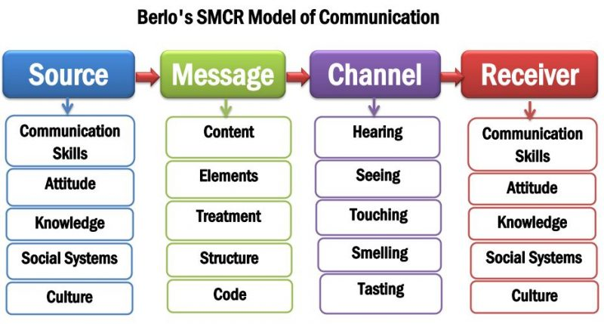
Figure 03: Berlo model of communication (Source: Coursehero.com, 2017)
Case Study on Berlo model of communication
Essential components of Berlo's communication model are sender, messages, channel and receive, and this theory is based upon the understandability of messages sent by a person to the receiver. The fundamental concept of this Model is how to communicate with the receiver and elaborate the Model with the concept professor's case. The professor's house was destroyed by fire, and he begged help from the villagers, but they did not help the professor due to the vague communication process. The essential thing of the Berlo model is communication; message sender and receiver communication are crucial for exact results. Sending a simple and understandable message to the villager's professor could have avoided such misunderstanding. So it is essential to send a message through the proper channel to avoid misunderstanding between sender and receiver (Mańko, 2020). I have had a similar experience with such misunderstanding in my workplace because I have faced a nightmare experience. I was staked in my office lift and due to poor communication lift man did not understand my situation, and he ignored the situation.

3.0 Communication Skills
Excellent verbal communication skills are essential for collaborating, communicating with other people's supervisors and speaking with customers or clients. Communication skills mean speaking concisely and loudly while building a good rapport with the audience.

3.1 Verbal Skills
Good communication skills mainly depend upon Verbal communication, which is mainly used for any communication. Verbal skills generally use for convincing people with excellent language conveying meaning. Verbal skills include oral communication, such as speaking to another individual over the telephone, face-to-face conversation, interviews, debates, presentations Etc. Additionally, verbal skills include certain domains like written correspondence, letters, emails, etc. Verbal communication occurs in a variety of contexts, such as business meetings, group discussions, performance reviews, one-on-one conversations, interviews, disciplinary hearings, sales pitches, and social gatherings (Beaulieu, Hanley and Santiago, 2013).

3.2 Non-Verbal Skills

A few important components make up Non Verbal skills, which often refer to the absence of or disinterest in the use of words as a means of communication. Body language is a powerful kind of non-verbal communication in general. Both verbal and non-verbal thinking are tested. The primary form of nonverbal communication is body language. The most essential nonverbal cues include body language, eye contact, haptic, appearance, artefacts, loudness or tone of voice, body language, proxemics or personal space, and facial emotions (Ayasrah, 2022).

Case study: A day with the Chief
This case study is based on miss communication with ER, an employee of a reputed company. Generally, eggs are ubiquitous food served on the day of ester, and she was surprised about serving an order of eggs from the CA for company staff. Though egg means it was not real chicken egg and company chief means it was chocolate eggs. That is why ER became surprised and felt awkward about the egg serving initiative on the day of ester. Proper communication is the only way to avoid such a situation (Britt & Kreyer, 2011).

3.3 Listening Skills

It might be difficult to identify listening abilities, even though there are several indicators that can be used. In order to comprehend people, listening requires careful attention and processing of other points of view. Listening is a strategy for interpersonal and responsive communication that promotes awareness, comprehension, and empathy. The capacity to accurately hear and analyse signals is known as the listening tool. Most crucially, successful communication depends on active listening. In actuality, attentive listening skills are crucial for properly delivering information. Otherwise, there is a chance of easily being misconstrued. A sound or activity is the focus of listening. In actuality, listening to someone involves hearing what they are saying and attempting to decipher what they mean. Complex emotive, cognitive, and behavioural processes are involved in listening. Therefore, listening is a crucial talent since it improves understanding and communication as well as being one of the fundamental abilities (Rezaei & Hashim, 2013).

Case study: Max the multi Tasker
This case study shows the pathway for multitasking, one of the most challenging jobs. Research shows that the brain cannot handle more than two tasks simultaneously.
4. 0 Advantages and Disadvantages of Technology in Communication
Communication Technology
Communication technology is a medium which has extreme power to transfer data or information among general people and such mechanisms play essential roles develop digital communication platforms. Such positive intentions of the people help them to make decisions, solve problems, and those initiatives are crucial for maintaining communication with each other. The following communication tools are considered mediums of modern communication systems

Advantages of technology in communication
The general advantage of technology covers some specific areas of the communication sector, representing some advanced communication factors. Communication technology Increases data Security and helps to gain more efficient knowledge from this sector. Information Technology Can Help Businesses to Save Money and Information Technology Benefits Communication Systems. It is also mentioned that communication advantages include crucial factors such as improving Productivity and incorporating Different Learning Styles. It Improves Collaboration. Communication technology prepares a person for the Future to deal with different challenges. The crucial point is that Communication technology Connects people with technologies for better learning opportunities in Future. Wider Talent Net is one of the Biggest Advantages of Information Technology. The following are the major advantages of technology:
- Communication technology Saves Time and money
- It has Ease of Mobility and congestion issues.
- It ensures better Communication Means
- It is cost efficiency
- It is very crucial to make Innovation in many fields
- It improves Banking and other sectors.
So, considering the advantages mentioned above, it is evident that, Communication technology is a tool which directly impacts every individual lifestyle, and it plays a vital role in easing the complexities of daily life. Several factors are essential communication technology tools, which are crucial for advancing lifestyle (Park, 2021).

Disadvantages of technology in communication
To better realize the disadvantages of technology, it is essential to understand communication technology. The prime disadvantage of communication is that it consumes a huge amount of Time to listen, write, speak, read, or talk to someone. Another disadvantage is that someone can accidentally hurt another person's feelings when trying to do something. Those factors are not welcoming in case of maintaining the relationship and could result in a damaging relationship with another person (Wayne, 2018). The following are the major disadvantages of technology:
- It is hard to use for people of older generations
- Cyberbullying and cyber-scam
- It is only sometimes a reliable source
- It makes communication less individual
- It is not easy to understand whom you are communicating with.

5.0 Conclusion
This report has revealed the pathway of the communication method. Communication which is considered as the most effective things in the twenty-first century, it requires a lot of steps to maintain properly. The above discussed model of communication can help anyone to maintain communication properly. Besides, communications skills need to be exercised in a great scale so that everyone can maintain proper communication skills in daily necessary issues and complete everything properly and perfectly.

6.0 References
Ayasrah, M.N. (2022). The Utilization Level of Computer Techniques by Teachers of Special Education Centers to Give Students with Autism Spectrum Disorders the Verbal and Non-Verbal Communication Skills. International Journal of Early Childhood Special Education, 14(1), pp.111–122. doi:10.9756/int-because/v14i1.221015.
Britt, A. and Kreyer, N. (2011). We are leading beyond borders: insights and case studies from IBM's Global Chief Human Resource Officer study. Strategic HR Review, 10(4), pp.18–25. doi:10.1108/14754391111140963.
Beaulieu, L., Hanley, G.P. and Santiago, J.L. (2013). We are improving the Conversational Skills of a College Student with Peer-Mediated Behavioral Skills Training. The Analysis of Verbal Behavior, 30(1), pp.48–53. doi:10.1007/s40616-013-0001-8.
Li, X. and Akagi, M. (2019). We improve multilingual speech emotion recognition by combining acoustic features in a three-layer model. Speech Communication, 110, pp.1–12. doi:10.1016/j.specom.2019.04.004.
Lawrence, D. (2018). Pratyabhijñā Apoha Theory, Shannon–Weaver Information, Saussurean Structure, and Peircean Interpretant Agency. Religions, 9(6), 191. doi:10.3390/rel9060191.
O'Donnell, R. & Schramm, T. (2021). Theory of Computing, 17(1), pp.1–30. doi:10.4086/toc.2021.v017a009.
Mańko, R. (2020). The Political is an Analytical Category in the Critical Study of Case Law (Theoretical Model and Case Study). Krytyka Prawa, 12(3), pp.90–108. doi:10.7206/kp.2080-1084.397.
Park, C. (2021). Different determinants affect first and late mover advantage in a smartphone market: a comparative analysis of Apple iPhone and Samsung Galaxy. Technology Analysis & Strategic Management, 34(3), 1–16. doi:10.1080/09537325.2021.1895104.
Rezaei, A. & Hashim, F. (2013). Impact of Awareness Raising about Listening Micro-skills on the Listening Comprehension Enhancement: An Exploration of the Listening Micro-skills in EFL Classes. Australian Journal of Teacher Education, 38(8). doi:10.14221/ajte.2013v38n8.4.
Salmon, P. & Young, B. (2018). Creativity in clinical communication: from communication skills to skilled communication. Medical Education, 45(3), 217–226. doi:10.1111/j.1365-2923.2010.03801.x.
Wayne, D.M.C. (2018). The Future of Education. Advantages and Disadvantages of Online Education. GRIN Verlag.
Yan, S.J. (2014). Study on Shannon Source-Coding Theory. Applied Mechanics and Materials, 687-691, pp.4158–4162. doi:10.4028/www.scientific.net/amm.687-691.4158.
Zelizer, B. (2015). Making Communication Theory Matter. Communication Theory, 25(4), 410–415. doi:10.1111/comt.12075

