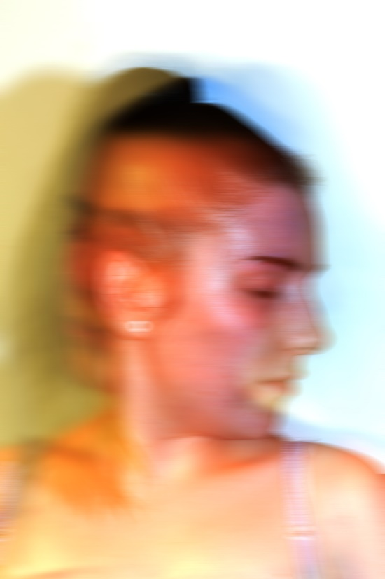
Haven been given the novel Metamorphoses to read, I read into the key themes of the book such as alienation. Through researching many aspects of alienation such as mental-health, isolation, depression, anxiety and withdrawal. In researching many ideas and using inspiration from different photographers I have been able to come up with many portraits that represent how the main characters are addressed. Gregor, the main character is a sales man alienated by his family and his surroundings in the way his body transfers into a bug making him seem crazy. His sister Greta is seen to be the female of the family where she now must grow up fast and find a job to cover the income Gregor brought to support his family.
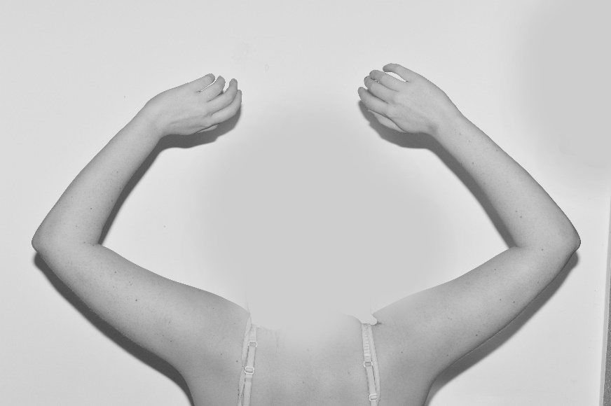
Researching different artist has made me explore portraits in different ways in positioning the camera, lighting and how the body is expressing feeling and emotion of how your mind thinks over your body by alienation. The surrounding images are influenced by photographers such as Michal Macku, Katie Joy Crawford, Taylor Chan and Edward Honoker. In expressing the novel my final image is the portraits that are highly influenced by Taylor Chan and Michal Macku. Having two portraits influenced by Chan has abled me to work with space, black and white and how the girl is positioned in the frame. Also having an image inspired by Macku has created a more substantial piece by having the thought of your mind taking over your body, which is a high representation of the main character Gregor.



