

Student Name: VEDANT RAKESHBHAI PATEL

Student ID: 2437457

Module Name: Strategic Management

Module Code: LCMB7003

Lecturer’s Name: Amare Desta

Work Count: 5459

Term 2

Executive Summary
This report outlines an extended organisational growth plan by Tesco PLC to India, developed in an ever more volatile, digitised and institutionally complicated global business environment. The following discussion is grounded in the existing strategic management frameworks and highlights the strategic agility urgency to operate effectively in the emerging markets.
The analysis has recognised India as a promising but difficult market with a huge and young population, high urbanisation rates, increasing digital usage, and a growing organised retail market, but still with a set of long-term regulatory limitations and a monopoly of the informal kirana retailers. An in-depth macro-environmental and industry analysis reveals that the competition is at a very high level, the buyer power is very high, and the threat of a substitution is very high, which confirms the necessity of a well-planned entry strategy.
The analysis based on the VRIO framework shows that the supply-chain efficiency and data-analytics of Tesco are transferable competitive advantages, and the brand equity will require the localisation and development on the basis of partnerships. The recommendation is a wholesale-plus e-commerce hybrid entry mode because it fits the institutional milieu in India, has low transactions costs, and reduces the exposure to risk. Competitively, it suggests a cost-leadership strategy with the support of local sourcing, developing own-label, and selective adaptation.
Finally, Balanced Scorecard anchored by Triple Bottom Line principles enables holistic evaluation of the financial performance, customer acceptance, operational efficiency, and creation of sustainable value. The study concludes that adaptive execution, strategic ecosystem partnering, and sustainability-oriented growth are the key to Tesco remaining successful in the Indian market.

Table of Contents
Executive Summary 2
1. Introduction 6
2. Selection of Organisation and Target Market 7
2.1 Overview of Tesco PLC 7
2.2 Justification for Selecting India as the Target Market 10
3. Comprehensive Strategic Analysis 12
3.1 Macro-Environmental Analysis - PESTEL 12
3.1.1 Political and Legal Factors 12
3.1.2 Economic Factors 13
3.1.3 Sociocultural Factors 14
3.1.4 Technological Factors 15
3.1.4 Environmental Factors 16
3.2 Industry and Competitive Analysis - Porter’s Five Forces 18
3.2.1 Competitive Rivalry – High 18
3.2.2 Threat of Substitutes - High 19
3.2.3 Buyer Power - High 20
3.2.4 Supplier Power - Moderate 20
3.2.5 Threat of New Entrants – Medium to High 20
3.3 Internal Strategic Analysis: VRIO Framework 21
4. Strategy Development and Formulation 22
4.1 Strategic Objectives for Indian Expansion 22
4.2 Market Entry Strategy 23
4.3 Competitive Strategy and Positioning 25
4.4 Risk Assessment and Mitigation 27
5. Performance Evaluation Framework 28
5.1 Selection of Framework 28
5.2 Balanced Scorecard Design 29
5.3 Triple Bottom Line Alignment 30
6. Conclusion 31
7. References 32

List of Figures
Figure 1: Tesco PLC Corporate Logo 8
Figure 2: Tesco PLC Business Model Overview 8
Figure 3: Tesco PLC International Growth and Global Performance Overview 9
Figure 4: Omnichannel and Multichannel Commerce 10
Figure 5: Emerging Urban Population Trends in India 11
Figure 6: India Retail and E-commerce Market Size Overview 12
Figure 7: Growth of Private Label Brands in Indian Retail 13
Figure 8: Evolution of FDI Policy in Indian Retail Sector 14
Figure 9: India GDP Growth Rate Trend 15
Figure 10: E-Commerce Growth in India 16
Figure 11: Rapid Growth of UPI Transactions in India 17
Figure 12: Sustainability Framework in India’s Consumer Products & Retail Sector 18
Figure 13: Major Retail Competitors in the Indian Market 19
Figure 14: Traditional Kirana Store 20
Figure 15: VRIO Analysis 22
Figure 16: Comparison of Joint Ventures and Strategic Alliances 25
Figure 17: Porter’s Generic Competitive Strategies Framework 26
Figure 18: Advantages of Private Label Strategy in Retail 27
Figure 19: BSC Framework 29
Figure 20: Triple Bottom Line Framework 31

List of Tables
Table 1: Strengths and Limitations of the PESTLE Framework 19
Table 2: Strengths and Limitations of the Porter’s Five Forces Framework 22
Table 3: Comparison of Entry Modes 26
Table 4: Risk Assessment and Mitigation Strategies 29
Table 5: Balanced Scorecard Framework for Tesco’s 30

1. Introduction
The modern global business setting is being defined by accelerated globalisation, accelerated digitalisation, greater regulatory complexity and the increased strategic significance of new markets. The development of digital technologies has redefined the way of retailing, customer interaction and supply chains, and unstable geopolitical and regulatory environments have posed more uncertainties to multinational businesses. In this regard, organisations need to exhibit strategic agility, the ability to detect changes in the environment, respond quickly, and restructure the resources in an efficient manner, to be competitive enough to pursue internationalisation.
This report discusses Tesco PLC which is a top international retail and conglomerate with strong supply-chain operations, information-based decision-making process, and multichannel retail chain. Tesco has reached a high level of maturity in many developed markets, and in this regard, it faces a strategic pressure to develop high growth prospects in foreign markets. India is proposed as the promising growth market, as it has a large and young demographic base, and fast-growing middle-income population, increasing digitisation, and progressive formalisation of the retail market, despite the presence of regulatory and structural challenges.
This report aims at developing a theoretically supported and evidence-based organisational expansion plan to enable Tesco enter the Indian market. The report is divided into four sections, namely the selection and justification of the organisation and target market; thorough strategic analysis using models like PESTLE, Porters Five Forces, and the Resource-Based View; the development and formulation of the strategy based on the market-entry and competitive-strategy models; and the performance evaluation with the help of a Balanced Scorecard and sustainability-oriented measures.

2. Selection of Organisation and Target Market

2.1 Overview of Tesco PLC
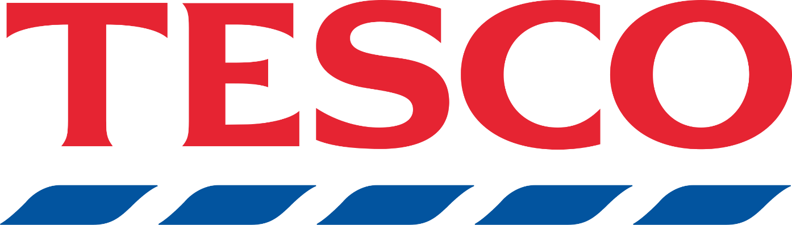
Figure 1: Tesco PLC Corporate Logo
Tesco PLC is one of the largest food and grocery retailers in the globe with its operating base in the United Kingdom. The company has an extensive history of operation in Europe and few global markets. Tesco conducts a diversified business model of retail, which includes large-format hypermarkets, supermarkets, convenience stores, wholesale business, and rapidly growing online platform.
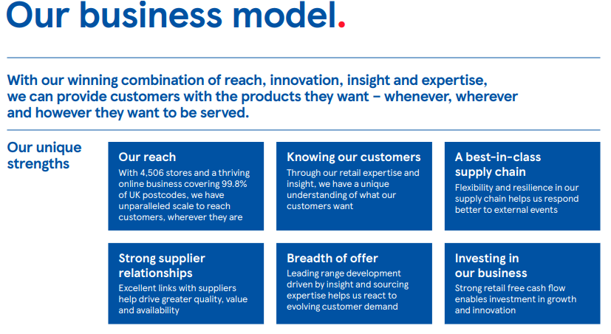
Figure 2: Tesco PLC Business Model Overview
The company model is based on economies of scale, efficient sourcing, and a strong focus on customer value delivery, thus being able to engage in meaningful competition in both price-sensitive and high-end market segments (Tesco PLC, 2016; Tesco PLC, 2024).
On the global stage, Tesco has used a discrete expansion policy by focusing in markets where operational capacity and value-led offer can be transferred. During the previous times, Tesco left a number of global markets to focus on performance; its new global system focuses on have the discipline to grow, to capitalise efficiently, and to form the ability to settle regulatory and operating risk through partnerships (Tesco PLC, 2024). Such a measured strategy indicates the experience gained through previous internationalisation processes and indicates increased strategic responsiveness.
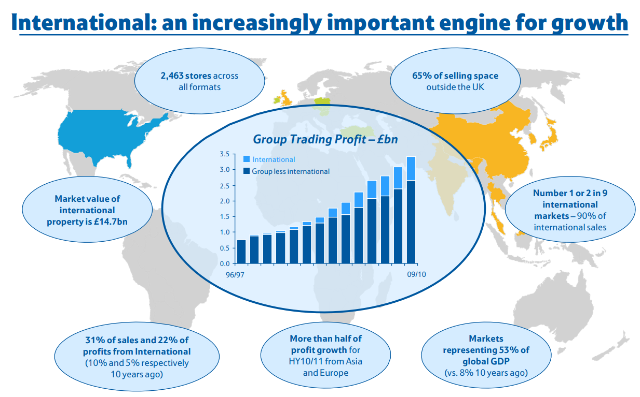
Figure 3: Tesco PLC International Growth and Global Performance Overview
Tesco has a number of core competencies that enable it to have a competitive strength. To begin with, its efficiency in the supply chain is a key ability, supported by effective logistics, centralised purchasing, and long-term relationship with suppliers, which enables the management of costs and dependability in large quantities (Tesco PLC, 2016). Second, Tesco has developed strong brands under its own label, including Tesco Value and Tesco Finest, which helps the company to provide differentiated quality levels and helps it to preserve its margins and customer loyalty. The option of the private labels gives the capacity to customize product assortments to meet local tastes in emerging markets. Thirdly, the large-scale use of data analytics through the Clubcard loyalty programme is a strategic asset of Tesco. The knowledge gained by using Clubcard data influences pricing initiatives, marketing strategies, and product inventory thus, helping Tesco to match its products with consumer behaviour (Tesco PLC, 2024).
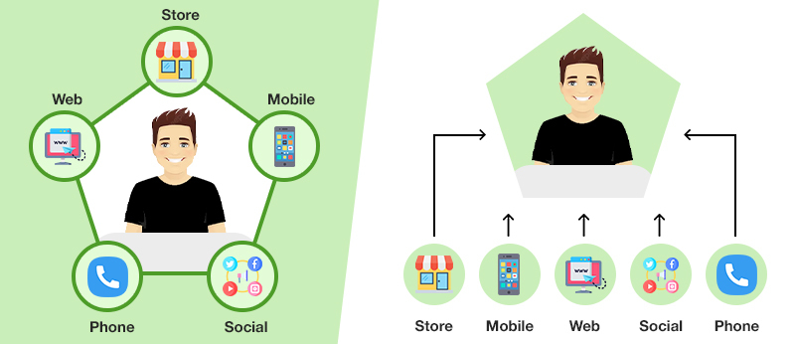
Figure 4: Omnichannel and Multichannel Commerce
Lastly, the multichannel and omnichannel retailing functions adopted by Tesco, including stores, online grocery stores, home-delivery services and click-and-collect services, have become a focus of its value-adding offer and have been deployed in especially digitally transforming markets.
Regardless of these strengths, Tesco faces growth limitations in developed economies like the United Kingdom and Western Europe because the level of competition in the retail sector, margin pressure, and low growth in demand are all limiting growth opportunities. These issues have further increased the strategic significance of the necessity to find high-growth emerging markets, in which the competencies possessed by Tesco can be utilized more efficiently to produce long-term value (Tesco PLC, 2024).

2.2 Justification for Selecting India as the Target Market
India forms one of the most attractive emerging retail markets in the world, which can be explained by its vast size, excessive growth prospects, and continued structural restructuring. The country has a population of more than 1.4 billion with a median age of less than 30, has enjoyed a significant demographic dividend which is likely to support the continued consumption growth in the long-run.
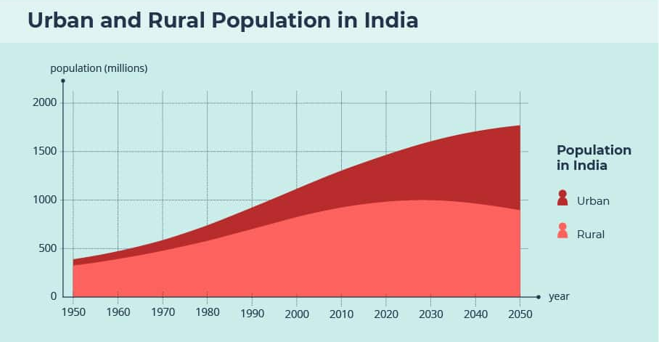
Figure 5: Emerging Urban Population Trends in India
Rapid urbanization and the growth of disposable income has accelerated the growth of the middle-income group and increased the need to market new formats of retail, branded products and convenient purchasing experiences (Lakshmi et al., 2025).
Indian retail industry is going through a significant shift, which is marked by the concomitant existence of the traditional unorganised retail (kirana stores) and a fast-growing organised and digital retail environment. The rate of penetration of organised retail and e-commerce has increased at a rapid pace driven by mass smartphone adoption, expansion of digital payment systems, and logistics innovation. The industry forecasts predict significant increases in the organised retail and fast-moving consumer goods distribution by 2028, which will be supported by the changing consumer behaviour and enhanced supply-chain industry (CPM International, 2024; Sahu et al., 2025). The derived hybrid framework system produces opportunities to international retailers that are good at balancing contemporary retail efficiencies to the local market.
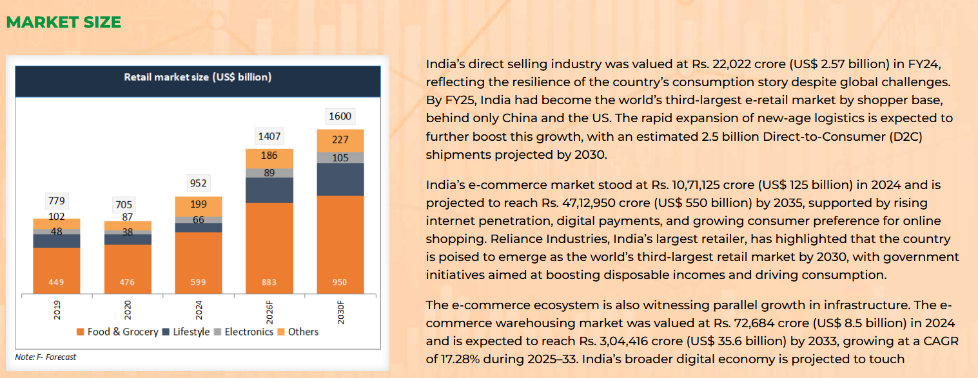
Figure 6: India Retail and E-commerce Market Size Overview
Strategically speaking, India proves to be very compatible with the positioning of Tesco as value-based. Indian consumers have a high price sensitivity and are at the same time focusing on quality with a growing focus on quality, which strengthens the tiered approach of private-label and cost-leadership capabilities of Tesco (Behera, 2025; Reddy, 2025). The intensive experience of Tesco in the creation of cost-effective own-brand products provides a substantial chance to modify the offerings to the local environment and maintain the margin discipline. Evidence from digital retail leaders in India demonstrates that well-managed private labels can achieve rapid acceptance when aligned with local tastes and price expectations (Sindhuja et al., 2025). Moreover, India has considerable sourcing efficiencies, where local procurement decreases costs and helps meet sustainability and community activities goals.
Historically, foreign retailers investing in India have faced issues relating to Foreign Direct Investment (FDI) limitations, complex regulatory systems, and the necessity to carry out far-reaching localisation. Entry and scale expansion has been limited by the regulations of multi-brand retail and heterogeneity of state level regulations. However, an expanding liberalisation strategy, the emergence of wholesale and digital modes of distribution, and an increased understanding to strategic alliances have increasingly increased the viability of market access (Lakshmi et al., 2025). In this changing environment, India is an opportune time that Tesco deploys a partner-led, digitally facilitated growth strategy to keep up with the modern events of the market and institutional change.
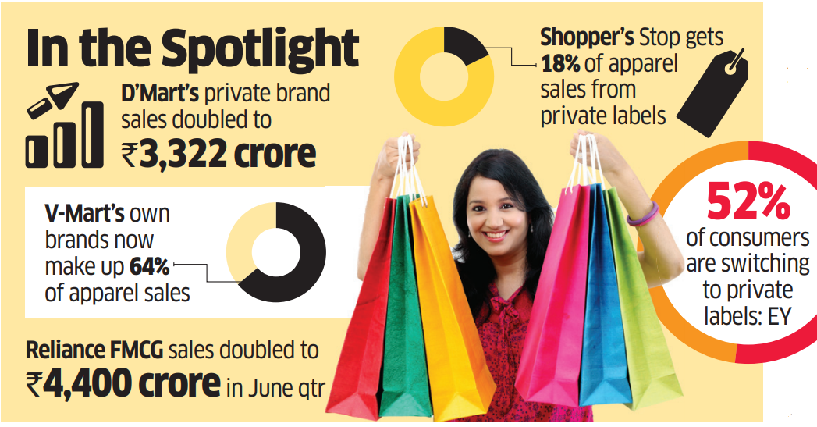
Figure 7: Growth of Private Label Brands in Indian Retail
India has become appealing today in a critical evaluation due to the combination of demographic momentum, maturing digital infrastructure and formalization of the retail sector. Tesco is well poised to excel due to its proven ability to operate in the price-competitive setting, make decisions based on data, and adjust formats to the domestic circumstances. It is a combination of these strengths that help Tesco to maneuver through the complexity of India as it plans its long-term growth prospects.

3. Comprehensive Strategic Analysis

3.1 Macro-Environmental Analysis - PESTEL

3.1.1 Political and Legal Factors
The political and legal retailing environment in India is quite complex in terms of regulatory nature and slow pace of liberalisation. Foreign Direct Investment (FDI) in multi brand retail is politically sensitive as it indicates worries touching on the protection of small retailers and domestic jobs. Presently, a maximum of 51% FDI is allowed on the government approval route under such conditions as local sourcing and consent at the state level (Kundgir, 2024). Since individual states still have the freedom to decide on how to implement it, access to markets is unequal which brings geographic disintegration and limits homogenous national policy.
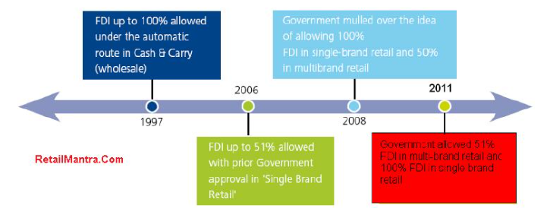
Figure 8: Evolution of FDI Policy in Indian Retail Sector
Such restrictions limit the quick growth, but at the same time facilitate partnership-based and wholesale-based entry models that reduce the political opposition and improve local integration (Bholane, 2025). Empirical findings also show that policy divergence at the state level provides mixed results in both urban and rural markets, thus supporting the need to adopt location-specific approach as opposed to universal implementation (Watson et al., 2025). In this regard, regulatory navigation, institutional awareness and stakeholder engagement are the important political capabilities of Tesco in the Indian market.

3.1.2 Economic Factors
India has great long-term growth potential but at the same time, it has structural economic problems. The expansion in the GDP has always been greater than 6%, which places India at the top among the fastest-growing leading economies across the globe (World Bank, 2024). Increased incomes, the expansion of accessibility to consumer credit, and increased economic formalisation are all supportive to sustained retail growth. However, there is a high level of inequality in the distribution of income, with strong differences among regions and the urban and rural populations, which contributes to the retail demand trends and price elasticity (Roy et al., 2024).
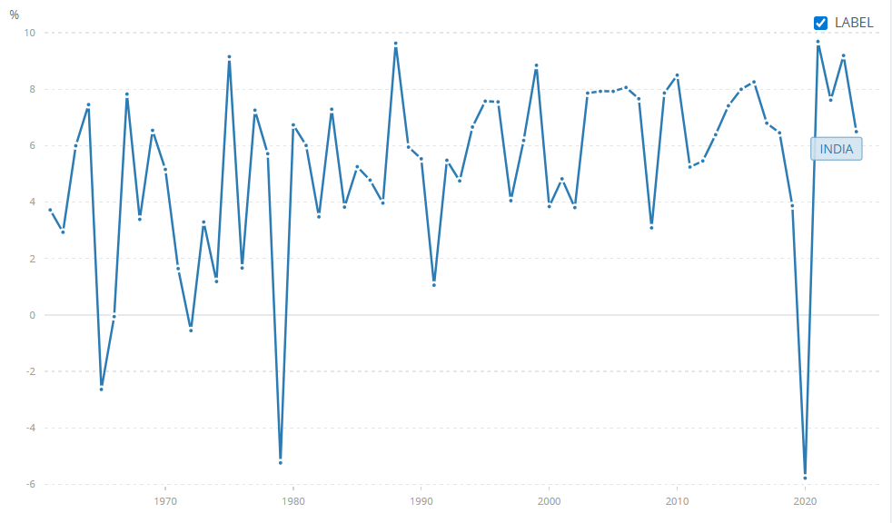
Figure 9: India GDP Growth Rate Trend
The dynamics of inflation are still of considerable importance. The retail inflation fell to about 2.1% in mid-2024 thus increasing the short-term purchasing power (IBEF, 2024). Despite that, logistics and supply-chain expenses remain on a high level, which is due to the lack of infrastructures and unstable fuel prices. The introduction of the Goods and Services Tax (GST) has improved transparency in the tax and increased operation efficiency but has also increased the sophistication of compliance among the retailers who have operations across multiple states (Krishna, 2025). These conditions highlight the significance of the realization of scale economies, cost control, and supply-chain optimization in order to enter the market successfully.

3.1.3 Sociocultural Factors
The sociocultural environment in India has a very strong influence on retail behaviour. The kirana stores are still highly dominated by neighbourhood kirana stores because of proximity and personalised service, and informal credit provision (Kundu, 2021). Consumers are very price-sensitive and highly promotional especially to the goods that are essential (Behera, 2025). This is in line with the value-based positioning adopted by Tesco but requires a high degree of localisation of prices, product offerings, and store images.
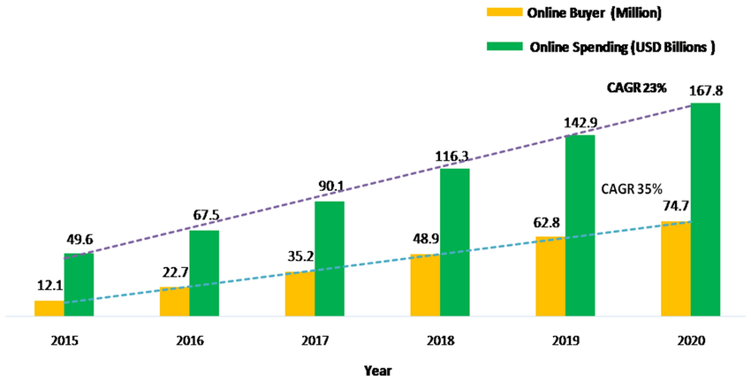
Figure 10: E-Commerce Growth in India
At the same time, urbanisation, changing lifestyles and increased involvement of women in the labour force are driving the need to be served in an organised retailing and electronic commerce platforms. The younger generation of urban buyers is becoming more attracted to convenience, openness, and variety of the product, thus, fueling the growth of online platforms and modern retail format (Lakshmi et al., 2025; Parihar, 2025). In this regard, Tesco would need to find a balance between the operational efficiencies offered by modern retail models and the cultural gradients of shopping thus appreciating coexistence as opposed to the displacement of traditional retailers.

3.1.4 Technological Factors
Technological development is one of the major driving forces of retail change in India. High smartphone adoption, widespread use of digital payment services and government policies like the Unified Payments Interface (UPI) have accelerated the growth of e-commerce and omnichannel selling (Barthwal, 2025). Digitalization in payments has increased efficiency in transaction and reduced the use of cash thus leading to the growth of formal retail activity.
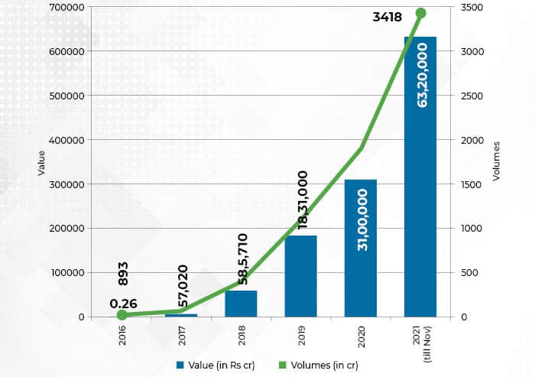
Figure 11: Rapid Growth of UPI Transactions in India
Although the infrastructure of e-commerce has already expanded beyond cities, there are still unbalanced distribution last-mile logistics (Koley, 2025). The progress in data analysis, storage, and demand prediction generates efficiency in the operations of structured retailers, yet the adoption is unevenly distributed between social cohorts and economic levels. In the case of Tesco, the introduction of technology supports the basis of data-driven and omnichannel strategic plans and requires a gradual and dynamic implementation.

3.1.4 Environmental Factors
The sustainability of the environment is gaining prominence in the Indian retail industry. Issues related to plastic waste, packaging, and food loss are increasingly getting acute particularly in urban markets. Empirical studies have shown that sustainability programs have a positive implication on consumer behaviour and brand perception (Rajesh et al., 2025). Despite the fact that the environmental regulations in India are relatively weaker than those in the developed markets, the enforcement mechanisms are becoming stronger. In the case of Tesco, sustainability serves as a compliance requirement, reputational initiative and is supported by its set of promises to responsible sourcing and waste minimization.
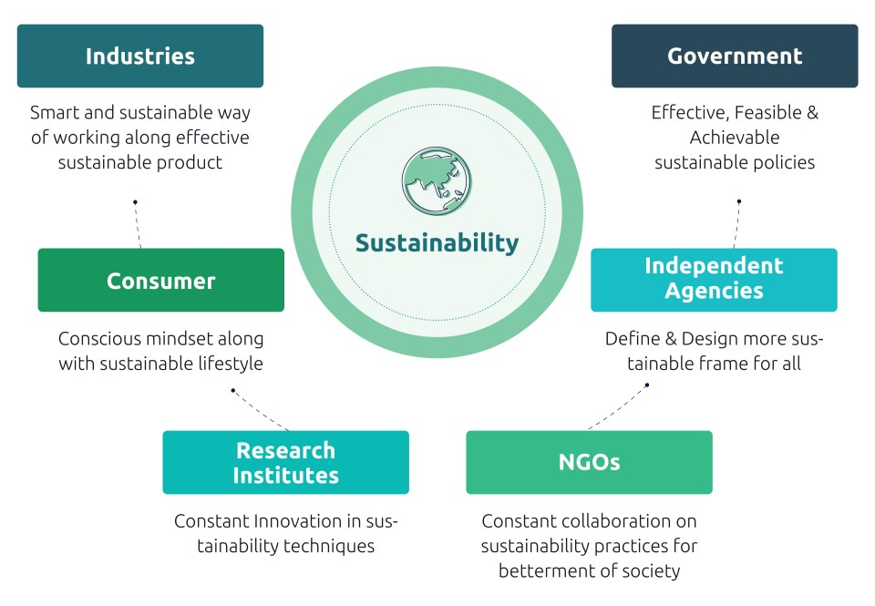
Figure 12: Sustainability Framework in India’s Consumer Products & Retail Sector

Critical Evaluation of PESTLE
Strengths of PESTLE | Limitations of PESTLE
Provides a structured overview of macro-level forces | Lacks predictive capability in volatile environments
Useful for comparing emerging and developed markets | Oversimplifies informal sector dynamics
Encourages systematic environmental scanning | Does not capture firm-level strategic interaction
Table 1: Strengths and Limitations of the PESTLE Framework
The PESTEL framework can be used to organise the complex data of macro-environment and outline broad opportunities and limitations in the new markets (Phan, 2021; Karadzhov et al., 2025). However, its disadvantages are amplified in the situation like India, where informal retail, regional heterogeneity, and rapid institutional development play their role. Andersen (2024) argues that to avoid the static understanding, the PESTLE framework should be complemented with the analysis of the industry and firms to exclude these interpretations. In the context of India, the PESTLE alone would be inadequate in capturing the resilience as it is found in kirana networks or the adaptive behavior among the local competitors and hence the need to combine analytical tools.

3.2 Industry and Competitive Analysis - Porter’s Five Forces

3.2.1 Competitive Rivalry – High
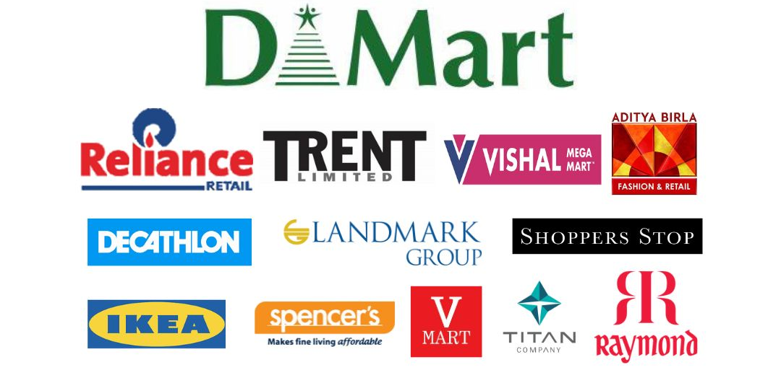
Figure 13: Major Retail Competitors in the Indian Market
The competition in the Indian retail market is strong and it is on the increase. The structured segment is controlled by strong domestic conglomerates, including Reliance Retail and Tata Group, and supplemented by worldwide digital platforms, led by Amazon-Flipkart. Reliance Retail has been able to grow at a very high pace with the help of physical and digital formats, including Reliance Smart and JioMart, cashing in on its size, capital strength, and local sourcing capabilities (Reliance Industries, 2023). The Tata Group is a group competing in a variety of retail verticals, which is supported by a strong brand trust and backward integration.
Competition based on prices is also highly noticeable, which reflects the strong price sensitivity of Indian consumers and the widespread presence of discounts and advertising campaigns (Behera, 2025). Empirical researches prove that these competitive pressures present an enormous influence over the process of consumer decisions and also deteriorate the profitability of retailers (Kushwaha et al., 2019). As a result, the rivalry paradigm has gone beyond competitive rivalry at traditional firm levels and comprises of ecosystem-based competition where logistical efficiencies, digital payment systems, and data analytics capabilities are the determinants of competitive edge.

3.2.2 Threat of Substitutes - High
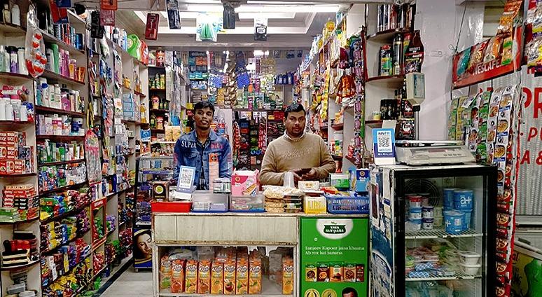
Figure 14: Traditional Kirana Store
The intensity of the threat of substitutes is high, due to the ongoing prevalence of traditional kirana stores. These are small, family-owned retailers that have a large share of grocery sales and are deeply rooted in the local communities (Kundu, 2021). Kiranas offer convenience, custom service, custom credit options, and home delivery, which integrated retailers can hardly achieve altogether.
Despite such significant growth rates in the sphere of organised retail and online commerce, kirana stores continue to coexist and evolve and gradually introduce digital modalities of payment and enter into partnerships with digital platforms (Barthwal, 2025). This persistent substitute threat constrains pricing power and necessitates hybrid strategies rather than direct displacement of traditional retail formats.

3.2.3 Buyer Power - High
Indian retail sector has high buyer power which is explained by low switching costs and high price elasticity. Customers critically compare price in physical stores, online platforms and local retailers and switch their business easily depending on marketing stimuli (Behera, 2025). Cost-conscious behavior is also intensified by socioeconomic variations and inflationary forces (Roy et al., 2024).
Digitalisation has also enhanced the strength of buyers by creating transparency and availability of substitutes in terms of prices. Convenience and pricing are the most determining factor of choice as reported in studies on online retail behaviour, which increases the competition pressure on retailers (Parihar, 2025).

3.2.4 Supplier Power - Moderate
The supplier power in the Indian market is moderate. The large fragmented base of agricultural and fast-moving consumer goods suppliers reduces the bargaining power of suppliers, thus providing an advantage to large retailers who can negotiate good contractual terms through economies of scale and the implementation of the private-label strategy (Sebastian and Gupta, 2018). Nevertheless, the presence of local sourcing requirements and reliance on small-scale producers increase the cost of coordination and limit the flexibility of its operations (Kundgir, 2024).

3.2.5 Threat of New Entrants – Medium to High
The barriers to entry are medium to high, because of high capital and the complexity of regulations and the logistical issues connected to distribution (Aggarwal et al., 2023). However, with the arrival of digital and platform-based types of businesses, the impact of these barriers to entry is reduced, thus maintaining competition levels, especially in the field of online shopping (Koley, 2025).

Critical Reflection on Porter’s Five Forces
Strengths | Limitations
Clarifies industry rivalry and profit pressures | Assumes formal market structures
Useful for entry barrier assessment | Understates informal sector dominance
Supports comparative industry analysis | Static view in a rapidly evolving market
Table 2: Strengths and Limitations of the Porter’s Five Forces Framework
The model developed by Porter is effective in shedding light on the level of competition and structural pressures in the Indian retail industry (Aggarwal and Shefali, 23). However, it is not very applicable in formal-informal market settings. The framework does not sufficiently depict the resilience nature of kirana networks or the dynamic nature of digital ecosystems. Researchers argue that the analysis of the ecosystem and the dynamic capability theory provides the complementary perspectives that cannot be left out when explaining the competitive advantage in these settings (Goyal, 2020; Paksoy et al., 2023). It is therefore possible to conclude that though Porters Five Forces provides a useful underlying foundation; it needs to be complemented with dynamic and institution-sensitive models so as to inform the development of strategies that are robust.

3.3 Internal Strategic Analysis: VRIO Framework
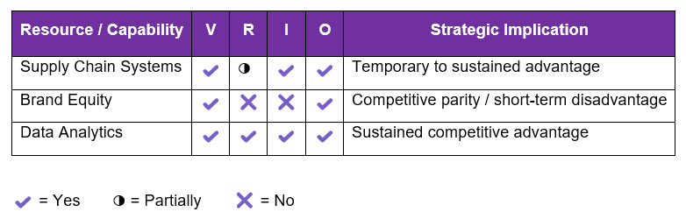
Figure 15: VRIO Analysis
Tesco supply-chain systems are a highly developed and strategically important capability system. Cost efficiencies and product availability are based on substantial investments in centralised procurement, advanced logistics, and supplier integration within the massive network structures (Tesco PLC, 2016; Tesco PLC, 2024). This ability is especially beneficial in the Indian context, which is characterised by inefficiencies in logistics and disintegrated bases of suppliers that increase operating costs (CPM International, 2024). Expertise in supply chains is not exclusive to large domestic conglomerates like Reliance; however, the systems at Tesco are hard to copy, due to embedded processes, economies of scale, and long-running relationships with suppliers. However, it can only be transferred partially because infrastructural limits and local sourcing policies make it impossible to fully implement the Tesco model in the UK (Lakshmi et al., 2025).
The brand equity that Tesco holds is still valuable, but its relatively low level in the Indian market is still low. Domestically, Tesco is linked to quality and value (Tesco PLC, 2024), but the lack of local brand recognition weakens any short-term competitive edge, which once again is why localisation strategies and strategic collaboration are needed (Behera, 2025). Moreover, The Tesco data-analytics capacity which runs on the data obtained through its Clubcard scheme has strategic implications. It optimises the pricing, promoting tactics, and inventory, which is a comparatively uncommon and expensive resource to duplicate. Nevertheless, the success of its use still depends on the level of local digital adoption (Parihar, 2025; Barthwal, 2025).

4. Strategy Development and Formulation

4.1 Strategic Objectives for Indian Expansion
- Market Penetration: To achieve a 5% share of the organised grocery retail segment in selected Tier 1 and Tier 2 Indian cities within five years through a phased wholesale and digital entry strategy.
- Sustainable Profitability: To reach operational breakeven by Year 4 and attain operating margins of 6 - 7% by Year 6, supported by private-label expansion, local sourcing, and supply chain efficiencies.
- Ecosystem Partnerships: To establish strategic partnerships with at least three local suppliers, logistics providers, or digital platforms within the first three years to strengthen compliance, sourcing, and market legitimacy.
- Omnichannel Integration: To develop an integrated retail model generating 30% of total sales through digital channels by Year 5, combining e-commerce, click-and-collect, and neighbourhood store collaborations.
The goals are aligned with the SMART model, thus being clear, measurable, relevant, and include clearly established timelines (Ayoub, 2017). They encompass the regulatory and cultural complexity of India, which focus on sustainable profitability, ecosystem partnerships and digital integration. The SMART criteria can provide an objective clarity which increases strategic focus, performance monitoring and later enable adaptive decision-making in uncertain retail settings (Bjerke et al., 2017).

4.2 Market Entry Strategy
Joint ventures (JVs) have been used in the past to gain access to very regulated retail markets where the convergence of ownership, resources and local knowledge between foreign entrants and domestic counterparts can be achieved. According to empirical data, JVs remain to be a salient phenomenon in emerging markets with a high level of institutional uncertainty as it induces the process of learning and the risk sharing (Liu et al., 2024). However, joint ventures are often characterized by governance complexities, goal complements and control-related conflicts. Observations in the international setting, especially Walmart operations, show that the constructs of joint venture hamper strategy flexibility and slow down the process of decisions on the fast-changing retail settings (Ji, 2025).
Strategic alliances are a less-equity based strategy since they provide cooperation without integration of ownership. Partnership types with local suppliers, logistic or digital solutions provide a fast entry to the market and limit capital exposure. Empirical data indicate that these types of alliances are effective in institutionally diverse and technologically evolving markets, which allows companies to combine complementary strength (Chahal, 2025; Pandya, 2025). Nevertheless, alliances can be vulnerable to reduced long-term stability and offer chances of opportunism in case there are gaps in the governance mechanisms.
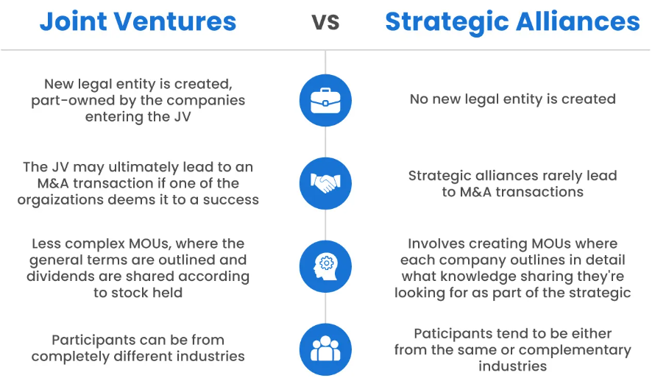
Figure 16: Comparison of Joint Ventures and Strategic Alliances
In India, a wholesale plus e-commerce hybrid model has gained prominence due to regulatory constraints on multi-brand retail and rapid digital adoption. Business to business delivery through wholesale schemes to kirana stores, and business to consumer interaction through e-commerce schemes all help in these processes. The scaling is incremental and helps to alleviate regulatory friction with this model. Empirical research suggests that the hybrid strategies of wholesale-digital minimize the cost of transactions, the conflict of channel, and they remain flexible with strategies (Du, 2025).
In the view of the institutional theory, the hybrid model enhances the legitimacy as it helps to engage the small retailers and makes sure that the sourcing regulations are adhered to (Dodds et al., 2025). Transaction-cost economics also supports this organisational structure since the model limits governance costs but maintains internal jurisdiction over critical activities. Overall, the hybrid approach will reduce capital risk, allow incremental growth, and will be able to make flexibility in the Indian context of a highly volatile retail environment.
Entry Mode | Advantages | Limitations | Strategic Suitability
Joint Venture | Regulatory legitimacy, shared risk | Control conflicts, low flexibility | Moderate
Strategic Alliance | Low capital, rapid access | Opportunism risk, instability | Moderate
Wholesale + E-commerce Hybrid | Regulatory compliance, flexibility, scalable | Slower brand building | High
Table 3: Comparison of Entry Modes

4.3 Competitive Strategy and Positioning
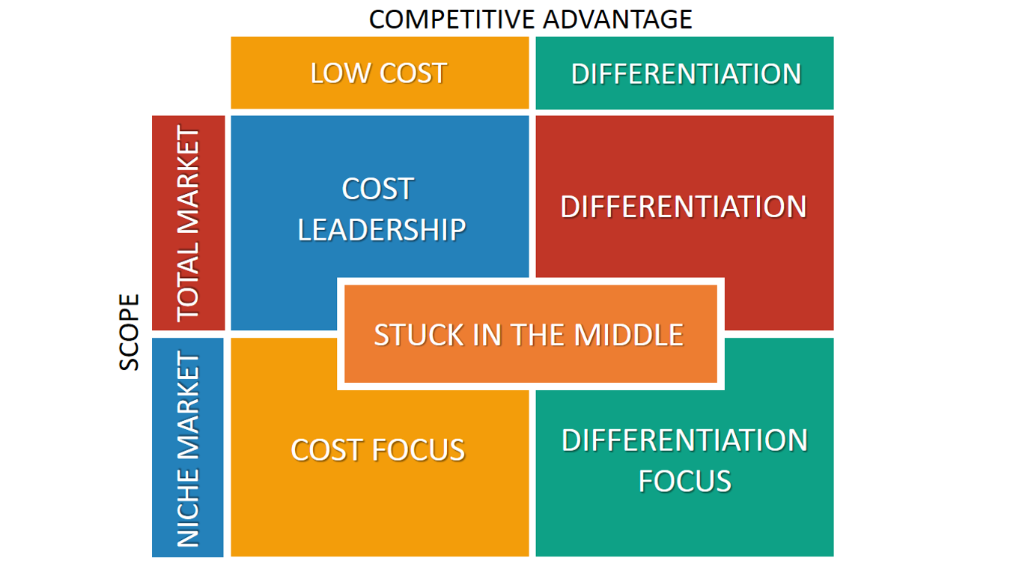
Figure 17: Porter’s Generic Competitive Strategies Framework
The competitive approach by Tesco PLC in the Indian market is best conceptualised through the Porters generic strategies framework with cost leadership supplemented by localisation being the main focus. The concept of cost leadership fits well in the Indian retailing context, where consumers tend to be very price-sensitive, switching between organised, unorganised, and digital retailing channels quite frequently (Dwivedi, 2025). Empirical studies show that cost leadership will improve the competitive advantage and sustainability in the volatile and emerging markets (Ali et al., 2021; Sharma et al., 2025).
The cost leadership strategy is expected to be fulfilled by Tesco by increasing its supply-chain efficiency, enjoying significant economies of scale, and inclusive sourcing locally instead of engaging in fierce rivalry. The evidence provided by emerging economies shows that the combination of cost leadership and efficiency in operations helps to enter the market and maintain profitability in the long run (Navaia et al., 2024). In India, the logistic cost is comparatively high, and the spoilage level is high as well, Tesco can create a high level of cost benefits in comparison with small rivals due to the effectiveness of the system of inventory management and demand forecasting.
Adaptation-standardisation debate is one of the key axes of Tesco strategic positioning. Standardisation leads to efficiency in operations as well as maintenance of brand uniformity but excessive reliance on standardisation may destroy market relevance in cultural heterogeneous settings. Contemporary literature increasingly views adaptation and standardisation as complementary, with firms standardising core systems while adapting customer-facing elements such as product assortment, pricing, and promotions (Poulis, 2024; Eze et al., 2024). Based on this evidence, Tesco should centralize its back-end operations, such as logistics, data analytics and governance of its own-label, and decentralize its store formats, product mixes, and communications to suit the local culinary preferences and income levels.
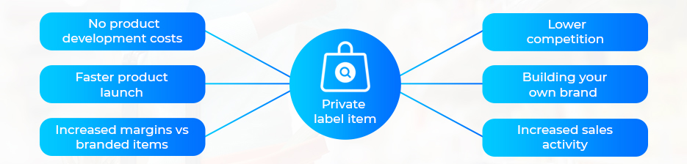
Figure 18: Advantages of Private Label Strategy in Retail
One of the most important aspects of the cost-leadership strategy by Tesco entails the creation of its own brand. The introduction of own-labeled products improves the control of the margin, gives the flexibility of prices, and provides differentiation. The empiric research reveals that the image of acceptance of the brands under private label among the Indian customers is on a growing trend though it depends on the transparent provision of quality and value (Reddy, 2025). Local sourcing of own brand adds to the cost effectiveness, currency risk reduction, and sustainability responses. This hybrid positioning in combination will prepare Tesco to compete better with organized retailers and tough traditional formats.

4.4 Risk Assessment and Mitigation
Risk Area | Nature of Risk | Mitigation Strategy
Regulatory Risk | India’s evolving FDI rules, state-level policy variation, and sourcing compliance requirements can delay expansion and increase costs. Sudden regulatory changes may disrupt planned retail formats. | Use scenario planning to model alternative regulatory outcomes and adopt flexible entry structures that limit sunk costs and allow rapid adjustment (Krummel, 2022).
Cultural Risk | Cultural heterogeneity across regions affects consumer preferences, communication styles, and shopping behaviour. Weak localisation can reduce brand acceptance and engagement. | Continuously localise product assortment, pricing, marketing messages, and service formats while maintaining core brand values (Devi, 2023; Agag et al., 2024).
Supply Chain Risk | Fragmented suppliers, infrastructure gaps, and reliance on small producers increase risks of stock-outs, quality variation, and cost volatility. | Enhance strategic agility through modular supply chain design, multiple sourcing options, and digital monitoring to improve resilience (Sharif et al., 2020).
Competitive Risk | Incumbent retailers may respond with aggressive discounting, supplier exclusivity, or rapid imitation of formats. | Apply scenario-based competitive intelligence to anticipate retaliation and adjust pricing, partnerships, and rollout speed dynamically (Ali et al., 2021).
Table 4: Risk Assessment and Mitigation Strategies

5. Performance Evaluation Framework

5.1 Selection of Framework
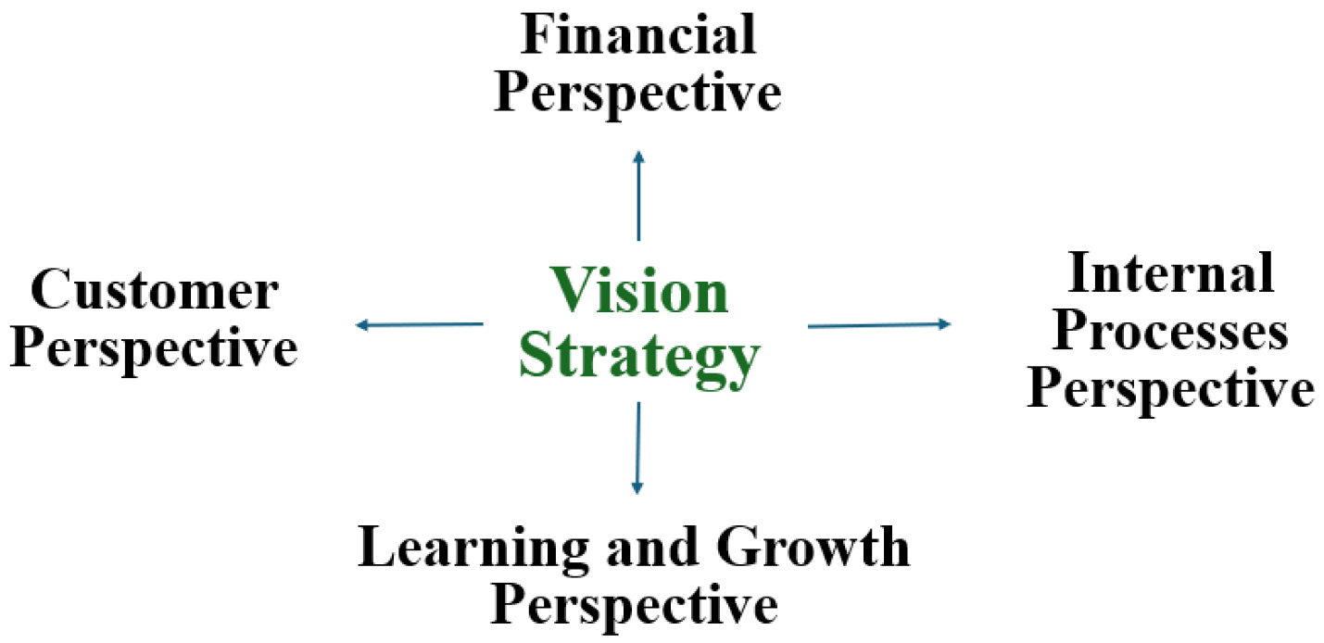
Figure 19: BSC Framework
The Balanced Scorecard (BSC) is an appropriate performance appraisal model that Tesco should adopt to expand into India because it ensures a holistic and strategy-oriented evaluation of the financial and non-financial aspects. Unlike traditional measures, the BSC combines the customer, internal process, and learning perspectives, a complex strategy that is especially vital in new markets where capacity building usually comes first before profitability (Afshar et al., 2025). Using a price-sensitive and institutionally challenging retail market in India, the performance metrics should be based on customer trust, supply chain efficiency, developing digital capabilities, and financial performance. In addition, the balanced scorecard can be fused with the concepts of Triple Bottom Line to determine the economic, social, and environmental creation of values in the long run (Morrison, 2025).

5.2 Balanced Scorecard Design
Perspective | Key Objectives | Key Performance Indicators (KPIs)
Financial | Achieve sustainable growth | - Revenue growth rate  - Operating margin  - Cost-to-serve
Customer | Build market acceptance | - Market share  - Customer retention rate  - Value perception index
Internal Processes | Enhance operational efficiency | - Supply chain lead time  - Store productivity  - Inventory turnover
Learning & Growth | Build long-term capabilities | - Local talent development rate  - Digital capability adoption
Table 5: Balanced Scorecard Framework for Tesco’s
On a financial basis, revenue improvement and operating profit margin are essential measurements of business feasibility of the retailers in the Indian market that are extremely competitive. However, the high cost of logistics and distribution makes the cost-to-serve parameter specifically relevant, as it will reflect the ability of Tesco to exploit economies of scale and optimise supply-chain efficiencies at the same time maintain the low-price propositions of a competitive offer.
On the consumer side, market share in the organized retail provides a clear measure of competitive position, and customer retention provides loyalty in the low-switching-cost market. Consumer survey-based value-perception factors are imperative in India where buyers are highly sensitive to balance between price and quality but not brand prestige.
Regarding the internal process views, alignment and optimization of operational processes are viewed as the determinants of the organizational performance. The effectiveness of the supply chains, the output of retail stores as well as the inventory turnover make the fundamental components of the cost-leadership strategies in the retail sector. Empirical studies have shown that increases in inventory management measures and the elasticity of logistics systems significantly add to the competitive advantage in new markets (Afshar et al., 2025).
In terms of learning and growth, long-term performance is determined by the ability to develop local managerial skills and introduce digital capabilities, such as data analytics, integration with digital payments, and coordination of the omnichannel. These indicators capture Tesco’s capacity to adapt and innovate over time.

5.3 Triple Bottom Line Alignment
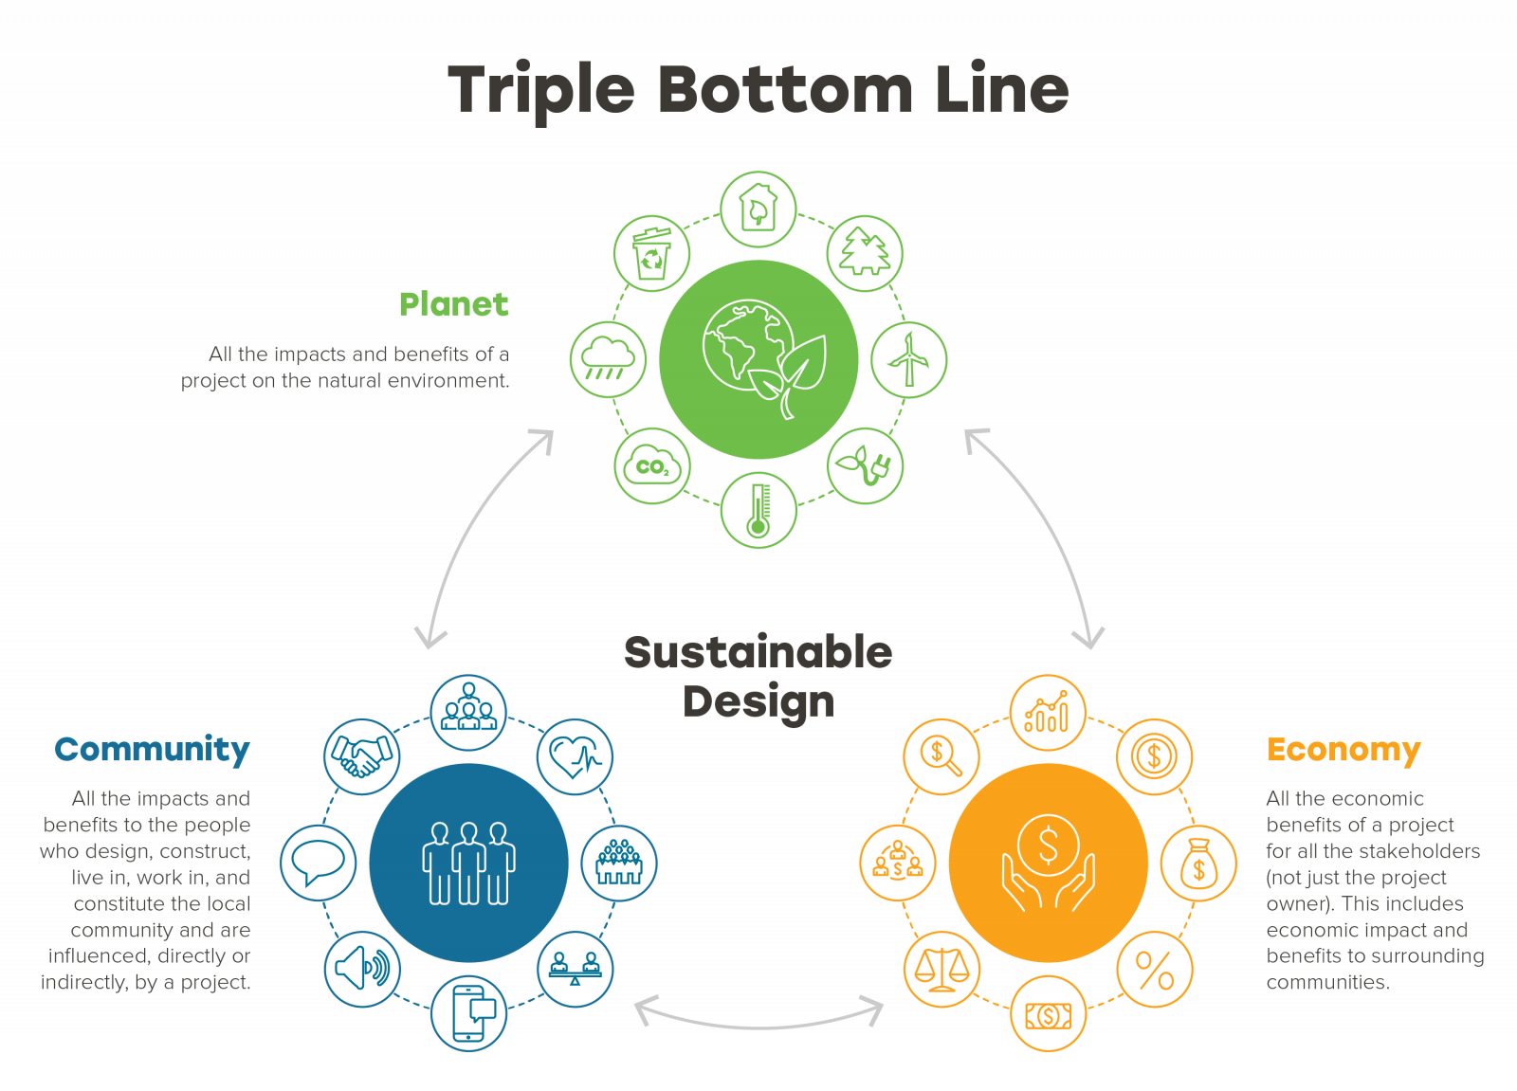
Figure 20: Triple Bottom Line Framework
In order to strengthen the number of sustainability considerations being integrated, the Balanced Scorecard is adjusted to indicate the Triple Bottom Line (TBL) framework. The economic viability is considered by profitability and cost-efficiency indicators. The social inclusion is visible in the level of local sourcing, generation of employment opportunities as well as enhancement of skills among the Indian employees and hence inclusivity enhances growth. Environmental responsibility is measured using also such quantitative indicators as waste reduction, implementation of greener packaging, and reduction of supply-chain emissions. Inclusion of triple-bottom-line (TBL) measures in the Balanced Scorecard framework ensures that the expansion initiative of Tesco would have sustainable economic, social, and environmental impacts, as opposed to emphasizing on short-term monetary gains (Phatak et al., 2025; International Journal of Environmental Sciences, 2025).

6. Conclusion
This report has presented a detailed evidence-based organisational expansion plan of Tesco PLC to the Indian market with special emphasis on the importance of strategic agility in coping with complex and fast changing foreign markets. With the use of proven strategic models, the analysis revealed high growth potential of India and at the same time showed high regulatory and cultural and competitive barriers. The analyses of the PESTLE and industry implicitly indicated a hybrid retail landscape of institutional diversities, highly price-sensitive, and the co-existence of the organised and unorganised form, hence requiring the adaptive and locally responsive response to be formalised as opposed to the standard approaches.
It was revealed in the analysis that the core capabilities of Tesco, i.e. supply chain efficiency, data analytics, and knowledge of a personal label offer a plausible foundation of competitive advantage, provided to be supported by localisation and partnership development. It was found that a wholesale plus e-commerce hybrid entry strategy represented the most suitable approach because it balanced the elements of legitimacy, transaction-cost efficiency and risk exposure. Conclusively, a blend of a Balanced Scorecard model and Triple Bottom Line (TBL) offers an effective system to evaluate the performance and sustainability in a systematic manner. Sum it up, Tesco stands a chance of success in the Indian market when effective implementation, tactical risk management, and enduring growth are implemented.

7. References
Afshar, Z. and Mutahir, H. (2025) ‘Performance evaluation using balanced scorecard framework’, Public Sector Case Study, 5, pp. 40–47.
Agag, G., Eid, R., Lababdi, H.C., Abdelwahab, M., Aboul-Dahab, S. and Abdo, S.S. (2024) ‘Understanding the impact of national culture differences on customers’ online social shopping behaviours’, Journal of Retailing and Consumer Services, 79, 103827. https://doi.org/10.1016/j.jretconser.2024.103827
Aggarwal, V. and Shefali (2023) ‘Porter’s five forces model and its applicability for FDI in Indian retail sector’.
Ali, B. and Anwar, K. (2021) ‘Porter’s generic competitive strategies and its influence on the competitive advantage’, International Journal of Advanced Engineering, Management and Science, 7, pp. 42–51. https://doi.org/10.22161/ijaems.76.5
Andersen, P.D. (2024) The PESTEL framework and its variants for analysing the strategic environment. SSRN. https://doi.org/10.2139/ssrn.5266562
Ayoub, R. (2017) SMART objectives: A strategic approach to achieving business success. https://doi.org/10.5281/zenodo.14642257
Barthwal, M. (2025) ‘Impact of digital payments on retail consumers and small vendors’, International Journal for Multidisciplinary Research, 7(2).
Behera, M.K. (2025) ‘Price sensitivity and discounting strategies in retail distribution’, The Academic, 3(5).
Bholane, K. (2025) FDI in Indian retail sector – advantages and disadvantages. SSRN. https://doi.org/10.2139/ssrn.5093375
Bjerke, M.B. and Renger, R. (2017) ‘Being smart about writing SMART objectives’, Evaluation and Program Planning, 61, pp. 125–127. https://doi.org/10.1016/j.evalprogplan.2016.12.009
Chahal, A.K. (2025) ‘Strategic alliances: How they work in business’, International Journal for Multidisciplinary Research, 7(3).
CPM International (2024) Indian retail and FMCG sector trends and growth insights to 2028. Available at: https://www.cpm-int.com/in-blog/indian-retail-and-fmcg-sector-trends-and-growth-insights-2028
Devi, P. (2023) ‘Impact of cultural diversity on marketing strategies in India’, Universal Research Reports, 10, pp. 159–163. https://doi.org/10.36676/urr.v10.i4.1279
Dodds, R. and Smith, W. (2025) ‘Institutional theory: Assessing longitudinal change towards sustainability’, Journal of Destination Marketing & Management, 37, 101001. https://doi.org/10.1016/j.jdmm.2025.101001
Du, H. (2025) ‘E-retail platform or wholesale strategy for a manufacturer developing a market channel’, Computers & Industrial Engineering, 204, 111078. https://doi.org/10.1016/j.cie.2025.111078
Dwivedi, S. (2025) ‘A study on retailing in India: Growth and challenges’, International Journal of Environmental Sciences, 11(17s).
Eze, F.J., Inyang, I.B. and James, E.E. (2024) ‘Standardization versus adaptation of marketing mix in international markets: A systematic literature review’, World Journal of Advanced Research and Reviews, 22(2), pp. 1192–1212. https://doi.org/10.30574/wjarr.2024.22.2.1470
Goyal, A. (2020) ‘A critical analysis of Porter’s five forces model of competitive advantage’, Journal, 7, pp. 149–152. https://doi.org/10.1729/Journal.25126
IBEF (2024a) India’s retail inflation eases to 2.1% in June. Available at: https://www.ibef.org
IBEF (2024b) Retail industry in India. Available at: https://www.ibef.org/industry/retail-india
Ji, Y. (2025) ‘Walmart’s international market entry strategies: Benefits and challenges’, Advances in Economics, Management and Political Sciences, 165, pp. 108–113. https://doi.org/10.54254/2754-1169/2025.21596
Koley, J. (2025) ‘Effect of e-commerce in the retail trade in India’, IJRIAS. https://doi.org/10.51584/IJRIAS.2025.10040056
Krummel, D. (2022) ‘Expansion in the retail sector—market entry strategies in consideration of formal and informal institutions: A Tesco case study’, Open Access Library Journal, 9(2). https://doi.org/10.4236/oalib.1108377
Kundu, S. (2021) ‘Is kirana the answer to India’s retail dominance?’, Economic and Political Weekly, 56.
Kundgir, B. (2024) ‘FDI in multi-brand retail in India: Myths and realities’, ShodhKosh, 5, pp. 273–275. https://doi.org/10.29121/shodhkosh.v5.i7SE.2024.6177
Kushwaha, S. and Gupta, M. (2019) Impact of competition on decision making of Indian retail consumers.
Lakshmi, N., Sai, Y., Charan, S., Sekar, D., Prasanna, D., Santosh, I. and Mukhi, S. (2025) ‘The future of retail in India: Blending organized and unorganized upsurge challenges and opportunities’, Journal of Management and Social Research. https://doi.org/10.61336/jmsr/25-04-25
Liu, D., Fu, N., Wang, G. and Su, L. (2024) ‘Past, present, and future of international joint ventures’, Journal of Business Research, 176, 114568. https://doi.org/10.1016/j.jbusres.2024.114568
Morrison, M. (2025) Applying the balanced scorecard to the multi-language e-commerce website platform project. SSRN. https://doi.org/10.2139/ssrn.5315087
Navaia, E., Moreira, A. and Ribau, C. (2024) ‘The mediating roles of cost leadership and cost focus strategies on innovation capabilities and export performance’, Cogent Business & Management, 11(1). https://doi.org/10.1080/23311975.2024.2375410
Ndlovu, S.G. (2024) ‘Private label brands vs national brands: New battle fronts and future competition’, Cogent Business & Management, 11(1). https://doi.org/10.1080/23311975.2024.2321877
Olabode, O., Kumar, N. and De, D. (2025) ‘Food loss and waste management in the retail food supply chain’, Journal of Environmental Management, 387, 125718. https://doi.org/10.1016/j.jenvman.2025.125718
Paksoy, T., Gunduz, M.A. and Demir, S. (2023) ‘Overall competitiveness efficiency: A quantitative approach to the five forces model’, Computers & Industrial Engineering, 182, 109422. https://doi.org/10.1016/j.cie.2023.109422
Pandya, V. (2025) ‘Strategic alliance: A review of evolution, measurement, antecedents, and research issues’, International Journal of Global Research Innovations & Technology, 3(2), pp. 173–178. https://doi.org/10.62823/IJGRIT/03.2(II).7754
Parihar, N. (2025) ‘Consumer behaviour in online retailing in India’, IJRSI. https://doi.org/10.51244/IJRSI.2025.12060077
Phan, S. (2021) ‘The effect of PESTLE factors on development of e-commerce’, International Journal of Data and Network Science, 5, pp. 37–42.
Phatak, S. and Nikam, V.B. (2025) ‘Sustainable business model innovation: Integrating triple bottom line metrics into performance evaluation frameworks’, International Journal of Engineering Development and Research, 13(3), pp. 273–280.
Roy, S. et al. (2024) ‘The rich–poor divide in India’, Applied Geography, 166, 103267. https://doi.org/10.1016/j.apgeog.2024.103267
Sahu, H. and Soni, N.K. (2025) ‘E-commerce and traditional retail business models in India’, International Journal of Research Publication and Reviews, 6(9), pp. 1515–1523. https://doi.org/10.55248/gengpi.6.0925.3264
Sebastian, V.J. and Gupta, R. (2018) ‘Retail ecosystem in India’, Theoretical Economics Letters, 8(3). https://doi.org/10.4236/tel.2018.83014
Sharif, M.H. and Datta, R. (2020) Risk management for a retail business.
Sharma, M. and Khurana, S. (2025) ‘Impact of effective generic business strategies on probability of default’, NMIMS Management Review, 33(1), pp. 29–39. https://doi.org/10.1177/09711023251323380
Sindhuja, K. and Rani, S. (2025) ‘Private label branding strategies towards digital marketing of Amazon in Chennai City’, Journal of Neonatal Surgery, 14, pp. 38–49. https://doi.org/10.52783/jns.v14.3098
Tesco PLC (2016) Tesco annual report and business model. Available at: https://www.tescoplc.com/media/264185/tescoar16_businessmodel.pdf
Tesco PLC (2024) Tesco annual report and financial statements 2024. Available at: https://www.tescoplc.com/media/zgvhd0dn/tescos_ar24.pdf
Watson, P. et al. (2025) ‘Heterogeneous impacts of statewide policies across urban and rural markets’, Journal of Rural Studies, 119, 103753. https://doi.org/10.1016/j.jrurstud.2025.103753
World Bank (2024) GDP growth (annual %) – India. Available at: https://data.worldbank.org

