Lecturer: Dr Md Nazmul Hasan Assignment Title: Coursework (Innovative Product Plan)
Wesley Regis (1713352)
Developing Innovation and Creativity for Business Advantage Module Code: BMSW6102

Contents
- Introduction
- What is the purpose of innovation for business?
- PHOENIX TOGETHER multimedia social network management system innovation
- Unique selling point of PHOENIX TOGETHER multimedia social network management system
- Vision Statement
- Mission statement
- Target customer and benefits
- PHOENIX TOGETHER SWOT analysis
- Sustaining PHOENIX TOGETHER and Strategy
- competitors
- E-commerce
- Financial benefit of using a SaaS
- Marketing
- Customers journey
- Conclusion
- References

List of figures
- Figure 1: PHOENIX TOGETHER Business Logo
- Figure 2: PHOENIX TOGETHER SWOT analysis
- Figure 3: Strategic Innovation framework
- Figure 4: Customer Journey Map
- Figure 5: Customer Journey Map

- Introduction.
This report is based on innovative actions of the need pull innovation driver theory taken to fulfil gaps created by the covid 19 pandemic to fulfil consumer demands for services hindered by the measures put in place for social distancing.
PHOENIX TOGETHER social media website and app system
- What is the purpose of innovation for business?
Innovation for business is “the process of developing or improving new services or products to increase performance or add value to existing business components or emerging business opportunities to gain a competitive advantage”. (Hitt, Ireland and Hoskisson, 2015)
Innovation is considered to be “a catalyst for investors seeking new ideas to set new leading boundaries in their markets or for creating new markets to profit from”. (Ismail, Ansell, Ismail and Kleyn, 2012)
For these reasons’ innovation is considered the driving force within economic growth as businesses seek to remain relevant to the changes that they are affected by events and trends from the external environment impacting consumer needs.


Figure 1: PHOENIX TOGETHER Business Logo

- PHOENIX TOGETHER multimedia social network management system innovation
The conditions of social distancing placed on grassroots football clubs severely disrupted and impacted young aspiring grassroots football player and parents key stakeholders to any club for revenues of sustainability.
The inability to train in their teams and receive regular coaching in methods pre covid19 where no longer possible. With no access to facilities or regular planned training sessions many players development and fitness dropped along with healthy relationships due to the isolation measures.
Phoenix together is an interactive social media website with a mobile app, it comprises of a digital platform that allows players and parent direct remote contact with the club and their team group through multimedia functions. its database has categories of prerecord training drills and coaching session plans to train from home, accessible all day with regular planned live sessions by coaches.
The diverse functionality of the website platform allows coaches to keep direct contact with their teams face to face by video call singular or group.
- Unique selling point of PHOENIX TOGETHER multimedia social network management system
The app is designed around “bringing the pitch to the home for players” (phoenixutdfc.com 2020) that want to go the extra mile and increased connectivity for members of the club.
The unique selling point of the innovation is that existing club management software system programs only cater for administration services, or online training apps only cater for drills and session plans, whereas PHOENIX TOGETHER unites both software’s features into one with multimedia communication capabilities to bring the experience of interfacing to a new level for grassroots clubs and beyond.
The app comprises of encrypted logins for all members, weekly tips and prize give away for players with pre-recorded education, training and advice from UEFA A and B coaches, interactive tactics boards and virtual class rooms, social breakout rooms and personal messaging service (similar to what’s App), customised training plans for players and coaches with progress monitoring facilities and automated updates and alerts.
The app also has a 3-tier membership with locked contents viewable by paying a subscription fee applicable to the level of access granted.
Funds generated by the extra access subscription fees will be allocated to paying special guest coaches and content creators.
As a safeguarding measure the app is only exclusive to club members as a security although it has the capacity to link with open networks and social media platforms to reach larger audiences for marketing it is only by the administrators’ permission to advertise in the closed social network.
PHOENIX TOGETHER also has administration functions and is only available to members who pay their subscription through the website, as means to enhance the customer experience for members and increase their engagement into the club even after it the pandemic.
- Vision Statement
Bespoke “contemporary football coaching, mentoring character building on and off the pitch” (phoenixutdfc.com 2020) through connectiveness for inclusiveness on demand.
- Mission Statement
To stay connected with its members be the best providers of bespoke football training and mentoring for all potential candidate in and out of opening hours by remote access 24 hours a day for those that want to go the extra mile through a culture of inclusiveness.
- Target customer and benefits
Although the innovation was created for phoenix united, to sustain player development of the club and keep connections with their members, PUFC has seen how this innovation can be:
- marketed as a bespoke package that they want to target other clubs and independent football coaches, as means to motivate their members to be more engaged with their club or company and manage their administrative needs.
There are “43000 grassroots football clubs in the UK alone with 650,000 players actively playing the sport, (news.sky.com 2021) With a market of over 1m grassroots clubs globally (uefa.com 2022)”.
- Grow the phoenix brand name through franchising.

“Franchising is a method of expansion for an established and successful business looking to grow a network. It can also help businesses to expand both nationally or internationally, strengthen the brand and reach of a company and act as a good method of securing its future, but only if it is done well”. Menzie.com 2015

- targeted at players 5 – 18 years of age and parents to assist their child with their football development away from the facilities as well as being an automated administration tool for the club and members.
- Generating incomes for both PUFC and client club by its 3-tier membership and subscription charges they can apply to end users for the use of their innovation

- PHOENIX TOGETHER SWOT analysis (Figure 2)

- Sustaining PHOENIX TOGETHER and Strategy
the phoenix together innovation by management at the cub will switch their existing online management system Team fee pay to the new system, fees that were normally designated to the company will be used for the maintenance and development of the new system.
Because the technologies used for the app are readily available, to protect their intellectual property of this innovation, PUFC have copy righted the initiative for the possible sustainability for franchising and future incentives the system can offer external businesses, as the potential for duplications are high from competitors of similar size or larger.
The covid 19 pandemic provided the best opportunity with everyone staying at home and digital devices became our safest way to keep connected to each other to get their members to get engaged and familiarise in all the feature of the new system and promote the service as the new way of communicating and doing business with PUFC.
To help member with the transition to the new system support will be provided through the administration of the club who will be trained by the systems developers appypie.com.
“Appy Pie – A name synonymous with no code business solutions started to make technology accessible). Appypie.com 2015
The system is low maintenance because of its A. I. technology that makes it fully automated, with additional Continuous support provided by the developers and PUFC admin department. For any queries and technical support of use.
A strategy to franchise the system as a measure to make profits from and expand the club brand as a revenue of income for the sustainment of the system and to fund the marketing necessary to generate the income for sustainability and future development.
The success of PUFC innovation will rely on a well thought out strategies to market the website and app package to other clubs, as “new innovations are prone to fail without adequate research and development going into the implementation of a necessary marketing campaign”. (Gala, Woodroof and Drehmer, 2022)
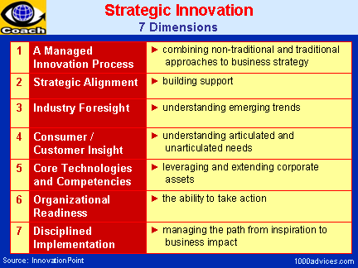
1000advices.com 2001 (Figure 3)

- competitors
the phoenix together innovation does not have competitors of similar innovation as the immediate competition only cater for a third of the capabilities it boasts.
- Football club digital management systems (teamfeepay.com)
- Online coaching programmes (edge of play.com)
- Social media multimedia capabilities.
However, this does not stop similar sized and larger entities from the sports industry from duplicating the innovations as the software innovation are all borrowed existing technologies. This could become a major threat to the organisation as they may boast larger resources for marketing.

- E-commerce
PHOENIX TOGETHER is an e-commerce business.
“E-commerce is a digitalised business model that operates online buying and selling goods or services” (Mobile E-Commerce Website for Technology-Based Buying Selling Services, 2019). With more and more businesses and people turning towards digital solutions for their everyday needs the e-commerce market is seen as the future strategic direction for sustainability for SME’s MNE’s to align their business to
PHOENIX TOGETHER website and mobile app was produced using a SaaS provider (software as a service) to establish the system, paying for their expertise to develop the contents and coding of the site that is managed and accessed via the cloud computing service.
To market the system, members and potential users will be able to access the website by accredited search engines such as
- Google
- Google chrome
- Microsoft edge
- Bing
Or as a download to any digital devices they have from:
- Google Play store
- Apple App store
- Samsung Galaxy apps
- Amazon App Store

The PHOENIX TOGETHER website and app contain
- Archives of football training and education PDFs, audio and video: 24 hrs access online to documented football contents, text, audio and video format.
- Slide presentations: for step by step explanations to training or education contents
- Advice blogs: professional, amateur and community advice
- Messaging hub with voice and face to face communications: for players, parents, coaches, mentors, admin and management to stay connected
- Breakout rooms: for coaches, mentors or management to conduct specialised meetings, classes or sessions.
- Animated tactic boards: for visual breakdown of tactics for visual learning support
- Account payment facilities: for members to manage their subscription payments and other
- Player and parent forums and groups: To exchange and discuss topics, ideas or views
- Performance monitoring software: to chart team and individual progression
- Personal Player training plans: for assisted and self-development
- Remote interfacing with video and presentation capabilities: for online live learning experiences.
- Internal private social network: to allow all members to speak with each other and club hierarchy directly.
- Session planners: for team training sessions
- club online retail shop: selling club merchandise, kits and equipment

- Financial benefit of using a SaaS
At the application is remotely stationed on the cloud there is no need of a server if necessary, it operates like a rental service, as access is granted for a period and a fee is charged for the service. “The SaaS reduces cost as the software applications already exist and configured. It saves on cost as the technology inhabit a multi-tenant environment where the licensing and maintenance fees for hardware and software are spread across all user of the application reducing the rental fee, and affordable for SME’s”. IBM.com (2020)
The fees for using the service will be paid from the club account along with the development fee
“Which could cost up to £50,000 - £100,000, depending on the number of hours it takes to develop the system to its full potential”. Onix-systems.com (2021)
PUFC already has a recently updated server pre covid 19 which will be of beneficial use to house the application and communicate with the cloud.
The cost is further reduced as the cloud does all the maintenance to the application, so staff is only required to update and authorise content making the system low maintenance.
PHOENIX TOGETHER only accepts digital payments for services and purchases for retail to be paid by card, bank transfer or payment services like PayPal, apple pay.
Because the system is accepting electronic card payments there are law abiding security regulations standards PCI DSS (Payment card industry data security standard) “they must comply with for the collecting, processing, storing and transmitting of personal information”. Pcicomplianceguide.org 2022 against breaches of practice that can bring reputable damage to a company along with severe fines.
- Marketing
Covid 19 presented the perfect platform to implement the system to existing members.
The system was marketed via what’s app and Facebook to existing members and affiliated coaches.
To market and launch the system a seminar will be arranged to invite local grassroots clubs and coaches to show case the contents and capabilities of the system and app. To get across to a larger audience and targeted consumers, social media platform such as Google and accredited search engines Facebook, Twitter, Instagram, and Linked In will be used, taking advantage of their business search engines and existing sports / footballing and coaches groups to reach the types of consumer they need for advertising and communications.
Investment will have to be made for advertising on search engines, so to minimise cost a bulk of advertising will have to be manually inputted over social networks.
Likewise, the launch is necessary so potential business clients can have a physical experience and take them through the customers journey they can experience.

- Customers journey
“Customer journey mapping is the process of creating a map, that visualises the experiences of your customers' interactions with your brand. This framework helps businesses step into the shoes of their customers and see their business from the customer's perspective” (Venkatesan and Kim, 2021)
There are 3 types of customers that can experience great automated functions and capabilities that will assist with their needs to remain organised and connected to each other.
- Football clubs
- Independent coaches
- User members
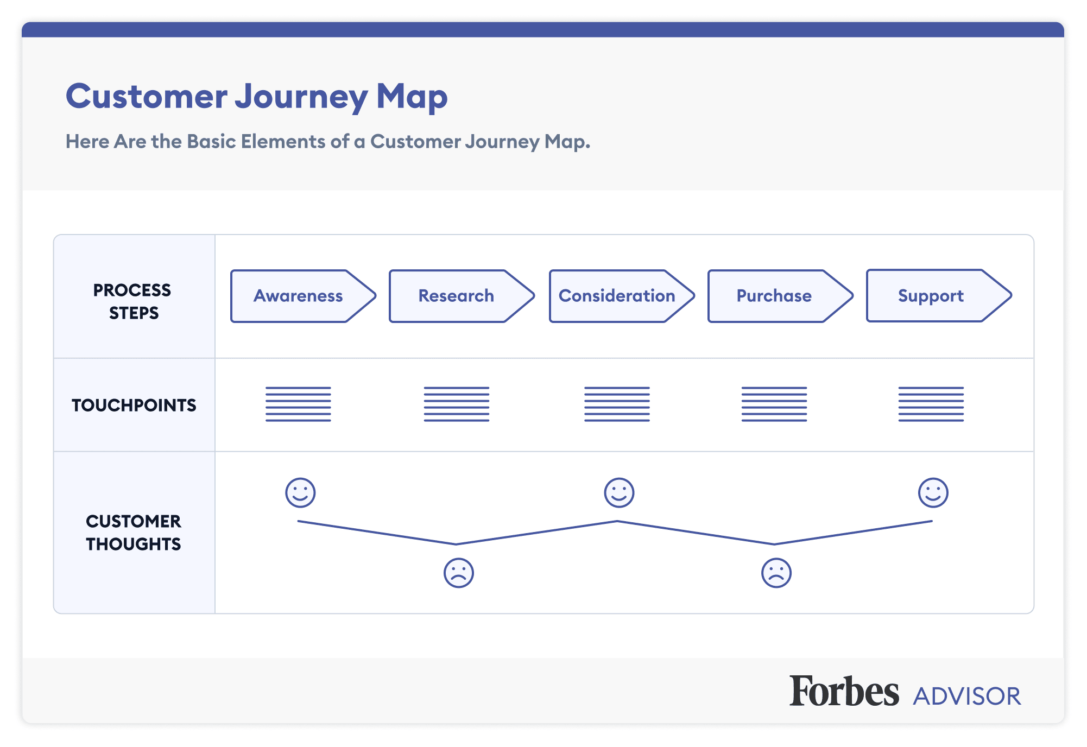
Forbes.com 2021 (Figure 4)
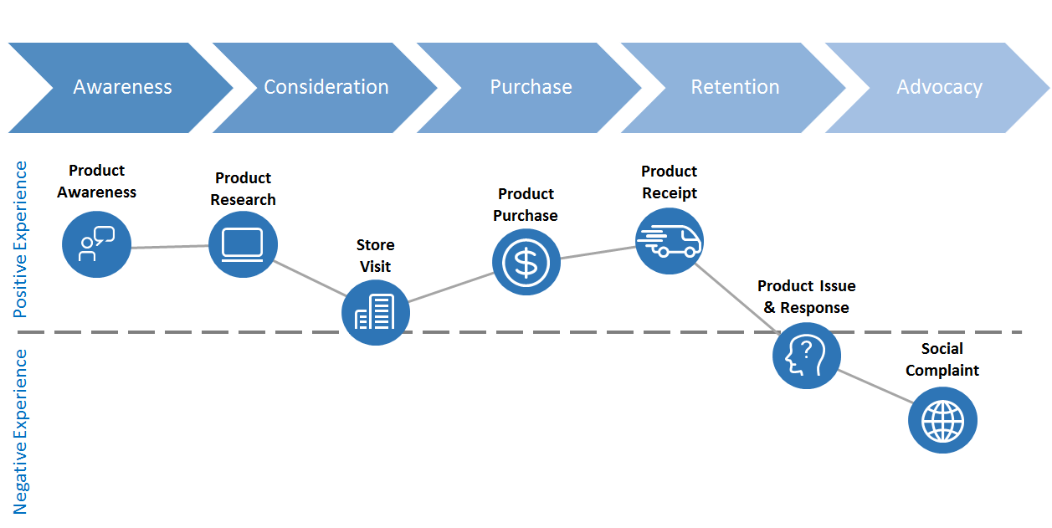
medium.com 2017 (Figure 5)
Football clubs can move many of their manual paper-based processes to the system, saving them valuable time.
Phase 1 as the system will automatically carry out the necessary requirements they need, with minimal input for data entry or retrieval.
Phase 2 the customer can expect up to the time analytics and feedback displayed in an easy to read format, presented on easy to use on screen interface.
Phase 3 they will have the capability to perform audio, video calling and SMS / MMS chat simultaneously at, with the combined ease of use for dragging material from their desktop, making multitasking possible with live interactivity all in one place to limit the frustration or fatigue of jumping from one application to another.
Phase 4 the customer can expect a swift reply from the support network if they encounter any problems while using the system.
Phase 5 the system also gathers information on usage for the A.I. to help make bespoke setting designed around the user and feedback from the end user for purposes of improving the system each time it is in use, through alerts and update that the user has control of switching off.
The system gives the user ownership of managing their affair that matters to them, e.g. clubs: a management system to ease the work load off coaches so they can focus more on their coaching, ease the problems of communication for members with the club and each other while being able to self-develop themselves and handle their business in their own time.

PUFC plan 2 launches for PHOENIX TOGETHER, a planned webinar to present the system potential to prospective candidate’s clubs and coaches through Microsoft teams and hold a seminar post covid 19 date to be confirmed.

- Conclusion.
This innovation by PUFC boast a powerful platform that eliminates the sometimes-frustrating need for multiple applications for communications and processing information to keep clubs, SME’ and independent companies organised, while keeping the communication channels open.
Despite the identified threat that organisations of similar or larger size can use legal loopholes the organisation has a window of opportunity to become the spearhead of the market, but they must have a sound proof strategy within their ideas for marketing and move quickly to seize the opportunity.
the unique selling point entices its members to be engaged with its organisation, aligning and benefiting both parties through its core value of the organisation vision and mission statement of inclusiveness.

- References

- Hitt, M., Ireland, R. and Hoskisson, R., 2015. Strategic management. Stamford, Conn.: Cengage Learning.
- Ismail, T., Ansell, G., Ismail, T. and Kleyn, N., 2012. New markets, new mindsets. South Africa: Stonebridge.
- phoenixutdfc.com club philosophy Available at: http://www.phoenixutdfc.com/club-philosophy
- phoenixutdfc.com club philosophy Available at: http://www.phoenixutdfc.com/club-philosophy
- news.sky.com, 2021 thousands of grassroots football clubs will close as result of coronavirus report retrieved April 9, 2022 from
https://news.sky.com/story/amp/covid-19-thousands-of-grassroots-football-clubs-will-close-as-result-of-coronavirus-report-12210029
- uefa.com, 2021 inside uefa news, how is uefa developing grassroots football across Europe. Retrieved April 9, 2022 from
https://www.uefa.com/insideuefa/news/0261-107dc76a334e-3a016e9fb189-1000--how-is-uefa-developing-grassroots-football-across-europe/
- https://www.menzies.co.uk/how-franchising-can-help-grow-your-business/
- Appypie.com 2015 about us retrieved April 10, 2022 from
https://www.appypie.com/about-us
- Gala, P., Woodroof, P. and Drehmer, C., 2022. GOING THE EXTRA MILE: TEACHING INNOVATIONS DURING COVID TIMES. Marketing Education Review, pp.1-4.
- International Journal of Engineering and Advanced Technology, 2019. Mobile E-Commerce Website for Technology-Based Buying Selling Services. 8(6S), pp.884-888.
- IBM.com 2020 top 5 advantages of software as a service. Retrieved April 11 from https://www.ibm.com/cloud/blog/top-5-advantages-of-software-as-a-service
- Onix-systems.com 2021 the components and cost of SaaS application development April 11 from https://onix-systems.com/blog/the-components-and-cost-of-saas-application-development
- Pcicomplianceguide.org 2022, what are the PCI compliance fines and penalties? April 12, 2022 from
https://www.pcidssguide.com/what-are-the-pci-compliance-fines-and-penalties/?amp
- Venkatesan, R. and Kim, T., 2021. Customer Journey Map. SSRN Electronic Journal

