 APPENDIX GA36a

LEVEL 4 ASSESSMENT SPECIFICATION

Student name: | Max Aaron | Student ID number: | 2014490
Programme:
Module: | Digital Surveying
Module code: | ACBA4002 | Contribution to Overall Module Assessment (%): | 50%
Lecturer: | Dr Jamiu A. Dauda | Internal Verifier: | Gavin Traylor
Assignment Title: | Essay | Word count (or equivalent): | 2000 words
Submission deadline: | 10th January 2022 | Return date of provisional marks & written feedback: | 4th February 2022

A report focussing on:

Digital Surveying

Prepared for:

Dr Jamiu A. Dauda

Created by:

Max Aaron

Table of Contents
Introduction 3
Instruments 4
Methods of Surveying 4
Surveys classified by purpose 4
Topographic Surveys 4
Hydrographic Surveys 4
City Surveys 5
Construction Surveys 5
Mine Surveys 5
Forestry Survey 6
Digital Surveying Technologies 6
Listed Buildings 6
Surveying Tools Used in Listed Buildings 6
The Survey 6
Planning 7
Field Work 7
The Report 7
Bibliography 8

Introduction
In surveying there are many factors, these can be classified firstly into primary and secondary factors. There are two Primary factors which are Geodetic Surveying and Plane Surveying. Geodetic Surveying considers the earths geometric shape which is curved and covers an area greater than 250km^2. Whereas, Plane Surveying considers the earth as a flat plane, usually covering areas smaller than 250kn^2 and therefore is the more commonly used type of surveying.

Surveys are then classified by secondary factors of which there are four. These are; the classification according to the instruments being used, the purpose of the survey, the methodology being implemented, and also the field of work (Designer, 2010).

Instruments
Surveying classified by the instruments used would be chain surveys, Compass Surveys, Plane table survey, levelling, and theodolite surveys (Designer, 2010).

Methods of Surveying
Surveys according to the methodology being used would be considering Triangulation, Traversing, or Trilateration.

Surveys classified by purpose
Furthermore, there are factors of surveying which are considered by their purpose. These would be; Cadastral Survey, City Survey, Construction Survey, Forestry Survey, Hydrographic Survey, Industrial Survey, Mine Survey, Photogrammetric Survey, Route Survey, Topographic Survey.

Topographic Surveys
Surveys considered by their purpose explain the survey in greater depth and are a lot more specific to the survey being conducted and the field of work that they are under. For example, topographic surveys are surveys which are used to produce maps called topo-maps, by determining the positions of natural and artificial features such as rivers, hills, roads and canals (Poudel).
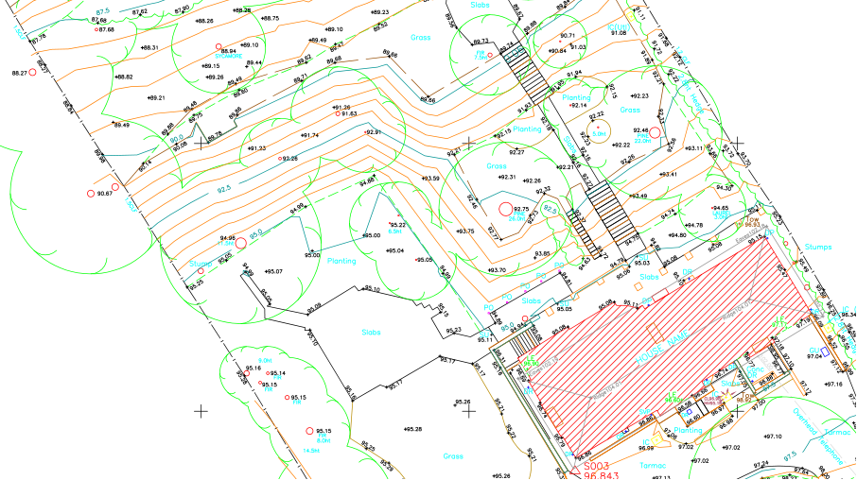
Figure 1 (Surveys, 2021)

Hydrographic Surveys
Hydrographic Surveys are specific to studying the sea. They are used to examine the the physical features under water by determining the M.S.L. (mean sea level) along with the depth of sea bed and natural/artificial objects, tide measurement, velocity of the water, and the area. It is mainly carried out by the use of instruments such as sensors e.g. sound, electronic (K, 2021).

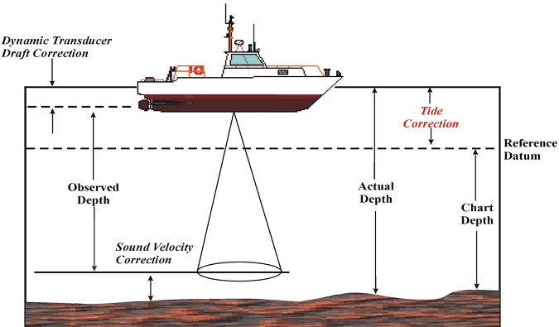

Figure 2 (K, 2021)

City Surveys
City Surveys are self-explanatory. They are for the purpose of planning expansions or improvements in a city. They help determine property lines, and the natural and artificial aspects of the city such as the land or buildings. They also therefore can be used to produce a map of the city.

Construction Surveys
Construction surveys are often conducted on site to determine the positions of pre-existing objects, proposed positions, and as-builts by collecting data such as coordinates, reference lines, dimensions and elevations. This is done by use of instruments such as theodolites and dumpy levels.

Mine Surveys
Mine surveying is explained as “the digging of mine shafts and galleries and the calculation of volume of rock” (Wegen, 2018). Although the basic principles of mine surveys have kept, to some extent, unchanged the technology being used in this sector has drastically changed. This type of surveying is unique in its purpose as it requires specific techniques to carry out the survey due to the type of field, for example, vertical shafts or narrow passages. The types of technology used are terrestrial laser scanning, airborne laser scanning, airborne photogrammetry, unmanned arial systems, and satellite imagery (Wegen, 2018).

Forestry Survey
Forestry Surveys are carried out to examine the forest management, mensuration, production, and conservation of forest land.

Digital Surveying Technologies

Listed Buildings
Listed Buildings are buildings which are of historical or architectural value and therefore are protected. There are 3 main classifications of listed buildings. Grade 1 are buildings which are of high interest and significance. Grade 2* are particularly important buildings with more than special interest. And lastly, Grade 2 are buildings of interest with regard to protecting them thus being the most common type of listed building (What does Grade 2 listed mean?, 2018). Examples of reasons these buildings would be surveyed are; to draw a detailed plan/elevation of the building, to determine the present conditions of said building, retrofitting and renovation plans such as facades, fulfilment of building legislation.

Surveying Tools Used in Listed Buildings
There are various different tools used to measure and survey, some are more advanced and more accurate than others. The most traditional technique used is pacing. This is when someone is able to use their own pace to measure a distance by having calculated their pace from a set distance that they previously measured. However, this tool would be the least accurate as it is an approximation. Steel and fibreglass measuring tapes are a more accurate traditional approach. They offer accuracy of 1 in 10,000 and 1 in 1,000 respectively. The more modern and current tool used for linear measurements in listed building surveys is laser measuring. These use a laser which is emitted onto a surface, which then is reflected back to the device and a measurement is calculated. There are other factors which require other tools for example, thermal cameras which are used to detect the thermal efficiency of buildings such as the heat loss in buildings or dampness. Some areas in a building aren’t easily accessible such as the roof or gutters, this is where a telescopic inspection camera is used.

The Survey
In a survey of a listed building there are five key stages. The planning stage, field work, computing, mapping, report.

Planning
In the planning stage an initial investigation of the buildings history takes place. This means collected any information about the construction of the building such as as-builts, planning applications and regulations, drawings and maps such as plan/elevation and topography. From all this data, a risk assessment is conducted to evaluate if the building is deemed safe to be surveyed.

Field Work
This stage is where the current information of the listed building is collected. The surveyor builds the report by measuring and examining the building internally and externally, reviewing the condition of the building. Firstly, the preliminaries of the survey will need to be captured in a survey document report. This details everything relevant to the survey conducted. This will contain the following; Title and address of the property, the client's name, address and contacts, the survey date and time, the property status for example freehold, leasehold or common hold, the current and previous occupancy, the extent of the survey for example full structural services reports, any specialists in attendance for example an electrician or heating engineer, the age of the property, the disposition of rooms, floor plans and elevations if available, elevation (flooding potential) and orientation (solar effect), estate/garden area and disposition if appropriate, means of access roads, drainage positions (Dauda, 2021). Within the report various details may be also included such as wall details or roof details. These would outline materials used, the construction methods used, measurements, possible evidence of causes of damage or potential damage, changes in original details such as measurements or materials, repairs, standard building regulations being followed. The surveyor would then compare these details to the present state of the building.

The Report
An initial assessment is carried out by the surveyor on all integral parts of the listed building and marked in one of the following categories: Good, Fair, Poor, Very Poor, Not Inspected. For example, the walls of the building would be examined by looking firstly at the materials used such as bricks and cladding, concluding the condition of them and any evidence of repairs. It would be noted if the wall is solid or cavity, to then examine, if cavity, the insulation used along with painting and rendering. The damp proof course and air brick locations and functionality would be looked at, is it efficient, was it installed correctly. And finally, are there any signs of stress, settlement, or damage to parts of the building visible. The walls of the building would then be given a satisfactory rating. If given “good” then the building is deemed structurally sound with no significant repairs needed. The complete opposite can be said for a building marked as “very poor” (Yacob, 2016).

After the buildings condition has been assessed, the occupancy is noted as occupied, partly occupied, vacant or unknown. Photographs of the buildings structures and main bodies will be included in the report to show in detail the condition of the building. Finally, the date and time of the site visit is recorded along with photos dated.

Bibliography
Dauda, D. J. (2021). Digital Surveying.
Designer. (2010). Classification of Surveys and Surveying Methods in Engineering. Retrieved from civil projects online: https://www.civilprojectsonline.com/surveying-and-levelling/classification-of-surveys-and-surveying-methods-in-engineering/
K, N. S. (2021). Hydrographic Surveying – Methods, Applications and Uses. Retrieved from The Constructor: https://theconstructor.org/surveying/hydrographic-surveying-methods-uses/13838/
Poudel, E. M. (n.d.). Types of Surveying. Retrieved from Dream Civil: https://dreamcivil.com/types-of-surveying/
Surveys, P. L. (2021). Precise Land Surveys. Retrieved from Precise Land Surveys: https://www.preciselandsurveys.co.uk/topographical-surveys/
Wegen, W. V. (2018). Surveying in the mining sector. Retrieved from GIM: https://www.gim-international.com/content/article/surveying-in-the-mining-sector
What does Grade 2 listed mean? (2018). Retrieved from Bidwells: https://www.bidwells.co.uk/what-we-think/what-does-grade-2-listed-mean/
Yacob, S. (2016). Building Condition Assessment. Retrieved from MATEC: https://www.matec-conferences.org/articles/matecconf/pdf/2016/29/matecconf_ibcc2016_00072.pdf

Generic Assessment Criteria |  | Marks available |  | Marks  awarded
1. Engagement with Literature Skills
.
 |  | 15
2. Knowledge and Understanding Skills

 |  | 25
3. Cognitive and Intellectual Skills

 |  | 25
4. Practical Application Skills

 |  | 20
5. Transferable Skills for Life and Professional Practice

 |  | 15
Assessment Mark (Assessment marks are subject to ratification at the Exam Board. These comments and marks are to give feedback on module work and are for guidance only until they are confirmed. ) | Late Submission Penalties (tick if appropriate) |  |  |  | %
 | Up to 1 week late (40% Max) |  |  |  | %
 | Over 1 week late (0%) |  |  |  | %

