Problem Solving and Decision Making

STUDENT NAME | SHIULI AKTER
STUDENT NUMBER | 1706999
MODULE NAME | PROBLEM SOLVING AND DECISION MAKING
MODULE NUMBER | BMSK4004
TUTOR NAME | MUSHFIQUR RAHMAN

A complex problem in the workplace including its scope and impact:
Context:
Marks and Spencer (M&S) is very renowned retailers in the UK and the company is famous for retailing clothing, luxury products, and home products. Among them, the profit comes from retailing clothing is very significant in their total earned a profit as a significant percentage of profit comes from the clothing segments of the company. However, in recently, the company has experienced a decline in their sales of clothing and in the last year the sales is reduced by 2.3% comparing to the previous period which impacted on the overall profit of the company. The total sales of clothing are decreased to £3.2 billion in the last year which is a 1.4% reduction in the total sales (Adair 2018). Thus, in order to retain the position in the clothing, the management of the M&S wants to introduce a new clothing brand ‘XXX’ to attract more potential customers to increase the sales of the clothing of the company.
Scope and Impact:
The clothing industry in the UK is very profitable compared to other industry as the people of the UK are much fashionable and they spend a significant amount of their income for the purpose of purchasing clothing. Besides, the growth of sales of the clothing in the UK is increased by 1% comparative to the previous years. However, the global market of the clothing industry is also profitable at around 3.3% of total spending is occurred for purchasing clothing in around the world (Almond, 2017). The scope of the proposed clothing brands includes identifying the target customers whether they are a rich or middle class, feasibility analysis, and identification of cheap sources of production. For identifying the target customers, the company conducts a research on the percentage of the middle-class customers and the rich customers as well as to do the cost-benefit analysis to find the cheapest means of production for this proposed branded clothing. The company wants to capture the maximum market share as possible by this proposed clothing brand so they give a huge concern about targeting the profitable segments for this branded clothing.

Analysis information on the identified problem, to help inform the decision-making process:
The UK’s clothing industry plays an important role in the overall economy of this country. In the last year, this industry has contributed nearly £29 billion pounds to the UK’s economy (Brest 2017). However, by keeping all of these issues, the M&S wants to introduce a new clothing brand to retain more customers which may impact positively on their total profit. Here, for introducing the new brands, the company faces some problems like analysis the true growth of this industry, identification of the appropriate target markets, finding the suitable way of distributions as well as production. All of these are discussed in the below:
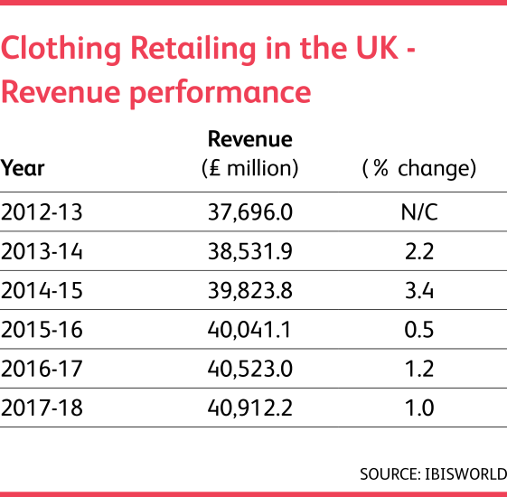
Figure 1 Revenue performance of clothing retailing In UK
source: (Freeman et. al, 2017).

From the above chart, it can see that the revenue from the clothing retailing is increasing in the UK and the present rate of growth of increasing in the revenue is 1% and it expects that this will increase more in the upcoming year’s decease the present rate is declined due to the Brexit issue. However, it can see that the overall revenue in this industry is £40,912.12 in the last year which was £40,523 in the last previous year. However, the success of the clothing business mostly depends on identifying the proper target customers and the target customers should select by analysing their income and demand properly. The income difference among different class people is given in below:
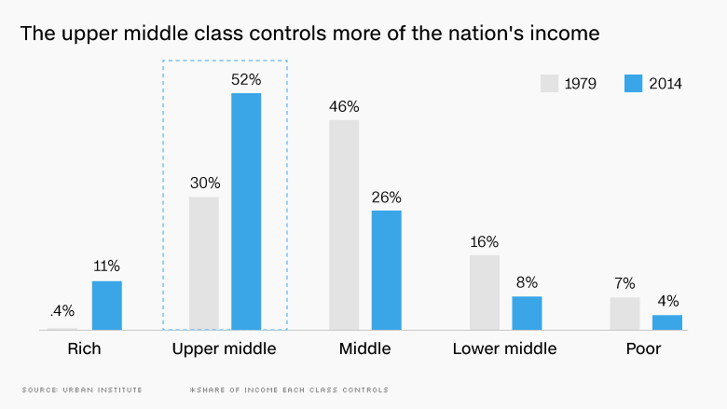
Figure 2 control of the Nation's income
source: (Jones 2016).
From the above chart, it can see that the upper-middle-class people have more control over the nation's income in the UK which is 52% and the second highest in the middle class which is 26%. However, this control is increasing in case of upper-middle-class people and the rate is decreasing in the case of middle-class people. That means the company should select the upper-middle-class people for their proposed brand as they control more on the nation's income of the UK. However, selecting the proper segments of this brand is also important. The percentage of spending on clothing by men and women is given in the below:
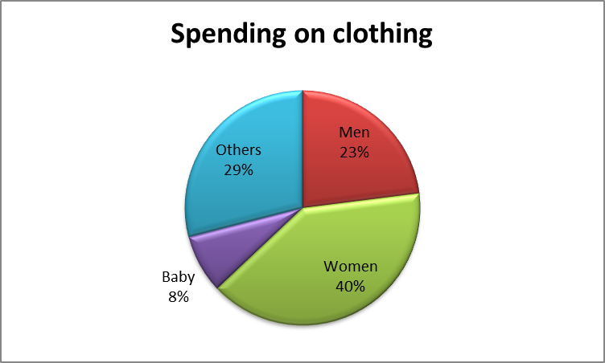
Figure 3 Percentage of spending on clothing
sources: (Lane, 2016).
In this show, it is clear that the women are spending more on clothing which is nearly 40% and then the percentage of men’ is 23%. Thus it is wise for the M&S to produce the cloth mainly for women under their proposed brands as it will help to increase the total sales of the company. However, the price determination is also important for clothing business as unfavourable price may reduce the sales despite having good quality. The percentage of price charge by the UK’s famous retailers are shown in the below:

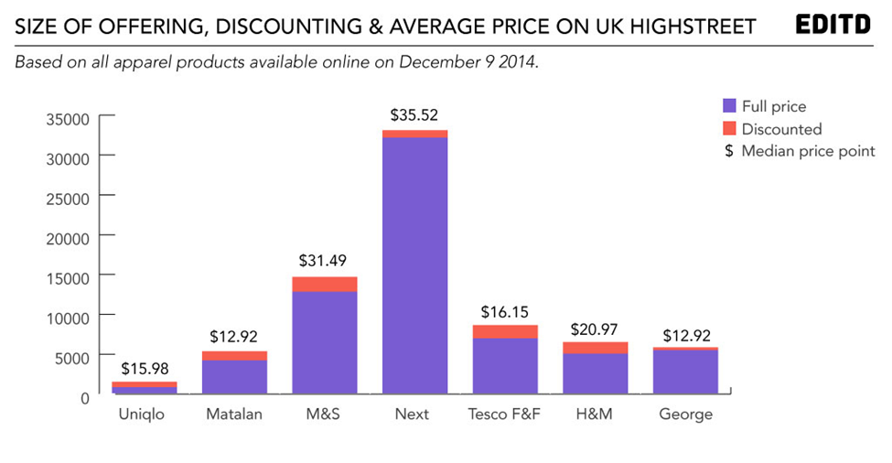
Figure 4 Average offered price by the famous retailers
Source : (Moedas 2017).
From the graph, it can see that the Next charge most for their products which is average $35.52 and the second highest is the M&S which is $31.49. Thus the company can reduce their price slightly for their proposed brands to attract more customers. Moreover, the identification of the cheapest way of production is also important in the clothing business. The lowest labour rates are shown in the below:
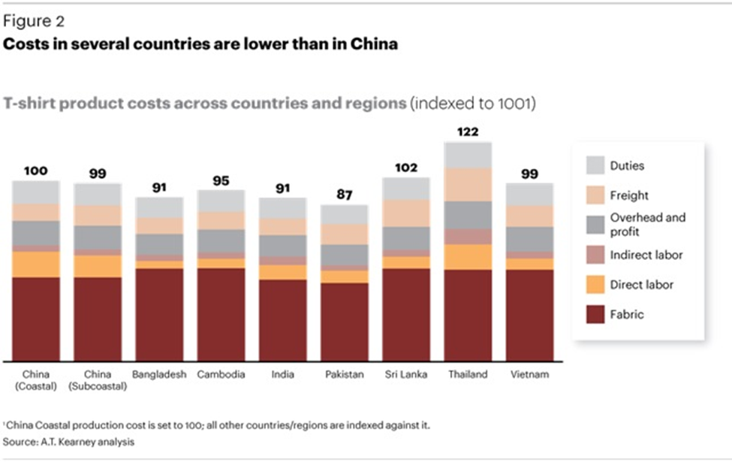
Figure 5 Comparison of cost of labour
source: (Shapira 2017).
From the above chart, it can see that the lowest labour rate is 87 in Pakistan and second lowest is 91 in both Bangladesh and India. Thus the company should take wise decision in case of selecting the country where the actual; production will occur.
However, according to a statistic it is revealed that nearly 35% of proposed brands have failed to achieve its intended goals (Almond, 2017). However, the company’s main goal is to select the right target markets and the right place for production.

A range of alternative solutions to the problem:
The company should develop a number of alternatives for solving the problems because alternatives may not go as expected. Thus it is wise for developing a number of alternatives for solving a problem as if one alternative may fail then the other alternatives can be implemented to solve the problem (Fitzgerald, 2012). In this case, the problem of the establishment of the new clothing brand, the following alternatives are chosen in the context of identification of proper target customers and then choosing the best place for producing the cloth.
Alternatives regarding the identification of the target customers:
The M&S chooses two alternatives for targeting the customers for the proposed brands and obviously it is the upper-middle-class customers, as they have more income than the other class of people and their spending on branded cloth is also higher than other class. Besides, the upper-middle-class people are more fashionable and they like to spend frequently for purchasing the branded cloth than middle or other class of the people. As the average price of the products of the M&S is higher than other retailers so, it is wise for the company to target the upper-middle-class people because poor or middle-class people may not afford to buy the high priced quality products (Moedas, 2017). Another alternative of identification of the target customers for the proposed branded clothing of M&S can be the middle-class people. As the middle-class people are in the second position of controlling the nation’s income so they can be the potential customers for their products because if the company may reduce the price of the products, then they may impact significantly on the company’s total sales.
Alternatives regarding choosing the best place for production:
The cost of production is very crucial in the determination of the price as if the cost of production of a particular price is high then the company cannot reduce the price significantly but the cost price is low then the company will be able to offer the products with low price (Jones, 2016). The first alternatives for choosing the place for the production of the proposed branded clothing in Bangladesh as the labour price of Bangladesh is quite lower than most of the countries of the world and the same time Bangladesh have a good reputation of producing the quality products with lower cost. The second alternative for the profitable production place for the proposed branded clothing in India as India has a lower labour rate and the quality of their products is also good. Besides, India has a reputation for delivering products on time.

A decision-making technique to evaluate a range of solutions to identify the most appropriate option:
The main issues of launching a new clothing line in the M&S’s product line are a determination of the target customers and the suitable place for production. However, in the case of targeting customers, the two possible segments are upper middle class and middle class and the comparison between these two class is shown in the below:
Criteria | Upper middle class | Middle class
Control over nation’s income | High | Low
Demand for high-quality products | High | Low
Ability to afford branded products | High | Medium
Level of consciousness during purchase time | Medium | High
The upper-middle-class customers have more control over incomes and their demand and their ability to afford the branded quality clothes are higher than the middle-class customers. On the other hand, the middle-class customers are also very aware of the choosing the best quality cloth with a comparatively lower cost during the purchase of the cloth and the upper-middle-class people shows less consciousness during purchase time. Thus by considering all of these factors, it is wise for the M&S to choose the upper-middle-class customers for their proposed branded cloth and should produce higher quality products for attracting the upper-middle-class customers.
The second main issue of launching a new cloth line in the M&S’s product line is choosing the best place for producing the branded cloth and two alternatives place is selected and the comparison between these two places are shown in the below:
Criteria | India | Bangladesh
Cost of labour | low | Low
Quality of the raw material | Relatively lower than Bangladesh | Relatively higher than India.
Delivery products on time | Do not late | Rarely late
Level of safety in the Garment factory | Good | Not so good but recently they have taken several safety measures.
Political condition | Good | Not so good
Both two alternatives seem provides equal advantages to the company as the cost of labour in both countries is lower and both of the countries are sincere about providing the product on time but the quality of the raw material of Bangladesh is relatively higher than India. On the other hand, the political condition and the safety measures in Bangladesh are not so good than those of India. As the political condition and the safety condition may cause the result of the delay in delivering the products because the unfavorable political condition may result the stop of the production, so, it is wise for the company to choose India for producing their proposed branded products as it seems India offers more suitability to the company than Bangladesh.

A plan for implementing the solution
The fashion retailing industry of the UK is getting increasingly competitive day by day as companies like Primark, ASOS and H&M are giving tough competition of M&S regarding all the segments of the industry (Kashi, and Franek, 2014). To successfully launch the new clothing brand "XXX" to the upper-middle-class target customers the company need to be very precise in their implementation stage. The plan for the implementation is below:

Aims and Objective of plan
The aim of the proposed plan is to assist M&S to launch their new clothing brand “XXX” in the UK marketing successfully to enable increased profit opportunities.
The objectives are:
- To allow the company to pass the initial hurdles and establish their physical location successfully
- To attract all 80% of the customers in the targeted areas within the first 1 year
- To allow the company spread their branches in Wembley and Southall within 1 year
- To maintain operational excellence for the sustainable future

Market and Business Environmental Analysis
To formulate the right strategies for the implementation, plan the company needs to be very much aware of the factors from both internal and external environment of the business and the organisation needs to be aware of the industry circumstances as well to identify the gaps in the market. The external analysis for M&S new product line “XXX” is below:

PESTLE
To evaluate the external environment of the business PESTLE framework is used as it helps to find out the issues of the outside environment that are not within the control of the company but can affect the business operations significantly. The application of the PESTLE framework in the given context is below:
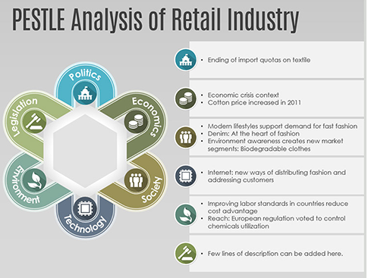
Figure 6: PESTLE Framework
Source: (Tsalikis, and Peralta, 2016).
Political: The factors of the political environment affect the fashion retailing industry the most as most of the companies outsource their products from cheap labour countries hence the relationship of the UK government with those governments are important determiner regarding the progress of the fashion retailing industry. Moreover, the import quotas like least developed countries like Bangladesh have been over and there are increased restrictions regarding the import quota issues and all these are creating complications in the Fashion industry and most of these factors are forcing increased costs for the products threatening the profit margin for the company (Baker, 2017). There are issues like political turmoil in the largest two countries like India and Bangladesh where most of the products are being sourced and so on are also affecting this industry.
Economic: The movement in the economic environmental factors have significant impact on the fashion retailing brand and for high street fashion retailing brand like M&S as the people’s income, saving pattern, unemployment rate, inflation and movement of the GDP determine the business for the fashion retailing brand (Battersby, and Shuchman, 2013). The worldwide looming economic crisis will have an adverse impact on the business of M&S and also the rise of inflation causing the increase of the cotton price and also people's decreasing buying power will have a significant adverse impact on the business of M&S. As fashion products are not necessity goods hence movement of the economy remains sensitive to it.
Social: The social trends are changing at a fast rate and it affects the dressing pattern abruptly. The fashion retailing brands are needed to be very much aware of the social changes as they need to cope up with these to match the demands of the consumers. For this, M&S will not be able to do business by selling single fashion line for eternity rather they need to upgrade their product lines and combine those in their clothing lines to attract the customers as they demand newer varieties and changes in the dress up.
Technological: The technological trends regarding the fashion retailing industry are changing especially presently around 65% of the total sales in the fashion retailing segment are conducted through the online mediums and most importantly there have been larger implications of digital technologies regarding marketing, supply chain management and also production management for the fashion retailing companies (Gilligan, et al, 2013). M&S needs to interrogate these things closely in their operations to allow continues flow of their operations and to successfully launch their brands.
Legal: The legal issues are sensitive and are need to be handled with proper care. These include the laws regarding labour safety, consumer's right protection and so on. For M&S sustaining the labour rights in the home country the UK and also from the country, they are planning for source the products from will be challenging as labour laws keep changing and there is structural rigidity especially in the countries like Bangladesh and India where the products will be sourced from. However, the company will need to strictly maintain those.
Environmental: The environmental issues include the waste management and implementing and promoting the green initiatives. M&S needs to abide by the guidelines regarding the water use required for their production, textile materials use and their proper waste management and also needs to patronize the green initiates to allow the proper operations of them with proper success.

Five Forces Analysis
Fashion retailing industry is extremely competitive as the quality of the clothes is more similar for most brands but it is the design and distinctiveness in presence and branding that allow the companies having a competitive edge. To successfully launch the products, the company will need to understand the industry dynamics and Porter's five forces model will help to do that which is presented below:
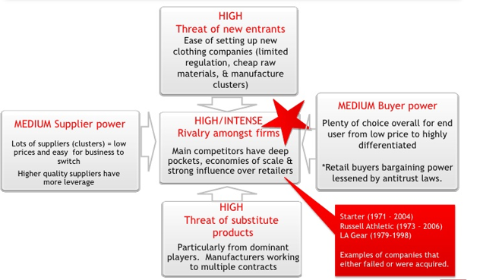
Figure 7: Five Forces Analysis
Source: (Black, 2017).
The threats of the new entrants are higher mainly because there are no regulatory bindings and also the sourcing of finished products are easier and there are fewer chances for differentiation in quality although setting up fashion retailing brand at bigger scale and setting up high street fashion retailing brand is still not so easy because of higher capital needs and customers brand loyalty. The bargaining power of the buyers are moderate mainly because most of them buy at a larger scale and there are enough alternatives like Bangladesh, India and Vietnam as all these countries offer cheap labour but for retail buyers bargaining power is lower because of the new antitrust law. The threats from the substitute products are higher mainly because there are enough same quality alternatives in all segment of the business (Ferrell, et al, 2017). For high street products like in this case, there can be competition from H&M, Mango, ASOS and Primark and these companies almost offer similar products making the substitution threats higher. The supplier's power is moderate as there are ample alternatives and the buyers can easily replace their choices with similar quality alternatives. The rivalry among the competitors are said to be higher as there are giant companies and the market share is concentrated and also scattered and there are many small brands as well. 15% of the market share is held by M&S, 12% ASOS and 7% Primark and traditional retail brands like Tesco and others are also posting extensive threats all these make the competition higher (Fitzgerald, 2017). Considering the above facts M&S needs to be really smart enough in giving differentiated messages to the consumers to successfully launch their new brands.

SWOT Analysis
The company needs to have a clear and precise idea regarding their own strong factors and weaknesses as well which can be illustrated by the SWOT analysis which is below:
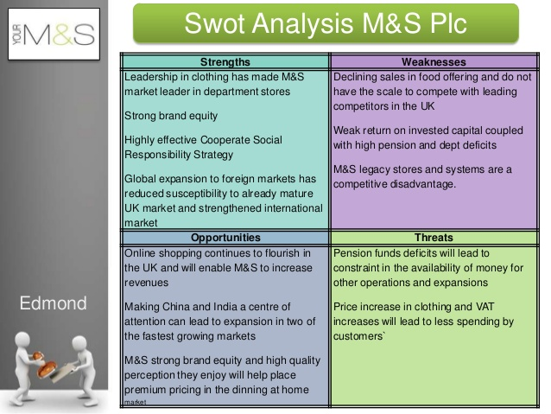
Figure 7: SWOT Framework
Source: (Black, 2017).

STP Analysis
Before making the final implementation of their proposed fashion line they need to have proper ideas regarding segmentation, targeting and positioning of their new brand which is below:
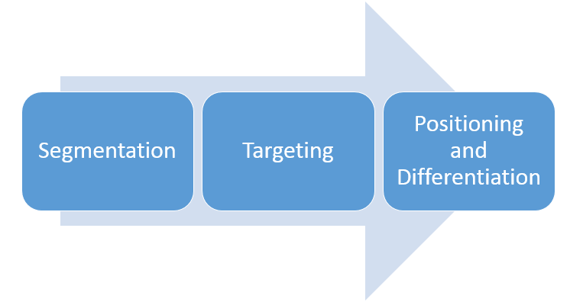
Figure 8: STP Analysis
Source: (Henriques, 2016).
The company has opted to segment their customers according to their income range and stability as their main target customers will be a higher middle class or people having an annual income of around $£$2-$£5m$. Their main target customers will be youth ageing around 20-40 and they are going to differentiate their new product lines and will position themselves as the highest quality giver allowing unique and distinctive design. The company is going to use distinctive materials that will be good for earing and also good for the environment as well.

Implementation Plan
The implementation plan will start by preparing WBS and making schedule accordingly. The breaking down of the task demonstrating the breakdown is below:

WBS
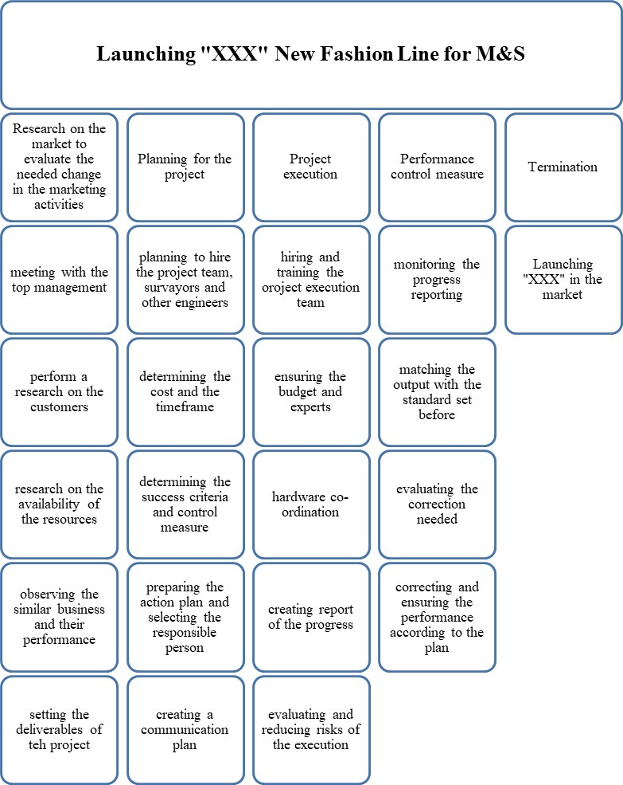
Figure 9: WBS
Source: Author

Schedule and Gantt Chart
The time schedule for implementing the project’s operations are below:
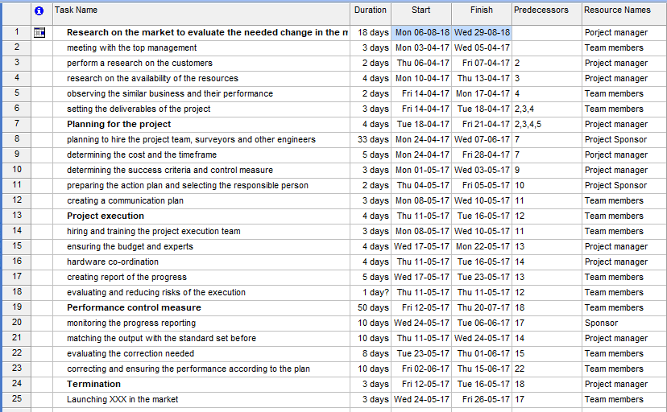
Figure 10: Schedule
Source: Author
The time chart is demonstrated below with the following Gantt chart:
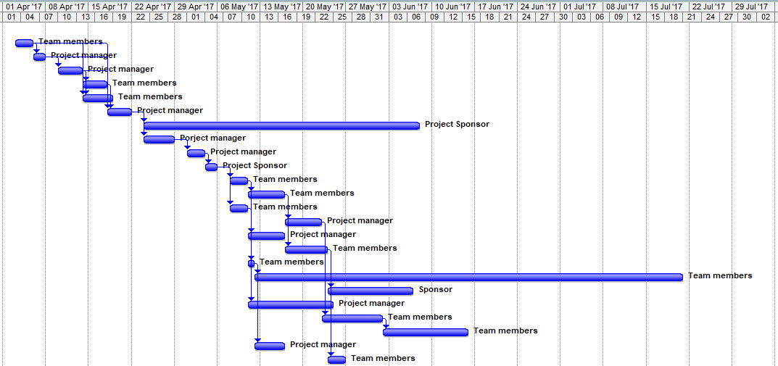
Figure 11: Network
Source: Author

Network Diagram
The network graph for this project is below:
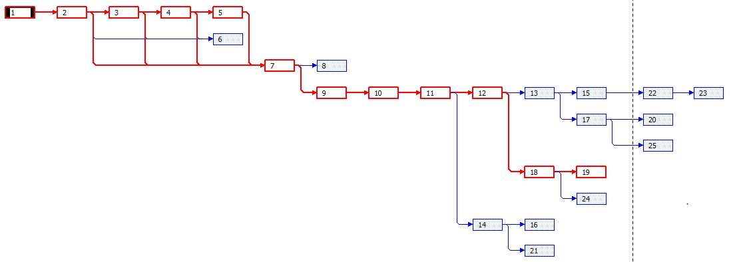
Figure 12: Network Diagram
Source: Author
The critical tasks numbers are activity 1,2,3,4,5,7,9,10,11,12, 18 and 19 and so total duration for the product launching will be 18+3+2+4+2+4+3+2+3+1+50=89 days.

Budget
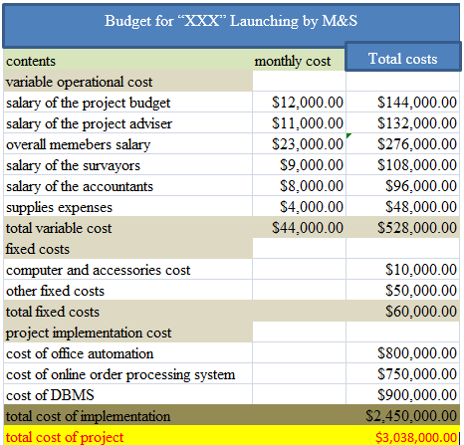
The budget costs segmentation is below:
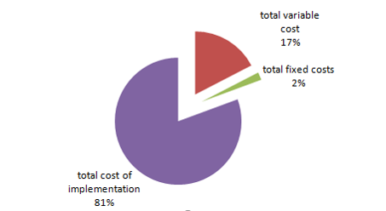
Figure 13: Budget breakdown
Source: Author
The pie chart demonstrates that 81% of the costs for the budget for launching “XXX” for M&S will be spent behind the successful implementation of the project.

Risks
The probable risks that are going to affect the project’s operation and adversely affect it are the financial, human resources, technical, communicational, management and coordination risks. The chances for financial risks are lower as M&S is a financially stable company. The chances for human resources risks can be higher as they are going to source the products from India and there can be risks regarding coordination and control as the project’s operational area is vast.

Communication of the plan to stakeholders
The identification of the related stakeholders is important to delineate the proper stakeholder communication plan for the company. The determination of the related power and interests is also important. For detecting the relevant stakeholders and for determining their power and interests the stakeholder matrix for M&S is below:
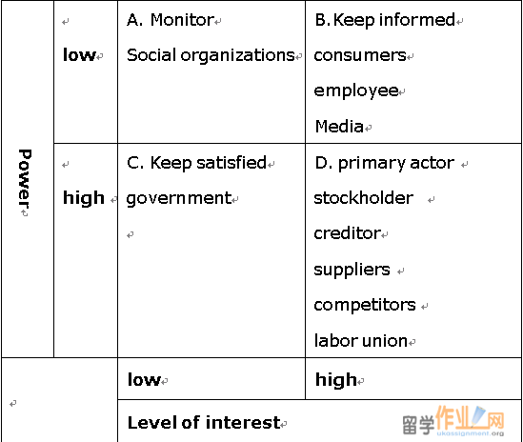
Figure 14: Stakeholder Matrix
Source: (Kourdi, 2017).
Stakeholders with the high level of power and interests such as the investors and customers will be regularly communicated through the formal and informal way. The investors will be given a proper annual report where their information needs will be fulfilled and customers will be communicated through social media and so on. The company will regularly arrange meetings with suppliers and also will let the media and other responsible parties to avoid adverse mindset from them (Piccirillo, et al, 2014). The regulations will be strictly managed and implemented to fulfil the desires of the government.

Appropriate monitoring and review techniques to ensure successful implementation of the solution
To see whether the launching of the new fashion brand “XXX” has been proved to be successful for the company there will be a separate review team to illustrate the performance of the new clothing line. For monitoring and review the following framework will be implemented:
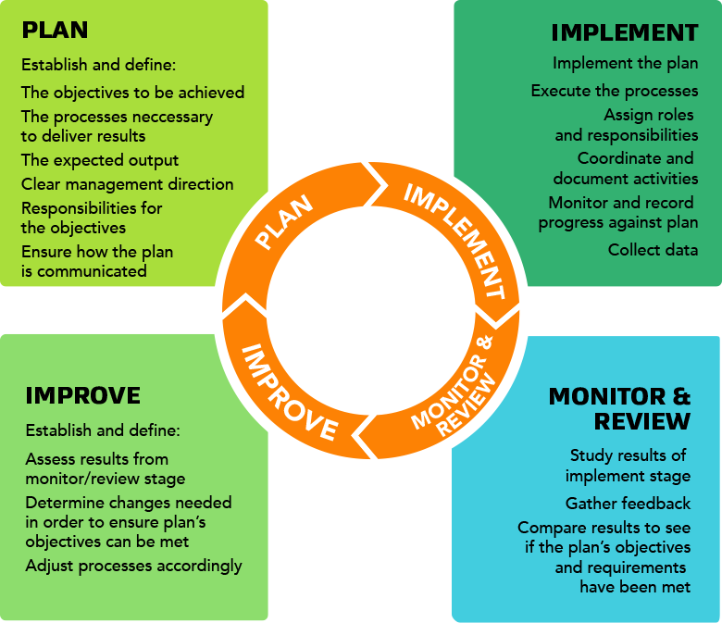
Figure 15: Monitoring and Review Schedule
Source: (Tsalikis, and Peralta, 2014).
Along with implementing the above framework the company is going to apply some performance measurement tools like KPIs, surveys and 360 evaluations. The execution of KPIs against which the performance of the new product line that will be judged is below:

KPI Factors | 1st quarter | 2nd quarter | 3rd quarter | 4th quarter
Market Share | 4% | 7% | 10% | 25%
Customer Acquisition Rate | 40% | 60% | 70% | 78%
Customer Loyalty Rate | 50% | 60% | 65% | 75%
The performance of the new fashion brand will be judged against these criteria and if the new brand can successfully attain these targets the launching of the new fashion brand will be termed as successful.

References
Adair, J. (2018). Decision making and problem-solving.
Almond, K. (2017). A Potential Dichotomy: Clothing, Fashion, and the UK Apparel Industry. The International Journal of Design in Society, 11(1), pp.1-14.
Baker, A. (2017). Business decision making. New York: St. Martin's Press.
Battersby, A. and Shuchman, A. (2013). Scientific Decision Making in Business. OR, 16(1), p.118.
Black, K. (2017). Business statistics. Hoboken, NJ: Wiley.
Brest, P. and Krieger, L. (2017). Problem Solving, Decision Making, and Professional Judgment. Cary: Oxford University Press.
Ferrell, O., Fraedrich, J. and Ferrell, L. (2017). Business ethics. Boston: Houghton Mifflin Co.
Fitzgerald, S. (2012). Decision making. 1st ed. Oxford, U.K.: Capstone Pub.
Fitzgerald, S. (2017). Decision making. Oxford, U.K.: Capstone Pub.
Freeman, M., Conti, L., and Eliot, G. (2017). The mill on the Floss.
Gilligan, C., Neale, B. and Murray, D. (2013). Business decision making. Deddington, Oxford: P. Allan.
Henriques, A. (2016). Good decision? bad business?. International Journal of Management and Decision Making, 6(3/4), p.273.
Jones, R. (2016). Report on the UK clothing industry and market. Journal of Fashion Marketing and Management: An International Journal, 1(1), pp.83-96.
Kashi, K. and Franek, J. (2014). Applying Group Decision Making and Multiple Attribute Decision Making Methods in Business Processes. Applied Mechanics and Materials, 693, pp.237-242.
Kourdi, J. (2017). Business strategy. London: Profile.
Lane, C. and Probert, J. (2016). Between the Global and the Local: A Comparison of the German and UK Clothing Industry. Competition & Change, 8(3), pp.243-266.
Moedas, C. (2017). Globalisation and regionalization in the clothing industry: survival strategies for UK firms. International Journal of Entrepreneurship and Small Business, 4(3), p.291.
Piccirillo, E., and Noro, M. (2014). Guidebook for supporting decision making under uncertainties. Hackensack, NJ: World Scientific.
Shapira, Z. (2017). Organizational decision making. Cambridge: Cambridge University Press.
Tsalikis, J. and Peralta, A. (2014). Priming effects on business ethical decision making. Priming effects on business ethical decision making, 01(01).
Tsalikis, J. and Peralta, A. (2016). Priming effects on business ethical decision making. Priming effects on business ethical decision making, 01(01).

