ACDA5005 – Smart and Connected Devices Report

Introduction
A web interface was developed to allow the end user to login using a supplied username and password. Once logged in, the user would be able to transfer the data from the sensor text files and access a single page that would allow them to run predefined searches, search against text strings and view graphs representing the data.
SQL design
A new database was created in mySQL with two tables added.
The first table was named ‘rainfall’ and is used to store the imported data from the three text files supplied. The structure of this table is shown below. The primary key was set to the ID field which had an auto increment set to ensure a unique value was added for each record. A ‘mydata’ field was created with an integer value of 10 for the rainfall data. On reflection, this value could have been reduced to 3 as the rainfall was never over a 3-digit number. A field for ‘thedate’ was created with a timestamp value of 6, and was also set with the update on current timestamp option, which means that the column is automatically updated to the current timestamp when the value of any other column in the row is changed from its current value. The final field was added for the sensor, which was set with an integer value of 10. This was set at a high value to allow many sensors to be monitored in the future.
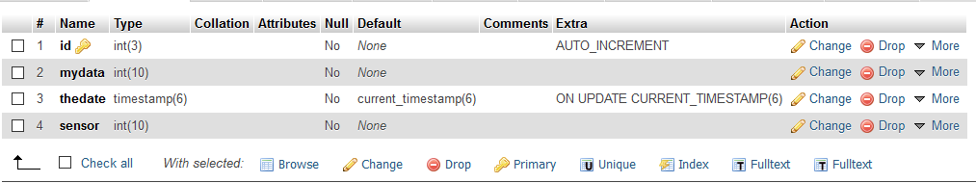

The second table setup was called ‘users’ and was used to store the details of the users logging into the system. The fields created in this table can be seen below. Each user had an ID primary key set against the user details.

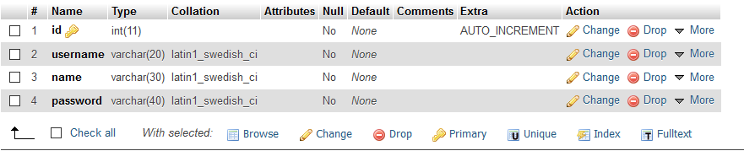

Web Interface Design
The login page shown below was designed as the landing page displayed to the end users when they accessed the system. A CSS style sheet was used to customise the font and colour of the login page to make it more visually appealing.

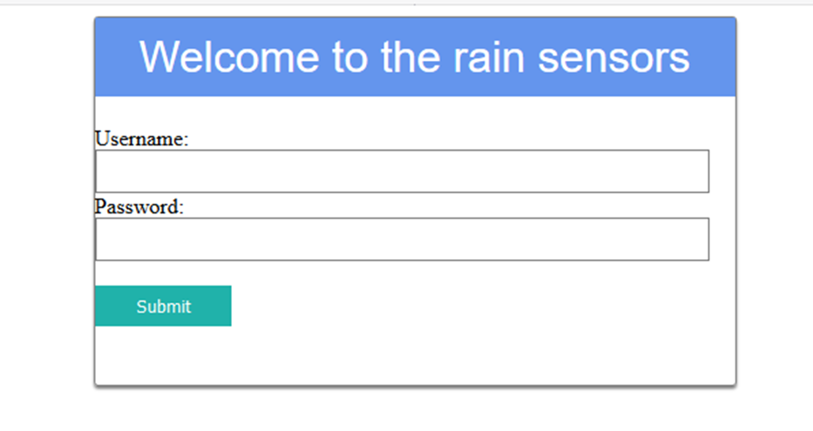

The user is prompted to login using a HTML form, which asks for a username and password to be entered before clicking on the submit button. On submitting the form, the check.php script is run and checks if the username and password entered were found in the ‘users’ table that was created in the SQL database. If the user and password entered existed, the user would be logged in successfully and notified of this. They would also have the option to navigate to the search page or transfer data from the sensors. If the details entered were incorrect, the user would be informed on this and returned to the login page to try again. An extract of the script can be seen below.

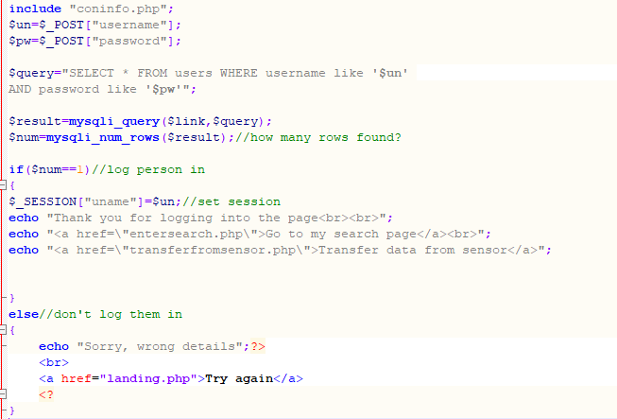

Once logged into the system, the HTML page below would be displayed. The user has the option to navigate to the ‘my search page’ or to transfer data from the sensors
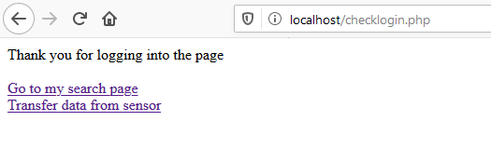

On clicking the ‘transfer data from sensor’ hyperlink, the transferfromsensor.php script would be run, which would pull the data from the 3-rainfall text into the rainfall table, and clear the data from the files. On completion, the user is informed that the data has been transferred and has been erased, and a hyperlink is displayed allowing them to navigate to the search page.

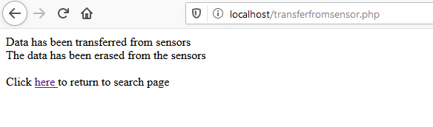
The transferfromsensor.php file was created to pull in the data from 3 text files. Three variables called myfile, myfile2 and myfile3 were declared at the start of the script.
The ‘fopen’ function with the ‘r’ argument was used to check each of the text files can be opened. If not, the user is promoted with “unable to open file!”
The ‘fread’ and ‘fclose’ functions were then used to read the data and close the text file.
The data was then stored in an array and the linebreaks were cleared off, the line of data read and split into 3 sections, a datastamp added , and then enter into the database.
The process above was done for all 3 rainfall text files, after which point the ‘fopen’ function with the ‘w’ argument was run to clear the data out of the files. At the end of the script, the user was promoted to say the data had been transferred from the sensors and had been erased. A HTML link was added to allow the user to navigate to the search page.

Extracts from the script are below
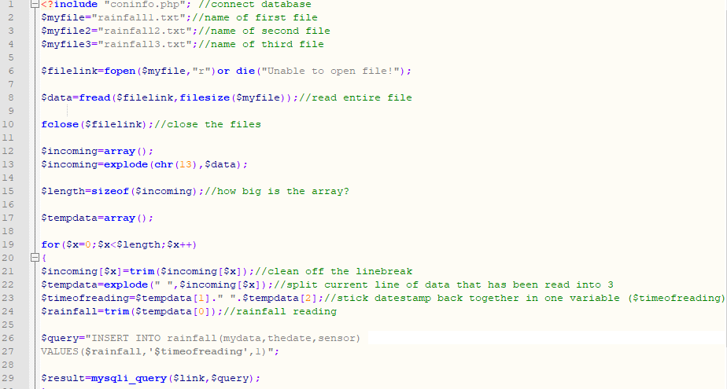

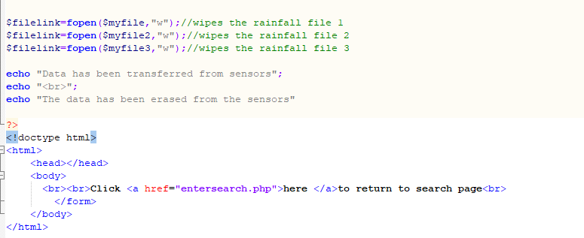

The search page was designed to allow the user to have a single page view of the searches available and to scroll up and down to view the graphs. The search page is shown below
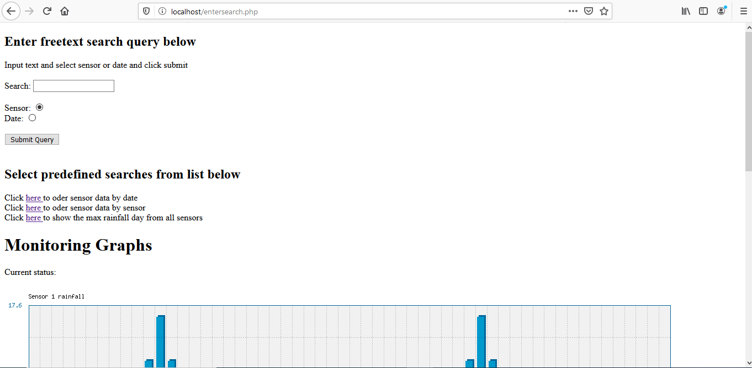

A free text search query is available with radio selections for ‘sensor’ and ‘date’. This allows the user to enter a specific sensor or date into the search box, with the results being displayed.
On clicking ‘submit query’ the showdatabase.php script is run. This would take the text entered and radio box selected on the form, and set them as variables $search and $ft. The sql query would then run across all fields within the rainfall table where the field type was as selected and the text was as per the search entered.
The results would be shown which included the ID, mydata, the date and sensor. If no results were found, the user would be shown ‘Sorry, nothing found’. An extract of the script is shown below.
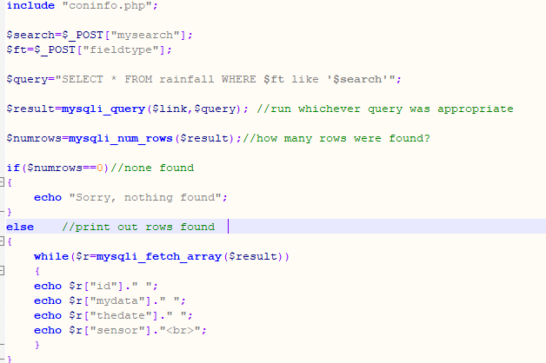
Three predefined searches were created which could easily be run by the user.
Search one was to order sensor data by the date across all three sensors. This would be a useful search, displaying the data from the sensors in date order.
The second search was to order the data by the sensor it came from, grouping the search results by sensor 1, 2 and then 3.
The third result created was to display the day with the maximum rainfall across all the sensors. This was a very useful search, which could be run as and when the sensor data is imported and changes.
The results were displayed to the user on screen and included all the fields in the table. The MAX query was used in SQL to determine the maximum value from the ‘mydata’ field. The ID, data, date and sensor with the maximum value were then displayed to the user. Extract from the php code is below.
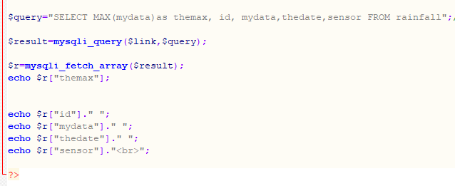
Finally, three graphs were created using phpMyGraph to provide the user with a visual interpretation of the data collected from the sensors. Each graph used was styled individually to give a varying array of data representation from sensors 1, 2 and 3
The first graph was a column graph and displayed the data from sensor 1, providing the sensor data reading as the Y axis and the date as the X.
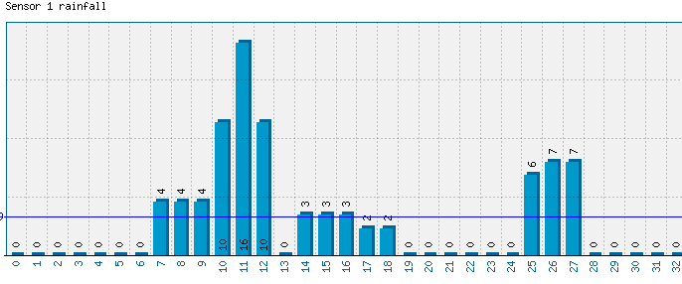
A separate script was created for each graph and configuration settings were set which included the title, width and high of the graph. The coninfo.php script was included to connect to the database. A SQL query was run to select the data from the rainfall table where the sensor was 1, 2 or 3. The data was stored in an array and the graph was then plotted onto a png image using the phpMyGraph script. A link to the graph image files were created on the search page so that the graphs were displayed under each other.
Vertical polygon graph and line graphs were used for sensor 2 and 3.


