Data Handling & Business Intelligence (LCBB5000_BIRM)

Lecturer: Zahra Mohammadnazari
Student: Sergiu Diaconu - 2126929

Table of Contents
Introduction 4
Dataset 4
Part 1 5
Part 2 10
Conclusion 14
References 15

Table of Figures
Figure 1: Calculations of Part 1 (a) 6
Figure 2: Trend of processing times for each tool 7
Figure 3: Frequency of Hadoop processing time 7
Figure 4: Pivot table of Average Processing time 8
Figure 5: Correlations between Hadoop and Tableau Processing time 8
Figure 6: Scatter plot of Tableau Processing time by Hadoop Processing time 10

Introduction
The "GreenMed_Healthcare_2023" dataset offers a careful assessment of the handling times given by a few legitimate huge information stages and innovations. Pioneer in medical care examination GreenMed Advancements directed this review to assess Hadoop, Flash, R, Python, and Scene's ability to oversee enormous datasets. The association's obligation to involving enormous information in understanding consideration arrangements required this broad examination. The broad measurable devices of Succeed and SPSS were utilized in its execution. GreenMed Advancements tries to upgrade its information handling techniques via cautiously examining key execution factors. Further developing patient results is the venture's definitive objective, exhibiting the fundamental job that productive information examination plays in the development of the medical services industry.
Dataset
The information being offered gives day to day handling speeds for five particular enormous information devices: Hadoop, Flash, R, Python, and Scene. It traverses the long stretches of January through February of 2023. The fastidiously organized information delineates the varieties in execution that each instrument encounters throughout a day, demonstrating the functional viability and trustworthiness of every gadget. Hadoop_ProcessingTime, Spark_ProcessingTime, R_ProcessingTime, Python_ProcessingTime, and Tableau_ProcessingTime are significant markers that give a far reaching perspective on what amount of time every innovation requires to handle information. This transient picture is critical to GreenMed Developments since it could assist them with coming to vital conclusions about how to best augment their large information examination to work on understanding results.

Part 1
a) Analyzing the GreenMed_Healthcare_2023 dataset will give a far reaching image of how well the different information examination devices utilized by GreenMed Developments perform. The objective of this exploration is to reveal insight into Hadoop, Flash, R, Python, and Scene handling times, which are all fundamental for augmenting the viability of the business' information driven medical care contributions (Hendrian, Julaeha, and Ardiansyah, 2023). It is normal that the bits of knowledge gathered from this examination will work on persistent results and viability.
1. Mean Processing Time for Hadoop
The Hadoop handling time normal for the example is 2.777 seconds. This measurement, which demonstrates the typical time that Hadoop spends handling information in a given day, is vital for figuring out the device's general viability. As found in the realistic, Hadoop is appropriate for errands that don't demand constant examination on the grounds that to its unobtrusive handling time.
2. Median Processing Time for Spark
The typical reaction time for Flash is 2.747 seconds. A rundown of numbers' center worth, or middle, diminishes the effect of exceptions and gives a more reliable proportion of focal propensity. Considering that over portion of the handling spans are underneath this end, Flash seems to work rather reliably.
3. Highest Processing Time for R
R showed a greatest handling season of generally 4.867 seconds on January 16, 2023. This pinnacle might demonstrate a computationally burdening task that day or a likely bottleneck. These abnormalities require examination since they might highlight basic issues or explicit situations in which R isn't the most fitting device.
4. Standard Deviation for Python Handling Time
For Python, the standard deviation of handling time is roughly 1.297 seconds. This number demonstrates the level of variety from the mean. At the point when the standard deviation is lower, Python's handling speeds appear to be less flighty, proposing a more steady exhibition.
5. Tool with the Lowest Average Processing Time
Python is the apparatus with the least typical handling time, getting started at 2.573 seconds. In view of its effectiveness, Python might be picked for information handling in GreenMed over different choices, particularly for assignments where there's no time to waste. Notwithstanding, other execution models, for example, the intricacy of the undertakings that each device can execute, should likewise be thought of.
6. Interpretation of Handling Time Contrasts
The distinctions in handling times between these devices can be credited to various elements, including the sort of information examination assignments for which they are planned, the intricacy of the datasets, the computational productivity of the calculations each apparatus utilizes, and the equipment foundation on which they are working. Python's simpler administration of certain information handling assignments and appropriate libraries, for example, may represent the language's below handling time. On the other hand, circulated registering stages, for example, Hadoop and Flash might display longer handling times because of information transmission across an organization.
The examination features that it is so vital to consider the specific information handling prerequisites of each task and helps with choosing the most ideal device to get everything taken care of. For instance, while having longer handling times, Flash or Hadoop might be picked for dispersed figuring jobs because of their solid treatment of huge datasets. In any case, in view of its enormous environment of information science bundles and higher handling rates, Python may be a superior choice for applications requiring fast, iterative information handling systems.
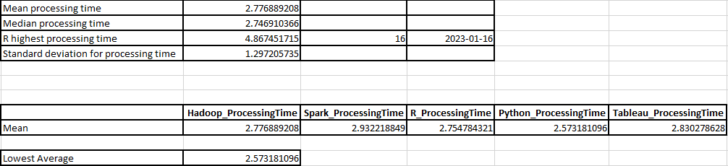

b) The GreenMed dataset examination tells the best way to exquisitely report the information handling times for different insightful devices by skillfully using Microsoft Succeed's highlights (Setiyanto and Setiawan, 2022). The handling times for each apparatus over the long haul on various days are shown utilizing line outlines in the report. This realistic portrayal causes to notice the distinctions and examples, working with a quick cross-fleeting exhibition correlation. The line graph is a simple strategy to follow the ascent and fall of handling times, finding days that have odd highs or lows that might require more examination. It has plainly variety coded lines for Hadoop, Flash, R, Python, and Scene.
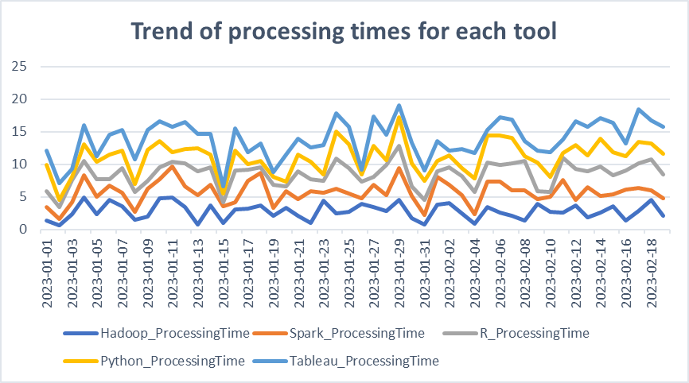
Besides, a very much planned histogram investigates the handling time recurrence conveyance of Hadoop. This perception gives a reasonable viewpoint of the most well-known handling time stretches while featuring the focal inclination and circulation of the information by binding the scope of handling times. This kind of histogram is an essential device for sorting out the normal working reach and distinguishing any peculiarities or exceptions in Hadoop's presentation.
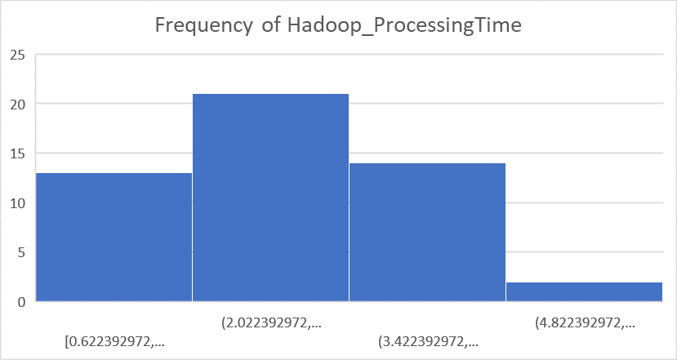
Moreover, turn tables are utilized to give month to month and by and large midpoints of handling times for each instrument, gathering the colossal numbers into a reasonable viewpoint. This even total, worked with by Succeed's turn table capability, empowers a careful comprehension of hardware effectiveness and lays the basis for an organized examination by looking at the month-over-month contrasts.
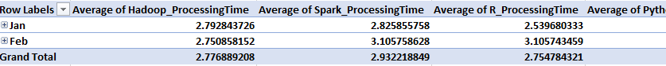

By consolidating turn tables for information conglomeration and outlines for graphical information show, the report goes past fundamental information revealing. It is a complete story that quantitatively and refines the dataset, transforming numbers into stories that are pertinent to GreenMed Developments' day to day exercises. At the point when joined, the plain and visual amalgamations give light on the perplexing elements of handling time execution and empower information driven decision-production for better quiet consideration.
c) Part 1:
In the mind boggling domain of information examination, appreciating the synchronization between various factors is basic. GreenMed Developments' investigation of Hadoop and Scene handling speeds delivered a connection examination, the consequences of which are informational and engaging.
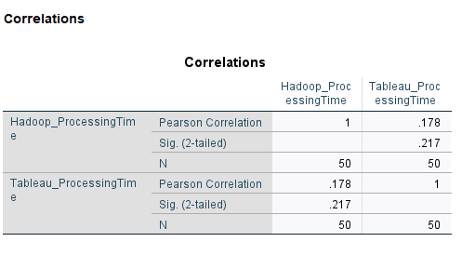
The Pearson affiliation Coefficient, a strategy that actions the direct relationship between two factors, is utilized to survey the connection among Hadoop and Scene's handling times. These two instruments appear to have a feeble yet certain straight connection, with a relationship coefficient of 0.178. This powerless connection demonstrates that there might be a slight propensity for Scene's handling time to increment somewhat in lined up with Hadoop's handling time.
Moreover, the noticed association is measurably not huge on the grounds that the two-followed importance worth of 0.217 is higher than the traditional alpha models of 0.05. This suggests that there isn't sufficient data to proclaim with certainty that there is a connection among Hadoop and Scene's handling rates, given the setting of the information explored.
Past information investigation, consideration is started by the human translation of these measurable discoveries (Guerrero, Guerrero, and Rauscher, 2019). It proposes a story where the two heavyweights of the huge information handling area, Hadoop and Scene, dance to the beat of their own drums, sometimes moving as one however principally separated. This independence could originate from the different utilitarian spaces that each device involves; Scene, with its skill in information perception, and Hadoop, with its strong information handling framework, are suitable for various phases of the information examination process.
GreenMed Developments could find that the low relationship demonstrates that picking Scene or Hadoop for a specific information handling task will not fundamentally affect the presentation of one instrument. Understanding that concurrent tasks utilizing the two apparatuses are probably not going to fundamentally influence each other's handling terms ought to help the organization better arrangement and distribute its assets.
In the wide image of information examination, where each device should be appropriately picked for its expected use, such bits of knowledge are fundamental. They help GreenMed Advancements in making an effective work process where each apparatus can be used to its fullest potential without waiting be worried about execution decay brought about by between device handling time conditions. Accordingly, GreenMed is prepared to satisfy the needs of enormous information examination, guaranteeing that patient consideration is upheld by productive and convenient information handling.

Part 2:
To investigate the connection between the handling paces of the two projects, a scatterplot was built, where the level pivot addresses Hadoop's handling time and the upward hub addresses Scene's (Kafle, 2019). The scatterplot is a measurable visual story that shows the circulation of spots on a material, every one of which means an alternate crossing point of the handling times of the two devices on a given day.
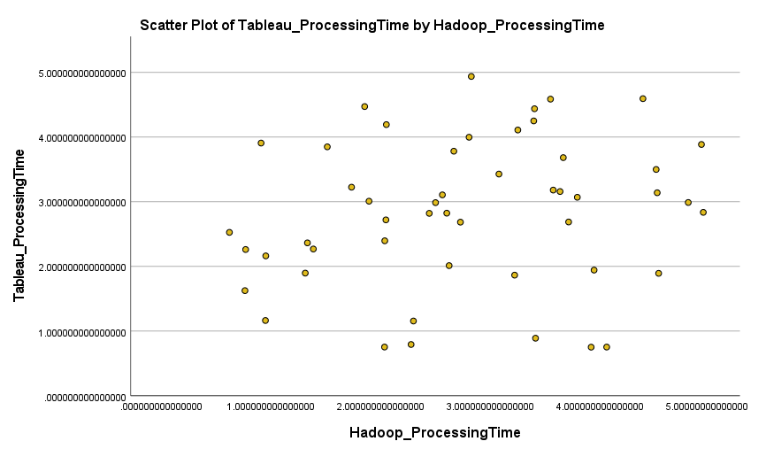
The situation we are seeing portrays a story of roundabout connection instead of a powerful connection between the two factors. Dissipated across the plot, each dab goes about as a solitary sentinel, with simply a slight rising direction detectable as we stroll from left to right along the Hadoop hub. The recently referenced positive affiliation is upheld by this slight expansion in Scene's handling times in contrast with Hadoop's development, but it's even more a mumble rather than an uproarious tune.
The region involved by each point on the diagram, which is unconstrained by a tight straight design, is its most striking element. This realistic portrayal likewise upholds the factual outcomes: A relationship between's two factors that could precisely foresee changes in one probably won't be suggested by a Pearson Connection Coefficient of 0.178. Rather than a thick group of specks around a line of best fit, which would propose a high connection, the scatterplot shows a heavenly body of information focuses that recommend freedom with the potential for a powerless affiliation.
This scatterplot has direct yet significant ramifications for GreenMed Advancements. It recommends that Scene's functional efficiencies and Hadoop's are not profoundly associated. This freedom is an aid since it permits the medical services pioneer to completely use any innovation without being compelled by the reliant requests of effectiveness. Hadoop's information handling limit might influence Scene's perception timings without consistent thought, as well as the other way around.
a) Advantages and Disadvantages of SPSS, Excel, and Tableau
SPSS (Statistical Package for the Social Sciences):
Advantages:
- Advanced Statistical Analysis: SPSS is renowned for its robust statistical capabilities. It excels in conducting complex statistical analyses such as ANOVA, regression, and factor analysis. For instance, in healthcare analytics, researchers might employ SPSS to analyze the effectiveness of different treatments based on patient outcomes.
- Data Accuracy and Robust Testing: SPSS ensures accuracy and reliability in statistical testing, making it suitable for sophisticated medical research. Researchers at GreenMed Innovations can trust SPSS for precise statistical outcomes, which is crucial for making informed decisions in patient care solutions.
Disadvantages:
- Steep Learning Curve: SPSS may be challenging for beginners due to its complexity. Staff at GreenMed Innovations might need extensive training to utilize SPSS effectively, incurring additional costs and potentially delaying the integration of this tool into daily operations.
- Costs: The licensing fees associated with SPSS can be high. For a business like GreenMed, which may not require complex statistical techniques for every task, the investment in SPSS might be seen as an expensive undertaking.
Excel:
Advantages:
- Versatility: Excel is widely known for its versatility. It is a common tool in the commercial sector and is extensively used for various tasks, including spreadsheet management, budgeting, and organizing patient data. GreenMed's administrative staff can benefit from Excel's familiarity and user-friendly interface.
- Accessibility: Excel's accessibility is a key advantage. Professionals across various domains are familiar with its features, making it an ideal choice for general data management tasks. GreenMed's administrative tasks, such as scheduling and budgeting, can be efficiently handled using Excel.
Disadvantages:
- Limited Handling of Large Datasets: Excel has limitations when dealing with large datasets. It may experience performance issues and is not meant for massive data sets. In scenarios where GreenMed deals with extensive patient data, Excel's capabilities may fall short.
- Basic Statistical Capabilities: While Excel provides essential statistical tools like pivot tables and charts, its statistical capabilities are not as advanced as those offered by dedicated statistical software like SPSS. For in-depth scientific research requiring substantial datasets, Excel might not be the most suitable choice.
Tableau:
Advantages:
- Data Visualization Mastery: Tableau is a visual analytics platform, excelling in transforming complex data into visually engaging stories. GreenMed can leverage Tableau to create interactive dashboards presenting patient outcome information, making it easier for stakeholders to derive actionable insights.
- Handling Larger Datasets: Tableau is adept at handling larger datasets, providing a visual representation of data trends. In healthcare analytics, where extensive datasets are common, Tableau's capacity to handle larger volumes of data is advantageous.
Disadvantages:
- Cost and Training: Tableau can be costly, and its specialized features may require staff training. For a smaller company like GreenMed with limited resources, the investment in Tableau, both in terms of cost and training, may be a drawback.
- Limited Statistical Depth: Tableau primarily focuses on visualization and may not offer the same depth of statistical analysis as dedicated statistical software. For GreenMed, where statistical rigor is essential, reliance solely on Tableau might be limiting.
b) Importance of Data Governance with Examples:
Data governance is crucial for ensuring data accuracy, safety, and usability. In the healthcare sector, particularly for organizations like GreenMed Innovations, the importance of data governance cannot be overstated.
Examples:
- Patient Data Protection: GreenMed deals with sensitive patient data, including treatment plans and medical histories. Data governance policies are essential to comply with regulations like HIPAA, safeguarding patient confidentiality and building trust. Without robust data governance, there is a risk of data breaches, compromising patient privacy.
- Research Data Quality: GreenMed may engage in various research projects. Data governance ensures that information collected for research is accurate, dependable, and verifiable. For instance, in a clinical trial, adherence to data governance rules guarantees the reliability of patients' responses to a new medication, ensuring the integrity of the research findings.
- Data Democratization: Data governance extends beyond protection to include data democratization. It ensures that non-technical personnel, like marketing analysts, have access to data without compromising its integrity. For GreenMed, this means that accessing patient demographic data and customizing health programs doesn't require high IT expertise, promoting collaboration across different departments.
- Preventing "Garbage In, Garbage Out": In data analytics, the quality of the insights derived is directly linked to the quality of the data input. Data governance prevents the issue of "garbage in, garbage out" by ensuring that data used by analytics tools is of the highest quality. This is critical for GreenMed to make informed decisions based on reliable data.
- Creativity and Collaboration: Data governance fosters creativity by providing a secure and well-managed environment. GreenMed can engage in joint research, build partnerships, and communicate confidently with stakeholders, knowing that data governance policies protect their interests and comply with ethical and legal obligations.
- Balancing Accessibility and Security: Data governance involves a delicate balance between accessibility and security. It ensures that data is accessible to those who need it while maintaining control to prevent unauthorized use. This is particularly important for GreenMed, where different teams require access to specific datasets for their respective tasks.
In conclusion, data governance is an integral part of effective healthcare data management. It ensures the protection of patient information, maintains research data quality, promotes data democratization, prevents data quality issues, and fosters creativity and collaboration. For GreenMed Innovations, these examples underscore the critical role of data governance in supporting data-driven decision-making and enhancing patient outcomes.
s is significant since the consequences of patient consideration rely upon the convenient and compelling understanding of information.

Conclusion
GreenMed Developments utilized the "GreenMed_Healthcare_2023" dataset to inspect various information handling techniques. The investigation shows how Hadoop, Flash, R, Python, and Scene are not quite the same as each other with regards to overseeing enormous datasets. The examination stresses the advantages and downsides of each device concerning handling capacities and rates, and it likewise exhibits that it is so vital to match the right instrument to the particular requirements of an information driven medical services project. The fastidious way where GreenMed has utilized these instruments to upgrade patient consideration and drive medical services investigation highlights the need of doing effective and custom fitted information examination.

References
Abraham, R., Schneider, J. and Vom Brocke, J., 2019. Data governance: A conceptual framework, structured review, and research agenda. International journal of information management, 49, pp.424-438.
Booker, Q.E., Rebman Jr, C.M., Powell, L., Wimmer, H., Breese, J. and Levkoff, S., 2023. Data Analytics Position Description Analysis: Skills Review and Implications for Data Analytics Curricula. In Proceedings of the ISCAP Conference ISSN (Vol. 2473, p. 4901).
Guerrero, H., Guerrero, R. and Rauscher, 2019. Excel data analysis. Springer International Publishing.
Hendrian, S., Julaeha, S. and Ardiansyah, M., 2023. Pengaruh Penerapan Teknologi Informasi Pembuatan Ap-likasi Raport Berbasis Microsoft Excel Terhadap Kemampu-an Tenaga Pengajar SMP Bina Bangsa Mandiri Di Gunung Putri Bogor. JPT: Jurnal Pendidikan Tematik, 4(1), pp.171-176.
Janssen, M., Brous, P., Estevez, E., Barbosa, L.S. and Janowski, T., 2020. Data governance: Organizing data for trustworthy Artificial Intelligence. Government Information Quarterly, 37(3), p.101493.
Kafle, S.C., 2019. Correlation and regression analysis using SPSS. Management, Technology & Social Sciences, 126.
Setiyanto, S. and Setiawan, I., 2022. Data science with excel. International Journal of Computer and Information System (IJCIS), 3(3), pp.104-110.
Xu, J. and Garfield, M., 2023. Analytics for an Audience of Healthcare Professionals: Curriculum Design and Student Perceptions. In Proceedings of the ISCAP Conference ISSN (Vol. 2473, p. 4901).

