Project Management Plan
Managing Projects in the Workplace BMSW 5104

Generations A 2 Z
Bionics Multivits©®

28/03/2022
Student name & NUMBER: abdul wahid ullah - 1912519
LECTURER: DAMINABO POKUBO AND ISAIAH OINO

TABLE OF CONTENTS

- Table of Contents
- Executive Summary
- Introduction
- Project Outline
- Project Scope
- Characteristics of Project Manager
- Stakeholders Analysis
- Work Breakdown Structure
- Benefits of Communication Methods
- Risk Assessment
- Conclusion.
- References
- Appendices

2. Executive Summary

This report’s objective is to critically examine and implement the project management plan of the launch of Generation X Bionics Multivits, a new multi vitamin supplement range. A detailed and structured plan has been implemented by using and evaluating the correct detailed project definition tools like scope, time, budget, and quality. Plus, the implementation of planning tools, of risk assessment, schedule, and other techniques to execute the project management plan. The new launch of this exciting new multi vitamin supplement that will appeal to all ages. The report has concluded a thorough research into market segmentation and backed by the stakeholder, the pharmaceutical company. The multi vitamin supplement will be re-branded and have a wider appeal in its market segmentation. It will be relaunched as a major player in the industry. Rightfully claiming dominance in the markets as well as supplying to one of our biggest stakeholders, the NHS. From the conception of project outline, scope, stakeholders’ analysis, and risk assessments and much more, the report will conclude with summary of the project management and its success.

3. Introduction

The project management plan was given to my team to launch its new multi vitamin tablets. The definition of project management (PM), according to Project Management Institution, (PMI) defines a project as
“A temporary endeavour undertaken to create a unique product, service, or result” (Snijders et al, 2013, p. 5).
This helps projects to be more effective and efficient, by logically using the right tools to achieve the right activities and deliverables. Activities and deliverables aid a service or product to be launched, these are components, that help a project management plan, such as time, stakeholders, scope, information and more. These activities define the outcomes of the project. Mentioned by (Roberts, 2011) “These defined deliverables that serves in a much better way than before.”
He also mentions that the “deliverables must be of sufficient quality to serve its intended purpose”. (Roberts, 2011).
Project management according to Hughes (2012), “project management are groups of related activities to achieve a specific objective”. (Roberts, 2011) describes a project management as,
“A Successful project is a temporary management environment created to produce a specified deliverable which, when used, leads to benefits which outweigh the investment made in its development and operation”. (Roberts, 2011, p.12)
“The multi vitamins industry is worth over $4549.7 million and it is said to increase to $4753.3 million in 2026”, mentioned in Market Watch (2022). And according to AsianPolyGlotView (2022) the global vitamin E product is to reach $2.17 Billion by 2026. The report will identify that a favourable brand is missing that would appeal to a wider market, in all generations, and demographics. Although there are thousands of brands and health shops selling multi vitamin supplements, they only target an older or a specific demographics.

4. Project Outline
The increasing sales of multi vitamin tablets and supplements have drastically increased since the Covid 19 pandemic and is set to rise according to a report, by ReportLinker (2022). This would be the ideal opportunity and time to launch this exciting new brand of multi vitamins. Henceforth, the project management plan has considered these external factors by implementing the Porters Five Forces Model (1979), see appendix 1. The objective is to re-brand and re-launch a new Multi Vitamin brand, that previously was futile by the stakeholder and sponsor the pharmaceutical company. The product has already been tried and tested and have various types of tablets and gummy vitamins for children. So, the product is ready on the shelves, to be re-branded, implementing an advertisement campaign and engaging with our stakeholders, is our main activities to achieve our objectives and goals. Our sponsor the major stakeholder the pharmaceutical company now have asked my team to expedite the launch of the exciting new multivitamin. In addition is to supply to one of our biggest stakeholders in their recruitment catalogue of procurements at the NHS. The project life cycle, see figure 3, the project scope is to have this product on the market in 12 months.
Project Management are key components that all work together to synchronise to attain one outcome to establish all its goals within budget, time, and quality. (Baker and Baker, 2014). See figure 1.

Investment
Policy measures
Stakeholders
People/Organizational Systems

IMPACT
Resources
Time
OUTCOME

Figure 1

Due to the previous unsuccessful launch of this multivitamin by the pharmaceutical company, they have now hired my team to help launch the new brand supplement. After the performing stage of Tuckman’s (1965), The Team Formation Life Cycle (see appendix 2), we decided to re-brand and re-launch the supplement on the market with advertisement campaigns. Samples will be given to the NHS and health groups and to some selected generational groups to sample and endorse the product. Due to a huge demand on multivitamins after the Covid 19 pandemic. Market research was conducted into market segmentations. The report came back as there is no generic brand that appealed to all, rather only the elders and specific demographics. (See Appendix 3 & 4).

5. Project Scope
What is scope? Scope is the timeline of the project from start to finish. The Iron Triangle or Project triangle have all the elements of time, quality and cost that is scope. The iron triangle is a project management tool. The three features are defined as a business case and set out in the business brief. See figure 2. The three fundamentals of the Iron Triangle for the project are:
- It must meet the strict quality requirements
- The project finished at the budgeted cost
- The project completed on time per schedule
All these three defined criteria’s must be met to attain the project scope.
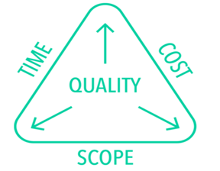
The iron triangle was conceived to help Project Managers to solve and assess the demands of cost, time, and quality in their project while trying to attain the aim of the project scope.
“The three objectives of the project are in fine balance, and everyone must be clear about changes to the specification of the project and changes to the deliverable.” (Reiss, 2007, p. 38)

Figure 2
“The work that must be performed to deliver a product, service or results with specified features and functions” according to (PMI, 2006; p.385). Scope looks at a project from start to finish, and the intended work packages and activities, that is needed to achieve the milestone, objectives, and goals to the finish line. See figure 3.

The Project Life Cycle of Generation A 2 Z Bionics Multivits
Generations A 2 Z Bionics Multivits®
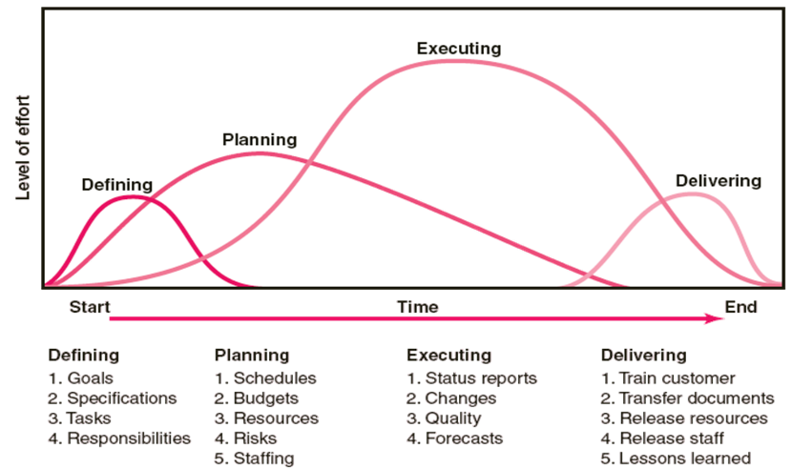
Initiation Close Out

Control/Evaluate/Monitor
Time 12 Months Months

Figure 3

The Project scope from start to finish date is 12 months. The products have already been manufactured, due to the previous unsuccessful launch of the product by the pharmaceutical company.
The scope planning actions, and deliverables have been implemented by
- A product analysis
- A cost/benefit analysis
- Recommendations have been made
- Alternatives have been identified. (See Appendix 5 & 6)

According to (Heagney, 2016, p.67) “Vision is what the final result will “look like.” It defines “done. “The mission is to achieve the vision. It answers the two questions “What are we going to do?” and “For whom are we going to do it?” Objectives should be SMART. (See Appendix 7).
Our mission, vision, goals, and objectives have been defined. We are to rebrand and relaunch the product. Appeasing to wider audience and market. Finalising a deal with our stakeholder the NHS with their procurements department. This product will appeal to the health conscious, millennials, and all generational demographic groups, on time and within the budget. See figure 3.

6. Characteristics of Project Manager
As the acting appointee of the role of a project manager, it is vital the qualities of manager who is exercising his role is executed diligently but effectively and efficiently.
Turner (1993) states that, a Project Manager are obliged to have at least four of the listed attributes below:
- Communication
- Initiative and Energy
- Negotiating
- Problem solving and results attitude
- Perspective
- Believing in oneself
In leadership and management, planning is a management element, whilst Direction Setting is a leadership element. While planning is a deductive activity that makes plans and creates budgets. Identifies and removes risks and creates order. Direction setting is inductive activity that creates visions and builds strategies. Makes changes overtime. Having to take risks. With a longer time, focused activity and sometimes disrupts the current order. The project manager (PM) must show stability in uncertain times. PM needs to show constraint by managing time, problem solving, always evaluating and monitoring. Whilst observing the quality and budget expectations. (Roberts,2011). Leadership of the project manager adheres to the three components to equip a specific deliverable. Success will be attained by focusing on the end deliverables. Although there are many team members in a group, some individuals may not present oneself practically as there maybe many egos and protagonists in a team.
“An improved understanding of yourself and your stakeholders will lead to more efficient communication and better project leadership decisions”. (Heagney, 2016, p.188)

7. Stakeholders Analysis
Stakeholders are anyone that has an avid interest in the project, connected by funding, financing, or by expressing their views and ideas and want something in return. It is vital that stakeholders need to be informed by explicating the project.
It is good practice to engage and establish the aims and goals of the project with all stakeholders involved, thus eliminating issues and problems later. It is also a great idea to have a plan of the 5-point stakeholders engagement plan, according to (Clayton, 2021)
- Identify – the stakeholders and their objectives to the project
- Analyse – the stakeholders and resources given to the project
- Plan – the stakeholders engagement process and the communication plan (see appendix 8 and 12)
- Act – By putting the plan into action, listening, reacting, and learning from stakeholders’ responses
- Review – creating a cycle by examining what was learnt to make further progress. (See appendix 8)
Also mentioned by (Heagney, 2016, p.47) “Regardless of how the role is defined, project stake-holders must be identified and then managed throughout the life of the project because they have a direct effect on whether your project will succeed or fail”.
According to Paul (2011), he describes three fundamental characteristics of a good project manager is by engaging with stakeholders, planning and control and managing risks.
Stakeholders can be managed by asking 3 simple questions according to (Heagney, 2016, p.49),
- Who benefits from the project?
- Who contributes to the project?
- Who is impacted by the project?
By deducting the answers to the questions. All the stakeholders do not need to be informed of a particular communication. They can be identified by deducing the most important principal stakeholders and action communication respectively by hierarchical order.

By actioning these comprehensive activities and examining the stakeholders and their respective importance. It is imperative a stakeholder’s analysis should be implemented in the project management plan. (See appendix 9).

8. Work Breakdown Structure
A work breakdown structure, known as WBS is a tool that breaks the work down in a structured way. The project is broken down from the principal component to many other components. These then become tasks or activities for a person who is responsible to undertake those principal task or activities. (See appendix 10).
According to Heagney (2016), the WBS can be subdivided into smaller tasks to a level that cannot be subdivided any further. At this stage it is easier to understand and estimate how long and how these smaller tasks are to be performed, than it would be to evaluate these factors at the initial upper levels. There is various technique for preparing the WBS.
- Top-down approach – primarily identifies the solution first and then the solution is scrutinised into gradual steps for implementation.
- Bottom-up approach – task that needs done to be completed. It is a good brainstorming solution to a problem.
- Mind-mapping approach – many specialists and project managers use this technique. The task is written in non-linear, branching format creating the WBS.
The WBS used in our project management plan is a top-down approach. It is important that whilst implementing your WBS, it is also important acting on Controlling Scope. Scope control includes techniques in controlling changes to project scope. (See appendix 11).

9. Benefits of Communication Methods
There are various methods of communication from verbal – by discussions, talking in meetings or having a heated disagreement or argument. Non-verbal can be observing someone’s body language. Other communication methods via your electronic devices, computers accessing emails, faxes, or talking. Written communication method can be in a form of a letter, memos, faxes, and letters. Presentations and videos can also be a form of audio-visual communication method. Communication can be hindered by the notion of perception, language, jargon, ambiguity, and an overload of information. A huge percentage of the project plan is all about communication. So, it is imperative that PM has good communication skills that stakeholders can understand clearly and succinctly and to the point, according to Buttrick (2009).
“Project managers and team members must predetermine how stakeholders should interact to achieve maximum efficiency as they move through the project life cycle”. (Heagney, 2016, p.81).
By leading a team successfully is by understanding the differences. The source of misunderstanding and conflicts arise from team members personal styles, egos, and protagonists. The team’s efficiency and performance can be increased if the PM identifies and resolves these issues from the start of the project and implementing a communications plan. (See appendix 12).

10. Risk Assessment
Risks are potential threats to the success of the project. The consequences of neglecting risks can be very detrimental to the project. This can be put down to by neglecting risks, lack of time to rectify problems or mistakes, stress, and many other factors. To eliminate PM needs to identify and predicting risks. Planning and having a wealth of experience helps. By anticipating risks having a contingency plan and controlling risks is paramount.
“A clear under-standing of the risks that face the project must be established. The sources of project risk are almost limitless, emphasizing the need for a well-thought-out, detailed plan. Typical examples include the loss of a key team member, weather emergencies, technical failures, and poor suppliers.” (Heagney, 2016, p.70).
It is vital then to implement a Risk Management Plan. Plans can be made but events beyond our control can scupper any plans, for example the Covid 19 pandemic. Its impossible to eliminate risks but can make responsible decisions when risks are identified. Risk management reduces the chance of something bad from happening and limit the effects when they do happen. The formal Risk Management Process highlights these points:
- Risk identification – project, product, and business risk.
- Risk analysis – estimation of likelihood of occurrence.
- Risk evaluation – plan to avoid or lessen the effects of the risks.
- Risk planning/monitoring – plan to mitigate the effects of risks and monitor the risks for entirety of The Project Life Cycle.
To counteract risks, it is a good idea to put in policies and procedure, training with supervision and monitoring. Clear roles, expectations and boundaries must be set.
These risks have been anticipated and have been implemented and a risk management have been concluded in the project management plan. (See appendix 13).

11. Conclusion
To conclude the project should be completed according to the project life cycle, aiming to complete all tasks in the specified time, evidently to avoid scope creep. Whilst focusing on each product activity and deliverables, each activity should be done in a timely manner with the aim of all deliverables being attained. Thus, the project will gain traction and will head in the right trajectory. Identifying and anticipating any risks in the project is essential. By conducting a risk assessment plan, plus having a contingency plan is vital to the success of the project. It is also imperative that all stakeholders are informed respectively. Keeping them engaged, in the entirety of the project life cycle, by always staying in continuous communication is key. This is because the stakeholders are the key to the project success or failure.

12. REFERENCES

2022. communication-plan. [image] Available at: <https://simplicable.com/new/communication-plan> [Accessed 7 April 2022].
2022. Iron Triangle. [image] Available at: <https://www.bing.com/images/search?view=detailV2&ccid=w9Px%2FAvt&id=3548A552970553533D054E077E3BE9C16BE4668E&thid=OIP.w9Px_AvtLWhNwy_UnqlyLAHaEp&mediaurl=https%3A%2F%2Fcdn-images-1.medium.com%2Fmax%2F1600%2F1*Su1bnrGz2WdTChT87HBhgA.png&cdnurl=https%3A%2F%2Fth.bing.com%2Fth%2Fid%2FR.c3d3f1fc0bed2d684dc32fd49ea9722c%3Frik%3Djmbka8HpO34HTg%26pid%3DImgRaw%26r%3D0&exph=375&expw=597&q=iron+triangle+project+management&simid=608016757770037285&form=IRPRST&ck=5EC011BEBFA15858A14929B28227293C&selectedindex=10&ajaxhist=0&ajaxserp=0&vt=0&sim=11> [Accessed 1 April 2022].
2022. Product Market Segmentation. [image] Available at: <https://www.bing.com/images/search?view=detailV2&ccid=jNxLLBHp&id=A25EB0436603CE5327096B49B16CDA1A45FD28D7&thid=OIP.jNxLLBHpPstkOs0FoiPPJgHaEb&mediaurl=https%3A%2F%2Ftextimgs.s3.amazonaws.com%2Fmktprinc%2Fsection_05%2F8cdc4b2c11e93ecb643acd05a223cf26.jpg&exph=695&expw=1161&q=market+segmentation+fo+a+new+product&simid=608021039864503323&form=IRPRST&ck=A4FE617DF51E3DCA7F533CD037AABCD4&selectedindex=14&ajaxhist=0&ajaxserp=0&vt=0&sim=11&cdnurl=https%3A%2F%2Fth.bing.com%2Fth%2Fid%2FR.8cdc4b2c11e93ecb643acd05a223cf26%3Frik%3D1yj9RRrabLFJaw%26pid%3DImgRaw%26r%3D0> [Accessed 4 April 2022].
2022. Product Work Breakdown Structure. [image] Available at: <https://www.bing.com/images/search?view=detailV2&ccid=%2b%2bNtHk6N&id=BF344C594995491B6A4DB335EC771D6CF2EEE611&thid=OIP.--NtHk6Nicd6ebDXlRgbfgHaEB&mediaurl=https%3a%2f%2fwww.bstemplates.com%2fwp-content%2fuploads%2f2018%2f09%2fproduct_work_breakdown_structure_diagram_7.png&cdnurl=https%3a%2f%2fth.bing.com%2fth%2fid%2fR.fbe36d1e4e8d89c77a79b0d795181b7e%3frik%3dEebu8mwdd%252bw1sw%26pid%3dImgRaw%26r%3d0&exph=464&expw=854&q=product+work+structure+diagram&simid=607989128262482710&FORM=IRPRST&ck=4A2E906119C91270821FC71A7717F33B&selectedIndex=0&idpp=overlayview&ajaxhist=0&ajaxserp=0> [Accessed 4 April 2022].
2022. Segmentation, Targeting, Positioning. [image] Available at: <https://www.bing.com/images/search?view=detailV2&ccid=EoDj4thH&id=7A9118C2865081E9977E50FFC34EAD815631483B&thid=OIP.EoDj4thHQXbehQeuwtZl8AHaEn&mediaurl=https%3A%2F%2F1.bp.blogspot.com%2F-V3V2kLAB_TA%2FVCO9pVbvjXI%2FAAAAAAAAAKA%2FCVFdMZ6cdO4%2Fs1600%2Fsegmentation-targeting-positioning-business-diagram-1-728.jpg&exph=454&expw=728&q=market+segmentation+fo+a+new+product&simid=608030467310299848&form=IRPRST&ck=DA87121ECC3D347667E397F298E7E375&selectedindex=17&ajaxhist=0&ajaxserp=0&vt=0&sim=11&cdnurl=https%3A%2F%2Fth.bing.com%2Fth%2Fid%2FR.1280e3e2d8474176de8507aec2d665f0%3Frik%3DO0gxVoGtTsP%252fUA%26pid%3DImgRaw%26r%3D0%26sres%3D1%26sresct%3D1> [Accessed 4 April 2022].
2022. Tuckman's Linear Group of Development. [image] Available at: <https://pressbooks.bccampus.ca/technicalwriting/chapter/understandingteamdynamics/> [Accessed 4 April 2022].
AsianPolyGlotView. 2022. The Worldwide Natural Vitamin E Product Industry is Expected to Reach $2.17 Billion by 2026. [online] Available at: <https://asianpolyglotview.com/2022/02/the-worldwide-natural-vitamin-e-product-industry-is-expected-to-reach-2-17-billion-by-2026.html> [Accessed 1 April 2022].
Berkun, S. and Berkun, S., 2008. Making things happen. Beijing: O'Reilly.
Buttrick, R., 2011. Project Workout. 4th ed. Harlow: Pearson Education UK.
Chang, J.Y., Jiang, J.J., Klein, G. and Wang, E.T., 2019. Enterprise system programs: Goal setting and cooperation in the integration team. Information & Management, 56(6), p.103137.
Clayton, M., 2021. The Top 20 Stakeholder Analysis Techniques All PMs Should Know. [Blog] Online PM Courses Build Your Project Career, Available at: <https://onlinepmcourses.com/the-top-20-stakeholder-analysis-techniques-all-pms-should-know/> [Accessed 6 April 2022].
Finance.yahoo.com. 2022. Multivitamin Capsules And Tablets Global Market Report 2022. [online] Available at: <https://finance.yahoo.com/news/multivitamin-capsules-tablets-global-market-095500630.html?msclkid=43042952b42a11ec98d23282583d5414> [Accessed 4 April 2022].
Finance.yahoo.com. 2022. The Worldwide Natural Vitamin E Product Industry is Expected to Reach $2.17 Billion by 2026. [online] Available at: <https://finance.yahoo.com/news/worldwide-natural-vitamin-e-product-190000483.html?guccounter=1&guce_referrer=aHR0cHM6Ly93d3cuYmluZy5jb20v&guce_referrer_sig=AQAAACXs3M0vDhE7s-rKfdXR7Q6xWkMZHNJN7x1iiM0MK6a2VpC51iYGK93gcQOlIz1CGp57TJ__Yu66a5LLTOBAB0EDjUQn-rHieZqIEflDfmq03PA7RtKPQ-a5kieMEFzhpBwe1a_pAjsqhOX3vPRQylJsuHDc6X1OHoCQsUGAIwIz> [Accessed 4 April 2022].
Finance.yahoo.com. 2022. Yahoo is part of the Yahoo family of brands. [online] Available at: <https://finance.yahoo.com/news/worldwide-natural-vitamin-e-product-190000483.html?guccounter=1&guce_referrer=aHR0cHM6Ly93d3cuYmluZy5jb20v&guce_referrer_sig=AQAAACXs3M0vDhE7s-rKfdXR7Q6xWkMZHNJN7x1iiM0MK6a2VpC51iYGK93gcQOlIz1CGp57TJ__Yu66a5LLTOBAB0EDjUQn-rHieZqIEflDfmq03PA7RtKPQ-a5kieMEFzhpBwe1a_pAjsqhOX3vPRQylJsuHDc6X1OHoCQsUGAIwIz> [Accessed 28 March 2022].
Geoff Reiss (2007) Project Management Demystified. London: Routledge. Available at: https://search-ebscohost-com.ezproxy.uwtsd.ac.uk/login.aspx?direct=true&db=nlebk&AN=197231&site=ehost-live (Accessed: 6 April 2022).
Hughes, B., Ireland, R., West, B., Smith, N. and Shepherd, D., 2012. Project management for IT-related projects. 2nd ed. Swindon: BCS Learning & Development Ltd.
Isc.hbs.edu. 2022. The Five Forces - Institute For Strategy And Competitiveness - Harvard Business School. [online] Available at: <https://www.isc.hbs.edu/strategy/business-strategy/Pages/the-five-forces.aspx> [Accessed 4 April 2022].
Joseph Heagney (2016) Fundamentals of Project Management. New York: AMACOM. Available at: https://search-ebscohost-com.ezproxy.uwtsd.ac.uk/login.aspx?direct=true&db=nlebk&AN=1135060&site=ehost-live (Accessed: 6 April 2022).
Joseph Heagney (2016) Fundamentals of Project Management. New York: AMACOM. Available at: https://search-ebscohost-com.ezproxy.uwtsd.ac.uk/login.aspx?direct=true&db=nlebk&AN=1135060&site=ehost-live (Accessed: 28 March 2022).
Kotler, PT, Armstrong, G, Harris, LC, & He, H 2019, Principles of Marketing, Pearson Education Limited, Harlow, United Kingdom. Available from: ProQuest Ebook Central. [5 April 2022].
Kumar, P., 2020. cost and benefit analysis. [image] Available at: <https://slidebazaar.com/blog/cost-benefit-analysis/> [Accessed 4 April 2022].
Locke, E.A. (1990) A theory of goal setting & task performance. Prentice-Hall, Inc.
Manata, B. et al. (2022) ‘Documenting the Interactive Effects of Project Manager and Team-Level Communication Behaviors in Integrated Project Delivery Teams’, Project Management Journal, 53(1), pp. 33–48. doi: 10.1177/87569728211047296.
Mariam, S. et al. (2022) ‘Knowledge-Oriented Leadership, Team Cohesion, and Project Success: A Conditional Mechanism’, Project Management Journal, 53(2), pp. 128–145. doi: 10.1177/87569728211063128.
Maylor, D., 2011. Project Management. 4th ed. Harlow: Pearson.
Sketch Bubble, 2022. Product Analysis. [image] Available at: <https://www.sketchbubble.com/en/presentation-product-analysis.html> [Accessed 4 April 2022].
Snijders, P., Wuttke, T., Zandhuis, A. and Newton, S., 2013. PMBOK Guide. Zaltbommel: Van Haren Publishing, p.5.

Appendices

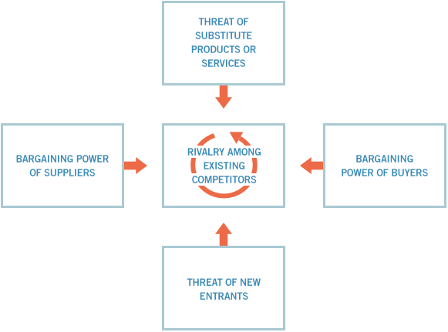
Appendix 1

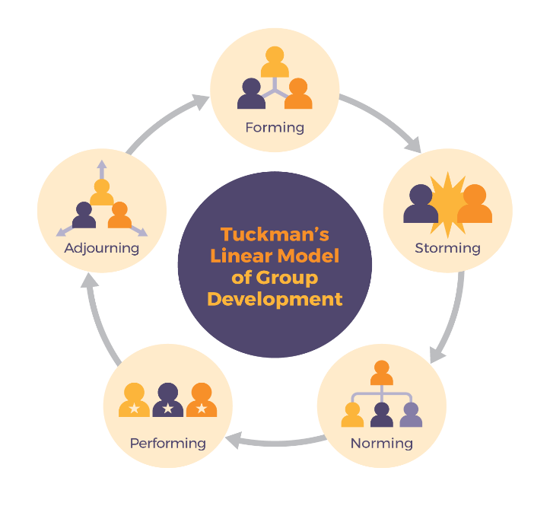
Appendix 2

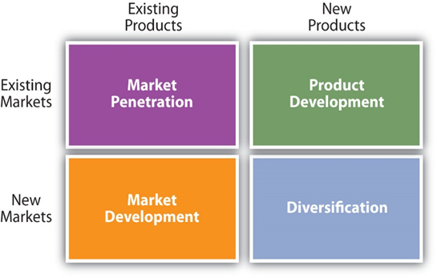
Appendix 3

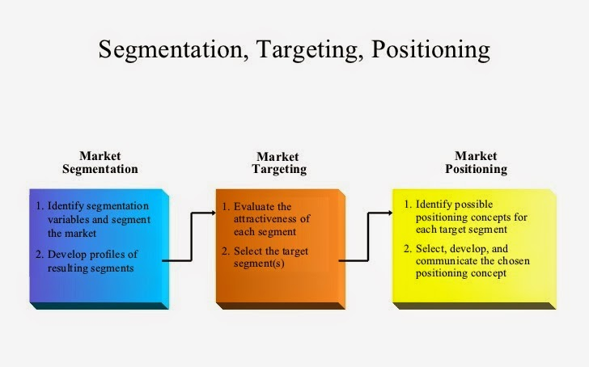
Appendix 4

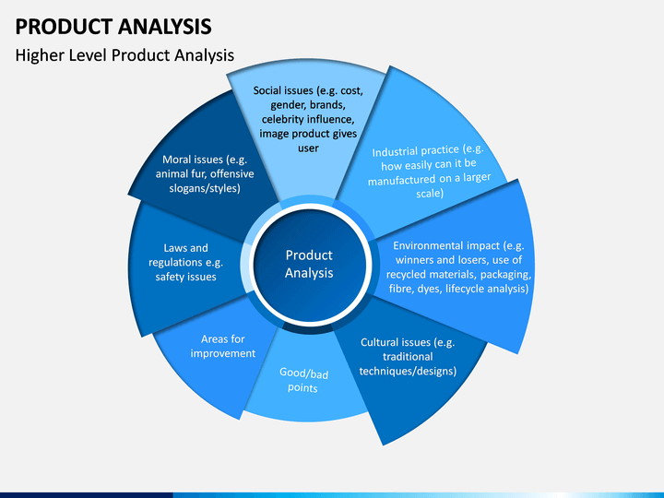
Appendix 5
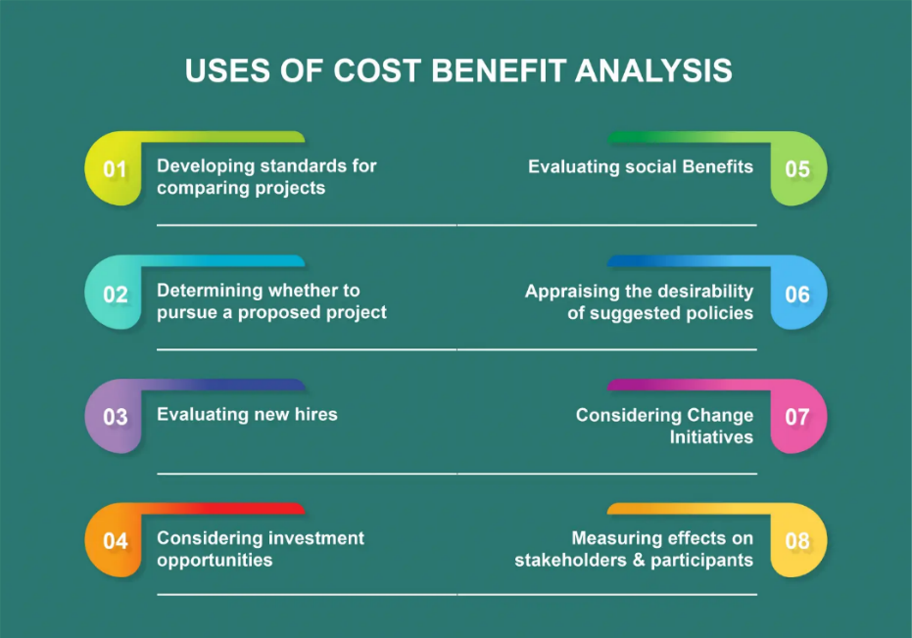
Appendix 6

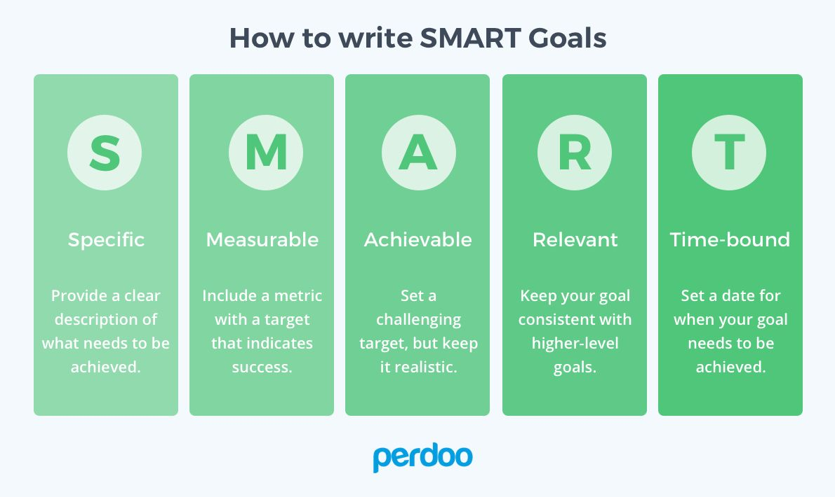
Appendix 7

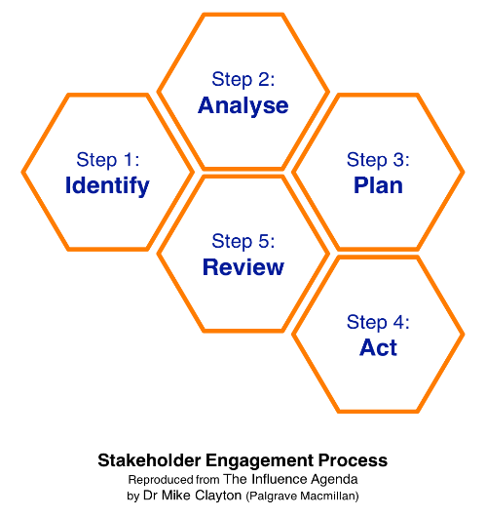
Appendix 8

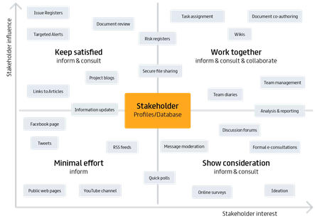
Appendix 9

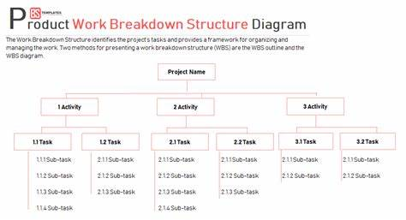
Appendix 10
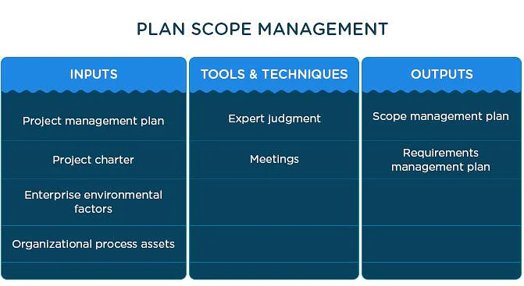
Appendix 11
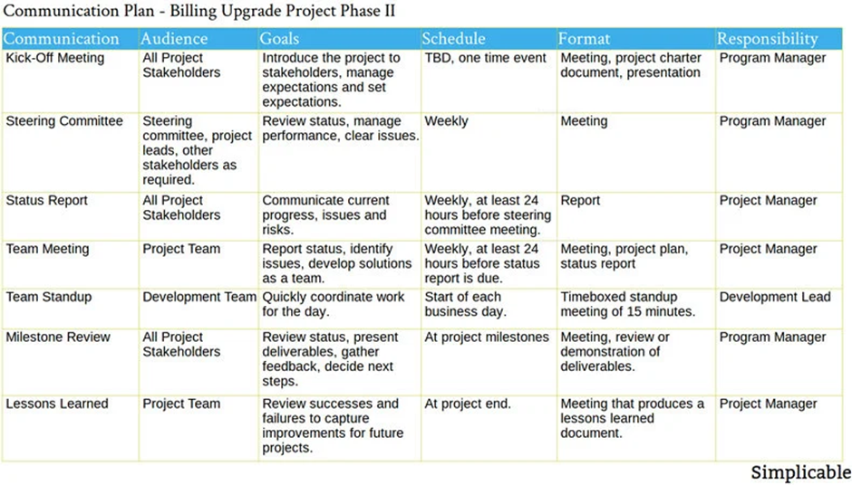
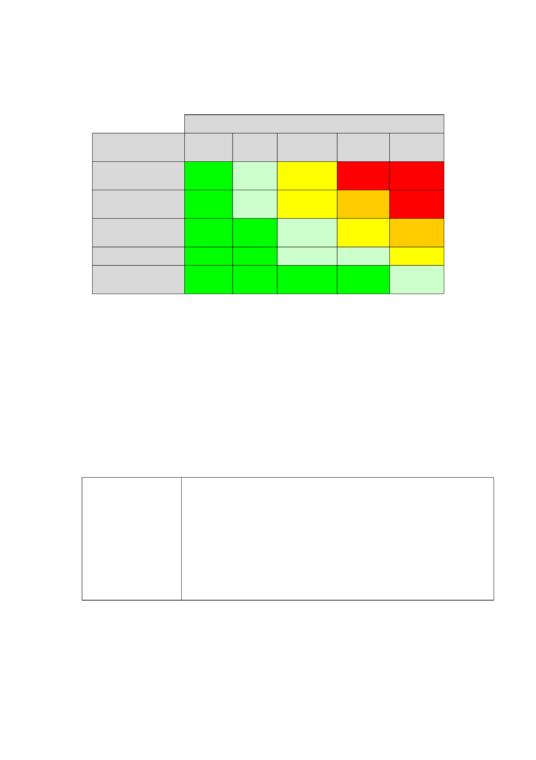
Appendix 12
Appendix 13

