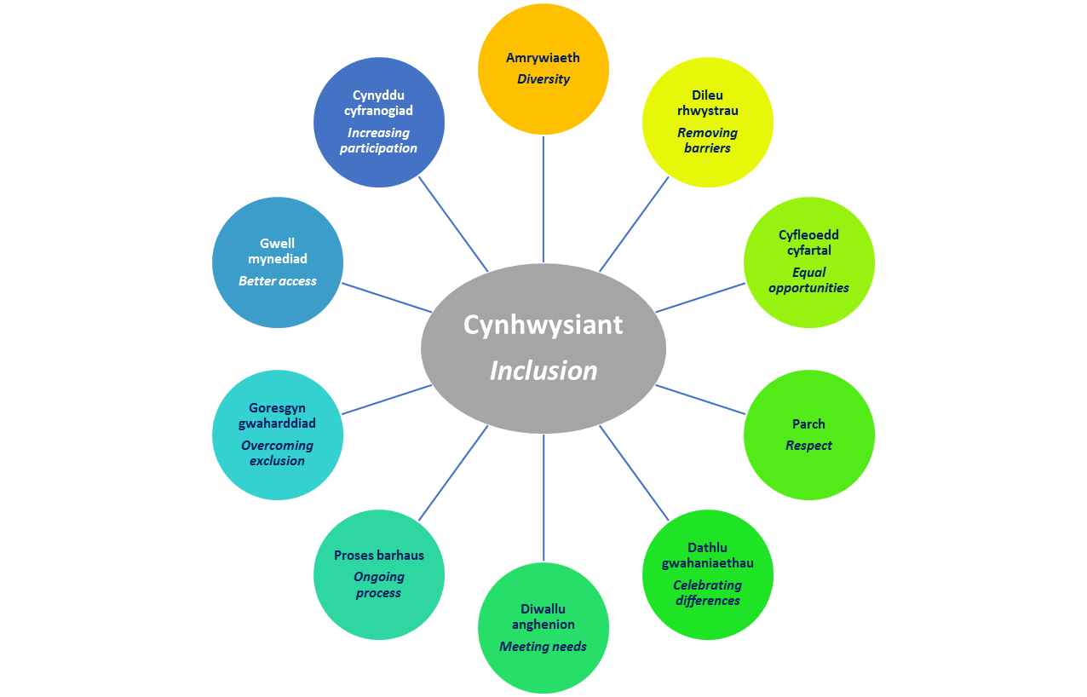
Individual Development Plans
It is reported by the Welsh Government (2018) that by introducing an IDP, this will ensure greater consistency and continuity For children with ALN who are looked after, the Act will require their IDP to be incorporated into the personal education plans (PEPs).
Cost implications Funding implications
Higher adult ratio – additional practitioners/TA’s
Training

Multi agency working
UNCRC Article 23: A child with a disability has the right to live a full and decent life with dignity and, as far as possible, independence and to play an active part in the community. Governments must do all they can to provide support to disabled children and their families.
Some of the11 changes and aims of the act;
- The introduction of the term ‘additional learning needs (ALN)’
- A 0 to 25 age range
- Increased participation of children and young people
- Increased collaboration#
- A simpler and less adversarial system
- The ALN Code
(Welsh Gov, 2018)

Discrimination
And stigma
Equality Act 2010 states that all possible networks should be taken to avoid discrimination of a child or any person with an ALN and address hate or discrimination against an ALN person.
Five General Principles;
- A child with SEN should have their needs met;
- ○ The SEN of children will normally be met in mainstream schools or settings;
- ○ The views of the child should be sought and taken into account;
- ○ Parents have a vital role to play in supporting the child’s education;
- ○ Children with SEN should be offered full access to a broad, balanced and relevant education.
(National Assembly for Wales, 2015)
SENCO’s ALNCO’s
Kotter and Schlesinger (1979 theory of resistance to change
Inclusion…..
The Impending changes to Special Educational Needs and Additional Learning Needs legislation in Wales

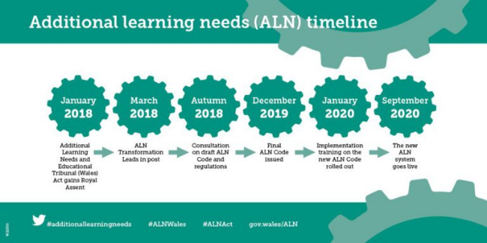

To Conclude….

