Richard Harris(Formerly Hankey)

ACCB6014

GPU Programming:
Shader Development

Contents
Introduction 3
Program Design 4
Object Loader 4
Lighting 4
Post Process Effects 4
Testing and experiments 5
Object Loader Test Cases 5
Lighting Test Cases 5
Post Process Test Cases 5
Applications of GPU Programming 6
Current usage 6
The commonality of use 6
Evaluation 6
Assessment of project 6
Problems and bugs 7
Considerations for improvements 7
Self-Reflection 7
References 8
References for model and textures. 8
Appendixes 9
Appendix 1 : snippets of code 9
ObjLoader.h 9
ObjLoader.cpp 11
Flat.frag 13
Flat.vert 15
Screen.vert 16
Screen.frag 16
Application.cpp 19
Appendix 2: Screenshots of application 36

Introduction
This report details the program in detail with its output and interpreting the details of the programming. Describing the algorithms and concepts implemented in the source code with test cases to emphasise the development of the program. Including a small discussion of the current trends of graphics programming and its common uses with an investigation of any new and arising trends. The report will end with a summary and proposition for improvements with a reflective observation of the project.

Program Design

Object Loader
The object loader is a simple loader, reworked and reconstructed from(ref) for the purpose of this project implementation. The loader uses the ifstream, C++ file handling module, and parses the elements of the .obj file into arrays and concatenating them in an array of the Vertex class. The loader is dynamic and will load any object of any size (within the boundaries of the OpenGL API maximum array size). The chosen object for this project is a dog statue or statuette. The original size of the object was quite large and dividing the vertex values by 10 seems to scale the object to a more manageable size in consideration of the viewport.
The object loader is limited though, as it can only load objects that a fully triangulated, the chosen dog object was not and had to be triangulated via another modelling program (Maya, or blender).
The object is then used in the Modern OpenGL standards: loading it in a Vertex Array Object(VAO) as a Vertex Buffer Object(VBO). Then drawing the arrays as triangles.

Lighting
The lighting is a simple Blinn-Phong illumination on the model, implemented on the object shaders, ‘flat.vert’; the vertex shader and ‘flat.frag’; The fragment shader. The vertex shader is responsible for the position and the view matrix of the object, setting the object to be within the clip space. The vector normals of the object is used to set up the calculations of the illumination model. It shall be noted that no calculations are needed to find the vertex normals as they are extracted from the model with the object loader.
The lighting calculations are derived from the tutorial provided by learnopengl.com and are modified for the purposes of this project. The normal calculations are done in the vertex shader program and result in calculating a normal matrix of the world space to allow distinct lighting illumination. In the fragment shader some of the calculations are provided by the Udemy course videos and the learnopengl.com tutorials. The fragment shader is responsible for calculating the material properties such as the shininess and the specular intensity; the Blinn portion of the lighting model and the Phong portion would be the calculations of the directional light on the model.
Multiplying these too together and normalising the outputs would result in the Phong shader. To create a Blinn-Phong lighting model, calculations would have to include a half vector, which is the dot product of the interpolated angle between the normals.
This method has created an unusual artifact though as it seems to have reduced the amount of “reflected” light.

Post Process Effects
The final component of the project is the post process effects(forthwith named Post FX) using image kernel calculations. This calculation is done in the ‘Screen.frag’ fragment shader. Each Post FX has its own kernel matrix[1]–[3] and is multiplied to the texture of the fullscreenQuad, which is essentially a copy of the scene captured as a texture and placed on an empty quad. This is an industry-standard of graphics handling. Using the OpenGL Scissor Test multiple times allowed the screen to be split into four and applying the post process effects onto one of the “cuts”, this works by enabling scissor test and doing activating the Post FX then disabling the scissor test and the post FX. Placing this into the rendering loop allows a seamless animation between the four “cuts”.
(screenshots and explanations).

Testing and experiments

Object Loader Test Cases
Test Case | Result | Next Step
Use previous loader to load object from file | FAIL | Use different file reading concept such as: ifstream
Use ifstream to load file | SUCCESS | Load object into application
Load OBJ into Application | FAIL | Research OBJ files
Load OBJ into Application | PARTIAL SUCCESS: Obj loads broken up into triangles | Read the f values
Load OBJ into with f values | FAIL: same as previous result | Consult a text or journal
Use Gordon et al’s [4] methodology | FAIL: same as previous result | More research is required
Use Maya to convert obj into triangles | SUCCESS | Load obj into application
Load obj into application | FAIL: obj now not loading | More research is required
Vector array has different pointers, looked into finding the current pointer of data and found (vector array).data().  Using (vector array).data() to load OBJ | SUCCESS | No further steps required

Lighting Test Cases
Test Case | Result | Next Step
Testing the ambient light method from learnopengl .com[1] | SUCCESS | Read about diffuse and specular light
Testing diffuse and specular light method from learnopengl.com[1] | SUCCESS | Read about phong lighting
Implement phong lighting | SUCCESS | No further steps
Realization of blinn-phong shading is not implemented.  using “half vec” method[5] | SUCCESS | No futher steps

Post Process Test Cases

Test Case | Result | Next Step
Testing Edge Detection | SUCCESS | Test other image kernels
Testing other image kernels | SUCCESS | Find a way to split the screen
Adding a new glviewport | FAIL | Try using a different shader
Using a different shader | FAIL | Try a new viewport and split the screen
Using a split with new viewport | FAIL | Research required
Using discovered method: glScissor | PARTIAL SUCCESS: the cut is frozen | Research required
Turning scissor test off after image kernel applied | PARTIAL SUCCESS: same image kernel applied to both sides of the cut | Try using a uniform bool to turn the image kernel off after scissor
Using uniform bool | SUCCESS | Apply 2nd image kernel to the other side of the cut
Applying 2nd image kernal | SUCCESS | Attempt more cuts
Attempting more cuts | SUCCESS | Apply animation
Applying animation | SUCCESS | No further steps

Applications of GPU Programming

Current usage
Programming on the GPU has been around since(year) and is a standard of today’s graphics handling. The current trends(as of 2020) of GPU programming are multiple GPU buffering and using multiple GPU calculations. Another is strictly coding in CUDA and other means. But the main trend which has propelled GPU programming to the next era is Real-Time Ray Tracing, which is a feat in the graphic rendering disciplines. Real-time ray tracing using dedicated “RTX” cards has allowed for the most realistic images in graphics applications.

The commonality of use
Real-time ray tracing is now becoming ubiquitous in the graphics development world and now is being applied to several applications of the art. Ranging from games, where it is most prominent to medical applications. Graphics and GPU rendering has been around for decades and is incredibly sustainable and relevant with multiple uses across multiple fields.

Evaluation

Assessment of project
The current application runs as intended and does the post-processing effects without any errors, although the effects do seem quite subtle, they can be increased by increasing the step size or using a multiplication factor. The multiplication of the transformation models could have been done with more dynamic influence, such as setting up a class method to modifications to the model transform or the view matrix. But as this is only implemented once for the one object in the project, it would seem fruitless to append this. The application itself runs smoothly with lags or noticeable bugs.

Problems and bugs
A thorough examination of this project and with the aforementioned test cases; there is no other visible bug or problems with the implementation.

Considerations for improvements
The project could be regarded as is in its infancy of development, there are a few improvements for deliberation:
- The object loader could have an algorithm to allow any object to be loaded that is not triangulated to be converted into triangles. Removing the need for use of other applications.
- The chosen post effects could be more expressive using some more exotic kernel calculations or even using vertex post-process effects.
- The application could have loaded multiple different objects, even though it can do so with the dynamic object loader, it is not implemented in this version.
- The textures could have been placed in a texture array, this has been tested and proven unsuccessful, the resulting code attempts have been deleted from the application.
- A light model could have been drawn to emphasize the direction and position of the light, such as a light cube or light sphere.

Self-Reflection
This project was originally very confusing and hard to grasp at the very start, but after many experimentations and investigations, it was proven that Modern OpenGL and GPU Programming was easy to understand and follow. There is room for improvement for the particular application, but future projects and experiments will be easy to implement after further understanding of shader language and the way Modern OpenGL functions. Developing this application has, however, shown capability to create an application or modify existing ones with a relative understanding of the languages and concepts.

References
[1] “Learn OpenGL, extensive tutorial resource for learning Modern OpenGL.” [Online]. Available: https://learnopengl.com/. [Accessed: 03-Dec-2020].
[2] M. Charemy, “Filtering - Basic Image Manipulation.” [Online]. Available: https://www.codingame.com/playgrounds/2524/basic-image-manipulation/filtering. [Accessed: 20-May-2021].
[3] V. Powell, “Image Kernels explained visually.” [Online]. Available: https://setosa.io/ev/image-kernels/. [Accessed: 20-May-2021].
[4] S. V Gordon and J. Clevenger, Computer Graphics Programming in OpenGl with c++. Pallai,David, 1377.
[5] E. Lengyel, Mathematics for 3D Game Programming and Computer Graphics Third Edition. .

References for model and textures.
[1] “cracked-concrete-texture-13-780x520.jpg (780×520).” [Online]. Available: https://storage.googleapis.com/webdesignledger.pub.network/LaT/edd/2016/02/cracked-concrete-texture-13-780x520.jpg. [Accessed: 20-May-2021].
[2] “Concrete-Texture-3.jpg (2000×1500).” [Online]. Available: https://unblast.com/wp-content/uploads/2020/02/Concrete-Texture-3.jpg. [Accessed: 20-May-2021].
[3] “ori_3445333_c17d6557cb16496c68cab8e15f0a0ac12b133f47_20-bright-square-tiles-background-textures.jpg (1400×933).” [Online]. Available: https://media1.thehungryjpeg.com/thumbs2/ori_3445333_c17d6557cb16496c68cab8e15f0a0ac12b133f47_20-bright-square-tiles-background-textures.jpg. [Accessed: 20-May-2021].
[4] Pixabay, “Close-up of Wooden Plank · Free Stock Photo.” [Online]. Available: https://www.pexels.com/photo/close-up-of-wooden-plank-326311/. [Accessed: 20-May-2021].
[5] “ConcreteDogStatue v1 Free 3D Model - .obj .stl - Free3D.” [Online]. Available: https://free3d.com/3d-model/concretedogstatue-v1--25932.html. [Accessed: 20-May-2021].
[1] “cracked-concrete-texture-13-780x520.jpg (780×520).” [Online]. Available: https://storage.googleapis.com/webdesignledger.pub.network/LaT/edd/2016/02/cracked-concrete-texture-13-780x520.jpg. [Accessed: 20-May-2021].
[2] “Concrete-Texture-3.jpg (2000×1500).” [Online]. Available: https://unblast.com/wp-content/uploads/2020/02/Concrete-Texture-3.jpg. [Accessed: 20-May-2021].
[3] “ori_3445333_c17d6557cb16496c68cab8e15f0a0ac12b133f47_20-bright-square-tiles-background-textures.jpg (1400×933).” [Online]. Available: https://media1.thehungryjpeg.com/thumbs2/ori_3445333_c17d6557cb16496c68cab8e15f0a0ac12b133f47_20-bright-square-tiles-background-textures.jpg. [Accessed: 20-May-2021].
[4] Pixabay, “Close-up of Wooden Plank · Free Stock Photo.” [Online]. Available: https://www.pexels.com/photo/close-up-of-wooden-plank-326311/. [Accessed: 20-May-2021].
[5] “ConcreteDogStatue v1 Free 3D Model - .obj .stl - Free3D.” [Online]. Available: https://free3d.com/3d-model/concretedogstatue-v1--25932.html. [Accessed: 20-May-2021].

Appendixes

Appendix 1 : snippets of code

These snippets of code are only the file that have been worked on, other files included in the template are not included here.

ObjLoader.h

#pragma once
#include <iostream>
#include <fstream>
#include <sstream>
#include<vector>
#include <glm.hpp>
#include "Utilities.h"

class ObjLoader
{
#pragma region Vertex Structs

public:

// upon creating object ask user for name of file, check if it exists, then open AND READS the file
ObjLoader(const char* path) { filePath = path; CheckFile(filePath); }
~ObjLoader();

void CheckFile(const char* p);

std::vector<Vertex> StoreAll();

private:
const char* filePath;

std::vector<glm::vec3> v;
std::vector<glm::vec2> vt;
std::vector<glm::vec3> vn;
std::vector<glm::vec3> f;
std::vector<Vertex> verts;

};

ObjLoader.cpp

#include "ObjLoader.h"

ObjLoader::~ObjLoader()
{
}

void ObjLoader::CheckFile(const char* p)
{
if(!p || p== NULL)
{
std::cout << "NO FILE FOUND" << std::endl;
}

}

// this reads the file and pushes all the information in an expanding vector array.
//parses the f values and pushes them on to a Vertex array with the corresponding f number.
//then returns the Vertex array.
std::vector<Vertex> ObjLoader::StoreAll()
{
Vertex vert_local(glm::vec3(0,0,0), glm::vec3(0, 0, 0), glm::vec2(0, 0));
float x, y, z;// temp values
std::string data;
std::string line = " ";

std::ifstream file(filePath);

while (!file.eof())
{
/*getline(file, line);
std::cout << line << std::endl;*/ // test file read

getline(file, line);
if (line.compare(0, 2, "v ") == 0)
{ // vertex position ("v" case)
std::stringstream ss(line.erase(0, 1));
ss >> x; ss >> y; ss >> z;
v.push_back(glm::vec3(x/10, y/10, z/10));
//vert_local = (Vertex(glm::vec3(x/10, y/10, z/10)));

}

if (line.compare(0, 3, "vn ") == 0)
{ // texture position ("vn" case)
std::stringstream ss(line.erase(0, 2));
ss >> x; ss >> y; ss >> z;
vn.push_back(glm::vec3(x, y, z));
}

if (line.compare(0, 3, "vt ") == 0)
{ // normals position ("vt" case)
std::stringstream ss(line.erase(0, 2));
ss >> x; ss >> y; ss >> z;
vt.push_back(glm::vec2(x, y*-1));
}

//if (line.compare(0, 2, "f ") == 0)
//{ // faces ("f" case)
// std::stringstream ss(line.erase(0, 1));
// ss >> x; ss >> y; ss >> z;
// f.push_back(glm::vec3(x, y, z));

//}

if (line.compare(0, 2, "f ") == 0) { // triangle faces ("f" case)
std::string oneCorner, vert, tex, norm;
std::stringstream ss(line.erase(0, 2));
for (int i = 0; i < 3; i++) {
getline(ss, oneCorner, ' '); // extract triangle face references
std::stringstream oneCornerSS(oneCorner);
getline(oneCornerSS, vert, '/');
getline(oneCornerSS, tex, '/');
getline(oneCornerSS, norm, '/');
int vertRef = (stoi(vert) - 1); // "stoi" converts string to integer
int tcRef = (stoi(tex) - 1);
int normRef = (stoi(norm) - 1);
verts.push_back(Vertex(v[vertRef], vn[normRef], vt[tcRef]));

}
}
}

/* if (v.empty())
{
std::cout << "empty" << std::endl;
}
vert_local=(Vertex(v.back(), vn.back(), vt.back()) );
verts.push_back(vert_local);

} */

file.close();
return verts;

}

Flat.frag

#version 430 core

out vec4 FragColour;

in vec2 TexCoords;
in vec3 Normal;
in vec3 FragPos;

struct DirectionalLight
{
vec3 colour;
float AmbientIntensity;
vec3 direction;
float diffuseIntensity;
};

struct Material
{
float specularIntensity;
float shininess;
};

uniform sampler2D texture1;
uniform DirectionalLight dirLight;
uniform Material material;
uniform vec3 cameraPos;
uniform bool blinnPhong;

void main()
{
vec4 ambientColour=vec4(dirLight.colour, 1.0f)* dirLight.AmbientIntensity;

float diffuseFactor=max(dot(normalize(Normal), normalize(dirLight.direction)), 0.0f);
vec4 diffuseColour = vec4(dirLight.colour * dirLight.diffuseIntensity * diffuseFactor, 1.0f);

vec4 specularColour = vec4(0,0,0,0);
if(diffuseFactor > 0.0f)
{

vec3 fragToCam= normalize(cameraPos - FragPos);
if(blinnPhong == true)
{
vec3 halfVec = normalize(fragToCam + dirLight.direction);
float specularFactor=dot(halfVec, normalize(Normal));
if(specularFactor > 0.0f)
{
specularFactor = pow(specularFactor, material.shininess);
specularColour = vec4(dirLight.colour * material.specularIntensity * specularFactor, 1.0f);

}
}
else{

vec3 reflectedVert=normalize(reflect(dirLight.direction, normalize(Normal)));
float specularFactor=dot(fragToCam, reflectedVert);
if(specularFactor > 0.0f)
{
specularFactor = pow(specularFactor, material.shininess);
specularColour = vec4(dirLight.colour * material.specularIntensity * specularFactor, 1.0f);

}
}
}
FragColour = texture(texture1, TexCoords) * (ambientColour * diffuseColour + specularColour);

//FragColour = (glm::vec4 ( 1.0,0.5,0.5,1.0))* (ambientColour * diffuseColour + specularColour);
}

Flat.vert

#version 430 core

// Input the location of our vertex position in our vertex buffer
layout (location = 0) in vec3 aPos;
layout (location = 1) in vec2 aTexCoords;
layout(location = 2) in vec3 norm;

out vec2 TexCoords;
out vec3 Normal;
out vec3 FragPos;

// Specify our uniforms (this is our data from our application which is CPU bound)
uniform mat4 model;
uniform mat4 view;
uniform mat4 projection;

void main()
{

TexCoords = aTexCoords;

gl_Position = projection * view * model *vec4(aPos, 1.0);

Normal= mat3(transpose(inverse(model)))*norm;

FragPos = (model * vec4(aPos, 1.0)).xyz;
}

Screen.vert

#version 430 core

layout (location = 0) in vec3 aPos;
layout (location = 1) in vec2 aTexCoords;

out vec2 TexCoords;

uniform float offset;

void main()
{
TexCoords = aTexCoords;

gl_Position = vec4(aPos.x, aPos.y, aPos.z, 1.0f);

}

Screen.frag

#version 430 core

out vec4 FragColour;

in vec2 TexCoords;

uniform sampler2D screenTexture;
// kernels for postFX
float sharpKernel[9] = float[](
0,-1, 0,
-1, 5,-1,
0,-1, 0
);

float edgeKernel[9] = float[](
-1, -1, -1,
-1, 9, -1,
-1, -1, -1
);

float embossKernel[9] = float[](
-2,-1, 0,
-1, 1, 1,
0, 1, 2
);

float blurKernel[9] = float[](
0.0625, 0.125, 0.0625,
0.125, 0.25, 0.125,
0.0625, 0.125, 0.0625
);

float simpleBlurK[9] = float[](
1,1,1,
1,1,1,
1,1,1
);

// modifiable pixel step
uniform vec2 u_step;

// bools for post FX
uniform bool edgeDetection;
uniform bool sharpen;
uniform bool emboss;
uniform bool blur;
uniform bool simpleBlur; // is not used
uniform float time;

//
ivec2 texture_size = textureSize(screenTexture, 0);
vec2 step_size = u_step/texture_size;

vec2 offsets[9] = vec2[](
vec2(-step_size.x, -step_size.y),
vec2( 0.0f, -step_size.y),
vec2( step_size.x, -step_size.y),
vec2(-step_size.x, 0.0f),
vec2( 0.0f, 0.0f),
vec2( step_size.x, 0.0f),
vec2(-step_size.x, +step_size.y),
vec2( 0.0f, +step_size.y),
vec2( step_size.x, step_size.y)
);

void main()
{
// algorithm for edgeDetection
vec3 colour = texture(screenTexture, TexCoords).rgb;

if(edgeDetection ==true)
{
vec4 sum = vec4(0.0);

for(int i = 0; i < 9; i++)
{
sum += texture(screenTexture, TexCoords + offsets[i]) * edgeKernel[i]*2;
}

sum.a = 1.0;
FragColour = vec4(vec3(sum), 1.0f);
//algorithm for sharpening
}else if(sharpen==true) {

vec4 sum = vec4(0.0);

for(int i = 0; i < 9; i++)
{
sum += texture(screenTexture, TexCoords + offsets[i]) * sharpKernel[i]*2;
}

sum.a = 1.0;
FragColour = vec4(vec3(sum), 1.0f);
//algorthm for embossing
}else if(emboss==true) {

vec4 sum = vec4(0.0);

for(int i = 0; i < 9; i++)
{
sum += texture(screenTexture, TexCoords + offsets[i]) * embossKernel[i]*2;
}

sum.a = 1.0;
FragColour = vec4(vec3(sum), 1.0f);
// algorthm for blurring
}else if(blur==true) {

vec4 sum = vec4(0.0);

for(int i = 0; i < 9; i++)
{
sum += texture(screenTexture, TexCoords + offsets[i]) * blurKernel[i]*2;
}

sum.a = 1.0;
FragColour = vec4(vec3(sum), 1.0f);

} else if(simpleBlur==true) {

vec4 sum = vec4(0.0);

for(int i = 0; i < 9; i++)
{
sum += texture(screenTexture, TexCoords + offsets[i]) * simpleBlurK[i]*2;
}

sum.a = 1.0;
FragColour = vec4(vec3(sum), 1.0f);

}else {

//else normal image
FragColour = vec4(vec3(colour), 1.0f);
}

}

Application.cpp

#include <Windows.h>

#include <glad.h>
#include <glfw3.h>
#include <glm.hpp>
#include <gtc/matrix_transform.hpp>
#include <gtc/type_ptr.hpp>

#include <stb_image.h>

#include <iostream>
#include <vector>

#include "Utilities/Shader.h"
#include "Utilities/Utilities.h"
#include "Utilities/ObjLoader.h"

int main()
{
#pragma region Window/OpenGL Setup

// Initialize GLFW
glfwInit();

// Set window hints
glfwWindowHint(GLFW_CONTEXT_VERSION_MAJOR, 4);
glfwWindowHint(GLFW_CONTEXT_VERSION_MINOR, 3);
glfwWindowHint(GLFW_OPENGL_PROFILE, GLFW_OPENGL_CORE_PROFILE);

glfwWindowHint(GLFW_SAMPLES, 8);

// Create window
GLFWwindow* window = glfwCreateWindow(SCREEN_WIDTH, SCREEN_HEIGHT, "OpenGL Template", NULL, NULL);

// Check if window was created sucessfully
if (window == NULL)
{
std::cout << "Failed to create GLFW window!" << std::endl;

glfwTerminate();

return -1;
}

// Make the current rendering context the window
glfwMakeContextCurrent(window);

#pragma region Callback Functions

// Register callback function for window resizing (callback functions should be registered after window creation but before game loop)
glfwSetFramebufferSizeCallback(window, FramebufferSizeCallback);

// Register callback function for cursor position (callback functions should be registered after window creation but before game loop)
glfwSetCursorPosCallback(window, MouseCallback);

// Tell GLFW to capture our mouse
glfwSetInputMode(window, GLFW_CURSOR_NORMAL, 0);

#pragma endregion

// Check all OpenGL function pointers have loaded
if (!gladLoadGLLoader((GLADloadproc)glfwGetProcAddress))
{
std::cout << "Failed to initialize GLAD" << std::endl;

return -1;
}

#pragma endregion

// Abitrary vertex data goes here
#pragma region Vertex Data

// Loads obj file and stores it into a vector of Vertex.
std::vector<Vertex>dogVerts;
ObjLoader Dog("src/Resources/Models/Dog.obj");
dogVerts = Dog.StoreAll();
size_t vertex_size = dogVerts.size() * sizeof(Vertex);

Vertex fullscreenQuad[6];

// Top left
fullscreenQuad[0] = Vertex(glm::vec3(-1.0f, 1.0f, 0.0f), glm::vec2(0.0f, 1.0f));

// Bottom left
fullscreenQuad[1] = Vertex(glm::vec3(-1.0f, -1.0f, 0.0f), glm::vec2(0.0f, 0.0f));

// Bottom right
fullscreenQuad[2] = Vertex(glm::vec3(1.0f, -1.0f, 0.0f), glm::vec2(1.0f, 0.0f));

// Top right
fullscreenQuad[3] = Vertex(glm::vec3(1.0f, 1.0f, 0.0f), glm::vec2(1.0f, 1.0f));

// Top left
fullscreenQuad[4] = Vertex(glm::vec3(-1.0f, 1.0f, 0.0f), glm::vec2(0.0f, 1.0f));

// Bottom right
fullscreenQuad[5] = Vertex(glm::vec3(1.0f, -1.0f, 0.0f), glm::vec2(1.0f, 0.0f));

#pragma endregion

// Vertex Array Objects, Vertex Buffer Objects and specifying how our vertex data is formatted all happens here
#pragma region Vertex Specification

unsigned int dogVAO; // A value OpenGL can reference when we want to use this object
unsigned int dogVBO;
// Much like the triVAO, we can refernce this VBO with this value

// Using the triVAO and triVBO values as a reference to our objects,
//we generate veretx arrays and buffers using said references
glGenVertexArrays(1, &dogVAO);
glGenBuffers(1, &dogVBO);

// Bind the VAO first to say which VAO we want to bind subsequent VBOs to,
//and then we follow up with binding the relevant VBOs
glBindVertexArray(dogVAO);
glBindBuffer(GL_ARRAY_BUFFER, dogVBO);

// Assigning our dogVerts array data to our vertex buffer object

//using dogVerts.data() is the only way to fully allow a dynamic sized obj to placed and read properly from the buffer array
glBufferData(GL_ARRAY_BUFFER, vertex_size, dogVerts.data(), GL_DYNAMIC_DRAW);

// Position data
glVertexAttribPointer(0, 3, GL_FLOAT, GL_FALSE, sizeof(Vertex), (void*)offsetof(Vertex, Vertex::Position));

// Enable the vertex data we formatted above
glEnableVertexAttribArray(0);

// Texture coordinate data
glVertexAttribPointer(1, 2, GL_FLOAT, GL_FALSE, sizeof(Vertex), (void*)offsetof(Vertex, Vertex::TexCoords));

// Enable the vertex data we formatted above
glEnableVertexAttribArray(1);

glVertexAttribPointer(2, 3, GL_FLOAT, GL_FALSE, sizeof(Vertex), (void*)offsetof(Vertex, Vertex::Normal));

// Enable the vertex data we formatted above
glEnableVertexAttribArray(2);

unsigned int fullscreenQuadVAO;
unsigned int fullscreenQuadVBO;

glGenVertexArrays(1, &fullscreenQuadVAO);

glGenBuffers(1, &fullscreenQuadVBO);

glBindVertexArray(fullscreenQuadVAO);

glBindBuffer(GL_ARRAY_BUFFER, fullscreenQuadVBO);
glBufferData(GL_ARRAY_BUFFER, sizeof(fullscreenQuad), &fullscreenQuad, GL_DYNAMIC_DRAW);

glVertexAttribPointer(0, 3, GL_FLOAT, GL_FALSE, sizeof(Vertex), (void*)offsetof(Vertex, Vertex::Position));
glEnableVertexAttribArray(0);

glVertexAttribPointer(1, 2, GL_FLOAT, GL_FALSE, sizeof(Vertex), (void*)offsetof(Vertex, Vertex::TexCoords));
glEnableVertexAttribArray(1);

#pragma endregion

#pragma region Framebuffer Creation

unsigned int framebuffer;

// Generate and bind a framebuffer
glGenFramebuffers(1, &framebuffer);
glBindFramebuffer(GL_FRAMEBUFFER, framebuffer);

// Generate and bind textures
unsigned int colourBuffer;
glGenTextures(1, &colourBuffer);
glBindTexture(GL_TEXTURE_2D, colourBuffer);

glTexImage2D(GL_TEXTURE_2D, 0, GL_RGB, SCREEN_WIDTH, SCREEN_HEIGHT, 0, GL_RGB, GL_UNSIGNED_BYTE, NULL);

glTexParameteri(GL_TEXTURE_2D, GL_TEXTURE_MIN_FILTER, GL_LINEAR);
glTexParameteri(GL_TEXTURE_2D, GL_TEXTURE_MAG_FILTER, GL_LINEAR);

glBindTexture(GL_TEXTURE_2D, 0);

glFramebufferTexture2D(GL_FRAMEBUFFER, GL_COLOR_ATTACHMENT0, GL_TEXTURE_2D, colourBuffer, 0);

unsigned int renderBuffer;

glGenRenderbuffers(1, &renderBuffer);
glBindRenderbuffer(GL_RENDERBUFFER, renderBuffer);

glRenderbufferStorage(GL_RENDERBUFFER, GL_DEPTH24_STENCIL8, SCREEN_WIDTH, SCREEN_HEIGHT);

glBindRenderbuffer(GL_RENDERBUFFER, 0);

glFramebufferRenderbuffer(GL_FRAMEBUFFER, GL_DEPTH_STENCIL_ATTACHMENT, GL_RENDERBUFFER, renderBuffer);

// Check frambuffer is correctly configured
if (glCheckFramebufferStatus(GL_FRAMEBUFFER) != GL_FRAMEBUFFER_COMPLETE)
{
std::cout << "Framebuffer is not complete!" << std::endl;
}

#pragma endregion

// Load our shaders here to compile and link them for execution on the GPU
Shader dogShader("src/Resources/Shaders/Flat.vert", "src/Resources/Shaders/Flat.frag");
Shader fullscreenShader("src/Resources/Shaders/Screen.vert", "src/Resources/Shaders/Screen.frag");

#pragma region Texture Loading

unsigned int textureID;

glGenTextures(1, &textureID);

int width;
int height;
int components;

/// <summary>
/// comment put the active code and uncomment the change in texture if required, its has been unsuccessful loading multiple
/// textures onto the stack with this template.
/// </summary>

//const char* path = "src/Resources/Textures/wood.png";
//const char* path = "src/Resources/Textures/ConcreteTexture.png";
//const char* path = "src/Resources/Textures/minecraft-diamond.png";
//const char* path = "src/Resources/Textures/purple.png";
const char* path = "src/Resources/Textures/Original.png";
//const char* path = "src/Resources/Textures/Cracked.png";

unsigned char* data = stbi_load(path, &width, &height, &components, 0);

if (data)
{
GLenum format = NULL;

if (components == 1)
{
format = GL_RED;
}
else if (components == 3)
{
format = GL_RGB;
}
else if (components == 4)
{
format = GL_RGBA;
}

glTexImage2D(GL_TEXTURE_2D, 0, format, width, height, 0, format, GL_UNSIGNED_BYTE, data);
glGenerateMipmap(GL_TEXTURE_2D);

// Parameters for texture wrapping
glTexParameteri(GL_TEXTURE_2D, GL_TEXTURE_WRAP_S, GL_REPEAT);
glTexParameteri(GL_TEXTURE_2D, GL_TEXTURE_WRAP_T, GL_REPEAT);

// Parameters for texture filtering
glTexParameteri(GL_TEXTURE_2D, GL_TEXTURE_MIN_FILTER, GL_NEAREST);
glTexParameteri(GL_TEXTURE_2D, GL_TEXTURE_MAG_FILTER, GL_NEAREST);

// Clean up
stbi_image_free(data);
}
else
{
std::cerr << "Texture failed to load at path: " << path << std::endl;

// Clean up
stbi_image_free(data);
}

#pragma endregion

dogShader.Use();

dogShader.SetInt("texture1", textureID);

// Render loop (this runs for as long as the window is open)
while (!glfwWindowShouldClose(window))
{
// Timestep (if your interested there is a fantastic article here about timesteps https://gafferongames.com/post/fix_your_timestep/)
// If we have enough time we may be able to discuss timesteps in class
currentFrame = (float)glfwGetTime();
deltaTime = currentFrame - lastFrame;
lastFrame = currentFrame;

// Process our mouse and keyboard input
ProcessInput(window);

// Binding our own framebuffer
glBindFramebuffer(GL_FRAMEBUFFER, framebuffer);

// Enable the depth test
glEnable(GL_DEPTH_TEST);

// Set window background colour
glClearColor(0.25f,0.25f,0.25f, 1.0f);

// Clear the colour and depth buffer
glClear(GL_COLOR_BUFFER_BIT | GL_DEPTH_BUFFER_BIT);

glActiveTexture(GL_TEXTURE0);
glBindTexture(GL_TEXTURE_2D, textureID);

// Binding our vertex arrays and shaders for our draw calls will happen here
#pragma region Render Here

// Work with our dogVerts vertex array
glBindVertexArray(dogVAO);

// Returning our view matrix

float u_time = sin(glfwGetTime());

glm::mat4 view = camera.GetViewMatrix();

glm::mat4 projection = glm::perspective(glm::radians(camera.zoom), (float)SCREEN_WIDTH / (float)SCREEN_HEIGHT, 0.1f, 100.0f);

glm::mat4 model = glm::mat4(1.0f);

// rotates the object facing the camera
glm::mat4 rotated = glm::rotate(model, 90.0f, glm::vec3( 0.0f,1.0f, 0.0f));

//moves the object down little and out so the object is not at camera origin
glm::mat4 translated = glm::translate(model, glm::vec3(0.0f, 0.0f, 5.0f));

//animated rotation of the model
glm::mat4 rotate_anim = glm::rotate(model, 1.0f*(float)glfwGetTime(), glm::vec3(0.3f, 1.0f, 0.0f));

//sets our view space to match the adjustments made above.
view = view * translated *rotated;

// We want to use our dogVerts shader
dogShader.Use();

dogShader.SetMat4("projection", projection);
dogShader.SetMat4("view", view);
dogShader.SetMat4("model", model * rotate_anim);

/// <summary>
/// this is setting the material,directional, diffuse lighting of the object, to acheive a blinn/phong
/// illumination.
/// </summary>
/// <returns></returns>
dogShader.SetVec3("dirLight.colour", 1.0f, 1.0f, 1.0f);
dogShader.SetFloat("dirLight.AmbientIntensity", 0.5f);
dogShader.SetVec3("dirLight.direction", 1.0f, -1.0f, 1.0f);
dogShader.SetFloat("dirLight.diffuseIntensity", 0.3f);
dogShader.SetFloat("material.specularIntensity", 1.0f);
dogShader.SetFloat("material.shininess", 32.0f);
dogShader.SetVec3("cameraPos", camera.position);
dogShader.SetBool("blinnPhong", true);

glDrawArrays(GL_TRIANGLES, 0, vertex_size);

glBindVertexArray(0);

// Bind our default framebuffer
glBindFramebuffer(GL_FRAMEBUFFER, 0);

// Disble the depth-test as we are rendering to a fullscreen quad
glDisable(GL_DEPTH_TEST);

// Set window background colour
glClearColor(0.25f, 0.25f, 0.25f, 1.0f);

// Clear the colour and depth buffer
glClear(GL_COLOR_BUFFER_BIT | GL_DEPTH_BUFFER_BIT);

// be sure to activate shader when setting uniforms/drawing objects

fullscreenShader.Use();

glBindVertexArray(fullscreenQuadVAO);

glBindTexture(GL_TEXTURE_2D, colourBuffer);

glDrawArrays(GL_TRIANGLES, 0, 6);

/// <summary>
/// these glscissor splits the screen space in 4, the glscissor renders the screenspace with the parameters
/// turning these on then doing post fx, then turning them off allows for seemless animation between the spaces.
/// </summary>
/// <returns></returns>
///

//Top right corner
glEnable(GL_SCISSOR_TEST);
glScissor(SCREEN_WIDTH / 2, SCREEN_HEIGHT/2, SCREEN_WIDTH, SCREEN_HEIGHT );
fullscreenShader.SetBool("blur", true);
fullscreenShader.SetVec2("u_step", 1.0f, 1.0f);
glDrawArrays(GL_TRIANGLES, 0, 6);
glDisable(GL_SCISSOR_TEST);
fullscreenShader.SetBool("blur", false);

//Top left corner
glEnable(GL_SCISSOR_TEST);
glScissor(0, SCREEN_HEIGHT / 2, SCREEN_WIDTH / 2, SCREEN_HEIGHT );
fullscreenShader.SetBool("edgeDetection", true);
fullscreenShader.SetVec2("u_step", 1.0f, 1.0f);
glDrawArrays(GL_TRIANGLES, 0, 6);
glDisable(GL_SCISSOR_TEST);
fullscreenShader.SetBool("edgeDetection", false);

//Bottom Left Corner
glEnable(GL_SCISSOR_TEST);
glScissor(0, 0, SCREEN_WIDTH / 2, SCREEN_HEIGHT / 2);
fullscreenShader.SetBool("sharpen", true);
fullscreenShader.SetFloat("time", glfwGetTime());
glDrawArrays(GL_TRIANGLES, 0, 6);
glDisable(GL_SCISSOR_TEST);
fullscreenShader.SetBool("sharpen",false);

//Bottom Right Corner
glEnable(GL_SCISSOR_TEST);
glScissor(SCREEN_WIDTH/2, 0, SCREEN_WIDTH , SCREEN_HEIGHT/2);
fullscreenShader.SetBool("emboss", true);
fullscreenShader.SetVec2("u_step", 1.0f, 1.0f);
glDrawArrays(GL_TRIANGLES, 0, 6);
glDisable(GL_SCISSOR_TEST);
fullscreenShader.SetBool("emboss", false);

#pragma endregion

glfwSwapBuffers(window);

// Get GLFW to poll any events (window and input events, this is where GLFW callbacks occur)
glfwPollEvents();
}

// Clean up
glfwTerminate();

return 0;
}

Appendix 2: Screenshots of application
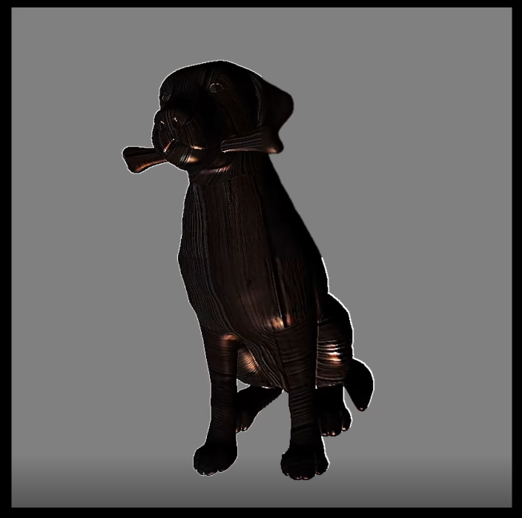
Screenshot of model with wooden texture
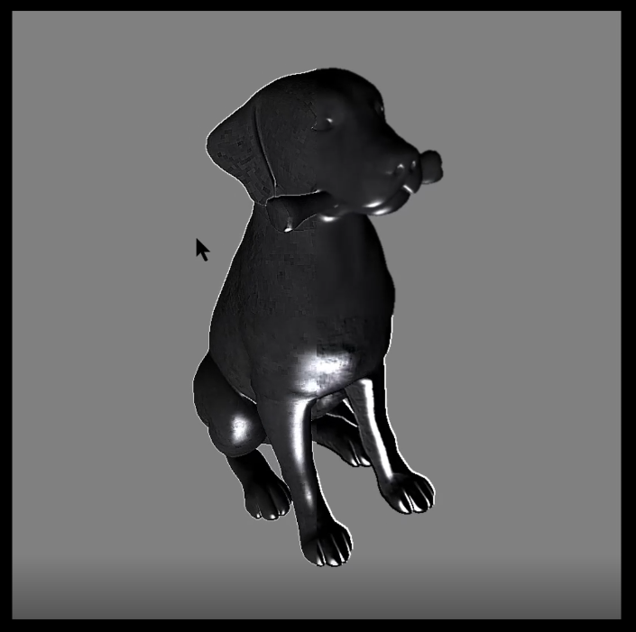
Screenshot of model with a basic concrete texture
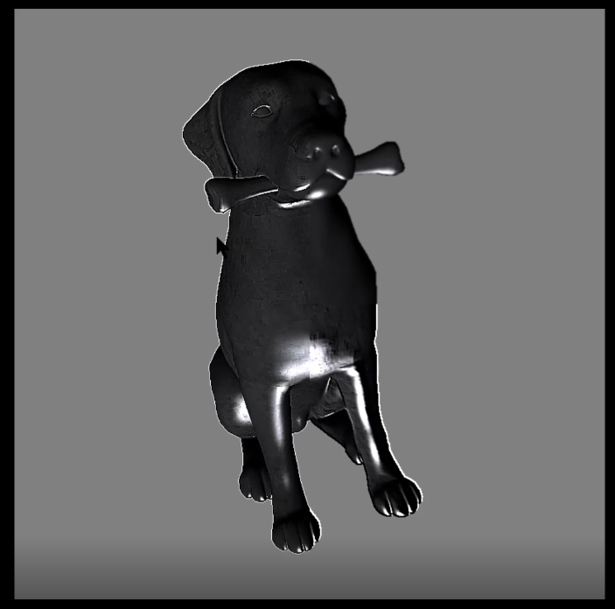
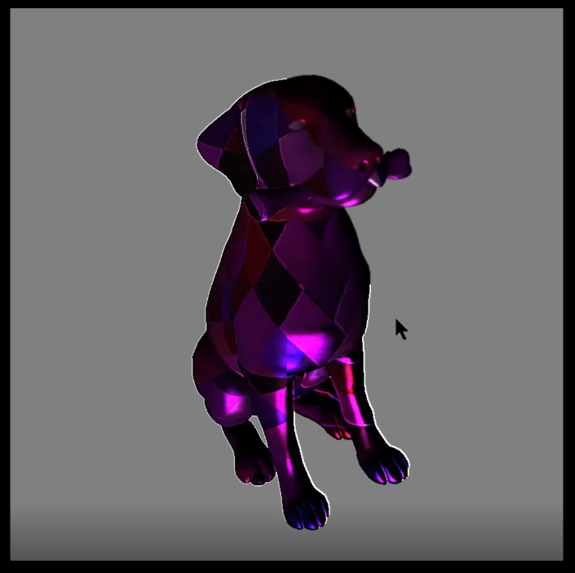
Screenshot of model with vibrant purple checker texture
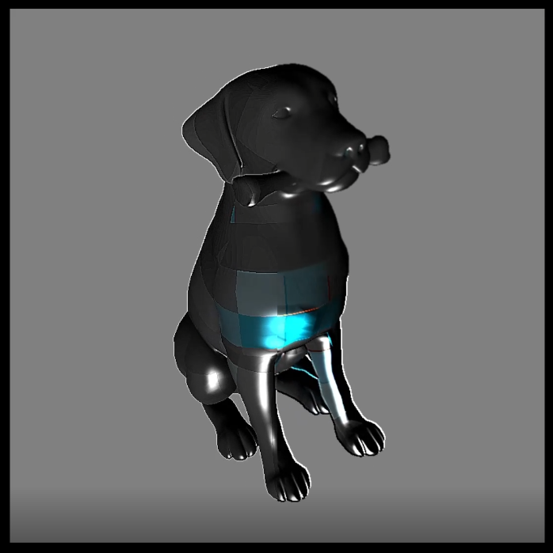
Screenshot of model with Minecraft diamond texture already with the template
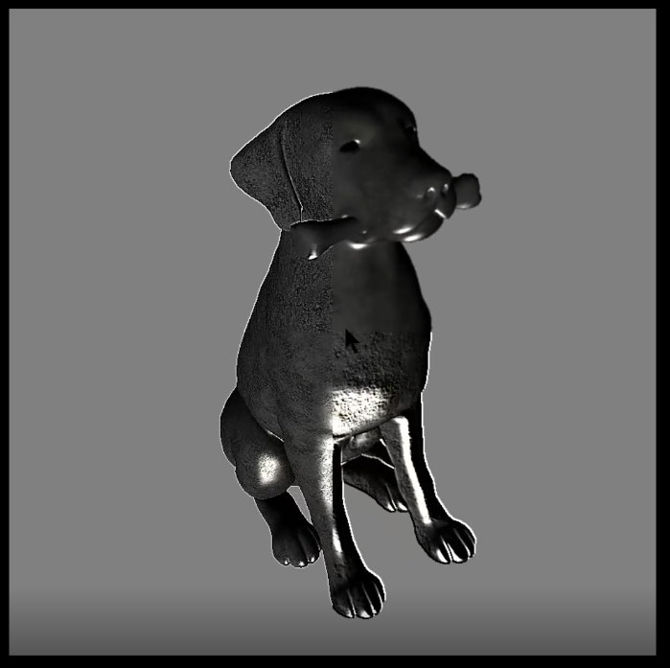
Screenshot of model with object’s original texture
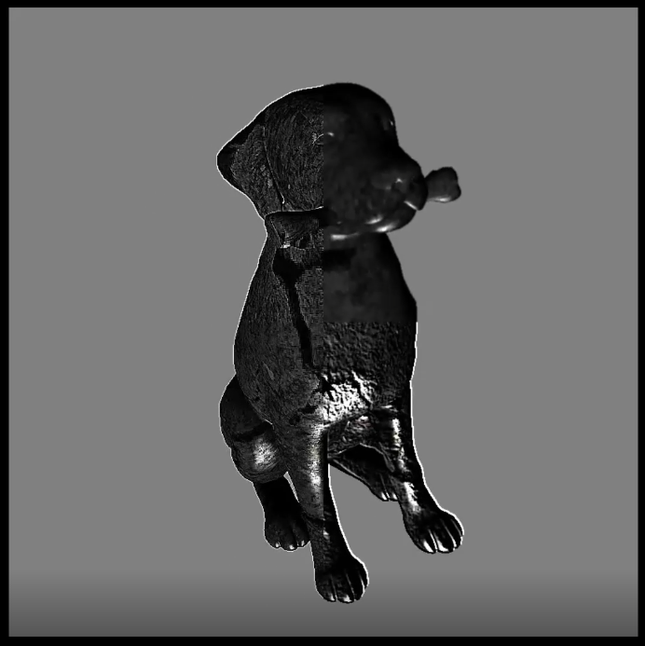 Screenshot of model with a cracked concrete texture

