1) a) State diagram
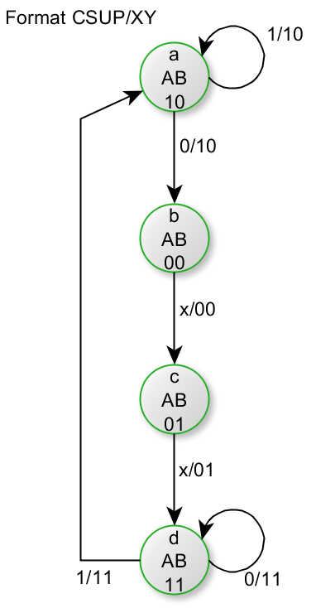
(4 marks)
b) State - Next state table

 |  | Present States |  | Input | Next States |  | Outputs
 |  | A | B | CSUP | A | B | X | Y
a | 0 | 0 | 0 | 0 | 0 | 1 | 0 | 0
a | 1 | 0 | 0 | 1 | 0 | 1 | 0 | 0
b | 0 | 0 | 1 | 0 | 1 | 1 | 0 | 1
b | 1 | 0 | 1 | 1 | 1 | 1 | 0 | 1
c | 0 | 1 | 0 | 0 | 0 | 0 | 1 | 0
c | 1 | 1 | 0 | 1 | 1 | 0 | 1 | 0
d | 0 | 1 | 1 | 0 | 1 | 1 | 1 | 1
d | 1 | 1 | 1 | 1 | 1 | 0 | 1 | 1

(6 marks)

c)
i)
DA | A B
CSUP | 0 0 | 0 1 | 1 1 | 1 0
0 | 0 | 1 | 1 | 0
1 | 0 | 1 | 1 | 1

DA = B + A.CSUP

DB | A B
CSUP | 0 0 | 0 1 | 1 1 | 1 0
0 | 1 | 1 | 1 | 0
1 | 1 | 1 | 0 | 0

DB = /A + B./CSUP

ii)
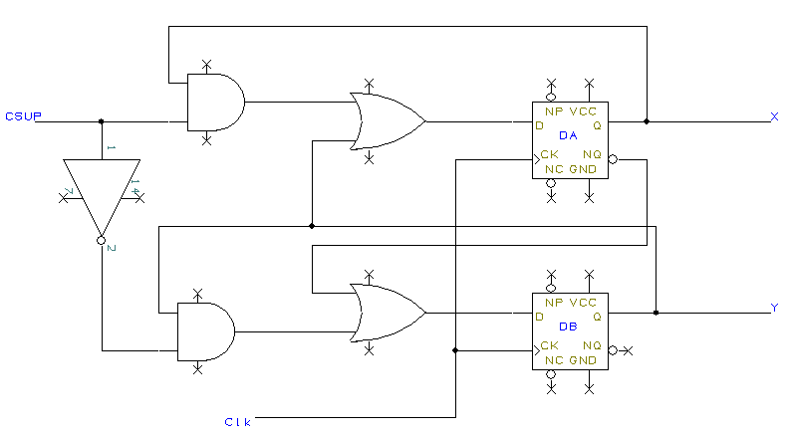
(10 marks)

2)
a)

therefore
(6 Marks)

b)
From the table the full functions are :-
(a) /A.B./C./D + (b) A.B./C + (c) A./B./C + (d) A.B.C.D + (e) A./B.C
A | B | C | D | Simplified F |  |  | Full F
0 | 0 | 0 | 0
0 | 0 | 0 | 1
0 | 0 | 1 | 0
0 | 0 | 1 | 1
0 | 1 | 0 | 0 | B./C./D |  |  | a
0 | 1 | 0 | 1
0 | 1 | 1 | 0
0 | 1 | 1 | 1
1 | 0 | 0 | 0 |  |  | A./B | c
1 | 0 | 0 | 1 |  | A.D | A./B | c
1 | 0 | 1 | 0 |  |  | A./B | e
1 | 0 | 1 | 1 |  | A.D | A./B | e
1 | 1 | 0 | 0 | B./C./D |  |  | b
1 | 1 | 0 | 1 |  | A.D |  | b
1 | 1 | 1 | 0
1 | 1 | 1 | 1 |  | A.D |  | d

All actual functions are operated by simplified functions
(8 Marks)

c)
(6 Marks)

3)
entity state_machine is
Port ( Clk : in STD_LOGIC;
X : in STD_LOGIC;
Y : out STD_LOGIC_VECTOR :="000");
end state_machine;

architecture Behavioral of state_machine is
type state_type is (state_1, state_2, state_3, state_4, state_5, state_6, state_7, state_8);
signal present_state : state_type := state_1;
signal next_state : state_type := state_1;
begin
State: Process (present_state, X)
begin
If X='0' Then
Case present_state is
When state_1 => next_state <=state_1; Y <= "000";
When state_2 => next_state <=state_5; Y <= "010";
When state_3 => next_state <=state_4; Y <= "110";
When state_4 => next_state <=state_6; Y <= "100";;
When state_5 => next_state <=state_6; Y <= "101";
When state_6 => next_state <=state_8; Y <= "011";
When state_7 => next_state <=state_8; Y <= "111";
When state_8 => next_state <=state_2; Y <= "001";;
When OTHERS => NULL;
end case;
else If x='1' THEN
Case present_state is
When state_1 => next_state <=state_2; Y <= "000";
When state_2 => next_state <=state_3; Y <= "010";
When state_3 => next_state <=state_6; Y <= "110";
When state_4 => next_state <=state_5; Y <= "100";;
When state_5 => next_state <=state_3; Y <= "101";
When state_6 => next_state <=state_7; Y <= "011";
When state_7 => next_state <=state_3; Y <= "111";
When state_8 => next_state <=state_1; Y <= "001";; When OTHERS => NULL;
end case;
end if;
end if;
end Process State;

clocked: Process (Clk)
begin
If((Clk='1') and (Clk'last_value='0')) Then
present_state <= next_state;
end if;
end Process clocked;
end Behavioral;
(20 marks)

4)a) a)

Entity three_to_eight is
PORT (
x : in STD_LOGIC_VECTOR (2 downto 0);
y : out STD_LOGIC_VECTOR (7 downto 0));
);
end three_to_eight;

Architecture Behavioral of three_to_eight is
begin
dec : Process(x)
begin
CASE x is
WHEN "000" => y <= "11111110";
WHEN "001" => y <= "11111101";
WHEN "010" => y <= "11111011";
WHEN "011" => y <= "11110111";
WHEN "100" => y <= "11101111";
WHEN "101" => y <= "11011111";
WHEN "110" => y <= "10111111";
WHEN "111" => y <= "01111111";
WHEN others => NULL;
end CASE;
end Process dec;
end Behavioral;
2 marks for entity and 4 marks for architecture
TOTAL = 6 Marks

4)b)
ENTITY fsm is
PORT ( Clk : in STD_LOGIC;
Rset : in STD_LOGIC;
X : in STD_LOGIC;
Y : out STD_LOGIC);
end fsm

Architecture Behavioral of fsm is

type state_type is (state_a, state_b, state_c, state_d, state_e, state_f, state_g);
Signal present_state, _next_state : state_type;
(1 mark)

begin
State: Process (present_state, Rset, X)
begin
If Rset='1' Then
next_state <=state_a;
Y <= '0';
else if Rset='0' Then
(1 mark)

If X='0' Then
Case present_state is
When state_a => next_state <=state_a; Y <= '0';
When state_b => next_state <=state_c; Y <= '0';
When state_c => next_state <=state_c; Y <= '0';
When state_d => next_state <=state_e; Y <= '0';
When state_e => next_state <=state_a; Y <= '0';
When state_f => next_state <=state_g; Y <= '0';
When state_g => next_state <=state_a; Y <= '1';
When OTHERS => NULL;
end case;
(5 marks)
else If x='1' THEN
Case present_state is
When state_a => next_state <=state_b; Y <= '0';
When state_b => next_state <=state_c; Y <= '0';
When state_c => next_state <=state_d; Y <= '1';
When state_d => next_state <=state_f; Y <= '1';
When state_e => next_state <=state_a; Y <= '0';
When state_f => next_state <=state_f; Y <= '1';
When state_g => next_state <=state_a; Y <= '1';
When OTHERS => NULL;
end case;
end if;
end if;
end if;
end if;
end Process State;
(5 marks)
clocked: Process (Clk)
begin
If((Clk='1') and (Clk last_value='0')) Then
present_state <= next_state;
end if;
end Process clocked

End Behavioral;
(2 marks)
(Total 14 marks)

