Task 1 – Written Reflection
The purpose of this paper is to critically reflect on personal practice and development in relation to Welsh language teaching and learning. The Welsh Government (2019) produced the Welsh Language Competency Framework which is utilised throughout as a tool for a self-assessment of Welsh Language skills (see Appendix 1). The paper aims to discuss areas in which my Welsh language skills have improved over the past year before giving recommendations to improve my future practice.
Improving Sentence Level Welsh
The aim of the session was to encourage learners to answer questions about the story of ‘Dillad Tedi Twt’ and encourage them to extend their Welsh vocabulary skills (Canolfan Gymraeg San Helen, 2002). It is evident in the video that learners consistently gave one-word answers to questions throughout the story. I feel the opportunity was missed to promote the simple sentence pattern ‘Mae Tedi Twt yn gwisgo …’ which would have been extremely beneficial in improving the Welsh literacy skills of learners. This idea is supported by Schwab and Lew-Williams (2016) who suggest that learners benefit from having the contextual background of the sentence to support language learning. By introducing the sentence patterns to learners, they would have been able to practise and reinforce new vocabulary in everyday life and through role play opportunities.
Recently I have become more confident with discussing and teaching sentence level Welsh. The language sessions undertaken within this module have been extremely beneficial in improving my knowledge and understanding of sentence structures and grammar rules within the Welsh language. In relation to the Welsh Language Competency Framework produced by the Welsh Government (2019), I believe I am at Foundation level for written Welsh skills as I can write a range of simple and complex sentences for a range of subjects to be used inside the classroom.
Going forward, to achieve the intermediary level, I need to improve my range of sentence patterns that can be adapted to support subject specific vocabulary which can then be used across the curriculum. To achieve this, it will be crucial to engage in Continual Professional Development (CPD) opportunities that allow me to develop subject specific Welsh. Furthermore, it is essential that I continue to practice my Welsh language skills every day. I continue to use Duolingo (2019) to rehearse and learn new vocabulary. The app allows me to practise reading, writing, listening and speaking skills simultaneously, although Essa Ahmed (2015) argues that the app is not effective in promoting language for higher levels.
Using Hand Gestures to Support Language Development
It is important to develop a range of teaching methodologies to support learners’ second language development. The video highlights the use of consistent hand gestures to support the written text. Although, the use of hand gestures could be improved by encouraging learners to engage and copy the action with the word or sentence. On reflection, this idea could have been utilised during the follow up task as learners could have been encouraged to put on the item of clothing, for example, ‘can you put on your menig?’.
Interestingly, Uilenburg et al. (2001) suggest that practitioners should not communicate in their first language as it removes the need for learners to try and communicate in a second language. However, Morett (2018) suggests that it is important that language learners can access the context of the language, therefore using hand gestures would be an effective way of consolidating understanding of new vocabulary. However, two studies conducted by Hirata and Kelly (2010) and Hirata et al. (2014) suggest that the effectiveness of hand gestures on second language acquisition is limited. In addition, the International Reading Association (2010) suggests that kinaesthetic learners benefit most from the use of hand gestures in the classroom. Therefore, the research indicates that although hand gestures can be useful for supporting second language learning it is essential that they are paired with other language learning methodologies to fully support second language development.
In relation to the Welsh Government’s (2019) Welsh Language Competency Framework I would suggest that I am currently at intermediary level for reading skills as I can confidently translate meaning from a range of texts by spotting familiar vocabulary and sentence patterns. I feel on the whole my pronunciation is fairly accurate when reading stories or writing text.
To achieve the higher level, I need to improve my ability to understand and interpret more complex texts across a range of subject specific areas of learning. To achieve this, it will be essential to engage in CPD opportunities that enhance my Welsh reading skills. Estyn (2012) champion good practice where the school have provided opportunities for all staff to develop their Welsh language skills. It would be beneficial to engage in more language learning courses either endorsed by the Welsh Government such as Learn Welsh Cymru (2018) or opportunities provided by the Local Consortia.
Using Repetition to Promote Language Development
Many academics note the importance of using repetition as a tool for second language learning (Kirsch, 2008; Kasper, 2018; British Council, 2018). During the video, drilling exercises were utilised to practice vocabulary and pronunciation of the learners’ Welsh language. The drilling exercises were used to encourage the whole class to repeat and practice vocabulary. As shown in the video, drilling exercises such as ‘I say… you say…’ were used to encourage learners to imitate and repeat new vocabulary. The ideology of encouraging learners to imitate, repeat and rehearse new vocabulary is supported by Ghazi-Saidi and Ansaldo (2017) who suggest drilling is one of the most effective ways to learn a second language, although they acknowledge that drilling has been criticised for being mechanical in the delivery which can limit the effectiveness of language transfer. Therefore, there is a need to ensure drilling exercises are engaging for learners which require innovative teaching methods from practitioners. This ideology is supported by Cekaite and Aronsson (2004) who suggest repetition exercises can be used playfully, emotionally and expressively to provide a meaningful opportunity to promote second language development.
There was a missed opportunity to use song in the session as the class were not familiar with the song I continued with the lesson. Since the video, I have observed good practice whilst on Professional Teaching Experience (PTE) where the practitioner sang sentence patterns in the melody of known nursery rhymes which was an engaging way of encouraging learners to repeat and practise vocabulary. Rukholm (2015, p.176) states ‘song provides children with the opportunity to practice the sounds and articulation of words and phrases’ which indicates that song can support second language development for learners of all levels and ages. Although, Cameron (2009) notes the difficulties of engaging older learners in mass singing exercises which provides an additional challenge when encouraging learners to use song to improve second language learning.
Since the video I have improved my own oral skills through language sessions within the module and daily practice encouraged by the app Duolingo (2019). I would currently suggest that my oral skills in line with the Welsh Government’s (2019) self-assessment tool would be foundation level. I feel that currently I am able to engage in conversations about familiar topics and I have an increased awareness and ability to use verb tenses correctly.
In the future, to improve my Welsh oral skills to an intermediary level it will be essential to continue to practice my oral skills through daily practice whilst developing vocabulary for different topics that lie outside of the school context. Furthermore, to ensure learners find drilling exercises engaging and exciting it is essential that I begin to use songs and games to encourage language practice and rehearsal. Wright, Betteridge and Buckby (1984) suggest that games provide engaging and purposeful language practice for learners of all ages and can be used to support speaking, listening, reading and writing skills.
In addition, I feel my listening skills have greatly improved whether that be responding to learners or practitioners as I can pick out the key points within the conversation. Currently, I would suggest that my listening skills are at Foundation level in relation to the Welsh Government (2019). To further improve and achieve the next level of intermediary it will be essential for me to continue engaging in conversations with natural Welsh speakers about a variation of topics both within and outside of school. It is important to consider the challenges of communicating with Welsh speakers as Pembrokeshire has a limited number of Welsh speakers as supported by Statistics for Wales (2020) which indicate that 28.2% of the Pembrokeshire population can speak Welsh. However, it is important to note that these findings are based on a sample from an annual survey which suggests that this is an estimate and cannot be used to represent the full population.
In conclusion, my Welsh language skills have improved since the recording of the video due to an engagement with language sessions within the module alongside efforts to engage in daily practice. The key areas that need addressing in the future include improving my personal knowledge and understanding of grammar rules and sentence patterns. Furthermore, ensuring that hand gestures are used to support learners understanding of context is crucial to improving their second language skills. Lastly, it is essential that repetition through drilling exercises are utilised to be an engaging and effective tool to improve learners' vocabulary and pronunciation of the Welsh Language.

Word count – 1557

Reference List
British Council. (2018) ‘Drilling 1’. Available at: https://www.teachingenglish.org.uk/article/drilling-1 (Accessed on 1st May 2020).
Cameron, K. (2009) ‘10 Tips for Increasing Student Participation in Singing at School Masses’, Momentum, 40(3), pp. 34–36.
Canolfan Gymraeg San Helen. (2002) Dillad Tedi Twt. Swansea.
Cekaite, A. and Aronsson, K. (2004) ‘Repetition and joking in children's second language conversations: playful recyclings in an immersion classroom’, Discourse Studies, 6(3), pp.373–393.
Duolingo, version 6.65.0, 2019, mobile app, Duolingo, Inc, Apple App Store.
Essa Ahmed, H. B. (2016) ‘Duolingo as a bilingual learning app: A case study’, Arab World English Journal, 7(2), pp. 255–267.
Estyn. (2012) Welsh second language comes first. Available at: https://www.estyn.gov.wales/effective-practice/welsh-second-language-comes-first (Accessed 2nd May 2020).
Ghazi-Saidi, L. and Ansaldo, A.I. (2017) ‘Second Language Word Learning through Repetition and Imitation: Functional Networks as a Function of Learning Phase and Language Distance’, Frontiers in Human Neuroscience, 11, p.463.
Hirata, Y. and Kelly, S.D. (2010) ‘Effects of lips and hands on auditory learning of second-language speech sounds’, Journal of Speech, Language & Hearing Research, 53(2), pp. 298–310.
Hirata, Y. et al. (2014) ‘Effects of Hand Gestures on Auditory Learning of Second-Language Vowel Length Contrasts’, Journal of Speech, Language & Hearing Research, 57(6), pp. 2090–2101.
International Reading Association. (2010) ‘Rope Them in With Hand Gestures’, Reading Teacher, 64(4), pp. 282–283.
Käsper, M. (2018) ‘Language teaching strategies' impact on third-grade students' reading outcomes and reading interest’, International Electronic Journal of Elementary Education, 10(5), pp. 601–611.
Kirsch, C. (2008) Teaching foreign languages in the primary school. London; New York: Continuum International Pub. Group.
Learn Welsh Cymru (2018) Learn Welsh Pembrokeshire. Available at: https://learnwelsh.cymru/about-us/providers/learn-welsh-pembrokeshire/ (Accessed on 28th April 2020).
Morett, L.M. (2018) ‘In hand and in mind: Effects of gesture production and viewing on second language word learning’, Applied Psycholinguistics, 39(2), pp. 355-381.
Rukholm, V. N. (2015) ‘Singing to Speak: An Examination of Adult L2 Learners and Vocabulary Learning Through Song’, Italica, 92(1), pp. 171–192.
Schwab, J.F. and Lew-Williams, C. (2016) ‘Repetition across successive sentences facilitates young children’s word learning’, Developmental Psychology, 52(6), pp.879–887.
Statistics for Wales (2020) Annual population survey – ability to speak Welsh by local authority and year. Available at: https://statswales.gov.wales/Catalogue/Welsh-Language/Annual-Population-Survey-Welsh-Language/annualpopulationsurveyestimatesofpersonsaged3andoverwhosaytheycanspeakwelsh-by-localauthority-measure (Accessed on 2nd May 2020).
Uilenburg, N. et al. (2001) ‘Effects of a format based second language teaching method in kindergarten. Applied Psycholinguistics, 22(1), pp.1-33.
Welsh Government. (2019) Welsh language competency framework. Available at: https://gov.wales/sites/default/files/publications/2019-06/welsh-language-competency-framework-for-education-practitioners.pdf (Accessed on 15th April 2020).
Wright, A., Betteridge, D. and Buckby, M. (1984) Games for language learning. Cambridge: Cambridge Handbooks for Language Teachers.

Appendices
Appendix 1

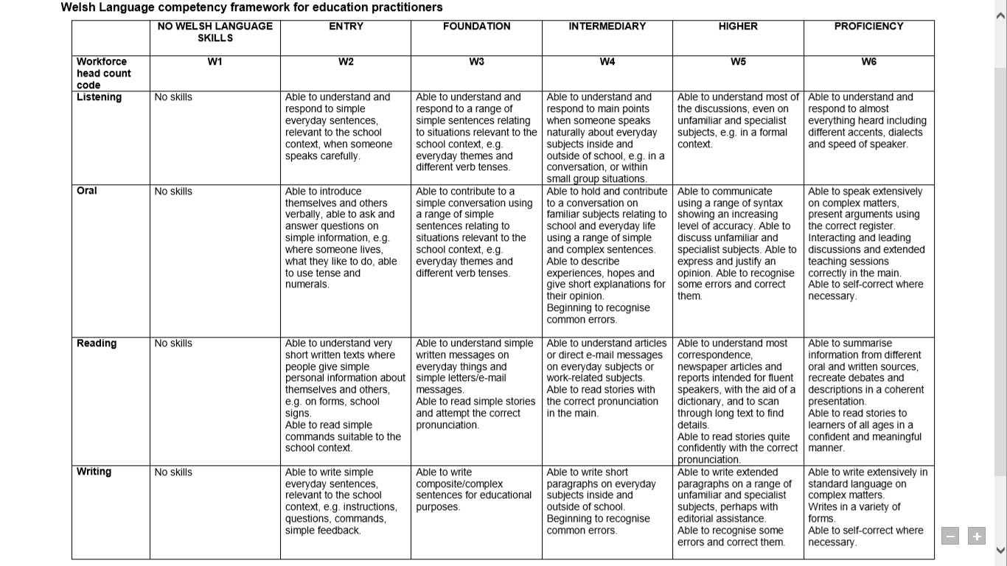

Task 2 – Lesson Plans

Lesson Plan Phase 2 - Lesson 1 of 2

Lesson Plan – Step 2 Cynllun Gwers – Cam 2

Student-teacher | Chloe Taylor | Class: | Year 4
AoLE/Subject | Languages, Literacy and Communication | Date: | May 2020
Lesson Focus: | The lesson will focus on improving learners’ ability to ask and answer questions about their home using previous knowledge on types of homes and rooms in the house.  The second focus is to encourage learners to develop the knowledge and understanding of writing in third person by describing the house of others.
Relevant/meaningful links to:  Curriculum  Cross-curricular responsibilities | Ambitious and Capable learners  - Can communicate effectively in different forms and settings in English and Welsh.  Language, Literacy and Communication  Understanding languages is the key to the world around us.  Progression Step (PS)2 - I can listen to, understand and later recall what I have heard.  PS3 - can understand the general meaning of what I hear and can communicate it in my language of choice.  Expressing ourselves through language is the key to communication  PS2 - I can ask and answer questions and exchange ideas and information.  Welsh Government (2020a).
Personal Targets  (Linked to QTS and identified in weekly review) | Professional Learning  Welsh Language Skills  - To improve personal Welsh Language skills  - To plan Welsh lessons that encourage learners to improve Welsh Language skills.

Learning Objectives | To communicate in third person both orally and written.
Success Criteria  (process/product) | I can ask questions in Welsh about another learner’s house.  I can understand their answers.  I can record information in Welsh  I can plan and write in third person.  I can share my writing verbally.

Key Resources Health & Safety | Appendix 1 – Drilling exercise PowerPoint  Appendix 2 – Differentiated grid box to complete during the opening phase.  Appendix 3 – Matiau Iaith to support learners with the writing of the short paragraph that has a range of vocabulary and sentence patterns.

Time | Content, Pedagogy & Assessment Opportunities (key teaching points and questions)
Links to Previous Learning | The topic for the term is ‘others and the world around me’ which explores topics that promote ethically, informed citizens of Wales and the world. Currently in Language, Literacy and Communication (English) learners are looking at autobiographies where they are also writing in third person. In the humanities learners are exploring how people live in other areas of the world in comparison with their own lives. In Science and Technology learners are planning and creating new inventions to help others across the world such as water filtration equipment.  Welsh Language: Learners will have spent the term looking at the different types of houses and the rooms in the house. Learners would have previously descried their own home in first person.  Learners have been practicing their oral skills by asking partners different questions about their house.
Opening Phase | 10 minutes: During the introduction there will be a quick recap through a drilling exercise for different vocabulary that will be used in the session. Drilling exercises should be supported by hand gestures such as a sleep motion for ystafell wely (see Appendix 1)  5 minutes: Learners will be given Appendix 2 which we will work through beforehand to ensure all learners fully understand the different sentence patterns that will be required. When participating in this activity learners should be continuously encouraged to use Welsh, this can be supported by positive praise through the token system.
Teaching & Core Learning | 10 minutes: The learners will begin by engaging in a small task (see Appendix 2) which encourage them to ask others questions about their homes, the grids will be differentiated to ensure all learners have the correct level of support to independently complete the task.  5-7 minutes: Once the class have completed the grid; the sentence structures will be modelled to show learners how the sentences are formed in the third person. If more support is needed for individuals or small groups, the teacher can encourage learners to lead the second example on the board.  Learners will be asked to choose one person from their grid to focus their writing task on. It will be important to encourage the more able learners to choose someone who has a variety of answers for example, she has … she does not have …  20 minutes: Learners will be given the opportunity to plan and complete a small paragraph about one or two people from the grid (for middle and higher attainers they can be encouraged to complete one male and one female from their grid). The level of support for learners will be differentiated as:  - LA would have sentence structures and vocab to fully support the work.  - MA would have some sentence structures that they may find difficult and vocabulary.  - HA would have some sentence structures that encourage them to extend their writing.
Plenary | 10 minutes: Learners can share their writing with a partner through a peer assessment task.  Prior to the assessment learners should create their own success criteria for the writing.  They can then use two stars and a wish for feedback to the learner. The learners can then use the purple polishing pen to make any improvements.

Lesson Plan Phase 2 – Lesson 2 of 2

Lesson Plan – Step 2 Cynllun Gwers – Cam 2

Student-teacher | Chloe Taylor | Class: | Year 4
AoLE/Subject | Languages, Literacy and Communication | Date: | May 2020
Lesson Focus: | To practice speaking, listening, reading and writing skills as a way to communicate in Welsh.
Relevant/meaningful links to:  Curriculum  Cross-curricular responsibilities | Languages, Literacy and Communication  Understanding languages is the key to the world around us.  PS2 - I can listen to, understand and later recall what I have heard  PS3 - I can understand the general meaning of what I hear and can communicate it in my language of choice.  PS2- I can develop my vocabulary through listening and reading and use these new words in a variety of contexts.  PS3 - I can listen and read to build my vocabulary, develop my pronunciation and sentence structures and use these in my own communication.  Welsh Government (2020a).  Literacy  Translanguaging  PS2 - I am beginning to draw on information presented in one language and convey it in my own words in another.  PS3 - I can receive information in one language and adapt it for various purposes in another language.  Welsh Government (2020b).
Personal Targets  (Linked to QTS and identified in weekly review) | Professional Learning  Welsh Language Skills  - To further improve my ability to plan and teach Welsh Language sessions within a Key Stage 2 environment.

Learning Objectives (Focus on Learning) | Each workshop activity will have a different LO.  Activity 1 – To extract information from a Welsh text.  Activity 2 – To translate sentences into Welsh.  Activity 3 – To extract information from an audio clip.  Activity 4 – To communicate verbally in Welsh.
Success Criteria  (process/product) | I can find key information from audio and written extracts to answer questions.  I can communicate verbally in Welsh.  I can structure sentences in Welsh.

Key Resources Health & Safety | Appendix 1 – Drilling exercise PowerPoint  Appendix 3 – Matiau Iaith  Appendix 4 – Activity 1 (differentiated resources)  Appendix 5 – Activity 2 (differentiated resources)  Appendix 6 – Activity 3 (differentiated resources)

Time | Content, Pedagogy & Assessment Opportunities (key teaching points and questions)
Links to Previous Learning | The topic for the term is ‘others and the world around me’ which explores topics that promote ethically, informed citizens of Wales and the world. Currently in Language, Literacy and Communication (English) learners are looking at autobiographies where they are also writing in third person. In the humanities learners are exploring how people live in other areas of the world in comparison with their own lives. In Science and Technology learners are planning and creating new inventions to help others across the world such as water filtration equipment.  Welsh Language: Learners will have spent the term looking at the different types of houses and the rooms in the house. Learners would have previously descried their own home in first person.  Learners have been practicing their oral skills by asking partners different questions about their house.  In the previous session, learners used third person to describe the home of someone else.
Opening Phase | Introduction: Bore ma flwyddyn pedwar, heddiw byddwn ni mynd practising our Welsh reading, writing, speaking and listening skills.  10 minutes: Drilling exercise to recap vocab (see appendix 1)  During the drilling exercise the practitioner should engage in a range on tone or choral repetition techniques. The practitioner should encourage individuals to practise alongside whole class or small groups. Drilling can also be supported by a range of hand gestures.
Teaching & Core Learning | This section of the lesson will be split into 4 workshops rotation activities (rotation across the week). Each rotation will be 25 minutes.  Activity 1 (Reading) – Learners will be asked to read a small passage in Welsh that describes the home of the class teacher (see appendix 4). Learners will then need to draw and label the houses described in the text.  Differentiation: Matiau Iaith (see Appendix 3)  Activity 2 (Writing) – Learners will be given facts about a member of staff’s home in English. They will need to translate these into Welsh sentences using the cut-out words (see appendix 5) before taking a picture and uploading to PicCollage (practitioners can encourage learners to work in pairs to be the fastest at completing the task).  Differentiation:  - LA – Will be given support from practitioners to complete the task. The practitioner should encourage learners to complete a few examples sentences before being asked to complete independently or with support. They can also use the Matiau Iaith.  - MA – Matiau Iaith  - HA – Matiau Iaith  Activity 3 (Listening) – Using QR codes there will be six different recordings of people describing their homes (see appendix 6). Learners will need to listen to the information and complete a set of questions about what they heard.  Differentiation:  - LA – Learners will be asked to complete a set of 5 questions. The recordings can be played over again to ensure learners can extract as much information as possible.  - MA – Learners will be asked to complete 8 questions.  - HA – Learners will be asked to complete 10 questions.  Activity 4 (Speaking) – Learners will video themselves and a partner asking about each other’s home (the activity is similar to that practiced in the previous session). The learners can write a script if they would find it helpful. There should be encouragement from practitioners to include expression in their speaking.  Differentiation:  - LA – A script template can be used for learners to gather and record their ideas.  - MA/HA – The Matiau Iaith can be used to support learners.
Plenary | 15 minutes: ‘The muddiest point’  Learners will be given a post it before being asked to write down the one thing they found the hardest during the rotation. These can then be displayed on the whiteboard. These issues can be discussed as a whole class, encouraging learners to share solutions to any issues or tips they have for others.

References
Welsh Government. (2020a) Languages, Literacy and Communication. https://hwb.gov.wales/curriculum-for-wales/languages-literacy-and-communication/descriptions-of-learning/ (Accessed on 20th April 2020).
Welsh Government. (2020b) Literacy and Numeracy Framework. https://hwb.gov.wales/curriculum-for-wales/cross-curricular-skills-frameworks/ (Accessed on 20th April 2020).

Appendices
Appendix 1 – PowerPoint for drilling exercise
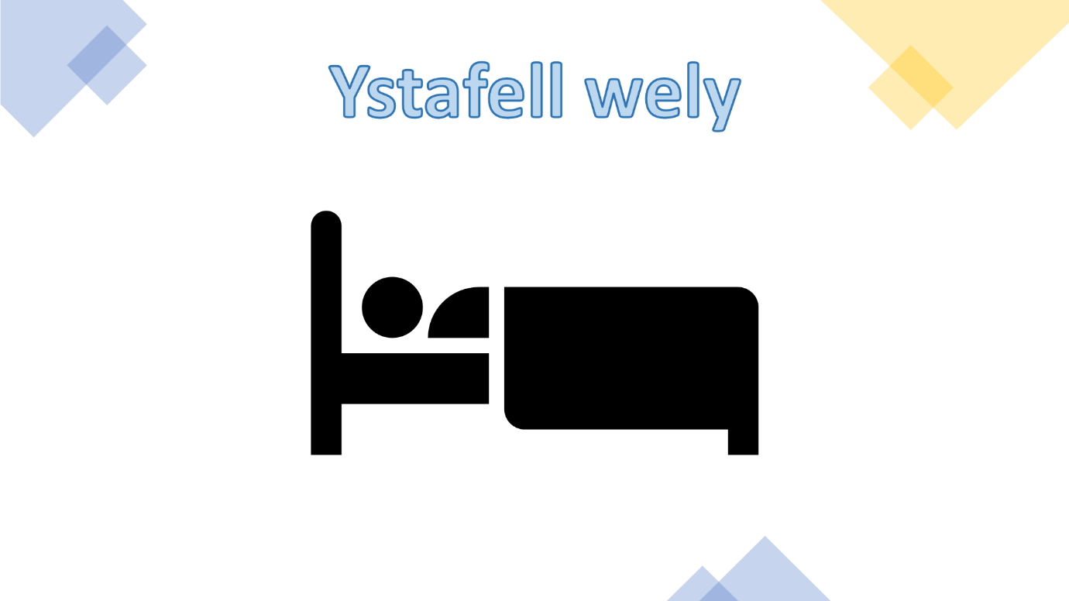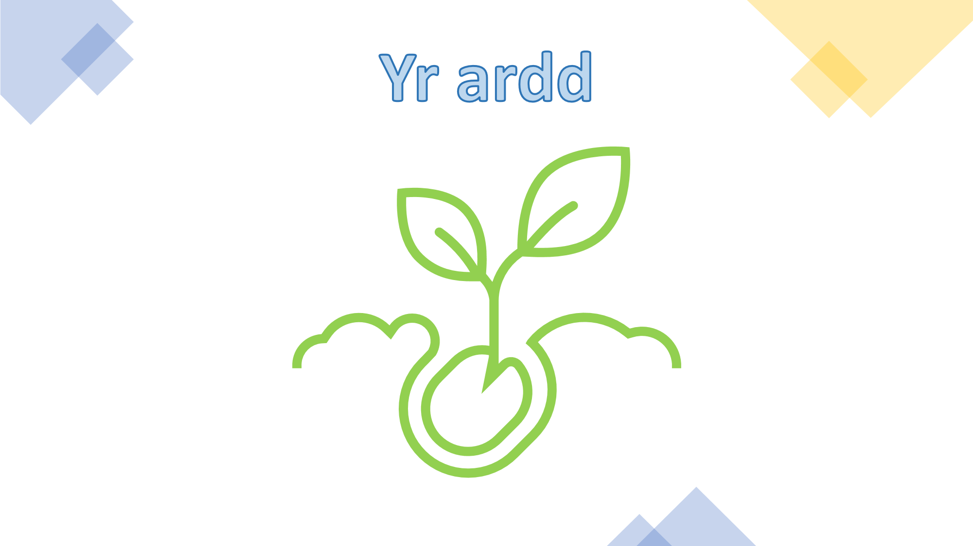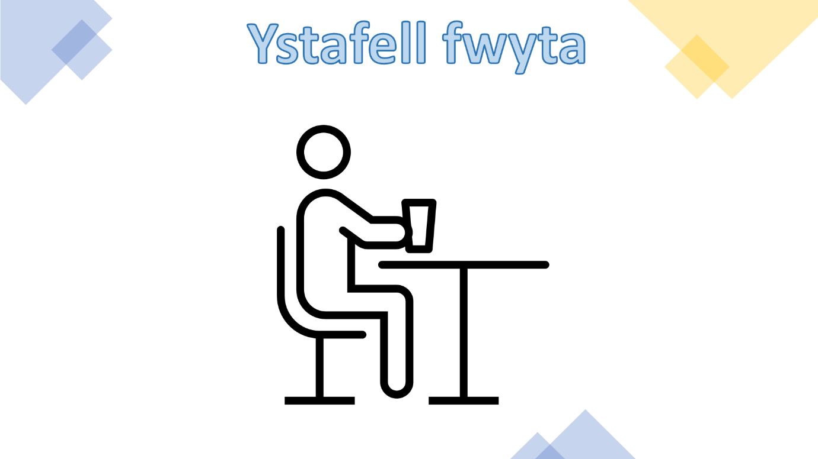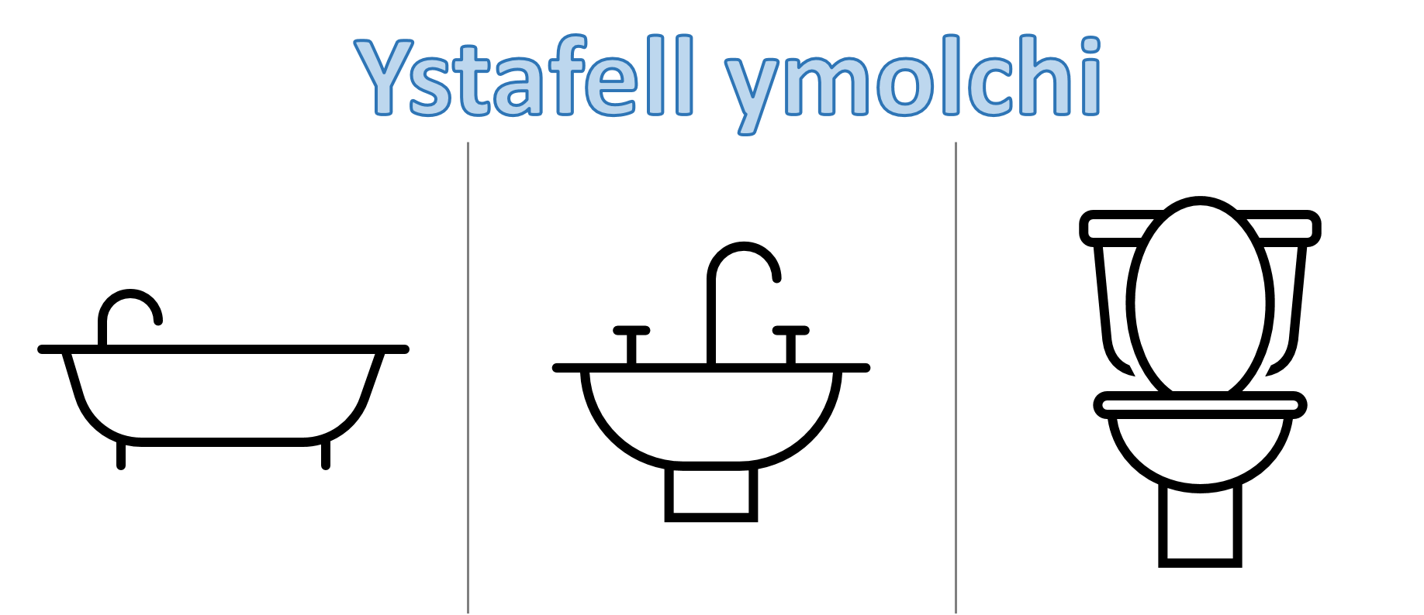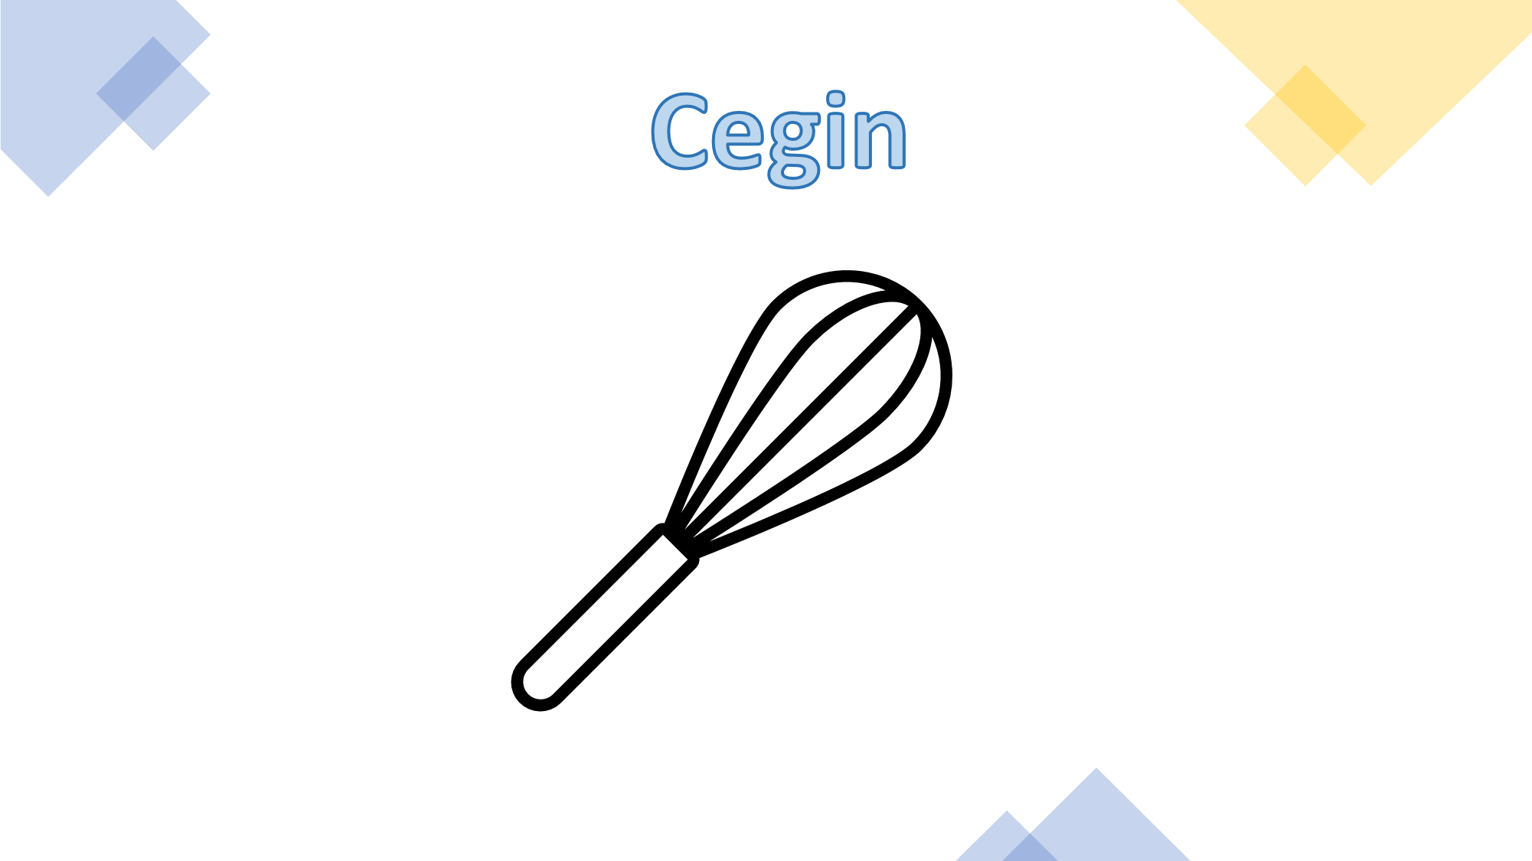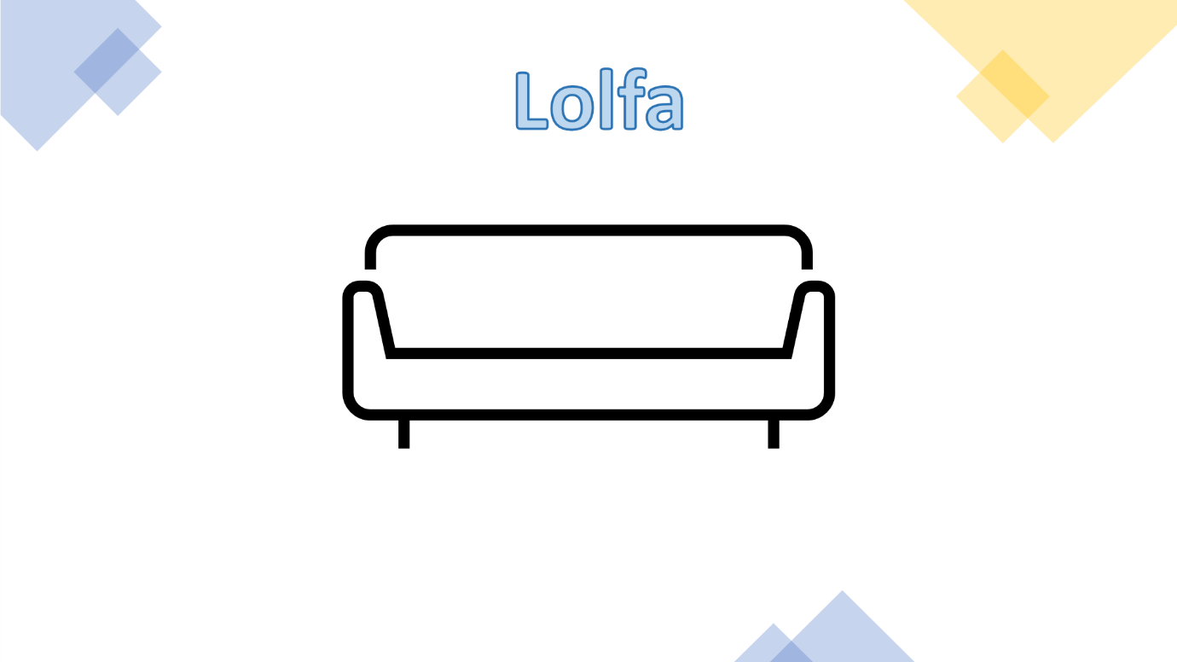

Appendix 2 – Differentiated Grids
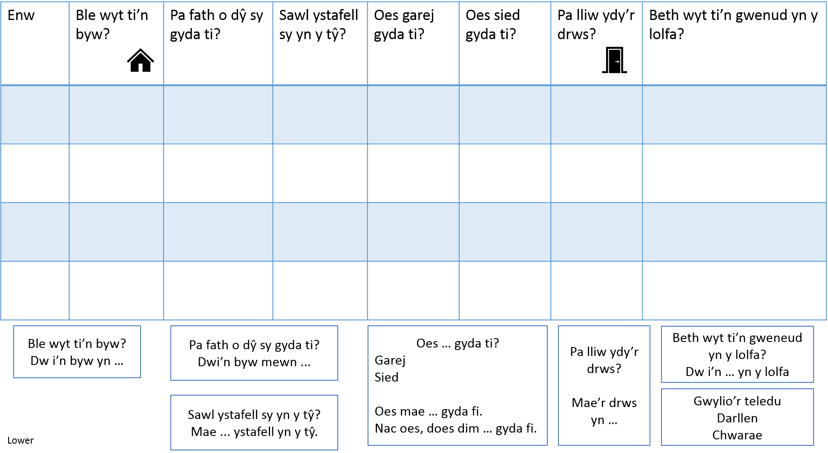
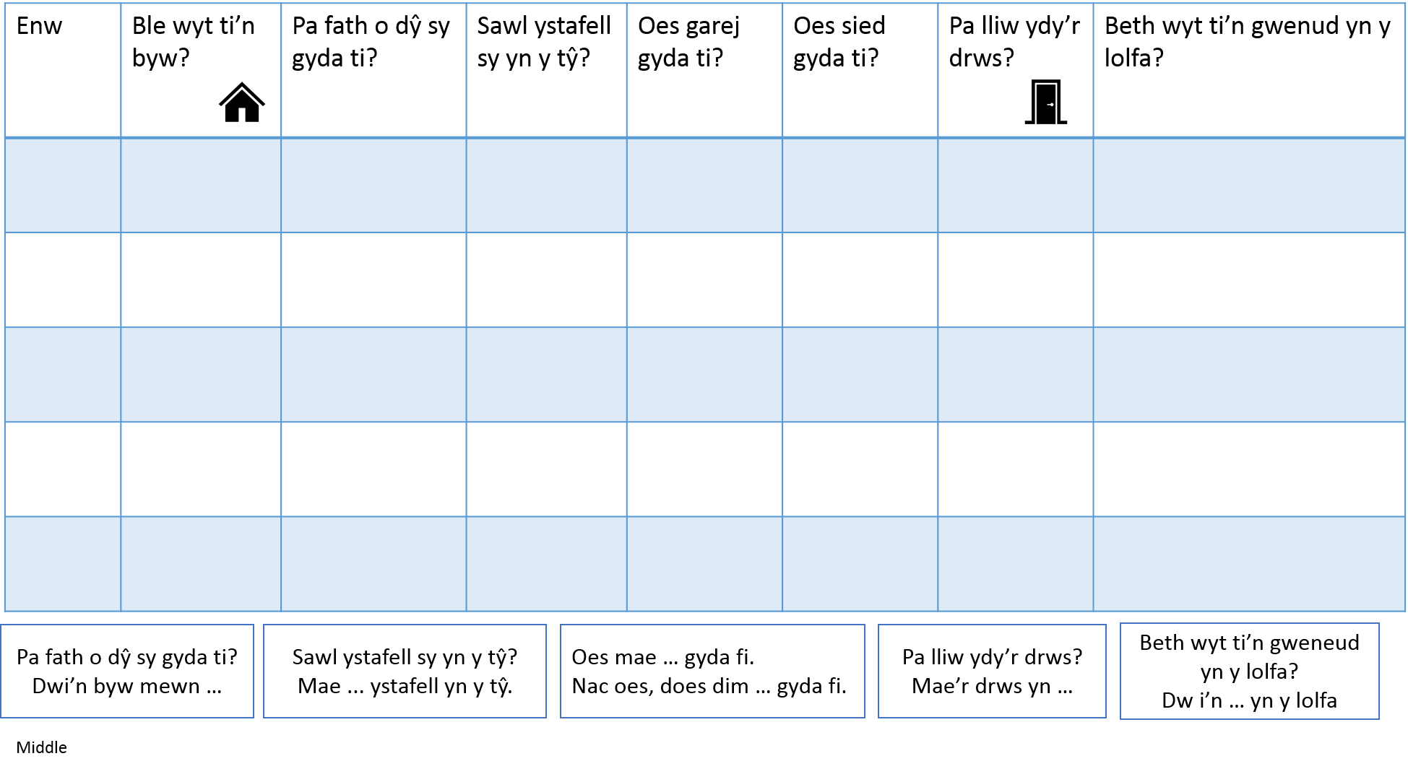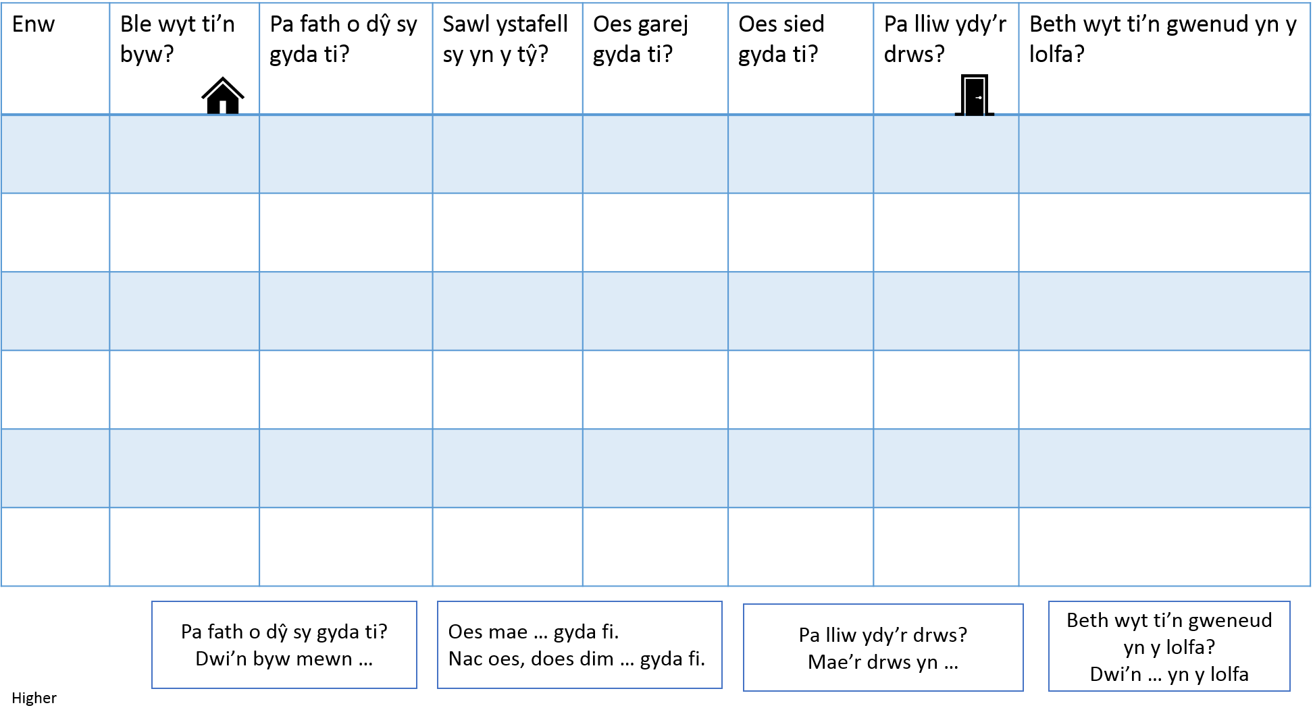

Appendix 3 – Matiau Iaith

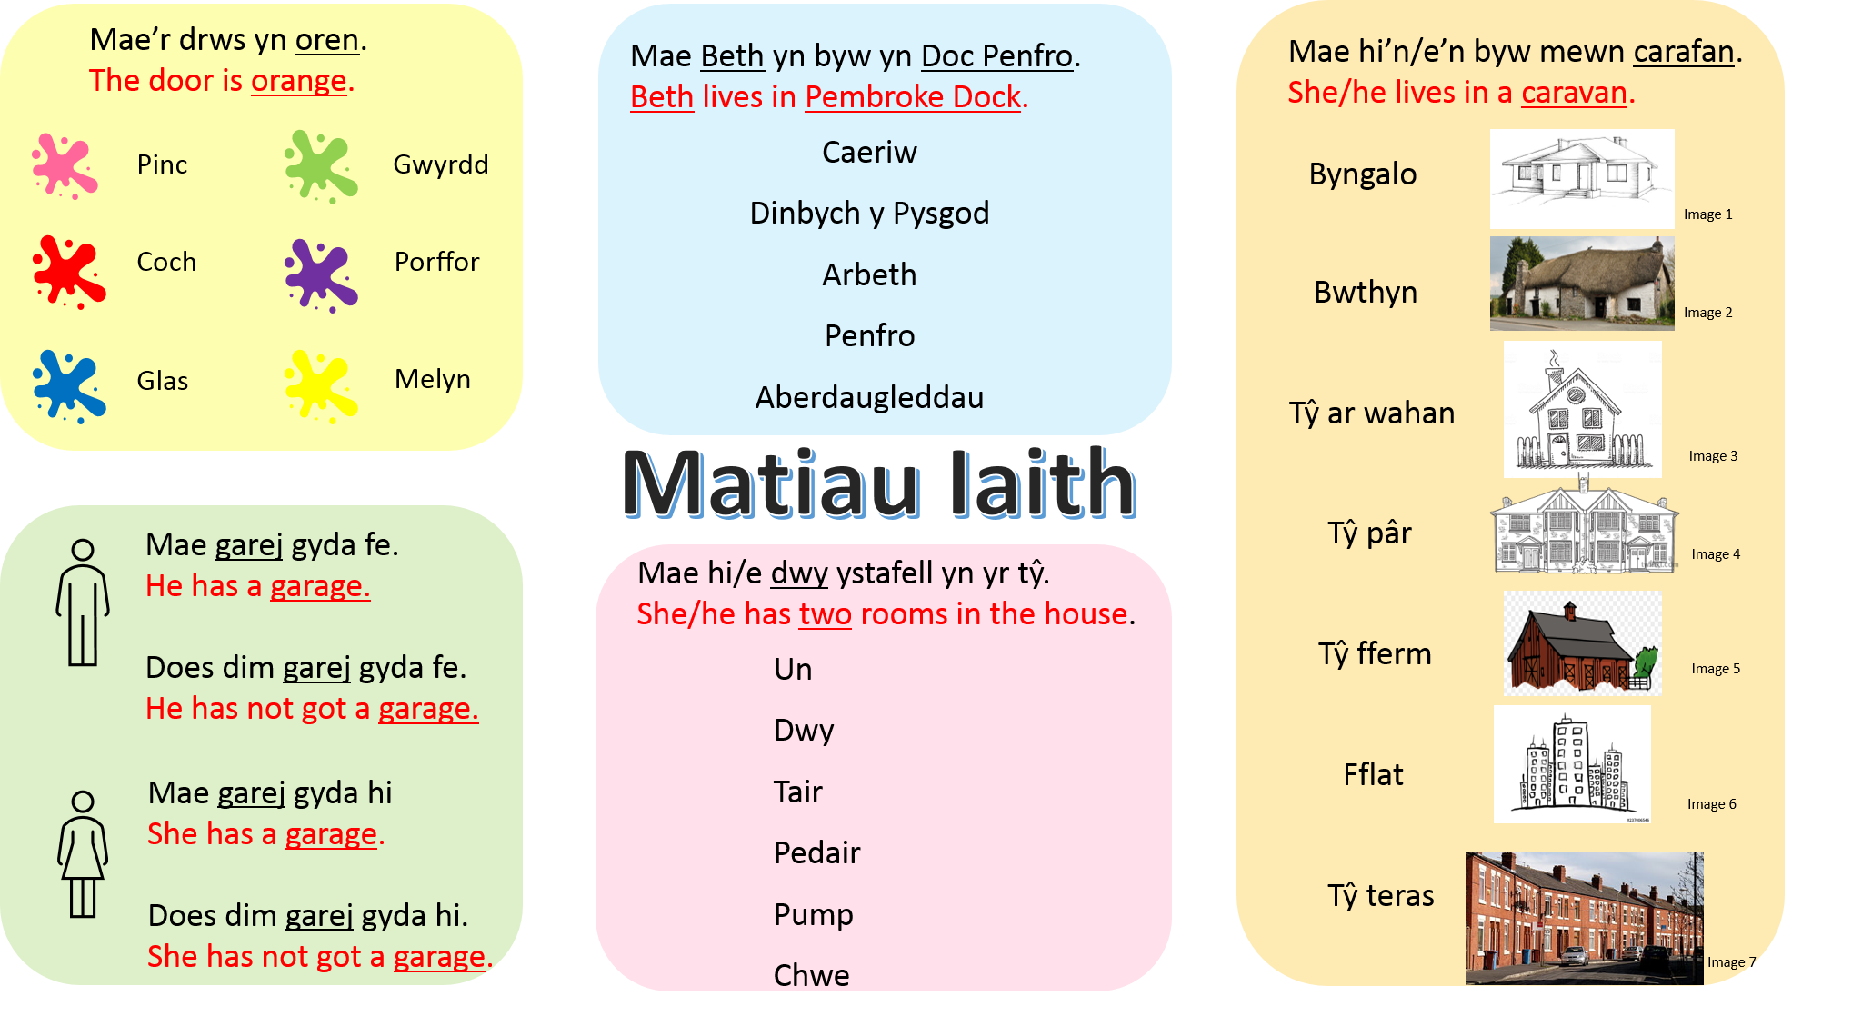
Appendix 4 – Activity 1 Resources
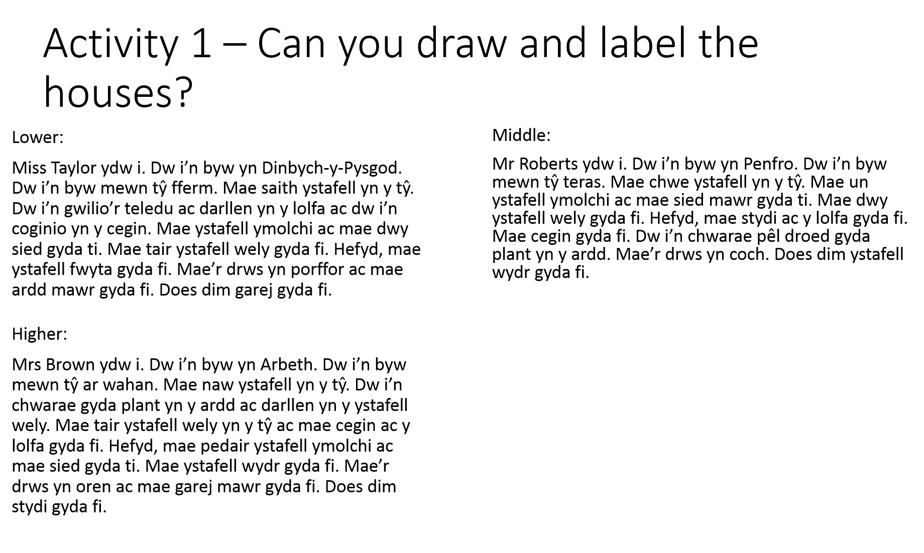
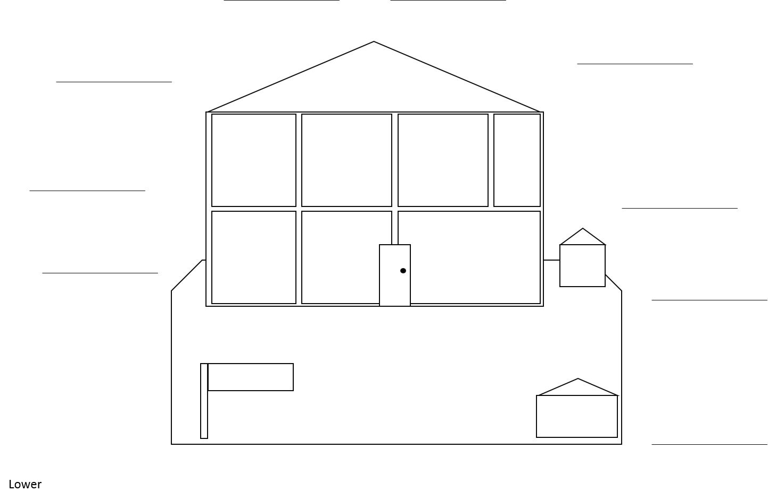

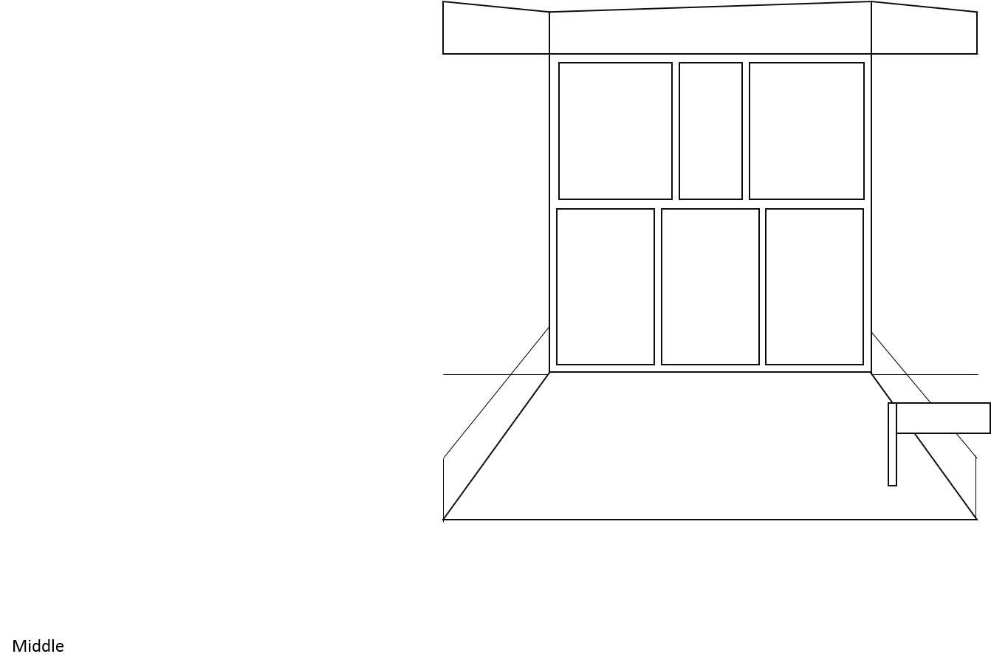

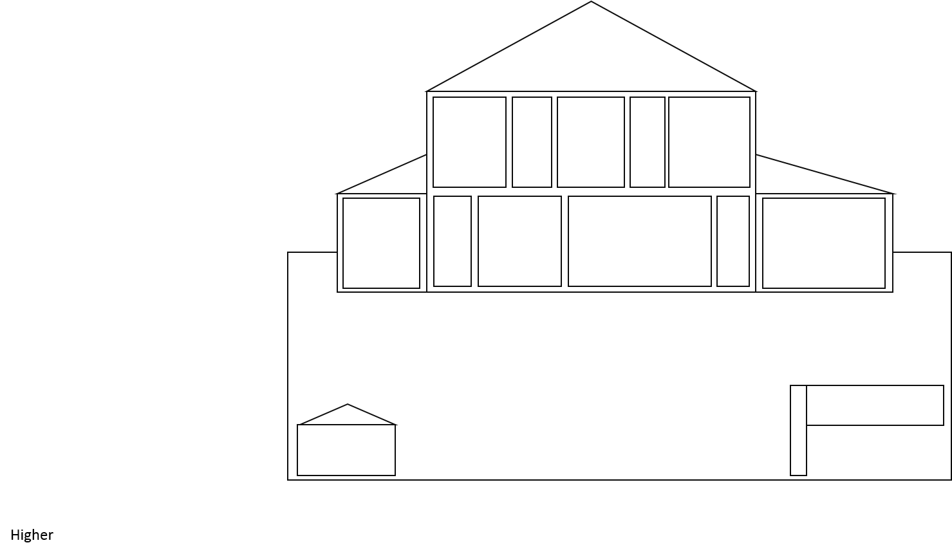

Appendix 5 – Activity 2 Resources
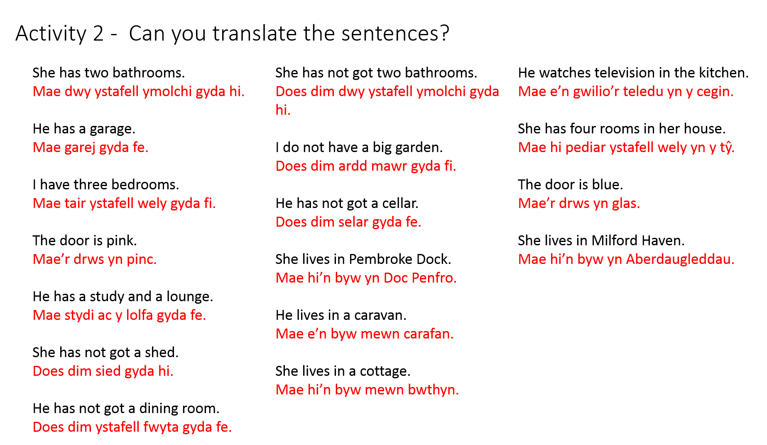

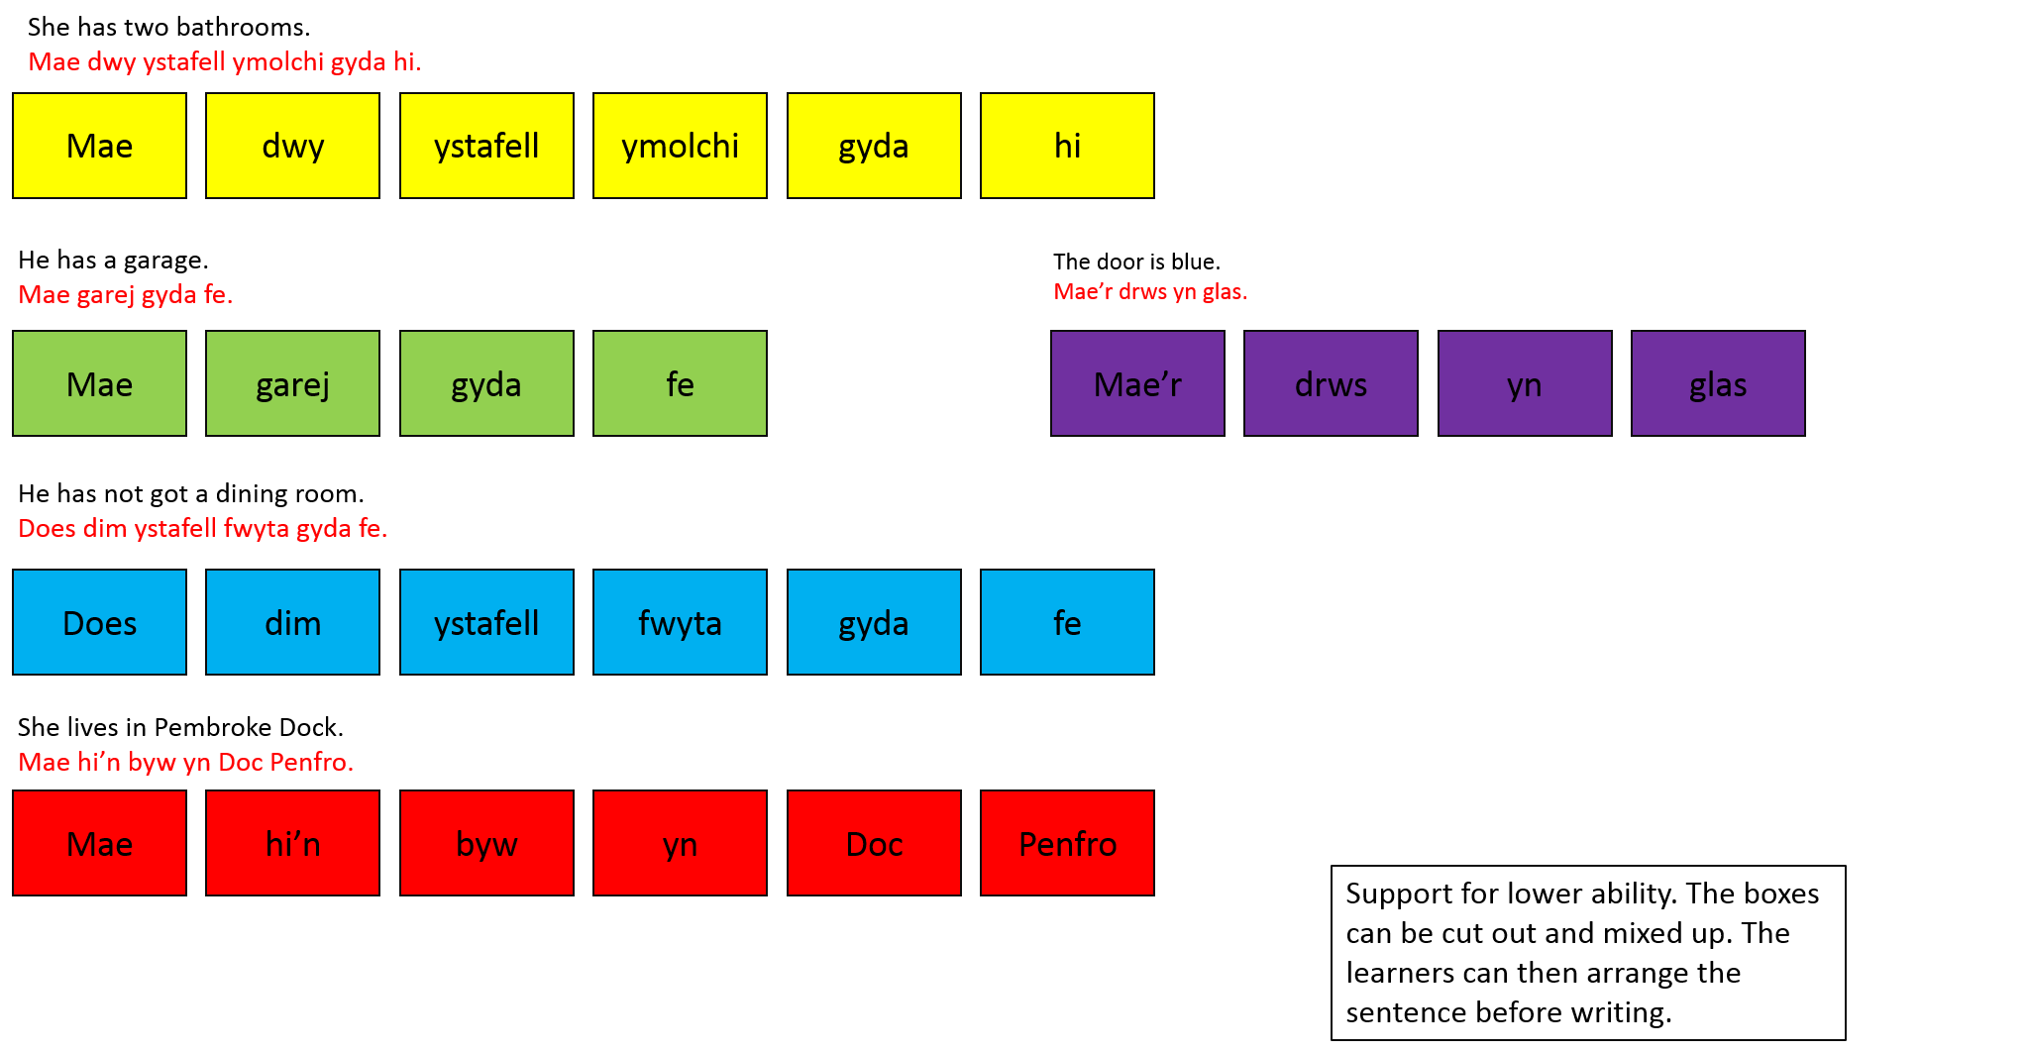

Appendix 6 – Activity 3 Resources


