Sean Andrew
Application Development Assignment 1
Table of Contents:

Introduction 1
Application Development Trends 1
Implimentation 3
Software requirements specification: 3
Software Design: 3
Implimentation 21
Evaluation 39
Bibliography 40

Introduction

In this report I am going to conduct research into the current developmental trends concepts when designing programs and looking into the different areas that is getting more focused on and what things are becoming more mainstream to consumers. I am also going to provide documentation of how I developed my program as well as conduct a variety of tests to show that it works to its intent.

Application Development Trends

When developing applications in todays world there is many different Frameworks that people can use to develop their applications on and ship them through which all are good at doing different things. One thing that has become something that a lot of big companies do like Amazon and Microsoft is “Continuous Delivery” which means that they are able to update their applications and programs with pieces of code really quickly and implement it to the existing application with minimal downtime needed. If this was to be put into a real-life scenario then there will be a need for all different kinds of hardware like a “CI build server, monitoring tools, and code management platforms” [1]

With C# based programs Microsoft have a service called Microsoft Azure which is a cloud based computing which allows developers to develop and manage applications online rather then on their own hardware which can be extremely useful for big companies with large work forces and especially with the current pandemic as it allows people to work from home no matter the hardware they people have as all the hard work is done on Microsoft servers. [2]

Another developmental trend is security as over the past couple of years with flaws being discovered in Windows and hardware (AMD and Intel CPU’s etc) [3] which is quickly making security a bigger a bigger issue with applications that are being developed as a lot of programs sometimes store some sensative information or can be used to get access to some sensative information so companies are forced to take take more and more time into developing better and stronger security measures.

Security is always going to be a massive part of development when coming to deveping applications and an even bigger one when developing applications that will store some sensative information. In the past couple of years there has been all different kinds of security flaws that have caused problems for applications, one of the latest ones is from a program called “Zoom” which had a problem of users being able to hyjack streams where people would use to host meetings and conferences. People were able to join ongoing meetings and onferences and send messages where if people clicked them it would install mallware onto their pc and spy on the meeting in progress.[4]

Overall with the developmental trends there are many different things that is taken into account and decided upon before actually designing the program like chosing the correct framework to work on, using the correct software to deleope the program on and a big part of it is making sure what they design and make is secure and safe if it is going to be handeling any sort of sensative information.

Implimentation

Software requirements specification:

CPU: AMD Ryzen 3 2200g or Intel equivilent

GPU: Nvidia GTX 750

RAM: 4GB Minimum

Operating System: Windows 7/10

Storage: 300MB

Some requirements of the program is that it is used on a Windows system as it using Microsoft SQL to handel the data inside of the program and will not work on MacOS

This program is design to store all the data nessesary about the different Fruits, Islanders and Islands in the Animal Crossing game which can be extreamly useful for people who would like to see who is in the game and who they could poentially meet as well as all the different fruits they can collect.

Software Design:

ERD:
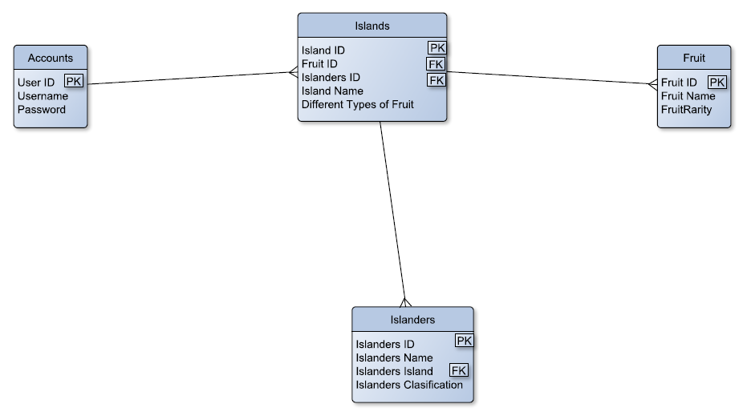

This is the table structure of how all the tables are linked and how they can interact with each other. This helps to show how the program will be able to access all of the data.

Pseudocode

Login Form

program start
initialise variable errorcount=0

login button is pressed
connect to the database
if username and password = 1 record in the database
close login form
open dashboard
else
display error message
errorcount + 1

if error count = 3
display error message
close program
else
do nothing

exit button is pressed
asks the user if they want to exit
if user responds yes
close the program
else
close message box

Dashboard form

form open

Islander button is pressed
close dashboard
open Islander form

Islands button is pressed
close dashboard
open Islands form

Fruit button is pressed
close dashboard
open Fruit Form

exit button is pressed
asks the user if they want to return to login
if user responds yes
close dashboard
open login
else
close message box

Islander form

form open

Initialise veriable IslandersNumber = 0

Initialise veriable IslandNumber = 0

connect to Islanders database

select 1 Islanders record where IslandersID = IslandersNumber
store IslandersID in IslandersNumber
store IslandID in IslandNumber
store IslandersName in IslandersName Textbox
store IslanderClassification in IslanderClassification Textbox
close connection

connect to Island database

select 1 Island record where IslandID = IslandNumber
store IslandName in IslandName Textbox

close connection

FindIslander button is pressed
open FindIslander form

EditIslander button is pressed
pass IslandersNumber to EditIslander Form
open EditIslander form
close Islander form

DeleteIslander button is pressed
asks the user if they want to delete the Islander and their Islands
if user responds yes

connect to Islanders database

delete Islanders record where IslandersID = IslandersNumber

close connection

delete from Islands record where IslandersID = IslandersNumber

close connection

display message Deletion complete

close message box

else

display message error

exit button is pressed
asks the user if they want to return to login
if user responds yes
close Islander Form
open login
else
close message box

FindIslander form

form open

Initialise veriable IslandersNumber = 0

Initialise veriable IslandNumber = 0

connect to Islanders database

select all Islanders
store IslandersID in datatable
store IslandersName in datatable
store IslandersClasification in datatable
store IslandID in datatable

list all in datatable

if user clicks on cell

stores IslandersID in IslandersNumber
stores IslandID in IslandNumber

if user double clicks cell

stores IslandersID in IslandersNumber
stores IslandID in IslandNumber
pass IslandersNumber back to Islanders Form
pass IslandNumber back to Islanders Form
close FindIslander form

if cancel button is pressed

IslandNumber = 0
IslandersNumber = 0
pass IslandersNumber back to Islanders Form
pass IslandNumber back to Islanders Form
close FindIslander form

if text is entered in Filter Text box
filter datatable by Islandersname
list results

AddIslander form

form open

Initialise veriable IslandersNumber = 0

initialise veriable NewIslanderiD = 0

initialise veriable Error = false

AddIslander is pressed

display message asking if the user wants to add this islander
if User says yes

connect to the Islanders database

insert into Islanders IslandersID = IslandersID textbox
insert into Islanders IslandersName = IslandersName textbox
insert into Islanders IslandersClasification = IslandersClasification textbox
insert into Islanders IslandID = IslandID textbox

if IslandersID already exists or is in an incorrect
veriable error = true
display error message telling the user to enter another ID in the correct format
else
allow the insert

return NewIslanderID

close database connection

else

close message box

exit button is pressed
asks the user if they want to return to Islanders Form
if user responds yes
close AddIslanders form
else
close message box

EditIslander form

form open

Get IslanderNumber from Islanders Form

connect to the Islanders database

try

select all from Islanders database where IslandersID = IslanderNumber

store IslandersName = IslandersName textbox
store IslandersClasification = IslandersClasification textbox
store IslandID = IslandID textbox

close connection

else

display error message cant connect to database

EditIslander is pressed

display message asking if the user wants to Edit this islander
if User says yes

connect to the Islanders database

update Islanders where IslandersID = IslanderNumber

insert into Islanders IslandersName = IslandersName textbox
insert into Islanders IslandersClasification = IslandersClasification textbox
insert into Islanders IslandID = IslandID textbox

close database connection

else

close message box

exit button is pressed
asks the user if they want to return to Islanders Form
if user responds yes
close EditIslander form
else
close message box

Fruit form

form open

Initialise veriable FruitNumber = 0

connect to Fruits database

select 1 Fruit record where FruitID = FruitNumber
store FruitID in FruitNumber
store FruitName in FruitName in Textbox
store FruitRarity in FruitRarity Textbox
close connection

connect to Fruits database

select 1 Fruits record where FruitID = FruitNumber
store FruitName in FruitName Textbox

close connection

FindFruit button is pressed
open FindFruit form

EditFruit button is pressed
pass FruitsNumber to EditFruit Form
open EditFruit form
close Fruit form

DeleteFruit button is pressed
asks the user if they want to delete the Fruit
if user responds yes

connect to Fruits database

delete Fruits record where FruitsID = FruitsNumber

close connection

delete from Fruits record where FruitsID = FruitsNumber

close connection

display message Deletion complete

close message box

else

display message error

exit button is pressed
asks the user if they want to return to login
if user responds yes
close Fruit form
open login
else
close message box

FindFruit form

form open

Initialise veriable FruitsNumber = 0

connect to Fruit database

select all Fruits
store FruitsID in datatable
store FruitName in datatable
store FruitRarity in datatable

list all in datatable

if user clicks on cell

stores FruitsID in FruitsNumber

if user double clicks cell

stores FruitsID in FruitsNumber
pass FruitsNumber back to Fruits Form
close FindFruit form

if cancel button is pressed

FruitNumber = 0
pass FruitsNumber back to Fruits Form
close FindFruit form

if text is entered in Filter Text box
filter datatable by Fruitsname
list results

AddFruit form

form open

Initialise veriable FruitsNumber = 0

initialise veriable Error = false

AddFruit is pressed

display message asking if the user wants to add this Fruit
if User says yes

connect to the Fruits database

insert into Fruits FruitsID = FruitsID textbox
insert into Fruits FruitsName = FruitsName textbox
insert into Fruits FruitRarity = FruitRarity textbox

if FruitsID already exists or is in an incorrect
veriable error = true
display error message telling the user to enter another ID in the correct format
else
allow the insert

return NewFruitID

close database connection

else

close message box

exit button is pressed
asks the user if they want to return to Fruit Form
if user responds yes
close AddFruits form
else
close message box

EditFruit form

form open

Get FruitNumber from Fruits Form

connect to the Fruits database

try

select all from Fruits database where IslandersID = IslanderNumber

store FruitsID = FruitNumber textbox
store FruitsName = FruitsName textbox
store FruitRarity = FruitRarity textbox

close connection

else

display error message cant connect to database

EditFruit is pressed

display message asking if the user wants to Edit this Fruit
if User says yes

connect to the Fruits database

update Fruits where FruitsID = FruitsNumber

insert into Fruits FruitsName = FruitsName textbox
insert into Fruits FruitRarity = FruitRarity textbox
insert into Fruits FruitID = FruitID textbox

close database connection

else

close message box

exit button is pressed
asks the user if they want to return to Fruit Form
if user responds yes
close EditFruit form
else
close message box

Island form

form open

Initialise veriable FruitNumber = 0

Initialise veriable IslandNumber = 0

Initialise veriable IslanderNumber = 0

connect to Islands database

select 1 Fruit record where IslandID = IslandNumber
store IslandID in IslandNumber
store IslandName in IslandName in Textbox
store NumberOfDifferentFruits in NumberOfDifferentFruits Textbox
close connection

connect to Fruits database

select 1 Fruits record where FruitID = FruitNumber
store FruitName in FruitName Textbox

close connection

connect to Islanders database

select 1 Islanders record where IslandersID = IslanderNumber
store IslandersName in IslandersName Textbox

close connection
FindIsland button is pressed
open FindIsland form

EditIsland button is pressed
pass IslandsNumber to EditFruit Form
open EditIsland form
close Island form

DeleteIsland button is pressed
asks the user if they want to delete the Island
if user responds yes

connect to Islands database

delete Islands record where IslandsID = IslandsNumber

close connection

display message Deletion complete

close message box

else

display message error

exit button is pressed
asks the user if they want to return to login
if user responds yes
close Account form
open login
else
close message box

FindIslanders form

form open

Initialise veriable IslandsNumber = 0

Initialise veriable IslandersNumber = 0

Initialise veriable FruitsNumber = 0

connect to Island database

select all Islands
store IslandID in datatable
store IslandName in datatable
store IslandersID in datatable
store FruitID in datatable

list all in datatable

if user clicks on cell

stores FruitsID in FruitsNumber
stores IslandID in IslandNumber
stores IslandersID inIslandersNumber

if user double clicks cell

stores FruitsID in FruitsNumber
stores IslandID in IslandNumber
stores IslandersID inIslandersNumber
pass FruitsNumber back to Fruits Form
pass IslandNumber back to Fruits Form
pass IslandersNumber back to Fruits Form
close FindIsland form

if cancel button is pressed

FruitNumber = 0
IslandersNumber = 0
IslandNumber = 0
pass FruitsNumber back to Fruits Form
pass IslandNumber back to Fruits Form
pass IslandersNumber back to Fruits Form
close FindIsland form

if text is entered in Filter Text box
filter datatable by Islandsname
list results

AddIslands form

form open

Initialise veriable IslandsNumber = 0

Initialise veriable IslandersNumber = 0

Initialise veriable FruitsNumber = 0

initialise veriable Error = false

initialise veriable NewIslanderID = 0

AddIsland is pressed

display message asking if the user wants to add this Island
if User says yes

connect to the Islands database

insert into Islands IslandID = IslandID textbox
insert into Islands IslandName = IslandName textbox
insert into Islands FruitID = FruitID textbox
insert into Islands IslandersID = IslandersID textbox
insert into Islands NumberOfDifferentFruits = NumberOfDifferentFruits textbox

if IslandID already exists or is in an incorrect
veriable error = true
display error message telling the user to enter another ID in the correct format
else
allow the insert

return NewIslandID

close database connection

else

close message box

exit button is pressed
asks the user if they want to return to Island Form
if user responds yes
close AddIsland form
else
close message box

EditIsland form

form open

Get IslandNumber from Island Form

connect to the Islands database

try

select all from Islands database where IslandsID = IslandNumber

store FruitsID = FruitsID textbox
store IslandersID = IslandersID textbox
store IslandName = IslandName textbox
store NumberOfDifferetFruits = NumberOfDifferetFruits textbox

close connection

else

display error message cant connect to database

EditIsland is pressed

display message asking if the user wants to Edit this Island
if User says yes

connect to the Islands database

update Islands where IslandsID = IslandsNumber

insert into FruitsID = IslandsID textbox
insert into IslandersID = IslandersID textbox
insert into IslandName = IslandName textbox
insert into NumberOfDifferetFruits = NumberOfDifferetFruits textbox

close database connection

else

close message box

exit button is pressed
asks the user if they want to return to Island Form
if user responds yes
close EditIsland form
else
close message box

Accounts form

form open

Initialise veriable AccountNumber = 0

connect to accounts database

select 1 Fruit record where UserID = AccountNumber
store UserID in AccountNumber
store Username in Username in Textbox
store Password in Password Textbox
close connection

FindAccount button is pressed
open FindAccount form

EditAccount button is pressed
pass AccountNumber to EditAccount Form
open EditAccount form
close Account form

DeleteAccount button is pressed
asks the user if they want to delete the Account
if user responds yes

connect to accounts database

delete accounts record where UserID = AccountNumber

close connection

display message Deletion complete

close message box

else

display message error

exit button is pressed
asks the user if they want to return to login
if user responds yes
close Account Form
open login
else
close message box

FindAccount form

form open

Initialise veriable AccountNumber = 0

connect to Account database

select all Account
store UserID in datatable
store Username in datatable
store Password in datatable

list all in datatable

if user clicks on cell

stores UserID in AccountNumber

if user double clicks cell

stores IslandersID in AccountNumber
pass AccountNumber back to Account Form
close FindAccount form

if cancel button is pressed

AccountNumber = 0
pass AccountNumber back to Account Form
close FindAccount form

if text is entered in Filter Text box
filter datatable by Username
list results

AddAccount form

form open

Initialise veriable AccountNumber = 0

initialise veriable Error = false

initialise veriable NewAccountID = 0

AddAccount is pressed

display message asking if the user wants to add this Account
if User says yes

connect to the account database

insert into account UserID = UserID textbox
insert into account Username = Username textbox
insert into account Password = Password textbox

if UserID already exists or is in an incorrect
veriable error = true
display error message telling the user to enter another ID in the correct format
else
allow the insert

return NewAccountID

close database connection

else

close message box

exit button is pressed
asks the user if they want to return to Account Form
if user responds yes
close AddAccount form
else
close message box

EditAccount form

form open

Get AccountNumber from Account Form

connect to the account database

try

select all from account database where UserID = AccountNumber

store UserID = UserID textbox
store USername = Username textbox
store Password = Password textbox

close connection

else

display error message cant connect to database

EditAccount is pressed

display message asking if the user wants to Edit this Account
if User says yes

connect to the account database

update Islands where IslandsID = IslandsNumber

insert into UserID = UserID textbox
insert into Username = USername textbox
insert into Password = Password textbox

close database connection

else

close message box

exit button is pressed
asks the user if they want to return to Account Form
if user responds yes
close EditAccount form
else
close message box

Implimentation

Login Form

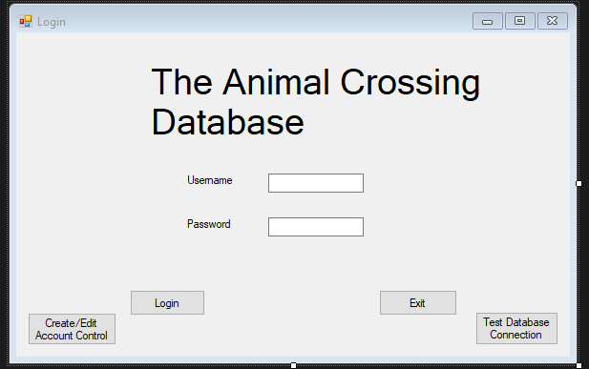

Dashboard Form

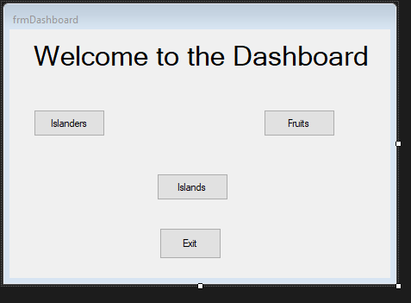

Islander Form

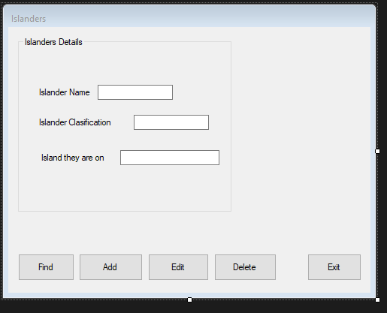

FindIslander Form
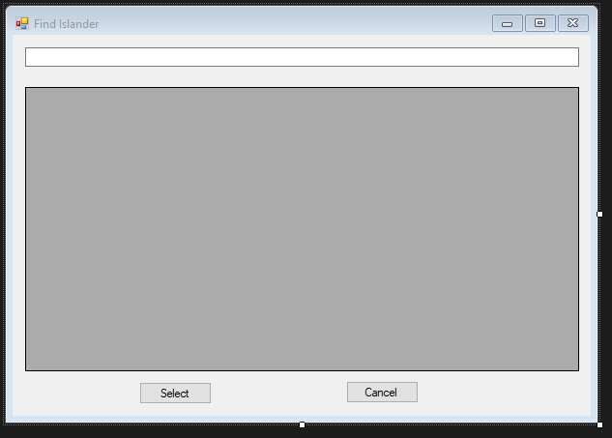

AddIslander Form
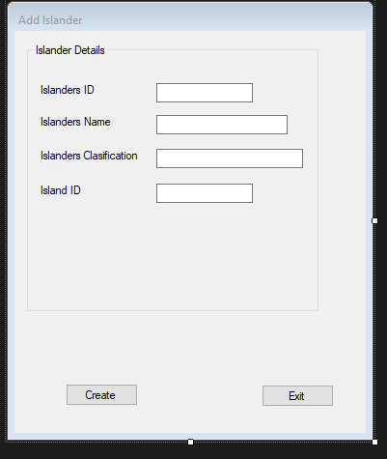
EditIslander form
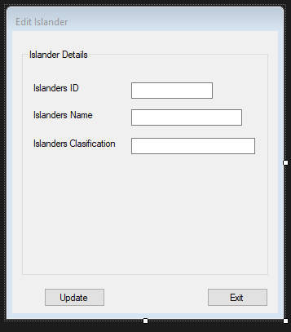

Island Form
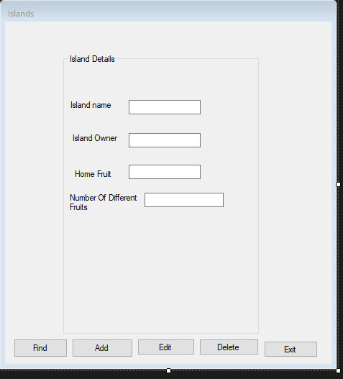

AddIsland form
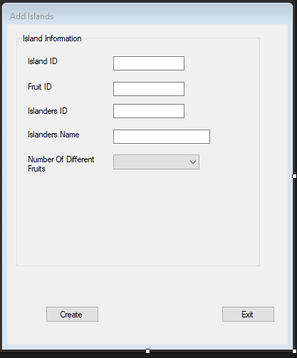

EditIsland form
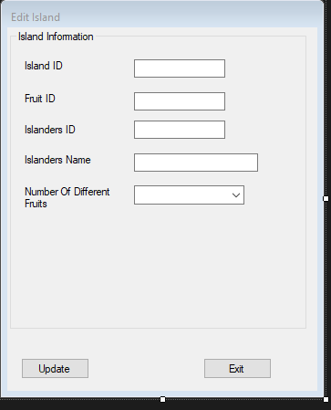

FindIsland form
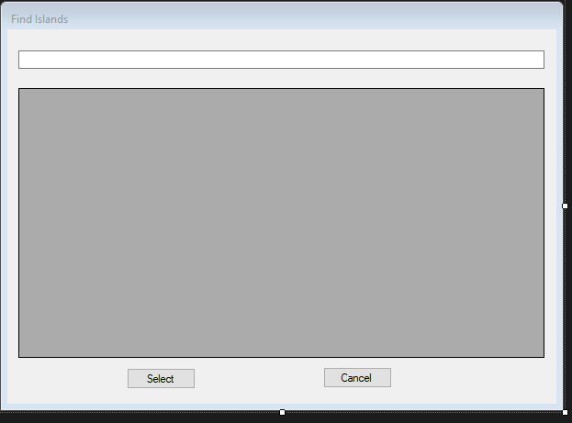

Fruit form
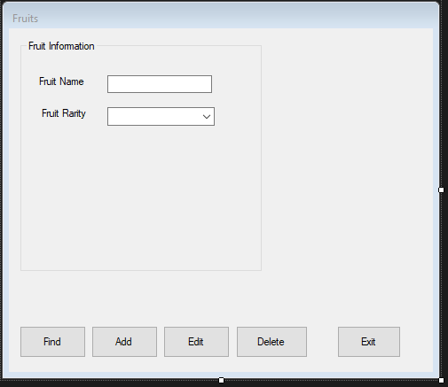

FindFruit form
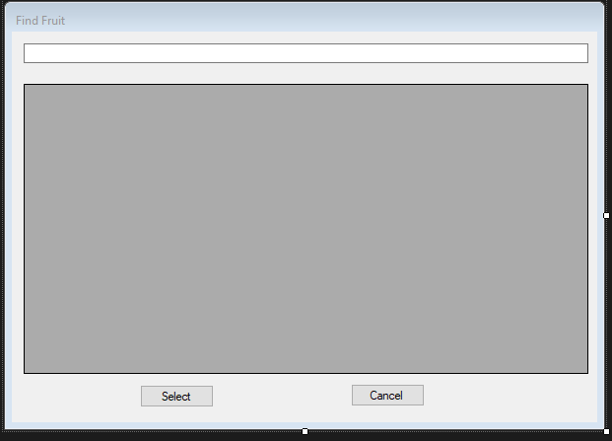

EditFruit form
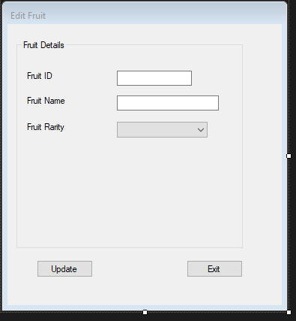

AddFruit form
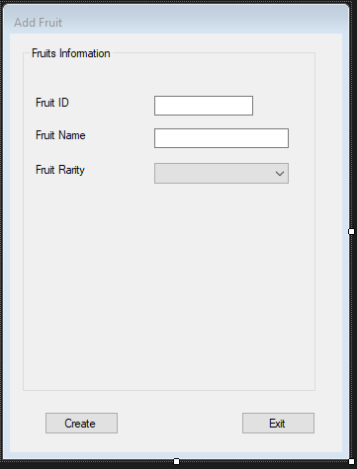

Accounts form
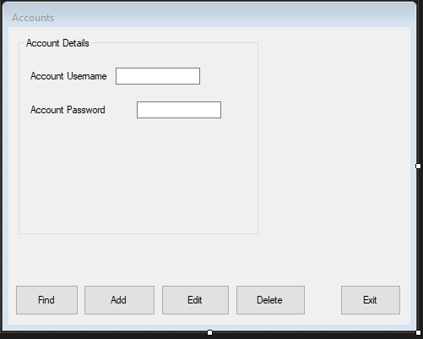

FindAccounts form
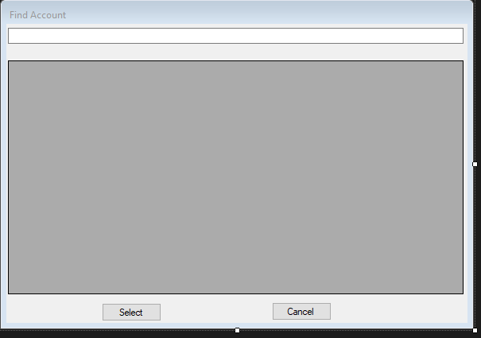

AddAccounts form
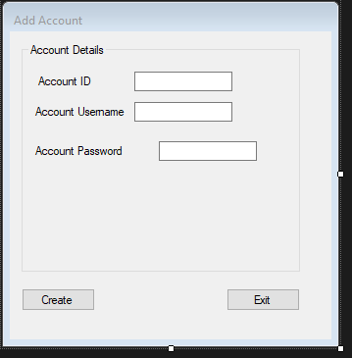

EditAccount form
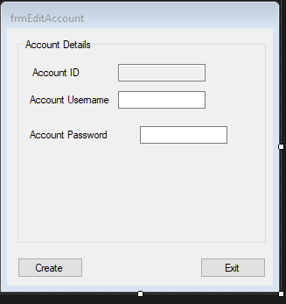

Software Verification and Validation

Test Num | What is the test | Test Data | Expected outcome | Actual outcome
Login Test
1 | Test to see if the User can log in with a correct username and password | Username = Sean  Password = Andrew | Allowed access | Allowed access
2 | Test to see if the User can get in with an username from one account and a password from another | Username = Sean  Password = John | Denied access | Denied access
3 | Test to see if the User can get in when two accounts of the same username an password exist | Username = Test  Password = Test | Denied access | Denied access
4 | Test to see if after 3 failed attempts to login the program will shutdown | 3 failed attempts to login | Shut down Program | Shut down Program
5 | Test to see if entering a text character in the Islander ID box when creating a Islander will display an error | Islander ID = t | Error | Error
6 | Test to see if entering a text character in the Island ID box when creating a Islander will display an error | Island ID = t | Error | Error
7 | Test to see if entering a text character in the Fruit ID box when creating a Fruit will display an error | Fruit ID = t | Error | Error
8 | Test to see if entering a text character in the Island ID box when creating a Island will display an error | Island ID = t | Error | Error
9 | Test to see if entering a text character in the Islanders ID box when creating a Island will display an error | Islanders ID = t | Error | Error
10 | Test to see if entering a text character in the Fruit ID box when creating a Island will display an error | Fruit ID = t | Error | Error
11 | Test to see if entering a duplicate Islander ID when creating an Islander | Islander Id =5 | Error | Error
12 | Test to see if entering a duplicate Island ID when creating an Islander | Islander Id =2 | Error | No Error
13  Retest | Test to see if entering a duplicate Island ID when creating an Islander (RETEST) | Islander Id =2 | Error | Error
14 | Test to see if entering a duplicate Fruit ID when creating an Islander | Fruit Id =2 | Error | Error
Adding items to the database
15 | Test to see if a user is able to add Fruit to the database | Fruit ID = 6  FruitName = Mango  Fruit Rarity = 5 | Accept | Accept
16 | Test to see if a user is able to add an Island to the to the database | IslandID = 4  FruitID = 4  IslandersID = 6  IslandName = Creepy Island  NumberOfDifferentFruits = 2 | Accept | Accept
17 | Test to see if a user is able to add an Islanders to the to the database | IslandersID = 9  IslandersName = Benry  IslandersClasification = Bear  IslandID = 4 | Accept | Accept
Editing items in the database
18 | Test to see if a user is able to edit Fruit in the database | Edit Cherries  To Cherry | Accept | Accept
19 | Test to see if a user is able to edit Island in the database | Edit York Island  To Old York Island | Accept | Accept
20 | Test to see if a user is able to edit Islanders in the database | Edit Tom Nook  To Tom | Accept | Accept
21 | Test to see if a user is able to add a User to the to the database | UserID = 5  Username = Admin  Password = Admin | Accept | Accept
22 | Test to see if a user is able to edit Users in the database | Edit Password = Admin  To Password = Password | Accept | Accept
Delete Items from the database
23 | Test to see if a user is able to delete Users in the database | Delete Account Admin | Accept | Accept
24 | Test to see if a user is able to delete Fruit in the database | Delete Mango | Accept | Accept
25 | Test to see if a user is able to delete Island in the database | Delete Creepy Island | Accept | Accept
26 | Test to see if a user is able to delete Islanders in the database | Delete Benry | Accept | Accept
27 | Test to see if when deleting an Islander it will delete the Island too | Delete Islander Test Which Should delete Island Test | Accept | Accept

Test 13
To fix the issue I had I had to back into SQL server management an set IslandID as a primary key as it was allowing duplicate Islands to be created and caused problems with data
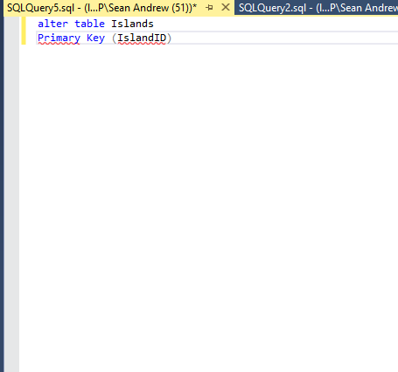

After doing this it fixed the issue where I was able to put in 2 of the same IDs

Evaluation
Overall I think the implementation of the program I have designed fulfils its purpose and handles data handling and management correctly with its login system and the ability to display information from multiple tables on one form. If I was to redesign this in the future I would try to make some of the ways to enter data on the forms more intelligent where it would pull information from the databases and the users will be able to pick from the options in the database already for example: a drop down list of all the IDs in a certain table.

Another thing I would try and do is try to look into implementing different types of ways users can input data on forms into the databases like radio buttons, check boxes, multiple choice selection etc instead of having the user enter everything into textboxes which leaves room for human error

Bibliography

[1] | “Stackify,” [Online]. Available: https://stackify.com/software-development-trends-2018/.
[2] | “Microsoft Azur,” Microsoft, [Online]. Available: https://azure.microsoft.com/en-us/.
[3] | “Intel chips security flaw,” Engadget, [Online]. Available: https://www.engadget.com/2020/03/06/intel-chips-unpatchable-security-flaw/?guccounter=1&guce_referrer=aHR0cHM6Ly9kdWNrZHVja2dvLmNvbS8_dD1mZmFiJnE9aW50ZWwrQ1BVK3NlY3VyaXR5K2ZsYXdzJmlhPXdlYg&guce_referrer_sig=AQAAADF3kFmcKk73-Kl5JeqEBSKECYkVIQf53UEa4ijSK2gx.
[4] | “USA Today,” [Online]. Available: https://eu.usatoday.com/story/tech/2020/04/01/zoom-demand-zooms-but-problems-coronavirus-drives-stay-home-video-chats-zoom-has-issues-beyond-deman/5102150002/.
[5] | “W3Schools,” [Online]. Available: https://www.w3schools.com/sql/default.asp.

