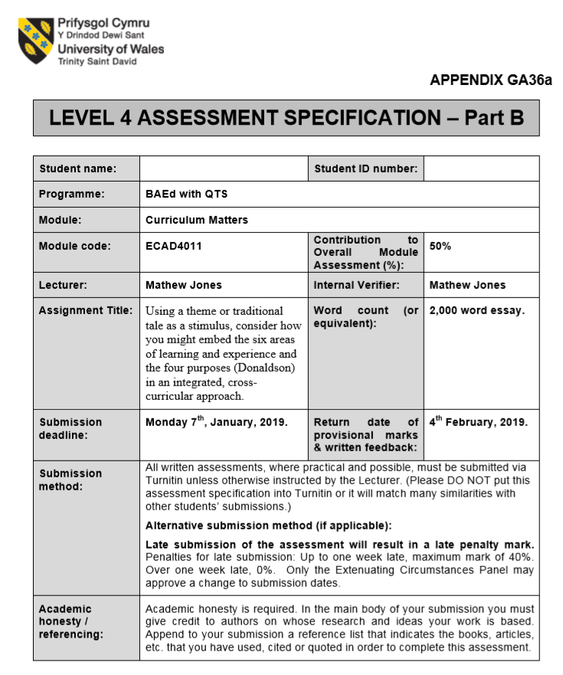

1800691
Joshua Morgan Randell

“If we teach today’s students as we taught yesterday’s, we rob them of tomorrow” (John Dewey, 1902). This quote perfectly outlined the need for a cross-curriculum structure of teaching in schools, as a way of delivering knowledge more effectively, and putting content from subjects into a more realistic perspective.
In his book, ‘Cross-Curricular Learning 3-14’, Johnathon Barnes stated that “cross-curricular approaches to teaching and learning have a long history”. This is the act of involving curricula in more than one subject, and this has been the thematic approach of most schools throughout the UK. Cross-curricular teaching is “when skills, knowledge and attitudes of a number of different disciplines are applied to a single experience, theme or idea” (Barnes. J 2012). In this essay, activities and lessons will be highlighted, along with how they promote cross-curricular learning and combine the said skills, knowledge and attitudes from different subjects into one, using the overarching theme of a a traditional tale.
After careful consideration, my chosen topic for my KS2 teaching is the traditional tale of The Tortoise and the Hare. I believe that this story contains some good moral lessons. I find that it is also very flexible for teaching in what are considered both traditional, and academic, subjects under the new curriculum. I believe that this story will allow me to put together activities that integrate several of the six Areas of Learning from Donaldson’s Successful Futures in each. My chosen year group is that of year four due to the simplicity of the story and activities. I have tried to include as many Areas of Learning into my activities and lessons, but only when appropriate. This is so pupils are developing skills from all subject areas, rather than just focusing on one. “In Cross-Curricular work the intention is to progress learning at all levels. Therefore, it aims to assess the attitudes towards and progress in understanding one’s self, understanding others, understanding essential local issues to the community, collaboration and understanding global issues. This is because cross-curricular is the only approach that allows this to take place” (Rowley and Cooper, 2009). This approach to learning has been used to address the many issues posed by the structure of the old curriculum. The main one being the issue of availability and time-management. Jim Rose stated that the “availability of time management will continue to pose considerable problems unless a better fit of curriculum” (Rose, Reviews of education and a new National Curriculum 2013, para 2.3). He further called the curriculum “overcrowded”, which gave “insufficient time to enable children to engage, adequately with every subject”. I have also tried to push the Literacy and Numeracy Framework (LNF) where possible and effective. I have also made sure to include the Digital Competence Framework (DCF), as technology is rapidly growing and is viewed as the way forward as a major tool of teaching. Furthermore, the Y Cwricwlwm Cymreig (YCC) has been considered in all of my activities for the inclusion of Welsh and the Welsh culture. I have also taken Donaldson’s Successful Futures into consideration when crafting these activities, particularly his ‘Four Purposes’ and his opinions on the curriculum. Each activity definitely encourages challenge and ambition in pupils.
The above story could also be used to construct a PE lesson on simple movements. The activity would mainly consist of pupils moving around the space using small, slow, crawling movements, like the tortoise in the story, and then using their legs to leap and bound as fast as they can, similarly to the hare. The teacher will call out a scene from the story for the pupils to interpret the movements of the character in said scene. Pupils will then be instructed to act out and recreate parts of the story by using their movements to tell that particular scene that the teacher had called out. There are three areas of learning that will be focused during this activity. This activity heavily focuses on Physical Development, as well as integrating skills from Creative Development, and the communication aspect from Language, Literacy and Communication Skills. To develop teamwork skills, at certain points of the activity, children will be placed in groups in order to select and perform a movement that fits with the character of the story, when called out by the teacher. Communication and Understanding, with both their team and the teacher’s instructions, skills will be present and utilised by the pupils here. Creativity is also needed in this activity in order for the pupils to create the movements. The best ones will be demonstrated to the rest of the class as both encouragement for the groups watching, and the group demonstrating. This activity is designed to give pupils the opportunity to, and encourage them to regularly, engage in frequent and regular physical activity beneficial to their health, fitness and well-being, as well as develop and grow their listening and understanding skills, as they will need to be paying attention to the story in order to perform the correct action. Pupils confidence and interest in fitness and PE is becoming important, so this activity focuses on increasing this. This activity is made to be fun, but is also made to develop pupils’ skills, knowledge and understanding of the subject through the use of the tale as a theme for the lesson. The LNF is also promoted here, as pupils explore the theme through roleplay. I find that this cross-curricular method of teaching can “improve student’s ability to pose multiple responses to problem stimuli” (Byrne. R 2017). Taking inspiration from Successful Futures, this activity could also embed one of Donaldson’s four purposes. This activity can be used again and again throughout the curriculum, under other themes if needed, to increase confidence and encourage physical fitness, which can create “Healthy, confident individuals”, “ready to lead fulfilling lives”.
Pupils will be told the tale and split into groups of four, five, or six, depending on the number in the class. Each group will be given a character from the tale, and will have to tell that character’s personal story, and what purpose they serve to the overall narrative, using only six to ten words on an A4 sheet of paper. Pupils are able to use drawings, numbers etc, also on their A4 paper. This activity is to encourage creative thinking, and most importantly teamwork skills. With the consideration of the LNF Framework, pupils will have to explain information, exploring and using ways to be convincing, e.g. use of vocabulary, gesture, visual aids, etc. I find that combining elements from Literacy and Language, and elements from Creative Development gives pupils the perfect way to demonstrate their points. Pupils are not limited to words only, or are not limited to only drawing. “Cross-Curricular learning is a powerful way to generate creative thinking” (Barnes. J 2012). A multidisciplinary approach has been used when structuring this activity. Obviously, a disadvantage of this is pupils do not spend as much time on one subject. However, this approach centres on allowing pupils to draw knowledge and skills from different disciplines, which will allow them to diversify their answers with perspectives from other subjects. Due to the potential competitive nature of this activity, ambition is encouraged, particularly to be better than other groups. This incorporates two of the four purposes Donaldson enforced in Successful Futures. Firstly, as stated previously, healthy competition within the classroom can encourage ambition, and make learners more capable. Secondly, teamwork is encouraged, making pupils become more “creative contributors” to their group and work, which will pass on to their later lives.
Creative development is also very important to grow and develop and children. The focus of this activity will be giving pupils as much creative freedom as the teacher possibly can. Pupils will be tasked with creating and decorating their own tortoise shells, essentially creating a shell for the character of the tortoise in the tale. Pupils will have the choice between the use of clay for the base, or the use of papier-mâché. The hope is to allow pupils to explore, experiment with and apply the elements of the visual, tactile and sensory language of art, craft and design, as well as use a lot of methods and processes to create something similar, but unique from one another. Pupils will also be encouraged to use different materials to decorate their shells. This includes, paints, pens, pencils, etc. Pupils will have to focus on using all the creative elements of art to create their shells, e.g. line, pattern, colour, texture, etc. a disadvantage within this activity is that because it is so open, not every detail can be planned, and certain skills, such as communication during the creation, cannot be assessed for all pupils. This is seen as a general problem in cross-curricular learning. Barnes stated that “Subject progression is difficult to achieve, even when only two subjects are involved. It is almost impossible with three or more” (2012). As similar to the previous activity, this activity encourages “creative contributors” to the class, and through the pupils helping each other throughout the activity.
To conclude, some may argue that the cross-curricular approach taken by the new curriculum is ineffective for many reasons. It has been argued that there has been a trend to “add more and more content with too little regard for the practicalities and expertise needed to teach it effectively” (DFE, 2009). This new approach has also exposed a lack of training. To support this point, Barnes and Shirley (2007) found that “Many teaches have had little experience of cross-curricular work, either as pupils or subsequently during their school-based training”. However, this new approach has allowed flexibility in time restraints, as learning can range from a day, term or even a whole academic year if needed. However, personally, I believe that a cross-curricular curriculum is the correct way forward. It allows pupils to put skills into a more realistic perspective which can be used in real life scenarios. I believe that I have effectively constructed three potential cross-curricular lessons/activities using the theme of The Tortoise and the Hare, which can be used to develop skills from a range of disciplines rather than focusing on one subject at a time. I have focused on combining certain areas of learning into different activities that encourage different skills from each respected area. Using my chosen theme, I have done my best to encourage as many different variations of learning as I possibly can through these activities. Through the process of constructing these activities, I made sure not to isolate any content from an area of learning to an activity. Although, I believe that certain knowledge should be split into set subjects, in order to form some sort of structure within the curriculum and to uphold continuity in all schools, I also believe that completely limiting certain content to a subject is a step backwards. “There is no benefit in creating a false opposition between ‘subjects’ and the ‘child’ as a focus for curriculum” (John Dewey, 1902).

Reference List

- Johnathan Barnes, Cross-Curricular Learning 3-14, third edition, (19 December 2006)
- Prof. Graham Donaldson CB, Successful Futures, (February 2015)
- Richard Byrne, The benefits of Cross-Curricular Learning, (27 September 2017): https://www.kidsdiscover.com/teacherresources/the-benefits-of-cross-curricular-learning/
- The Departmental Report, 2009
- Strangely Familiar: cross-curricular and creative thinking in teacher education, (July 2007)
- Howard Gardener, Multiple Intelligences, (1993)
- John Dewey, The Child and the Curriculum, (1902)
- Range and Skills from Welsh Government (2016): http://learning.gov.wales/resources/collections/key-stages-2-4?lang=en

