LCBB5004 Managing People
Assessment 2: Written assignment
Table of Contents
PART 1 3
Introduction 3
Importance of the behaviours for Effective HR Professionals Working in the UK 3
Application of the map for HR professionals globally 5
PART 2 7
Introduction 7
Reason for skills shortages despite significant unemployment in the UK public sector 8
Long-term labour market developments & Skills shortages in healthcare sector professions in the UK 9
Conclusion 10
References 11

PART 1

Introduction
The CIPD Map addresses both required and elective components of human resource management, including core values, knowledge, and behaviours. Four levels of impact are identified, together with the skills and attitudes required to achieve them, in the CIPD Map (Jones and Martain, 2019).

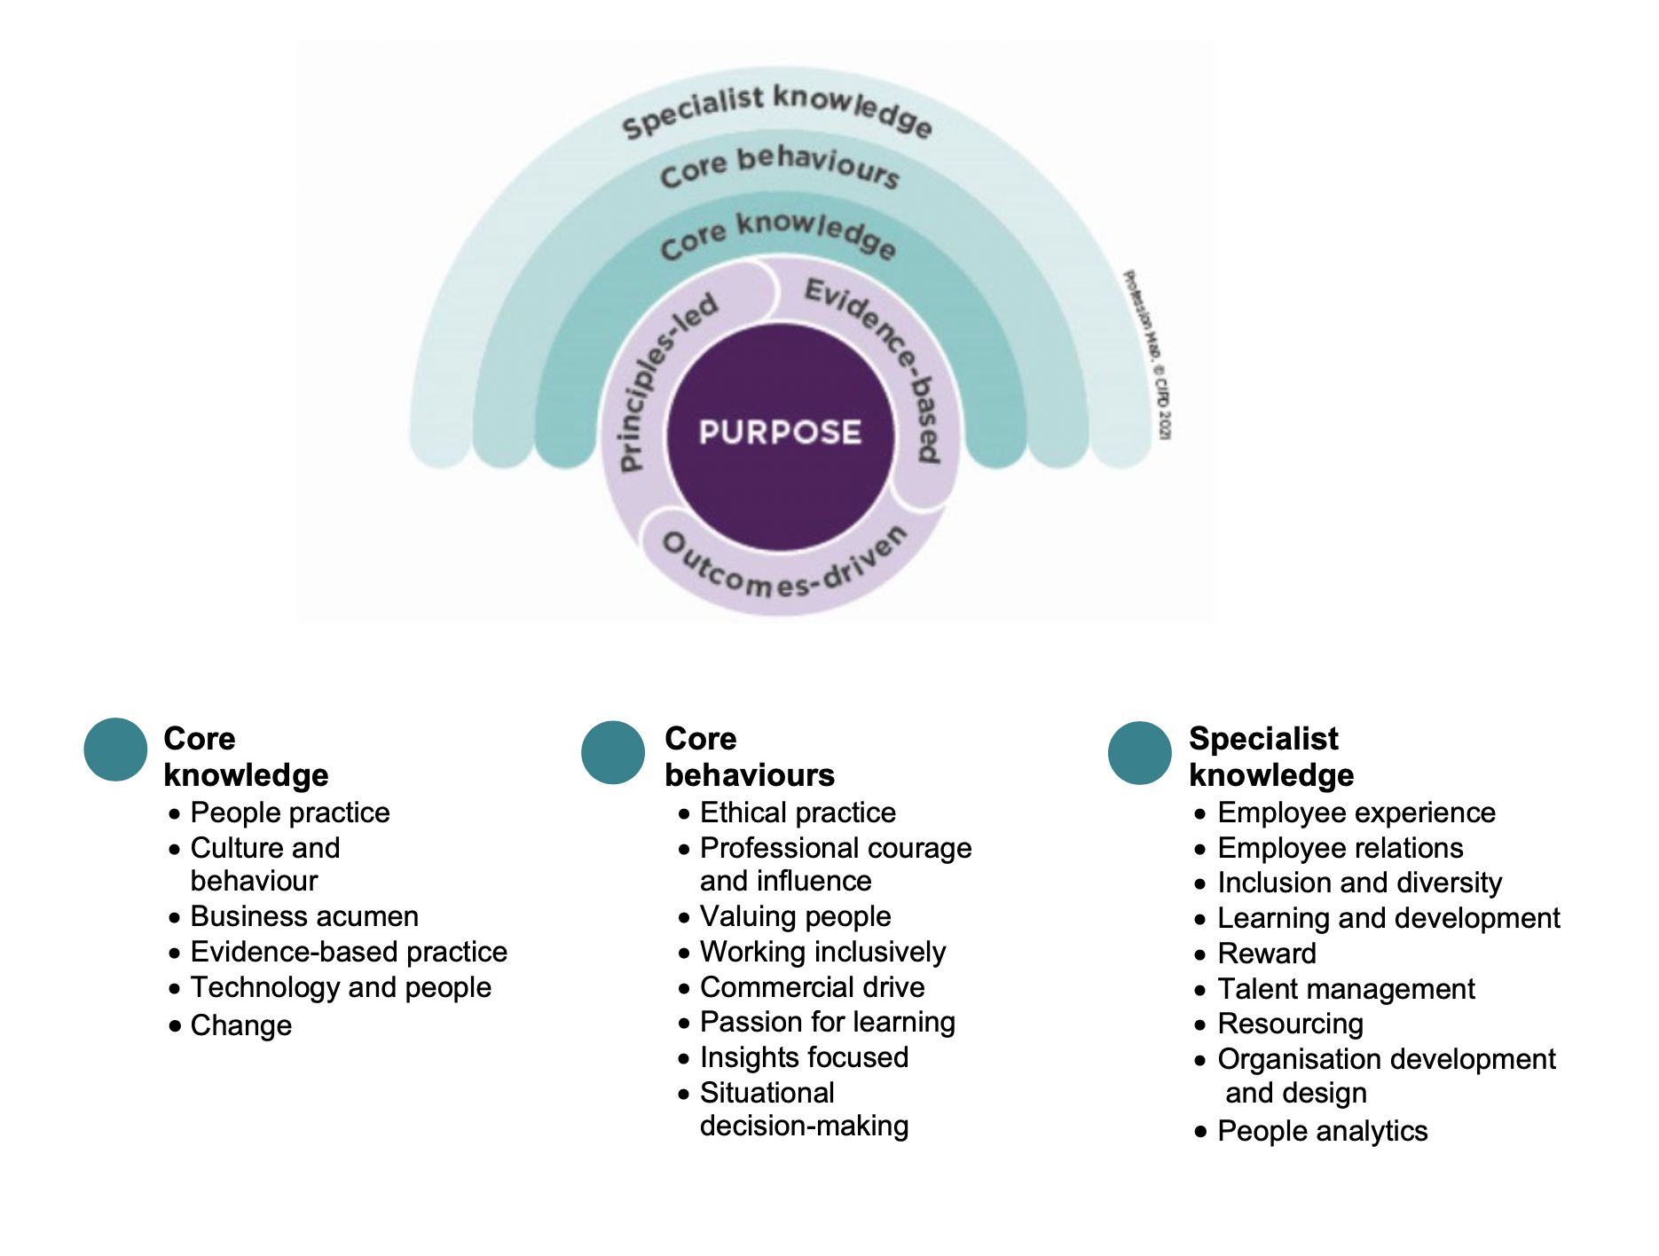
Figure 1: CIPD Professional Map
Source: (CIPD, 2021)

Importance of the behaviours for Effective HR Professionals Working in the UK
The CIPD Profession map's eight core behaviours imply a transition for HR professionals (Porter, Fagg and Smith, 2018). By emphasising ethical and evidence-based decision-making, one may provide value for individuals, organisations, society, and the profession. These behaviours are crucial for successful UK HR workers.
Ethical practice
In today's day of openness, disagreeable activities are rising. Human resources are meant to be an organisation's moral compass and an example of ethical workplace behaviour. A consistent ethical framework helps professionals make smart decisions and avoid unethical traps (Trullen and Valverde, 2017). Fostering an ethical culture improves morale and reduces unethical risks. Macroeconomic performance and consumer interactions are positively affected by ethical conduct.
Professional courage and influence
HR, OD, and Learning professionals must speak up when truth, justice, and "being right" are weaponized. HR professionals must have the moral courage to speak up for ethics, morality, and fairness and advocate for positive outcomes (Thomson, 2019). With new digital technologies and economic, social, and commercial models, we face new challenges that demand us to be courageous to improve the future of work.
Valuing people
Strong values are vital for teamwork. Humane and compassionate ways of communicating with employees, suppliers, other CEOs, and other societal and governmental stakeholders reduce friction and tension. Human resources specialists must cherish and prioritise people (Jones and Martain, 2019). This requires maintaining a healthy equilibrium between consideration, compassion, and fairness, as well as encouraging others to do the same.
Working inclusively
As more initiatives cross international boundaries, geographies, and cultures, individuals must be acknowledged and given the tools to cooperate effectively. HR specialists impact an organisation's success through encouraging an open environment, boosting cross-boundary collaboration, establishing trusting environments, and resolving issues productively.
Commercial Drive
Human resources specialists must prioritise employee and corporate financial measures. Identifying and tackling an organisation's biggest people-related difficulties, opportunities, and threats (McGurk, 2017). It includes communicating with consumers, comprehending financial tasks, proving change's worth, and assuming responsibility for its implementation. HR personnel must care for themselves to stay energised and resilient.
Passion for learning
Lifelong learning is a cornerstone of professionalism; this mind-set focuses on how people support CPD in themselves and others. HR learning must be holistic (Johannessen and Saetersdal, 2019). Human resources should reflect on their learning and analyse how it affects their work by asking for thoughts on everyday approaches, being curious about various professions, and communicating with other experts.
Situational decision-making
Situational decision-making entails making effective and pragmatic choices and avoiding a "one-size-fits-all" approach. It involves identifying options' benefits, risks, and compliance with professional principles. Great practitioners have the expertise and experience to assess each issue separately, employing insight and awareness to provide the best potential answer. They're curious about context and adaptable, intelligent, and innovative in delivery. Modern workspaces aren't one-size-fits-all. Policies and procedures provide advice; application requires competence.

Application of the map for HR professionals globally
The Chartered Institute of Personnel and Development (CIPD) Profession Map is an interactive set of criteria designed to enable those who work in human resources to continually evolve and improve the world of work. Everyone who works in human resources (HR) should adhere to the same set of standards and principles, and that is the goal of the Profession Map, which aims to help instil a shared professional identity across the industry. It is possible to utilise the map to determine one's capabilities and skills to assist with professional growth and the design of one's career route, as well as the career path of the team (Cohen, 2017). The standards provided by Profession Map can be used to establish a baseline for performance at the individual, team, and organisational levels, all of which contribute to an increase in operational efficiency.
The CIPD Profession Map serves as a guide for human resources professionals. It is a tool that we may access online that assists us in development, in achieving our professional development goals, in planning and supporting career development, and in other similar endeavours. The professional map has many benefits, one of which is that it applies to all organisations irrespective of their size, practice, or industry. Another advantage is that it encompasses the totality of the HR and L&D professions. Because it is not based on organisational structure, culture, job levels, or roles, it can be developed around professional competency. This map details the knowledge and behaviours that HR and L&D professionals need to exhibit to fulfil our requirements for professionals and to be considered qualified in their fields.
Human resources must sustain a shared purpose to maintain group identity. Industry standards help all professionals. The HR department can develop trust to initiate and foster positive change because of similar values. The CIPD Profession Map divides the professional values into three different groups, which are principles-led, evidence-based, and outcome-driven, respectively. Since the world of work is in a constant state of flux, the CIPD map needed to be updated to reflect these shifting landscapes (Johannessen and Saetersdal, 2019). The function of human resources (HR) has undergone a sea change as a direct result of new objectives, technologies, and ways of working. By moving the focus to value-based decisions, organisations, HR professionals, and most importantly, the employees themselves, will gain from using the CIPD Profession Map.
After using the map, the full value of each individual will become obvious, which will result in the opening of doors to opportunities that were previously unavailable. The most essential thing to take away from the new CIPD map is the confidence it can instil that both, an HR professional, and the company are doing everything in their power to guarantee that the organisation is adhering to the highest possible worldwide industry standards. It is possible to utilise the map to determine one's capabilities and skills to assist with professional growth and the design of one's career route, as well as the career path of the team (McGurk, 2017). The standards provided by Profession Map can be used to establish a baseline for performance at the individual, team, and organisational levels, all of which contribute to an increase in operational efficiency.

PART 2

Introduction
The UK has record-high employment levels. That's an indication of the health of the country's labour market, but it hides a fundamental vulnerability: a mismatch between worker capabilities and company needs. 40% of UK workers are unqualified for their jobs, according to the OECD, the largest mismatch of all countries studied. In the UK, two-thirds of OECD knowledge categories and nearly all workplace skills are lacking. Almost half of companies (46%) have hard-to-fill openings, similar to last quarter (47%). Only looking at firms with vacancies, this ratio jumps to 75%. 53% of public, 45% of private, and 41% of non-profit businesses cited hard-to-fill positions. Hard-to-fill openings are most widespread in healthcare (64%) and construction (51%). The paper will analyse skill gaps in the public sector despite high unemployment and long-term labour market dynamics to address skills shortages in healthcare professions in the UK.

Reason for skills shortages despite significant unemployment in the UK public sector
When companies are unable to fill open positions in a particular occupation or in a subfield of that occupation, this is referred to as a skill shortage. The United Kingdom's Industrial Strategy Council has projected that there will be an extraordinary scarcity of skilled workers in the sector in ten years. Businesses are having a harder and harder time filling open positions with qualified candidates due to a lack of available candidates that possess the necessary abilities (Pauw, Oosthuizen and van der Westhuizen, 2020).
As a result of challenges in recruiting employees with the appropriate qualifications and experience, UK firms are reported to have spent a total of £4.4 billion over the past 12 months on temporary labour, recruitment costs, and increased salaries. Because of this tendency, the value of engaging in continual professional development, investing in appropriate staff training, and recruiting people with potential has been brought into focus. Employers have reported a total of little less than 309,000 open positions across 169 distinct professional vocations. At the professional level, 106,000 open positions were deemed difficult to fill. Just under 79,000 of those positions were regarded as being very challenging to fill due to a lack of qualified candidates. Because of a lack of qualified candidates, nursing positions, computer programming jobs, and human resources officer positions topped the list of most graduate job openings (Arthur, 2021).
More and more widespread graduate talent shortages were encountered by smaller businesses as compared to larger enterprises. The labour market in the UK is not a single, unified entity, and the list of skill-shortage jobs differed greatly from region to region. The phrase "low quantity of candidates with the appropriate skills" was cited most frequently by businesses as the primary cause of vacancies being difficult to fill. The United Kingdom experienced a severe shortage of skilled employees in the aftermath of Brexit, which resulted in a smaller pool of workers readily available from the EU. The COVID-19 pandemic made an already difficult situation even more difficult. A certain location is suffering from a severe lack of available skilled workers. Jobs that employed a large number of individuals in their retirement years left a skills gap as those workers left the workforce. There is a significant shortage of competent professionals that possess specialised skill sets. Rapid shifts in the demand for a certain vocation might be caused by the introduction of new technologies or by shifts in the structure of the economy. Because of this, there was either an unexpected surplus or a deficit of qualified personnel.

Long-term labour market developments & Skills shortages in healthcare sector professions in the UK
According to the Skills Shortage Bulletin that was published by the Edge Foundation in July 2019, one out of every eleven positions in the National Health Service (NHS), which is the largest employer in the United Kingdom, is currently vacant. This unequivocally demonstrates the serious lack of skilled workers available in the UK's healthcare sector. It is being worked on to make this situation better, and one of the strategies being implemented is the change of visa limits for healthcare workers (Kinnison and May, 2016). However, before we get into that, let's have a look at what this gap entails.
The number of people graduating from nursing programmes has dropped by 4%, which means that there are 41,000 open positions in the nursing profession. During the same period, several problems have also surfaced in the fields of medicine, adult social care, and mental health. Brexit is also partly to blame for the shortfall. As a result of Brexit, a large number of European healthcare professionals have left the country. These individuals have been essential in maintaining the system. In light of the Health Foundation's projection that the shortage of nurses alone will exceed 70,000 during the next five years, there have been urgent calls for action. Employers in the UK report that they are unable to locate people with the skills they want for two-thirds of the roles in their companies, which is part of a larger national trend of skills shortages in the country. The skills gap in healthcare is expected to expand in the coming years due to an ageing population and rising demands on NHS services, which poses a serious long-term socioeconomic threat (Buerhaus, 2021).
Health services in England are at greater risk from a lack of personnel than they are from financial difficulties, as predicted in a report co-authored by the Health Foundation, The King's Fund, and the Nuffield Trust. They warn that if the number of overseas recruits and freshly qualified workers does not increase rapidly, the current deficit of over 100,000 workers would grow even larger (to 350,000 by 2030). Furthermore, the NHS is suffering as a result of healthcare staff shortages, with current employees struggling to provide the high-quality care necessary to meet rising demand. This has consequences for both the standard of treatment and the rates of staff retention, as many recently graduated professionals are quitting the field. Outside of the medical and nursing fields, there are also large numbers of openings in adult social care (approximately 110,000) with 1 in 10 social worker and care worker positions unfilled. The most defenceless and in need members of society in a society where healthcare is provided by the public sector are at imminent risk.

Conclusion
Supply and demand cause employers problems. Record openings and forward-looking indicators on recruitment intentions show considerable demand for workers. Several factors limit the number of candidates. First, unemployment is high but skilled people are low, therefore fewer individuals are seeking work. Second, fewer people are working than before the outbreak. This is largely due to immigrants who went home, but elderly workers also left the workforce early. Employers are attempting not to lose personnel, according to the research. Official redundancy rates are at historic lows, and future redundancy intentions are below pre-pandemic levels.

References
Arthur, R., 2021. Studying the UK job market during the COVID-19 crisis with online job ads. PLOS ONE, 16(5), p.e0251431.
Buerhaus, P., 2021. Shortages of hospital registered nurses: Causes and perspectives on public and private sector actions. Nursing Outlook, 50(1), pp.4-6.
Cohen, D., 2017. Developing Proficiency in HR. Chicago: Society for Human Resource Management.
Johannessen, J. and Sætersdal, H., 2019. The Future of HR. Bingley: Emerald Publishing Limited.
Jones, R. and Martain, S., 2019. HRM fundamentals. Nollamara, W.A.: HRVET.
Kinnison, T. and May, S., 2016. Evidence-Based Healthcare: The Importance of Effective Interprofessional Working for High Quality Veterinary Services, a UK Example. Veterinary Evidence, 1(4).
McGurk, J., 2017. Learning and Talent Development in Transition: The CIPD learning and Talent Development Survey. FOR - Rivista per la formazione, (86), pp.113-116.
Paauwe, J., Guest, D. and Wright, P., 2019. HRM and performance. Chichester, West Sussex, UK: Wiley.
Pauw, K., Oosthuizen, M. and van der Westhuizen, C., 2020. Graduate Unemployment in the Face of Skills Shortages: A Labour Market Paradox. SSRN Electronic Journal,.
Porter, K., Fagg, R. and Smith, P., 2018. Leadership and management for HR professionals. Amsterdam: Elsevier Butterworth-Heinemann.
Thomson, R., 2019. Managing People. 2nd ed. Boston: Taylor and Francis.
Trullen, J. and Valverde, M., 2017. HR professionals' use of influence in the effective implementation of HR practices. European J. of International Management, 11(5), p.537.

