Mariana Lavinia Neda 2312753
Budgeting Principles and Approaches
Principles and Concepts of Finance

Table of Contents
Introduction 3
a. Preparation of Statements 3
b. Problems of Blue Thread Ltd and management actions to address the problems 6
c. Conditions for a Successful Budgeting System and Behavioral Considerations for Budgeting Success 9
Conditions for a Successful Budgeting System 9
Clearly Defined Organisational Objectives 10
Effective Communication and Transparency 10
Thorough Financial Planning and Realistic Budgeting 11
Integration with Performance Measurement Systems 11
Flexibility and Adaptability 11
Effective Financial Management and Internal Controls 11
Employee Involvement and Commitment 11
Behavioural Considerations for Budgeting Success 12
Resistance to Change and Budget Acceptance 12
Goal Congruence and Motivation of Employees 13
Ethical Considerations and Budget Gaming 13
Stress and Workload Management 13
d) Critical evaluation of traditional approaches to budgeting considering an evolving environment of business and flaws in methods of traditional budgeting 14
Critical Evaluation of Traditional Budgeting 14
Incremental Budgeting 14
Zero-based Budgeting (ZBB) 14
Performance-based Budgeting (PBB) 15
Flaws in Methods of Traditional Budgeting 16
Lack of Flexibility 16
Focused on Short-term Goals 16
Conclusion 17
References 18

Introduction
Important finance management tools, budgeting and budgetary control are used by organisations to effectively allocate resources, maintain low costs, and attain strategic targets. A budgeting system acts as a guide for financial planning, where expenses are aligned with anticipated revenues in order to be profitable (Cools et al., 2017). Budgetary control, by contrast, makes sure that fiscal plans are maintained through the review of performance, detection of variations, and prompt corrective action. A good budget system will enhance organisational viability, use of resources, and decision-making.
However, for a budgeting system to work, there are some organisational prerequisites to be fulfilled. These include good financial management, good financial policies, strategy, transparency, and sound management. Budgeting also affects the behaviour of employees, and hence management needs to consider behavioural factors like motivation, resistance to change, ethical behaviour, and stress management. If these human factors are not handled well, they can undermine the functionality of budgeting systems. The requirements for an efficient budgeting system are discussed here critically and all major behavioral concerns that the management must address are considered in the report.

a. Preparation of Statements
1. Stock Budget and Cash Budget
Month | Opening Stock (£000) | Purchases (£000) | Cost of Sales (£000) | Closing Stock (£000)
June | 90 | 150 | 130 | 110
July | 110 | 180 | 156 | 134
Aug | 134 | 190 | 137 | 187
Sept | 187 | 160 | 143 | 204
Oct | 204 | 200 | 150 | 254
Nov | 254 | 210 | 163 | 301
Table 1: Stock Budget
(Source: Created by Learner)
Blue Thread Ltd's stock levels increase significantly from £90,000 in June to £301,000 in November, exceeding the £40,000 minimum requirement. While stock purchases align with sales, excess inventory ties up cash, impacting liquidity. The company risks overstocking, leading to higher holding costs, potential markdowns, or obsolescence. A more efficient stock management strategy is needed to optimise inventory turnover. Reducing purchases and aligning stock levels with demand could improve cash flow without affecting sales. Additionally, negotiating better supplier terms can enhance financial flexibility. Overall, better inventory control is essential for reducing financial strain while maintaining profitability.
Month | Opening Cash (£000) | Receipts (£000) | Payments (£000) | Closing Cash (£000)
June | -25 | 198 | 184 | -11
July | -11 | 238 | 211 | 16
Aug | 16 | 208 | 238 | -14
Sept | -14 | 218 | 206 | -2
Oct | -2 | 228 | 234 | -8
Nov | -8 | 248 | 246 | -6
Table 2: Cash Budget
(Source: Created by Learner)
Blue Thread Ltd starts with a £25,000 overdraft in June and aims to eliminate it by November. While the business is profitable, cash flow remains tight, with an overdraft of £6,000 still remaining by November. High stock purchases, refurbishment costs (£36,000), and delayed supplier payments strain liquidity. Despite steady sales, cash outflows exceed inflows in some months, causing fluctuations. To improve cash flow, the company should reduce stock purchases, postpone refurbishments, and negotiate better supplier terms. Effective working capital management is essential to eliminate overdrafts and ensure financial stability while sustaining business operations.
2. Budgeted Profit and Loss Account
Item | Amount (£000)
Sales Revenue | 1350
Cost of Sales (65%) | -878
Gross Profit (35%) | 472
Admin Expenses | -153
Selling Expenses | -43
Depreciation (Included in Admin) | -36
Interest Paid | -6
Credit Card Charges | -12
Taxation | -15
Net Profit | 243
Table 3: Profit and Loss account
(Source: Created by Learner)
Blue Thread Ltd generates a net profit of £243,000 over six months, with a 35% gross profit margin and an 18% net profit margin. While profitable, high admin expenses (£153,000), selling costs (£43,000), and credit card fees (£12,000) impact earnings. Additionally, non-cash depreciation (£36,000) reduces reported profit but does not affect cash flow. Despite profitability, cash flow struggles due to high stock levels and refurbishment costs. To improve financial health, the company should optimise inventory, reduce unnecessary expenses, and explore lower-cost payment methods. Profitability is strong, but better cash management is essential for sustainability.

b. Problems of Blue Thread Ltd and management actions to address the problems
Financial Problems
There are different problems that have been found for the organisation. Therefore, it is necessary to address them and find appropriate strategies to mitigate the challenges.
High Stock Levels and Excess Inventory
- Excessive Inventory: The stock budget reveals a significant rise in stock levels, from £90,000 in June to £301,000 in November, which is above the minimum required stock of £40,000. This means that the company is holding far more inventory than necessary, which ties up valuable cash and affects the efficiency of the company.
- Cash Flow Impact: The high stock levels reduce available cash for other critical operations. The availability of excess inventory can lead to liquidity issues, making it harder to meet short-term obligations such as paying suppliers or covering operational costs.
Tight Cash Flow and Overdraft Issues
- Persistent Overdraft: The company starts with an overdraft of £25,000 in June and struggles to eliminate it. By November, the overdraft remained at £6,000, indicating that the company was not able to achieve its target of eliminating the overdraft by the end of the six-month period.
- Fluctuating Cash Flow: The cash budget shows that, although sales are strong, the company experiences months where cash inflows fall short of cash outflows. For example, in August and September, outflows from stock purchases, admin expenses, and refurbishment costs exceed cash receipts, leading to negative cash balances.
- Inadequate Liquidity: Despite being profitable, the business is unable to maintain sufficient liquidity to cover its obligations, which can lead to operational challenges and reliance on credit lines to meet short-term needs.
High Operating and Administrative Expenses
- Excessive Admin Expenses: The company’s admin expenses, a total of £153,000 over the six-month period, are high relative to sales. These costs reduce profitability and limit the company’s ability to invest in growth or pay down debt.
- Selling Expenses: The selling expenses, which total £43,000, also contribute to financial strain. High selling expenses, combined with other operational costs, affect the company’s ability to maintain profitability.
- Credit Card Fees: The company incurs credit card charges of £12,000, which represents a reduction in income from sales made via credit card. These fees increase overall costs and reduce the company’s effective sales revenue.
Store Refurbishment and Unnecessary Expenditures
- Refurbishment Costs: The company’s planned store refurbishment expenses of £36,000 are a significant drain on cash, especially when cash flow is tight. These costs increase the financial strain and contribute to a negative cash balance, even though the company has already achieved profitable sales.
- Non-Essential Capital Expenditure: Spending on refurbishment may not be the most urgent or effective use of available funds, given the company’s current cash flow situation. It could be delayed or reduced to improve liquidity in the short term.
The management actions
High Stock Levels and Excess Inventory
- Improve Inventory Management: Implementation of just-in-time (JIT) inventory systems to better align stock purchases with actual sales needs, ensuring stock levels do not exceed what is required for sales forecasts.
- Negotiation of Better Supplier Terms: Working with suppliers to negotiate shorter lead times or more flexible payment terms can help the business to have appropriate stocks as per the demand of the customers and will help the business to pay the suppliers as per their convenience and as per the sales (Seitz et al., 2022). This will reduce the financial burden and will help in managing better financial stability to increase their sustainability.
- Forecasting Demand Accurately: Using more accurate and data-driven sales forecasting methods to predict demand more precisely is needed as this would help to better control inventory levels and avoid overstocking.
Tight Cash Flow and Overdraft Issues
- Focus on Cash Flow Management: Prioritising cash flow management by reviewing the timing of cash inflows and outflows (Mohammadi, 2024). This will ensure that the business has enough liquidity to cover critical short-term obligations. A detailed cash flow forecast can help identify potential shortfalls in advance.
- Delay Non-Essential Expenditures: Postpone or reduce non-essential capital expenditures, like store refurbishments, until the business achieves a healthier cash flow. This would help conserve cash for more urgent needs.
- Increase Receivables Collection Efficiency: Strengthening the accounts receivable process to speed up collections and offering discounts for early payment or streamlining credit terms could encourage customers to pay faster (Barnabas and Oloyede, 2024).
Persistent Overdraft and Fluctuating Cash Flow
- Strategic Reduction in Stock Purchases and cost-reduction initiatives: Reduce purchases of stock in months with low sales forecasts or high existing inventory levels (Fildes et al., 2022). By limiting stock purchases when not absolutely necessary, the company can free up cash to pay down the overdraft. Then, identifying areas where expenses can be reduced without compromising the quality of operations can be done. For example, renegotiating contracts with suppliers, reducing administrative expenses, or even reassessing energy consumption can help reduce outflows.
High Operating and Administrative Expenses
- Streamlining Admin Costs: By reviewing administrative costs to identify areas where cuts can be made without sacrificing operational efficiency. This could involve renegotiating vendor contracts or consolidating job roles.
- Optimising Selling Expenses: Consider reducing selling expenses by switching to more cost-effective marketing channels or optimising advertising spending to increase its effectiveness.
Store Refurbishment and Unnecessary Expenditures
- Reallocation of Resources: Focusing on higher-priority initiatives that directly impact profitability, such as improving inventory management, optimising sales strategies, or enhancing customer experience, rather than investing in costly refurbishments at this time (Le et al., 2025). This will enhance the cost management and will enhance the ability of the business to mitigate cost-related issues.
- Reduce Capital Expenditure: Instead of large capital expenditures, explore cheaper alternatives like partial refurbishments or minor updates that will still maintain store appeal without draining cash reserves (Rami Reddy, 2024). From this, the organisation will have better operational cash and will also be able to grow the business as per their need.
Improve Profitability vs. Cash Flow Conversion
- Focus on Cash-Flow-Oriented Strategies: Developing strategies that prioritise cash flow over profitability, such as offering incentives for cash payments or reducing reliance on credit sales (Alhassan and Islam, 2021).
- Reduce Non-Essential Costs: Focusing on cutting non-essential costs, like unnecessary admin or marketing expenditures, while maintaining focus on areas that directly generate revenue or improve cash flow.
Implement Stronger Financial Controls
- Developing a strong Credit Control and Cash Flow Forecasting System: The incorporation of strong credit policies for customers ensures payment terms that are more favourable for the company, such as requiring shorter payment windows for customers (Abbas and Yahaya, 2024). On the other hand, the implementation of more detailed cash flow forecasting tools will be effective in tracking when payments and receipts will occur, helping to identify any future shortfalls and proactively managing cash needs.

c. Conditions for a Successful Budgeting System and Behavioral Considerations for Budgeting Success

Conditions for a Successful Budgeting System
In order to use effective budgeting and budgetary control, organisations need to develop an environment of fiscal responsibility, discipline, and flexibility. For an effective budgeting system, the following are the musts:
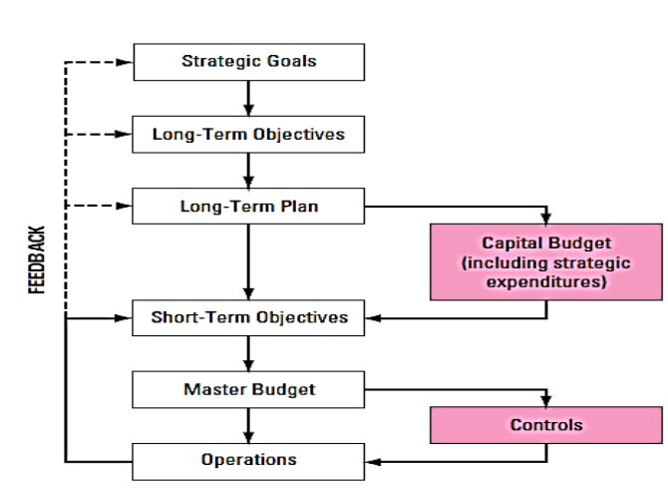
Figure 1: Conditions of the budgeting process
(Source: Sallam, 2017)

Clearly Defined Organisational Objectives
A budgeting system has to be based on an organisation's strategic objectives, whether they are targeted at revenue growth, cost savings, market penetration, or sustainability. In the absence of clearly set objectives, budgeting becomes arbitrary and unsuccessful. Budget planning must be tightly coupled with general business strategies in organisations (Le and Nguyen, 2020). For instance, if a firm is projecting international expansion, its budget should translate to investment in new market research, supply chain management, and regulatory compliance.

Effective Communication and Transparency
Clear budgeting procedures must be followed in order to have the trust and commitment of workers. When finance goals and limits are clearly told, workers may align their endeavours with budget standards. Misconception or unreliability has the potential for resistance, non-compliance to budgets, as well as misconceptions (Nikulina et al., 2019). Regular budget meetings, in-line financial reporting, and money dashboards using technology facilitate enhanced transparency so that financial information is shared with all the parties involved.

Thorough Financial Planning and Realistic Budgeting
Effective budgeting necessitates financial planning based on historical information, sector trends, and practical revenue projections. Inadequate forecasting leads to budgetary deficits or indiscriminate cost-reduction, generating operational inefficiencies (Marecki and Wieloch, 2019). Companies need to incorporate rolling forecasts, zero-based budgeting, and scenario planning to create more accurate and dynamic financial plans. For instance, a retail organisation can apply past sales records and seasonal patterns to modify budget provisions for peak and off-peak seasons.

Integration with Performance Measurement Systems
Budgeting must not stand alone but must be harmonised with Key Performance Indicators (KPIs), Balanced Scorecards, and variance analysis approaches. This keeps financial planning harmonised with operation performance measures such that organisations are able to measure progress against planned targets (Nurgaliyeva et al., 2020). An example is that a manufacturing organisation may integrate its budgetary control system with the production efficiency KPIs so that it monitors resource use and cost-effectiveness.

Flexibility and Adaptability
During a fast-paced changing business landscape, inflexible budgets can restrict the capacity of an organisation to counter market changes, inflation, or international economic shifts. Flexible budgeting methods like rolling budgets or activity-based budgeting enable organisations to make real-time adjustments (Asogwa and Etim, 2017). For instance, during economic slowdowns, businesses can shift budgets to focus on critical spending and postpone non-vital investments.

Effective Financial Management and Internal Controls
An effective budgeting system needs to be backed by governance mechanisms that impose financial discipline, accountability, and adherence to industry regulations (Gallani et al., 2019). Internal controls like budget examination, audit, and expenditure approvals prevent fraud and mismanagement. Ethical governance ensures proper alignment of financial allocations to CSR commitments for long-term sustainability.

Employee Involvement and Commitment
Employees also have a role to play when implementing the budget. Involving employees in the budget preparation increases their sense of ownership, hence improving commitment and compliance. Participatory budgeting, when departmental heads are involved in financial planning, provides realistic and attainable budget figures (Wagner et al., 2021). For instance, involving frontline managers during budget preparation can assist organisations in finding areas where costs can be reduced that otherwise may be overlooked by top management.

Behavioural Considerations for Budgeting Success
Although budgeting targets financial constraints, its efficiency largely hinges upon human conduct. Workers' expectations, drives, and dispositions toward budget activities strongly impact finance discipline. Below are some areas of human conduct that should receive management attention:
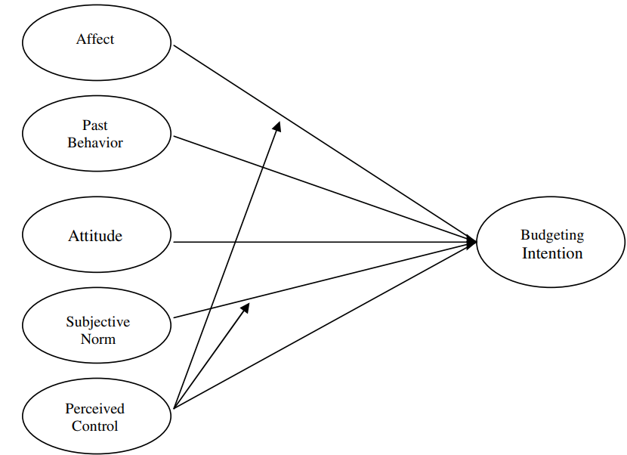
Figure 2: Attitude to maintain a financial budget
(Source: Kidwell and Turrisi, 2004)

Resistance to Change and Budget Acceptance
Implementing a new budget system usually meets with resistance, especially if the workers view it as a cost-reduction tool and not a strategic planning tool. Resistance may result from fear of change, ignorance, or anticipation of added workload (Cash et al., 2017). Workers feel constrained by financial limitations and, therefore, will be resistant to adopting the system.
To counter this challenge, businesses should seek change management strategies. Offering training programs, open communication, and phased implementation will facilitate smooth transitions. Budget benefits of greater efficiency, employee job security, and career advancement opportunities should also be stressed by the management (Bergmann et al., 2022). Engaging employees in budget planning and decision-making also guarantees acceptance and involvement.

Goal Congruence and Motivation of Employees
For a budgeting process to be successful, employee goals should be aligned with organisational financial goals. When budgets are used as cost-reduction mechanisms only, employees are demotivated. Budgetary targets should be realistic, goal-based, and tied to rewards like bonuses, promotions, or training (Mollah et al., 2023). When workers recognise how budget compliance leads to company stability and individual career advancement, they are more apt to follow financial controls. For instance, a company that incentivises cost-saving ideas by employees can promote a culture of effectiveness and budgetary prudent decision-making. Performance-based budgeting, in which financial performance directly influences rewards, increases motivation and goal congruence.

Ethical Considerations and Budget Gaming
Budgeting structures may at times result in fraudulent financial practices including budget gaming, financial data falsification, or misallocation of resources. Budget requests may be overstated to obtain surplus funding or revenue figures understated for setting easy finance targets. Budget accuracy is hence distorted and leads to inefficiency (Cabannes and Lipietz, 2018).
To counter these threats, organisations need to instil ethical financial behaviour through well-defined policies, internal audits, and accountability procedures. Promoting a culture of integrity, backed by frequent budget reviews and open financial reporting, can avoid unethical activities (Okeke et al., 2024). For instance, firms that have whistleblower protection programs in place provide a safe environment in which employees feel comfortable reporting financial misbehaviour without fear of retribution.

Stress and Workload Management
Budgetary pressures and tough financial goals can enhance levels of stress among workers, resulting in burnout, decreased productivity, and job dissatisfaction. Workers who are pressured by unrealistic budget expectations may resort to counterproductive activities, including cutting corners or overworking to achieve financial targets (Bogoviz et al., 2017). Budgetary expectations should be realistic from a management point of view and consider external market forces. Contingency planning is possible through flexible budgeting, thus avoiding undue financial burden on employees. Additionally, organisations need to offer employee well-being programs, workload management practices, and mental health services to counteract the stress of financial pressures.

d) Critical evaluation of traditional approaches to budgeting considering an evolving environment of business and flaws in methods of traditional budgeting

Critical Evaluation of Traditional Budgeting

Incremental Budgeting
Incremental budgeting is a traditional approach considering the budget of the previous year is utilised as a baseline. On the other hand, a set of minor adjustments are made to involve inflation, modifications in costs, or expected revenue. Such a methodical approach assumes a certain level of stability and continuity. This can be executed with a small range of variations from year to year (King, 2024).
However, budgeting in an incremental way can prove to be problematic in business-related environments experiencing a rapid form of transformation. It assumes the circumstances in the past aligned with aspects associated with the projection in the future. This may not reflect a rapid form of shifts in technological advancements, the market, or behaviour of consumers. Apart from these, this methodical approach can encourage satisfaction. This is due to the capability of departments to flip their budgets without evaluating the requirement for change in a critical way. Retail startups such as Debenhams relied on a number of traditional regimes including budgeting in an incremental way. However, such companies operating on a large scale utilises the budgeting’s “use it or lose it” aspect (Bartels, 2021). This tends toward spending their entire budget to secure similar funding in the upcoming period along with causing an inefficient allocation of resources.

Zero-based Budgeting (ZBB)
ZBB is based on the justification of the complete range of expenses instead of the assumption of the expense of the previous year to carry forward. Such an approach encourages a brief review of the complete range of expenses along with forcing departments to make spending a priority. This is focused on a number of critical areas and efficiency (Al-Jumaili and Awad, 2024).
However, ZBB is considered excessively efficient in the management of costs along with being capable of being helpful for a number of organisations in spotting waste. It consumes time and resources in a major form. ZBB can cause delays considering a number of strategic moves in industries with a rapid form of progression. This is due to the requirement of a long set of justifications for each of the lines of the budget. This can prove to be a disadvantage during the requirement of business entities to adapt to a set of exclusive opportunities, obstacles, or shifts in the market at a quicker rate. For instance, Unilever successfully implemented ZBB along with major entities such as General Motors, Honeywell, and Hershey. More than 40% of companies utilising ZBB are prone to fulfilling an aggressive form of cost-related targets excessing 20% (Deloitte, 2022).
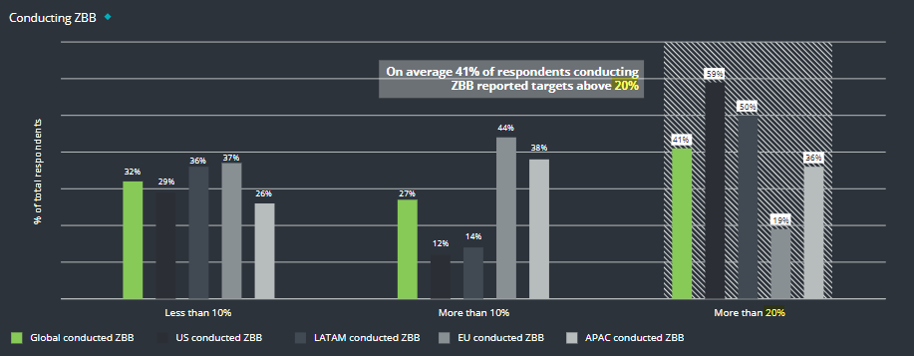
Figure 3: Usage of ZBB
(Source: Deloitte, 2022)

Performance-based Budgeting (PBB)
Budgeting based on performance allocates a number of resources based on the performance or outcomes of a specific set of programs or departments. It focuses on achieving a vast range of outcomes. These include profit margins, satisfaction of customers, or targets regarding productivity. This can be executed instead of justification of costs. It aligns the allocation of resources to a core set of indicators of performance or KPIs (Amburgey, 2024).
However, this approach aligns spending with the goals of the business entity along with proving to be problematic in an evolving environment in a rapid form. The indicators of performance may become outdated or irrelevant over time as well. Apart from these, it may tend toward an excessive form of pressure on a set of departments to fulfill targets. This could suppress creativity and the tendency to take risks. Around 60% of business entities are prone to utilising a set of basic spreadsheets to track the performance of employees and relevant budgeting (Johnivan, 2025). Such an approach is helpful for companies operating in the private sector in aiming to introduce improvements in the procedure of making decisions along with the allocation of resources. A majority of OECD-based nations adopted performance-based budgeting in any form to focus on transparency in the protocol.

Flaws in Methods of Traditional Budgeting

Lack of Flexibility
The traditional approach to budgeting is considered strict due to binding a number of organisations into a set of spending-based plans ideated previously. Such an approach to rigidity can prevent the adaptation to a range of exclusive obstacles or opportunities. However, flexibility is vital for staying competitive in the business-related environment witnessed at the current level. Flexibility in operations has tended toward innovation considering more than 70% of entities (Tracy Brower, 2022). Sticking to a number of outdated budgets can hamper the development of innovation-related activities and eventual growth.

Focused on Short-term Goals
A traditional methodical approach to budgeting generally stresses the control of costs for the short term instead of a set of strategic goals in the long term. This can introduce limitations to a range of investments in innovation and growth in the future. This can tend toward a downturn in a competitive form of markets through the focus on controlling a number of costs at an immediate level. Large retailers are prone to witness a struggle to introduce innovation in the market due to their persistent involvement in a traditional model of budget focused on costs.
Aligning with Beyond Budgeting Model (BBM)
The framework aligns with the critiques of the traditional approach to budgeting. BBM stresses decentralisation, planning in a continuous way, and predicting forecasts. The goal is to respond to the modifications in the market in a rapid way. This can be evident instead of a rigid approach along with controlling costs considering a short period. It encourages innovation through the empowerment of teams. The goal is to make decisions based on information obtained in real-time (Denning, 2020).

Conclusion
Traditional methods of budgeting are generally considered effective for controlling costs along with aligning resources with a set of objectives. However, these can confront a number of major obstacles in the business-related environment prone to be paced. Their rigidity and focus on a number of goals for a short period of time can introduce limitations to flexibility. Apart from these, incremental budgeting can encourage satisfaction. On the other hand, ZBB and PBB can consume a sizeable time due to the necessity of a detailed analysis required for each item in the budget. These may hamper the development of innovation. Organisations are required to adopt an excessively dynamic form of approach to budgeting. The goal is to remain competitive and responsive specifically in industries experiencing a rapid form of transformation.

References
Abbas, M. and Yahaya, O.A., 2024. Do creditors care about ESG performance. International Journal of Management, Economics, and Social Sciences, 13(5), pp.320-346.
Alhassan, I. and Islam, K.A., 2021. Credit management strategies and financial performance of industrial goods sector in Nigeria. Indian Journal of Finance and Banking, 8(1), pp.59-74.
Al-Jumaili, H.N. and Awad, M.A., 2024. Zero-Based Budgeting Versus Management Strategy And Applicability.
Amburgey, T., 2024. Council Post: How Local Governments Can Rethink Their Budgets In Hard Fiscal Times, Forbes. Forbes Magazine. Available at: https://www.forbes.com/councils/forbestechcouncil/2024/10/10/how-local-governments-can-rethink-their-budgets-in-hard-fiscal-times/ (Accessed: 15 February 2025).
Asogwa, I.E. and Etim, O.E., 2017. Traditional budgeting in today's business environment. Journal of Applied Finance and Banking, 7(3), p.111.
Barnabas, B. and Oloyede, J., 2024. Cash Flow Optimization: Strategies for Enhancing Short-Term Liquidity. Available at SSRN 5004465.
Bartels, F., 2021. Changing current “use it or lose it” policy would result in more effective use of defense dollars.
Bergmann, M., Brück, C., Knauer, T. and Schwering, A., 2020. Digitization of the budgeting process: determinants of the use of business analytics and its effect on satisfaction with the budgeting process. Journal of Management Control, 31(1), pp.25-54.
Bogoviz, A.V., Ragulina, Y.V., Komarova, A.V., Bolotin, A.V. and Lobova, S.V., 2017. Modernization of the approach to usage of region’s budget resources in the conditions of information economy development, pp.1-8.
Cabannes, Y. and Lipietz, B., 2018. Revisiting the democratic promise of participatory budgeting in light of competing political, good governance and technocratic logics. Environment and Urbanization, 30(1), pp.67-84.
Cash, P.J., Hartlev, C.G. and Durazo, C.B., 2017. Behavioural design: A process for integrating behaviour change and design. Design Studies, 48, pp.96-128.
Cools, M., Stouthuysen, K. and Van den Abbeele, A., 2017. Management control for stimulating different types of creativity: The role of budgets. Journal of Management Accounting Research, 29(3), pp.1-21.
Deloitte, 2022. Zero-based budgeting Global perspectives and lessons learned. Available at: https://www2.deloitte.com/content/dam/Deloitte/uy/Documents/strategy/us-operations-zero-based-budgeting.pdf (Accessed: 15 February 2025).
Denning, S., 2020. How Equinor And Handelsbanken Abolished Budgeting, Forbes. Forbes Magazine. Available at: https://www.forbes.com/sites/stevedenning/2019/06/24/how-equinor-and-handelsbanken-abolished-budgeting/ (Accessed: 15 February 2025).
Fildes, R., Ma, S. and Kolassa, S., 2022. Retail forecasting: Research and practice. International Journal of Forecasting, 38(4), pp.1283-1318.
Gallani, S., Krishnan, R., Marinich, E.J. and Shields, M.D., 2019. Budgeting, psychological contracts, and budgetary misreporting. Management Science, 65(6), pp.2924-2945.
Johnivan, J. R., 2025. 85 Must-Know Performance Management Statistics for HR in 2025 - SSR, RSS. SelectSoftware Reviews. Available at: https://www.selectsoftwarereviews.com/blog/performance-management-statistics (Accessed: 15 February 2025).
Kidwell, B. and Turrisi, R., 2004. An examination of college student money management tendencies. Journal of Economic Psychology, 25(5), pp.601-616.
King, S., 2024. Council Post: 8 Best Practices Businesses Should Add To Their End-Of-The-Year Budget Checklists, Forbes. Forbes Magazine. Available at: https://www.forbes.com/councils/forbesbusinesscouncil/2022/11/22/8-best-practices-businesses-should-add-to-their-end-of-the-year-budget-checklists/ (Accessed: 15 February 2025).
Le, T.N. and Nguyen, D.D., 2020. An impact of budgetary goal characteristics on performance: The case of Vietnamese SMEs. The Journal of Asian Finance, Economics and Business, 7(9), pp.363-370.
Le, T.N., Phan, Q.H., Nguyen, P.H. and Nguyen, L.A.T., 2025. Rethinking Reverse Logistics: Neutrosophic Strategies for Warehouse Management Challenges. Neutrosophic Sets and Systems, 81, pp.89-131.
Marecki, K. and Wieloch, M., 2019. Dilemmas of the budgeting process. Journal of Management and Financial Sciences, (39), pp.61-69.
Mohammadi, A., 2024. Dynamic Cash Flow Management Under Uncertainty: Integrating Scenario Planning and Advanced Analytical Tools. International Journal of applied Research in Management, Economics and Accounting, 2(1), pp.23-34.
Mollah, M.A.S., Rouf, M.A. and Rana, S.S., 2023. A study on capital budgeting practices of some selected companies in Bangladesh. PSU Research Review, 7(2), pp.137-151.
Nikulina, S.N., Butyugina, A.A. and Gorbunova, E.E., 2019. Investment activity in conditions of automation use of budgeting system. In IOP Conference Series: Earth and Environmental Science, Vol. 341, No. 1, p. 012217.
Nurgaliyeva, A., Ismailova, D. and Sarybayeva, I., 2022. Regarding the prospects for the introduction of the budgeting system of international financial organizations of the future. Futurity Economics & Law, 2(3), pp.38-47.
Okeke, N.I., Bakare, O.A. and Achumie, G.O., 2024. Forecasting financial stability in SMEs: A comprehensive analysis of strategic budgeting and revenue management. Open Access Research Journal of Multidisciplinary Studies, 8(1), pp.139-149.
Rami Reddy, L., 2024. WHAT ARE THE BARRIERS TO CIRCULAR TRANSITION IN SMALL AND MEDIUM SIZED ENTERPRISES IN THE RETAIL DESIGN INDUSTRY?: A MICRO LEVEL PERSPECTIVE.
Sallam, A.M.H., 2017. Improving Strategic Performance Management Using Beyond Budgeting Information: An Exploratory Study, pp.34-107.
Seitz, A., Akkerman, R. and Grunow, M., 2022. A contract portfolio perspective on the role of customer order lead times in demand fulfilment processes with supply shortage. International Journal of Production Research, 60(12), pp.3792-3808.
Tracy Brower, P., 2022. New Data Proves Flexible Work Really Works: 7 Factors For Success, Forbes. Forbes Magazine. Available at: https://www.forbes.com/sites/tracybrower/2022/11/06/new-data-proves-flexible-work-really-works-7-factors-for-success/ (Accessed: 15 February 2025).
Wagner, J., Petera, P., Popesko, B., Novák, P. and Šafr, K., 2021. Usefulness of the budget: the mediating effect of participative budgeting and budget-based evaluation and rewarding. Baltic Journal of Management, 16(4), pp.602-620.

