

Student name: Petra Stankova
Student ID: 2216986

Module name: Independent Project
Module code: BMHP 6020
Supervisor’s name: Bianka Sanfilippo

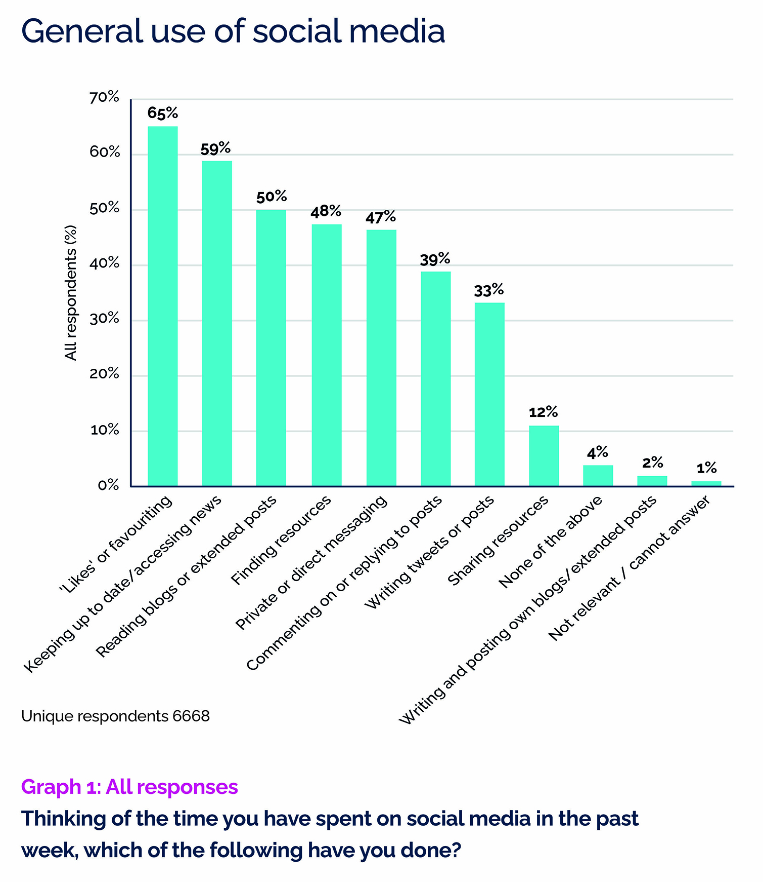  (pedrozacommunications.co.uk, ) |  | Impact of social media  to adults in the UK  Aim  The aim of this study is to explore how social media affects adults in the United Kingdom. It will look at how social media influences positively and negatively mental health, relationships, daily behaviour, work, and overall well-being.  Objectives:  To examine the impact of social media on adults in the United Kingdom.  To identify the positive effects of social media, such as communication and social connection.  To investigate the negative effects, including mental health issues, misinformation, and online harassment.  To explore how social media influences adults, behaviour, relationships, and well-being.  To suggest ways to promote healthier and safer social media use among adults in the UK. |  |   (ielts.net, )
Methodology  Literature review method  This study will use secondary data research methods.  Data collection: systematic peer-reviewed journal articles published in English within the last 10 years and related to Impact of social media to adult in the UK (University of Wales Trinity Saint David, 2024).  Databases used: Google Scholar, PubMed, ProQuest, UWTSD library  Keywords: “social media”, “adults”, “UK”, “mental health”, “well-being” |  |  |  | Data Analysis  Thematic analysis was used to identify common themes and similarities across the articles (Braun and Clarke, 2021).  Ethical considerations  Avoid plagiarism by giving credit to the original authors through proper in-text citations and references (Mark Saunders et al., 2019).  Use reliable and academic sources such as books and peer-reviewed journals.  Present information honestly and do not change or misinterpret the original findings (John W. Creswell and J. David Creswell, 2018).  Respect copyright and intellectual property when using other authors’ work.  references

Inclusion and exclusion criteria
Inclusion criteria:
Adults aged 18+
UK-focused studies
Peer-reviewed journal articles
Published between 2015–2025

Exclusion criteria:
Studies focused only on children or teenagers
Sources that are not peer-reviewed, such as books, websites, reports, or opinion articles
Studies published before 2015
Research done outside the United Kingdom
Participants under 18 years old
Articles written in languages other than English

.

References

Booth, A., Sutton, A. and Papaioannou, D. (2016) Systematic approaches to a successful literature review. 2nd edn. London: SAGE Publications.
Creswell, J.W. and Creswell, J.D. (2018) Research design: Qualitative, quantitative, and mixed methods approaches. 5th edn. Thousand Oaks, CA: SAGE Publications.
Google Scholar (2026) Google Scholar. Available at: https://scholar.google.com (Accessed: 22 June 2026).
IELTS.net (2025) Mental health awareness through social media. Available at: https://ielts.net/mental-health-awareness-through-social-media/ (Accessed: 22 June 2026).
Pedroza Communications (2025) General use of social media. Available at: https://pedrozacommunications.co.uk/ (Accessed: 22 June 2026).
University of Wales Trinity Saint David (2024) Library and learning resources. Available at: https://www.uwtsd.ac.uk/library/ (Accessed: 22 June 2026).

