MA Equality and Diversity: Community Profile

- Introduction and Aims of the Community Profile

A community profile is designed to understand and recognise the needs of a population (Hawtin, Percy-Smith, 2007). As suggested by, Hawtin and Percy-Smith (2007) a community profile addresses the resources that are available within the community and potential developmental plans to improve the current residence lives and future generations of the community. It is important to recognise the current, previous and future legislations that will make a difference within the community and will help to cater for all individuals. This can be recognised with the Well-Being of Future Generations Act, 2015 (Welsh Government, 2016) which addresses the 7 well-being goals for Wales and how it plans to change and essentially, better the communities and the lives of those living in Wales. In addition to this, the Well-Being of Future Generations Act, 2015 (Welsh Government, 2016) places emphasis on how the changes that should be made within the communities, cities and towns in Wales should be of long-term effect and help the future generations to gain understanding of the causes of these issues and knowledge on how to prevent them.
This community profile will identify the community needs, funding purposes and areas of improvement or change within a Welsh community. By considering the social, economic, environmental and issues within the community, the profile will address the possible implementations that will help improve the living conditions of the individuals. Furthermore, the community profile will promote and encourage living a more sustainable life and endorsing equality within the community. The community profile will consider current and previous legislation that will help improve the community and uphold the potential changes that could occur.
This community is based upon the outskirts of a multi-cultural city in Wales. As of 2015, the Office of National Statistics (ONS cited in One Newport Casnewydd, 2016) suggested that the city holds an overall population of 3,099,086 people (One Newport Casnewydd, 2016). As the research indicates, the community is only a small part of the large city, however the estate does hold the 4th highest population rating within the city (One Newport Casnewydd, 2016). In 2015, the Office of National Statistics (cited in One Newport Casnewydd, 2016) noted that there are only 7,631 people within the community. This data recognises how small of an area the community is, amongst a large portion of population.
The make-up of the community’s population varies. However, as the data suggests many people who live within the community are between the ages of 16-64. In 2015 there were 1,504 children between 0-15, 4,720 people between 16 – 64 and 1,407 people over the age of 65 (One Newport Casnewydd, 2016). Although, looking back at previous data from 2001, the population has dropped by 7.82% as in 2001, there were 8, 278 people living within the community, the majority of whom were aged between 16-64 (One Newport Casnewydd, 2016). Furthermore, the data indicates that there has been a significant decrease of people aged 0 – 15, which have decreased by 29.09% since 2001 (One Newport Casnewydd, 2016). These statistics can be shown in the figure below.
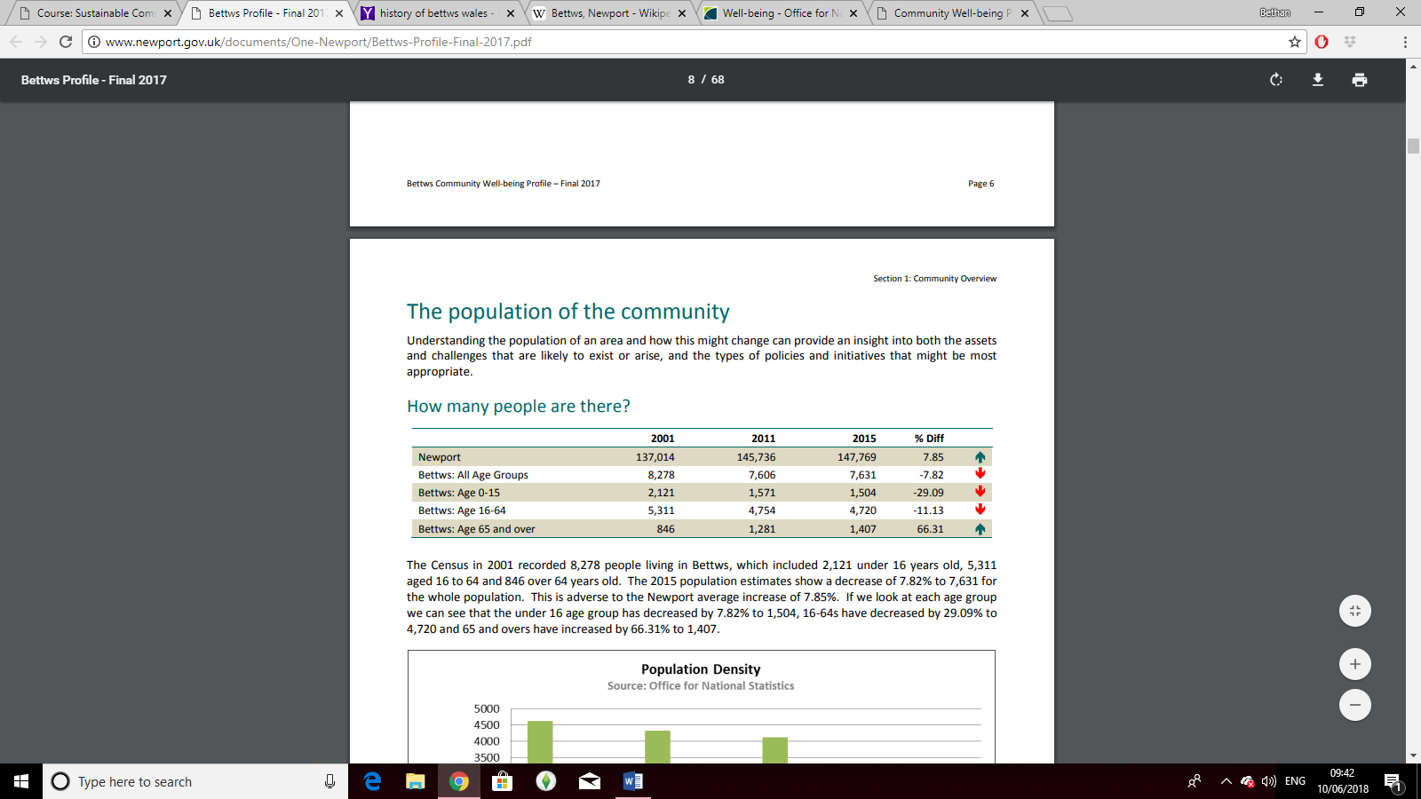
Figure 1(One Newport Casnewydd, 2016).
Although there is no current data available, the 2017 community profile for the community indicates that it is likely that the community population will continue to decrease within the upcoming years (One Newport Casnewydd, 2016).
The previous data from 2011, shows that the population of the community are made up of mostly those of white background, with only 5.4% of those form a non-white background. This data shows that most people within the community are of the white British ethnicity. In addition to this, the overall amount of people within the city who are from the Black and Minority ethnic group are mostly based within the community as there is an overall population of 10.1%, this shows that 5.4% of the ethnic group are based within a small zone of the city (2011 Census Table, Office for National Statistics, cited in One Newport Casnewydd, 2016).
As of 2011 there were 39.6% of the community that do not follow a religion, 50.9% that follow Christianity and 8.7% that did not disclose their religion. This shows that there is an overall census of following Christianity over any other religion (2011 Census Table, Office for National Statistics, cited in One Newport Casnewydd, 2016).
Within the community there are many facilities available for a range of people such as sporting facilities for those who play football, rugby and cricket. A public library, a doctor’s surgery, two churches, a police station, 3 schools and a small shopping area which includes a dentist, pharmacy, a council office, hair dressers and other small shops. As recognised, all these facilities can be useful for a community that is of medium proportion and can cater for many people. However, if these facilities aren’t suitable for members of the community, there is public transport available to access other areas of the city. There are 2 public buses available to gain access to the city centre, by using a number 15 and 16 bus service, people of the community can access surrounding areas at ease for an affordable price of less than £3.50-day ticket (Newport Bus, 2018).
In comparison to the surrounding areas of the city, the community is particularly popular to live in. However, the Welsh Index of Multiple Deprivation recognises that there are significant areas of deprivation across the community ( cited in One Newport Casnewydd, 2016). Therefore, there are potential areas to improve upon, these will be discussed in the upcoming chapters of this community profile.

- Community Issues and Impacts:

On the word of Meadows et al (2005) sustainability is about maintaining respectable levels of social, economic and environmental living within communities. Whilst ensuring that all within the community are equal and being treated as fairly as possible by being provided with appropriate services, which can help the future generations. Brundtland (1987) suggests that sustainable development meets the needs of the present individuals without putting the future generations at risk of damaging their needs and environment. In addition to this, McKeown (2002) indicates that the three well-being areas, social, environmental and economy are to be considered as a whole and not three separate areas of the community as they are all connected (Brudtland, 1987). An example of the three connecting issues has been provided by Baker (2006) who illustrates that linkages between environmental and economic patterns can develop when agricultural policies encourage the overuse of chemical fertilizers. This can lead to land degradation and contamination of water. Which essentially will require funding to fix these issues, however the funding may not always be available right away.

Some of the issues that communities can face have been addressed in the research of Speth (2005). His research indicates that many factors may contribute to the errors within a community. Shiva (2013) states that economic growth can have a considerable effect on a community and therefore should be considered a vital issue within a community. As Shiva states “when economies are measured only in terms of money flow, the rich get richer and the poor get poorer”. This is exactly what the Well-Being of Future Generations Act (2016) is continuously trying to rectify and change, as one of the Well-Being goals is to help people in Wales be lifted from poverty and provided an income that can appropriately support a family. Economic issues may differentiate between communities, although a common economic issue is poverty. Poverty makes a significant difference within the type of life some individual leads and the community that they live in. As explained in the Brudtland Report (1987) sustainable development is the concept of needs and mostly focus on the needs of those in poverty, which a priority should be given towards. Therefore, those who are living in poverty should be the most important area of development and the government, local authorities and communities should be placing importance on those who are living in poor conditions (WCED, 1987).

2.1. Economic

As previously suggested, the small community in Wales is known for being an area of deprivation and poverty (One Newport Casnewydd, 2016). The community has been sectioned into 6 areas, shown in the image below. The map of the community illustrates which parts of the community are of the most deprived areas.
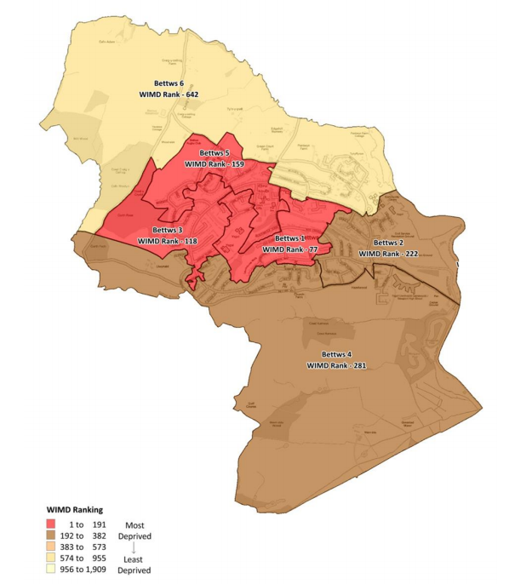
Figure 2 (One Newport Casnewydd, 2016).

As indicated by the Welsh Index of Multiple Deprivation (WIMD), the centre of the community is known for being the most deprived. WIMD specifically looks at the smaller areas within Wales that are listed as the most deprived areas and find alternative options to help lift these communities from deprivation (Welsh Government, 2015).
Within the centre of the community there is several facilities that may have a contributing factor towards the deprivation that these individuals are in. Within this section of the estate, there is are three pubs, a church, a police station, a school, a shopping area, a doctor’s surgery and a library (One Newport Casnewydd, 2016). Therefore, those who are living in this area of essentially living in the busiest part of the community. In addition to this, the second most deprived area of the community is the largest area and that is because the majority of this area is a new housing estate, a petrol station and a recently built high school. In which are also increasing the population and are also popular areas of the community each day. This data indicates that the busiest parts of the community seem to be the areas that are surrounded by most the most deprived individuals who may be living in poverty (One Newport Casnewydd, 2016).
Moreover, no areas within the community is struggling with housing, physical environment or issues regarding access to services. This implies that people are living within suitable housing and physical environments and can gain easy and quick access to services if required. Overall, the research indicates that there could be alternative options to try and remove these individuals away from being deprived by relocating and evenly distributing the facilities across the community to eliminate the busier areas, potentially pulling people away from the most deprived areas (One Newport Casnewydd, 2016).
In addition to this, there are many people within the community that are receiving JobSeekers Allowance. However, the research suggests that the data is limited and therefore does essentially cause issues for tracking the levels of deprivation across the community (One Newport Casnewydd, 2016). Although there is a high proportion of people who work part-time hours and a high proportion of people who are unemployed. 8.0% of people within the community is are unemployed which is higher than the overall percentage of the city, which is 5.3%. However, 37.3% of the community are working full time hours (One Newport Casnewydd, 2016) It has also been indicated that the main types of employment that people are in include transport and storage, wholesale, retail trade, construction and accommodation and Repair of motor vehicles. These specific types of jobs are known for being more physical than most and therefore an individual within the jobs may require more health care.
From the previous data, it shows that the community does struggle economically and it is important to recognise that 30.1% of the population are in full time employment which means that they are working towards improving their financial income. However, the community is noted to be in economic trouble as it has a higher unemployment rating than any other community within the city. However, although the unemployment ratings are the highest within the city, it also holds the highest rating for the amount of people within part-time employment within the city but the lowest rating for the amount of people in full-time employment. Therefore, at least a 15.9% of the community are in some form of employment of at least up to 16 hours of work a week (One Newport Casnewydd, 2016). Therefore, this research does indicate that a portion of the community are willing to work but there could be potential issues that stop people within the community from working full-time hours or even working at all. In section 4, the potential areas of improvement and long-term impact is addressed regarding the economic issues within the community.

2.2 Socially
The social well-being of the community considers the health, housing and safety communities of the community. A report by One Newport Casnewydd (2016) suggests that the health levels within community have increased over the years. In 2014 it was suggested that the average woman will live until 82 years old and the average man will live until 78 years old. As indicated by the government, those over the age of 65 are eligible for retirement (Gov.uk, 2018). Therefore, the average woman will live 17 years after they retire. Whilst a man will live only for 13 years after they retire, this information shows that the average individual in the community will enjoy only a small portion of their lives after they are no longer required to work (Gov.uk, 2018). In addition to this, the life expectancy of individuals within the community has increased by 2% from 2009 to 2014 which is not a massive difference but if the life expectancy rating continues to grow it will make a difference in the community population in the long term (One Newport Casnewydd, 2016).
Research suggests that there is a significant inequality in health between those living within high deprivation areas than those living in low deprivation areas (NHS Wales, Public Health Wales Observatory, 2014). The research indicates that notion that those living in deprived areas suffer more ill health than those in low deprived areas, this recognising the issues that come with those that live in high deprivation areas (One Newport Casnewydd, 2016). The data suggests that 38.1% of the community are in very good health and with only 2.6% in very bad health. The following results indicate the 2011 census of health within the community, 34.2% in good health, 17.1% in fair health and 8.0% in bad health. These results suggest that overall, most of the community are in at least fair health and only a small percentage of the community are struggling with their health, whether this may be physical or mental health (One Newport Casnewydd, 2016).
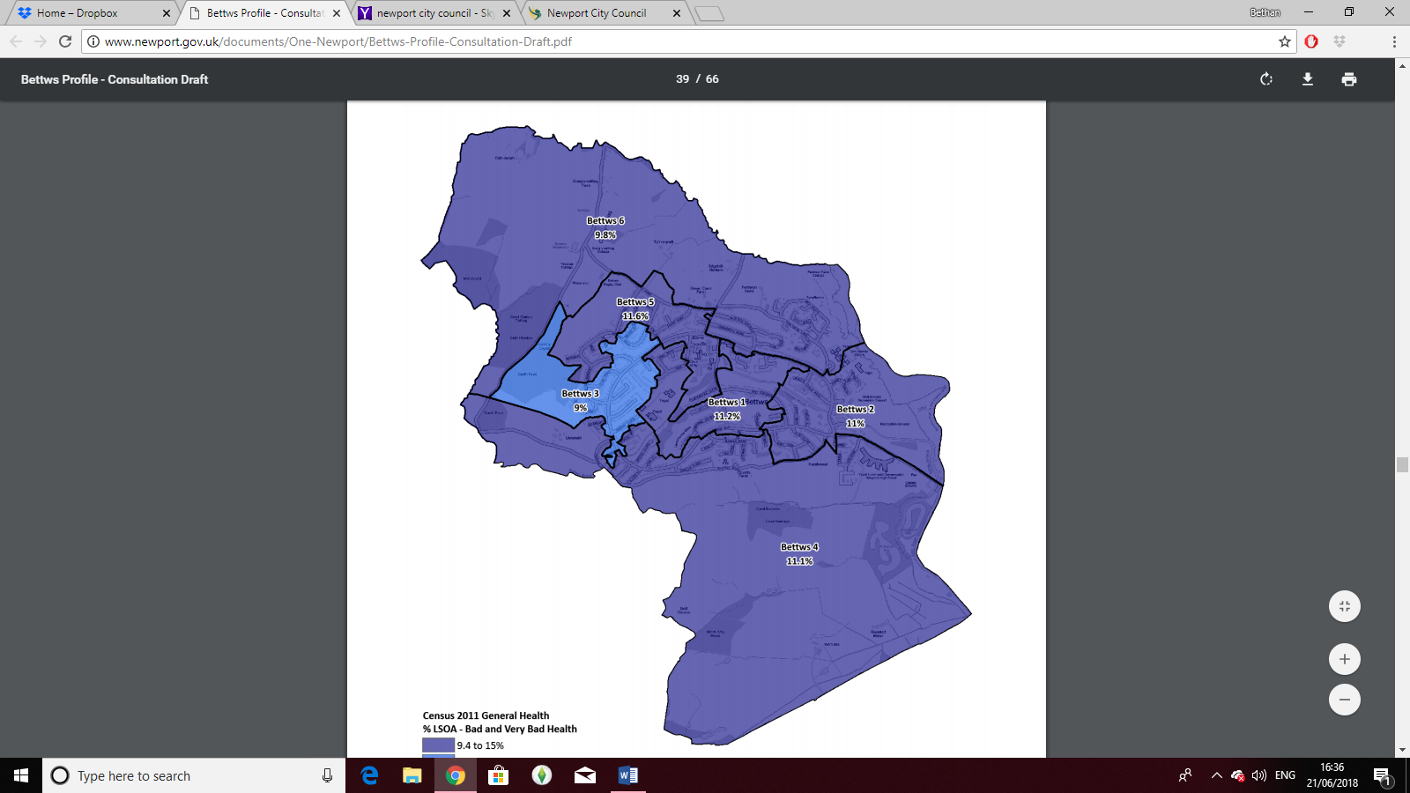
Figure 3 (One Newport Casnewydd, 2016).
The figure above indicates the areas of individuals that are struggling with health whether it be bad or very bad health. It shows that the percentage of these people are distributed across all areas but less of these individuals live within the 3rd location. As indicated by Foxcroft et al (2002) there are many types of ill health and issues that can come from being unwell, however the most common issue in Wales is alcohol misuse which can cause serious harm and put individual’s health at risk when consumed in above moderation (One Newport Casnewydd, 2016; NHS Wales, 2014). Statistics by NHS Wales (2014) in 2014 indicates that alcohol levels are significantly higher in Welsh males than females. The data suggests that 46% of males’ drink alcohol either 3 or 4 days a week within a 12-month period, whereas only 35% of females drink within this frequency (NHS Wales, 2014).
Health levels have been negatively influenced by over-consumption of alcohol and as the statistics shown by NHS Wales (2014) notes that 8100 males and 4600 females were admitted to hospital with an alcohol related injury. However, the ratings indicate that 21.5% of females were admitted to hospital due to unintentional injuries but the ratings were considerably higher in men, at 31.0% of men who were admitted because of unintentional injuries. These statistics recognise that alcohol can encourage accidental and unintentional injuries that can lead to long-term and lasting physical disabilities and put pressure on an individual’s emotional well-being. In addition to this, the statistics show the mortality ratings between 2010 and 2012, stating that 990 males and 530 female deaths were reported each year due to alcohol misuse, this data recognising that these deaths could have been prevented had it not been to high alcohol consumptions (NHS Wales, 2014). Therefore, these statistics recognise the issues that the community face as there is such a high alcohol intake amongst members of the community (One Newport Casnewydd, 2016).
In addition to this, living conditions also play a considerable role into the social well-being of an individual within the community. The community has 3,357 homes within the community, which is only 5% of what the whole city holds (One Newport Casnewydd, 2016). Of these homes, Newport City Homes takes control of 1292 of these homes, Charter has 119 homes and Linc Cymru has 26 of these homes (One Newport Casnewydd, 2016) which shows that the majority of the community is being maintained by Newport City Homes which are commonly known for their affordable housing. However, not all people in the community have previously been happy within the community and there are many reasons that they wish to be rehoused. Individuals suggested that their home within the community was not a permanent home and therefore, wished to relocate in order to find a permanent and secure home. In addition to this other reason were because of health or medical reasons, overcrowding, to move closer to family and friends to being asked to leave by family or friends. However, a large portion of the community were happy with their living conditions within the community and liked where they live (One Newport Casnewydd, 2016).
However, the new building properties have been shown significant consideration due to the high quality of the properties. The new builds cost an average price of £192,338 in comparison to the average price of a second hand home within the community which have been listed as at high of £109,271 (Newport City Council, 2015). Most of the community is built upon semi-detached homes which cost an average of £106,833 which makes a considerable loss to an individual’s monthly wage (Newport City Council, 2015). Therefore, this research suggests that the cost of living has raised for the new properties and the research indicates a rising cost for mortgages and because of this, have prevented members of the community from purchasing a home within the private rented sector (One Newport Casnewydd, 2016). On average, a weekly rent in bed for 2 and 3 bedroom houses are at £126 a week. Whereas within the city as a whole, a 2 bedroom house is £125 and a 3 bedroom house is £144 for a week, this showing a small difference between housing prices within the community (One Newport Casnewydd, 2016). These results illustrate a home costing issue within the community.
As illustrated from the data above, there is a social issue within the community and there should be action taken to help improve the social living conditions for those within the community. These actions have been illustrated in section 5.

3.3. Environmental
The environmental issues within the community can is a broad range of issues that affect the current state of the natural environment within the community. (Dobson, 1998) states that environmental issues impact the wellness of the community and therefore are vital to assess and improve in order to provide a sufficient home environment and community for those living in it. The Welsh Index of Multiple Deprivation (cited in One Newport Casnewydd, 2016) provides indicators of environmental issues such as air concentrations, air emissions, flood risks and waste disposal and industrial sites.
Research identifies that the community is not struggling or at risk of any issues regarding physical environment (One Newport Casnewydd, 2016). Figure 4 shows a ward map (One Newport Casnewydd, 2016) which recognises that the main concern is Zone C2 floods. Throughout the community there is a small canal that leads to larger spaces of water, however the canals are controlled well and are generally very low down and are of low risk to the community (One Newport Casnewydd, 2016).
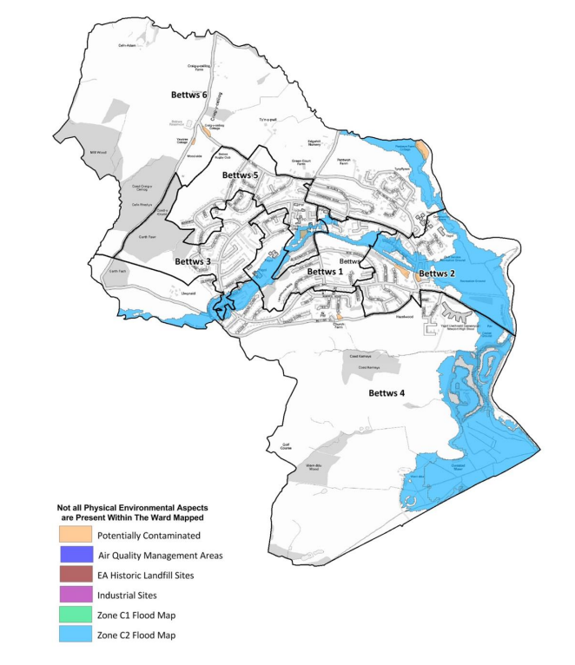
Figure 4 (One Newport Casnewydd, 2016).
The landscape of the community has open spaces which are commonly used for sport and recreational purposes. However, the community has a small deficiency regarding the amount of open spaces that are available, the community has 8.99 hectares of open space across the whole community (One Newport Casnewydd, 2016). Figure 5 recognises these areas of land; the light green areas show the natural greenspace across the community. Whilst the green shade with E shows open space provisions which are equipped, the letter F in the green shows open space provisions that are formal and the letter I in the green shows informal open spaces (One Newport Casnewydd, 2016). It is identified in figure 6 that there are not that many areas within the community that are of natural greenspace, however there are many places that can provide sufficient access for sporting and recreational purposes (One Newport Casnewydd, 2016).
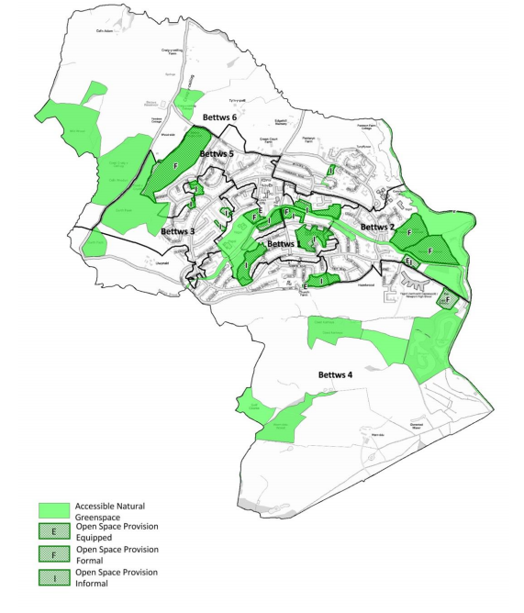
Figure 5 (One Newport Casnewydd, 2016).

Although there is no evidence to show that there is a risk of flooding within the community. However, the city as a whole has a high probability of flooding are the land has a large river flowing the city. Figure 6 shows the large portion of the city that is of high risk of flooding if there are no flood defences in place to protect the area. This shows that a large section of the city would be affected but the community in discussion would not be affected (One Newport Casnewydd, 2016).
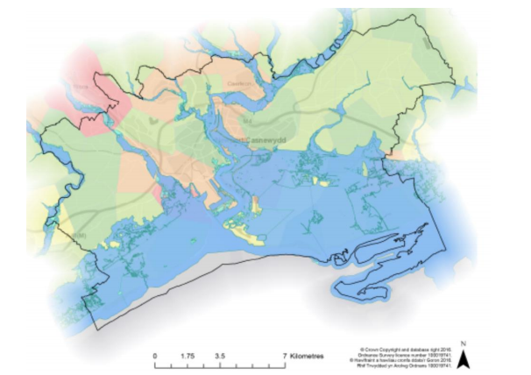
Figure 6 (One Newport Casnewydd, 2016).
Furthermore, there is no clear research that indicates any potential risks and issues within the community regarding the environment. Therefore, indicating that there are fewer issues regarding the environmental factors in comparison to the issues stated previously within social and economic factors.

- Methods used to collect data about your community
People within the community often are included within the research, planning and developmental changes and this is done through a variety of research methods. Unfortunately, no empirical data was collected within this community profile due to a failure of timing. However, had there been enough time the empirical data for this community profile would have been a questionnaire amongst the people within the community. The following questionnaire are questions that would be beneficial for the community profile.
3.1 Questionnaire for Community Profile:
Question 1: What is your age?
Question 2: What is your gender?
Question 3: How long have you lived within the community?
Question 4: Do you feel that your local council or government provide enough support?
Question 5: What issues do you have regarding the economic state of the community?
Question 6: What issues do you have regarding the social aspects of the community?
Question 7: What issues do you have regarding the environmental state of the community?
Question 8: Are you a home owner? If so, what type of home? I.e Detached, semi-detached etc.
Question 9: Do you think buying a home is expensive within your community?
Question 10: What is your employment status? If you are not employed, please state your reasons why.
Question 11: Do you think the community is safe enough for children, the elderly and families?
Question 12: What is the crime like within the community?
Question 13: Do you feel safe, comfortable and happy within your community?
Question 14: What are the positive aspects about your community?
Question 15: What are the negative aspects within your community?
Question 16: What changes would you like to see happen? Why?
I believe that these questions would help provide sufficient data for this community profile and would recognise the opinions and views of individuals within the community who understand what it is like to live within it. These 16 questions are only a small preview into what the questionnaire would look like. Additional questions regarding flooding, education, children’s well-being, traffic, and provisions would be included in order to truly understand and gain an insight into the issues that people face within the community. All these contributing elements would also recognise the potential poverty, lifestyle and problematic experiences people may have or continue to face whilst living in the area.
Moreover, the above sections were written from previous secondary data from the local council and services within the community and the overall city. Due to the lack of empirical data it was difficult to build a community profile without having more of an insight from people who live within the community. Ultimately, it was important to support the community profile with secondary data that has been relevant and recent within the past years.
The majority of the research has come from existing reports, the main report was the previous community profile which was written in 2016 (One Newport Casnewydd, 2016) which showed relevant and recent research that recognises the issues and positives that happen within the community and therefore, ultimately have an effect on the future. As suggested by the Welsh Government (2016) the well-being of future generations act 2015 does indicate that all communities should be looking to improve and progress in order to provide appropriate and suitable living conditions for the future generations. The previous community profile (One Newport Casnewydd, 2016) does recognise factors that will contribute towards future generations and therefore, is following the legislation that promotes it.
Other secondary research was included from the local council and services within the community and the entire city. As stated previously it was difficult to find the reverent secondary research, although Newport City Council (2015) and Newport City Council (2018) provided relevant information that was informative and useful to back up the community profile.
- Discussion:
Through thorough research, the information that has been discussed shows significant agreement with relevant work from (REFERENCE). As identified in their literature, Innes et al (2010) recognises that the community should be informed and kept up to date in regards to the overall health of the religion and community and therefore, should be included within the alternations and developmental aspects of the community. Innes et al (2010) states that without regular feedback to show the issues within the community, no changes can be made and the community cannot be made more sustainable and difficult to encourage sustainable living. In regards to the previous research from One Newport Casnewydd (2016), which is a previously written community profile. It has been recognised that the community did contribute to the research by completing questionnaires and short interviews to discuss their local community. Although this was unable to be done for this community profile, the recent community profile discussed the issues and positives thoroughly and gave a clear insight into how to make the community more sustainable.

Previous research indicates that the community does have areas of deprivation, however the population levels have continued to drop in recent years (One Newport Casnewydd, 2016). As Srinivasan, O’Fallon, and Dearry (2011) suggests, there is a connection between high deprivation rates and high population, although in this case, the community is not struggling with high population as the ratings have decreased over the years. In addition to this, the community is not completely struggling in deprivation except one area of the whole community. Reasons for this may be due to the fact that it is the centre of the community in which has multiple shops, pubs and schooling areas, it is therefore, the most popular and busy area to live in within the community (One Newport Casnewydd, 2016). Furthermore, this essentially agrees with the research of Srinivasan et al (2011) as the population is decreasing amongst the years and this that, the deprivation ratings are decreasing also. This suggests that the community is doing better with regards to eceonomic but socially, they are losing members of the community each year.

As recognised section 3.2, health issues area of considerable concern within the community. Figure 4 recognises the most deprived areas of the community which are 1, 3 and 5. The area with the most notable bad health was area 3, which is also known for being one of the busier areas within the community (One Newport Casnewydd, 2016). The literature of Rejineveld (1998) makes a connection been deprivation and ill health, stating that it is generally known for those living with poor health to be living with a more deprived and low socioeconomic area. However, research does state that age and gender does have a role within poorer health but also a significant issue which influences poorer health is smoking which is a common contributor within the more deprived areas (Rejineveld, 1998). In addition to this, Fone, Dustan, Lloyd, Williams, Watkins and Palmer (2007) argues that more deprived areas have more people with mental health problems due to the stresses in life regarding money but also the social cohesion levels within the community that are factors of mental health problems. Therefore, their literature recognises that physical and mental health issues can influenced due to living in more deprived and low socioeconomic areas (Sloggett, 1994).

Through research it has been noted that there are very few issues regarding the environment within the community. However, it was recognised that the city as a whole is at high risk of flooding if there are no flood defences in place. As shown in figure 7, there is a large flow of river passing through the city which would need a fully structured and working flood defence system in order to prevent huge flooding throughout the city. Fortunately, the community would be at low risk of being affected if there would be a flood but several areas of the city would be affected which could potentially cause for all communities in the city. De Bruijn (2016) suggests flood risk management is crucial to ensure that there is “a resilience of a flood risk management system to flood waves” this is important to ensure that the system be used to help the area recover from flooding faster and more effectively. Moreover, flood waves from the flood management system my cause social and economic disruption as properties may be damaged, emotional shock, need for evacuations and the destruction of ecosystems and monuments. Furthermore, although flood management systems will provide sufficient help at a faster pace, there is still risk of damage to the communities (De Bruijn, 2016).

- Recommendations: outline your recommendations for future action / research
Due to there being no empirical data within this community profile, there is no recommendation from the community. However, it is important to recognise that there are concerns within the community that should be addressed in order to provide a sustainable community for current residents and the future generations.
In regards to environment aspects, there are very limited things to say as the area itself is well kept and has low risk to flooding. However, it’s important to note that the city should be protected with flood management plans and defences in place to keep the communities as safe as possible and easier to recover from, should a flood ever happen.
In addition to this, the community could consider adding more facilities and housing opportunities in order to increase the population. As recognised, the population has decreased over the years and previous research states that it will continue to decrease in the upcoming future (One Newport Casnewydd, 2016). Therefore, it’s important to promote the community and introduce new people to keep it more sustainable and function. This would be beneficial as it would provide more opportunities for those in the future.
Finally, it’s crucial to recognise the health ratings within the community and how the local health services can contribute towards helping those with health problems, whether they are mental or physical. There is a contributing factor to health problems such as unemployment and low socio-economic areas. An increase in population may result in an increase in local employment opportunities as businesses will grow, this may ultimately help to increase the socio-economic status within the area. However, this may not occur for several years and this is what the Welsh Government (2016) has suggested within the published legislation the Well-Being of Future Generations Act.
It is vital that the community is not only focusing on how to improve the lives of those who currently live in it, but to ensure that future generations are being given a better chance with a more sustainable environment to be supported within.

- References:

- Baker, S. (2006). Sustainable Development. London: Routledge
- Brundtland Report. (1987). World Commission on Environment and Development. [Online] Available at: http://mom.gov.af/Content/files/Bruntland_Report.pdf [Accessed 10/06/2018]
- De Bruijn, K. (2016). Resilience and Flood Risk Management, A Systems Approach applied to Lowland Rivers. [Online] Available at: file:///C:/Users/bethan/Downloads/ceg_bruijn_20051011.pdf [Accessed 06/7/2018]
- Dobson, A. (1998). Justice and the Environment. Conceptions of Environmental Sustainability and Theories of Distributive Justice. Oxford; Oxford University Press
- Fone, D., Dustan, F., Lloyd, K., Williams, G., Watkins, J., and Palmer, S. (2007). ‘Does social cohesion modify the association between area income deprivation and mental health? A multilevel analysis’ International Journal of Epidemiology. Vol 36, issue 2, PP 338-345.
- Foxcroft, D.R., Ireland, D.J., Lister-Sharp, G., Lowe & Breen, R. (2002).’Longer-term Primary Prevention for Alcohol Misuse in Young People: A Systematic Review.’ School of Health Care. Vol 98. PP 397-411
- Gov.uk (2018). Working After State Pensions Age. [Online] Available at: https://www.gov.uk/working-retirement-pension-age [Accessed 21/06/2018]
- Innes, J.E. & Booher, D.E. (2010). ‘Indicators for Sustainable Communities: A Strategy Building on Complexity Theory and Distributed Intelligence’ Planning Theory and Practice. [Online] Available at: https://www.tandfonline.com/doi/abs/10.1080/14649350020008378 [Accessed 06/07/2018]
- McKeown, R. (2002). The ESD Toolkit 2.0 [Online] Available at: www.esdtoolkit.org [Accessed 10/06/2018]
- Meadows, D.H., Meadows, D.L., Randers, J. & Behrens, W. (2005). The Limits to Growth. New York: Universe Books
- Newport Bus Service. (2018). Timetable for Number 15 and 16. [Online] Available at: file:///C:/Users/bethan/Downloads/15-16-BETTWS-26-02-2018.pdf [Accessed 10/06/2018]
- Newport City Council. (2015). House Prices. [Online] Available at: http://www.newport.gov.uk/en/Business/Locate-in-Newport/House-prices.aspx [Accessed 21/06/2018]
- Newport City Council. (2018b). Application Details. [Online] Available at: http://planning.newport.gov.uk/swift/apas/run/WPHAPPDETAIL.DisplayUrl?theApnID=15/1106&theTabNo=10&backURL=%3Ca%20href=wphappcriteria.display%3ESearch%20Criteria%3C/a%3E%20%3E%20%3Ca%20href=%27wphappsearchres.displayResultsURL?ResultID=360693%26StartIndex=1%26SortOrder=APNID:asc%26DispResultsAs=wphappsresweek1%26BackURL=%3Ca%20href=wphappcriteria.display%3ESearch%20Criteria%3C/a%3E%27%3ESearch%20Results%3C/a%3E [Accessed 21/06/2018]
- NHS Wales, Public Health Wales Observatory. (2014). Alcohol and Health in Wales 2014. [Online] Available at: http://www2.nphs.wales.nhs.uk:8080/PubHObservatoryProjDocs.nsf/85c50756737f79ac80256f2700534ea3/d7ead329fc08591480257d7200326f03/$FILE/AlcoholAndHealthInWales2014_v2a.pdf [Accessed 22/06/2018]
- One Newport, Casnewydd. (2017). Community Well-Being Profile, 2017. [Online] Available at: http://www.newport.gov.uk/documents/One-Newport/Bettws-Profile-Final-2017.pdf [Accessed 10/06/2018]
- Rejineveld, S.A. (1998). ‘The Impact of Individual and Area Characteristics on Urban Socioeconomic Differences in Health and Smoking’ International Journal of Epidemiology. Vol 27, Issue 1. PP 33-40.
- Shiva, V. (2013). How Economic Growth has become Anti-Life. [Online] Available at: https://www.theguardian.com/commentisfree/2013/nov/01/how-economic-growth-has-become-anti-life [Accessed 10/06/2013]
- Sloggett, A. (1994). Higher Mortality in deprived areas: community or personal disadvantage? [Online] Available at: https://www.bmj.com/content/309/6967/1470.full [Accessed 06/07/2018]
- Speth, J. (2005). Red Sky At Morning. Yale: Yale University Press
- Shobha Srinivasan, Liam R. O’Fallon, Allen Dearry (2011). ‘Creating Healthy Communities, Healthy Homes, Healthy People: Initiating a Research Agenda on the Built Environment and Public Health’, American Journal of Public Health. Vol, 93, Issue no. 9 pp. 1446-1450.
- Welsh Government. (2015). Welsh Index of Multiple Deprivation. [Online] Available at: https://gov.wales/statistics-and-research/welsh-index-multiple-deprivation/?lang=en [Accessed 17/06/2018]
- Welsh Government. (2016). Well-Being of Future Generations Act, 2015. [Online] Available at: https://gov.wales/docs/dsjlg/publications/160401-wfg-easy-read-en.pdf [Accessed 10/06/2018]

