Gaynor Vine: 1706442
Module: ADAD5001; Research Practices
Dissertation Proposal
Lecturer: Sarah Tombs
Word Count 2,585

Introduction
This dissertation will explore the implicit connection artists have with their materials and how this impacts upon their artwork. The intrinsic link between art as a method of storytelling will be explored with the aim to investigate the mental, emotional, spiritual and physical changes this creates within the human body. Scientific evidence will be examined, demonstrating the physical impact storytelling has on the body through positive perception, affecting our emotions. Keywords to be considered are: connection, storytelling and evolution. This dissertation will analyse how far the spiritual connection between artists and art material, art work and storytelling can create powerful, physical changes within the human body.
Connection
Artists talk about the connection to materials and finding inspiration for their work. This connection has been made with materials such as; painting, sculpting, music, and dance and many other materials. Some artists say that through this connection, they are tapping into their own source of inspiration, or god, and from this they have gained new understanding, or have been inspired.
Many artists who work this way argue their songs or paintings did not come from them, but came from this source of inspiration that they were connecting to and they were just channelling the information.
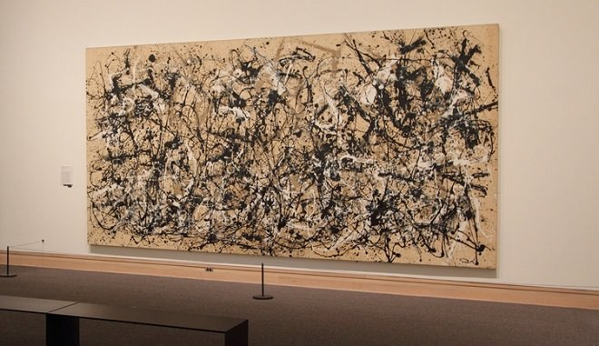
Figure 1 Autumn Rhythm
Jackson Pollock is an artist who uses the connection to material for his paintings. He doesn’t have any preconceived idea of what the painting will be; he has an idea of what he wants to paint, but he does not know what the finished painting will look like.
When you're working out of your unconscious, figures are bound to emerge. Painting is a state of being. Painting is self-discovery. Every good artist paints what he is." - Jackson Pollock (Autumn Rhythm)
There does seem to be a spiritual element with the way that these artists work; where they seem to be questioning reality and making this connection to find answers.
Spirituality refers to the deepest values and meanings by which people seek to live. It conveys an outlook, vision or aspiration about life that involves thinking holistically about identity, about one’s own and that of others (Ayra, 2016)
It is my belief that this connection is related to the stories that we are telling ourselves and we use art materials as conduits to connect with a higher source to have a conversation. By doing this, it helps us to evolve to a higher level of understanding.
Wassily Kandinsky sought to convey profound spirituality through his paintings. The artist’s thoughts, feelings, and actions, when translated into art, have the power to affect the spiritual climate of his or her society. (Lebowitz, 2017)
Many artists, such as Kandinsky believed that they were gaining new knowledge that could help humanity and create a better future, and saw themselves as prophets.
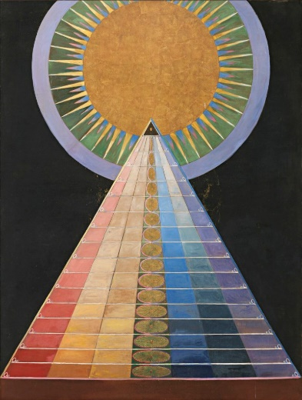
Figure 2: The Alterpiece, Hilma, Af Klint (1915)
Hilma Af Klint was one of these artists and believed that when she was painting, she was in contact with a higher consciousness that spoke and conveyed messages through her. Her connection was not just with one source, she believed that we are able to connect to entities in many alternate realities. The information Klint was receiving in her conversation seemed to be more highly advanced for contemporary society of the time to understand, and made instructions in her will that her paintings should not be available to the public for at least 20 years after her death (About Hilma af Klint).
Perhaps the information that she was receiving may be compared to science fiction movies, which have had a massive influence on society. Many of the technologies that have been promoted in these films, have now become reality. By telling these stories we are influencing society, as this connection does not only impact the artist but also influences the viewer.
A work of art has a story to tell, which may resemble an experience or belief similar to the viewers, which will trigger emotions or memories in them. The painting or movie is a visual representation of the artist’s reality and emotions experienced which are in turn felt by the viewer. They are able to see reality from another person’s point of view, which in turn helps them to understand their own.
The key to this connection arguably could be storytelling. Rather than talking to another person, the artist is making a connection to his own source of inspiration and having a conversation. Through this, they gain new information, which expands their outlook on life, and also the way they view themselves, which ultimately questions, what is so important about stories and how can they influence us?

Storytelling
Storytelling is an important part of the human experience. From cave etchings, to myths and legends, humans have been sharing stories of the world that they see around them (Corson-Knowles). Stories are part of our daily lives, this could be the stories we tell to our friends, the books we read, the films we watch, or the stories that go on in our minds. But what power do stories have, and how are they influencing us?
The Empathy Museum’s Clare Patey says, ‘Stories have a transformative power to allow us to see the world in a different way than we do if we just encounter it on our own. Stories are an entry point to understanding a different experience of the world” (The power of storytelling, 2016).
From the perspective of connection to materials, I think the important part of this is related to the artist’s beliefs and the stories they focused on. These artists were on a spiritual journey, learning to understand themselves and the world they were experiencing. They were not weighed down by the stories of contemporary culture of the time, but were looking inside themselves for answers and using this connection to gain new insights and wisdom.
The key to this is the stories that we tell, and the feelings and vision they build, which all happen within the body. Our energy and vibration increases when we focus on positive things; we feel healthy, our outlook on life expands, and we take on a new way of living, which alters the way that our mind works (Carter, 2019).
This evidence suggests that this is not just about the connection to physical materials, but that a key material in this, is the physical body. Everything happens in the body where the connection is made. These artists are experiencing a connection with their physical body, gathering up their stories, which ultimately produce energy. They focus their attention and their energy on making this connection with their source of inspiration, which is another energy source. They set the intention that they are connecting to a higher power, which means a higher vibration and higher wisdom. They use their art material as a conduit, and transcribe the conversation in the art form that is appropriate to them. Just like any other conversation, the theme of the stories they have been focusing on will determine the topic of conversation with this connection.
Physical reality is an energy system; our thoughts are made of energy, as are our words and actions. As you bring more energy to any thought, any conversation, and any action, you increase your powers of creation (Carter, 2019). The stories we focus on produce an energy which we are tapping into; we then focus this energy on something outside of ourselves, connecting to an alternative source of energy. Those energies mix and this has an influence on our physical, mental and spiritual bodies.
This process is completed through stories, as a story can often be the only way to activate parts of the brain and gain access to new information. Stories alter the chemical processes in the brain, as they produce emotions and feelings, which in turn produce a frequency, or a vibration (Comaford, 2018). From the visions we are building up, they create emotions and feelings inside of us of what it would be like to talk to this person, which changes the frequency in the body.
This connection is comparable to having a telephone conversation. This may be subliminal, where you don’t even realise that you are talking, but thoughts and images come in. What you are doing is connecting to that energy and exchanging ideas, which may come through in images and feelings; it’s a conversation.
This new knowledge may be something that you have never experienced before, but it builds up different emotions and feelings of experiencing this yourself; these activate parts of the brain and chemical reactions. These new emotions change the way you see the world; you have a new insight and your world opens up. What this ultimately means is that you have gained new knowledge and evolved to a higher level of understanding, and so has the way that your brain works, as you have opened up new avenues in the mind.
Consciousness arises only when the brain cells fire at a fairly high rate. The high firing rates of Beta waves indurates alertness, while the low rate of Delta waves indicates deep sleep (Carter, 2019)

Evolution
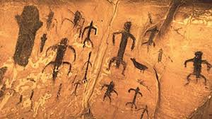
Figure 3: Levanso's Cave Drawing
The knowledge that we have gained throughout history, through the stories shared by our ancestors, have arguably helped us to evolve to a greater understanding. This was through people sharing stories of events taking place that formed their understanding of the world. Through time these stories evolved as knowledge and understanding grew. In all ancient scripts there are stories about creation which had a spiritual element to them. Many ancient carvings and text talk about beings who came to the earth to share their knowledge and teachings on how we could evolve ourselves to become more like them (Black, 2019). At the time, they were depicted as god’s because to our unevolved mind we could not even comprehend a reality where we were able to do what they were teaching.
It is from these teachings that philosophers and scientific minded people began investigating these theories and discovered that within ancient scripts were many lessons that we could use to advance our society. In one of the religious teachings, Krishna is known to have said that all of the universe is inside us, that what we see on the outside is just a reflection of what is inside (Bhatta, 2018). Our reality is a mirror of what is going on inside us and is made up from the stories that we tell ourselves; these originate from our beliefs and our perception of the world, which in turn are reflected into our reality.
Scientists are now questioning whether the reality that we experience is real, as they have now discovered that we may be connected to a holographic matrix, activated by our thoughts and feelings, projected into a physical form outside of ourselves, which we see as reality (Carter, 2019). This is comparable to the words of Buddha; he told us not to get wrapped up in anything you see happening around you that may distract you from your path, because none of it is real. We are to follow the middle path, which is ourselves and our physical bodies, because it all comes from inside us (Rong).
Jesus also told us that we each have the kingdom of heaven inside us, that we can create it for ourselves (Treybig). He said that we were all made in the image of God, which meant that we can create. In the beginning was the word, and from the words of God came creation. Everything we create starts with words, with thoughts that we have in our minds, which then build up a vision, producing feelings, where we are able to tap into that reality and bring that into our lives which is called creation. When we think of it this way, what the ancients were teaching us was right. We now have proof that we are creating our realities, and we can create a vision of a brighter future.
Now we have the knowledge of how our bodies work and how we create our realities, we can look at the stories that are being promoted in contemporary culture, and see if they benefit us.
We should not underestimate the psychological effect of the statistical world-picture; it thrusts aside the individual in favour of anonymous units that pile up into mass formations (Jung, 1990)
Those stories are based on leaders, large companies, and governmental influences being in control. There is nothing really about us finding out who we are, or giving us ideas of how to create a better reality for our children. The stories they promote for our lives, are about war, poverty, abuse and death. As we have learnt, as we listen to those stories, our mirror neurons activate, which have an effect on our health and influence the reality that we experience.
The goal and meaning of individual life (which is the only real life) no longer live in individual development but in the policy of the state, which is thrust upon the individual from outside and consists in the execution of an abstract idea which ultimately tends to attract all life to itself (Jung, 1990).
According to Kandinsky, we as artists have a responsibility to monitor our thoughts and the stories we focus on, as they create a spiritual atmosphere, which when continually focused on, will come into our reality (Kandinsky, 1977). It is all storytelling, but who is to say that any of it is real, whether it be the stories in our mind, or the stories that are being promoted in contemporary culture.
The idea of a conscious but embodied brain is centre to many sci-fi fiction and horror movies, and is often used as a thought experience in philosophical debates about the nature of reality. In recent years, the notion has ceased to be entirely theoretical as modern technology edges towards the possibility of including in the brain a virtual reality experienced through the body. It is even possible that such a thing has been achieved already, and the external world, as we experience it, is not “real” at all (Carter, 2019).
The stories that are told about us in contemporary culture are not true. We only have to look at our own lives to realise that. We know that we are so much more than the stories that are being told about us. We are souls who are having a human experience, and we are doing that through this physical body (Colier, 2015). From the evidence discussed in this proposal, we can see that this body allows us to create things for us to experience.
Conclusion
I do believe that we are now at another junction, where we are discovering that many of the things that we thought we knew about ourselves and the world around us, are not true. We are now getting to see just how beautiful this human body is and what it is capable of. Rather than focusing on what is promoted in contemporary culture, we should do as Buddha says, and take our minds off those stories and start focusing on creating a vision of the world that we would like to create, creating our own Garden of Eden, where people are healthy and know who they are. We have many tools to help us through this, like mindfulness, meditation and art therapy, where we can use art to tap into our emotions, connect to a higher source of inspiration and allow beauty to come through and create a new reality.

Bibliography

About Hilma af Klint. (n.d.). Retrieved July 19th, 2019, from Hilma af Klint: https://www.hilmaafklint.se/about-hilma-af-klint/
Autumn Rhythm. (n.d.). Retrieved July 17th, 2019, from Jackson Pollock, Biography, paintings and quotes : https://www.jackson-pollock.org/autumn-rhythm.jsp
Ayra, R. (2016, August ). Spirituality and Contemporary Art. Retrieved january 23rd, 2016, from Oxford Research Encyclopedia : https://oxfordre.com/religion/view/10.1093/acrefore/9780199340378.001.0001/acrefore-9780199340378-e-209
Bhatta, K. (2018, June 2018). Krishna in Universe: Universe in Krishna. Retrieved July 18th, 2019, from Krishna Universe : https://krishnauniverse.com/universe-in-krishna/
Black, J. (2019, February 26th). The origins of human beings according to ancient Sumerian texts. Retrieved July 18th, 2019, from Ancient Origins: https://www.ancient-origins.net/news-human-origins-folklore/origins-human-beings-according-ancient-sumerian-texts-0065
Carter, R. (2019). The Brain Book. London : Dorling Kindersley Limited .
Colier, N. (2015, July 6th ). Spiritual Beings on a Human Journey—Remembering Our Stardust. Retrieved July 18th, 2019, from Psycholgy Today : https://www.psychologytoday.com/gb/blog/inviting-monkey-tea/201507/spiritual-beings-human-journey-remembering-our-stardust
Comaford, C. (2018, June 2nd). Emotions Have Energy: What Energy Are You Sending? Retrieved July 5th, 2019, from https://www.forbes.com/sites/christinecomaford/2018/06/02/emotions-have-energy-what-energy-are-you-sending/#3d4cfeeb2545
Corson-Knowles, T. (n.d.). Stories Matter: Why Stories are Important to Our Lives and Culture. Retrieved July 3rd, 2019, from TCK Publishing: https://www.tckpublishing.com/stories-matter/
Curtis, P. a. (1998). Barbara Hepworth. London : St Ives artists .
Davies, B. (2018, October 23rd). At the Guggenheim, "Hilma af Klint: Paintings for the Future" makes you rethink what it means to be modern. Retrieved from Artnet: https://news.artnet.com/exhibitions/hilma-af-klints-occult-spirituality-makes-perfect-artist-technologically-disrupted-time-1376587
Davies, B. (October, 23rd). At the Guggenheim, "Hilma af Klint: Paintings for the Future" makes you rethink what it means to be modern. Retrieved from Arnter.
Evans, M. (n.d.). Untitled.
Frank, E. (1983). Jackson Pollock. New York: Modern Masters Series .
Jung, C. G. (1990). The Undiscovered Self. New Jersey: Princeton University Press.
Kandinsky, W. (1977). Concerning The Spiritual In Art. New York: Dover Publications.
Lebowitz, R. (2017, June 12th). How to Be an Artist, According to Wassily Kandinsky. Retrieved July 18th, 2019, from Artsy: https://www.artsy.net/article/artsy-editorial-artist-kandinsky
Pollock, J. (n.d.). Atumn Rythm .
Pollock, J. (n.d.). Autumn Rhythm. USA.
Rong, T. b. (n.d.). Buddhism - The Middle Path . Retrieved July 18th, 2019, from Teachings in Chinese Buddhism: https://www.buddhanet.net/cbp2_f4.htm
The power of storytelling. (2016, December 2016). Retrieved from the health Foundation : https://www.health.org.uk/newsletter-feature/power-of-storytelling
Treybig, D. (n.d.). “The Kingdom of God Is Within You”—What Did Christ Mean? Retrieved July 18th, 2019, from Life, Hope & Truth: https://lifehopeandtruth.com/prophecy/kingdom-of-god/the-kingdom-of-god-is-within-you/

