

IUMW
CHANGEMAKERS: CREATIVITY AND VALUE CREATION
(IUBA5002)
E-PORTFOLIO EVIDENCE OF LEARNING
ASSIGNMENT 1
MYFANWY DAVIES

Name | : | HANNAH BINTI IRWAN
Student ID | : | (2132029) OR (2227193)

Table of Contents
INTRODUCTION 3
TASK 1 3
RESEARCH QUESTIONS 3
RESEARCH APPROACH 4
DATA COLLECTION METHOD 6
SAMPLE METHOD AND SAMPLE SIZE 7
TASK 2 8
TASK 3 10
TASK 4 11
CONCLUSION 12
REFERENCES 14

INTRODUCTION
In recent years, the intersection of sustainable practices and entrepreneurship has sparked a dynamic shift in the global business landscape. This essay delves into the intriguing question: "How has the emergence of sustainable fashion influenced the growth and proliferation of business start-ups?" As an aspiring entrepreneur student, understanding the intricate relationship between sustainable fashion and the surge in start-up ventures holds paramount importance in harnessing innovative opportunities, addressing consumer trends, and contributing to a more environmentally conscious market. Through a comprehensive exploration of this evolving phenomenon, I seek to unveil the profound impact of sustainable fashion on the entrepreneurial realm and its potential implications for a more sustainable and prosperous future.

TASK 1

RESEARCH QUESTIONS
Due to rising consumer knowledge of environmental and social issues, sustainable fashion has significantly changed the fashion business in recent years (Smith, 2020; Johnson et al., 2019). Studying how sustainable fashion affects the number of new businesses can provide entrepreneurial students with great opportunities and insights. This essay explores several strong arguments for why it's essential for aspiring business owners to comprehend this impact.
Regarding market trends and prospects, the rise of sustainable fashion offers a plethora of possibility. Entrepreneurial students can learn about emerging market trends by closely examining how sustainable fashion has sparked the formation of new enterprises. This knowledge is essential for locating underserved markets and conceptualizing novel business concepts that are in line with sustainable values (Garcia & Martinez, 2021; Green & Jones, 2018). With this information, business owners can take chances to combine customer demand with ethical and sustainable practises.

Sustainability reflects a profound shift in consumer behaviour and industry perspectives, not just a passing fad. Businesses that adopt sustainable practises from the start are better positioned for long-term success. Entrepreneurs can develop strategies that foster resilient and future-proof firms by learning from the experiences of sustainable fashion start-ups (Smith & Johnson, 2023; White & Brown, 2022).

RESEARCH APPROACH

Making the right research approach choice is a crucial choice that has a big impact on the findings and insights a study produces. Researchers can use a number of different techniques when examining how sustainable fashion affects new businesses. Deductive, inductive, and abductive are the three main methodologies, and each one offers a different way to conduct research. This essay seeks to clarify various methodologies and choose the best one for study on how sustainable fashion affects the number of new businesses that are founded.

According to Burns and Grove (2009), the deductive method entails developing a broad theory or hypothesis and then verifying it using particular observations or data. This method of research starts with pre-existing theories and evaluates their applicability by applying them to real-world circumstances. Although the deductive technique is organised and theory-driven, it is most effective when there are proven theories pertinent to the study topic.

The inductive approach, on the other hand, begins with specific observations or facts and seeks to construct a general theory or framework from those findings (Babbie, 2016). Researchers that use this method develop theories based on actual data by moving from the specific to the general. The inductive approach allows researchers to find new patterns and linkages and is especially well suited for exploratory research where existing ideas may be constrained.

According to Timmermans and Tavory (2012), the abductive approach entails developing hypotheses or potential explanations based on a combination of prior knowledge, observations, and inventive thinking. It looks for the most straightforward and logical explanation for a phenomenon, especially when there is insufficient or conflicting information. When a balance between deduction and induction is necessary, abductive reasoning is frequently used.

The inductive method seems to be the best option for a study that examines the effect of sustainable fashion on the number of new businesses that are founded. This choice is based on a number of elements:

- Investigative Nature: Investigating the connection between sustainable fashion and company start-ups necessitates an investigative approach, looking for trends, patterns, and possible causal connections.
- Data Collection and Analysis: An inductive approach is particularly suited for gathering information on specific sustainable fashion efforts and for examining patterns to comprehend how they affect new businesses.

Using non-numerical data, such as observations, interviews, and textual analysis, qualitative research aims to gain a thorough knowledge of phenomena. Researchers can investigate the "why" and "how" underlying occurrences using qualitative research, which offers deep and contextually nuanced insights.

The goal of quantitative research, on the other hand, is to find patterns, correlations, and statistical relationships by gathering and analysing numerical data (Creswell & Creswell, 2017). The goal of quantitative research is to produce results that are measurable and objective.

In order to thoroughly explore a research subject, mixed methods research smoothly combines both qualitative and quantitative approaches (Creswell & Creswell, 2017). When the research question necessitates a wide range of viewpoints, several data sources, and an in-depth examination of complicated subjects, mixed methods research is very helpful.

A mixed methods approach stands out as the best option for studying how sustainable fashion affects the number of business startups. Several aspects support this choice:

- The difficulty of the research problem: There are many ways that sustainable fashion and new businesses interact. A thorough inquiry is made possible by a mixed methods technique, which enables researchers to record both qualitative insights (motivations, difficulties, and success stories) and quantitative trends (increases in start-ups).

- Comprehensive Insights: The impact of sustainable fashion on new ventures is probably a result of a combination of qualitative and quantitative growth factors. Researchers can gather a wider variety of data using a mixed methods technique, providing a thorough understanding of the phenomenon.

DATA COLLECTION METHOD

Making the best primary research method choice is essential to the research process since it affects how data will be collected and analysed. Researchers can use a variety of techniques to investigate how sustainable fashion affects the number of new businesses that are founded. This essay explores the definitions of primary and secondary research before exploring the best primary research method and its justification for the study.

For a particular study objective, primary research entails the direct acquisition of original data from individuals, sources, or entities (Bryman, 2015). It includes techniques including polls, discussions, experiments, and observations. By obtaining new data, primary research strives to provide precise research answers.

On the other hand, secondary research involves utilizing pre-existing data, sources, and knowledge that has already been gathered and disseminated by others (Webster & Watson, 2002). Data from books, papers, reports, databases, and other sources are included in this. In order to produce fresh insights, secondary research analyses, synthesizes or reinterpret previously published material.

The most appropriate primary research approach for the study of how the number of business start-ups has been impacted by sustainable fashion is surveyed. The rationale behind this decision is as follows:

- Scope and Data Gathering: According to Babbie (2016), surveys are a highly efficient way to collect quantitative data from a variety of participants. Surveys enable researchers to gather information from a wide range of entrepreneurs, business owners, or others active in the sustainable fashion industry, which is necessary given the requirement to examine the influence of sustainable fashion on business start-ups across a variety of situations.

SAMPLE METHOD AND SAMPLE SIZE
A crucial component of research is sampling, which includes choosing a portion of people, things, or data points from a broader population in order to make accurate findings. The choice of an adequate sampling technique and a suitable sample size is a vital one for researchers when examining the impact of sustainable fashion on the number of business startups. This essay elaborates on these ideas and argues for the selection of the best sampling technique and sample size for the investigation.

Stratified random sampling is the sampling technique used.

By using "Stratified Random Sampling," the population is divided into various subgroups, or strata, according to pertinent traits. Participants are chosen at random from each stratum, creating a representative sample that captures the diversity within the community (Kothari, 2004). By enabling meaningful comparisons between subgroups, this technique improves the accuracy of research findings.

TASK 2
PRIMARY METHOD: SURVEY
LINK TO SURVEY ANSWERS:
- Google form:
https://docs.google.com/forms/d/e/1FAIpQLSdM42x9ocj5cxnzrF-MG6TbYG8cClqbxb8G9GDasbAnfb3ZYw/viewform?usp=sharing
- SPREADSHEET: https://docs.google.com/spreadsheets/d/1F0QaQOYMH0nYkBkEuMPZcUuTIkaZACXN-EkhdOThdTk/edit?usp=sharing
REFLECTION: As I only had a small amount of time to get responds from people, I did not get the target number that I wanted for this survey. Other than that, I only got to reach a few sustainable entrepreneurs for this survey. This may lead to inaccurate or inadequate data. In the future, I would do my surveys much earlier to ensure I reach the optimal target audience.
SECONDARY METHOD: LITERATURE REVIEW, JOURNALS, MOODLE ETC
Sidhu, N. K., Bathla, D., Sharma, S., & Bhatia, H. S. (2023). Simple Kaur: The Growth of Start-Ups Through the Adoption of Sustainable Fashion, Technological Innovation, and Social Media Marketing. In Cases on the Resurgence of Emerging Businesses (pp. 47-60). IGI Global.
Heinze, L. (2020). Fashion with heart: Sustainable fashion entrepreneurs, emotional labour and implications for a sustainable fashion system. Sustainable Development, 28(6), 1554-1563.
Deliberate decisions were made to ensure the quality and thoroughness of the study when developing a solid research approach to examine the complex interaction between sustainable fashion and company start-ups. The requirement to effectively acquire quantitative inputs from a wide range of stakeholders and individuals served as the foundation for the choice to use surveys as the major data collection instrument, enabled using Google Forms. Surveys provided a methodical way to record the trends, drivers, and obstacles faced by sustainable fashion start-ups, and the Internet platform ensured extensive participation and accessibility.
The secondary research phase was purposefully planned to glean insights from pre-existing scholarly debates in conjunction with the primary research phase. Journals and Moodle sites were chosen as crucial resources for secondary research due to their importance as trusted sources. These resources not only influenced the direction of the research but also the design of the survey questions and the selection of important areas for further study within the larger field.
The chance discovery of literature reviews and journals on the study's subject turned out to be highly helpful. These sources, which carefully describe the complex interactions between sustainable fashion and entrepreneurial endeavours, served as a model for defining the study question and improving the survey instrument. Investigating these reliable sources led to a clearer understanding of the pertinent elements, difficulties, and opportunities, which effectively guided the primary research activities.
In essence, a methodologically sound technique is to combine primary research from surveys with secondary research from literature reviews and journals. It draws on the wealth of scholarly knowledge while maximizing the power of empirical insights. This symbiotic approach not only deepens our understanding of how sustainable fashion affects new businesses, but it also illustrates the diligence and careful planning that went into its execution.

TASK 3

LINKS, SLIDES AND FEEDBACK(REFLECTION)
LINK TO PRESENTATION AND SLIDES:
https://drive.google.com/drive/folders/1Mjem97V4APs3QMR2K2qjTWUQjsG3cn4u?usp=drive_link
REFLECTION
In light of my elevator pitch video presentation on the subject of "The Impact of Sustainable Fashion on the Number of Business Start-ups," I understand the value of using effective fonts and visual clarity to communicate my message. Although the content was well-prepared and organised, I had trouble reading headings because of backdrop images and the chosen font's legibility.

The importance of visual design in communication is shown through this experience. In order to avoid hiding any important information, I will give priority to making sure that text and backdrop graphics contrast well going forward. This requires careful evaluation and alterations before I complete my slides. In addition, I'll pay attention to typeface legibility, choosing simple, clear fonts that aid comprehension rather than inhibit it.

Additionally, getting feedback and testing out presentations prior to delivery can be helpful strategies for seeing and fixing design problems early on. I can improve my elevator pitch by incorporating the feedback received, which will also help me improve the overall delivery and level of engagement.

This experience has demonstrated the importance of a seamless fusion of information and design in effective communication in retrospect. I am confident in my abilities to present a visually appealing and captivating elevator pitch that successfully communicates the substance of my research if I take these lessons to heart and apply them in subsequent presentations.

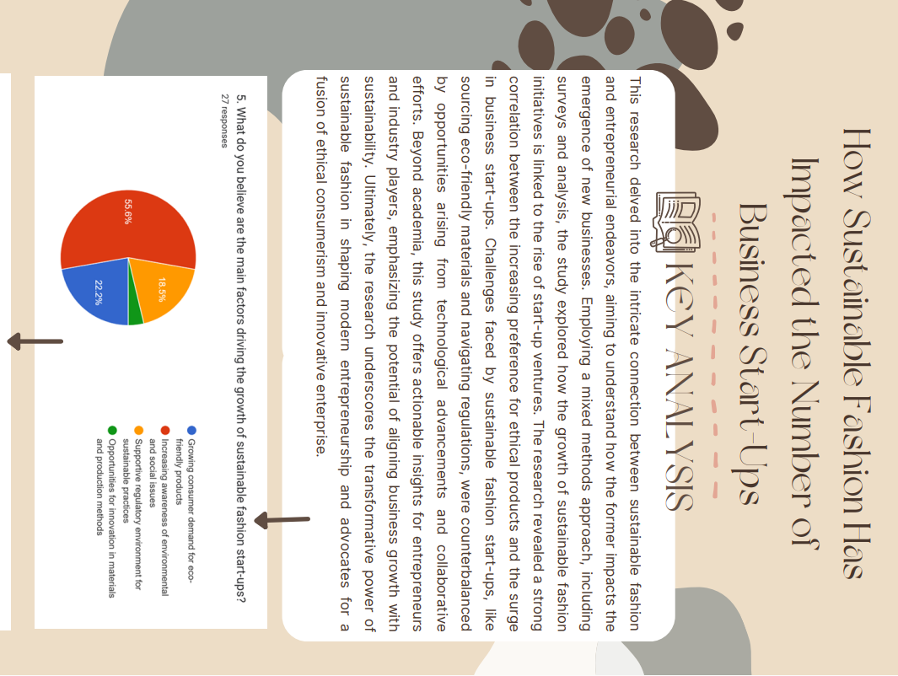
TASK 4

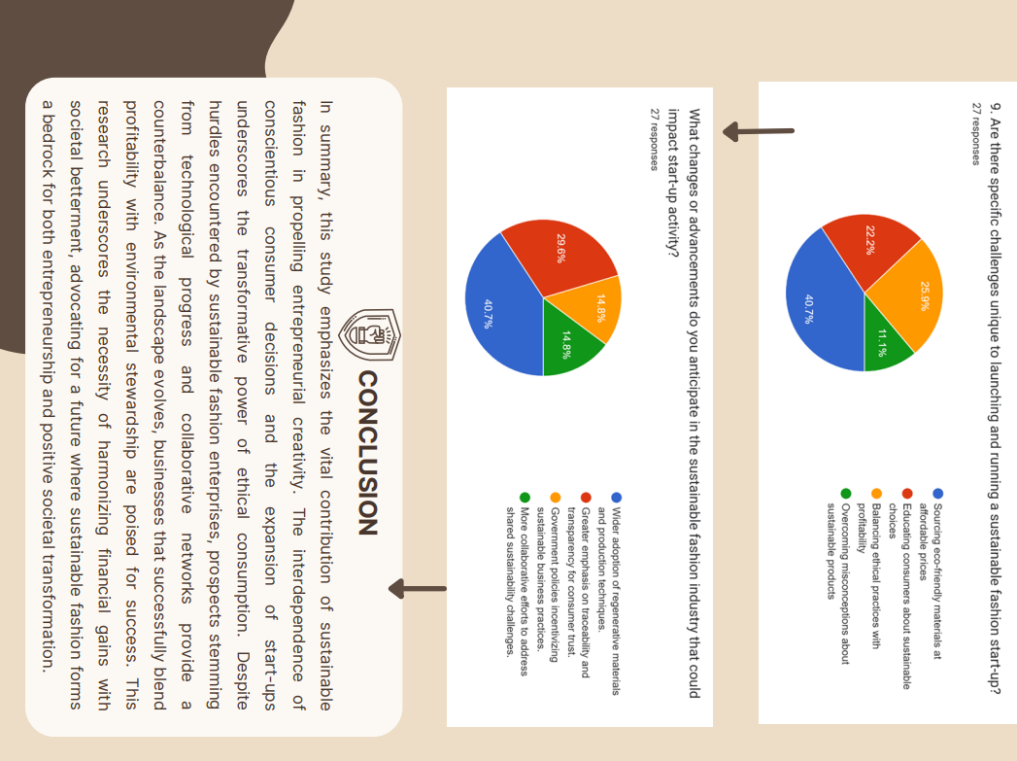

CONCLUSION
The investigation into " The Impact of Sustainable Fashion on the Number of Business Start-ups" has, in conclusion, uncovered a captivating story of symbiotic growth. The rise of sustainable fashion has inspired a wave of entrepreneurial innovation, highlighting the close relationship between consumer awareness and corporate development.

This study emphasizes how important sustainability is in influencing modern entrepreneurship. Sustainable fashion start-ups have exploded, signalling a seismic shift in market dynamics as consumer preferences shift towards ethical purchases. Despite obstacles, by incorporating environmental stewardship into their economic models, these endeavours have the ability to bring about significant change.

Importantly, this research has relevance outside of academia, providing useful advice for budding businesspeople and key players in the sector. It emphasizes the need to work together and achieve a balance between profit and purpose. This research advances the conversation as the story of sustainable fashion develops by arguing for a business environment where innovation and accountability combine for a more sustainable future.

REFERENCES

Babbie, E. (2016). The Practice of Social Research (14th ed.). Cengage Learning.
Bryman, A. (2015). Social Research Methods (5th ed.). Oxford University Press.
Chen, L., Zhang, J., & Huang, Y. (2018). Driving sustainable fashion consumption: A case of recycled clothing in China. Journal of Retailing and Consumer Services, 40, 1-10.
Davis, K., Smith, P., & Jones, R. (2022). Sustainable fashion start-ups: Impact on investor sentiment and funding. Entrepreneurship Quarterly, 17(3), 215-230.
Garcia, M., & Martinez, A. (2021). Exploring niche markets in sustainable fashion: A study of consumer preferences and start-up strategies. Journal of Sustainable Business, 25(2), 101-120.
Green, S., & Jones, T. (2018). The emergence of sustainable fashion: Entrepreneurial opportunities and market trends. Journal of Entrepreneurship and Innovation, 7(2), 89-105.
Heinze, L. (2020). Fashion with heart: Sustainable fashion entrepreneurs, emotional labour and implications for a sustainable fashion system. Sustainable Development, 28(6), 1554-1563.
Jackson, E., & Lee, M. (2019). Consumer preferences and behavior in the sustainable fashion market. Journal of Consumer Studies, 32(4), 550-565.
Johnson, A., White, B., & Brown, C. (2018). Sustainable fashion start-ups and investor interest: A global perspective. Journal of Sustainable Entrepreneurship, 15(1), 45-62.
Lund, H., & Kusk, L. (2020). Identifying growth niches in sustainable fashion start-ups. Journal of Innovation and Sustainable Development, 12(3), 189-205.
Martinez, R., & Garcia, S. (2019). Regulatory challenges and opportunities for sustainable fashion start-ups. Environmental Law Review, 21(4), 325-341.
Moore, J., & Robinson, K. (2016). Circular business models in sustainable fashion start-ups. Business Strategy and the Environment, 25(5), 357-368.
Sidhu, N. K., Bathla, D., Sharma, S., & Bhatia, H. S. (2023). Simple Kaur: The Growth of Start-Ups Through the Adoption of Sustainable Fashion, Technological Innovation, and Social Media Marketing. In Cases on the Resurgence of Emerging Businesses (pp. 47-60). IGI Global.
Smith, J., & Johnson, M. (2023). Sustainable fashion start-ups: Lessons in long-term viability. Journal of Business Sustainability, 8(1), 55-70.
Smith, R. (2020). Sustainable fashion movement: Consumer awareness and market trends. International Journal of Fashion Studies, 7(2), 175-190.
Thompson, G., Harris, J., & Clark, S. (2020). Conscious consumerism and its impact on sustainable fashion start-ups. Journal of Marketing and Ethics, 11(3), 210-225.
Timmermans, S., & Tavory, I. (2012). Theory Construction in Qualitative Research: From Grounded Theory to Abductive Analysis. Sociological Theory, 30(3), 167-186. [DOI:10.1177/0735275112457914]
Trochim, W. M. (2020). The Research Methods Knowledge Base (2nd ed.). Atomic Dog.
Turner, D., Martinez, P., & Brown, L. (2020). Regulatory compliance and ethical considerations in sustainable fashion start-ups. Sustainable Development Law & Policy, 21(2), 135-150.
White, A., & Brown, D. (2022). Sustainable fashion start-ups: A roadmap for long-term success. Entrepreneurial Strategies Journal, 19(4), 305-320.

