

Name: Mirabela Mutcu
ID: 2108200
Module: Problem Solving and Decision Making 4004
Assignment 2: REPORT
Lecturer name: Md. Nazmul Hasan

Table of Contents
The Introduction 3
The summary of the Case Study 3
The external analysis: macro environment 4
The internal analysis: Micro environmental 5
Solutions to consider 5
Evaluation of the solution 6
The bibliography 7

The Introduction

The accompanying report is composed with the principal motivation behind talking about central issues that have been brought up in the Presentation for the Problem-Solving module. Having this as a primary concern, all through the presentation, four given prerequisites have been met having into account the given contextual analysis. In the presentation that has been written the SWOT and PESTLE examination have been applied on the given contextual investigation to then have the option to propose various arrangements which to assist with the tackle of the issue. Hence, this multitude of themes will be more explained in this scholarly paper guaranteeing that the crowd figured out how to comprehend it right.

It is important to go through each bullet point that has been included in the presentation written for the problem to be understood correctly with the right details and further the potential solutions to be explained along with an action plan which to discuss how those are going to be accomplished.

The summary of the Case Study

The given contextual analysis is about the Mid Cheshire Hospital NHS Foundation Trust which has begun to manage the staff non-appearance issue, and regardless of whether their objectives have been met, this issue has expanded thing that has diminished the nature of the administrations that are advertised. The idea of the issue, as it has been referenced in the past slide is staff truancy which since it has expanded in time exhibits that reality that staff has affected each other to be missing while seeing that there are no actions taken against their activities.

The effect of this issue was upon the development of the organization as they have paid large chunk of change and the nature of the administrations gave diminished also. The insights addressed for the situation study are showing the seriousness of issues. For instance, it is referenced for the situation concentrate on that as a result of the non-attendance the trust needed to pay around £1 million, aside from that, the rising number of individuals missing affected the abatement in the nature of the administrations that are conveyed to the patients. This isn't great particularly we are on about the wellbeing and prosperity of individuals.

Having as a main priority all that has been examined over, the issue has to do with the Human Management procedures that are applied in the organization. It ought to be exploited all representatives that are working in the organization to keep them roused and ensure that every one of the undertakings they should finish are done as such in time following the assumptions. The supervisory group ought to include better in the inspiration of the representatives as though they are persuaded, they will connect more, and consequently the presentation that they will have in the errands they in all actuality do will increment too.

The external analysis: macro environment

Regardless, the microenvironment is investigating the outside climate of something, intending what's going on remotely. This kind of climate should be researched intermittently to ensure that preventive measures are being set contingent upon (Ghuman, 2010). To examine the Macro climate of the issue the PESTLE investigation will be applied, implying that it will be taking a gander at the Political, monetary, social, mechanical, lawful, and natural (Hussey and Jenster, 2001). The PESTLE analysis is applied in a lot of different contexts that are met by different organizations and even by people that are willing to take some action towards a change / situation. The six factors that are being investigated as part of the framework, are supporting those applying it to find out what is possible to go wrong with their situation / action. Therefore, based on the information that is being accumulated for each factor, the person / company that applied the framework can take some stable and explicit decisions which to act as preventions in front of the factors.

The political factors: these have to do with the choices that are being taken by the public authority, thusly in this issue, one political component has to do with the Brexit choice as this has affected many individuals from different nations to surrender their positions. The Brexit has affected because people have started back to their countries and automatically this has made a lot of companies lose a lot of members of staff.

Further the economic factors have to do with the money related sway over the organization on account of the issue. With regards to the contextual investigation, one financial issue has to do with the assessments that are paid in any event, for the missing staff. Because the company must pay a lot of things, it may get difficult to pay multiple salaries, taxes and so on, this influences staff shortage because the company may run low on money that are being paid towards salaries.

Speaking about the social factors these relate to the inclinations of individuals, impact, etc. With regards to this contextual analysis, the individuals from staff are affecting each other to be missing as they see nothing is going on. Therefore, this influences the expectations that people have from the jobs that they are applying for.

With regards to the technological factors, these have to do with the improvement of innovation and its impact in various settings. Talking about this contextual investigation, the organization needs to consider potential new computerized techniques that could end up being useful to the representatives be more inspired for the work they complete. Technology is linked with staff shortage because if there were not enough resources in the company, employees would not have enough materials to make use of.

The legal factors allude to strategies, rules, and guidelines that are being executed regarding the organization. These are applied to all individuals that work in the organization and should be followed. Accordingly, in the trust, there are work guidelines that should be kept assuming there is an agreement that has been agreed upon.

Finally, the environmental factors can be forestalled by providing for representatives the chance of working remotely so the contamination levels are being diminished.

Overall, considering everything that has been mentioned above, it can be taken into consideration that there are multiple factors that can further affect the organization negatively and therefore, there is need of good solutions and planned implementation for them to be successful. w e t y u j h g f s E w e r t y g f d s c v b h g f d w e t y u j h g f s

The internal analysis: Micro environmental

The microenvironment is something contrary to the large-scale climate and this since this is investigating the inward components of the issue/individual/organization. Accordingly, to research these interior components, the most well-known structure utilized is the SWOT examination (Badenhorst-Weiss, 2008). The SWOT investigation represents qualities, shortcomings, valuable open doors, and dangers. In the show this inside climate system is being applied working on it concentrate on that has been given (Pahl and Richter, 2009. For instance, the SWOT Analysis goes as it follows:
The strengths for the situation study incorporate that by perceiving the number of individuals is missing, they are turning out to be more mindful of the need of progress in their association. w e t y u j h g f s E w e r t y g f d s c v b h g f d w e t y u j h g f s

The weaknesses have to do with the nature of administrations that are conveyed to patients as it ought to be at a significant level. w e t y u j h g f s E w e r t y g f d s c v b h g f d w e t y u j h g f s

The opportunities have to do with the use of new procedures which to assist with the Human Resources Management. w e t y u j h g f s E w e r t y g f d s c v b h g f d w e t y u j h g f s

The threats for the organization have to do with the time it would take to carry out the new systems. w e t y u j h g f s E w e r t y g f d s c v b h g f d w e t y u j h g f s

In any case, the association should examine these obviously to comprehend that the association needs a change regardless of what amount of time it will require, it is slow on the uptake, but still good enough.

Solutions to consider

Observing answers for the association for the situation study is critical on the grounds that generally the organization will keep on coming up short while paying cash and losing execution, likely even clients. Subsequently, taking into account all the data that has been up to this point aggregated, a portion of the arrangements considered include:

- Sort out gatherings to make it clear to the workers that following their timetables is obligatory, this ought to declare ahead of time intensive calls, messages and letters sent home to ensure that the correspondence has shown up at the representative.
w e t y u j h g f s E w e r t y g f d s c v b h g f d w e t y u j h g f s
- Contemplate carrying out remunerating techniques to the representatives that are chipping away at or more their objectives, so they feel appreciated for the work they are doing. This will add to the further inspiration of the representatives.
w e t y u j h g f s E w e r t y g f d s c v b h g f d w e t y u j h g f s
- Apply approvals to the ones that are advancing truancy on various occasions. These ought’s to be proposed as supervisory crew and informed to the representatives while in the gathering, so they know what results will be confronted. faced.

Evaluation of the solution
As it has been referenced in the past area, arrangements are significant. Investigating the proposed arrangements, it is critical to refer to that they are completely connected to each other for achieving the target of uniting representatives and supporting them to work in a roused manner. Assuming the representatives will be more mindful of the limitations, rewards, and decides that are in effect recently executed, they will most presumably change their mentality confronting the organization. Assuming they will see that all that has been referenced is applied also, they will then see, that the activities that they have had up to this point, are not any more acknowledged.
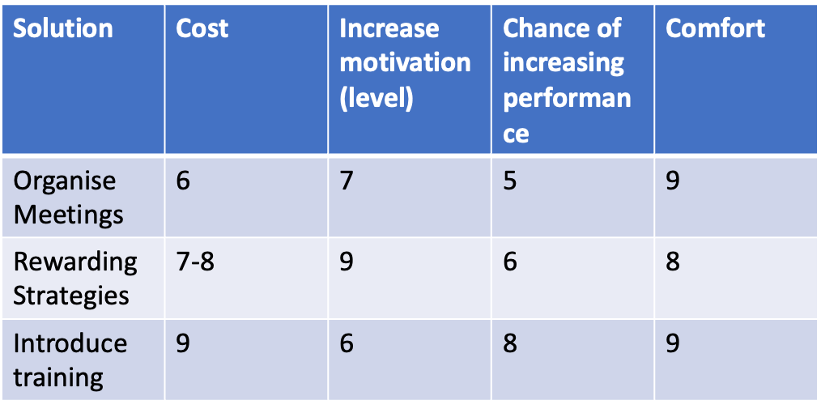
As the grid attached in the above table discusses, the main conclusion to draw is that all the proposed solutions would be effective on different levels, however, the most effective strategy that the company could apply has to do with training. By introducing training, the employees will become more confident with the work they do.

Action Plan

Goal | Resources Needed | Benefit | Time frame
Spread more awareness about importance of following shifts | A campaign / member from the management team which to hold periodic discussions | In this way the employees will understand better their responsibility facing the company | Within three months
Improve the leadership style of the organisation to spread more motivation around the employees | A transactional leader which to be able to bring all the employees together and keep their motivation levels up. | By having motivated employees it would be easier to reduce the absenteeism levels. | Within five months

The bibliography



