

━━━━━━━━━━━━━━━━━━━━━━━━━━━━━━━━━━━━
An integrated academic prototype for maintenance, non-emergency safety, IT support and AI-assisted service coordination
AI-ASSISTED SMART ESTATE, SAFETY AND IT SUPPORT MANAGEMENT PLATFORM

ACCA6020 Independent Project Report

Name: Abubarkar Dembele
Student ID: 2128085
Supervisor: Dr Mohamed Ben Farah
Submission Date: 30 July 2026

DECLARATION OF ORIGINALITY
I, Abubarkar Dembele, declare that I am the sole author of this Project, that all references cited have been consulted, that I have conducted all work of which this is a record, and that the finished work lies within the prescribed word limits.
This work has not previously been accepted as part of any other degree submission.
Signed: 
Date: 30 July 2026

FORM OF CONSENT
I, Abubarkar Dembele, hereby consent that my Project, submitted in candidature for the B.Sc. (Hons) Applied Computing degree, if successful, may be made available for inter-library loan or photocopying, subject to the law of copyright, and that the title and abstract may be made available to outside organisations.
Signed:
Date: 30 July 2026

Copyright Acknowledgement
I acknowledge that the copyright of this project report, and any product developed as part of the project, belong to the University of Wales Trinity Saint David, Birmingham.

ABSTRACT
This project designs and evaluates an AI-assisted digital platform for estate management, safety reporting and IT support. The problem addressed is the fragmentation of maintenance requests, non-emergency safety reports, technical support enquiries and worker updates across informal channels such as messages, calls and paper records. The proposed prototype combines a guided AI assistant, structured ticket forms, request classification, priority suggestions, task assignment, status tracking and an administration dashboard. The project uses an applied, prototype-based methodology involving a focused literature review, requirements analysis, low-fidelity system design, iterative interface development and later usability evaluation with adult participants. The Week 5 output is Prototype Version 1, represented by an architecture model, workflow, module map and Canva-ready wireframes. AI remains assistive: suggestions are reviewed by a human before action. Privacy, data minimisation, transparency, accessibility and security are treated as design requirements. The expected final contribution is a practical and evaluated prototype showing how a unified platform could improve visibility, consistency and accountability while identifying limitations and future development requirements.

PROJECT COMPLETION AND WORD-COUNT PLAN
This document presents the project report structure, research base, development evidence, prototype design, testing protocol and appendices for the Independent Project. The report is organised around the module handbook requirement for a development/design-based Computing project and keeps supporting evidence in the appendices so the main chapters remain focused.
Chapter | Target final words | Status at Week 5
1. Introduction | 1,200 | Completed draft
2. Literature Review | 2,500-2,800 | Completed literature draft
3. Methodology and System Design | 2,000-2,200 | Completed draft
4. Implementation and Development | 1,500-1,700 | Prototype Version 1 documented
5. Testing and Evaluation | 1,200-1,400 | Protocol and evidence template prepared
6. Conclusion and Recommendations | 600-700 | Evaluation-linked conclusion drafted
7. Reflection | 500-600 | Reflective log prepared

TABLE OF CONTENTS
Table of Contents
DECLARATION OF ORIGINALITY 2
FORM OF CONSENT 2
Copyright Acknowledgement 2
ABSTRACT 3
PROJECT COMPLETION AND WORD-COUNT PLAN 3
TABLE OF CONTENTS 3
LIST OF TABLES 3
1.0 INTRODUCTION 5
1.1 Background 5
1.2 Problem Statement 5
1.3 Aim 6
1.4 Objectives 6
1.5 Research Questions 6
1.6 Scope 6
1.7 Dissertation Structure 6
2.0 LITERATURE REVIEW 7
2.1 Review Method and Scope 7
2.2 AI-Assisted Digital Service Platforms 7
2.3 AI in Real Estate, Property and Facilities Management 7
2.4 AI and Predictive Building Maintenance 8
2.5 Smart Safety and Incident Reporting 8
2.6 IT Service Management and Ticketing 8
2.7 User Experience, Accessibility and Trust 9
2.8 Privacy, Cybersecurity and Responsible AI 9
2.9 Synthesis of Related Literature 9
2.10 Rationale and Research Gap 10
2.11 AI-Assisted Customer Service and Ticket Classification 10
2.12 Human-Centred AI, Explainability and Adoption 11
2.13 AI Background for the Proposed Application 12
3.0 METHODOLOGY 12
3.1 Research and Development Approach 12
3.2 Project Stages 13
3.3 Stakeholders and User Roles 13
3.4 Functional Requirements 13
3.5 Non-Functional Requirements 14
3.6 User Scenarios 14
3.7 System Architecture and Design 14
3.8 User Workflow 16
3.9 Module and Role Structure 16
3.10 Data Model Concept 18
3.11 AI-Assisted Triage Algorithm 18
3.12 Tools and Techniques 19
3.13 Prototype Development Phases 20
3.14 Data Collection and Analysis 21
3.15 Ethics, Legal and Professional Considerations 21
3.16 Project Plan 21
3.17 Requirements Prioritisation Using MoSCoW 21
3.18 Information Architecture and Navigation Design 22
3.19 Data Entities and Audit Trail 22
3.20 Security-by-Design Requirements 22
3.21 Quality Assurance and Change Control 23
4.0 IMPLEMENTATION AND DEVELOPMENT - WEEK 5 PROTOTYPE VERSION 1 23
4.1 Prototype Strategy 23
4.2 Screen Inventory 24
4.3 Administration Dashboard Wireframe 24
4.4 Service Request Form Wireframe 25
4.5 AI-Assisted Triage Wireframe 26
4.6 Canva Build Instructions 26
4.7 Prototype Content Set 27
4.8 Definition of Prototype Version 1 Complete 27
4.9 Visual Identity and Design System 27
4.10 Expanded Prototype Screen Set 27
4.11 Screen-by-Screen Interaction Logic 32
4.12 Prototype Build Procedure in Canva 33
4.13 Prototype Version 1 Completion Checklist 33
5.0 TESTING AND EVALUATION - PROTOCOL FOR WEEKS 7-8 33
5.1 Planned Usability Tasks 33
5.2 Questionnaire Plan 34
5.3 Evaluation Criteria 34
5.4 Participant Recruitment and Ethical Procedure 34
5.5 Measures and Analysis Plan 34
5.6 Planned Prototype Version 2 Decision Rules 35
5.7 Reporting Results Without Fabrication 35
6.0 CONCLUSION AND RECOMMENDATIONS - DRAFT POSITION 35
6.1 Interim Conclusions at Week 5 36
6.2 Recommendations for Future Working Implementation 36
6.3 Limitations of the Current Draft 36
7.0 REFLECTION - WORKING LOG 37
7.1 Reflection on Scope and Project Identity 37
7.2 Reflection on Research and Referencing 37
7.3 Reflection on Prototype Development 37
7.4 Reflection on Next Steps and Time Management 38
REFERENCES 38
APPENDICES 42
Appendix A - Literature Search and Research Notes 42
Appendix B - Prototype Screens and Interaction Evidence 42
Appendix B.1 - Role, Module and Ticket Lifecycle Evidence 43
Appendix B.2 - Prototype Screen Checklist 44
Appendix C - Technical Models, Algorithm and Tools 44
Appendix C.1 - AI-Assisted Triage Pseudocode 45
Appendix D - Ethics and Participant Documents 45
Appendix D.1 - Participant Information Statement 45
Appendix D.2 - Consent Statement 45
Appendix D.3 - Questionnaire Items 45
Appendix E - Test Evidence Pack 45
Appendix E.1 - Usability Task Sheet 46
Appendix E.2 - Raw Results Template 46
Appendix E.3 - Prototype Version 2 Change Log 46
Appendix F - Exhibition Poster Evidence 48
Appendix F Checklist 49

51

LIST OF TABLES
Table 4. Role access matrix showing screens, actions and data visibility. Source: Author's own design. 20
Table 5. AI-assisted triage algorithm stages. Source: Author's own design. 21
Table 6. Tools and techniques selected for the project. Source: Author's own design. 21
Table 7. Prototype development phases and evidence. Source: Author's own design. 22
Table A1. Literature search and design-use summary. 44
Table C1. Tools and techniques used or planned. 46
Table C2. AI-assisted triage algorithm stages. 46

1.0 INTRODUCTION

1.1 Background
Digital platforms increasingly mediate how organisations receive requests, communicate with users and coordinate operational work. Estate and community environments involve multiple service processes, including property maintenance, non-emergency safety reporting, IT support, worker allocation and progress monitoring. When these processes are managed through separate messages, calls, spreadsheets or paper records, information can be duplicated, overlooked or difficult to audit. The proposed project responds to this practical problem by designing a single prototype platform through which users can report issues and administrators can classify, assign, monitor and close requests.
Artificial intelligence is relevant because many of these requests begin as unstructured natural-language descriptions. A user may write that a light is broken, a device cannot connect to Wi-Fi, a leak is spreading, or an area feels unsafe. Natural language processing and classification techniques can transform these descriptions into structured categories and assist with urgency assessment, response drafting and knowledge guidance. However, the application proposed here does not treat AI as an autonomous decision-maker. Its role is to support triage and communication while a responsible person reviews important outputs. This human-in-the-loop position is consistent with risk-management guidance that emphasises validity, safety, transparency, privacy and accountability [8], [9].
Research in real estate, facilities management and building maintenance demonstrates that AI can support property analysis, smart-building operation, predictive maintenance, defect recognition, energy optimisation and customer service [1]-[6]. These developments show that property and facilities workflows are becoming data-driven. Nevertheless, many advanced studies assume sensor networks, digital twins or large datasets. A small estate or multi-service organisation may first need a more basic digital foundation: consistent request capture, category selection, ticket status, task assignment and user communication. The project therefore concentrates on an achievable prototype while identifying advanced predictive maintenance and Internet of Things integration as future development.
The project also includes IT service management because estate users and workers increasingly depend on connected devices, internet access and digital services. ITIL-style ticketing principles show the value of logging incidents, defining priority, assigning responsibility, documenting progress and recording resolution [17]. Similar workflow logic can be shared by maintenance, safety and IT support modules. A unified design may reduce the need for separate systems while still preserving different fields and escalation rules for each service type.

1.2 Problem Statement
The central problem is fragmented service management. A maintenance fault may be sent by WhatsApp, a safety concern may be reported verbally, an IT problem may be emailed, and a worker update may remain in a private message. These channels are convenient individually but provide no shared record of request status, priority, ownership or resolution. Fragmentation can result in delayed responses, repeated explanations, weak accountability and limited management information. It also makes it difficult to identify recurring issues, such as repeated faults in one building area or frequent technical problems affecting the same users.
AI can help structure incoming requests, but it introduces additional risks. An automated system may misclassify urgency, generate inaccurate guidance, expose personal information or give users an unrealistic impression that a human has reviewed their report. Consequently, the design problem is not simply how to automate. It is how to create a usable and responsible platform in which AI assistance improves consistency without removing human oversight. The application must collect only necessary data, communicate the role of AI clearly, support corrections and preserve an auditable workflow.
The research problem is therefore expressed as follows: how can an AI-assisted prototype integrate estate maintenance, non-emergency safety reporting and IT support into a clear ticket-based workflow that is usable for ordinary users, manageable for administrators and designed around privacy, accessibility and human review?

1.3 Aim
The aim is to design, develop and evaluate a prototype AI-Assisted Smart Estate, Safety and IT Support Management Platform that centralises service requests, provides AI-supported classification and guidance, enables task assignment and status tracking, and presents operational information through an administration dashboard.

1.4 Objectives
- To critically review recent literature on AI-assisted service platforms, smart estate and facilities management, building maintenance, IT service management, usability, cybersecurity and responsible AI.
- To identify stakeholder needs and define functional and non-functional requirements for a multi-role platform.
- To design system architecture, user workflows and a low-fidelity interface prototype covering maintenance, safety, IT support, AI guidance, task management and administration.
- To develop Prototype Version 1 using Canva-ready interface designs and linked interaction logic.
- To test and evaluate the prototype with low-risk adult participants using task completion, questionnaire ratings and qualitative feedback.
- To recommend improvements for usability, accessibility, security, scalability and future technical implementation.

1.5 Research Questions
- RQ1: What problems arise when estate maintenance, safety and IT support requests are managed through disconnected channels?
- RQ2: Which AI-assisted functions are useful and appropriate for request classification, priority suggestion and first-line guidance?
- RQ3: What functional, non-functional, ethical and security requirements should guide the prototype?
- RQ4: How usable, understandable and trustworthy is Prototype Version 1 for representative adult users?
- RQ5: What changes are required before the concept could be developed into a secure working system?

1.6 Scope
The project covers literature review, requirements analysis, system modelling, low-fidelity and interactive prototype design, and usability evaluation. The prototype includes role selection, a dashboard, AI help, maintenance requests, safety reports, IT support tickets, task assignment, progress updates and administration analytics. AI functionality is represented through rule-based or example classification and generated draft guidance. The study does not deploy a production AI model, process live emergency reports, connect to emergency services, control physical devices, or store real sensitive data. Payment systems, live CCTV analysis, biometric identification and offensive cybersecurity functions are outside scope.

1.7 Dissertation Structure
Chapter 1 defines the background, problem, aim, objectives, questions and scope. Chapter 2 critically reviews recent related research and identifies the research gap. Chapter 3 explains the prototype-based methodology, requirements and system design. Chapter 4 documents Prototype Version 1 and the decisions made during development. Chapter 5 presents the testing method and, after Week 7-8, the results and evaluation. Chapter 6 concludes the project and recommends future work. Chapter 7 reflects on project management, technical learning, research practice and limitations.

2.0 LITERATURE REVIEW

2.1 Review Method and Scope
The literature review uses a focused narrative approach suitable for an applied undergraduate computing project. Sources were selected from peer-reviewed journals, conference papers, academic books, standards and official professional guidance. Priority was given to material published from 2021 onwards because the university template asks for 25-30 recent references. Older sources are retained only where they provide established concepts, such as usability definitions or IT service management. Search themes included artificial intelligence in real estate, digital facilities management, predictive building maintenance, AI-enabled Internet of Things, service ticketing, conversational AI, explainable AI, data protection, web security, accessibility and prototype development.
The review does not claim to be a full systematic review. Instead, it synthesises evidence directly relevant to the proposed modules and design decisions. Each theme is considered in terms of benefits, limitations and implications for the prototype. This supports traceability: requirements in Chapter 3 can be linked to evidence rather than being based only on personal preference.

2.2 AI-Assisted Digital Service Platforms
AI-assisted digital service platforms combine user interfaces, data capture, automated analysis and human-managed workflows. In the proposed system, AI is expected to operate mainly on text. Natural language processing can identify keywords, intent and context in user descriptions, while classification can map a request to categories such as maintenance, safety or IT support. Generative AI can draft acknowledgement messages or basic guidance. These functions can reduce repetitive administration and make initial responses more consistent, especially where a small team receives requests across several service areas.
The value of AI depends on the workflow surrounding it. An accurate classification is useful only if it leads to a visible ticket, appropriate priority, responsible assignee and tracked outcome. Research on business use of AI repeatedly distinguishes between narrow, task-focused augmentation and unrealistic attempts to automate entire processes. The prototype therefore applies AI to bounded tasks: suggesting a category, suggesting urgency, producing a draft reply and directing the user to the correct form. Final submission, task assignment and closure remain accountable human actions.
Large language models create additional opportunities because they can produce conversational explanations and work with varied wording. Yet generated content can be factually wrong, overconfident or inconsistent. NIST identifies validity, reliability, safety, security, transparency, explainability, privacy and fairness as characteristics of trustworthy AI [8]. The NIST Generative AI Profile further highlights risks such as confabulation, information integrity, privacy leakage and human over-reliance [10]. For the prototype, these risks justify visible labels such as “AI suggestion”, a review screen, editable output and restrictions against presenting AI guidance as emergency or professional advice.

2.3 AI in Real Estate, Property and Facilities Management
Recent real-estate research describes AI applications in property valuation, recommendation, market forecasting, fraud detection, customer support and smart-building management [1]. Kuppan, Acharya and Divya identify operational efficiency and decision support as important benefits while also noting data quality, explainability, regulation and integration challenges. These challenges are directly relevant to a small platform because inconsistent categories or incomplete request descriptions can reduce the usefulness of automation.
Facilities and property management are undergoing wider digitalisation through cloud platforms, Building Information Modelling, sensors, digital twins and analytics [4], [6], [7]. Chui’s review of digitalisation in property and facilities management identifies opportunities for integrated information and improved decision-making but also continuing gaps concerning interoperability, adoption and implementation [7]. The implication for this project is that a future estate platform should be modular. Ticket management can operate without IoT, while a later version could accept sensor alerts or link requests to digital building records.
Research on AI adoption in real-estate practice also shows that perceived usefulness does not guarantee implementation. Adoption is affected by cost, expertise, trust, infrastructure and organisational readiness [2], [3]. Therefore, the prototype uses familiar interaction patterns: forms, status labels, dashboards and human approval. Its contribution is not to reproduce an enterprise property system but to explore an affordable and understandable integrated workflow for a small estate or community context.

2.4 AI and Predictive Building Maintenance
Building maintenance has traditionally depended on scheduled inspections and reactive repair after a failure is noticed. Recent research shows movement toward predictive and condition-based maintenance using machine learning, computer vision, Building Management System data and IoT sensors [4]-[6]. Zheng et al. identify predictive maintenance, automated defect recognition, structural health monitoring, multi-source data integration and energy optimisation as major research areas [4]. Similar reviews show that AI and digital twins can support real-time monitoring and scenario analysis [5].
Predictive maintenance is outside the immediate technical scope because it requires operational sensor data, historical fault records and validated models. Nevertheless, it influences the platform architecture. Maintenance tickets should use consistent categories, locations, timestamps, urgency and status history so that future data can support trend analysis. A repeated-fault dashboard or sensor-generated ticket could later be added without redesigning the entire workflow.
The literature also warns that maintenance AI must be interpretable to operators. A prediction without understandable evidence may be difficult to trust or act upon. For that reason, the prototype describes reasons for urgency suggestions using plain language, for example “high priority because water may cause further property damage”. This is a simplified design application of explainability rather than a claim that the prototype contains a validated predictive model.

2.5 Smart Safety and Incident Reporting
Safety management requires timely reporting, consistent classification, escalation and documented resolution. Digital incident-reporting systems can improve visibility compared with informal verbal reporting, but their usefulness depends on clear terminology and appropriate urgency rules. The proposed platform is limited to non-emergency concerns such as broken lighting, unsafe access, damaged equipment or repeated environmental hazards. The interface must state that emergencies should be reported through the relevant emergency route rather than through the platform.
AI may assist by identifying safety-related language and suggesting a priority, but false negatives would create serious risk. Consequently, the prototype uses conservative rules: users select urgency, obvious high-risk keywords trigger a warning, and administrators review the final ticket. The system does not automatically close, downgrade or dismiss safety reports. This demonstrates the principle that riskier decisions require stronger human oversight.

2.6 IT Service Management and Ticketing
IT service management provides a mature model for converting user problems into manageable records. A ticket typically includes a unique identifier, category, impact or urgency, status, owner, timestamps, communication history and resolution. ITIL 4 presents service management as a way of co-creating value through structured practices rather than treating technical support as isolated repair work [17]. Incident management seeks to restore normal service, while service request management handles predictable user needs. These concepts can be adapted to maintenance and safety because all three domains require intake, triage, assignment, updates and closure.
A shared ticket model offers practical benefits. Users can see whether a request is new, assigned, in progress or closed. Administrators can filter urgent or overdue items. Workers receive a defined task and can add updates. Management can view counts by category and status. The prototype uses these common fields while allowing module-specific information. For example, IT support may ask for device type, maintenance may ask for location, and safety reporting may ask whether immediate danger remains.

2.7 User Experience, Accessibility and Trust
A technically complete system can still fail if users cannot understand its navigation or terminology. The platform serves users with different levels of digital confidence, so the design should minimise memory demands, use visible status, prevent errors and provide clear recovery. WCAG 2.2 recommends perceivable, operable, understandable and robust digital content [19]. Relevant prototype decisions include sufficient contrast, descriptive labels, keyboard-compatible design concepts, clear focus order, readable text and error messages that explain how to fix a problem.
Trust is particularly important when AI is visible. Users should know which content is generated or suggested, what information is used and who remains responsible. ICO guidance recommends transparency, fairness, data minimisation and appropriate explanations for AI-assisted processing [9], [11]. The design therefore separates the original user description from the AI suggestion, allows editing, and provides a short explanation of why a category or urgency level was proposed.

2.8 Privacy, Cybersecurity and Responsible AI
The platform would process names, contact information, location details and issue descriptions. Some descriptions could reveal personal circumstances, vulnerabilities or security information. UK GDPR principles require lawful and transparent processing, purpose limitation, data minimisation, accuracy, storage limitation, integrity and accountability. The prototype does not store real participant service data, but privacy-by-design requirements are still documented: collect only necessary fields, avoid sensitive information, display a privacy notice, define role-based access and set retention rules for any future deployment.
Web applications also face risks such as broken access control, injection, insecure design, authentication failures and logging weaknesses. OWASP Top 10 guidance supports secure input handling, server-side validation, access control and monitoring [20]. The NIST Cybersecurity Framework 2.0 organises cybersecurity outcomes around Govern, Identify, Protect, Detect, Respond and Recover [12]. These sources inform non-functional requirements even though the Week 5 artefact is a design prototype rather than a deployed web application.
Responsible AI requirements include human review, correction, output labelling, auditability and restrictions on automated decisions. The AI component should not infer sensitive characteristics or make decisions about access to housing or emergency response. In a future implementation, prompts and outputs would require testing for unsafe guidance, bias and information leakage. An AI risk register should be maintained alongside ordinary software risks.

2.9 Synthesis of Related Literature
Source/theme | Main contribution | Limitation or risk | Design implication
AI in real estate [1]-[3] | Customer support, decision support, property analytics | Data quality, trust, adoption cost | Keep AI narrow, transparent and affordable
Building maintenance [4]-[6] | Predictive maintenance, defect detection, digital twins | Requires sensors and validated datasets | Create structured maintenance data now; predictive functions later
Property/facilities digitalisation [7] | Integrated information and digital workflows | Interoperability and readiness barriers | Use modular architecture and common ticket model
NIST AI RMF [8], [10] | Trustworthy AI and risk-management functions | Framework requires local implementation | Include human review, labels, monitoring and risk log
ICO AI guidance [9], [11] | Fairness, transparency and UK GDPR compliance | Compliance depends on actual processing context | Data minimisation, explanation and privacy notice
NIST CSF / OWASP [12], [20] | Security governance and web risks | Prototype cannot prove production security | Document secure implementation requirements
WCAG 2.2 [19] | Accessible and understandable interaction | Requires formal testing in later versions | Use clear labels, contrast and accessible navigation
IT service management [17] | Ticket lifecycle and service accountability | Designed primarily for IT services | Adapt lifecycle across maintenance and safety

2.10 Rationale and Research Gap
Existing research is rich in individual domains: AI for real estate, predictive building maintenance, smart-building sensors, IT helpdesk systems, safety reporting and conversational interfaces. However, these areas are frequently studied or implemented separately. Advanced property systems may focus on asset data and digital twins, while helpdesk platforms focus on IT incidents, and safety tools use specialist reporting processes. There is less attention to a low-cost, user-centred prototype that combines ordinary estate maintenance, non-emergency safety and IT support through one AI-assisted ticket workflow for a small organisation.
The project addresses this gap at the design and evaluation level. Its novelty is not a new machine-learning algorithm. The contribution is an integrated interaction model showing where AI adds value, where human control is essential and how shared workflow components can support different service modules. The project also creates an evidence-based prototype that can be tested with users before investment in full technical development.
Observed gap | Project response
Disconnected domain-specific systems | Unified navigation and shared ticket lifecycle
Advanced AI assumes large datasets | Prototype uses bounded classification and draft guidance
Limited attention to small-organisation affordability | Canva/Figma prototype and modular implementation plan
Insufficient user transparency around AI | Visible AI labels, explanations and review step
Accessibility often treated late | Accessibility included in requirements and evaluation
Security claims without deployed evidence | Prototype distinguishes design requirements from tested security

2.11 AI-Assisted Customer Service and Ticket Classification
A central technical function of the proposed platform is the conversion of free-text requests into consistent service categories. Natural language processing can identify recurring terms, intent and context in descriptions such as “water is coming through the ceiling”, “the corridor light is broken” or “my laptop cannot connect to Wi-Fi”. A classification component can then suggest maintenance, safety or IT support and propose an urgency level. Research on natural language processing in customer service shows that chatbots, question-answering systems and classification models are common applications, but their performance depends strongly on the quality, diversity and representativeness of training data [31]. For the academic prototype, the safest design is not to claim fully automatic understanding. The interface therefore labels classification as a suggestion, displays the reason in plain language and enables the administrator to correct it before the ticket is assigned.
Generative AI also creates opportunities for drafting first-line responses. Evidence from customer-support environments indicates that AI assistance can increase productivity and help less-experienced staff resolve issues more consistently, although the benefits vary by task and worker experience [32].

This matters for the proposed platform because a short response can acknowledge a request, restate the issue and explain the next step. Nevertheless, generated text may be confidently wrong, overly general or unsuitable for a safety-sensitive situation. The prototype therefore separates the customer’s original description from the AI-generated draft, records whether the suggestion was accepted or edited, and prevents automatic sending. This creates a visible human-in-the-loop control rather than hiding AI behind the service workflow.
The literature also warns that generative AI customer service contains tensions between efficiency and empathy, personalisation and intrusion, and power and vulnerability [33]. These tensions support the decision to keep the assistant narrow in scope. It should help users understand forms, identify a service route and draft non-binding guidance. It should not diagnose hazardous building conditions, promise completion times, make disciplinary judgements about workers or replace emergency services. By constraining the role of the AI, the project converts broad technological possibilities into a realistic and governable feature set.

2.12 Human-Centred AI, Explainability and Adoption

A technically functional system can still fail if users do not understand or trust it. Human-centred AI design treats interaction, control and feedback as part of system quality rather than as cosmetic interface choices. The proposed prototype makes the AI contribution visible through labels such as “suggested category”, “suggested priority” and “draft guidance”. It also provides an edit option and a short explanation of why a suggestion was produced. This approach aligns with the ICO’s expectation that organisations explain AI-assisted processing to affected people and with NIST guidance that trustworthy AI should be accountable, transparent, explainable, privacy-enhanced and managed throughout its lifecycle [8]-[11].
Adoption is also influenced by perceived usefulness and effort. A resident is more likely to use a platform if reporting a fault is quicker and clearer than sending several messages. A worker is more likely to maintain accurate updates if the task screen shows only the information needed for the job. An administrator is more likely to trust AI-assisted triage if corrections are simple and recorded. The design therefore uses progressive disclosure: users first select a service, then complete only the fields relevant to that service, then review a summary. This reduces cognitive load and supports users who may have limited technical confidence.
The project’s contribution is not a new machine-learning algorithm. Its contribution is a coherent interaction and workflow model that demonstrates how AI support could be placed responsibly inside an estate service process. The literature suggests that valuable AI adoption depends on integration with business processes, governance and user practice, not only model accuracy. Consequently, evaluation will examine whether participants can recognise the AI’s role, correct a suggestion and understand that a human remains accountable.

Literature theme | Evidence from research | Design response in this project
AI in property and facilities management | Supports predictive maintenance, building analytics, digital twins and operational decision support [1]-[7]. | Begin with structured requests and ticket data; treat predictive maintenance and sensors as future work.
NLP and customer support | Supports intent recognition, question answering, response drafting and ticket classification [31]-[33]. | Use suggestions and editable drafts rather than autonomous decisions.
IT service management | Structured logging, priority, ownership and resolution improve visibility and accountability [17]. | Use a shared ticket lifecycle across maintenance, safety and IT modules.
Responsible AI | Transparency, privacy, accountability, validity and human oversight are central controls [8]-[11]. | Label AI outputs, preserve original text, record edits and require human approval.
Usability and accessibility | Clear navigation, feedback and accessible content improve effective use [18], [19]. | Use plain labels, high contrast, mobile layouts, visible status and large touch targets.
Cybersecurity | Modern web and API systems require access control, secure authentication, validation and monitoring [12], [20], [21]. | Specify role-based access, least privilege, audit logs, secure APIs and data minimisation for future implementation.

2.13 AI Background for the Proposed Application
The AI background for this project is centred on natural-language service triage rather than advanced autonomous decision-making. Users normally describe problems in ordinary language: for example, a leaking sink, a broken external light or a Wi-Fi problem. The platform needs to convert this informal text into a structured service route so that the request can be logged, prioritised and assigned. This is why the most relevant AI area is natural language processing, supported by supervised text classification and controlled draft-response generation.
A realistic academic prototype does not need to train a large model from scratch. The first working version could use a simple rules layer and a small service taxonomy. For a future coded version, Python can process request text, extract terms and map requests to categories. A traditional machine-learning option would be TF-IDF feature extraction with a classifier such as Logistic Regression or Linear Support Vector Classification. This is appropriate because the categories are limited and explainable: Maintenance, Safety, IT Support or General AI Help. Scikit-learn documents TF-IDF as a method for converting text into numerical features that machine-learning algorithms can use [36].
The project also needs responsible AI controls. NIST describes trustworthy AI using characteristics including validity, reliability, safety, security, resilience, accountability, transparency, explainability, privacy and fairness [8]. NIST’s Generative AI Profile also highlights risks such as information integrity problems, privacy leakage and over-reliance on generated output [10]. For this reason, the prototype keeps the AI assistant narrow: it suggests a category, urgency and draft guidance, but the user or administrator must review the result before action is taken.
AI function | What it does in this project | Why it is useful | Control / limitation
Text classification | Maps user description to Maintenance, Safety, IT Support or AI Help | Reduces confusion and improves consistency | Shown as a suggestion, not a final decision
Priority suggestion | Suggests Low, Medium or High based on risk keywords and user-selected urgency | Helps administrator see urgent requests quickly | Administrator can override; emergency warning remains visible
Draft guidance | Produces a short non-binding response or next-step message | Improves first response and user confidence | No emergency, medical, legal or inspection claims
Knowledge guidance | Explains which form to use and what information to provide | Supports users with lower digital confidence | Plain English wording and editable output
Audit comparison | Stores AI suggestion separately from final decision | Allows later evaluation of usefulness and mistakes | Requires secure logging in future implementation

3.0 METHODOLOGY

3.1 Research and Development Approach
The project uses an applied design-and-evaluation methodology. The purpose is to create an artefact that responds to an identified problem and then evaluate whether the design is understandable and useful. A prototype-based development approach is appropriate because user needs and interface decisions can be explored before expensive implementation. The process is iterative: literature informs requirements; requirements inform diagrams and screens; feedback identifies revisions; and evaluation determines whether the design meets the objectives.
The study uses secondary research and small-scale primary feedback. Secondary research provides the AI, property management, IT service management, usability and governance foundation. Primary data will be collected later from adult participants through structured usability tasks and a short questionnaire. The project does not recruit children or vulnerable participants and does not ask participants to submit real incidents or personal service data.

3.2 Project Stages
- Stage 1 - confirm scope and proposal direction.
- Stage 2 - complete focused literature review and research-gap analysis.
- Stage 3 - define stakeholders, requirements and user scenarios.
- Stage 4 - create architecture, flowchart, module map and screen structure.
- Stage 5 - build Prototype Version 1 in Canva or Figma.
- Stage 6 - improve prototype and verify service-category logic.
- Stage 7 - conduct usability testing with consenting adults.
- Stage 8 - analyse quantitative ratings, qualitative themes and risks.
- Stage 9 - complete report, recommendations and reflection.
- Stage 10 - final editing and viva preparation.

3.3 Stakeholders and User Roles
Role | Main needs | Main permissions
Resident / customer | Report issues quickly, receive clear guidance, track progress | Create request, view own requests, add information, give feedback
Worker / technician | Receive assigned tasks and update progress | View assigned tasks, update status, add work notes
Administrator / estate manager | Triage, prioritise, assign and monitor all work | View all records, edit category/priority, assign tasks, close tickets, view analytics
System owner | Configure services, privacy, retention and access | Manage settings, roles and audit requirements
Research participant | Test prototype without real operational data | Complete defined tasks and provide anonymous feedback

3.4 Functional Requirements
ID | Requirement | Priority
FR01 | The system shall provide role-based entry for customer, worker and administrator. | Must
FR02 | The system shall allow a user to submit a maintenance request. | Must
FR03 | The system shall allow a user to submit a non-emergency safety report. | Must
FR04 | The system shall allow a user to submit an IT support ticket. | Must
FR05 | The system shall suggest a request category from user-entered text. | Must
FR06 | The system shall show that AI output is a suggestion and requires review. | Must
FR07 | The system shall generate a unique ticket reference and status. | Must
FR08 | An administrator shall assign a ticket to a worker or support role. | Must
FR09 | A worker shall update progress and completion notes. | Should
FR10 | A user shall view the current status of their request. | Must
FR11 | The dashboard shall summarise tickets by category, urgency and status. | Should
FR12 | The system shall provide a feedback form after task completion. | Should
FR13 | The system may support multilingual labels in a future version. | Could
FR14 | The system may accept IoT or sensor-generated maintenance alerts in a future version. | Could

3.5 Non-Functional Requirements
ID | Quality requirement | Acceptance direction
NFR01 Usability | Core tasks should be understandable without training. | Most participants complete each core task without facilitator intervention.
NFR02 Accessibility | Interfaces should follow WCAG 2.2 concepts. | Readable contrast, clear labels, logical navigation and error messages.
NFR03 Privacy | Only necessary information should be requested. | No special-category data required; privacy notice displayed.
NFR04 Security | Access should be role-based and inputs validated in a future build. | Security requirements mapped to OWASP and NIST CSF.
NFR05 Reliability | Submitted requests should preserve status history. | No unexplained disappearance or duplicate state in prototype flow.
NFR06 Transparency | AI involvement should be visible. | Suggestion label, explanation and edit/reject controls.
NFR07 Performance | A future working system should respond promptly. | Ordinary pages target under two seconds under expected load.
NFR08 Scalability | Modules should be separable and extensible. | Architecture permits additional categories or sensor integrations.
NFR09 Mobile responsiveness | Core screens should work on common phone layouts. | Prototype uses single-column form and touch-friendly controls.

3.6 User Scenarios
Scenario | User goal | Expected workflow
Maintenance leak | Report a leak before property damage increases | Select maintenance, enter location/details, receive high-priority suggestion, review and submit
Broken external light | Report a non-emergency safety concern | Select safety, describe location, confirm risk, submit for administrator review
Wi-Fi problem | Receive IT support for connection failure | Select IT support, describe device/problem, receive troubleshooting draft, create ticket
Worker task update | Record progress after attending a request | Open assigned ticket, change status, enter note, submit update
Administrator triage | Review and assign new tickets | Filter new/urgent, verify AI suggestion, assign worker and set due action
User follow-up | Check whether action has been taken | Enter account or reference, view status history and latest update

3.7 System Architecture and Design
The proposed system uses a layered architecture. The presentation layer contains mobile or web interfaces. The application layer contains maintenance, safety, IT support, AI help and task-management modules. The AI support layer performs limited text classification, priority suggestion and response drafting. The data layer stores user accounts, tickets, categories, status history, assignments and feedback. The administration layer provides filtering, analytics and configuration. In a future implementation, role-based access and server-side validation would mediate every data request.
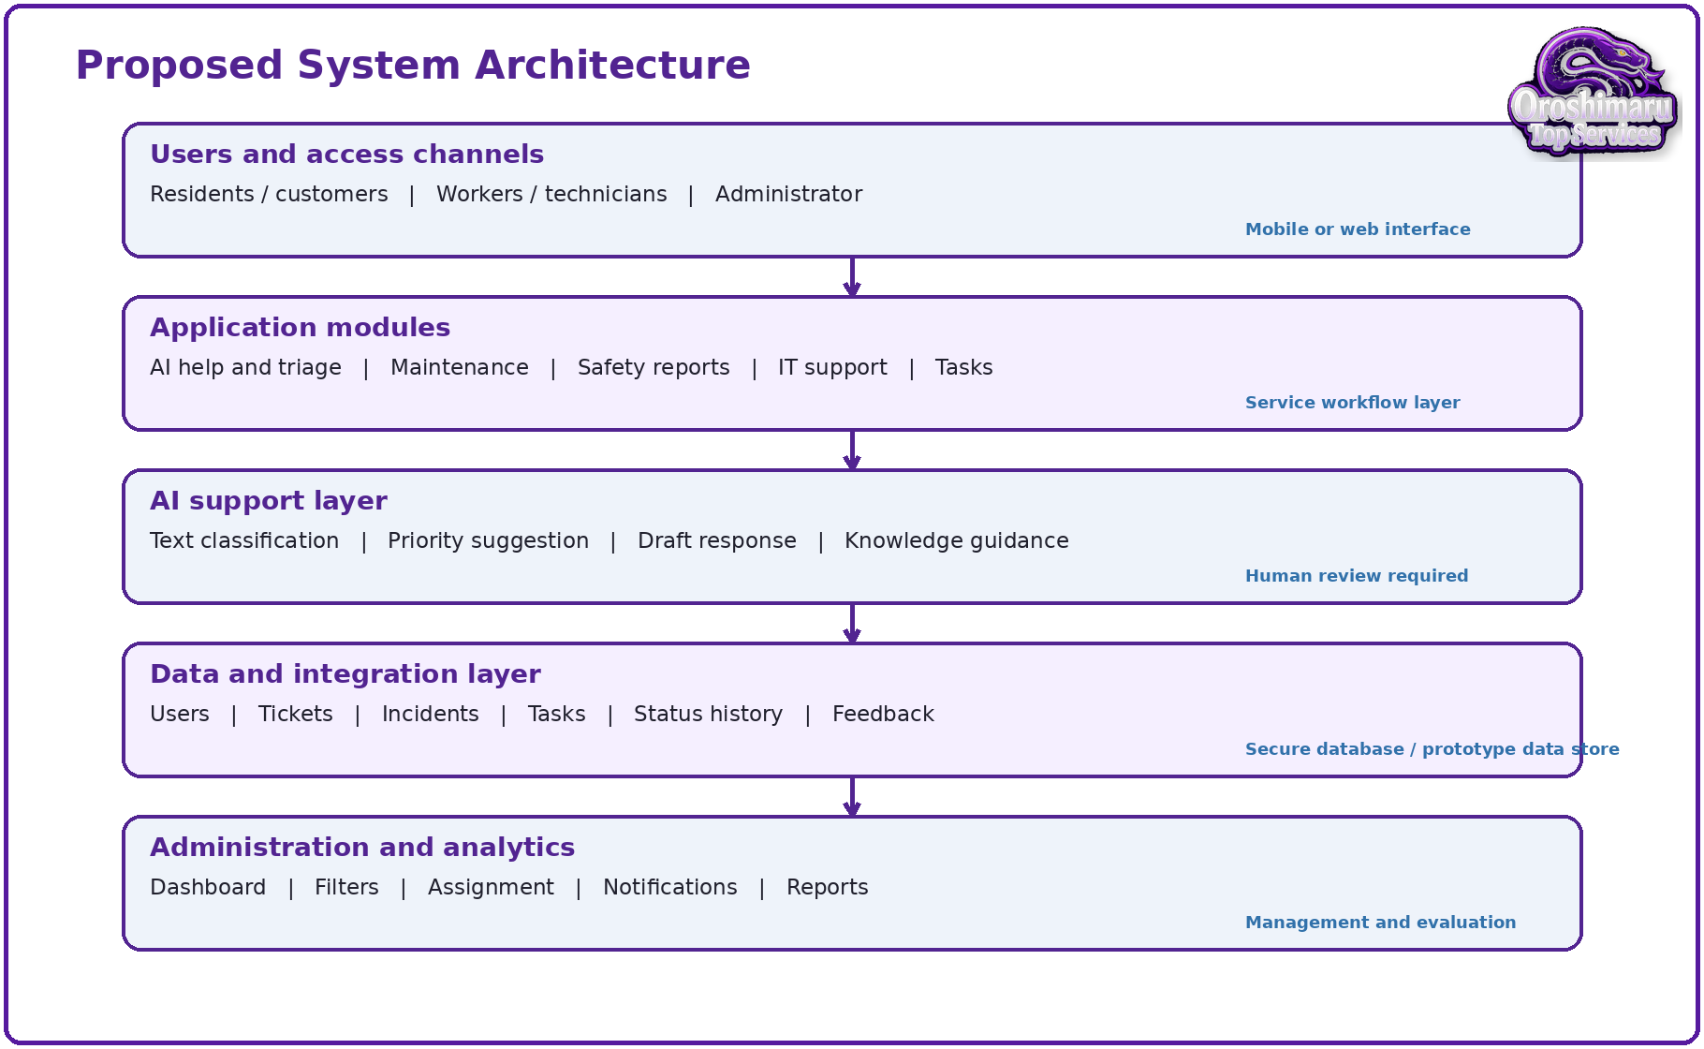
Figure 1. Proposed system architecture. Source: Author's own design.
The architecture separates AI assistance from the authoritative workflow. A request can still be submitted if an AI service is unavailable. Administrators can correct categories and priorities. This reduces dependence on one model and supports later comparison between AI suggestions and human decisions.

3.8 User Workflow
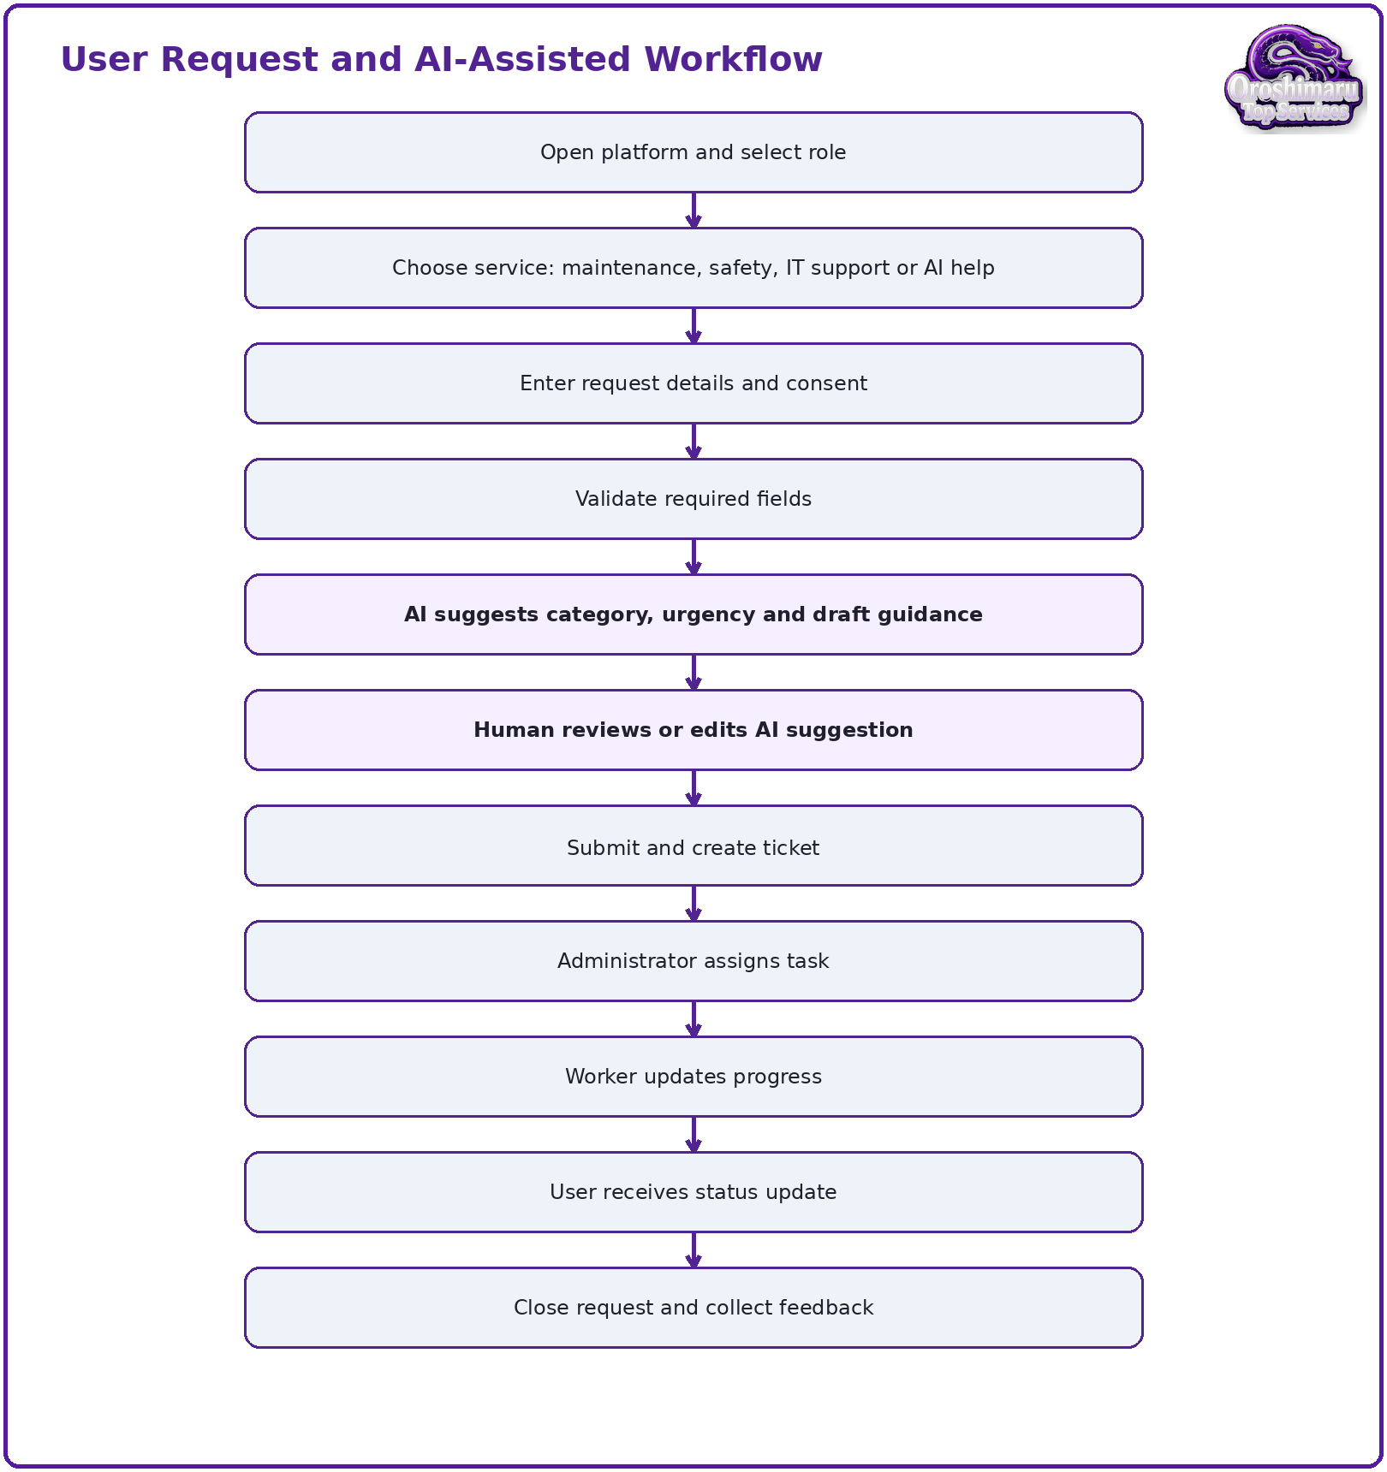
Figure 2. User request and AI-assisted workflow. Source: Author's own design.
The review step is the most important control point. The user sees the original description and proposed interpretation before creating the ticket. For higher-risk safety or maintenance requests, the system can also display an emergency warning or instruct the user to contact an appropriate service where immediate danger exists.

3.9 Module and Role Structure
This section defines the people in the prototype and shows how each role connects to the same service record. The structure has been simplified so the project does not look like separate screens placed together. Each role has a clear responsibility, a limited set of screens and a controlled view of data. This supports usability, privacy and security because users only see the functions needed for their role.
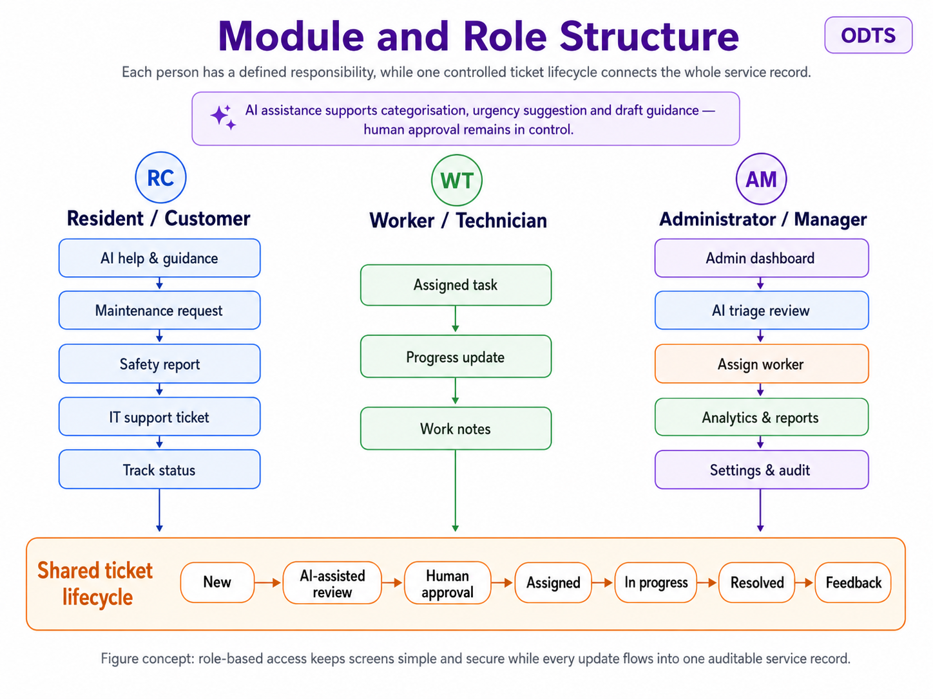
Figure 3. Module and role structure showing users, platform modules and the shared ticket lifecycle. Source: Author's own design.
The diagram shows that the Resident/Customer creates and tracks a request, the Worker/Technician updates assigned tasks, and the Administrator/Manager controls triage, assignment, monitoring and audit decisions. The AI Assistant is not a person with authority. It supports the workflow by suggesting categories, urgency and draft guidance, but final action remains with a human reviewer.
Table 4. Role access matrix showing screens, actions and data visibility. Source: Author's own design.
Role / person | Main screens | Main actions | Data they should see
Resident / Customer | Welcome screen; customer dashboard; service request form; AI review; ticket tracking; feedback | Reports maintenance, safety or IT issues; reviews AI suggestion; submits ticket; tracks progress; gives feedback | Own requests, status, approved updates and privacy notice
Worker / Technician | Worker dashboard; task details; update progress screen | Views assigned work, checks priority and location, updates progress and adds work notes | Assigned tasks only, approved safety notes and work history
Administrator / Manager | Admin dashboard; triage review; assignment; analytics; settings | Reviews AI suggestions, corrects category/priority, assigns worker, monitors tickets and closes requests | All tickets needed for management, audit history and anonymised feedback
AI Assistant | AI help; triage review; draft guidance | Suggests category, urgency and guidance from request text; explains the reason for the suggestion | Only request text needed for triage; no final decision authority
System Owner | Settings; access rules; retention and audit configuration | Manages roles, retention rules, service categories and future integrations | Configuration and security evidence
The shared ticket lifecycle is the core structure connecting the whole project: New -> AI-assisted review -> human approval -> assigned -> in progress -> resolved -> feedback. This gives the viva a clear story: every person contributes to one controlled service record, rather than to disconnected screens. It also supports the final evaluation because participants can test whether each role and status is understandable.

3.10 Data Model Concept
A future database would require at least the following entities: User, Role, Ticket, Category, Assignment, StatusUpdate, Attachment, AIRecommendation and Feedback. Ticket is the central entity. Each ticket belongs to a user and category, contains an urgency level and may have one current assignment. StatusUpdate records preserve history, while AIRecommendation stores the proposed category, priority, explanation and whether it was accepted or changed. Separating AI recommendations from final decisions supports auditing and later evaluation of AI usefulness.

3.11 AI-Assisted Triage Algorithm
The prototype uses a simple and explainable triage algorithm rather than claiming to contain a fully trained AI model. The purpose is to show how a future implementation could convert free-text requests into structured tickets while keeping human review in control. This is important for a development-based computing project because it demonstrates logic, data flow and system behaviour, not only visual screens.
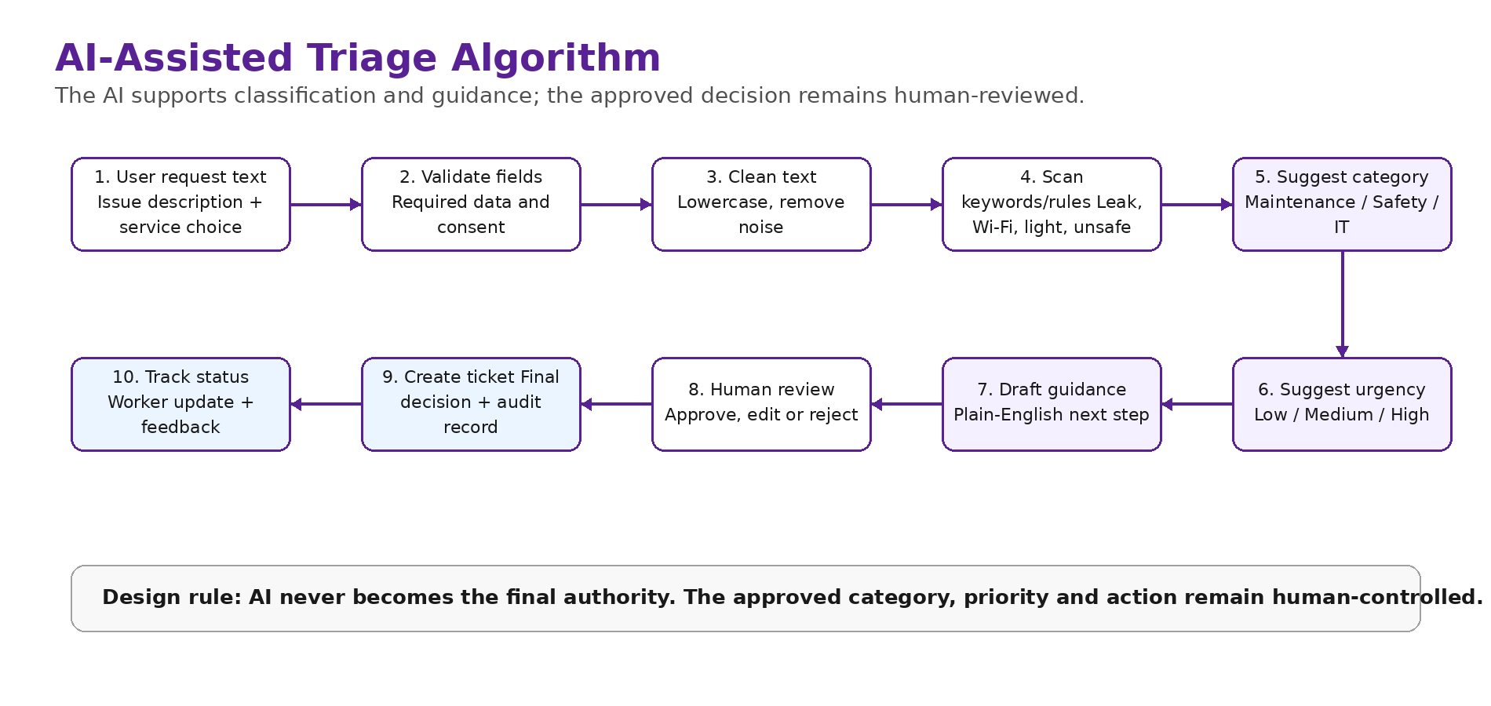
Figure 4. AI-assisted triage algorithm used to classify and review incoming service requests. Source: Author's own design.
Table 5. AI-assisted triage algorithm stages. Source: Author's own design.
Stage | Input / action | Output
1. Capture request | User enters service type, title, description, location, urgency and consent. | Raw request record.
2. Validate fields | System checks that required fields are present and that the issue is not an emergency. | Valid request or warning message.
3. Classify category | Keyword/rule logic checks terms such as leak, light, Wi-Fi, password, door, hazard and device. | Suggested category: maintenance, safety or IT support.
4. Suggest urgency | Rules check risk words such as water, electrical, unsafe, blocked, urgent or repeated. | Suggested priority: low, medium or high.
5. Draft guidance | System generates short non-binding next-step guidance. | Editable draft message.
6. Human review | Administrator checks, edits or rejects AI suggestion. | Approved category, priority and response.
7. Create ticket | Final approved decision is stored separately from the AI suggestion. | Ticket ID, audit trail and status timeline.
The algorithm is deliberately transparent. A future Python version could start with deterministic rules and then be extended with natural language processing or machine-learning classification after enough labelled ticket data exists. This staged approach avoids pretending that the prototype has validated predictive accuracy before real testing.

3.12 Tools and Techniques
The following tools are selected because they match the current development stage. The Week 5 deliverable is a research-informed prototype, while the final report can explain how the design could later become a working system.
Table 6. Tools and techniques selected for the project. Source: Author's own design.
Tool | Use in this project | Why it is suitable
Canva / Figma | Prototype screens, poster evidence and clickable interface flow. | Fast visual design, easy export of screens, suitable for usability testing.
Draw.io / yEd | Flowcharts, role/module diagrams, system architecture and possible ER diagrams. | Clear system modelling without needing a working back end.
Python | Future AI-assisted classification, keyword/rule logic and evaluation data analysis. | Readable, common in AI/NLP, supports libraries such as pandas and scikit-learn.
Flask / FastAPI / Django | Possible future web application or API implementation. | Suitable for building secure server-side workflows and connecting to databases.
SQLite / PostgreSQL | Future storage for users, tickets, categories, assignments, status updates and feedback. | Relational structure fits the ticket lifecycle and audit trail.
Google Forms / Microsoft Forms / Excel | Questionnaire collection and basic analysis of usability feedback. | Simple, low-risk tools for small participant samples.
Microsoft Word / Turnitin | Final report writing, referencing, appendices and submission. | Matches university submission process and report formatting requirements.

3.13 Prototype Development Phases
The prototype is built in phases so that the work is traceable from research gap to evaluation evidence. This avoids creating attractive screens without showing how they answer the project objectives.
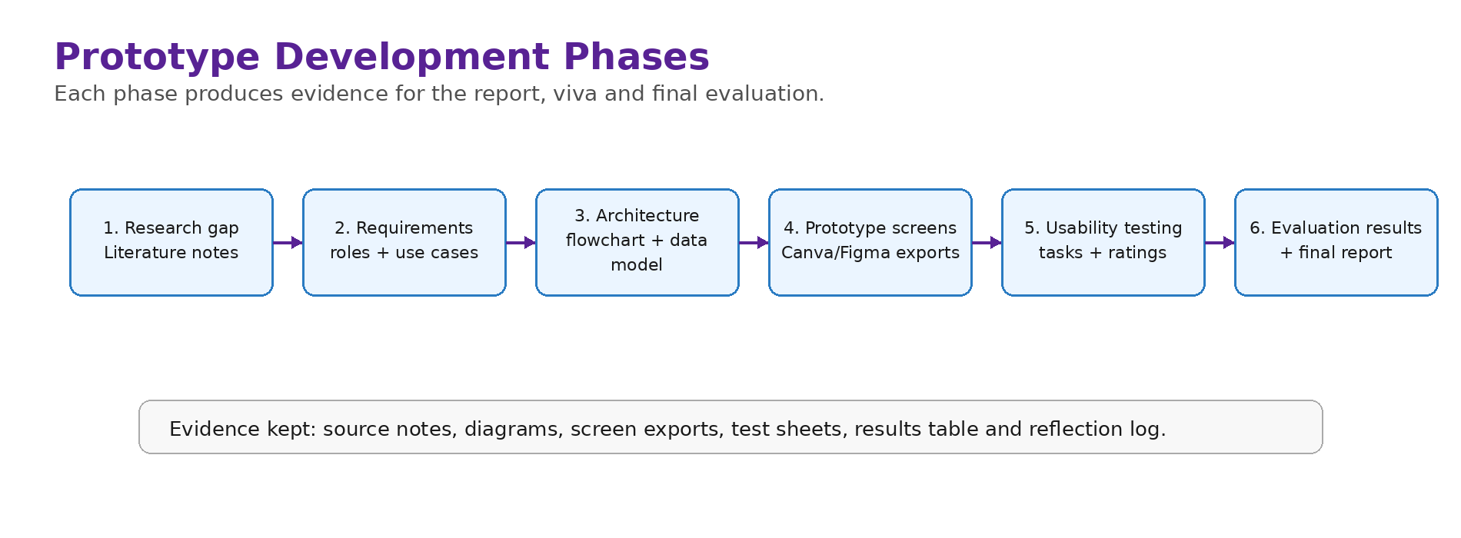
Figure 5. Prototype development phases from research gap to evaluation and final report. Source: Author's own design.
Table 7. Prototype development phases and evidence. Source: Author's own design.
Phase | Main work | Evidence produced | Checklist link
1. Research gap | Review AI, smart estate, IT service management, safety and responsible AI literature. | Literature synthesis and research gap table. | Research-informed literature.
2. Requirements | Define users, functional requirements, non-functional requirements and risks. | Role table, MoSCoW list, scenarios and ethics notes. | Knowledge and analysis.
3. System design | Create architecture, workflow, module/role structure and data model. | Figures, diagrams and data entities. | Technical/design content.
4. Prototype build | Create screens and link the customer, admin and worker journey. | Canva/Figma screens and interaction logic. | Prototype/demo evidence.
5. Testing | Run approved usability tasks with adult participants. | Task sheets, questionnaire ratings and observations. | Testing and evaluation.
6. Evaluation | Analyse ratings and comments, then improve Version 2. | Results table, charts, change log and reflection. | Findings and recommendations.

3.14 Data Collection and Analysis
Testing will use five to ten adult participants if approved and practical within the module timetable. Participants will receive fictional scenarios and will not enter real personal incidents. Measures will include task completion, observed difficulty, time-on-task where practical, and five-point ratings for clarity, ease of use, usefulness, trust and visual organisation. Open comments will ask what confused participants and what should be improved.
Quantitative responses will be summarised using counts, percentages, medians or means as appropriate for the small sample. Qualitative comments will be coded into themes such as navigation, terminology, trust, privacy, missing functions and visual design. The analysis will be exploratory rather than statistically generalisable.

3.15 Ethics, Legal and Professional Considerations
Participation will be voluntary and based on informed consent. Participants may stop without giving a reason. Feedback will be anonymised in the report, and no sensitive personal data will be requested. The prototype will use fictional names, locations and incidents. Data will be stored securely for the period required by the university and then deleted according to the approved plan. Testing will not begin before the relevant ethics form has been approved and signed.
Professional boundaries are also important. The platform is not an emergency service, medical adviser or legal adviser. AI-generated content is presented as general guidance and cannot replace professional inspection. Cybersecurity features are defensive and awareness-focused. The final report will distinguish clearly between features demonstrated in the prototype and features that would require production implementation and security testing.

3.16 Project Plan
Week | Main activity | Output / milestone
1 | Confirm project scope and supervisor feedback | Approved proposal direction
2 | Complete focused literature review | Literature review notes
3 | Define requirements and user scenarios | Requirements specification
4 | Design workflow and platform structure | System workflow diagram
5 | Build first prototype | Prototype Version 1
6 | Improve prototype and test service categories | Prototype Version 2
7 | Collect user feedback | Feedback dataset
8 | Analyse results and risks | Evaluation findings
9 | Write final report and recommendations | Draft final report
10 | Final editing and viva preparation | Final report and presentation

3.17 Requirements Prioritisation Using MoSCoW
Because the original concept contains many possible modules, requirements must be prioritised to protect the ten-week schedule. The MoSCoW method separates requirements into Must have, Should have, Could have and Will not have for this prototype. “Must” requirements are necessary to demonstrate the main research problem: users must be able to select a role, submit a structured request, view an AI suggestion, create a ticket and track status. “Should” requirements improve the workflow but can be simplified, such as worker assignment, filtering and basic dashboard summaries. “Could” requirements include multilingual support, attachment previews and knowledge-base recommendations. Live sensor data, emergency dispatch, payment processing, automatic surveillance and autonomous safety decisions are explicitly excluded.
Priority | Prototype requirements | Reason
Must have | Role selection; service selection; request form; AI-assisted review; ticket creation; status tracking; admin review. | Directly demonstrates the project aim and supports usability testing.
Should have | Worker assignment; task updates; dashboard filters; notifications; user feedback screen. | Shows end-to-end coordination and supports evaluation.
Could have | Attachments; multilingual labels; FAQ recommendations; simple analytics charts. | Adds realism if time permits without changing the core workflow.
Will not have now | Live IoT sensors; emergency-service integration; payment; facial recognition; autonomous decisions. | Outside academic prototype scope and introduces disproportionate technical, legal and ethical risk.

3.18 Information Architecture and Navigation Design
The information architecture uses role-based entry points while maintaining a shared service model. Residents or customers see four primary actions: report maintenance, report a non-emergency safety concern, request IT support and ask the AI assistant for guidance. Workers see assigned tasks, priority, location, notes and progress controls. Administrators see all tickets, AI suggestions, filters, assignment controls and summary information. This separation reduces clutter and supports least-privilege access because each role is presented with only the actions required for its responsibilities.
Navigation is designed around a shallow hierarchy. A user should reach any main request form within two selections from the dashboard, and the ticket status should remain visible after submission. Consistent navigation labels are used across screens: Home, New Request, My Requests, AI Help and Profile for customers; Tasks, Updates and Completed for workers; Dashboard, Requests, Workers, Analytics and Settings for administrators. Back actions and confirmation screens reduce the risk of accidental submission. The mobile design uses a bottom navigation bar for high-frequency customer actions, while the wider administrator dashboard uses a left navigation panel.

3.19 Data Entities and Audit Trail
The conceptual data model contains User, Role, Ticket, ServiceCategory, AIAssessment, Assignment, StatusUpdate, Attachment and Feedback entities. A Ticket stores the user’s original description, location, service category, urgency, consent record and timestamps. The AIAssessment stores the suggested category, suggested priority, draft guidance, model or rule version and a confidence or explanation field. The administrator’s final category and priority are stored separately so that AI output is not confused with an approved decision. Assignment links a ticket to a worker, while StatusUpdate records chronological progress. Feedback is linked to the ticket through a pseudonymous identifier rather than being displayed to workers as personal information.
An audit trail is necessary because the system coordinates tasks that may affect property, safety and user trust. Important events include account login, request creation, AI suggestion generation, administrator correction, assignment, status change, attachment upload and closure. In a future implementation, logs should be protected from ordinary modification and retained according to a documented schedule. The prototype represents this principle visually through a ticket timeline and a review history rather than by implementing a production logging service.

3.20 Security-by-Design Requirements
Security is treated as a design constraint rather than a feature added after prototyping. Role-based access should restrict residents to their own requests, workers to assigned tasks and administrators to authorised management functions. Authentication should support strong passwords and, for administrator accounts, multi-factor authentication. Input validation is required on both client and server sides, and attachments should be restricted by file type, size and malware scanning. Data in transit should use current TLS, while sensitive database fields and backups should be encrypted where appropriate. Secrets and API keys must not be embedded in client-side code.
OWASP guidance is relevant to a future web or mobile implementation because broken access control, authentication weaknesses, injection, insecure design and API authorisation failures can expose ticket data or allow unauthorised actions [20], [21]. The prototype therefore documents object-level authorisation, rate limiting, session expiry, secure error messages, audit logging and minimal API responses as future acceptance criteria. The NIST Cybersecurity Framework 2.0 provides a broader governance structure through Govern, Identify, Protect, Detect, Respond and Recover functions [12]. These functions can guide a later security plan even though the Week 5 deliverable is a visual prototype rather than a deployed platform.

3.21 Quality Assurance and Change Control
Prototype quality will be controlled through a simple change log. Each revision will record the screen changed, the reason, the source of feedback and the expected benefit. Version 1 represents the initial design produced from literature and requirements. Version 2 will be created after usability testing and will include only changes justified by evidence or supervisor feedback. This prevents unstructured visual redesign and creates a clear link between research, evaluation and implementation decisions.
Change ID | Prototype area | Reason/source | Planned action
C01 | Service selection | Scope and user-role analysis | Separate maintenance, safety and IT support using clear cards.
C02 | AI review screen | Responsible AI literature | Show original text, suggestion, explanation and edit/approve controls.
C03 | Ticket timeline | Need for accountability | Display chronological submission, review, assignment and completion states.
C04 | Admin dashboard | Supervisor and business workflow needs | Show open, urgent, in-progress and completed requests with filters.
C05 | Accessibility | WCAG 2.2 and usability principles | Increase contrast, label icons, use large touch targets and avoid colour-only status.

4.0 IMPLEMENTATION AND DEVELOPMENT - WEEK 5 PROTOTYPE VERSION 1

4.1 Prototype Strategy
Prototype Version 1 is intentionally low fidelity. Its purpose is to validate information structure, navigation and workflow before visual polish or coding. Canva is suitable for this stage because screens can be recreated quickly, duplicated for different states and linked as a presentation or interactive sequence. The prototype should use the same colours, typography, button style and spacing across every screen. The diagrams and wireframes in this chapter are templates that can be copied into Canva and adapted by the student.
The first version will demonstrate the complete journey rather than every possible setting. A resident can submit a request, review an AI suggestion and receive a ticket reference. An administrator can see the request on a dashboard, assign it and update its status. A worker can view an assigned task and provide a progress note. This end-to-end path is sufficient for initial evaluation.

4.2 Screen Inventory
Screen | Purpose | Core elements
1. Welcome / role selection | Explain platform and choose entry role | Platform purpose, role buttons, emergency warning
2. Customer dashboard | Provide shortcuts and current requests | New request, AI help, active tickets, status cards
3. Service selection | Choose correct workflow | Maintenance, safety, IT support, general help
4. Request form | Capture structured details | Category, title, description, location, urgency, contact, consent
5. AI triage review | Make AI support visible and correctable | Suggested category, priority, explanation, draft guidance, edit/approve
6. Confirmation | Create traceable record | Ticket ID, status, expected next step
7. Track request | Show progress and communication | Timeline, assigned role, latest update, add information
8. Worker tasks | Support task completion | Assigned list, priority, location, update form
9. Admin dashboard | Manage workload | Counts, filters, ticket table, assignment controls
10. Feedback | Evaluate completed service | Ratings and open comment

4.3 Administration Dashboard Wireframe
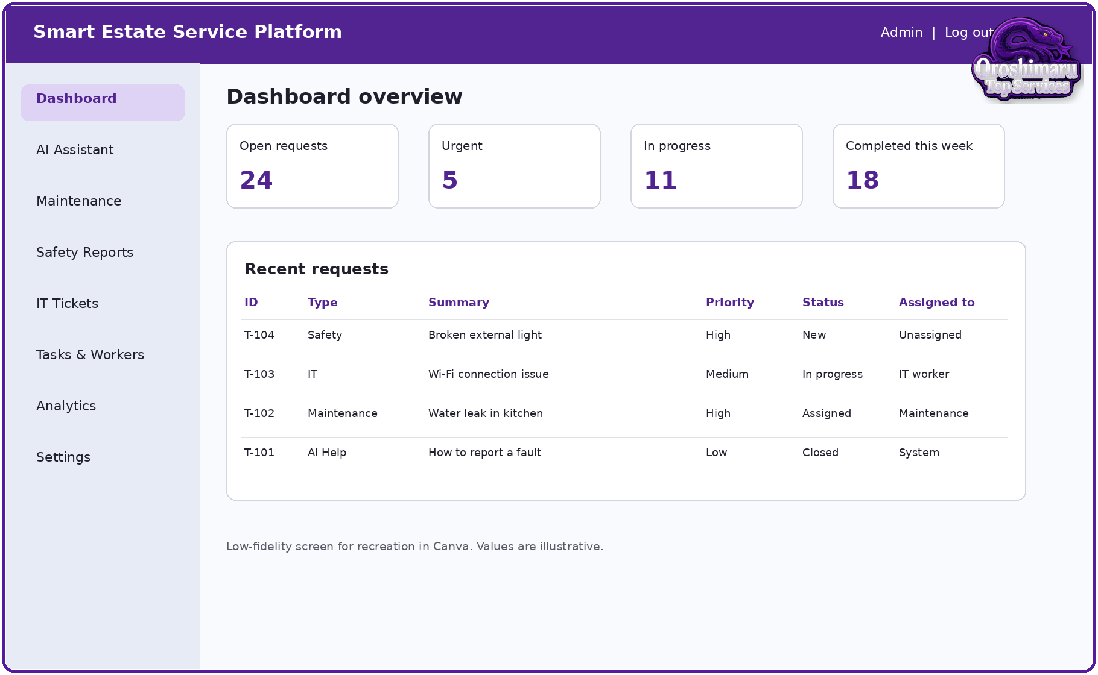
Figure 6. Administration dashboard wireframe for recreation in Canva. Source: Author's own design.
The dashboard prioritises visibility. Summary cards show workload, while the request table exposes category, description, priority, status and assignment. In Canva, the student should create reusable card, button and table components. Purple can be used for navigation and primary actions, blue for secondary information, and neutral backgrounds for readability.

4.4 Service Request Form Wireframe
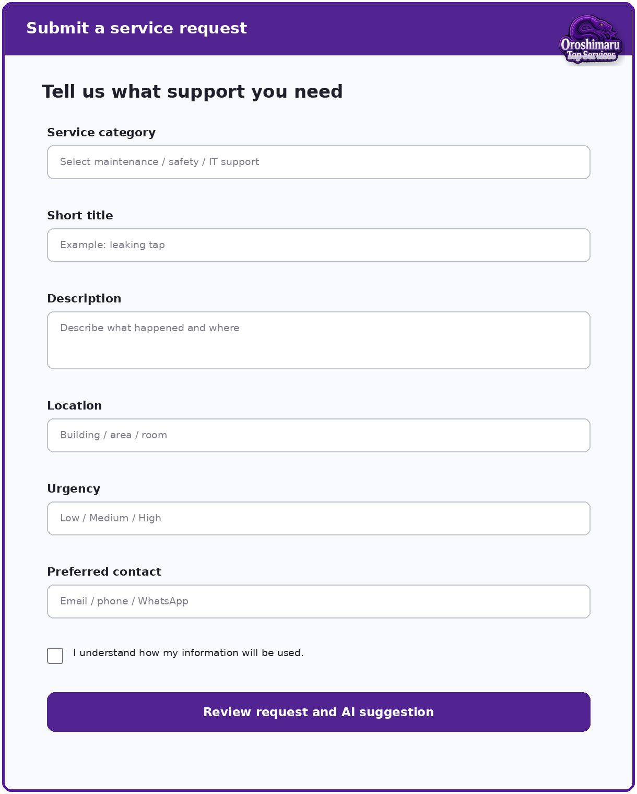
Figure 7. Service request form wireframe for recreation in Canva. Source: Author's own design.
The form is intentionally single-column to suit mobile screens and reduce scanning complexity. It separates service category from description, allowing manual selection even if AI later proposes a correction. The consent statement should link to a short privacy explanation. An emergency message should appear when the safety category is selected.

4.5 AI-Assisted Triage Wireframe
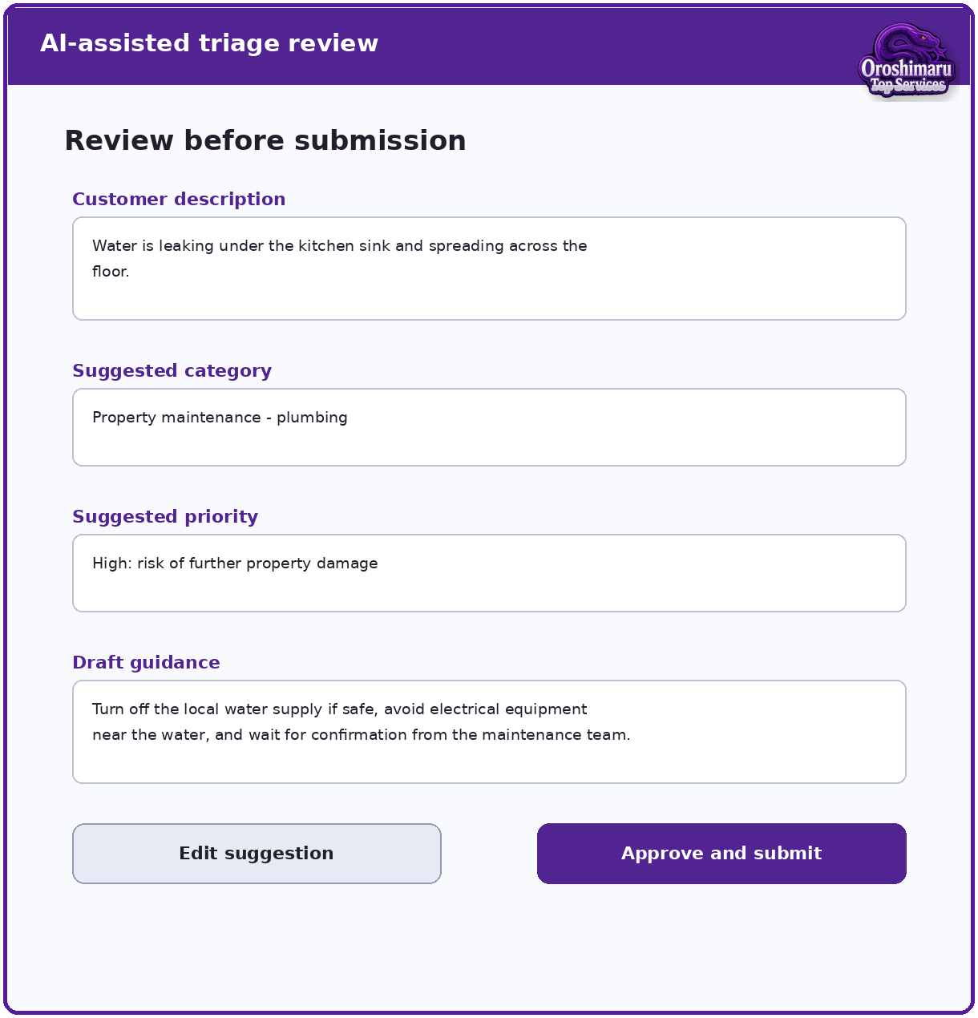
Figure 8. AI-assisted triage review wireframe for recreation in Canva. Source: Author's own design.
This screen prevents hidden automation. It shows the original description, proposed category, priority and draft guidance as separate sections. The user can edit or reject the suggestion. In a working system, the final ticket would preserve both the AI recommendation and the approved decision for auditing. The prototype should not imply that the AI has inspected the property or confirmed the cause of a fault.

4.6 Canva Build Instructions
- Create a 390 x 844 px mobile design for customer and worker screens, plus a 1440 x 900 px desktop design for the administration dashboard.
- Create a small design system page containing colours, heading styles, body text, buttons, cards, form fields, status badges and icons.
- Build the welcome screen and role selection first; duplicate frames to preserve consistent navigation.
- Create separate request-form variants for maintenance, safety and IT support by changing only module-specific fields.
- Create the AI review screen using a visible “AI suggestion” label and edit/approve controls.
- Create confirmation and tracking screens with the same fictional ticket reference across the journey.
- Create worker and administrator views using the same request data so the workflow appears connected.
- Link buttons in Canva presentation mode or export the screens to a clickable PDF/presentation for testing.
- Add figure captions and include exported prototype screens in Chapter 4 and Appendix B.

4.7 Prototype Content Set
Use one consistent fictional scenario across the prototype: “Water is leaking under the kitchen sink in Flat A12.” The proposed AI category is Property Maintenance - Plumbing, and the priority is High because further property damage may occur. The administrator assigns the ticket to Maintenance Worker 1. The worker changes the status from Assigned to In Progress and then Completed. A second scenario can show an IT support request, and a third can show a broken external light as a non-emergency safety report.

4.8 Definition of Prototype Version 1 Complete
Prototype Version 1 is complete when the following evidence exists: architecture diagram, workflow diagram, module map, ten core screens, one linked customer journey, one administrator view, one worker update view, consistent visual components and a short design rationale. It does not need a database or live AI integration at Week 5. The prototype must be sufficiently complete for a participant to understand what to click and what result to expect.

4.9 Visual Identity and Design System
The prototype uses the Oroshimaru Top Services identity as a consistent visual system rather than decorative branding applied independently to each screen. The primary palette uses deep purple, violet, blue, black, white and neutral grey. Purple identifies headings, primary actions and active navigation; blue is used for supporting information and links; neutral backgrounds preserve readability. The snake logo appears in the header or corner at a restrained size so that it identifies the platform without competing with form labels and safety information. The interface avoids using decorative imagery behind body text.
Typography is hierarchical and consistent. Large headings identify the current task, medium labels identify form sections and standard body text explains actions in plain English. Buttons use action verbs such as “Review request”, “Approve and submit”, “Save update” and “Track request”. Status chips include both text and colour, because colour alone may not be accessible. Icons can be added in Canva, but every icon should be paired with a label to prevent ambiguity. The design system should be maintained across all prototype screens so that later polishing does not change the underlying interaction logic.

4.10 Expanded Prototype Screen Set
Prototype Version 1 now contains an end-to-end set of customer, worker and administrator screens. The welcome screen introduces the system and role selection. The customer dashboard provides service cards and recent tickets. The request form collects only information relevant to triage. The AI review screen displays suggested classification, priority and draft guidance before submission. The confirmation and tracking screens preserve the ticket reference and timeline. The worker task screen supports progress updates. The administrator dashboard supports review, assignment and monitoring. The feedback screen captures ratings and comments for evaluation.
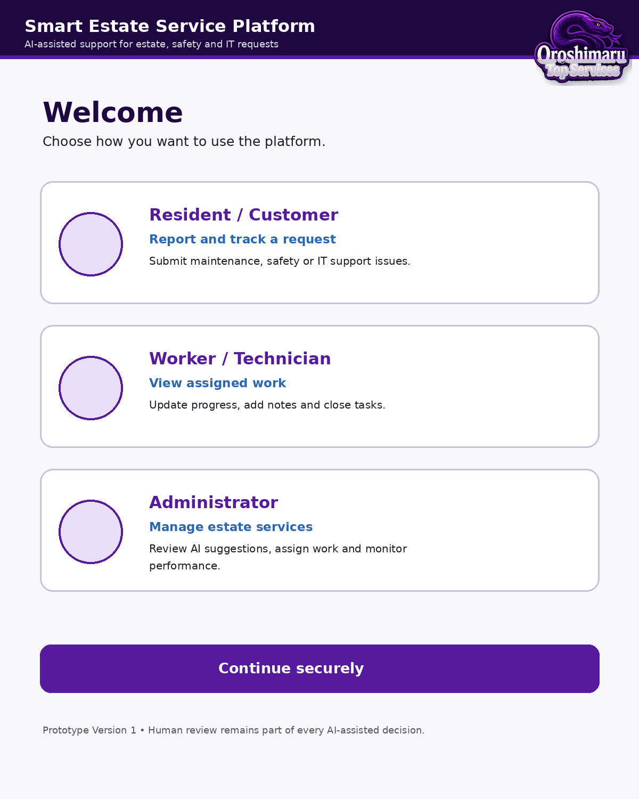
Figure 9. Branded welcome and role-selection screen for recreation in Canva. Source: Author's own design.
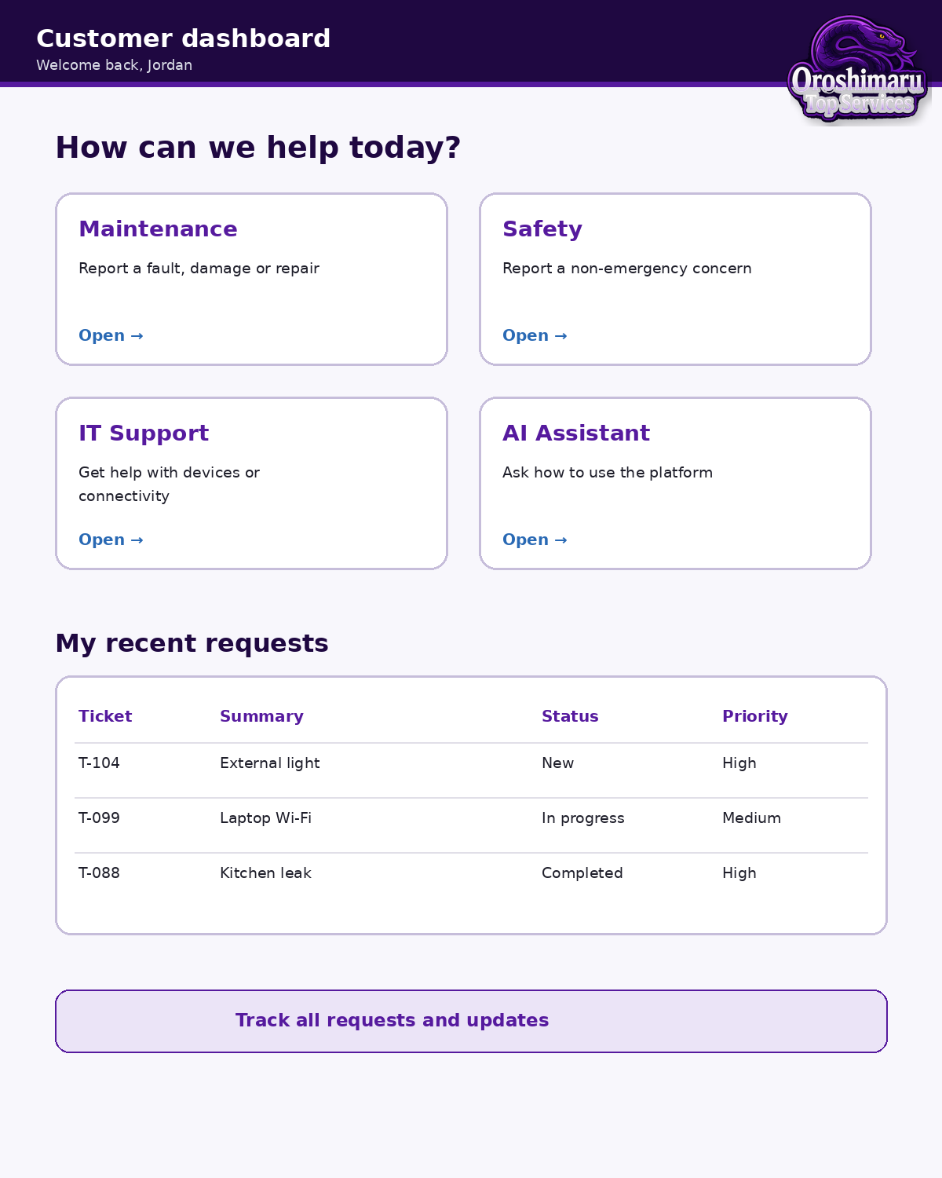
Figure 10. Branded customer dashboard wireframe. Source: Author's own design.
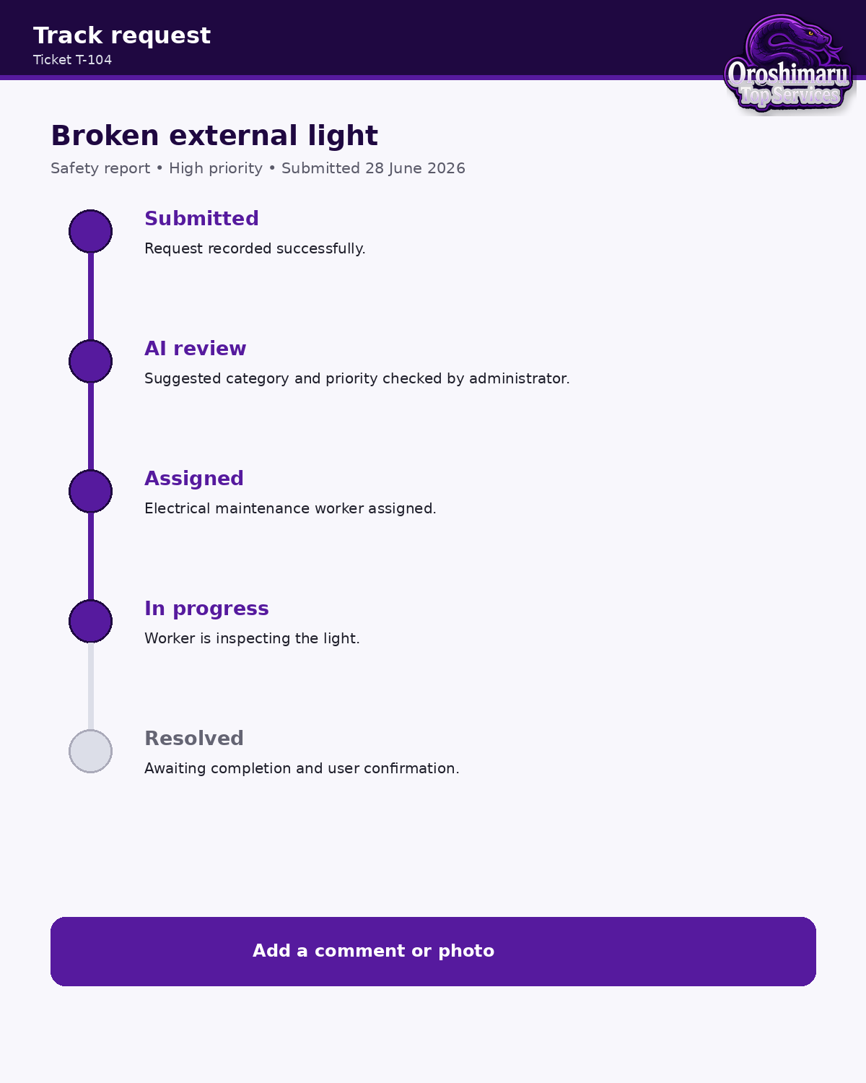
Figure 11. Branded ticket tracking and status timeline screen. Source: Author's own design.
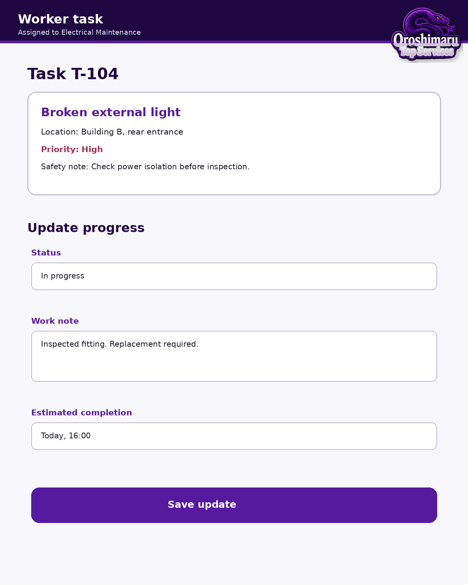
Figure 12. Branded worker task and progress-update screen. Source: Author's own design.
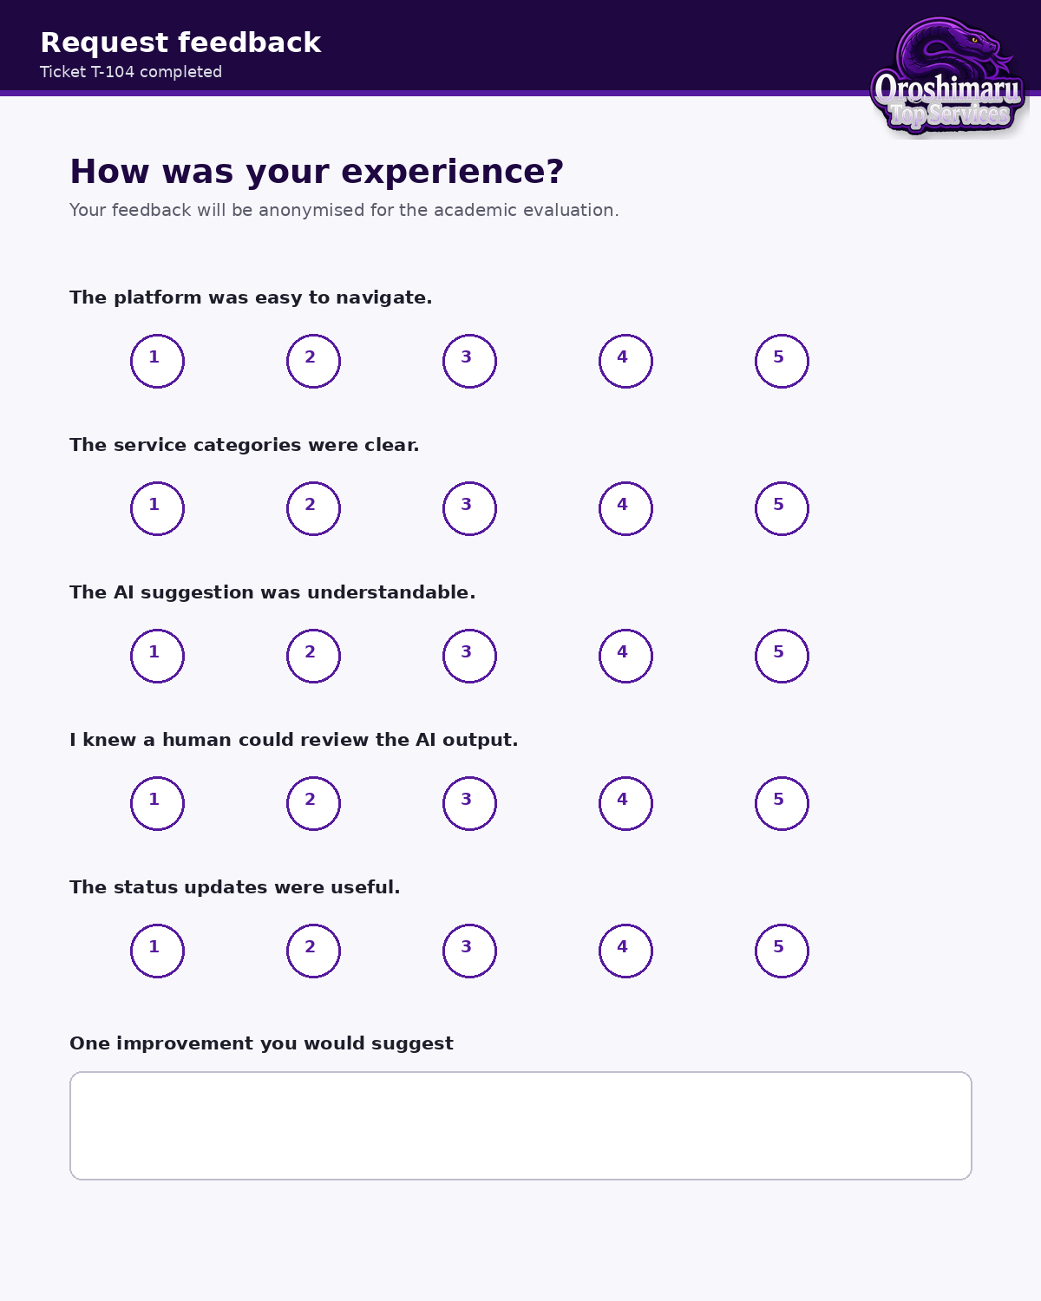
Figure 13. Branded user feedback and evaluation screen. Source: Author's own design.

4.11 Screen-by-Screen Interaction Logic
On the welcome screen, the user selects Resident/Customer, Worker/Technician or Administrator. In a working system, this selection would be combined with authenticated role information rather than allowing users to grant themselves privileges. The customer dashboard then presents a small number of high-level service choices. Selecting Maintenance, Safety or IT Support opens a tailored form. Selecting AI Assistant opens guidance that explains which service is appropriate and how information will be used.
The request form uses conditional fields. Maintenance requests may ask for room or building location, type of fault, risk of further damage and whether utilities are affected. Safety reports may ask whether the issue is an emergency, whether there is an immediate hazard and whether the area can be avoided. IT tickets may ask for device type, operating system, network status and error message. The form provides an emergency warning where necessary and does not imply that the platform monitors requests continuously.
After the user selects Review, the AI-assisted triage screen summarises the original description and presents suggested category, priority and draft guidance. The user can return to edit the request. An administrator can later accept or correct the suggestion. Submission creates a ticket reference and a status of New. The status timeline then shows Submitted, AI Review, Assigned, In Progress and Resolved. Each stage displays a timestamp and short explanation. The design avoids promising that a report has been acted on merely because it has been submitted.
The worker screen shows only assigned operational information. It includes task summary, location, approved priority, safety note, current status and a progress-note field. The worker cannot see unrelated customer requests or confidential administrator notes. The administrator dashboard presents service totals, priority filters, recent requests and assignment controls. For future development, analytics should be aggregated to reduce unnecessary exposure of personal data.

4.12 Prototype Build Procedure in Canva
The Canva build should begin with a master mobile frame and a master desktop frame. The mobile frame can use a 390 by 844 pixel layout, while the administrator dashboard can use a 1440 by 900 pixel layout. Create reusable components for the header, logo, navigation, service card, form field, status chip, primary button, secondary button and confirmation banner. Lock background elements and duplicate the master page for each screen. This reduces inconsistent spacing and makes later revision faster.
Use a spacing scale such as 8, 16, 24 and 32 pixels. Keep body text left aligned, maintain clear white space around fields and use the same corner radius for cards and buttons. Export each screen as PNG for the report and keep the editable Canva file as project evidence. The interactive prototype should link service cards to forms, forms to the AI review page, approval to confirmation, ticket references to tracking and administrator rows to assignment. Add a visible “Back” control and test every link before participant sessions.
The branded figures embedded in this report are reference designs rather than mandatory final artwork. They should be recreated in Canva so that the student can adjust typography, icons and spacing while preserving the documented workflow. The report should include the final exported screens, not only the early wireframes, and the appendix should show a small selection of Version 1 and Version 2 comparisons.

4.13 Prototype Version 1 Completion Checklist
Area | Completion evidence | Week 5 status
Research foundation | Literature review and research gap linked to platform features. | Complete draft
Requirements | Functional, non-functional, ethical and security requirements documented. | Complete draft
Architecture | Layered architecture, role/module map and conceptual data model. | Complete draft
Customer flow | Role selection, dashboard, request, AI review, confirmation and tracking. | Designed
Worker flow | Assigned task and progress-update screen. | Designed
Administrator flow | Dashboard, review, assignment and status monitoring. | Designed
Branding | Purple/blue/grey visual system and Oroshimaru logo applied. | Applied to reference screens
Evaluation readiness | Tasks, questionnaire, consent wording and change log prepared. | Planned; ethics approval required before data collection

5.0 TESTING AND EVALUATION - PROTOCOL FOR WEEKS 7-8

5.1 Planned Usability Tasks
Test ID | Participant task | Success criterion
T01 | Select the correct service for a leaking sink | Maintenance route selected without help
T02 | Submit the fictional leak request | All required fields completed and review screen reached
T03 | Review and correct an AI suggestion | Participant identifies that the suggestion is editable
T04 | Find the status of an existing ticket | Correct ticket and latest status located
T05 | Report a broken external light | Safety route used and non-emergency warning understood
T06 | Submit a Wi-Fi problem | IT support form used and ticket confirmation reached
T07 | Administrator assigns an urgent ticket | Correct worker and status selected
T08 | Worker updates task progress | Progress note and status saved in prototype flow

5.2 Questionnaire Plan
- The platform was easy to navigate.
- The service categories were clear.
- The AI suggestion was easy to understand.
- It was clear that a human could review or change the AI output.
- The status-tracking process was useful.
- I would feel comfortable using the platform for a non-emergency request.
- The interface looked organised and professional.
- What was confusing or missing?
- What one change would improve the platform most?

5.3 Evaluation Criteria
The prototype will be evaluated against task completion, usability, clarity, perceived usefulness, AI transparency, trust, privacy understanding and accessibility. Results must not be invented before testing. Chapter 5 should later include participant characteristics in non-identifying form, a test-results table, summary charts, thematic findings, examples of changes between Prototype Version 1 and Version 2, and a discussion linked back to the research questions.

5.4 Participant Recruitment and Ethical Procedure
Testing will involve a small convenience sample of adult participants who can understand the prototype and provide voluntary feedback. Participants may include classmates or adult contacts, but they should not be placed under pressure to participate and should not be vulnerable service users. Before testing, each participant will receive a short information statement explaining the purpose of the study, what they will do, the approximate duration, the fictional nature of the scenarios, how data will be used and their right to stop without giving a reason. Consent must be recorded before any task or questionnaire data is collected.
No participant will be asked to report a real emergency, disclose medical information or provide genuine property-security details. Test tasks will use fictional names, locations and issues. Observation notes will use participant codes such as P01 and P02. Raw data will be stored securely and retained only for the period required by university policy. Screenshots used in the report will avoid names, email addresses, phone numbers and other identifiers. Data collection must not begin until the appropriate ethics process has been completed and the supervisor has approved the materials.

5.5 Measures and Analysis Plan
The evaluation combines quantitative and qualitative evidence. Quantitative measures include task completion, whether help was required, number of navigation errors, time on task where practical, and ratings on a five-point agreement scale. The small sample means that descriptive statistics are more appropriate than claims of statistical generalisation. For each rating item, the report can present frequency, median or mean with a clear statement of sample size. Task completion can be shown as a percentage, but the report should also explain where participants struggled.
Qualitative comments and observation notes will be analysed thematically. The process will involve reading all comments, assigning short codes, grouping related codes and naming themes. Expected themes may include navigation clarity, category wording, trust in AI, visibility of human review, privacy concerns and dashboard usefulness. These are provisional categories only; the final report must reflect the actual data. Representative quotations can be included anonymously where consent permits, but quotations should be short and selected to explain findings rather than to decorate the report.
Evaluation dimension | Evidence | Example success indicator
Effectiveness | Task completion and errors | Most participants complete core submission and tracking tasks without intervention.
Efficiency | Time on task and unnecessary steps | Participants reach the correct service route with limited backtracking.
Clarity | Ratings and comments | Service labels, status and AI suggestions are understood.
Trust and transparency | Ratings, interview comments and correction task | Participants recognise that AI is assistive and know how to edit or challenge it.
Accessibility | Observation and checklist | Text is readable, controls are labelled and interaction does not depend on colour alone.
Usefulness | Ratings and comments | Users see value in centralised requests, assignment and status tracking.

5.6 Planned Prototype Version 2 Decision Rules
Not every suggestion should automatically become a design change. A change will be prioritised when it affects task completion, causes repeated confusion, creates an accessibility or privacy problem, or is supported by several participants and the project objectives. Cosmetic preferences with no usability effect may be recorded but deferred. Changes that expand the project beyond scope, such as building a live sensor network, will be placed in future recommendations rather than added during Week 6.
The Version 2 change log will state the problem, evidence, design response and verification. For example, if participants interpret the AI priority as a final decision, the screen can be changed from “Priority: High” to “AI suggestion: High — administrator review required”. If users cannot find their ticket reference, the confirmation screen can enlarge the reference and add a direct Track Request button. Version 2 should then be checked against the same tasks to confirm that the change did not introduce new problems.

5.7 Reporting Results Without Fabrication
The present Week 5 document deliberately contains a protocol rather than invented findings. When testing has occurred, Chapter 5 should be updated with the real participant count, task results, rating table, charts, themes, limitations and Version 2 evidence. Any failed task or negative comment should be reported honestly. A credible evaluation is not one in which every participant gives a perfect score; it is one in which the method is clear, limitations are acknowledged and design changes are justified by evidence.

6.0 CONCLUSION AND RECOMMENDATIONS - DRAFT POSITION
At Week 5, the project has established an evidence-based design direction and created the materials required for Prototype Version 1. The literature supports integrated digital workflows, AI-assisted text handling and structured ticket management, while also showing that privacy, explainability, security and adoption barriers must be treated seriously. The proposed architecture therefore keeps AI assistive and preserves human review. A final conclusion cannot be written until user testing is complete. The final chapter should state which objectives were achieved, summarise the strongest evaluation findings and recommend priorities for a working implementation, including secure authentication, database design, API controls, model testing, audit logs, mobile accessibility and carefully governed sensor integration.

6.1 Interim Conclusions at Week 5
The work completed through Week 5 indicates that the project problem is suitable for an Applied Computing independent project. The platform combines requirements analysis, system architecture, data modelling, user experience, AI-assisted interaction, cybersecurity and evaluation. The literature provides a strong rationale for digital property workflows and AI-assisted triage, but it also demonstrates that sophisticated predictive systems depend on reliable data, integration and governance. The project therefore adopts a staged approach: first establish a transparent ticket-based service foundation, then consider advanced analytics, sensors and predictive maintenance after the core workflow has been evaluated.
The main design conclusion is that AI should support classification, response drafting and guidance while accountability remains with identifiable human roles. This is reflected in separate storage of original user text, AI suggestion and administrator decision; visible edit and approval controls; and a ticket history that records assignments and updates. This design is more realistic than presenting a chatbot as an autonomous estate manager. It also creates clearer criteria for future testing: users should understand what the AI did, what it did not do and who is responsible for the next action.

6.2 Recommendations for Future Working Implementation
A future implementation should begin with a secure responsive web application because this can support mobile and desktop access without maintaining separate native applications. A modern front end could connect to a documented API and relational database. Authentication should use an established identity provider where possible, with role-based authorisation enforced on the server. Ticket and audit data should be backed up, encrypted and protected by retention controls. Monitoring should detect failed logins, suspicious access, repeated API errors and abnormal use.
The AI component should be introduced incrementally. An early working version could use deterministic rules and a controlled service taxonomy before adding a language model. If a model is used, evaluation should measure classification accuracy, false urgency assignments, harmful or unsupported guidance, consistency across user wording and performance for different language levels. Prompts, model versions and decision thresholds should be documented. High-risk categories should always be escalated to a person, and emergency wording should direct users to appropriate emergency channels rather than relying on the platform.
Further enhancements may include multilingual support, SMS or low-bandwidth reporting, attachment handling, knowledge-base retrieval, contractor scheduling, asset registers, QR codes for locations and aggregated service analytics. IoT and predictive maintenance should be considered only after data ownership, device security, interoperability and maintenance responsibilities are defined. These recommendations preserve the project’s long-term smart-estate vision while recognising that reliable service management and user trust are prerequisites for advanced automation.

6.3 Limitations of the Current Draft
The prototype is based on one project context and a small future participant sample, so findings will not represent every estate, business or user group. Canva wireframes can demonstrate interaction and visual hierarchy but cannot prove database performance, cybersecurity, model accuracy or operational reliability. The literature review is broad because the platform combines several domains, which creates a risk that individual areas receive less depth than a specialised project. These limitations are acceptable if the report remains precise about its contribution: an integrated, research-informed and evaluated prototype, not a production platform.

7.0 REFLECTION - WORKING LOG
The project requires careful control of scope. Combining estate maintenance, safety, IT support, worker coordination and AI could become too broad if each area were implemented as a complete product. The decision to build a design prototype makes the project achievable and allows the research to focus on integration, workflow and user experience. A major learning point is the distinction between demonstrating an AI interaction and claiming that an AI model is safe or accurate. The report must remain precise about what has been designed, what has been tested and what remains future work.
Reflection should be updated weekly. Useful topics include supervisor feedback, changes to the title or scope, difficulties locating recent sources, decisions about Canva screens, management of the ethics process, participant recruitment, prototype revisions, time management and how the project relates to future work in AI, IT support and smart-estate services.

7.1 Reflection on Scope and Project Identity
The most important early challenge was controlling the relationship between the wider Oroshimaru Top Services vision and the academic project. The business concept includes AI automation, IT support, device services, property work, safety and future smart-estate functions. Attempting to build every service as a complete system would make the project unmanageable. The refined project identity is therefore an integrated service-management prototype. Different services share a common workflow, while the report remains focused on computing questions such as requirements, classification, roles, data, usability and responsible AI.
Using the Oroshimaru visual identity gives the prototype a realistic context and makes the screens feel connected. However, academic quality depends on more than branding. The design must remain readable, accessible and evidence-based. The logo and purple palette are therefore used consistently but not allowed to obscure labels or dominate safety information. This balance between creative ownership and professional restraint is part of the project learning.

7.2 Reflection on Research and Referencing
The literature search showed that current research is strongest in areas such as smart buildings, predictive maintenance, digital twins and AI-enabled property management. Fewer sources address the exact combination of maintenance, non-emergency safety and IT support for a small estate context. This initially made the literature appear disconnected, but synthesis revealed shared concepts: structured data capture, prioritisation, human decision support, workflow visibility, trust and security. The research gap is therefore based on integration and usability rather than a claim that no related technology exists.
A further learning point is the need to verify references carefully. Search-engine results and AI tools can produce incomplete titles, missing page ranges or incorrect publication details. The final report should retain only sources that can be located through the university library, publisher website, DOI record or recognised standards body. IEEE numbering must remain consistent when paragraphs are moved. A reference-management tool can reduce errors, but every entry still requires manual checking.

7.3 Reflection on Prototype Development
Creating the prototype as a set of reusable components is more efficient than designing each page independently. The role cards, service cards, form fields, status chips and buttons can be duplicated and edited in Canva. This also makes usability changes easier because one component can be updated across several screens. The wireframes demonstrate that a prototype can communicate system logic without a working back end, but they also reveal the limits of visual design: technical claims must remain conditional until functionality is implemented and tested.
The human-review screen became a central design decision. At first, AI could have been represented as an automatic chatbot that classified and replied to every request. Research on responsible AI and data protection showed that this would make the prototype less credible, especially for safety and property issues. Showing the original description, AI suggestion and approval control makes the interaction more transparent and gives the evaluation a meaningful task: can users understand and correct the AI?

7.4 Reflection on Next Steps and Time Management
The next priorities are to recreate and link the screens in Canva, complete the ethics materials, run a small pilot test, improve Prototype Version 1 and then conduct the approved evaluation. Report writing should continue alongside development rather than being postponed until Week 9. Each week should produce evidence: screenshots, meeting notes, source records, change logs, test sheets and revised text. Maintaining this evidence will make the final implementation and evaluation chapters easier to complete and will support the viva.
Time management remains a project risk because visual polishing can consume time without improving the research outcome. A practical rule is to complete interaction and testing readiness before adding decorative detail. The final submission should prioritise accurate citations, clear diagrams, genuine test evidence, readable formatting and direct links between objectives, implementation and evaluation. Reflection will be updated after testing to include what changed, what did not work and how the project could be approached differently in a future implementation.

REFERENCES
[1] K. Kuppan, D. B. Acharya and B. Divya, “Foundational AI in insurance and real estate: A survey of applications, challenges, and future directions,” IEEE Access, vol. 12, pp. 181282–181302, 2024, doi: 10.1109/ACCESS.2024.3509918.
[2] A. K. Oyetunji, E. O. Alohan and O. Edionwe, “Exploring the integration of artificial intelligence in the Nigerian real estate practice,” Property Management, vol. 44, no. 2, pp. 341–359, 2026, doi: 10.1108/PM-09-2024-0101.
[3] A. O. Adediran, A. M. Aini and S. M. Ajibade, “Adoption of artificial intelligence in property management transactions: A systematic review and trend analysis,” Property Management, vol. 44, no. 2, pp. 199–223, 2026, doi: 10.1108/PM-02-2025-0007.
[4] Y. Zheng, B. Sun, Y. Guan and Y. Yang, “Artificial intelligence empowering the transformation of building maintenance: Current state of research and knowledge,” Buildings, vol. 15, no. 22, art. 4118, 2025, doi: 10.3390/buildings15224118.
[5] R. Pedral Sampaio, R. Aguiar Costa, J. Gomes and H. M. Sánchez, “A systematic review of artificial intelligence applied to facility management in the building information modeling context and future research directions,” Buildings, vol. 12, no. 11, art. 1939, 2022, doi: 10.3390/buildings12111939.
[6] A. M. Abdelalim, A. Essawy, A. Sherif, M. Salem, M. Al-Adwani and M. S. Abdullah, “Optimizing facilities management through artificial intelligence and digital twin technology in mega-facilities,” Sustainability, vol. 17, no. 5, art. 1826, 2025, doi: 10.3390/su17051826.
[7] C. Y. S. Chui, T. Zayed, J. Xing and S. Ma, “Emerging digitalization in property/facility management: A state-of-the-art review and future directions,” Intelligent Infrastructure and Construction, vol. 1, no. 2, art. 7, 2025, doi: 10.3390/iic1020007.
[8] National Institute of Standards and Technology, Artificial Intelligence Risk Management Framework (AI RMF 1.0), NIST AI 100-1, 2023, doi: 10.6028/NIST.AI.100-1.
[9] Information Commissioner’s Office, Guidance on AI and Data Protection. Wilmslow, UK: ICO, updated 2023.
[10] C. Autio et al., Artificial Intelligence Risk Management Framework: Generative Artificial Intelligence Profile, NIST AI 600-1, 2024, doi: 10.6028/NIST.AI.600-1.
[11] Information Commissioner’s Office and The Alan Turing Institute, Explaining Decisions Made with Artificial Intelligence. Wilmslow, UK: ICO, 2020.
[12] National Institute of Standards and Technology, The NIST Cybersecurity Framework (CSF) 2.0, NIST CSWP 29, 2024, doi: 10.6028/NIST.CSWP.29.
[13] V. Pamisetty, “AI-driven decision support for taxation and unclaimed property management: Enhancing efficiency through big data and cloud integration,” European Journal of Analytics and Artificial Intelligence, vol. 2, no. 1, pp. 1–20, 2024.
[14] B. A. Inam, Development of Real-Time Real Estate Management System Using Web Technology and Artificial Intelligence, B.Sc. research project, University of Uyo, 2023.
[15] M. S. R. Jahidi, “Digital transformation frameworks for smart real estate development in emerging economies,” Review of Applied Science and Technology, vol. 6, no. 1, pp. 139–182, 2021.
[16] P. L. V. S. Kiran, A Study to Analyze the Adoption of Augmented Reality & Virtual Reality and Impact of Artificial Intelligence on Real Estate Sector in India, doctoral dissertation, 2025.
[17] AXELOS, ITIL Foundation: ITIL 4 Edition. London, UK: TSO, 2019.
[18] International Organization for Standardization, ISO 9241-11:2018 Ergonomics of Human-System Interaction—Part 11: Usability: Definitions and Concepts. Geneva, Switzerland: ISO, 2018.
[19] World Wide Web Consortium, Web Content Accessibility Guidelines (WCAG) 2.2, W3C Recommendation, 2023, updated 2024.
[20] OWASP Foundation, OWASP Top 10:2025—The Ten Most Critical Web Application Security Risks, 2025.
[21] OWASP Foundation, OWASP API Security Top 10—2023, 2023.
[22] International Organization for Standardization, ISO/IEC 25010:2023 Systems and Software Engineering—Systems and Software Quality Requirements and Evaluation (SQuaRE)—Product Quality Model. Geneva, Switzerland: ISO, 2023.
[23] UK Parliament, Data Protection Act 2018, c. 12. London, UK: The Stationery Office, 2018.
[24] European Parliament and Council, Regulation (EU) 2016/679 (General Data Protection Regulation), 2016.
[25] K. Schwaber and J. Sutherland, The Scrum Guide: The Definitive Guide to Scrum, 2020.
[26] O. O. Lawal et al., “AI-enabled cognitive predictive maintenance of urban facilities: A systematic review and framework,” Buildings, vol. 15, no. 5, art. 690, 2025, doi: 10.3390/buildings15050690.
[27] S. Mazzetto et al., “Hybrid predictive maintenance for building systems using machine learning,” Buildings, vol. 15, no. 4, art. 630, 2025, doi: 10.3390/buildings15040630.
[28] A. Dziadosz et al., “Technical management of residential buildings—the idea of a support system with predictive elements,” Sustainability, vol. 16, no. 23, art. 10210, 2024, doi: 10.3390/su162310210.
[29] N. R. Amaliah et al., “Human-in-the-loop explainable AI for predictive maintenance,” Electronics, vol. 14, no. 17, art. 3384, 2025, doi: 10.3390/electronics14173384.
[30] A. Razma, “AI-based classification of IT support requests in multilingual enterprise service management,” Systems, vol. 14, no. 2, art. 223, 2026, doi: 10.3390/systems14020223.
[31] M. Mashaabi, A. Alotaibi, H. Qudaih, R. Alnashwan and H. Al-Khalifa, “Natural language processing in customer service: A systematic review,” arXiv:2212.09523, 2022.
[32] E. Brynjolfsson, D. Li and L. R. Raymond, “Generative AI at work,” Quarterly Journal of Economics, vol. 140, no. 2, pp. 889–942, 2025, doi: 10.1093/qje/qjae044.
[33] C. Ferraro, A. H. H. Sands and C. Campbell, “The paradoxes of generative AI-enabled customer service,” Business Horizons, vol. 67, no. 5, pp. 549–559, 2024, doi: 10.1016/j.bushor.2024.02.002.
[34] X. Lin et al., “How chatbots augment human intelligence in customer service,” Journal of Management Information Systems, vol. 41, no. 4, 2024, doi: 10.1080/07421222.2024.2415773.
[35] K. Marcineková et al., “Implementing AI chatbots in customer service: Evidence from a micro-enterprise,” Information, vol. 16, no. 12, art. 1078, 2025, doi: 10.3390/info16121078.
[36] Scikit-learn developers, “TfidfVectorizer,” scikit-learn documentation, 2026. [Online]. Available: https://scikit-learn.org/stable/modules/generated/sklearn.feature_extraction.text.TfidfVectorizer.html
[37] Meta Open Source, “Describing the UI,” React documentation, 2026. [Online]. Available: https://react.dev/learn/describing-the-ui
[38] Django Software Foundation, “Django documentation,” 2026. [Online]. Available: https://docs.djangoproject.com/
[39] FastAPI, “FastAPI framework documentation,” 2026. [Online]. Available: https://fastapi.tiangolo.com/
[40] PostgreSQL Global Development Group, “PostgreSQL documentation,” 2026. [Online]. Available: https://www.postgresql.org/docs/

APPENDICES
These appendices contain the supporting evidence for the report. They keep the main chapters focused while still showing the practical research, prototype, ethics and testing material required for a development-based computing project.

Appendix A - Literature Search and Research Notes
Table A1 records how the literature review was organised and how each research theme influenced the prototype. This supports the research-informed literature requirement while keeping detailed search notes outside the main chapter.
Table A1. Literature search and design-use summary.
Theme | Evidence sought | Design decision supported
AI-assisted service platforms | NLP classification, customer service AI, human-in-the-loop workflows | AI is used only for suggestions, category support and draft guidance.
Smart estate and facilities management | Digital property workflows, maintenance coordination, facilities platforms | Maintenance, safety and IT support are joined through one ticket lifecycle.
IT service management | Incident/request management, ticket status, ownership and closure | Each issue receives an ID, status, owner, update history and closure route.
Responsible AI and privacy | NIST/ICO/GDPR guidance, transparency, accountability, data minimisation | AI output is labelled, editable and separated from final human decisions.
Usability/accessibility | WCAG, clear navigation, form design, user-centred evaluation | Screens use plain labels, readable contrast, visible status and simple task flows.
Cybersecurity | OWASP/NIST CSF, role-based access, audit logging | Future implementation requires access control, validation, logs and secure APIs.
Screen | Purpose | Evidence shown
Welcome / role selection | Separates resident, worker and administrator routes. | Figure B2
Customer dashboard | Shows main services and active tickets. | Figure B2
Service request form | Captures structured issue, location, urgency and consent. | Figure B2
AI triage review | Displays category, priority and draft guidance before submission. | Figure B2
Ticket tracking | Shows submitted, AI review, assignment, progress and resolution. | Figure B3
Worker task | Allows assigned worker to update progress. | Figure B3
Admin dashboard | Supports triage, assignment and monitoring. | Figure B3
Feedback | Collects usability and service-evaluation responses. | Figure B3

Appendix B - Prototype Screens and Interaction Evidence
This appendix presents the cleaned prototype evidence used to explain the platform in the report and viva. The visuals have been rebuilt using the ODTS/Oroshimaru Top Services purple and blue identity so the prototype evidence is consistent with the final exhibition poster. The purpose is to show the main users, the screens they use, the information they can access, and the shared ticket lifecycle that connects the whole platform.

Appendix B.1 - Role, Module and Ticket Lifecycle Evidence
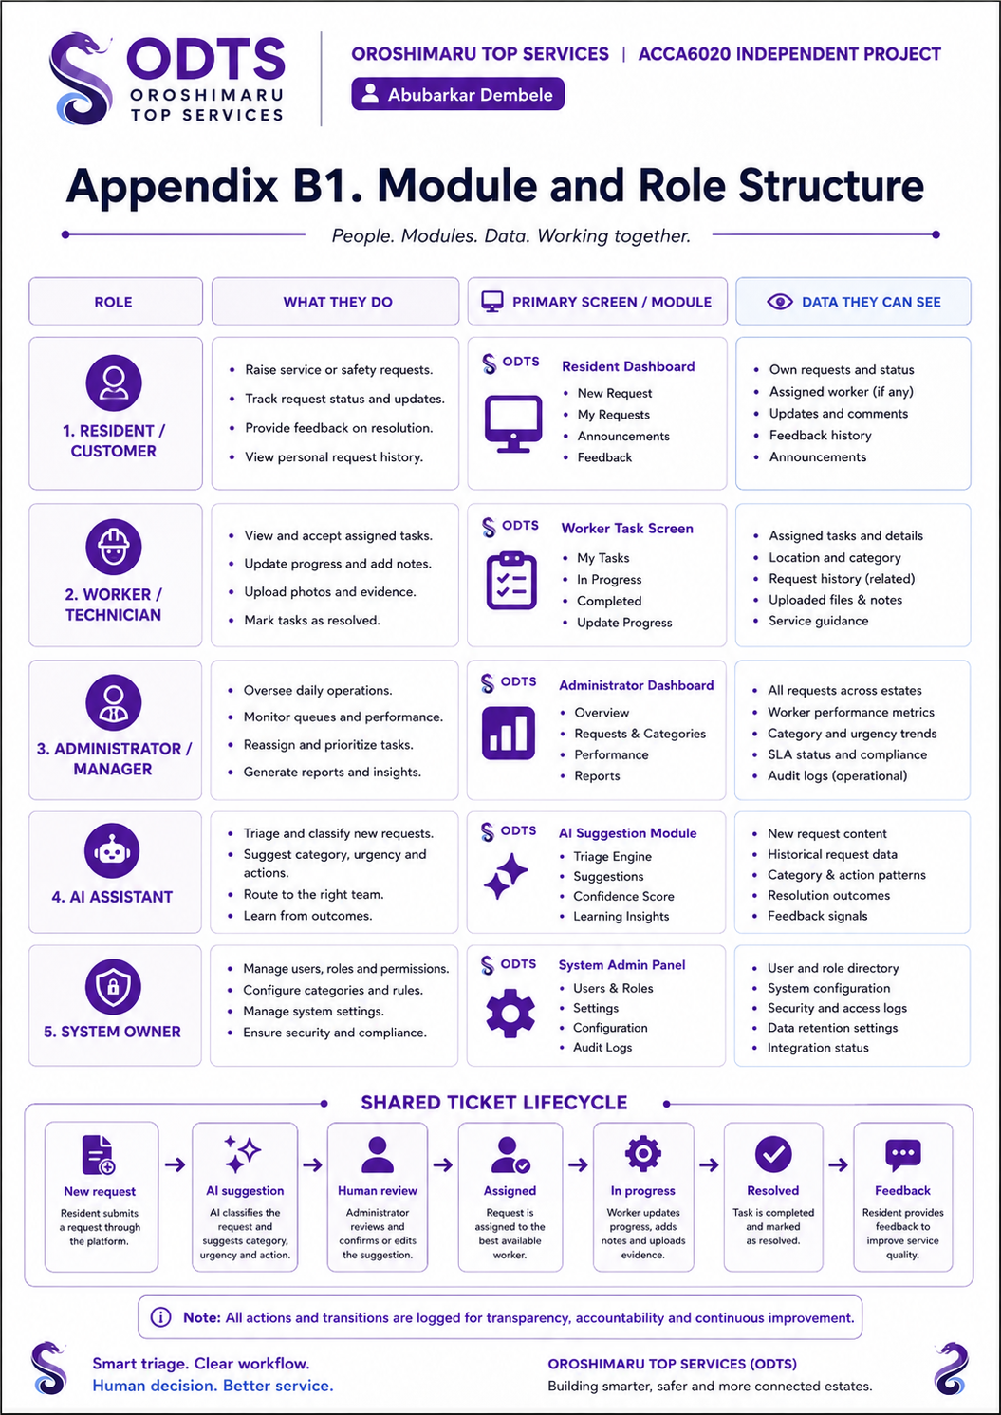
Figure B1. Final ODTS-branded module and role structure showing users, prototype modules, permitted data views and shared ticket lifecycle. Source: Author's own design.

Appendix B.2 - Prototype Screen Checklist
- Resident/customer dashboard: shows new request, request history, announcements and feedback access.
- AI-assisted request review: suggests category, urgency and draft guidance, but keeps the final decision under human review.
- Administrator dashboard: supports triage review, worker assignment, monitoring, reporting and audit trail checking.
- Worker task screen: shows assigned jobs, progress status, uploaded notes/evidence and completion updates.
- Feedback screen: records the user response after resolution so the service can be improved.
- Shared ticket lifecycle: new request -> AI suggestion -> human review -> assigned -> in progress -> resolved -> feedback.
These screens support the development-based nature of the project because they show system behaviour, user roles, workflow, permissions and evaluation evidence, not only questionnaire research.

Appendix C - Technical Models, Algorithm and Tools
This appendix provides extra technical detail supporting the design and implementation chapter. It shows the project is not only survey-based: it includes requirements, system modelling, an algorithm, interface prototypes, testing materials and a future implementation plan.
Table C1. Tools and techniques used or planned.
Tool / technique | Use in this project | Reason for selection
Canva / Figma | Clickable prototype screens and poster evidence. | Fast interface design and easy export for report evidence.
Draw.io / yEd | Architecture, workflow, role/module and lifecycle diagrams. | Clear system-modelling diagrams for academic explanation.
Python | Future text classification and triage logic. | Suitable for NLP, rule-based processing and machine-learning experiments.
scikit-learn / TF-IDF | Possible future supervised classifier. | Provides transparent baseline text-classification methods.
FastAPI / Django / Flask | Possible future web application backend. | Supports APIs, authentication logic and database connection.
SQLite / PostgreSQL | Future ticket, user, status and audit storage. | Relational structure suits the proposed data model.
Google Forms / Excel | Usability questionnaire and results summary. | Simple collection and descriptive analysis of participant feedback.
OWASP / NIST guidance | Security and responsible AI requirements. | Supports access control, audit logging and AI-risk controls.
Table C2. AI-assisted triage algorithm stages.
Stage | Input / process | Output
1. Capture request | User enters service category, title, description, location and urgency. | Structured request draft.
2. Clean text | Lowercase text and remove unnecessary spacing/noise. | Prepared description.
3. Keyword/rule scan | Look for terms such as leak, water, Wi-Fi, login, broken, unsafe or light. | Suggested service category.
4. Priority suggestion | Combine selected urgency with risk keywords. | Low, medium or high priority suggestion.
5. Draft guidance | Generate safe plain-English next-step guidance. | Draft response shown to user/admin.
6. Human review | Administrator or user checks, edits or rejects the suggestion. | Approved category, priority and action.
7. Ticket creation | Store original text, AI suggestion and final decision separately. | Auditable ticket record.
8. Status updates | Worker and administrator update progress. | Timeline, closure and feedback evidence.

Appendix C.1 - AI-Assisted Triage Pseudocode
Input: service_category, title, description, location, urgency_selected_by_user
Clean description by lowercasing text and removing unnecessary spacing.
Scan for keywords linked to maintenance, safety, IT support or general help.
Suggest a category and priority level.
Generate a short draft guidance message.
Display the original description, AI suggestion and explanation.
Allow the user or administrator to edit, approve or reject the suggestion.
Create the ticket only after review.
Store the AI recommendation separately from the approved human decision for audit and evaluation.

Appendix D - Ethics and Participant Documents
The signed ethics form should be inserted or uploaded with the submission evidence once the supervisor signature is received. Testing must use adult participants, fictional scenarios and anonymised results.

Appendix D.1 - Participant Information Statement
You are invited to test a prototype for an AI-Assisted Smart Estate, Safety and IT Support Management Platform. You will complete fictional tasks such as reporting a maintenance issue, checking ticket status and reviewing an AI suggestion. The purpose is to evaluate clarity, usability, trust and understanding. You do not need to provide real personal, medical, safety or property information.

Appendix D.2 - Consent Statement
I understand the purpose of the prototype test. I understand that the tasks are fictional and that my feedback will be anonymised for academic evaluation. I understand that I may stop taking part at any time without giving a reason.

Appendix D.3 - Questionnaire Items
No. | Question | Response type
1 | The platform was easy to navigate. | 1-5 Likert scale
2 | The service categories were clear. | 1-5 Likert scale
3 | The AI suggestion was understandable. | 1-5 Likert scale
4 | It was clear that a human could review or change the AI output. | 1-5 Likert scale
5 | The status-tracking process was useful. | 1-5 Likert scale
6 | The interface looked organised and professional. | 1-5 Likert scale
7 | What was confusing or missing? | Open comment
8 | What one change would improve the platform most? | Open comment

Appendix E - Test Evidence Pack
This appendix provides the test evidence structure for documenting usability testing. It separates task evidence, rating data and prototype changes so that results can be recorded clearly and consistently.

Appendix E.1 - Usability Task Sheet
Task ID | Participant task | Success criterion
T01 | Select the correct service for a leaking sink. | Maintenance route selected without help.
T02 | Submit the fictional leak request. | Required fields completed and AI review reached.
T03 | Review an AI suggestion. | Participant recognises the suggestion is editable.
T04 | Find the status of an existing ticket. | Correct ticket and latest status found.
T05 | Report a broken external light. | Safety route used and warning understood.
T06 | Submit a Wi-Fi problem. | IT support route used and confirmation reached.
T07 | Administrator assigns an urgent ticket. | Worker and status selected correctly.
T08 | Worker updates task progress. | Progress note and status saved in prototype flow.

Appendix E.2 - Raw Results Template
Participant | T01 | T02 | T03 | T04 | T05 | T06 | T07 | T08 | Notes
P01
P02
P03
P04
P05

Appendix E.3 - Prototype Version 2 Change Log
Change ID | Evidence source | Problem identified | Design change made | Verification
C01 | Participant feedback
C02 | Observation notes
C03 | Supervisor feedback

Appendix F - Exhibition Poster Evidence
The following poster is the final exhibition evidence for the AI-Assisted Smart Estate, Safety and IT Support Management Platform. It summarises the problem, aim, core modules, research method, shared ticket lifecycle, responsible AI controls, deliverables and prototype screen preview. The design uses the ODTS/Oroshimaru Top Services branding and was prepared as a visual summary for the exhibition and viva.
Canva poster link: https://www.canva.com/design/DAHPRGZZ18Y/GGSdbEz18bTJSKHXuyc14w/view

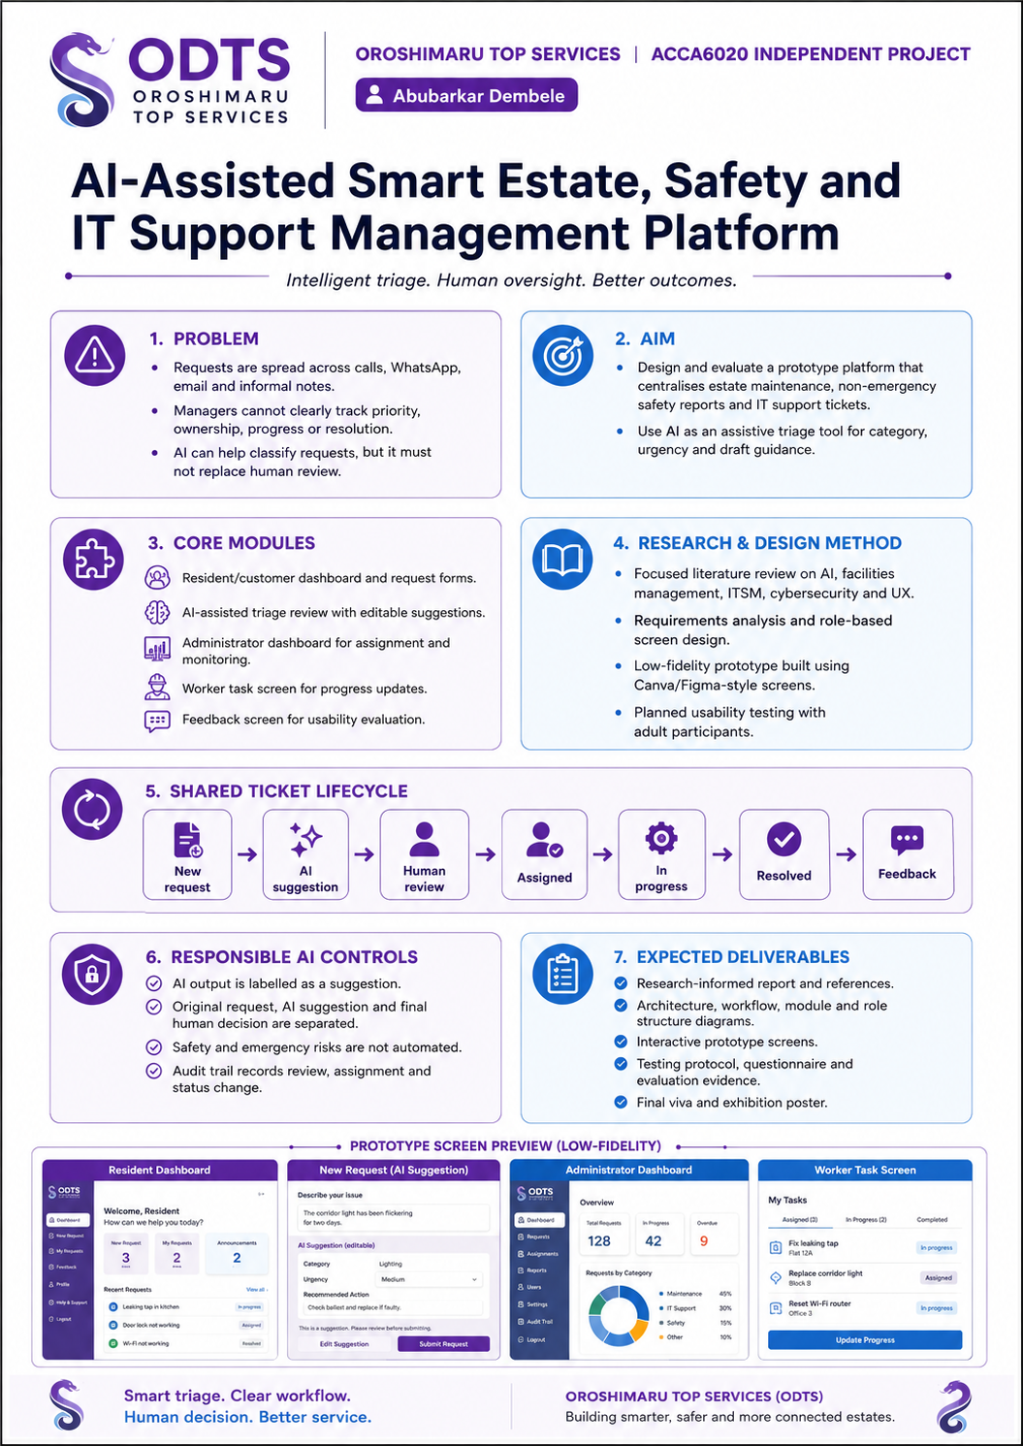
Figure F1. Final ODTS-branded exhibition poster for the AI-Assisted Smart Estate, Safety and IT Support Management Platform. Source: Author's own design.

Appendix F Checklist
- Poster includes the ODTS/Oroshimaru Top Services logo and consistent purple-blue branding.
- Problem, aim, modules, research method, workflow, responsible AI controls and deliverables are visible.
- Prototype screen preview is included to support the development/design component.
- The poster is readable as exhibition evidence and supports discussion during the viva.
- The editable Canva design link is recorded for traceability and future editing.

