DS 1 Template

My Screenshots/Photos
- Please add 4–6 screenshots or photos of your digital life.
- You can use your phone or laptop.
- For each screenshot, write one or two sentences explaining what it shows.

Screenshot/Photo 1
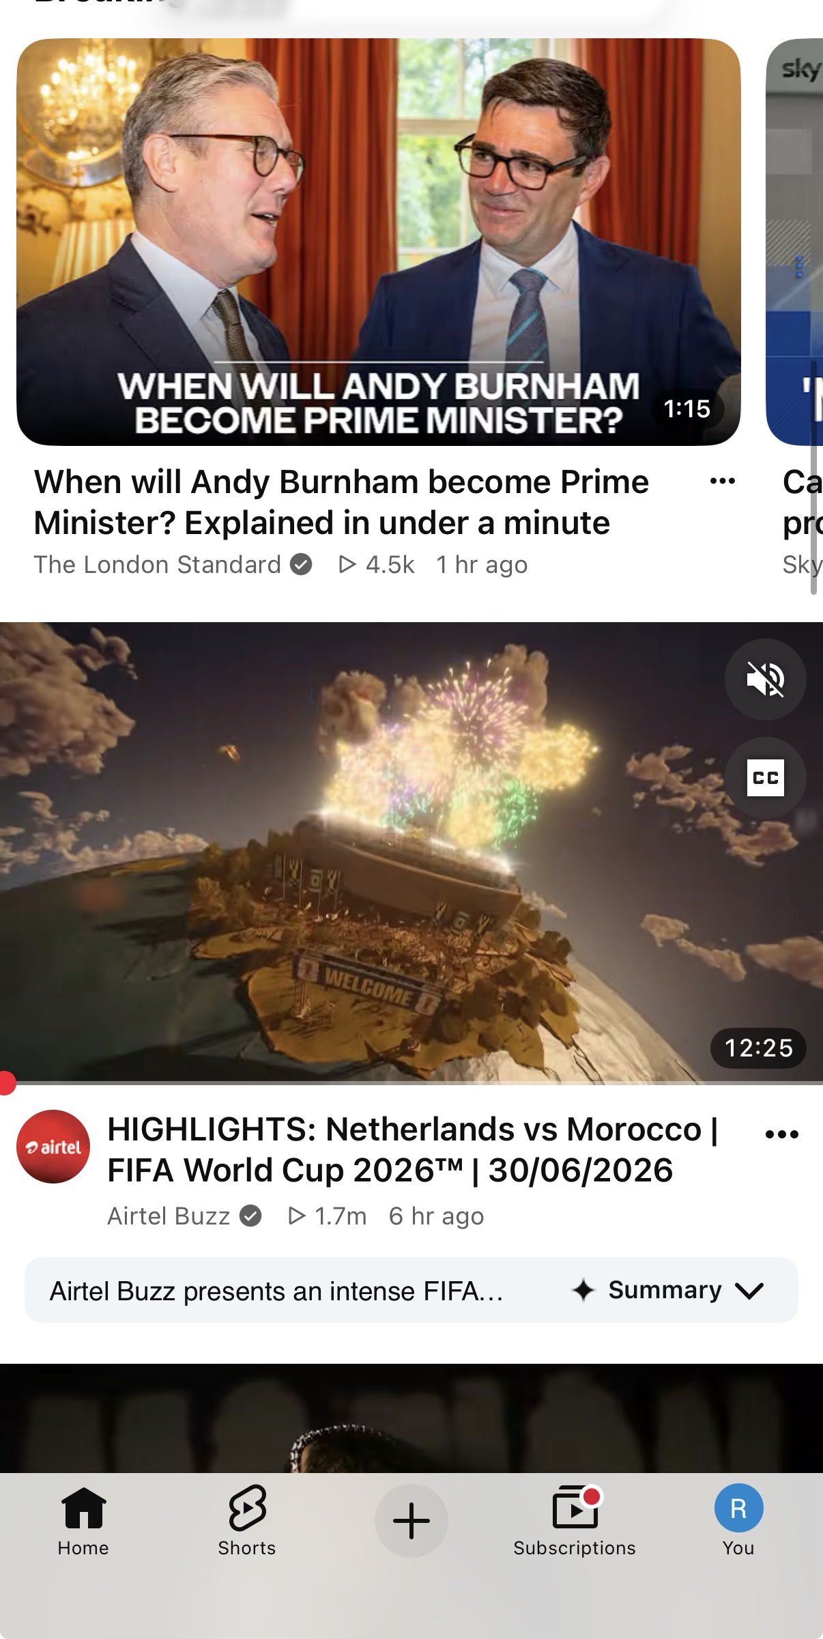
This is the picture from youtube. I watch video's here for entertainment. Sometimes for news as well

Screenshot/Photo 2
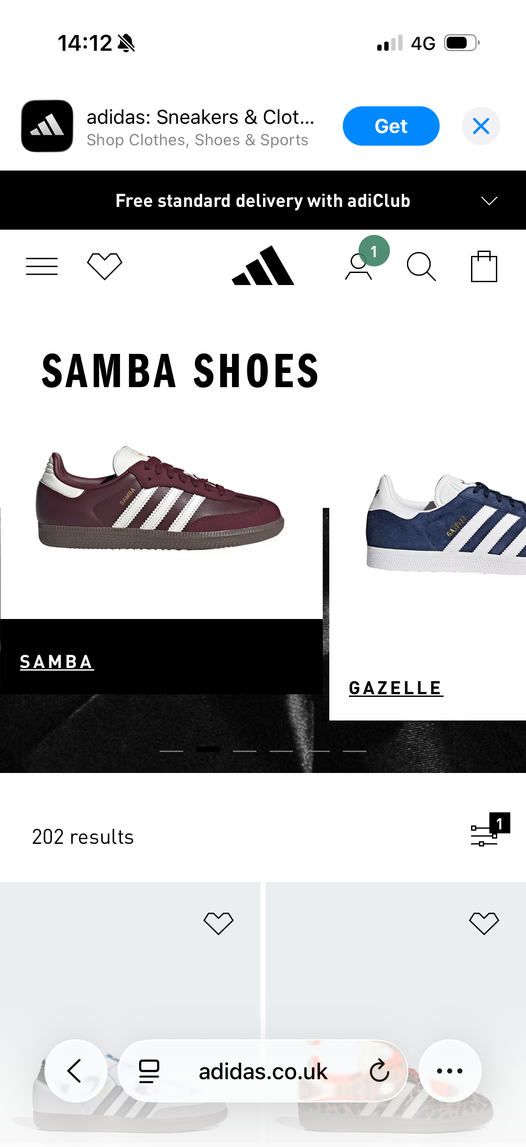
This is the picture from google it is in my digital life. I open links there as you can see in picture i opened the link for adidas website. I usually do shopping from there.

Screenshot/Photo 3
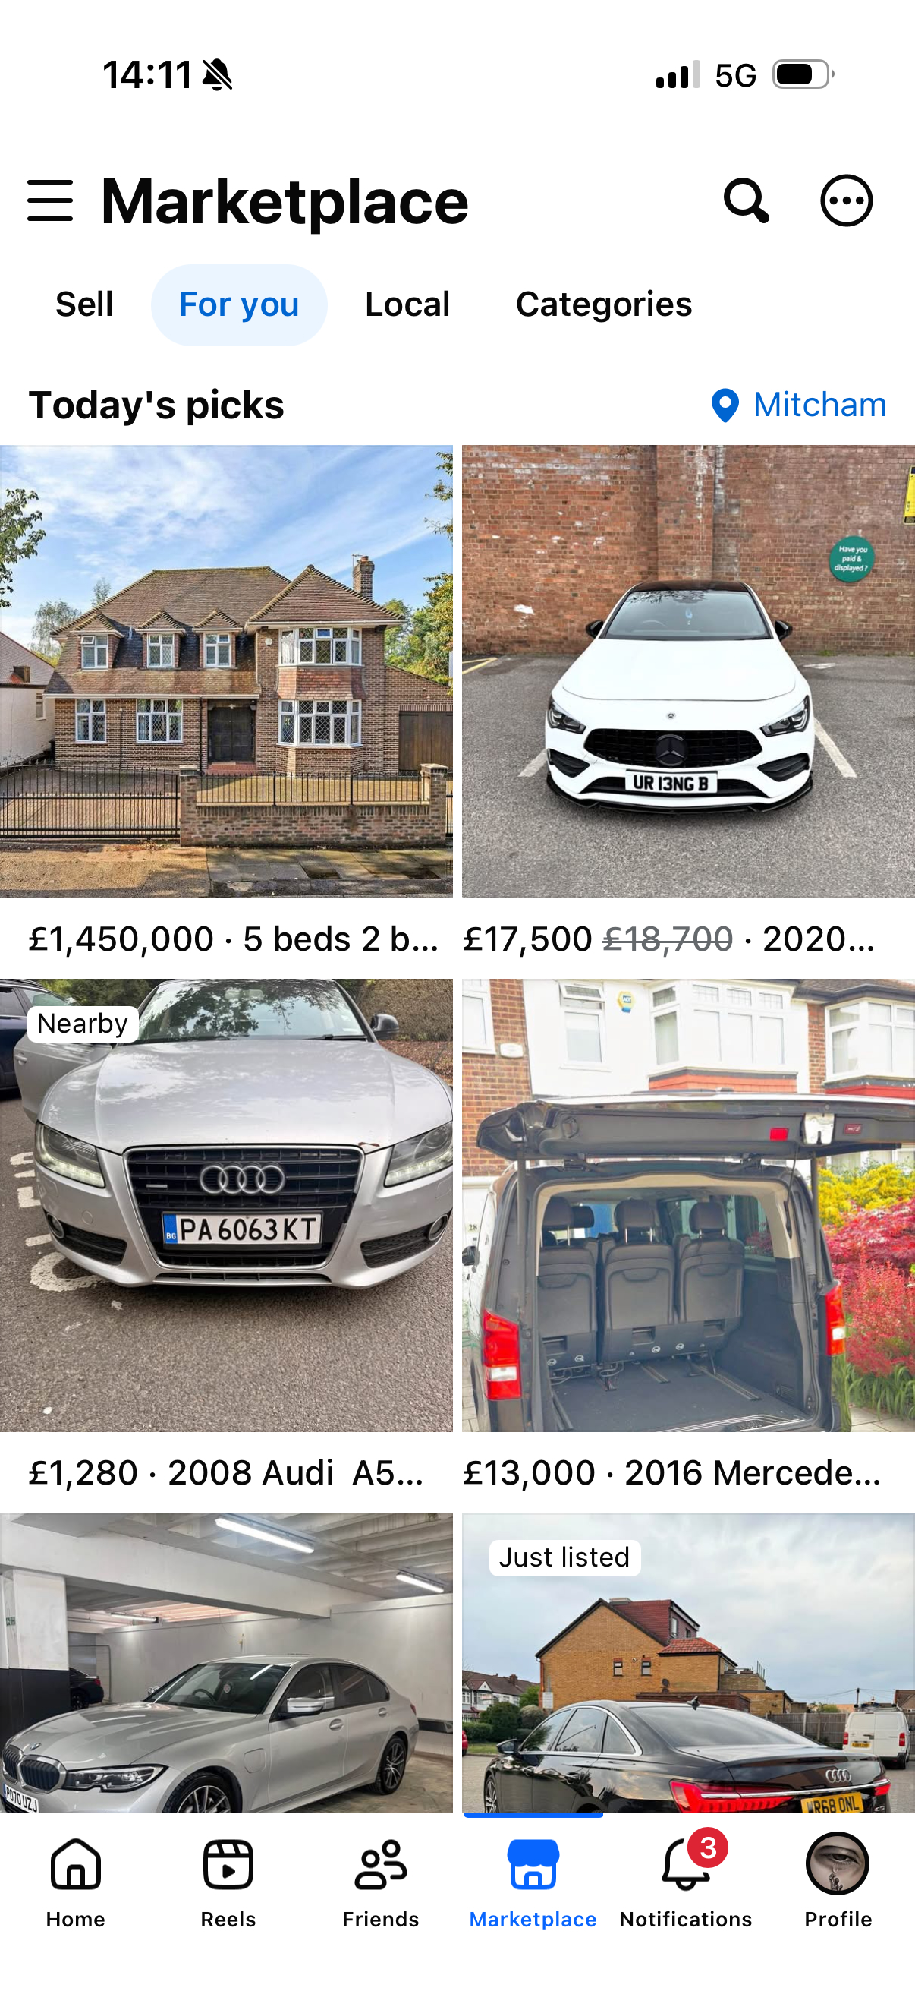
This is the picture from facebook market. I do car rentals so,i upload the pictures of my cars there.

Screenshot/Photo 4
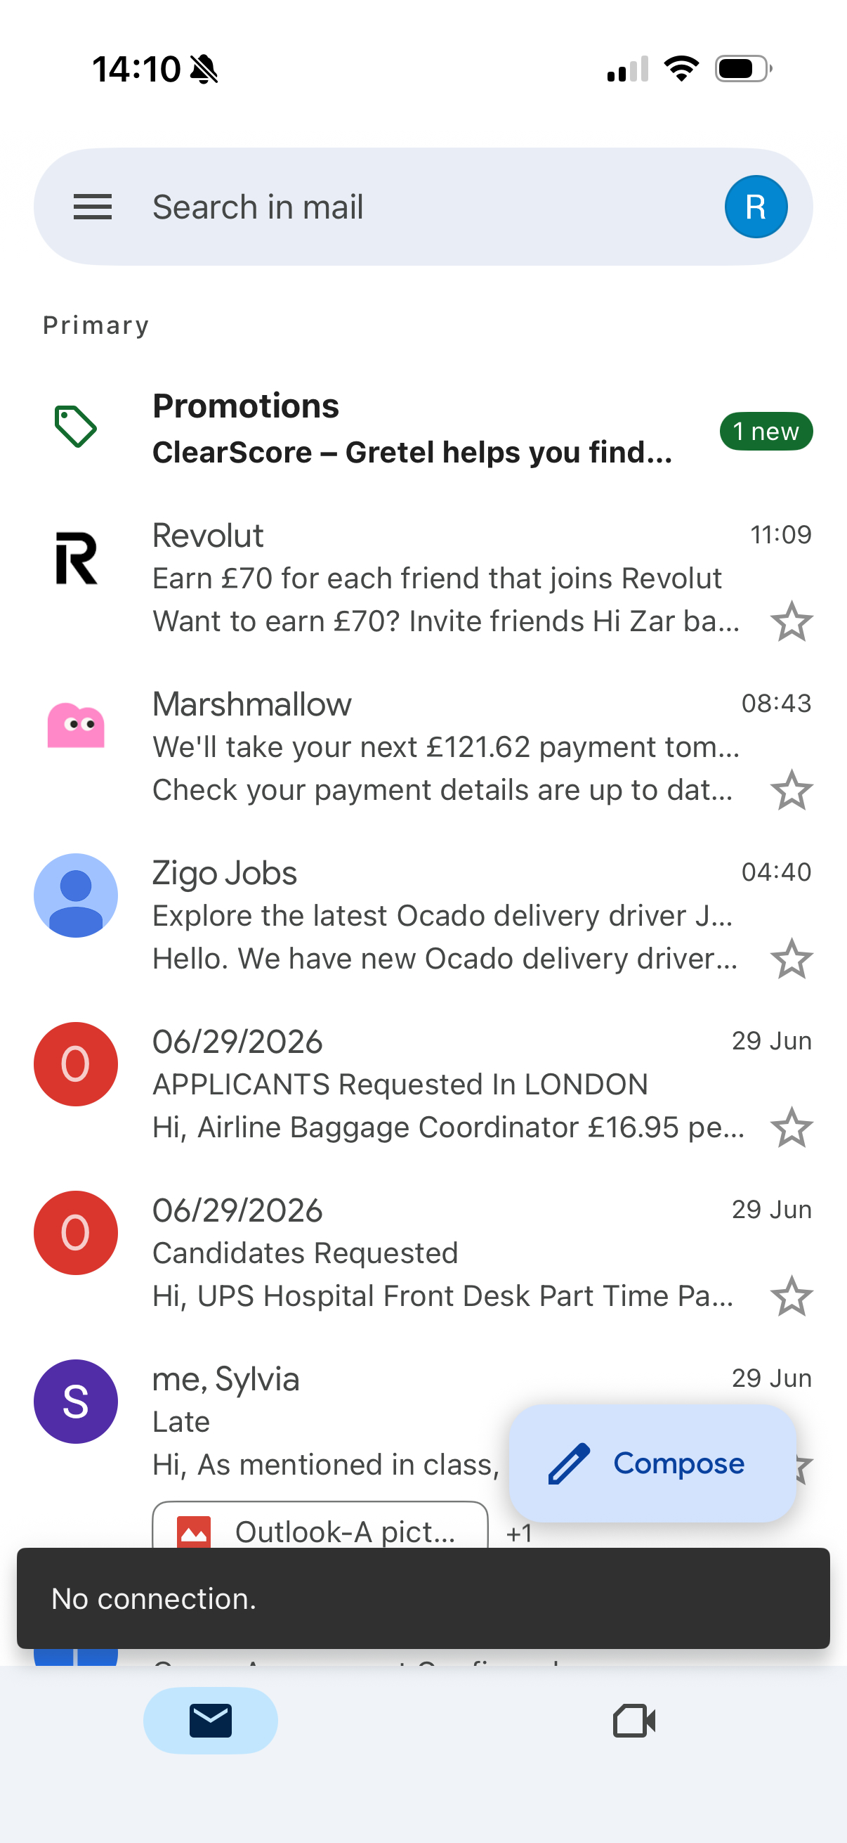
This is from my email i normally get emails from my wrok, University and from people to whom i am engaged with. It is in my daily life.

Screenshot/Photo 5
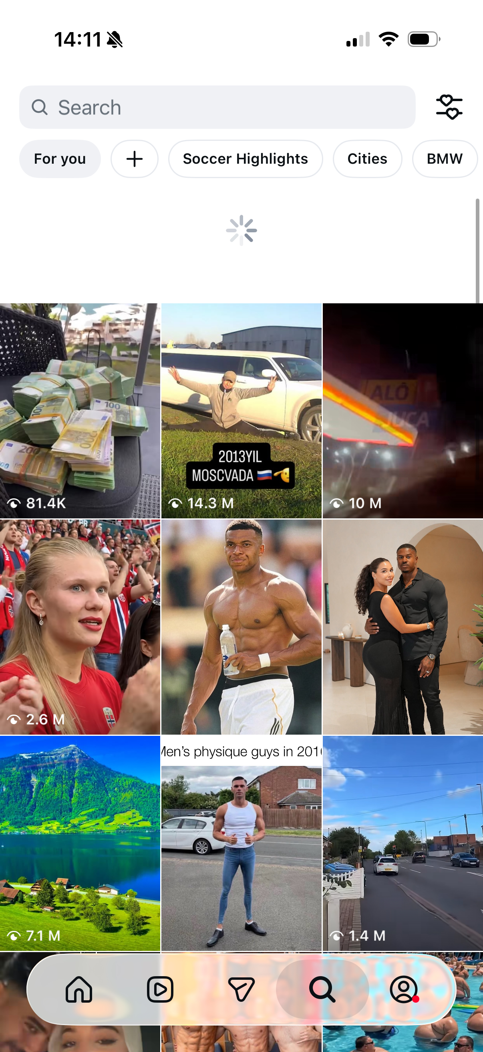
This screenshot is from instagram i watch reels here im my free time. Also i chat with my friends family members there. So, this is in my daily digital life.

Screenshot/Photo 6
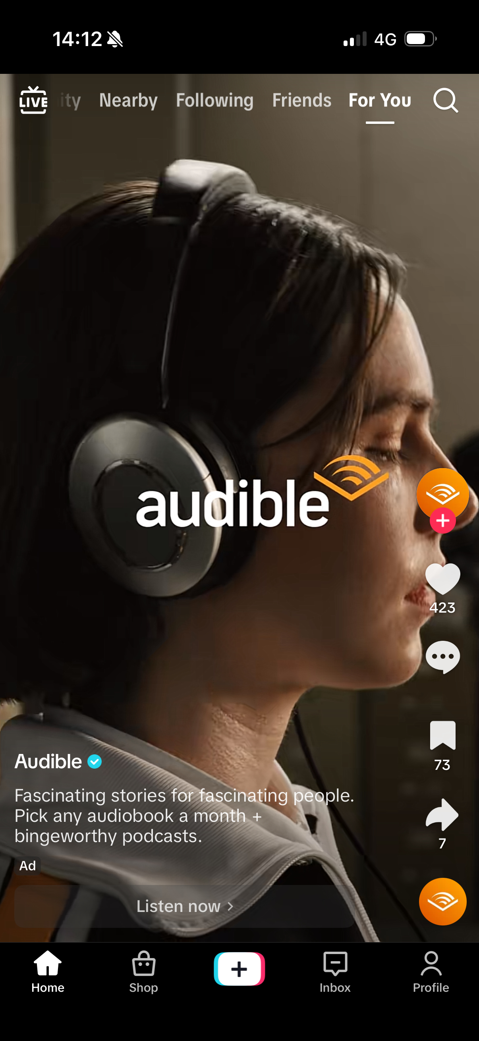
This picture is from Tiktok i watch diferrent contents there which people make. Also i check stuff from tiktok market place.

My Short Reflection
- Write 5–8 simple sentences about your digital life.
- You can use the sentence starters below if helpful.
My name is Zar Badsha.
I use digital tools to do my university work and find information.
I use my phone and laptop every day.
I feel confident when i use internet services safely.
I want to improve my computer and typing skills.
I also use technology to talk with family and friends.
I will use digital tools in a safe and responsible way.

Submission Checklist
Before you submit, please check:
​​​ ☒ I added 4–6 screenshots
☒ I wrote short sentences for each screenshot
☒ I wrote my short reflection
☒ My work is my own
☒ My file opens correctly
​​☒ My file opens correctly

