

Title of Applied Research Project: An investigation into the effects that social media has on the holistic development of young people

Name: Hywel Ainsworth

Student Number: 1500795

Programme of Study: BA Youth and Community Work

Undergraduate ARP Certificate

Name of the Programme of Study:

Name of Student (Capital Letters):

DECLARATION

I certify that the whole of this work is the result of my individual effort, and that all sources have been acknowledged.

Signed ............................................................... (Student)

Date ...............................................................DECLARATION

I am satisfied that this work is the result of the Student’s effort.

Signed .............................................................. (Lecturer)

Date ..............................................................

Abstract
This Applied Research Project investigates the effects that social media has on the holistic development of young people.
To completely understand the differing views that surround this issue, it has been crucial in undertaking a Literature Review, which analysed and compared relevant literature written around the Research Project.
Throughout engaging within the research with young people, three themes emerged as a result of the research, which are cyber bullying grooming and the threat of predators and impacts on body image and self-esteem.
A critical reflection of the research process is made, where an analysis of what went well and what can be improve about the research process is made.
This Applied Research Project makes recommendations for practice and finally concludes the process of the Research Project as a whole.

Acknowledgements
I would like to take the opportunity to thank people for their help and contribution throughout this process.
I would firstly like to thank my line manager, who has provided me with resources that have been useful for my Applied Research Project, and supported me through delivering my research activities, and throughout my placement.
I would also like to thank my supervisor for helping me and giving guidance to me throughout my Applied Research Project.
Lastly, I would like to thank the young people in my placement for participating within my research activities.

Table of Contents
Chapter 1: Introduction P.6
Chapter 2: Literature Review P.7 – P.11
Chapter 3: Methodology for Data Collection P.12 - P.15
Chapter 4: Presentation of Results P.15 – P.21
Chapter 5: Discussion, Critical Reflection, Conclusions P. 21 – P.25
Chapter 6: Recommendations for Practice P.25 – P. 26
Reference List P. 27 – P. 28

Chapter 1 - Introduction
This Applied Research Project will be focusing on the impact that social media has on the development of young people. The aims of the research are to firstly find out the types of social media that young people use, and how often they use it. Secondly, this research aims to educate young people on the dangers of using social media, and how young people can prevent themselves from being harmed. Finally, this research aims to find out how social media effects the holistic development of young people and their mental health. Within this day and age, many young people are using social media, whether it is just one platform or numerous platforms. Studies show that in 2017, 98% of young people aged between 16 – 24 were reported have accessed social media on the go (Office for National Statistics, 1996, no page number). There is a need for young people to be educated on the effects and dangers that are posed to them when using social media. Numerous people will benefit from this research, such as the young people themselves. Research gathered will be collected and analysed within this research project in various means, examples of how this will be done include focus groups and questionnaires. An example of a limitation of this research is that the group of young people will be going into secondary schools around Wales to deliver a production around mental health, and due to time restraints, the researcher will not be able to conduct any research with school pupils themselves. This is because there will not be enough time to collect adequate data and collect consent from parents and young people.

Chapter 2 - Literature Review
This literature review will explore and analyse a range of literature focused upon the themes linked with this piece of research which is “An investigation into the impact that social media has on the holistic development of young people.” It is anticipated that through the process of reviewing literature, themes will emerge which help direct and offer a focus to the research that will be undertaken for this Applied Research Project.
Social media has become very popular among young people within today’s society. Social media carries many benefits to it, such as it allows people to connect with friends and family, it allows people to make plans with one another. On the contrary, an article published by the BBC (Thelwell, 2017, no page number) notes that:
A survey of almost 5,000 students, mainly aged between 14 and 16, found a growing backlash against social media – with even more pupils (71%) admitting to taking digital detoxes to escape it.
(BBC Thelwell, 2017, no page number)
This article continues onto state that:
The survey of state and independent schools in England, by the Headmasters' and Headmistresses' Conference (HMC) and Digital Awareness UK, found that 57% of young people had received online abuse and 52% said it makes them feel less confident about themselves.
(BBC Thelwell, 2017, no page number)

Social media can have a negative impact on young people’s body image. Many young people want to look like their favourite celebrities. This could mean that young people want the clothes they wear, or the perfume/aftershave they bring out. The BBC (Roxby, 2014, no page number) published an article which states that ‘An inquiry by the All-Party Parliamentary Group on Body Image heard evidence that girls as young as five were worrying about their size and their appearance.’ This is a prime example of why parents and guardians should have more of an influence over what their children look at online.
There are many issues with social networking, however these can all be dealt with if youth workers are aware and understand the dangers to both the workers and young people. An example of an issue that may affect workers is that future employers check the profile of workers before employing them. Employees could lose their job if they bring the organisation they work for into dispute. Issues that young people may experience include cyberbullying. Young people can be groomed by adult, and young people can be involved in online exploitation through ‘sexting’ adults. Young people’s self-esteem could be damaged with these issues, and it could be something workers end up dealing with. Youth workers should always deliver informal issue based sessions to young people. Social media would be an example of an issue based session to deliver to young people, as nearly all young people use social media in one way or another. Sapin (2009, p.g.105) advocates this by saying
On-going anti-oppressive practice as well as issue-based youth work attempts to address the effects of inequalities by focusing on specific issues or targeting particular groups in order to have a more transformative function than simply offering support to young people during their transition from childhood to adulthood.
(Sapin 2009, p.g.105)

Whilst working alongside young people, youth workers need to make sure they are following the professional boundaries of the organisation they work for. If workers have a social media account, they need to make sure that they adjust the privacy settings on them, otherwise they risk getting into situations that could compromise a workers professional and personal position – both with current/future employers and family. Workers need to be happy with what they post online, this is because it can be viewed by anyone. Not only might it risk a worker’s professional position with their current/future employers, but it would also affect the professional relationship youth workers have with young people also. If young people are friends with youth workers on Facebook, it is not only bad practice, but it also breaks safeguarding related issues. As part of safeguarding young people, workers cannot speak to young people that they work with over social media. If a young person contacts a worker through a message or friend request, they must contact their line manager or supervisor to notify them that a young person has contacted them.
As discussed, there are many dangers that are posed to young people when using social media. Below are examples of these dangers.
Cyber Bullying
Cyber bulling is bullying someone using technology. Rogers (2010, p.g. 18) discusses that
Cyberbullying is different from face-to-face bullying because the bullies can keep a distance between themselves and their victims. This affords the bully a level of anonymity and a perceived sense of security that convinces them they won’t get caught.
(Rogers 2010, p.g. 18)
Examples include sending malicious comments and statuses targeting someone in particular and trolling. Cyber bullying can occur on a one-to-one basis, or in-group situations. If a young person is involved in regular threatening harassment using technology, they are committing an offence. An article written by the Daily Mail (Evans, 2013, no page number) states that ‘More than a million-young people are subjected to extreme cyber-bullying every day, according to the largest survey into online abuse.’ (Daily Mail, 2013, no page number) The article carries onto note that ‘Experts say cyberbullying can have a catastrophic impact on the self-esteem and have called for parents and regulators to recognise the seriousness of the issue.’ (Daily Mail, 2013, no page number) One of the disadvantages of young people using social media is how for many young people, it effects the way they look at their body image, which could impact on their mental health. An article published by ITV news (2017) states that ‘The survey of around 1,000 people aged between 11-25 was carried out ahead of an inquiry in Parliament into the impact of cyber bullying on young people’s mental health.’ (ITV News, 2017). This is true with young people that are being affected by social media. Both parents and professionals such as teachers, youth workers and social workers need to realise firstly when a young person is having issues with social media, and secondly need to know how to help support them. Batsleer (2008, p.g. 122) discusses that
A common motive for adopting bullying behaviour which isolates, traps or victimises outsiders, and those who do not belong to a group, is that it provides a protection against being bullied oneself.
(Batsleer 2008, p.g. 122)
Sexting
Sexting is the sending of sexual photos of yourself or someone else, via a form of technology. An article published by the BBC (2017, no page number) notes that
Officers in the North Wales and South Wales Police force areas have spoken to 166 young people, including 23 under 12s, for sending explicit images of themselves to others since 2013.
(BBC, 2017, no page number)

If young people are involved with this activity they are breaking the Sexual Offences Act 2003. This is if they send or have an inappropriate photo of someone under 18 in their possession. If convicted, they could receive a criminal offence. There are many effects that sexting has on young people. Once images and/or videos are sent they cannot get them back. It could be used against the person who sent them and end up being found by future employers and family. It can lead issues such as bullying and blackmail.
Grooming
Grooming is where an adult gets in contact with a young person, with the purpose of abusing them. Grooming is against the law, if individuals are grooming then they are breaking the Sexual Offences Act 2003. This is if an individual sends, or has an inappropriate photo of someone under the age of 18. An article written by the Telegraph (Sawer, 2016, no page number) looks into sexting among school children. This article states that ‘An estimated 44,000 secondary school pupils have been caught sending explicit messages.’ Online grooming has become extremely easy in recent years, with people making fake accounts to groom children and young people. An article published by The Sun (Wanless, 2017, no page number) supports this by noting that ‘Reported cases of online child grooming have risen by 64 per cent in England and Wales in the last year alone.’
In conclusion, from analysing the literature it is clear to see that a lot of research has gone into analysing the impacts that social media has on young people. This chapter has examined both the positive and negative impacts that social media has on young people, and the dangers that social media poses to young people. In order to explore this Applied Research Project question further, the next chapter will look into the methodology and methods that will be used to undertake research with young people to explore “An investigation into the impact that social media has on the holistic development of young people.”

Chapter 3: Methodology for Data Collection
This Applied Research Project will be looking to answer the question of “An investigation into the impact that social media has on the holistic development of young people.” The objective of this chapter is to discuss the methodological approach to the research, and also will be discussing the considerations and limitations of the research.
This research will be using both qualitative and quantitative data – a mixed methods approach. In the researcher’s opinion, using numerous methods of research is a vital way to getting the outcome of the research. Groundwater-Smith, Dockett & Bottrell (2015, p.g. 102) states that
The range of methods used in research with children and young people is extensive and includes the use of interviews and focus group methods; visual methods, such as photography, drawing and mapping; role play and other drama; the use of social media; and combinations of these.
(Groundwater-Smith, Dockett & Bottrell, 2015, p. 102)
While participating within this research, there are several ethical issues that need to be considered. Groundwater-Smith, Dockett & Bottrell (2015, p.g. 39) note that
Working in ways that reflect ethical symmetry requires us to acknowledge the multiple ethical issues inherent in research with children and young people, and to develop a set of ethical values – supplementary to institutional protocols – to guide our research and provide and anchor for our practice.
(Groundwater-Smith, Dockett & Bottrell (2015, p.g. 39)
One of the most important ethical considerations is that the young people’s participation within this research is voluntary. The young people who are participating within this research do not have to participate, they are given the choice. This links to youth work values and principles, and is supported by Banks (2010, p.g. 10) who notes that youth work is ‘a voluntary relationship with young people, who are free to choose whether or not to be involved.’ Whist undertaking research, researchers need to make sure that all participants give informed consent. Making sure that participants understand this is paramount. The British Education Research Association (2011, p.g. 5) notes that
Researchers must take the steps necessary to ensure that all participants in the research understand the process in which they are to be engaged, including why their participation is necessary, how it will be used and how and to whom it will be reported.
The British Education Research Association (2011, p.g. 5)
Research Considerations
There are numerous considerations before undertaking this research. One of these considerations is the amount of time the researcher has to complete the research. The researcher has limited time to gather, analyse and write up the research. Another consideration whilst undertaking the research is a consideration of the researcher’s skills and abilities. The researcher has certain skills and abilities that can be used whilst researching, and the researcher can learn and improve on new skills and abilities.
Methods
There will be numerous methods that will be used to collect the research. One of these methods will be the use of an online questionnaire. Dawson (2009, p.g. 97) states that ‘As with interviewing or focus groups, when designing a questionnaire start with easy questions with respondents will enjoy answering, thus encouraging them to continue filling in the questionnaire.’ A benefit of an online questionnaire is that it is quick to analyse. The results can of the online questionnaire can be analysed at any time. Another benefit of using online questionnaires is that it does not cost anything. Allowing participants to complete a questionnaire online saves money on printing out paper questionnaires for participants. Another method that will be used is a focus group. As Dawson (2009, p.g. 79) notes that ‘A focus group is where a number of people are asked to come together in order to discuss a certain issue for the purpose of research.’ Focus groups are beneficial in obtaining information about personal and group feelings, perceptions and opinions.
Limitations
There are several limitations to this research that the researcher needs to be mindful of. Firstly, the researcher has a limited time to undertake the research. Secondly, the researcher has a limited word count for the Applied Research Project, which means that information put into the research project needs to be precise and to the point. Another limitation to this research is that the young people that will be used within the research can withdraw at any time. This research is voluntary, which means that the young people can withdraw from it at any time, without reason.
To conclude, this chapter has looked into the methods, research considerations and limitations of the research. It is clear to see that there are many considerations and limitations that need to be thought through before engaging within the research, in order to examine further ‘An investigation into the effects that social media has on the holistic development of young people.’

Chapter 4: Presentation of Results
This chapter provides an outline of the results found whilst engaging in research activity with young people. Three themes that have emerged as a result of this research were cyber bullying, grooming and the threat of predators and impacts on body image and self-esteem. The data presented below under the three themes have come from the researcher’s focus group and online questionnaire.
Grooming & The Threat of Predators
A strong theme that emerged was that of grooming and the threat of predators. Throughout participating within the research, the theme of grooming was an underlying issue that arouse numerous times. This was a theme that all the young people from the focus groups noted, and what many participants of the online questionnaire commented upon. For example, Young Person A noted that they would ‘Block them.’ Young person B stated that they would ‘Go to the police.’ Both young people who engaged in the focus group, and the participants who took part in the questionnaire outlined that predators are a big issue within today’s society. A participant of the online questionnaire, when asked what they thought the dangers of social media are, noted that
Predators can get access to them. My daughter is young enough to still follow my rules about getting my approval before she adds someone or allows them to add her on social media

Cyber bullying
Another theme that emerged whist engaging within this research is cyber bullying. This was a theme that emerged in both the focus group and online questionnaire. Young people who participated in the focus group and online questionnaire noted that bullying has become a big part of today’s society, and with the use of the internet it has become easier to bully. A participant of the online questionnaire noted that
Misinformation is a biggy but so is fake profiles/fake people. there is also the issue of cyber bullying, with social media being so easily accessible the bullying doesn't stop in the classroom or on the streets, it's there at all hours, night or day.
Another participant backs this up by noting ‘Where to start? Bullying...back in the day bullying tended to finish at the school gate. Nowadays, online bullying is 24/7 with no escape for the person being bullied.’ This is backed up by a participant stating that
Cyber Bulling is one of the biggest dangers on social media and there still hasn't been a stop to it... over 60% of young people get bullied because of what they look like in a 'selfie' which then lowers the self confidence
A participant of the online questionnaire reaffirms this by when asked do you think social media has an impact on young people's development, they noted this
If you don't have any social media accounts, they are bullied. It's used to bully people and I believe has resulted in a lot of young people suicides. Young people become obsessed with it, wanting the most friend or followers etc. It's a way of exaggerating your life and lifestyle. It's also very good at influencing young people both in a good and bad way.

Impacts on Body Image and Self-Esteem.
Another theme that emerged was that of the impacts that social media has on young people’s body image and their self-esteem. In today’s society, many young people are affected by what they see and read on social media, and this can have a big impact on their self-esteem. When asked Do you think social media has an impact on young people’s body image? A participant noted
Definitely! Many young people these days are very obsessed with looking and being like someone on social media, whether somebody famous or just an ordinary person that poses on Instagram.
Within the focus group, when the group was asked ‘What are the impacts that social media can have on the holistic development of young people?’ Participant A noted ‘People can be influenced heavily by celebrities and the way they look, body wise and by the way they dress.’
The researcher will now present additional data from the online questionnaires. The Pie Chart below shows how many of the participants were over the age of 18. The researcher did not use any of the data from the one participant who was under the age of 18, as it had not been possible to seek the consent of the parent/guardian. However, each participant consented to engage in the questionnaire.
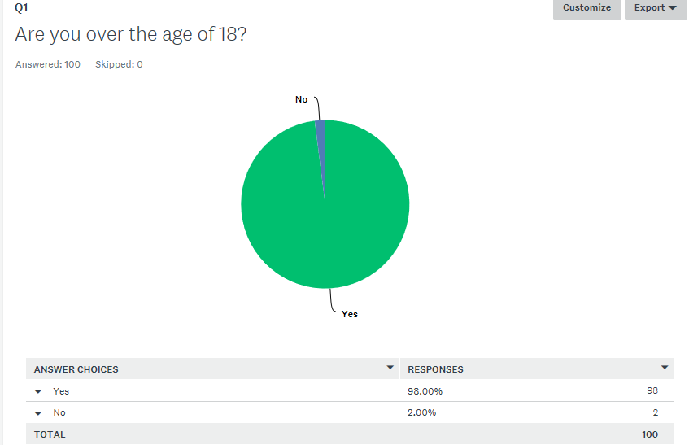

The second question on the online questionnaire asked participants to identify what social media platforms they use. The results can be viewed below.
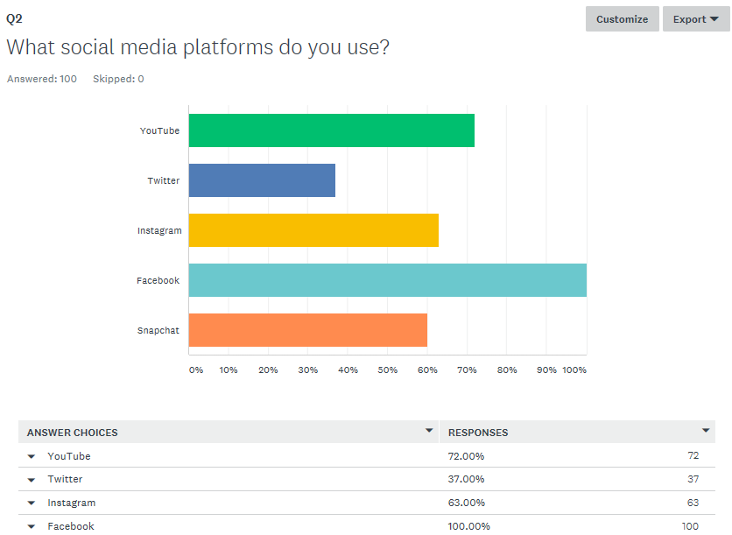
The same question was asked of the young people engaged in the focus group, and the graph below shows the results. As part of this research, young people engaged in a focus group. Below are the results.

All participants in the focus group were over the age of 18, and the Pie Chart below shows the gender breakdown.

Through engaging in research with the young people, there have been three themes that have been identified, which are cyber bullying, grooming, the threat of predators and impacts on body image and self-esteem. The next chapter will be discussing these themes in more detail in order to examine ‘An investigation into the effects that social media has on the holistic development of young people.’

Chapter 5 - Discussion, Critical Reflection, Conclusions
This chapter will be looking into the themes that emerged from the previous chapter in more detail. The three themes that emerged are cyber bullying, grooming and the threat of predators and impacts on body image and self-esteem. Within this chapter, a more detailed discussion of the themes that emerged within the research is presented in order to examine ‘An investigation into the effects that social media has on the holistic development of young people.’
Cyber Bullying
A strong theme of the research was that of cyber bullying. As a prominent theme, it was focused upon within the literature review. Nonetheless much has been written around this theme. An article written by The Daily Mail (Doyle, 2014, no page number) notes that ‘Unveiling new policies on internet safety, Ms Bradley warns of the potentially ‘devastating consequences’ of cyber-bullying, sexting and online trolls.’ The article carries onto state that ‘Parents will be warned they must 'face up' to the dangers of cyber bullying and make sure their children are aware of the risks of going online.’ Young person A from the focus group reaffirms this by saying that ‘It’s become a lot easier to bully, it carries on from school into the young person’s home.’

Grooming & The threat of predators
Another strong theme of the research was that of grooming and the threat of predators. As a prominent theme, it was focused upon within the literature review. There has been much written around this theme
An article written by the BBC (Ando, 2017, no page number) discusses about the work of The Child Exploitation and Online Protection centre. The article notes that ‘The article carries onto note that
Figures reveal that in its second year 297 suspected internet sex offenders were arrested - a threefold increase on the previous year - and 131 children were taken out of danger.
(BBC Ando, 2017, no page number)
As discussed within the literature review, grooming and the threat of predators has become a big problem within today’s society. Organisations such as the police are putting things in place to stop these sorts of things. A young person from the focus group reaffirms this by stating that ‘Organisations such as the police need to do more to protect children and young people online.’
Impacts on body image
The final theme that emerged was that of the impacts on body image. This theme was briefly focused upon in the literature review, however it emerged as a particularly prominent theme within the data collection. Within today’s society, social media has a considerable impact on young people. An article published by The Guardian (Wiseman, 2012, no page number) notes that
Today the web ensures that we are drowning in visuals: we're no longer comparing ourselves to "local images" – our friends – instead we're comparing ourselves to social-networked strangers, celebrities, and to Photoshopped images.
(Wiseman, 2012, no page number)

A participant of the online questionnaire noted that ‘The idea that young people need to look perfect is creating a massive problem amongst young people and their self-esteem.’ An article published by The Guardian (Bates, 2014, no page number) supports the participant’s observation, and notes that ‘New findings from the 2014 British Social Attitudes survey reveal that only 63% of women aged 18-34 and 57% of women aged 35-49 are satisfied with their appearance.’ A participant of the online questionnaire when asked whether social media has an impact on body image reaffirms this by noting
Defiantly. We constantly see photographs of celebrities, models, etc. who have ‘perfect’ bodies that are unachievable in real life. Also, social media opens up a world in which bullying is almost ignored, comments can be posted and removed, and these really get to vulnerable young people.

Critical Reflections
This part of the research project will be critically reflecting on the research process. Reflection is a vital tool that researchers need to use to see what went well, what did not go so well and what can be improved for undertaking research in the future. As Williams cited in Buchroth & Parkin (2010, p.g.113) discusses that
Reflective practice is at the heart of creative work with people. Community and youth work settings have historically encouraged workers to include regular reflective practices within their professional staff development and professional training courses at all levels.
(Williams cited in Buchroth & Parkin 2010, p.g.113)

The first reflection being that if the researcher had more time for the research project, more research would have been conducted around this topic. Due to there being a limited time for the researcher to conduct, analyse and write up the research, the researcher was only able to conduct a certain amount of research. Another reflection is that this is this is the first research project that the researcher has done. The researcher found the process daunting at first, but as the process went on, it became simpler and easier to interpret and understand. With the researcher participating in more research projects, it will enable the researcher to learn and develop these specialist skills and knowledge.
Conclusions
In conclusion, there has been much written around the impacts that social media has on the holistic development of young people. There is still yet to be more research conducted around this area. In this day and age, many young people use social media. Although there are many positive aspects to social media, such as keeping in touch with friends and family, many young people do not fully understand the risks and dangers that social media poses to them. Youth workers play a big part in educating young people in the dangers and risks of social media.
This chapter has explored the impacts that social media has on the holistic development of young people. Through reviewing literature, and through engaging in research with young people, it has been possible to see the many themes within the study. The final chapter of this Research Project will provide a summary of the main findings, and will discuss recommendations for further research and to answer the question ‘An investigation into the effects that social media has on the holistic development of young people.’
Chapter 6: Recommendations for Practice
This chapter aims to summarise the main findings of the research, and to recommendations for future practice. This chapter will conclude the research question of ‘An investigation into the effects that social media has on the holistic development of young people.’
Through engaging within the literature review, it is clear to see that there has been a lot written around the research project question. An example of this is by an article written in the Guardian (Campbell, 2017, no page number) notes that
Instagram has the most negative impact on young people’s mental wellbeing, a survey of almost 1,500 14- to 24-year-olds found, and the health groups accused it of deepening young people’s feelings of inadequacy and anxiety.
(The Guardian Campbell, 2017, no page number)

The literature review also looks into some of the dangers that social media poses to young people. On the other hand, there still needs to be research done into this area. Three prominent themes emerged as a result of undertaking research with young people. The three themes were cyber bullying, grooming and the threat of predators and impacts on body image and self-esteem. These themes were explored and analysed in great detail in chapters 4 and 5. More research on these themes needs to be conducted.
Recommendations for Further Practice
Within their practice, youth workers need to make sure that they stay on top of current policies that will influence their work. Also within their practice, youth workers need to educate young people on the risks and dangers that social media pose to them. A lot of research has gone into the benefits, risks and dangers of social media, but continuous research needs to be done. In regards to the research, the researcher has found the process to be challenging, but enjoyable. If the researcher was to conduct research like this again, changes would be made to the way the research was conducted. Firstly, the researcher would not use an online questionnaire as a means of collecting research. There were too many responses to analyse that took up a lot of time.
To conclude, this chapter has summarised the main results of the research and looked into the recommendations of practice. This Applied Research Project has reviewed relevant literature, participated in research with young people and presented the results, discussed the main themes that came out of the research and discussed the recommendations for practice in order to answer the question ‘An investigation into the effects that social media has on the holistic development of young people.’ The researcher believes that the question has been explored fully within this project, but also believes strongly that more research needs to go into this area.

References
Ando, B. (2008). BBC News, UK, Hunting the internet predators. [online] News.bbc.co.uk. Available at: http://news.bbc.co.uk/1/hi/uk/7359589.stm [Accessed 3 Jan. 2018].
BBC News. (2017). Hundreds of children in Wales sexting, police figures show. [online] Available at: http://www.bbc.co.uk/news/uk-wales-40565909 [Accessed 2 Nov. 2017].
BBC News (2007). Children at risk on the internet. [online] Available at: http://news.bbc.co.uk/1/hi/england/coventry_warwickshire/6669183.stm [Accessed 10 Jan. 2018].
Batsleer, J. (2008). Informal learning in youth work. London: SAGE.
Banks, S. (2010). Ethical Issues in Youth Work. 2nd ed. Hoboken: Taylor and Francis.
BERA, (2011) British Educational Research Association Ethical Guidelines (online) Available from www.bera.ac.uk/guidelines.htm. [accessed 9 Nov 2017]
Buchroth, I. and Parkin, C. (2010). Using Theory in Youth and Community Work Practice. 1st ed. London: Sage Publications Ltd.
Campbell, D. (2017). Facebook and Twitter 'harm young people's mental health'. The Guardian. [online] Available at: https://www.theguardian.com/society/2017/may/19/popular-social-media-sites-harm-young-peoples-mental-health [Accessed 10 Jan. 2018].
Davis, N. (2016). Online grooming of children often 'alarmingly fast', researchers find. The Guardian. [online] Available at: https://www.theguardian.com/society/2016/sep/08/online-grooming-of-children-often-alarmingly-fast-researchers-find [Accessed 3 January 2018]
Dawson, C. (2009). Introduction to Research Methods. 4th ed. How To Books.
Doyle, J. (2017). Facebook and Twitter could face threat of new laws if they fail to crack down on cyber bullying, minster warns. The Daily Mail. [online] Available at: http://www.dailymail.co.uk/news/article-4262456/Parents-banish-cyber-bullies-says-minister.html [Accessed 3 Jan. 2018].
Evans, B. (2013). One in five young people suffer 'extreme cyber-bullying' every day with Facebook accounting for more than half of the abuse. Daily Mail.
Groundwater-Smith, S., Dockett, S. and Bottrell, D. (2015). Participatory research with children and young people. London: SAGE.
Harrison, R. and Wise, C. (2005). Working With Young People. London: SAGE Publications Ltd.
Learning and Skills Improvement Service. (2012) Youth work National Occupational Standards, Coventry: Learning Skills and Improvement Service
Ons.gov.uk. (1996). Internet access - households and individuals - Office for National Statistics. [online] Available at: https://www.ons.gov.uk/peoplepopulationandcommunity/householdcharacteristics/homeinternetandsocialmediausage/datasets/internetaccesshouseholdsandindividualsreferencetables [Accessed 10 Jan. 2018].
O’Leary, Z. (2010) The Essential Guide to Doing your Research Project. London: Sage publications.
Ringrose, J., Gill, R., Livingstone, S. and Harvey, L. (2012). Children, young people, and sexting. London School of Economics and Open University.: NSPCC
Rogers, V. (2010). Cyberbullying. 1st ed. Jessica Kingsley Publishers.
Roxby, P. (2014). Does social media impact on social media?. BBC. [online] Available at: http://www.bbc.co.uk/news/health-29569473 [Accessed 6 Nov. 2017].
Thelwell, E. (2017). Teens 'rebelling against social media', says headteachers. [online] Available at: http://www.bbc.co.uk/news/uk-41509402 [Accessed 13 Oct. 2017]
The Guardian (2014). Why is women’s body image anxiety at such devastating levels?. [online] Available at: https://www.theguardian.com/lifeandstyle/2014/oct/14/women-body-image-anxiety-improve-body-confidence [Accessed 5 Jan. 2018].
Sapin, K. (2009). Essential skills for youth work practice. 1st ed. Los Angeles, Calif.: SAGE.
Sawer, P. (2016). Wave of sexting by school children raises fears of grooming. The Telegraph. [online] Available at: http://www.telegraph.co.uk/education/educationnews/12191946/Wave-of-sexting-by-school-children-raises-fears-of-grooming.html [Accessed 6 Nov. 2017].
Wanless, P. (2017). Government must make it law for net giants to stop our children suffering and being groomed online. The Sun. [online] Available at: https://www.thesun.co.uk/news/4873321/government-law-for-stop-children-groomed-online-nspcc-opinion/ [Accessed 21 Nov. 2017].
Wiseman, E. (2012). Uncomfortable in our skin: the body-image report. The Guardian. [online] Available at: https://www.theguardian.com/lifeandstyle/2012/jun/10/body-image-anxiety-eva-wiseman [Accessed 9 Jan. 2018].

