

Student name: Petra Stankova
Student ID: 2216986

Module name: Empowering the Older Person

Module code: BMHP6027_LON

Lecturer’s name: Laila Surani
Topic: Evaluating the care and support needs of older people.
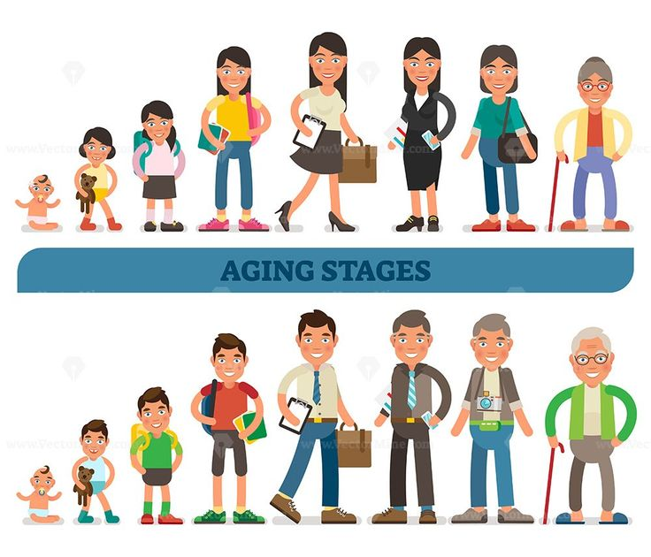  (VectorMine, 2022) |  | Critical Evaluation – Care, Empowerment and Support Needs  Support to maintain functional ability (e.g. mobility, daily tasks), not just treatment (World Health Organization, 2022). In practice, too much help can cause over-dependence and reduce recovery.  Independence is important for dignity and wellbeing (Office for National Statistics, 2023). Care settings may limit independence due to strict routines.  Freedom of choice is key to empowerment. People should be involved in decisions about their care (NHS England, 2023).  Social and emotional support is important, as loneliness is common (Campaign to End Loneliness, 2023). Activities in care homes are not person centred and meaningful. |  | 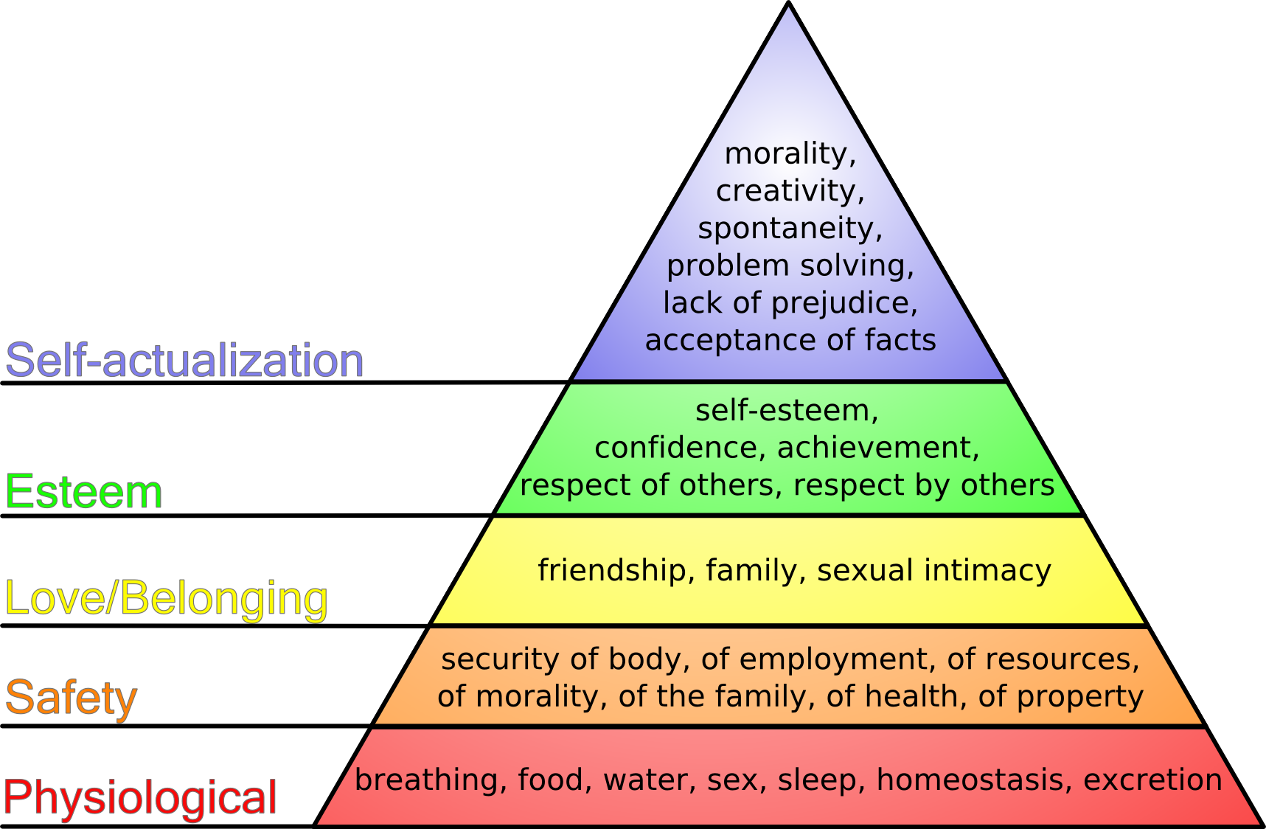  (Pychology, n.d.)
Introduction  Empowering older people means helping them have control over their lives and make their own decisions.  In the United Kingdom, around 1 in 6 people are aged 65+ (Office for National Statistics, 2023).  Globally, by 2030, 1 in 6 people will be aged 60 or over (World Health Organization, 2022).  Relevant Theories  Person-Centred Theory (Carl Rogers)  - Focuses on treating individuals with respect, empathy, and dignity.  - Supports empowerment by involving older people in decisions.  - May be difficult in busy care settings  __________________________________  Effectiveness and Benefits of Approaches & Interventions (UK)  Person-Centred care approach  Focuses on individual needs, preferences, and involvement in decisions. Improves confidence, independence, and health outcomes (BHF, 2023). Effective because it promotes empowerment and dignity. However, requires staff training and time, which may limit practice.  Integrated & Community-Based Care (UK Provision)  The NHS England promotes working in partnership with communities (NHS England, 2022). Community care helps older people stay at home longer and remain independent (Age UK, 2025). Reduces hospital admissions and improves quality of life but access may vary depending on local services |  |  |  | Relevant Theories  Maslow’s Hierarchy of Needs  - Older people need basic needs (health, safety) and higher needs (esteem, belonging).  - Empowerment improves self-esteem and wellbeing.  Lack of person-centred care can lead to older people feeling ignored and losing control over their lives (NHS England, 2023).  Cultural and communication barriers may prevent elderly from expressing their needs.  Limited access to community services and support can reduce opportunities to stay active and independent (Age UK, 2023).  ___________________________________  Recommendations for Improvement of Services to Empower Older People  Provide person-centred care that respects individual needs, preferences, and culture. Encourage independence in daily activities. Improve staff training (communication, cultural awareness). Offer meaningful and inclusive activities. Increase access to community-based services. Involve older people in decision-making about their care. Promote dignity, respect, and choice.  Conclusion  In conclusion, older people face many challenges in maintaining independence and functional ability, including health problems, loneliness, and lack of personalised care. Although services aim to support them, there are still gaps in practice. Improving person-centred care, promoting independence, and empowering older people through choice and involvement can significantly improve their quality of life.
UK Policy – “People at the Heart of Care”UK Government policy focuses on choice, control and independence (UK Government, 2021). Supports empowerment through personalised care and support plans. Challenges include funding, staffing, and implementation gaps.
_________________________________
Challenges Faced by Older People in Maintaining Independence and Functional Ability
Physical health problems such as mobility issues, chronic illness, and disability, which reduce their ability to carry out daily tasks (World Health Organization, 2022).
Cognitive decline (e.g. memory problems) can affect decision-making and independence.
Loneliness and social isolation are common and can negatively impact mental health motivation (Campaign to End Loneliness, 2023).
Some care settings promote over-dependence, where staff do tasks instead of encouraging independence.

.

References
Age UK (2023) Later Life in the United Kingdom 2023. Available at: https://www.ageuk.org.uk (Accessed: 17 March 2026).
Age UK (2025) NHS 10-year plan and older people. Available at: https://www.ageuk.org.uk (Accessed: 17 March 2026).
British Heart Foundation (2023) Person-centred care. Available at: https://www.bhf.org.uk (Accessed: 17 March 2026).
Campaign to End Loneliness (2023) Loneliness statistics. Available at: https://www.campaigntoendloneliness.org (Accessed: 17 March 2026).
Maslow, A. (1943) A theory of human motivation. Psychological Review.
NHS England (2022) Working in partnership with people and communities. Available at: https://www.england.nhs.uk (Accessed: 17 March 2026).
NHS England (2023) Health and wellbeing of older people. Available at: https://www.england.nhs.uk (Accessed: 17 March 2026).
Office for National Statistics (2023) Overview of the UK population: 2023. Available at: https://www.ons.gov.uk (Accessed: 17 March 2026).
Pychology, M.H. of N. (n.d.). Maslow’s Hierarchy of Needs. Available at: https://www.tastessightssounds.com/2015/12/maslows-hierarchy-of-needs.html (Accesed 17 March 2026).
Public Health England (2021) Health profile for England: older people. Available at: https://www.gov.uk (Accessed: 17 March 2026).
Rogers, C. (1961) On Becoming a Person. Boston: Houghton Mifflin.
UK Government (2021) People at the Heart of Care. Available at: https://www.gov.uk (Accessed: 17 March 2026).
VectorMine. (2022). Aging stages conceptual vector illustration collection, from baby to teenage to adult and elderly - VectorMine. Available at: https://vectormine.com/item/aging-stages-conceptual-vector-illustration-collection-from-baby-to-teenage-to-adult-and-elderly/ (Accesed 17 March 2026).
World Health Organization (2022) Ageing and health. Available at: https://www.who.int/news-room/fact-sheets/detail/ageing-and-health (Accessed: 17 March 2026).Maslow, A. (1943) A theory of human motivation. Psychological Review.
World Health Organization (2022) Ageing and health. Available at: https://www.who.int (Accessed: 17 March 2026).

