Letter of Transmittal

Jamie Black BSC (Hons) Building Surveying, MRICS, MCABE, MCIOB
Maes Yr Hen Ysgol, The Ropewalk
Hakin, Milford Haven
Pembs, SA73 3LW

5th February 2018

Mrs Lindsey Richards,
UWTSD, SABNE, Mount Pleasant
Swansea, SA1 6ED

Dear Mrs Richards,
We are writing to you with the assignment entitled ‘Procurement Problems’, for your consideration of marks towards the module ‘Contract, Professional Practice and Administration’.
This briefing paper makes recommendations as to the type of procurement route, contract and tender process that should be utilised in each of the 5 scenarios given. Where possible, we have given a written description of ‘assumptions’ that we have made for each scenario, to avoid any confusion. We have also given a brief description of the ‘Post Contract Process’ and ‘advantages/dis-advantages’ for each scenario.
Our recommendations have been based upon key construction issues and include: Time, Cost, Quality, Performance, Risk Allocation, Quality, Complexity, Competition, Certainty and Value for Money.
The information in this briefing paper is all my own work and has been produced using varying sources of information including journals, articles and the internet.
Where possible, expert guidance has been utilised from leading institutions including RICS, JCT and CIOB.
I hope you find the briefing paper very informative and wish you all the best with your proposals.
Please let us know if you have any concerns or require and further clarification on any of the issues within this report.
All the best.

Jamie Black BSC (Hons) Building Surveying, MRICS, MCABE, MCIOB
07792 072942
‘’Procurement Problems’’

Briefing Paper

Presented to
Mrs Lindsay Richards
Lead Quantity Surveyor
UWTSD, SABNE, Mount Pleasant Campus
Swansea SA1 6ED

Prepared By
Jamie Black
Managing Director BLX Building Surveyors
jamieblackgda@outlook.com

This briefing paper makes recommendations as to the type of procurement route, contract and tender process that should be utilised in each of the 5 scenarios given.
Since all 5 scenarios are based on ‘private’ funding and are not procured using ‘public funding’, we have opted to concentrate on the more popular ‘JCT Suite of Contracts’.
We have given a written description of ‘assumptions’ that we have made for each scenario, to justify our choice of procurement route and contract type. We have also given a brief description of the ‘Post Contract Process’ and ‘advantages/dis-advantages’ for each scenario, along with the type of tender process that we believe should be used.
Our recommendations have been based upon key construction issues and include: Time, Cost, Quality, Performance, Risk Allocation, Quality, Complexity, Competition, Certainty and Value for Money.

Version 1.01 5th February 2018
Table of Contents
Page numbers
- Scenario 1 5-8
  - Assumptions
    - Cost
    - Time
    - Quality
    - Risk
  - Procurement Route
  - Main Contract Type
    - Advantages
    - Dis-Advantages
  - Tendering Process/Selection

- Scenario 2 9-12
  - Assumptions
    - Cost
    - Time
    - Quality
    - Risk
  - Procurement Route
  - Main Contract Type
    - Advantages
    - Dis-Advantages
  - Tendering Process/Selection

- Scenario 3 13-15
  - Assumptions
    - Cost
    - Time
    - Quality
    - Risk
  - Procurement Route
  - Main Contract Type
    - Advantages
    - Dis-Advantages
  - Tendering Process/Selection

- Scenario 4 16-19
  - Assumptions
    - Cost
    - Time
    - Quality
    - Risk
  - Procurement Route
  - Main Contract Type
    - Advantages
    - Dis-Advantages
  - Tendering Process/Selection

- Scenario 5 20-22
  - Assumptions
    - Cost
    - Time
    - Quality
    - Risk
  - Procurement Route
  - Main Contract Type
    - Advantages
    - Dis-Advantages
  - Tendering Process/Selection

Bibliography 23
Appendix A – RIBA Plan of Works 2013 24
List of Figures
Figure 1 – Route to Major Project Construction Contract
Figure 2 – Typical Contractual Structure of Major Project Contract
Figure 3 – Route to Management Building Contract
Figure 4 – Typical Contractual Structure of Management Building Contract
Figure 5 – Route to Minor Works Building Contract with Contractors Design Contract
Figure 6 – Typical Contractual Structure of Minor Works Building Contract with Contractors Design
Figure 7 – Route to Design and Build (Package/Turnkey) Contract
Figure 8 – Typical Contractual Structure of Design and Build Contract
Figure 9 – Route to Prime Cost Building Contract
Figure 10 – Typical Contractual Structure of Prime Cost Building Contract
- Scenario 1
A private developer has purchased the land and is now interested in the construction of a new 10 storey office block in Cardiff city centre value £20 million.
  - Assumptions

1.1.1 Cost
A definitive budget for the project has been set and must not be exceeded. We assume the developer will want cost certainty from the outset.
1.1.2 Time
Whilst no timescales have been given, we assume that the developer will want the project completed at the earliest opportunity to start generating revenue.
    - Quality
We assume that the developer has a ‘professional team’ to assist with early project information up to the close of RIBA stage 2 (Concept Design). We assume the main contract (once let) will include the ‘contractor’ completing RIBA stages 3-7 and providing more detailed designs.
    - Risk
We assume the biggest risk to the developer is the budget. We assume there are no underlying issues with the site/land and all services are available. We assume that the developer wants to minimise their risk (exceeding budget) by employing a contractor to provide a full service of Designing and Building the project.

  - Procurement Route – Design and Build
This route benefits in time and cost, but at the expense of quality.
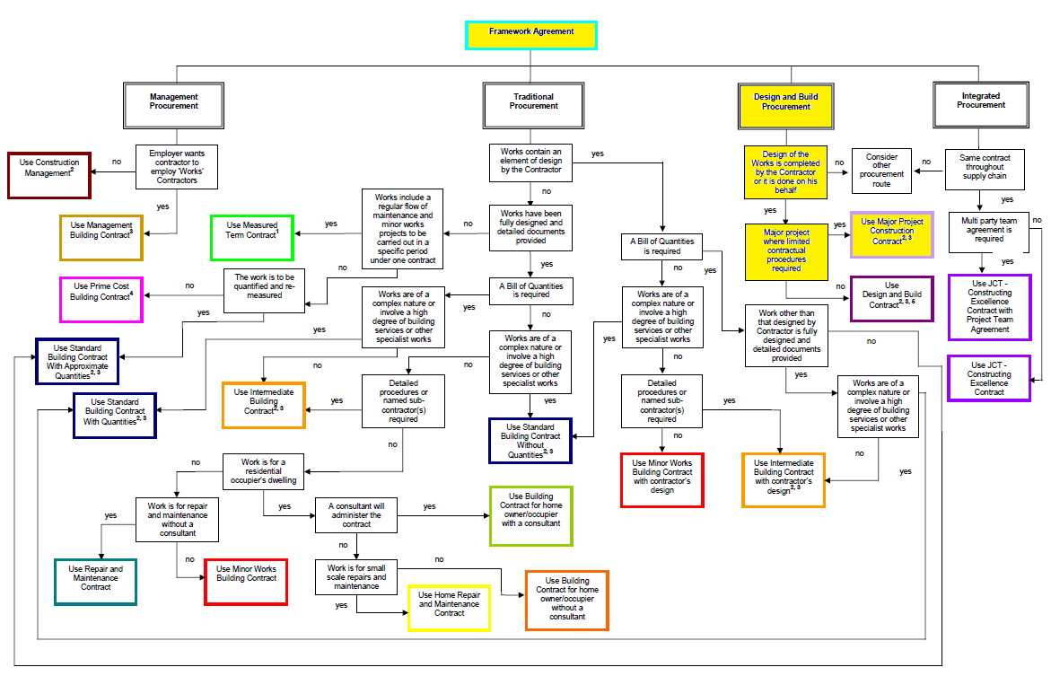
Figure 1. Route to main contract.
  - Main Contract Type – JCT Major Project Construction Contract (MP)
This contract is aimed at projects where major works are required on large scale construction projects. Providing the developer has outlined his requirements/expectations (pre main contract) then the contractor is obliged to complete the project within the timescales and to an agreed ‘Lump Sum’ (post contract), with monthly interim payments made/based on the contractors pricing Documents. The contractor therefore carries more risk in this respect, but utilises their experiences more to manage these risks.
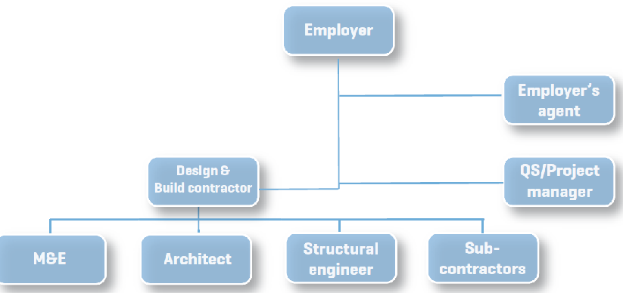
Figure 2. Typical Contractual Structure of MP Contract
    - Advantages

- A relatively fast method (post main contract) with guaranteed cost and completion dates agreed at the outset.
- Detailed design and construction can proceed in parallel meaning construction time can be reduced (post main contract)
- Client input into the outline design (pre main contract) meaning client’s expectations of quality can be achieved.
- The majority of risk is allocated to the contractor (post main contract) as a single point of responsibility
- A single contractual arrangement involving contractor’s early design and construction expertise.
- Client’s professional team (pre main contract) can be novated (post main contract) to the contractors, to ensure client’s expectations are met.
- Only risk to developer is contractor going out of business.

    - Dis-Advantages

- Client’s amount of detail in outline design (pre main contract) can lead to longer pre-tender time.
- Client’s changes in detail design (post main contract) can only be achieved with contractor’s approval and may create disputes over time and costs.
- Difficult to assess ‘value and competitiveness’ (pre main contract) due to lack of full detailed documentation (BofQs, Schedules, Drawings, Specifications).
- No benefit to client (post main contract) if contractor seeks greater competitiveness for specialist work or materials.
- ‘Novating’ of professional team can lead to disputes and conflict of interest.

  - Tendering Process/Selection
We would recommend a two-stage tendering and selection process through this procurement route and under this contract type.
Selective tendering (and shortlisting) should be carried out prior to stage 1 to ensure that ‘invitations to tender’ are only sent to contractors who are financially viable, sufficiently experienced and with the resources and technical capability to deliver the project successfully.
After receiving ‘bids’ from the ‘selected’ contractors, they can be analysed for competitiveness against preliminaries, contractors overheads/profit and elements of the design which allow proper pricing.
A contractor is then appointed (at stage 1) on a provisional basis under a Pre-Construction Services Agreement (PCSA) and is recognised as being the ‘preferred’ bidder/contractor.
This appointment is based on a lump sum or cost reimbursable price for the contractor’s consultancy and detailed design fees.
Through this process, early contractor involvement (at stage 1) can benefit in terms of value engineering, team work and fixed (instead of estimated) sub-contractor pricing, utilising contractors experience and technical expertise.
Stage 2 then involves negotiation with the preferred contractor over detailed designs, agreement of works programme and cost structures.
Once the negotiations are settled, the main contract can be ‘let/signed’ and all responsibility/risk (cost, time, quality, sub-contracting) passes to the main contractor, who is obliged to complete the project under the terms of the main contract.

- Scenario 2
The construction of a new private hospital in Swansea, SA1. There will be 3 operating theatres, 10 consulting rooms, High dependency unit and 20 beds. This will replace the existing private hospital in the Uplands area of Swansea.
  - Assumptions

    - Cost
No definitive budget has been set. We assume all outline costing has been carried out by the clients ‘professional team’ and the client has a ‘ball park’ figure to tender on, but no certainty.
    - Time
Whilst no timescales have been given, we assume that the client will want the project completed at the earliest opportunity to start generating revenue and to close the existing hospital. Transfer of staff can only be completed once the new hospital is complete and signed off.
    - Quality
Quality is the most important aspect of this scenario. We assume that the client has a ‘professional team’ to assist with all project information (specs, drawings, cost plan) up to the close of RIBA stage 3 (Developed Design). We assume the main contract (once let) will include a ‘specialist contractor’ completing RIBA stages 5 + 6 and assisting the client’s professional team to develop RIBA stage 4 (Technical design).
    - Risk
We assume the biggest risk to the client is cost, based on the type of building is required and the specialist equipment/fit out. We assume there are no underlying issues with the site/land and all services are available. We assume that the client and their professional team accept a greater element of risk (cost) but expect a greater level of quality from the ‘specialist contractor’ within a specified time.

  - Procurement Route – Management Contracting
This route benefits in time and quality, but at the expense of cost.
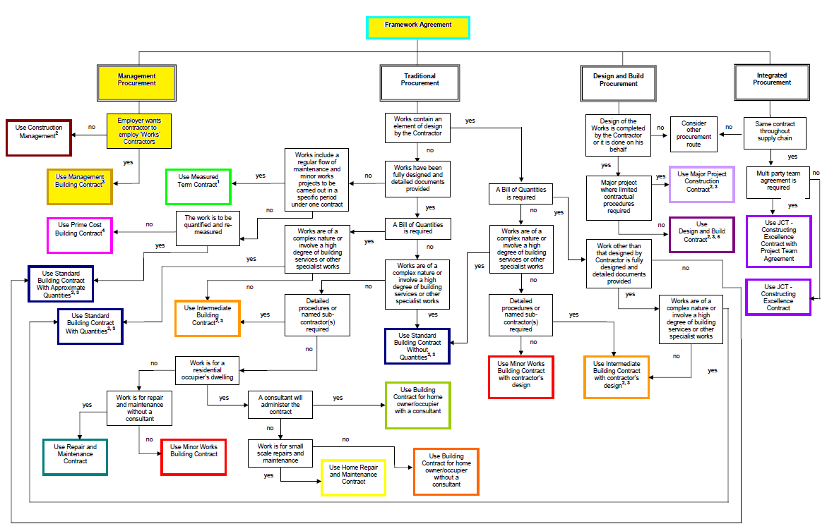
Figure 3. Route to main contract.
  - Main Contract Type – JCT Management Building Contract (MC)
This contract involves appointing a ‘management contractor’ with specialist knowledge to oversee the project under a series of separate works contracts. The Management Contractor assists with the pre-construction period by formulating the programme, contract cost plan, construction methods, specialist design as well as producing works packages. The management contractor appoints sub-contractors and manages/monitors them during the construction period. Interim payments are made monthly and can be based on Prime Cost of the Project, along with a Management Fee for the Management Contractor. The management contractor is obliged to complete the project within the agreed timescales (Post Contract). The contractor therefore carries more risk in this respect, but utilises their experiences more to manage these risks.
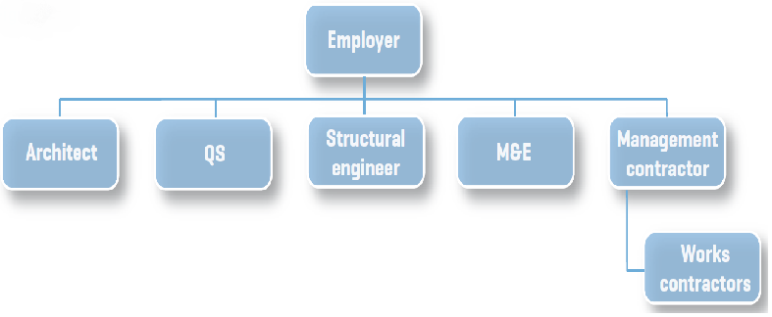
Figure 4. Typical Contractual Structure of MC Contract
    - Advantages

- Clients professional team have full control of design and quality (pre and post main contract) and as construction proceeds
- Detailed specialist design and construction can proceed in parallel meaning construction time can be reduced (fast tracked), with an earlier start on site (post main contract)
- The majority of risk (time, quality, management) is allocated to the contractor (post main contract) as a single point of responsibility
- A single contractual arrangement with the ‘management contractor’ to develop works packages and employ ‘works contractors’ who are directly contracted to the ‘management contractor’.
- Costs, valuations and payments can be monitored by clients QS and professional team.
- Competition (cost savings) still possible when ‘works contractors’ submit tenders.

    - Dis-Advantages

- Client’s amount of detail in outline design (pre main contract) can lead to longer pre-tender time.
- Clients changes in detail design (post main contract) can lead to abortive work increasing both time and cost.
- Difficult to assess ‘value and competitiveness’ (pre main contract) due to lack of full detailed documentation (BofQs, Schedules, Programme).
- No price certainty until the final work package has been let.
- Speculative risks (cost/time) lay with the client.
- Additional cost to the client of hiring a contract administrator and professional team.

  - Tendering Process/Selection
We would recommend a single-stage tendering and selection process through this procurement route and under this contract type.
Selective tendering should be carried out to ensure that ‘invitations to tender’ are only sent to ‘specialist contractors’ (pre main contract) who are financially viable, sufficiently experienced and with the technical capability to deliver the project successfully.
Through this process, early contractor involvement can benefit in terms of value engineering, team work and fixed (instead of estimated) sub-contractor pricing, utilising contractors experience and technical expertise.
After receiving ‘bids’ from the ‘selected’ contractors, they can be directly analysed for competitiveness (mainly cost against their management ‘fees’).
Negotiation with the preferred contractor over detailed designs, agreement of works programme and cost structures (target cost) can then take place.
Once the negotiations are settled, the main contract can be ‘let/signed’ and the majority of responsibility/risk (time, quality, sub-contracting) passes to the main contractor, who is obliged to complete the project under the terms of the main contract.
Open and competitive tendering can still take place during the appointment of sub-contractors, which can still involve the client’s professional team. This mean that overall costs can still be reduced and whilst the sub-contractors are directly contracted to the ‘management contractor’, they may need to enter into collateral warranties with the client.

- Scenario 3
Upgrading the ‘Small World’ theatre in Cardigan town centre. The Theatre is run by a group of volunteers who control the Theatre through a company limited by guarantee. This means that they might be liable for any losses the Theatre makes. The extent of the works is to refurbish the stage, provide disabled toilets and access and install a new kitchen that meets current hygiene standards and is suitable to be run as a commercial venture.
  - Assumptions

    - Cost
No definitive budget has been set. However, the volunteers require a ‘fixed price’ and cost certainty from the outset, to not exceed their allotted budget and incur heavy losses.
    - Time
Whilst no timescales have been given, we assume that the volunteers will want the project completed at the earliest opportunity to start generating revenue and to minimise lost income through the closure period (during works).
    - Quality
We assume that the volunteers have an ‘architect’ to assist with the project who has produced drawings, specifications and the quantity/quality of the work has been defined. We assume (due to the nature of the works required) that the RIBA plan of works is not required to be followed. We assume (pre-contract) the ‘contractor’ will provide detailed designs and types of finish, with their tenders.
    - Risk
We assume the volunteers want to carry no/very little risk with fixed cost, agreed timescales and quality of finish stated by the contractor (pre-contract). We assume there are no underlying/hidden issues with the building and there are no complexities to the work required.

  - Procurement Route – Traditional/Conventional Lump Sum
This route benefits in cost and quality, but at the expense of time.
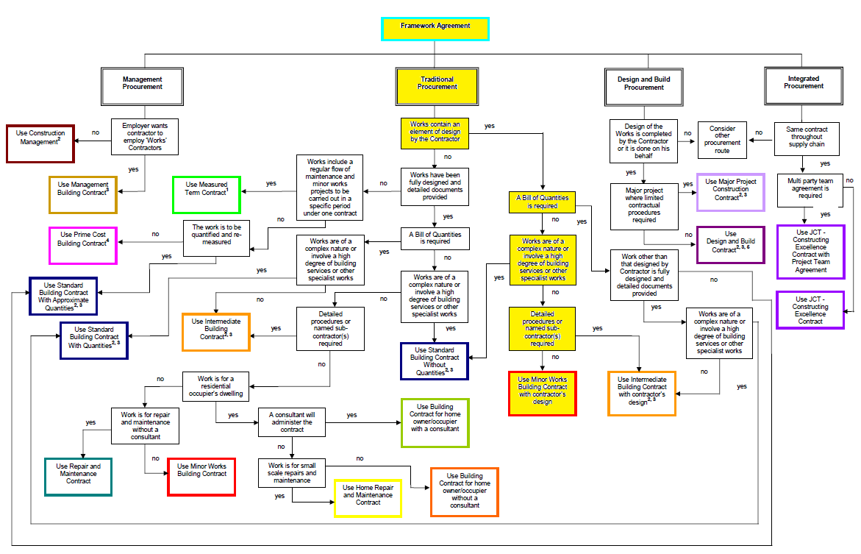
Figure 5. Route to main contract.
  - Main Contract Type – JCT Minor Works Building Contract with Contractors Design (MWD)
This contract is aimed at smaller, basic construction projects and where the work is more simplistic in nature. Providing the volunteers have outlined their requirements/expectations, then the contractor has the responsibility of completing the detailed design (Contractors Design Portion), providing a cost sum and producing a works programme (pre-contract). A payment structure can be written into the main contract by negotiation, due to the nature of the work. Post main contract, the contractor is obliged to complete the project within the proposed timescales and to an agreed ‘Lump Sum’ based on his cost plan and pricing documents. The contractor therefore carries more risk in this respect, but utilises their experiences more to manage these risks.
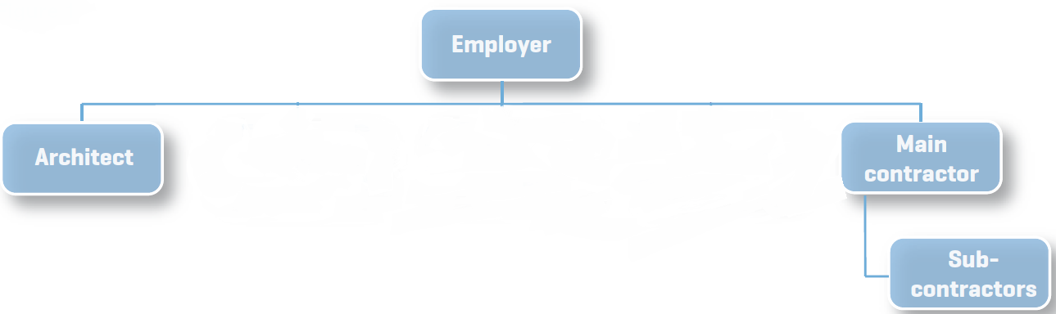
Figure 6. Typical Contractual Structure of MWD Contract
    - Advantages

- Guaranteed cost certainty and completion dates agreed at the outset.
- Volunteers professional team reduced to only 1 architect who can also administer the contracts (cost saving).
- Volunteers input into the outline design (pre main contract) meaning client’s expectations of quality can be achieved.
- The majority of risk is allocated to the contractor (post main contract) as a single point of responsibility
- A single contractual arrangement involving contractor’s early design and construction expertise.
- Only risk to volunteers is contractor going out of business.
- Open tendering can seek greater competitiveness and value

    - Dis-Advantages

- Volunteer’s amount of detail in outline design (pre main contract) can lead to longer pre-tender time, which leads to longer overall works programme.
- Client’s changes in detail design (post main contract) can only be achieved with contractor’s approval and may create disputes over time and costs.
- Difficult to assess ‘value and competitiveness’ (pre main contract) due to lack of full detailed documentation (BofQs, Schedules, Specifications).
- No benefit to client (post main contract) if contractor seeks greater competitiveness for specialist work or materials.
- Increasing risk to contractor can lead to higher tender prices.

  - Tendering Process/Selection
We would recommend a single-stage and open/competitive tendering selection process through this procurement route and under this contract type. Early contractor involvement will benefit in terms of value engineering, quality of finish, timescales and fixed pricing.
After receiving ‘bids’ from the contractors, they can be directly analysed for competitiveness (cost), as well as timescales and quality of finish.
Negotiation with the preferred contractor over detailed designs, agreement of works programme and cost structures (interim payments) can then take place. Once the negotiations are settled, the main contract can be ‘let/signed’ and all responsibility/risk (cost, time, quality, sub-contracting) passes to the main contractor, who is obliged to complete the project under the terms of the main contract.

- Scenario 4
INA Bearings require a new 5,000m2 factory to be located near their distribution centre in Llanelli, South Wales due to a new business venture. They will fit their own machinery.
  - Assumptions

    - Cost
No definitive budget has been set. Client’s professional team will give outline cost guidance based on ‘standard price indexes’ such as BCIS, as a comparison for tendering. We assume INA Bearings will want a ‘fixed’ price to give cost certainty from the start.
    - Time
Whilst no timescales have been given, we assume that INA Bearings will want the project completed at the earliest opportunity to install their own machinery and start generating revenue from their new venture.
    - Quality
We assume that INA Bearings have a ‘professional team’ to assist with project information up to the close of RIBA stage 2 (Concept Design) including building layout (to incorporate machinery). We assume the main contract (once let) will include the ‘contractor’ completing RIBA stages 3-6 and providing an ‘off the shelf’ factory, to the clients required standards.
    - Risk
We assume the biggest risks to INA Bearings are time and cost. We assume there are no underlying issues with the site/land and all services are available. We assume that INA Bearings want to minimise their risk (time, cost) by employing a contractor to provide a full service of Designing and Building the project using an ‘off the shelf’ approach.

  - Procurement Route – Design and Build
This route benefits in cost and time, but at the expense of quality.
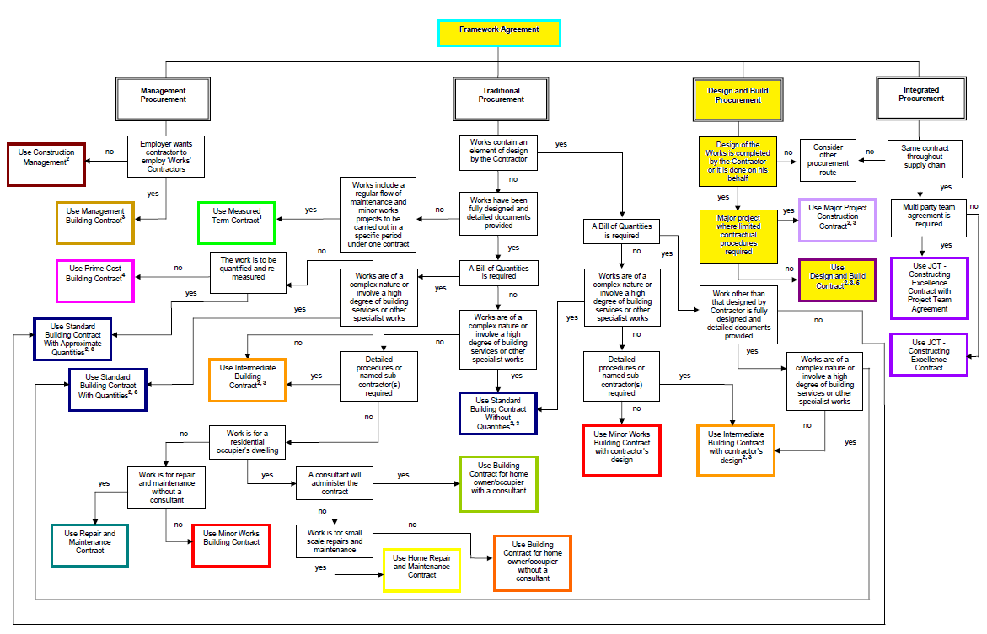
Figure 7. Route to main contract.
  - Main Contract Type – JCT Design and Build (Package/Turnkey) Contract (DB)
This contract is aimed at projects where the contractor carries out both the design and construction work. Providing INA Bearings have outlined their requirements/expectations (pre main contract), then the contractor is obliged to complete the project within the timescales and to an agreed ‘Lump Sum’ (post contract), with monthly interim payments made/based on the contractors Pricing Documents. The contractor therefore carries more risk in this respect, but utilises their experiences more to manage these risks.
Figure 8. Typical Contractual Structure of DB Contract

    - Advantages

- A relatively fast method (post main contract) with guaranteed cost and completion dates agreed at the outset.
- Detailed design and construction can proceed in parallel meaning construction time can be reduced (post main contract)
- Client input into the outline design (pre main contract) meaning clients expectations of quality can be achieved, along with adequate spacing requirements for machinery.
- The majority of risk is allocated to the contractor (post main contract) as a single point of responsibility.
- A single contractual arrangement involving contractors early design and construction expertise with costings and timings used from previous, similar developments.
- Client’s professional team (pre main contract) can be novated (post main contract) to the contractors to ensure client’s expectations are met.
- Only risk to developer is contractor going out of business.

    - Dis-Advantages

- Client’s amount of detail in outline design (pre main contract) can lead to longer pre-tender time.
- Client’s changes in detail design (post main contract) can only be achieved with contractor’s approval and may create disputes over time and costs.
- Difficult to assess ‘value and competitiveness’ (pre main contract) due to lack of full detailed documentation (BofQs, Schedules, programme).
- No benefit to client (post main contract) if contractor seeks greater competitiveness for specialist work or materials at sub-contracting stage.
- ‘Novating’ of professional team can lead to disputes and conflict of interest.

  - Tendering Process/Selection
We would recommend a two-stage tendering and selection process through this procurement route and under this contract type.
Selective tendering should be carried out prior to stage 1 to ensure that ‘invitations to tender’ are only sent to contractors who are financially viable, sufficiently experienced and with the resources and technical capability to deliver the project successfully.
After receiving ‘bids’ from the ‘selected’ contractors, they can be analysed for competitiveness against preliminaries, contractors overheads/profit and elements of the design which allow proper pricing.
A contractor is then appointed (at stage 1) on a provisional basis under a Pre-Construction Services Agreement (PCSA) and is recognised as being the ‘preferred’ bidder/contractor. This appointment is based on a lump sum or cost reimbursable price for the contractor’s consultancy and detailed design fees.
Through this process, early contractor involvement (at stage 1) can benefit in terms of value engineering, team work and fixed (instead of estimated) sub-contractor pricing, utilising contractors experience and technical expertise from previous, similar projects.
Stage 2 then involves negotiation with the preferred contractor over detailed designs, agreement of works programme and cost structures.
Once the negotiations are settled, the main contract can be ‘let/signed’ and all responsibility/risk (cost, time, quality, sub-contracting) passes to the main contractor, who is obliged to complete the project under the terms of the main contract.

- Scenario 5
Following a recent fire at Bluestone Holiday Park, the leisure centre and pool need to be completed before May 2018 ready for high season.
  - Assumptions

    - Cost
No definitive budget has been set. We assume cost will not be an issue as the insurance company is covering all costs. We assume the insurance company will cover re-instatement/replacement costs on a like-for-like basis and not ‘upgrading’ from previous specifications/design. We assume Bluestones professional team will manage costs at all stages and liaise with insurance company/contractors over payment structures.
    - Time
Clear timescales have been set. We assume that Bluestone require an early start on site to complete any demolition/clear up works and ‘following on work’ will be completed in sections. Bluestones professional team will produce/manage programmes (in conjunction with main contractor) and timescales as the project develops and the extent/nature of the work becomes clearer.
    - Quality
Bluestones professional team will deal with all design work and will manage all stages of RIBA plan of works. We assume that a like-for-like basis of quality is needed and all existing (from original build) drawings, specs, schedules, BofQs etc. are available to reference.
    - Risk
We assume the biggest risk to Bluestone is time. We assume that the extent of the work required has not yet been discovered, leading to design/construction having to run in parallel. Bluestones professional team will take on all responsibility (in-house) to try and manage all elements of risk (time, cost, quality), with the insurance company’s approval and in conjunction with the main contractor.

  - Procurement Route – Traditional/Conventional Cost reimbursement/Cost Plus
This route generally benefits in cost and quality, but at the expense of time (unless properly managed).
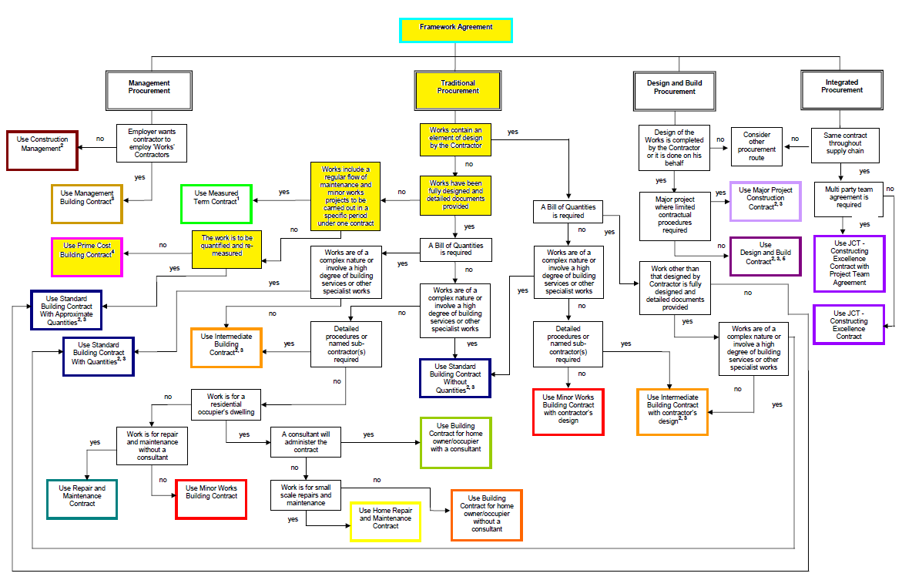
Figure 9. Route to main contract.
  - Main Contract Type – JCT Prime Cost Building Contract (PCC)
This contract is designed for use on projects where an early start on site is needed for urgent repair work. Under this contract, designs are completed (in sections) as work proceeds and after identifying the nature and extent of the work required. This enables construction/design to proceed in parallel. The contractor is required to complete the project within the timescales and to an agreed payment structure of either a cost plus or cost reimbursable agreement (based on clients QS figures), with a Contract Fee or Percentage added on for contractors profit/overheads and with monthly interim payments.
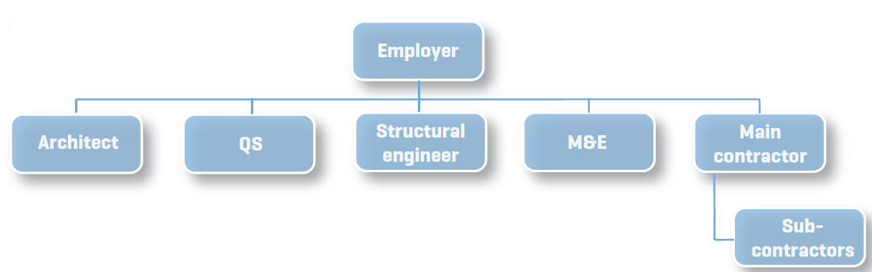
Figure 10. Typical Contractual Structure of PCC Contract
    - Advantages

- An early start on site makes this a relatively fast method (post main contract) with required completion dates agreed at the outset.
- Detailed design and construction can proceed in parallel meaning construction time can be reduced (post main contract)
- Contract fee can be altered (post main contract) as nature of works is discovered (with Contractor negotiation), allowing for variations in design work.
- Client input into the outline design (pre main contract) meaning client’s expectations of quality can be achieved.
- Time and quality risks are allocated to the contractor (post main contract) as a single point of responsibility
- Time and cost can be reduced by Contractor, based on a performance bonus.

    - Dis-Advantages

- No cost certainty until the nature of work has been discovered.
- Difficult to assess ‘value and competitiveness’ (pre main contract) due to lack of full detailed documentation (BofQs, Schedules, Drawings, Specifications).
- Major changes in design (during construction work) can lead to disputes over time and cost with Contractor.

  - Tendering Process/Selection
We would recommend a single-stage/open tendering and selection process through this procurement route and under this contract type. This will enable an earlier start on site. After receiving ‘bids’ from the contractors, they can be directly analysed for competitiveness (mainly cost, against their profit/overhead margins), as well as timescales and quality of finish.
Negotiation with the preferred contractor over detailed designs, agreement of works programme and cost structures (prime cost) can then take place. Once the negotiations are settled, the main contract can be ‘let/signed’ and the majority of responsibility/risk (time, quality) passes to the main contractor, who is required to complete the project under the terms of the main contract.
Through this process, early contractor involvement can benefit in terms of value engineering, team work and fixed (instead of estimated) sub-contractor pricing, utilising contractors experience and technical expertise. Open and competitive tendering can still take place during the appointment of sub-contractors, which can still involve the client’s professional team. This mean that overall costs can still be reduced and whilst the sub-contractors are directly contracted to the ‘main contractor’, they may need to enter into collateral warranties with the client.
Bibliography
Adriaanse, J., 2010. Construction Contract Law. 3rd ed. Basingstoke: Palgrave Macmillan.
Brook, M., 2017. Estimating and tendering for construction work. 5th ed. Abingdon: Routledge.
CIOB, 2010. A report exploring Procurement in the Construction Industry. (PDF) Ascot: Chartered Institute of Builders. Available at: https://www.ciob.org/sites/default/files/CIOB%20research%20-%20Procurement%20in%20the%20Construction%20Industry%202010_1.pdf (Accessed 18-01-18)
JCT, 2017. JCT Practice Note. Deciding on the appropriate contract. (PDF) London: Sweet and Maxwell. Available at: https://www.jctltd.co.uk/docs/Deciding-on-the-appropriate-JCT-contract-2016.pdf (Accessed 18-01-18)
JCT, 2017. JCT Practice Note. Tendering. (PDF) London: Sweet and Maxwell. Available at: https://www.jctltd.co.uk/product/tendering-practice-note. (Accessed 18-01-18)
RICS, 2014. RICS Guidance Note. Appropriate Contract Selection. (PDF) Coventry: Royal Institution of Chartered Surveyors. Available at: http://www.rics.org/uk/knowledge/professional-guidance/black-book/appropriate-contract-selection-1st-edition/ (Accessed 18-01-18)
RICS, 2014. RICS Professional Guidance. Tendering Strategies. (PDF) London: Royal Institute of Chartered Surveyors. Available at: http://www.rics.org/uk/search-results/?sq=tendering+strategies&so=Relevance (Accessed 18-01-18)
DLA Piper, 2017. Two stage tenders what is two stage tendering? (Online) Available at: https://www.lexology.com/library/detail.aspx?g=2e5ada34-30a9-4e9e-987a-6c8c270cb5a3 (Accessed 19-01-18)

Appendix A – RIBA Plan of Works 2013



