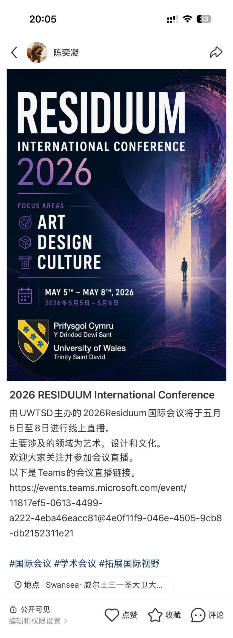
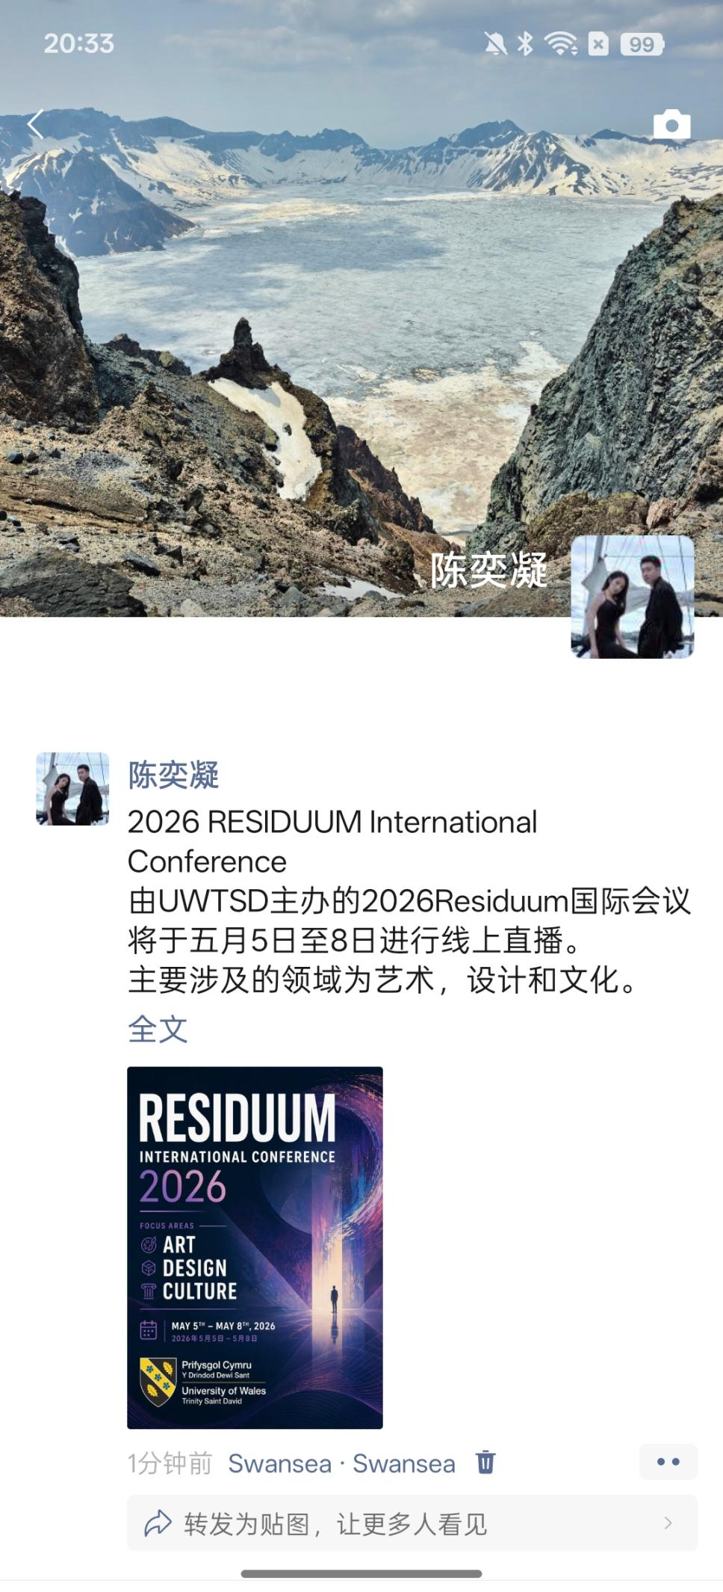
Regarding the promotion of this conference, I mainly posted conference-related content on my personal social media platforms, including WeChat Moments and Red Notes. The aim was to make the conference more visible to audiences in China, and thereby increase its public recognition and academic participation.

The reason for choosing these two social media platforms is that one is a private content-sharing platform, while the other is a public content-sharing platform. Sharing on a private platform can better inform people within my personal network who are related to, or interested in, the relevant fields. This makes the promotional audience more specialised, and is likely to attract people from art design and product design more directly. Sharing on a public platform can expand the range of people who receive the information to a greater extent. It can allow more people who are interested in art, design and culture to understand and participate in the conference. At the same time, during the conference submission stage, I also shared the conference with some scholars, teachers and doctoral students I know, with the expectation that they might make targeted submissions related to the conference theme.

During the promotion process, I also realised that promotion is not only about increasing the exposure and visibility of a conference. It also tests whether the promoter can communicate and express the conference content and information effectively. In addition, the promotional language and methods used on different social media platforms also vary, so the same promotional template should not be used across all platforms.

