THE IMPACT OF TECHNOLOGY INNOVATIONS ON THE ORGANIZATIONAL STRUCTURES OF FASHION COMPANIES

Programme: Doctor of Business Administration
Module name: Visions for The Future (LCDB7006)
Schedule: Term 1
Student ID: 1900036
Assignment Title: The Impact of Technology Innovations on The Organizational
Structures of Fashion Companies
The word count: 7000
Date of Submission: 13th May, 2019

CONTENTS

1. Introduction 3
2. The impact of old technologies on fashion companies 3
2.1 Gradual adaption 4
2.2 Balance 5
2.3 Strategic adaption 6
3. The conventional types of organization structure in fashion companies 7
3.1 Line structure 7
3.2 Matrix structure 7
3.3 Function structure 7
4. ‘Next big things’ change the modern fashion companies structure 8
4.1 The Internet of Things (in co-orperation with robots) 10
4.2 Cloud technology 11
4.3 Three-dimensional printing 12
5. The organizational structure of fashion companies in the future 13
5.1 Horizontal structure 13
5.2 Virtual structure 14
5.3 Flat structure 15
6. Recommendation 16
Reference 17

FIGURES

Figure 1. Regional matrix structure of Nike Inc. 8
Figure 2. Processes in horizontal structure company 14
Figure 3. Advantages and disadvantages of horizontal structure 14
Figure 4. The virtual network structure 15
Figure 5. Advantages and disadvantages of virtual structure 15

- Introduction
There are tons of fashion retailers in the market nowadays, in 2019. Many clothing brands have expanded into incorporate that have different market segmentation and target. First of all, there are companies such as Zara, Topshop, Uniqlo, Miss Selfridges, ect that serve many segments of customers with different price tag, gender, style, etc. In contrast, there are giant groups such as LVMH (owns Louis Vuitton, Dior, Kenzo, Fendi, etc), Richemont, PPR Gucci Group (owns Yves Saint Laurent, Bottega Veneta, Balenciaga, Alexander McQueen, etc) or Hermes that differenciating themselves as luxury goods. Those companies have been thriving through acquisitions and have created their own universe of luxury apparel and accessories. This paper will focus on companies on the fashion industry, which has been benefited from the revolution of technology in recent years. In the last two decades, the fashion retail which focused on fashion-forward designer and contemporary apparel has been blooming like never before (Vesilind, 2006).
The nature of the fashion industry is dynamic, therefore, with the combination with advanced technologies, the blooming of fashion industry in this century is inevitable. Technology changes life (Crisco, 2019), that’s an obvious statement, technology affects every single aspect of human-being lives, from transportation to health care and of course, fashion industry. Technology makes life easier, to create more compelling and insane ideas, to sell apparel and accessories without the need of physic stores, etc. Indeed, the effect of technology has been undeniable nowadays. Therefore, when the era of IoT (Internet of Things) has spread widely, fashion retailers have no choice but grab that opportunity, maximize the potential and function of technology. One of the newest technologies have been testing (will be commercialized extensively very soon in the near future) into fashion industry is the 3D printing, a new way of creating products with zero-waste, very eco-friendly and could save for manufactures tons of dollars every year. As stated above, the essece of fashion industry is dynamic, the same goes for those executives of these companies, they will adapt to this technology-era very easily and quickly. The flexibility of complicated systems has played a vital role in the area of evolution research. In this 21st century, IQ is not used to measure succeed anymore, now they use EQ – how someone controls emotions, how someone adapts with external environments, with climate change, etc. The importance of technology has been emphasized into fashion industry, and the potential for problem-solving has been progressively rised.
With that being said, this paper will indicate the connection between the development of corporations and the evolution of technology. The research will be critically examined based on three contexts. The second section will examine the affect of technology to fashion retailers. The third and forth sections will discuss about organization structure of fashion retailers and investigate the impacts of three most advanced technologies at the moment to fashion retailers, respectively. The fifth section will predict what the future holds for the organizational form of fashion retailers. Some recommendations will be the endgame for this research paper at the sixth part.
- The impact of old technologies on fashion companies
Looking at the structure of fashion companies all over the world before early 1990s – when Internet became popular, the current competition in the fashion industry is much more intensive than the past. Many people had been nostalgic about these good old days, executives of these fashion companies got used to the traditional way of applying. Before the blooming of Internet in 1990s, even the most insane people, they couldn’t believe that someday, they could buy any apparel or accessories they want from 5th Evenue in New York city to Oxford/Regent street in London without going there; no one could believe that all they have to do is a computer and their debit card numbers. Nonetheless, with the unprecedented advancement of technology, all fashion companies in the world have had to adapt with the situation and replace their old-school B2C (business to customer) transactions, applying more technology advances into their business and make life easier. Undoubtly, technology evolution has not only made life easier for fashion companies but also made customers have more choices for their preferences. For example, after Internet became trendy after 1990s, Taiwan witnessed a gradual strengthen in terms of economy in general and in fashion business in particular (Huang et al., 2016). After that period, consumers were looking for companies with more convenience purchase methods. The drawback of technology was that it is assessable for everyone, for every organizations, that’s not an exclusive product for a limited number of companies, that made the competition in fashion industries become truly rigorous; the fashion industry will never be the same after this period, that’s the fact. Like the name of one of Barack Obama’s speeches – ‘We need change’, companies at that time need to change themselves, need a significant review of what is going on internally and externally. The most important task to do was to advance the organizational structure, no more no less.
The advancement of technology not only transformed the individual performance significantly but also boosted the link between individual to individual. Each company had their own way of applying technologies into their business, in order to maximize the efficiency of supply chains and service. The term ‘technology’ could be implied as internet, factories, materials or services. The type of technology that a company used would define the structure of that organization system. Employees in fashion companies had been considered as resources as well. Their competence, combined with the development of technology will enhance organization performance.
Consequently, the revolution of technology not only decreased the workload for employees but also changed the way companies do the business transactions completely, followed by the unavoidable changes in organizational structure of fashion companies, and of course, it revolutionizes the fashion industruy as stated above. In parallel with these actions, companies must renovate their management format as well as the connections between employees, that was the compulsory condition for a successful model of applying technology into business.
With the rise of e-commerce, there has been a lot of room to turn over a new leaf for small-sized and medium-sized companies, just by reviewing their strategy and improve the organizational structure. Nonetheless, giants in the fashion industry needed to take the changes in their organizational structure gradually, in order to avoid unnecessary errors. Petersen and Strongin (1992) figured out three main contexts of the effect of technology advance on the adaption of organizations.
2.1 Gradual adaption
The preservation of organizational ecology together with institutional theories of corporations, this duo describes the apathy of organizations towards ‘changes’ and claims that it usually takes time for a company when facing something new, especially technology.
Organizational ecology x Institutional theory
Appleby (1969) when defining the tern ‘organization’, he didn’t just give one but a variety of interpretations. In the area of management, ‘organization’ could be described as the construction of relationships of individual to individual. In the other way, ‘organization’ could be referred to a process or a management component related to the development of a company’s structure. On the book Ecological Models of Organizations, Glenn Carroll referred that the level of change in organization was ahead of ecological theories. In his research, he stated that ‘organizational ecology’ is the new theoretical aspect that doesn’t not follow the sense of adaption model of corporational change (Amburgey and Rao, 1996). Correspondingly, he also claimed that most of organizational change, they are the consequences of the selection/replacement within the organization, rather than the internal revolution. Even with the massive impact from external environment, companies tend to maintain the daily running cycle rather than take necessary changes in terms of structure and strategy. Ryder (1999) also strengthen this viewpoint by stating that reinforcing and fostering the current ideas and organizational arrangement instead of transforming into a brand new model.
Evolutionary theory
In the short-term, the core competence of a company is measured by the price and the performance of the existed goods. And in the long-term, they measure the ability to create products at lower cost and faster than others. The role of managers will be assessed by his/her ability to strengthen technologies and production knowledge, in order to give employees power to adapt quicker with upcoming situations (Prahalad and Hamel, 1990). That’s the reason for the inertia of organizations, they can’t be highly affected by external factors, instead they keep their composure. Their ultimate goal is always to find new effective products in the current industry. Commonly, this is the first stage of an organization when facing something new in the market. Cashing in on new technology when it comes, that’s what new companies usually do. According to previous researches of and Laursen and Salter (2005) and Gobble (2016), there are two types of innovation: Incremental innovation and disruptive innovation. Oduro and Nyarku (2018) argued that incremental innovation requires fewer new resources and competencies. On the other hand, Charito and Markides (2003) stated that a disruptive innovation could contain a product/service that create a new approach of doing business. These types of innovations don’t take technology advance as its core but these types focus on changes the value scheme of firms. In terms of preserving technology innovations, entrenched companies would certainly do better than newbies but in contrast, for acquring new innovations, new firms complete the tasks in a superior way.
2.2 Balance
Accoridng to Wiatrak (2013), adaption is not the mutual nature between organizations but balance and stability is. After a comparatively long period of time of maintaining the inertia to develop, precipitous changes in structure systems could create chaos within the organization, plus the interferences from radical, revolutionary and calamitous technology. Technology evolution benefited organizations a lot, included changes in their stragies, constructions, power circulations or control schemes. Hence, which orgizations could catch the opportunities and applying technology changes in order to turn over a new leaf, breaking the stable loops (cultural and structural paralysises), those companies would be successful in the future. The term ‘radical change’ is to indicate the qualitative modification of a company’s rules of organizing (Nguyen, 2002) and the breaking loose from a current direction (Greenwood and Hinings, 1996). (Plowman et al., 2007) once claimed radical change could the consequence of changes at micro-level that happen several times, nevertheless those changes only got insignificant debate in the literature review on the area of organizational change. ‘Radical change’ refers to a transformation of a company between two places in the timeline (Weiss, 2003). By its nature, radical change is the process of replacing old strategies and old systems with new ones (Linder, 2004). It is believed that radical change would build a brigde between old and new stage and this brigde will provoke severe tension that is inevitable. Consequently, companies will reluctantly apply radical changes when the context is unavoidable, for example – business crisis or when new technologies outclasses the old ones. This brigde is not just a sole stage but many stages being affected by incremental innovations during a particular period of time. The purpose of these stages is to build up the foundation for organizational structure. At the same time, firms need to prepare to face disruptive technologies, which could put firms in trouble and comes all of a sudden. In such a vigorous competition in the market nowadays, for the purpose of being successful, organizations must become accustomed to revolutionary changes, in order to apply new technology into business and fit the rapid change of the industry.
2.3 Strategic adaption
For a couple of decades, ‘structure’ had been considered as something irrelevant to ‘strategy’. In an attempt to improve performance, encourage teamwork or cut cost, firms seek to optimize the organizational structures. But in fact, the relationship between ‘structure’ and ‘strategy’ is always bilateral. Elcock (1996) came up with an Organizational Infrastructure Review to illustrate the bilateral relationship between ‘structure’ and ‘strategy’. ‘Structure’ is not just a diagram of a company, ‘structure’ is every element that form the company, including employees, technologies, operations, processes, culture, etc. This structure has a considerably tight connection with ‘strategy’ of a company in order to accomplish its targets and goals. Structure is the foundation for strategy to be implemented. If a company changes ‘strategy’, there is no doubt that they need to change ‘structure’ to be compatible with the new ‘strategy’. If they don’t transform the ‘structure’ to fit in the new ‘strategy’, that old ‘structure’ will do nothing but bring the company back to the old ‘strategy’.
Worthley (1980) claimed that the power and capability of technology is astonishing; companies could boost productivity just with the help of computer speed and storage capacity. Accordingly, understanding and optimalizing the immense benefits of new technology is the excessively important. This action can only be comprehended through organizational innovations. Willcocks and Lester (1997) suggested that the transformation of a company is the consequence of a long process of learning and practicing, that transformation is independent from all external factors. He also indicates that the more autonomy a company is, the more successful that company will be in the future. That refers to the ability of an organization to make informed decisions when facing new challenge or external drive forces. Lam (2004) stated that for organizational objection, the most important thing is to balance and harmonize exploitation and exploration relentlessly, not just finding the perfect balance or stability of these. Last but not least, the strategic adaptation emphasizes the role of bureaucratic operation and organizational study, and the essential of persistent change of innovation to deal with environmental conflicts and unpredictability.
- The conventional types of organizational structure in fashion companies
3.1 Line structure
With many small fashion retailers, in the beginning stage, just some employees work collectively. Throughout the history of an organization, it has been inessential to have a complex organizational structure at that point but in reality, this structure is still there. As a rule, this type of organization shows that the power flows and the orders implement from the top to bottom. This organizational structure is also called as ‘scalar organization’ which indicates a scalable chain of order is a part of this type of executive organization. Within the line-structure organizations, daily orders happen without any lacks in communication (Gibson, 2012), all employees acknowledge who is in command. In multi-structured organizations, the executives don’t tend to identify disclosure from each individual. Because within this type of organization, everyone knows their functiosn and what they want to accomplish for themselves as well as the company (Mellinger, 2014). Additionally, unlike companies from fabrication or machinery industry, working as companies inside the service industry, fashion retailers can primarily establish autonomous subsidiaries themselves. Nevertheless, in practice, there are not too many companies using this kind of structure (independent) due to the dependant on supply chains. More importantly, the reason is the pressure of profitability, companies tend to trade-off with irrational from consumers (Pugh et al., 1968).
3.2 Matrix structure
Matrix administration was established in the early 1960s and was first technically applied in the aerospace industries in America (Kuprenas, 2003). A matrix structure was described as an intersection between a practical ranking and a project ranking (Turner and Müller, 2003). On other hand, Larson and Gobeli (1987) claimed it as a blended administrative form in which a regular ranking is overlapped by another forms of power or connection.
For the purpose of having a better service, fashion retailers took one member from each department, create a task and let them do it together. The struture of the task is in accordance with the demand of organizations. Despite the fact that employees in the company were trained before, they were still struggled and spent a lot of time with some particular customers in selling merchandises. Matrix structure is the solution when a company needs to deal with complicated customer needs or technical problems, as well as when it requires the equality between service and portfolio. Likewise, this structure could comfort the tensions between groups within the organization. Lorenz and Hennrich (2007) did illustrate Nike’s regional matrix structure (figure 1 below). Each staff will be allocated into a practical department like Marketing, Sales, Human Resources, Operations or Finance. Heads of departments will be responsible for their staffs in terms of managing. Later, products will be made by Operation department then the Marketing department will create marketing campaigns for Nike’s products. Each customer segment will have specific managers for their preferences: apparel, equipment or footwear.

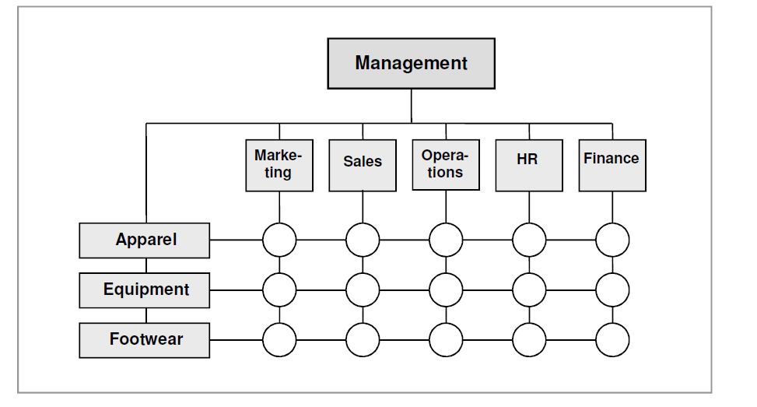
Figure 1. Regional matrix structure of Nike Inc. (Lorenz and Hennrich, 2007)
3.3 Functional structure
With larger and more complex structures, big fashion companies couldn’t apply the line structure, they go for the functional structure instead. A company that is splitted into smalller groups by territories of feature such as: Marketing, Information Technology, Finance, etc is a functional-structured company (Fodor and Fodor, 1980). Some researchers mentioned these practical areas as ‘silos’ - objects that are vertical and incoherent from each other. In accordance with, top management board in the organizations usually includes many practical heads such as COOs or CFOs. In general, communication takes place within each practical department and will be forwarded across other departments through heads. In the fashion industry, this type of structure works better than line structure. It undoubtly creates more efficiency performance as staffs with mutual abilities and knowledge are put in same group. Hence, each group of connoisseurs could work independently between functional departments. This organizational structure can help improving specialization. As suggested by Clark (1973), one of the drawbacks of functional structure is that practical departments might not communicate well inside the company, which could lead to a decrease in resilience and invention. Additionally, this structure could occult the company to see a bigger picture as each department tend to understand the company only from its own function. The newest tendency to fix this weakness is to create modern departments with ability to blend conventional departmental lines and the advancement of cross-functional connection. The functional structure has been presented in multiplicity of fashion retailers in the industry. The positive impact of this structure could be easily seen within big companies, small and medium-sized ones would be restricted by the communicative and innovative structure.
- ‘Next big things’ change the modern fashion companies structure
One of the biggest threats for fashion companies nowadays is that genenration Z (aka Millennials) is taking over the world, they become the most profitable customers of all segmentation. Generation Z force is rising each day goes by and very soon it is going to be the largest demographic in the workforce, that means the fashion industry need a new method to fit them. Not only they are ready spend more money for their favorite brands’ products, they are also very different in their shopping routines. Unlike 20 years ago, at the moment smartphones have became a default object that almost everyone in the world have one (at least), followed by other technology devices like tablets, smart TV, true-wireless earbuds. The speed of Internet is increasing with an insane speed, in 2019 we’ve already had 5G – which could download a two-hour movie in ~3.6 seconds. That leads to one thing, the most important thing, is the bloom of shopping online. Internet and technology have really revolutionized the way we buy stuffs. The rise of companies using shopping online has been signigficant, example in Vietnam, with the popularity of Facebook, shopping through Facebook pages has became unprecedented recently. In the past, in order to sell goods, fashion companis need good locations, beautiful stores, etc to attract customers which could cost them a lot of investments: money, time, human resources, etc. But technology changed everything, shopping in-store declines. Now when it comes to ‘shopping’, you just need a phone or a computer, and a wi-fi connection, go to a website, after some clicks, boom, your order is on its way to your house. Technology improved the efficiency of fashion services considerably. Additionally, data collected from customers could be re-used, companies analyse, segment the customers, figure out the newest trends to apply more suitable ads, to create more trendy stuffs for customers, etc. Thanks to technology revolution, small and medium-sized companies can now sell stuffs without spending a penny for physical stores. These examples proved that by applying technology into business, nothing is impossible for everyone in the market. According to a report in 2013 by The McKinsey Global Institute, Manyika et al. (2013) listed 10 ‘next big things’ that could heavily impact human-being lives. They include Mobile internet, Automation of knowledge work, Advanced robotics, etc just to name a few. Not only do those technologies minimize the tasks of human-being but they also transformed the way companies work. The intensity of companies in fashion industry has been very high since then, but with the technology era, it has gone to the next level of fierceness. One of the most important in the history of fashion industry came after the global financial crisis in 2008, which has been believed by a lot of experts to be the most severe financial crisis since the Great Depression in 1930s. During and after the 2008 crisis, there were dozens of obstacles for fashion retailers and the reasons for those difficulties were:
- In overall, the 2009 financial crisis damaged every single aspects of world economic across all industries but it affected the apparel retail industry in a severe way (Staritz, 2010). The obvious consequence of the 2008 crisis was the subprime loan and the explode of housing bubble (Friedman, 2011). America was significantly affected by this crisis, unemployment rate increased and reach the highest point of 10.1% in October 2009 (Driscoll, 2011). Those things striked directly to fashion industry by the downfall of international trade and customer spending. As companies saw reduced sales, suppliers were adversely affected because of low demand. Apparel retailers in America encountered decreased revenue, slow stock overturn and tight cash flows (Staritz, 2010).
- Additionally, the 2008 crisis made a change in customer behaviours and purchase will. They became more peaky and companies must adjust their strategy for the purpose of ‘the new’ customers who want lower price but still good value. During the recession, consumers recognized that they are still good without cutting off their shopping lists, hence it is essential for companies to be the most valuable in customer perceptions.
- Last but not least, cutting prices meant retailers needed to cut cost, apart from cutting supply chains, firing employees, etc. The question was “Is there any optimal choice for this situation?”. Yes, of course there will always be solution. And that solution named ‘technology’. Fashion retailers needed technology to cut tasks for their staffs, they needed technology to save money on physical stores. Technology did provide for fashion retailers in particular and for other companies all over the world in general, a platform (or an opportunity) to create new business models, to innovate better service in the future. There was no doubt at that point, many retailers could foresee the huge impact of technology in the purpose of surviving (thriving as well) during the 2008 financial crisis.
Now, let’s investigate further the three ‘big things’ that has changed the fashion retailers in a significant way for last decade, they are: The Internet of Things, Cloud technology and 3D printing.
4.1 The Internet of Things (in co-orperation with robots)
The Industrial Internet of Things (IIoT) also known as Industry 4.0 is the name granted to the use of IoT technology in business industry (McClelland, 2019). The idea is the same as for consumers of IoT - to use a combination of sensors, wireless networks, big data and analytics to evaluate and optimise industrial procedure. The penetration of IoT urged fashion retailers to level up their organizational structure, improve every departments, create new business and ultimately - cut cost. Porter (2001) figured out that Internet tried to transform company structures in order to decrease overall profitability, it could enhance business practice or take advantage against other competitors. Widespread e-commerce could help organizations to lower variable costs considerably, from that letting organizations to involve in price competition (Porter, 2001). During and after the 2008 recession, technology has played a vital role in lives. Digital networlds link with almost every techlogy devices, from smartphones to TV with multiplex access. Those innovations has brought the fashion business to the next level of capability, redefine customer experience and enhance customer value proposal. Fashion retailers that applied the right technologies would create a big advantage of bettering products and enhance customer experiences (Chitrakorn, 2018).
Artificial Intelligence (AI) has been developing with an unprecedented speed in fashion industry recently. AI can gather all collected data, analyze them and turn them in to valuable ‘future’ data which can speed up the chains, cut the cost and improve the flexibility of organizations (Engdahl, 2008). Moreover, AI can help companies for the forecast or retail planning. Nowadays, customers can expect better products as well as more convenient services thanks to Artifical Intelligence (Chitrakorn, 2018). A typical example of applying appropriated technology into the business is Asos – one the the biggest retailers in the UK. They used the AI to improve their searching systems in order to bring better online shopping experiences for customers. Now, customers just need to downloadthe Asos app (from Google Play or Appstore), open it, touch the camera icon on the screen and choose a photo of their favorite piece in their phone’s gallery, the app will automatically filter out all similar products in the blink of an eye (Boyd, 2017). Many economists had worried about the ‘invasion’ of AI which could lead to higher unemployment rate, but the truth was really different. In The impact of artificial intelligence on work - established in 2018, The Royal Society (2018) reported that the genuine percentage of work potentially replaced by automation (included robots and AI) will be decreased through time, varying from ~ 0% to 30% (depends on each nation), for example 9% and 24% in India and Germany respectively. And according to PwC, over the last 20 years in the UK, 20% of current jobs replaced by AI is likely to be pretty much the same as the sum of new jobs that are created, as written on the UK Economic Outlook report (Pwc.co.uk, 2018). It is believed that efficiency and real earnings increase and better products are created. In the moment, the most automatic activities contain tasks in highly structured and foreseen environments. Previous researches of (Manyika et al., 2017) and Hawksworthet al. (2018) indicated that those tasks could comprise: transportation, gathering and converting data, accounting, etc.
In fashion industry, machine learning is an extraodinary feature of Artificial Intelligence which allow computers to conduct tasks as smart as human. That includes a complex process of getting used to data, learning the patterns of data, rather than just ‘copy and paste’ like in the past. Recently, the abilities of machine learning is thrving remarkably, followed by bigger data, advanced algoriths, etc. AI is now ubiquitous in everything in daily lives as Google Assisstant, Bixby, Siri and other AI-powered virtual assistants on our smartphones, home applicances and even in our earbuds?! AI’s machine learning learns everything we interact with devices: face recognition, fingerprint recognition, voice recognition, photo recognition, etc and of course fashion retailers couldn’t let that advance slip through their fingers. They use advanced algorithms to trach everything from customers, from viewing emails, clicking into the ad links, reviewing products, adding to basket, etc and then give them recommendations to find the right products. Example, after you view an Asos tee shirt, the website will display some recommended products in the next page, it suggests some jeans or accessories that match with the tee shirt you look at the previous page. It’s the next level of customer experience, compared to the past. Additionally, they create real-time interactions with online customers via chatbots in their websites to solve some popular questions. Moreover, machine learning can analyze behaviours of customers in order to help fashion retailers predict the future trend of style or design. Another part that has been impacted significantly by AI or machine learning is warehouse department, they have seen a remarkble changes in their KPIs: from productivity, order precison or stock accuracy, etc (Guleria, 2018). The combination of AI and robots is like the combination of brain and brawn, that brings the best of both worlds for the business. For example, in 2018, an Uniqlo store replaced 90% of staffs their new automated warehouse with AI robots which can deliver products, read electronic tags, confirm inventory numbers, etc. Only a limited quanity of staffs was needed to accomplish other tasks (Finance.yahoo.com, 2018). Apart from all of these amazing benefits, AI still has its own weaknees, one of them is its bias. As a common rule, AI is still a computer and a computer can only do what human tell it, and that’s where the story begins. Biased AI systems are currently becoming more popular as AI leaves the laboratories and flows into the real life (Marr, 2019). Experts over the world has still debated about this issue but overall, the AI has been a trend and it shows no signs of stopping in the future.
4.2 Cloud technology
Cloud computing is a model where a huge amount of systems is linked in private or public networks, to deliver actively hierarchal base for application, file and data storage (Torry Harris, 2009). Thanks to the arrival of this technology, the cost of hosting, data storage and delivery is diminishd considerably. However, thing doesn’t go well for cloud technology as Artificial Intelligence. Despite the fact that cloud computing has been ubiquitous across many other industries but in the fashion industry, it still struggles (Ali and Haseebuddin, 2015). Fashion industry didn’t acquire the cloud technology fast enough, this technology can offer remarkable benefits such as lower costs, expandability, time-saving or flexibility. In contrast, a survey was carried out by Microsoft for appox 3,000 IT decision-makers or influencers in 13 countries and half and nearly 50% of participants from fashion retail industry claimed that their firms have already applied cloud technology, 33% was the percentage for those which are ready to use that tech (Microsoft, 2012).
On the other hand, cloud tech could indicate legal problems which can delay a mass approval. Sukviwatsirikul (2014) reported that the competition with giant fashion retailers (eg. Asos) and customer request will activate fast adoption ration in fashion retail industry. He also predicted the adoption rate of cloud tech in the industry will rocket from $4.2 to $15.1 billion from 2011 to 2015. Ali and Haseebuddin (2015) suggested that cloud tech could help collect and analyse data and real-time stock administration effectively. In retail sector, huge volumes of data are produced via Point of Sale (POS) systems. Cloud tech companies supply storage service and gather data from their servers linked to the supply chain to independent cash points at small stores and store it for the retailer. The data is easily accessible from anytime, anyplace. Another benefit of cloud tech is to enhance the efficiency of supply chains. There are three flows within supply chains: material, finacial and information flow. These three are backed by three columns: processes – the capacity of logistics, new product advancement and knowledge administration; enabling techs – operation and information techs for supply chain; organizational structures – the relationships between firms and internal/external companies plus administration approaches, performance quantification and award systems (Damodaram and Ravindranath, 2010).
Last but not least, companies can use cloud tech to collect data from customers to understand and enhance relationship with them. A cloud computing computer compare performance of products through periods of time. Cloud tech can realize the trend of each product and adjust the performance. The analytical results will be handed to retailers after. A good cloud tech company must help the retailers to see the trend and predictions within huge databases. Retailers can have better future forecast consequently.
4.3 Three-dimensional printing
The first 3D printer was released in 1986 by 3D Systems company. 3D technology allows manufactures to creatd three-dimensional substantial products. Commonly when creating an object, they start with removing segments from a material until the end of product design but with 3D printing, layers will be stacked because the printer releases the fabric from a container to build a 3D object (Wren, 2017).
3D tech helps companies to save time in the manufacture process by skip the delay between prototype and final products, by not only reduce cost/time for design but also enhance communication and decision making (Michalik et al., 2015). Additionally, 3D tech helped saving raw material costs and cut manual post-processing steps of conventional fabrication (Carbon, 2017). Adidas in 2017, released the very first 3D sneakers, with the help of Carbon – a 3D tech company from California. Digital Light Synthesis (DLS) is one of many break-through innovations of Carbon which uses digital light, oxygen and liquid resins to produce objects (adidas Group blog, 2017). Thanks to the collaboration with Carbon (especially DLS technology), adidas could produce the first 3D sneaker in the world and since then they have mass-produced 3D sneakers everywhere. Last but not least, 3D tech diminishes impediments to concept testing. Designers will have more time to test more prototypes throughout the R&D stage (Michalik et al., 2015). When it comes to the production stage, 3D tech enables for innovative products as now, the product is not restrained by physical limitations of conventional fabrication (Michalik et al., 2015). In fact, designers can make any 3D model based on their preferences in place of sticking with resstrained molds or tools (Weller et al., 2015).
In addition, 3D tech plays a vital role on manufacturing and supply chain administration as well. It advances customization as a new trend without investments in set-up or machine transitions, therefore the marginal cost of replication can be reduced to zero. Consequently, stock problem is resolved due to the fact that companies now can create products whenever they want (Weller et al., 2015). In 2016, adidas released the first ‘futurecraft’ shoe which made at industry-changing ‘speedfactory’ (adidas News, 2016). As the name indicates, ‘speedfactory’ focus on speed of the production process. Adidas will put in each big city a ‘speedfactory’ to collect real-world and lab data from runners. Next, the data will design upper digitally. The ‘speedfactory’ is more sustainable and effective than traditional factory. With this facility, adidas can cut the transporting product cost and cut production time. That means adidas can produce more sneakers faster, even if it’s new silo or restock (Ismael, 2018).
Nevertheless, 3D printing has its own limitations. The marginal costs of production is still higher than traditional technology. This is because of the material costs and energy consumption by machines (Weller et al., 2015). Experts also question about the product quality and commitment of designers to 3D tech with the lack of material. Not all companies can afford the high cost of mass-produce for 3D printing products at the moment, but it is believed that the cost will lower when more 3D tech suppliers join the fashion market.
- The organizational structure of fashion companies in the future
In the book The Future of Work: Attract New Talent, Build Better Leaders, and Create a Competitive Organization, Morgan (2014) provided some recommendations for future organizational structure, one of them was ‘flatter structure’. He said that no company that he aware of has ever started a journey to establish more hierarchical structure with more stratums, more administration, more bureaucracy and less communication; nevertheless, this is the common idea of what a rigorous hierarchy looks like and how it functions. Some organizational structure is good but a balance is required between being a pyramid and being absolutely flat. Otherwise stated, structure works well if it serves purpose of helping staffs find their compatible positions within the company and understand the definition of ‘relationship structure’. Nevertheless, it doesn’t mean that everything flows ‘top down’ as communication and co-operation flows up and down, and side to side.
5.1 Horizontal structure
Take a look at figure 2 to see how the horizontal structure classify employees around centre processes. Organization usually switched to a horizontal structure during a process named ‘reengineering’ (the reorganization from a vertical organization to horizontal one) (Hammer and Stanton, 1999). In a horizontal-structured company, everyonw within who work on a specific can access easily to one another, hence they can communicate and co-operate their tasks. This type of structure gets rid of both vertical hierarchy and outdated organizational limitations. Technology 4.0 era emphasizes computers and network-based co-ordination. Consumers demand faster and better products and employees need freedom to optimize their knowledge, skills, inteligence and take a greater responsibility. Therefore, horizental could be a model that fashion retailers should consider at the moment.
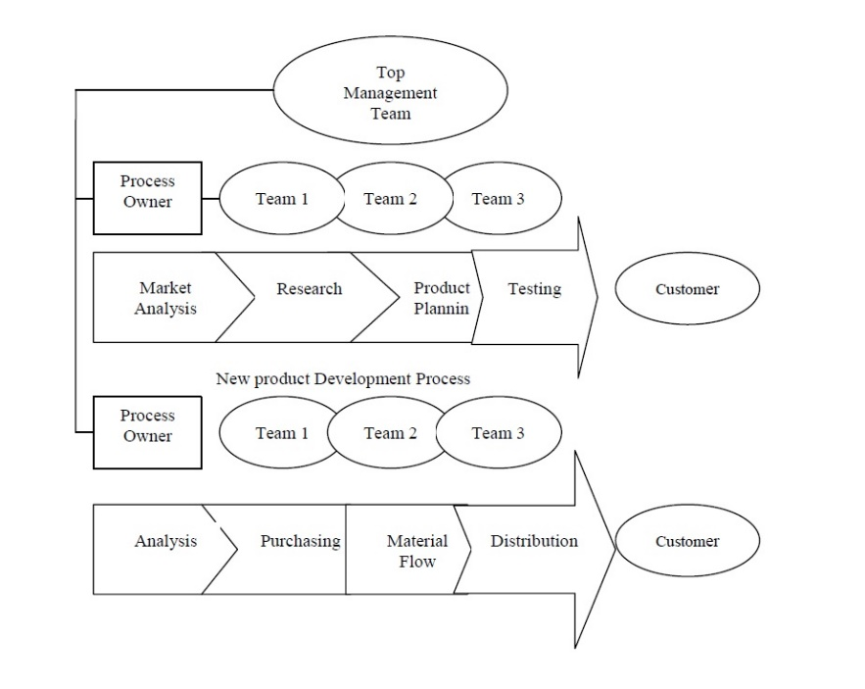
Figure 2. Processes in horizontal structure company (Ostroff, 1999)
Advantages and disadvantages of horizontal structure are condensed in the table below:
Pros | Cons
- Advances an attention to teamwork and cp-operation  - Advances flexibility and quick response to changes in customer demands  - Betters quality of life for employees by giving them opportunities to make decisions and be responsible for their results  - Employee has a wider view of organizational targets  - Let everyone focus on the production and deliver superior value to customers | - Can reduce in-depth skill development  - Conventional managers may be reluctant to give up power and authority  - Demands changes in culture, administration philosophy, award and information systems  - Demands unprecedented training efforts to make employees work efficiently in a horizontal team environment  - Identifying centre processes is complex and time-consuming
Figure 3. Advantages and disadvantages of horizontal structure
5.2 Virtual structure
A virtual form has been established with the purpose of dealing concurrently with higher levels of interdepartmental specialization and a bigger demand for fast adaptation that pursue from more volatility and disturbance within organizations. A virtual organization is a transient network of autonomous organizations – providers, consumers or even opponents – connected mainly to share skills through information technology (Druckman, 1997). An active company is one that determine a set of business capacities to highly productive operations, and then develop a virtual organization based on these capacities, letting the active company to create its business around the centre, highly productive information and products (Zakrzewska, 2008).
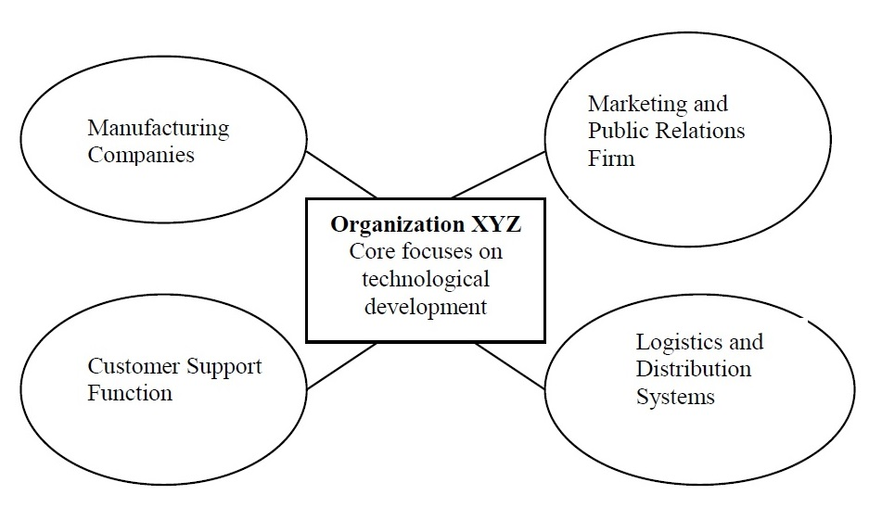
Figure 4. The virtual network structure (Daft, 2010)
Advantages and disadvantages of virtual structure are condensed in the table below
Pros | Cons
- Allows small companies to obtain talent and resources worldwide  - Provides the organization instant scale and reach without investing lots of money for factories, equipment or distribution facilities  - Make companies flexible and responsive to changing demands  - Lower management costs | - Managers do not have practical control over many actions and staffs  - Demands much time to handle relationships and possible conflicts with contract companions  - Risk of organizational failure if a companion flops to deliver or quit the business  - Questions about the loyalty of employee as employee could feel they can be substituted by contract services
Figure 5. Advantages and disadvantages of virtual structure
5.3 Flat structure
Flat-structured companies comparatively have some or just one layer of administration. It means the ‘chain of order’ from top to bottom is quicker and the number of employees that each manager control is bigger. Generally, in big fashion companies, they used the conventional organizations structure but as a result of many levels of administration from executive level to ground staffs, it takes lots of time for the decision-making process, leaving ground staffs to answer the delay to consumers which could diminish productivity. In contrast, flat-structured companies have less middle administration, enable the company work with comfort and less resistance. The enhancement of efficiency can lower the budget by getting rid of middle employees and reduce communication obstacles (Borkar, 2010). Organizations can divide tasks to other members by assigning lower-level employees more power or giving more responsibility to upper managers. In addition, there are plenty of ineffective activities can be wiped out by removing some middle-level managers (Strinfellow, 2010). In flat-structured organizations, vertical limits are eliminated to flatten the hierarchy and horizontal limits are taken off in order to substitute functional departments with cross-functional groups and to set up activities around processes. When fully functional, boundary-less companies get rid the barrier of geographic gap from external division. The transition from vertical structure into flat structure offers several challenges to executives and business owners, however it can be solved by appropriate preparation and instruction (Pal, 2014). But in reality, there are still a couple of challenges for companies which apply the flat structure: (1) Motivation - Employees in flat-structured companies have less managers to motivate them and give them feedbacks. The challenge within flat-structured companies is to foster self-motivation and breaking individual performance records. (2) Coherence - Companies with less supervision emphasize can miss some operative policies, letting different employees deal with different situations in dissimilar ways. Or some employees may sell low-quality products but others will get rid of those products, causing the disparity in quality control and production costs. (3) Promotion - In flat-structured companies, there are fewer managers to supervise the personal performance of employees. That could lead to the departure of well-performed staffs due to the lack of personal appreciation.
- Recommendation
A multi-dimensional method to build organizational structures indicates the existence of certain characteristic that describe a structure as a whole as well as its specific dimensions, includes specialization, structure, concentration and formalization. The suitable choice of these characteristics decides the nature of the company, represents the foundation for collaborations and establish the efficiency of the company’s operations. Despite that, there aren’t any comprehensive solutions for structuring organizational structures as a result of the complex relations between inidividual dimensions within the company and from the unpredictable environments (both internal and external). The best choice for each company depends on many elements such as targets, plans, technology, environment, culture, etc. These elements will fluctuate through time and fashion companies need to ready for constant changes in their organizational structures in the future. The direction of changes relies on the development strategy of organizations. Conversely, an effective application of adopted strategy relies on its structure and operation. Likewise, for the purpose of accomplishing maximum effect for the organization, executives of fashion companies should combine these two factors harmoniously.
Reference
adidas Group blog. (2017). ADIDAS UNVEILS INDUSTRY’S FIRST APPLICATION OF DIGITAL LIGHT SYNTHESIS WITH FUTURECRAFT 4D. [online] Available at: https://www.adidas-group.com/en/media/news-archive/press-releases/2017/adidas-unveils-industrys-first-application-digital-light-synthes/ [Accessed 2 May 2019].
adidas News. (2016). adidas Unveils First Futurecraft Shoe Created at Industry-Changing SPEEDFACTORY Facility. [online] Available at: https://news.adidas.com/futurecraft/adidas-unveils-first-futurecraft-shoe-created-at-industry-changing-speedfactory-facility/s/660af584-9bca-4f68-829d-9053a4da00e7 [Accessed 2 May 2019].
Amburgey, T. and Rao, H. (1996). Organizational Ecology: Past, Present, and Future Directions. Academy of Management Journal, 39(5), pp.1265-1286.
Appleby, R. (1969). Modern Business Administration. 1st ed.
Borkar, R. (2010). Flat Organizational Structure.
Boyd, C. (2017). Five ways fashion brands are using AI for personalization. [online] ClickZ. Available at: https://towardsdatascience.com/five-ways-fashion-brands-are-using-ai-for-personalization-1d2fbde8ac03 [Accessed 2 May 2019].
Carbon. (2017). The perfect fit: Carbon + adidas collaborate to upend athletic footwear - Carbon. [online] Available at: https://www.carbon3d.com/case-studies/adidas/ [Accessed 2 May 2019].
Charito, C. and Markides, C. (2003). Responses to disruptive strategic innovation. MIT Sloan Management Review, (44), pp.55–63.
Chitrakorn, K. (2018). 5 Technologies Transforming Retail in 2018. [online] The Business of Fashion. Available at: https://www.businessoffashion.com/articles/fashion-tech/5-technologies-transforming-retail [Accessed 2 May 2019].
Clark, D. (1973). The Formal and Functional Structure of Wales. Annals of the Association of American Geographers, 63(1), pp.71-84.
Crisco, R. (2017). The Impact of Assistive Technology on Quality of Life. M.A. Mills College.
Daft, R. (2010). Understanding the Theory and Design of Organizations. South-Western Cengage Learning.
Damodaram, A. and Ravindranath, K. (2010). Cloud Computing for Managing Apparel And Garment Supply Chains - An Empirical Study Of Implementation Frame Work. IJCSI International Journal of Computer Science Issues, 7(6).
Driscoll, M. (2011). Industry Surveys Apparel & Footwear: Retailers & Brands. [online] New York: Standard & Poor’s Equity Research Services. Available at: https://docs.wixstatic.com/ugd/8bc13d_9ebc2af633d64adab6d543d472ceb781.pdf [Accessed 2 May 2019].
Druckman, D. (1997). Enhancing organizational performance. 1st ed. Washington, D.C.: National Academies Press.
Elcock, H. (1996). Strategic Management. 2nd ed. New York: Macmillan.
Engdahl, S. (2008). Artificial intelligence. Farmington Hills, MI: Greenhaven Press.
Finance.yahoo.com. (2018). Uniqlo replaced 90% of staff at its newly automated warehouse with robots. [online] Available at: https://finance.yahoo.com/news/uniqlo-replaced-90-staff-newly-175631577.html [Accessed 2 May 2019].
Fodor, J. and Fodor, J. (1980). Functional Structure, Quantifiers, and Meaning Postulates. Linguistic Inquiry, 11(4).
Friedman, J. (2011). What caused the financial crisis. Philadelphia: University of Pennsylvania Press.
Gibson, J. (2012). Organizations: behavior, structure, processes. New York, NY: McGraw-Hill Irwin.
Gobble, M. (2016). Defining Disruptive Innovation. Research-Technology Management, 59(4), pp.66-71.
Gong, A. (2011). Five simple rules for the Cloud move. [online] Networks Asia. Available at: https://www.networksasia.net/article/five-simple-rules-cloud-move-1310620318 [Accessed 2 May 2019].
Greenwood, R. and Hinings, C. (1996). Understanding Radical Organizational Change: Bringing together the Old and the New Institutionalism. The Academy of Management Review, 21(4), p.1022.
Guleria, G. (2018). How AI is revolutionising the warehouse industry. [online] Glue Labs. Available at: https://blog.gluelabs.com/how-ai-is-revolutionising-the-warehouse-industry-4f7cbc40bb3d [Accessed 2 May 2019].
Hammer, M. and Stanton, S. (1999). How Process Enterprises Really Work. Havard Business Review, [online] (77). Available at: https://hbr.org/1999/11/how-process-enterprises-really-work [Accessed 2 May 2019].
Hawksworth, J., Berriman, R. and Goel, S. (2018). Will robots really steal our jobs? An international analysis of the potential long term impact of automation.
Huang, K., Hu, T., Wang, J., Chen, K. and Lo, H. (2016). From fashion product industries to fashion: upgrading trends in traditional industry in Taiwan. European Planning Studies, 24(4), pp.762-787.
Ismael, A. (2018). Adidas is now making city-specific running sneakers that account for differences in terrain — using feedback and data from runners around the world. [online] Business Insider. Available at: https://www.businessinsider.com/adidas-speedfactory-sneakers-2018-8?r=US&IR=T [Accessed 2 May 2019].
Kuprenas, J. (2003). Implementation and performance of a matrix organization structure. International Journal of Project Management, 21(1), pp.51-62.
Lam, A. (2004). Organizational Innovation. Royal Holloway College, University of London.
Larson, E. and Gobeli, D. (1987). Matrix Management: Contradictions and Insights. California Management Review, 29(4), pp.126-138.
Laursen, K. and Salter, A. (2005). Open for innovation: the role of openness in explaining innovation performance among U.K. manufacturing firms. Strategic Management Journal, 27(2), pp.131-150.
Linder, J. (2004). Outsourcing for radical change. New York: AMACOM.
Lorenz, K. and Hennrich, A. (2007). Regional Headquarters of MNCs in the sports industry. Master. Vienna University of Economics and Business.
Manyika, J., Chui, M., Dobbs, R., Marrs, A., Bisson, P. and Bughin, J. (2013). Disruptive technologies: Advances that will transform life, business, and the global economy.
Manyika, J., Chui, M., Miremadi, M., Bughin, J., George, K., Wilmott, P. and Dewhurst, M. (2017). A future that works: automation, employment, and productivity. 1st ed. McKinsey Global Insitute.
Maqsood Ali, M. and Haseebuddin, M. (2015). Cloud Computing for Retailing Industry: An Overview. International Journal of Computer Trends and Technology, 19(1), pp.51-56.
Marr, B. (2019). Artificial Intelligence Has A Problem with Bias, Here's How To Tackle It. [online] Forbes.com. Available at: https://www.forbes.com/sites/bernardmarr/2019/01/29/3-steps-to-tackle-the-problem-of-bias-in-artificial-intelligence/#c58b93d7a128 [Accessed 2 May 2019].
McClelland, C. (2019). What Is IoT? - A Simple Explanation of the Internet of Things | IoT For All. [online] IoT For All. Available at: https://www.iotforall.com/what-is-iot-simple-explanation/ [Accessed 1 May 2019].
Mellinger, M. (2014). Do Nonprofit Organizations Have Room for Advocacy in Their Structure? An Exploratory Study. Human Service Organizations Management, Leadership & Governance, 38(2), pp.158-168.
Michalik, J., Joyce, J., Barney, R. and McCune, G. (2015). 3D opportunity for product design. Additive manufacturing and the early stage. Deloitte University Press.
Microsoft (2012). The Microsoft SMB Business in the Cloud 2012. Redmond, Washington: Microsoft.
Morgan, J. (2014). The Future of Work: Attract New Talent, Build Better Leaders, and Create a Competitive Organization. 1st ed. Hoboken, N.J.: Wiley.
Nguyen, Q. (2002). Emotional Balancing of Organizational Continuity and Radical Change: The Contribution of Middle Managers. Administrative Science Quarterly, 47(1), p.31.
Oduro, S. and Nyarku, K. (2018). Incremental Innovations in Ghanaian SMEs: Propensity, Types, Performance and Management Challenges. Asia-Pacific Journal of Management Research and Innovation, 14(1-2), pp.10-21.
Ostroff, F. (1999). The Horizontal Organization: What the Organization of the Future Looks Like and how it Delivers Value to Customers. 1st ed. México: Oxford University Press, p.102.
Pal, R. (2014). Analytical Comparison of Flat and Vertical Organizational Structures. European Journal of Business and Management, 6(36).
Petersen, B. and Strongin, S. (1992). Market structure technology and the cyclicality of output. [Chicago, Ill.]: Federal Reserve Bank of Chicago.
Plowman, D., Baker, L., Beck, T., Kulkarni, M., Solansky, S. and Travis, D. (2007). Radical Change Accidentally: The Emergence and Amplification of Small Change. Academy of Management Journal, 50(3), pp.515-543.
Porter, M. (2001). Strategy and the Internet. Harvard Business Review.
Prahalad, C. and Hamel, G. (1990). The Core Competence of the Corporation. Harvard Business Review, (3), pp.79-91.
Pugh, D., Hickson, D., Hinings, C. and Turner, C. (1968). Dimensions of Organization Structure. Administrative Science Quarterly, 13(1), p.65.
Pwc.co.uk. (2018). [online] Available at: https://www.pwc.co.uk/economic-services/ukeo/ukeo-july18-full-report.pdf [Accessed 2 May 2019].
Ryder, D. (1999). Deciding to Change: Enhancing Client Motivation to Change Behaviour. Behaviour Change, 16(03), pp.165-174.
Staritz, C. (2010). Making the cut? Low-income countries and the global clothing value chain in a post-quota and post-crisis world. The World Bank.
Strinfellow, A. (2010). About Flat Organization Structure.
Sukviwatsirikul, U. (2014). A New Era for Retail Cloud. Computing Changes the Game.
The Royal Society (2017). Machine learning: the power and promise of computers that learn by example. [online] London: The Royal Society. Available at: https://royalsociety.org/~/media/policy/projects/machine-learning/publications/machine-learning-report.pdf [Accessed 2 May 2019].
The Royal Society (2018). The impact of artificial intelligence on work. London: British Academy.
Torry Harris (2009). Cloud computing - an overview. [online] Torry Harris. Available at: https://www.thbs.com/downloads/Cloud-Computing-Overview.pdf [Accessed 2 May 2019].
Turner, J. and Müller, R. (2003). On the nature of the project as a temporary organization. International Journal of Project Management, 21(1), pp.1-8.
Vesilind, E. (2006). Fashion Retail Thrives in S.F. Nabe. 192(11), p.6.
Weiss, A. (2003). Organizational consulting. Hoboken, N.J.: Wiley.
Weller, C., Kleer, R. and Piller, F. (2015). Economic implications of 3D printing: Market structure models in light of additive manufacturing revisited. International Journal of Production Economics, 164, pp.43-56.
Wiatrak, A. (2013). Nature and factors of organization architecture. International Journal of Contemporary Management, 12(4).
Willcocks, L. and Lester, S. (1997). In search of information technology productivity: Assessment issues. Journal of the Operational Research Society, 48(11), pp.1082-1094.
Worthley, J. (1980). Computer Technology and Productivity Improvement. Public Productivity Review, 4(1), pp.1-10.
Wren, C. (2017). Fashion In An Era Of 3d Printing. MA. Erasmus School of History, Culture and Communication.
Zakrzewska, A. (2008). Organizational design in the enterprise development process. 1st ed. Łódź: Wydawnictwo Politechniki Łódzkiej.

