Digital Skills and Research Methods
Module code BMSW 4003

Research report the impact of Virtual Learning Environment (VLE) – Moodle on students’ learning experience in the University of Wales Trinity Saint David London Campus

Student name: Hrisitna Deninska
Student ID: 1905508

Lecturer name: Modak Koushik

Table of Contents
1.0 Introduction 3
2.0 Background 4
3. 0 Aims & Objectives of the Research 5
Research Aim 5
Research Objectives 5
4.0 Research Method 6
Research Philosophy 6
Research Approach 6
5.0 Results 7
Primary Data (Questionnaires) 7
6.0 Discussion 14
Primary Data Analysis 14
Secondary Data Analysis 15
7.0 Conclusion 17
References 18
Appendix 1 (Questionnaires ) 19
Appendix 2 (Results) 20

1.0 Introduction
Virtual Learning Environment (VLE) can be considered as a platform where students and professors have the ability to deal online and have a better learning experience. It also provides a digital solution to any problems and no one is to present in a physical classroom here. The students and professors can do their academic activities from home in VLE. The purpose of this research is to find out the Impact of Virtual Learning Environment (VLE) – Moodle on students’ learning experience in UWTSD. In this research, the research tries to demonstrate the findings and experiences from primary and secondary sources of data. Most relevant and reliable data is used in the research to get an appropriate outcome. The aim and objectives of the researcher are observed in the research and discussed appropriately. A questionnaire was taken place for the purpose of collecting primary data and it contributes a lot to the research. Thus, the research has analysed the impact of VLE on the students of UWTSD and other UK institutes.

2.0 Background
A virtual learning environment (VLE) can be considered as a platform where students and professors have the ability to deal online and have a better learning experience. It also provides a digital solution to any problems and no one is to present in a physical classroom here (Hamilton, 2016). The students and professors can do their academic activities from home in VLE. It uses technology as much as it can to provide better services. VLE can also be considered as a system which provides opportunities to both students and professors to have an active environment of education and digital solutions. The technical supplement here plays a significant role to establish VLE. There is also some significance of VLE for an institute to adopt it within it and ensure proper learning. While using it, learners can get enough time for their study and ensure the best use of their time (Livingstone, Kemp and Edgar, 2018). The wastage is decreased here and the professor can get more opportunities for research. Besides, VLE can change the overall environment of the university which might be helpful for the educators. This research wants to know the impact o VLE on the students of UWTSD and other UK institutes and get the specific result.

3. 0 Aims & Objectives of the Research

Research Aim
The research is aimed to learn the impact of VLE on the learning experience of the students of the University of Wales Trinity Saint David, Birmingham Centre.

Research Objectives
There are also some objectives of this research like:
- To know the technique of VLE and its uses in online learning.
- To know the effect of VLE on the students of UK and their viewpoint.
- To measure how VLE can influence the students of UWTSD.
- To discuss how VLE can have a significant impact on the learning process of students.
- To evaluate the necessity of VLE for the students and educators.

4.0 Research Method

Research Philosophy
For this study of VLE in the University of Wales Trinity Saint David, the Positivism philosophy has been used and applied. The reason behind this is the researcher wants a positive outcome from this study of VLE and for this, the researcher thinks like a positivist which helps for keeping the social & traditional approaches unaffected (Byrne, 2011). Thus, the researcher tried best to bring proper outcomes and reliable data for the research and hopefully have the most positive outcomes.

Research Approach
The research is based on survey and questionnaires for primary data and secondary data has been collected from different reliable sources. There are two most common Approaches for research, and they are qualitative and quantitative approach (Bordens and Abbott, 2010). The scientific method for the quantitative approach is called deductive method and the scientific method for the qualitative approach is called the inductive method. The researcher here used questionnaires for the survey and used the quantitative approach for the research. Again, the scientific method for the research was deductive. For this research of VLE, secondary data has been collected from different reliable sources like journals, books, report, articles, website contents and others (Ryan, Scapens and Theobold, 2016). For primary data, questionnaires were used and the sample size for this research was 50 people of different ages. From those 50s most of them were the students of UWTSD, some were professors and the rest were the staffs and educators. The researcher has also tried to get an interview of students, professors and other related people to VLE. Thus, all data has been presented in the result part and the data were analysed in the discussion part.

5.0 Results

Primary Data (Questionnaires)
Result from primary data is shown below in table and graphs.
Table 1: Question 1: Which age group do you belong to?
Scale | Frequency
Under 20 | 6
20 to 30 | 19
30 to 40 | 16
40 to 50 | 5
50 or more | 4
Total | 50
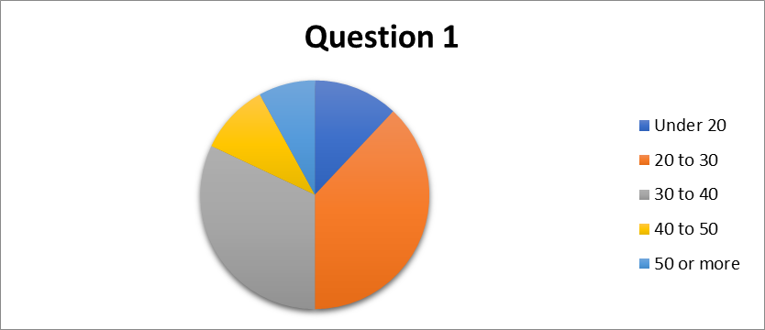
Q1 Graph Analysis: Here 38% people are in the age group 20 to 30 and 32% are from 30 to 40 so the research focused young and university students for the survey.

Table 2: Question 3: VLE & Moodle have a positive impact on my effectiveness in studying.
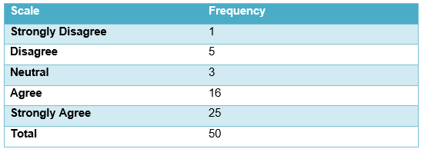
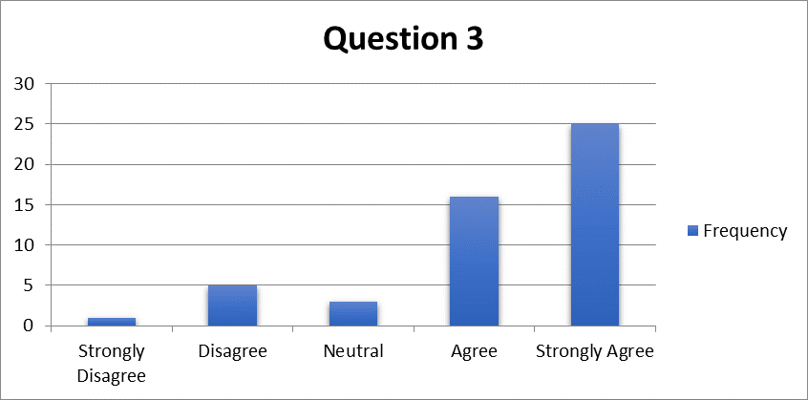
Q3 Graph Analysis: Here in the graph, 50% of the responses are strongly agreed with the statement.
So, it can be said that VLE & Moodle have a positive impact on the effectiveness in studying.

Table 3: Question 4: VLE &Moodle provides an essential help in my studies.
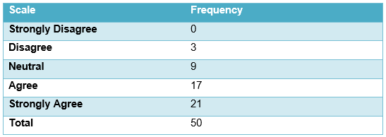
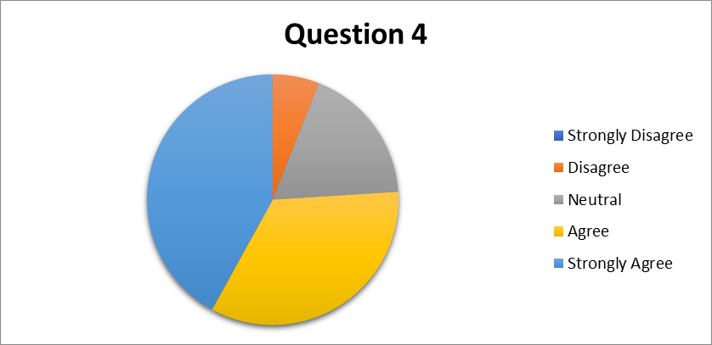
Q4 Graph analysis: In this graph, 43% people are strongly agreed and 34% are agreed.
Therefore, the people are positive with the statement and VLE &Moodle provides an essential help in their studies.

Table 4: Question 5: I am keen to learn more with Moodle than without it.
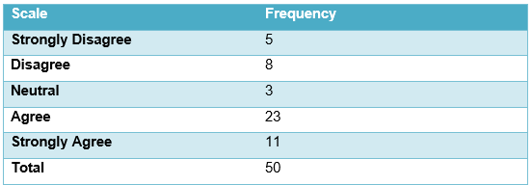
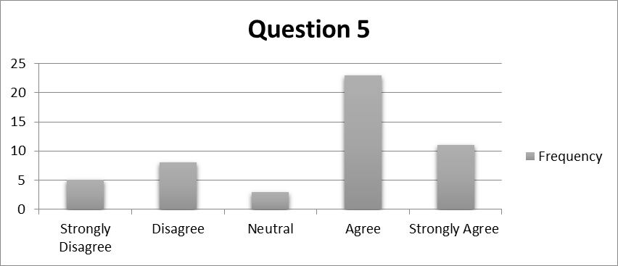
Q5 Graph analysis: The graph shows that 46% of the responses are agreed with the statement.
So, it can be said that students are keen to learn more with Moodle than without it.

Table 5: Question 6: VLE & Moodle help me improve my quality of learning.
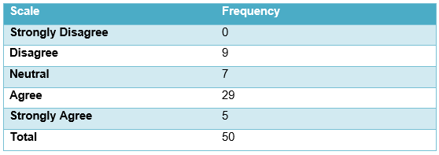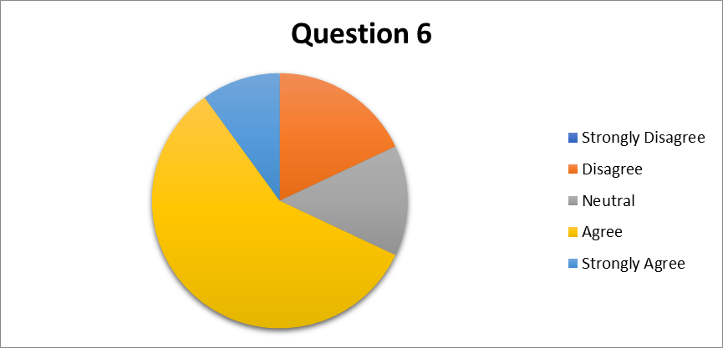
Q6 Graph analysis: In this chart, 58% responses are agreed.
Therefore, it can be said from the graph analysis that VLE & Moodle help the students to improve their quality of learning.

Table 6: Question 7: VLE & Moodle encourage me to learn independently at my own pace and place.
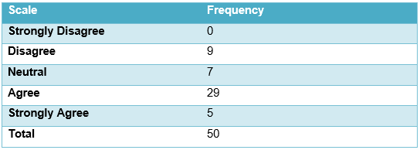
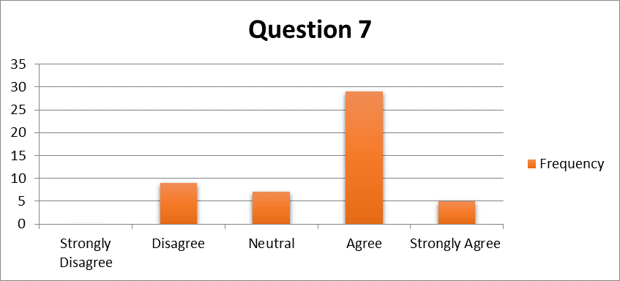
Q7 Graph analysis: This graph shows that 58% of the responses with the statement.
So, it is to be said that VLE & Moodle encourage students to learn independently at their own pace and place.

Table 7: Question 8: The resources for on Moodle are generally for information purposes.
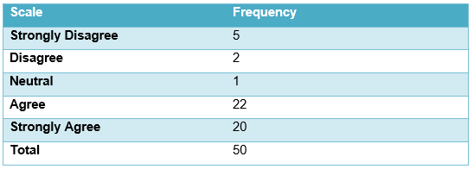
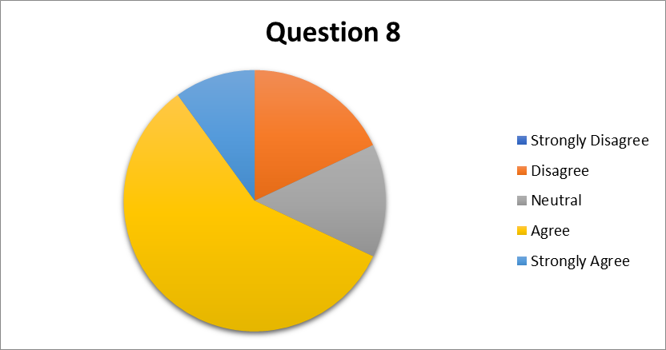
Q8 Graph analysis: In this graph, it is clear that 44% people are agreed and 40% are strongly agreed with the statement.
Therefore, it can be said that the resources for on Moodle are generally for information purposes.

Table 8: Question 9: The different activities on Moodle encourage me to talk to other students about the work.
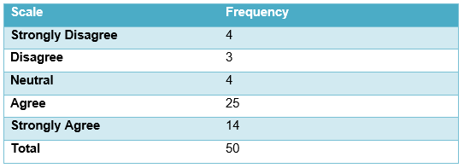
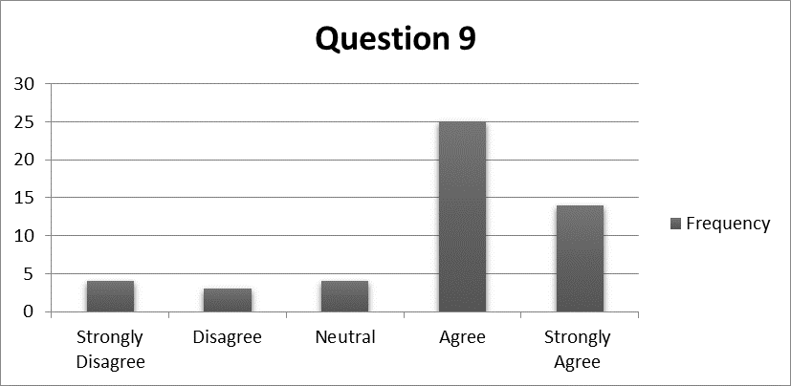
Q9 Graph analysis: In this graph 50% people are agreed with the statement.
So, from the graph analysis, it can be said that the different activities on Moodle encourage students to talk to other students about the work.

Table 9: Question 10: I am in control of my learning through Moodle increases my motivation to learn
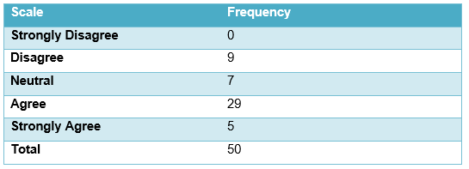
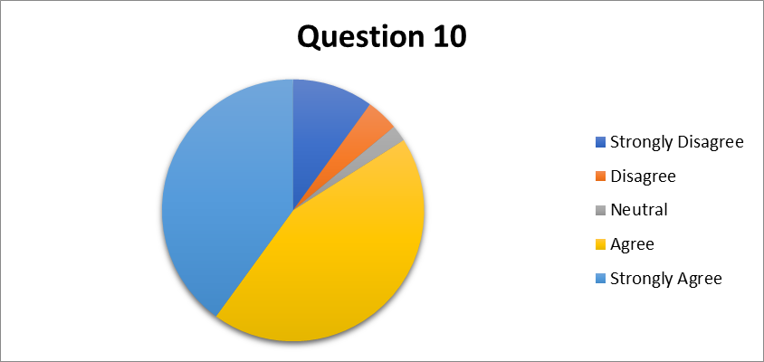
Q10 Graph analysis: The above chart shows that 58% of the responses are agreed with the statement of this question.
Thus, it is clear that students are in control of their learning through Moodle and it increases their motivation to learn.

6.0 Discussion

Primary Data Analysis
For this research, the researcher has collected primary data from different sources. For primary data, a questionnaire was used and the sample size for this research was 50 people of different ages. From those 50s, most of them were students of UWTSD, some were professors and the rest were the staffs and educators. The researcher has also tried to get an interview of students, professors and other related people to VLE (Telford, Becker and King, 2014). In the survey and interview session, most of the people were positive towards the VLE in UWTSD. The third question was if VLE & Moodle have a positive impact on my effectiveness in studying and most of the responses were positive so it can be said that there is a great impact of VLE & Moodle in the study of the students of UWTSD and others in UK (Herrera Mosquera, 2017). The fourth question in the survey was if VLE and Moodle provide essential help to the students or not. In this case, most of the results were strongly agreed or agreed with the statement and there is a significant role of VLE in studying and it provides essential help to the students. In the fourth on the researcher asked if the response maker was keen to learn more with Moodle than without it or not. Here, there was also a significant positive response from the survey and most of the students are learning more with Moodle than without it. The 6th one was whether VLE & Moodle help students improve their quality of learning or not and this case also have significantly positive outputs. So, VLE helps students to improve their quality (Sun and Liu, 2015). Question no 7 asked VLE & Moodle encourage people to learn independently at their own pace and place or not. The result was positive as most of the response was agreed or strongly agreed. Most of the people were agreed with the question no 8, “The resources for on Moodle are generally for information purposes” and the researcher can consider it. In question 9, the researcher asked if the different activities on Moodle encourage people to talk to other students about the work or not. According to the survey, the different activities can encourage people to discuss with others about the tasks and activities of learning and that seems good (Müller, 2013). The 10th and final question in the survey were if people are in control of their learning through Moodle increases their motivation to learn or not and the result was also positive as most of the people were agreed with that. Therefore, the research and investigation find the positive attitude of students and educators toward VLE and Moodle which is significantly great outcomes of the research (Wöber, Frew and Hitz, 2011).

Secondary Data Analysis
For this research, the researcher has collected data from both primary & secondary sources. The secondary sources are those which are the research or experiment of others. This research has analysed secondary data from different variable and dependable sources. Secondary data has been collected from books, journals, articles, reports, contents, websites, and other reliable resources. There were 15 to 20 sources used for collecting secondary data for this research. However, the secondary data also provides a positive review of VLE for students and their study purpose.
Table 10: Secondary Data Collection Sources
Source | Frequency
Books | 6
Journals | 10
Articles | 4
Reports | 3
Websites | 2
Total | 25

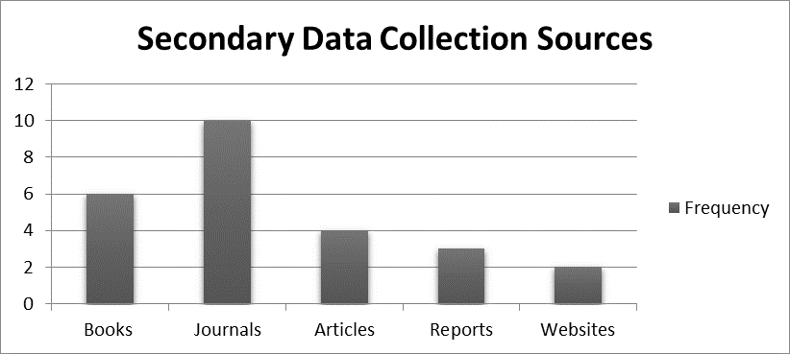
From the secondary sources, it is found that VLE aimed to create a digital platform to build an environment where the best use of technology will be ensured (Bloomfield, 2016). This will contribute a lot in the study of students and teaching of professors. There are a lot of advantages of VLE which can make the path of education easier and comfortable for all the parties like students, professors and other educators. Mostly, students can get benefits as they have a lot of opportunities here and have their own places to study (Tufaka and Babu, 2018). Thus, it can be said according to the secondary data, VLE has a significant impact on the study and it can play a vital role within the students of UWTSD.

7.0 Conclusion
To conclude, VLE in UWTSD is suitable according to the findings of this research. This research has found a significant positive impact of VLE on the students and educators of the universities. Other universities of UK can adopt it as the impact of VLE is positive and friendly in nature. This research is based on the students and educators’ point of view and their thinking. According to most of them, VLE has a positive role in learning and so a university should create a very strong platform of Virtual Learning Environment (VLE) – Moodle for the students and it might work for their success.

References
Bloomfield, P., 2016. VLE And Its Impact. Paisley: University of the West of Scotland.
Bordens, K. and Abbott, B., 2010. Research Design And Methods: A Process Approach.
Byrne, D., 2011. Philosophy Of Research.
Hamilton, M., 2016. Learning In A Virtual Learning Environment.
Herrera Mosquera, L., 2017. Impact of Implementing a Virtual Learning Environment (VLE) in the EFL Classroom. Íkala, Revista de Lenguaje y Cultura, 22(3), pp.479-498.
Livingstone, D., Kemp, J. and Edgar, E., 2018. From Multi-User Virtual Environment to 3D Virtual Learning Environment. Research in Learning Technology, 16(3).
Müller, D., 2013. Design Characteristics Of Virtual Learning Environments. Wiesbaden: Springer Gabler.
Ryan, B., Scapens, R. and Theobold, M., 2016. Research Method And Methodology. London [u.a.]: South Western Cengage Learninig.
Sun, Y. and Liu, Z., 2015. The study of binary interaction parameters on VLE for alternative refrigerant mixtures. Asia-Pacific Journal of Chemical Engineering, 10(3), pp.476-482.
Telford, W., Becker, A. and King, W., 2014. VLE Mapping Of Geological Structure.
Tufaka, A. and Babu, N., 2018. Application of Activity Coefficient Models in VLE Determination for Azeotropic System Using Othmer Type Ebulliometer. International Journal of Recent Trends in Engineering and Research, 4(1), pp.338-340.
Wöber, K., Frew, A. and Hitz, M., 2011. Information And Communication Technologies In VLE. Wien: Springer.

Appendix 1 (Questionnaires)
The Impact of Impact of Virtual Learning Environment (VLE) – Moodle on students’ learning experience

Reason for Survey: This questionnaire is a part of the research project on the topic of Virtual Learning Environment (VLEs.) in UWTSD

ID: 1905508

Question 1: Which age group do you belong to?
- Under 20 2) 20 to 30 3) 30 to 40 4) 40 to 50
- 50 or more

Question 2: In short, please describe why do you think is good the VLE/Moodle to be introduced to the UWTSD?
……………………………………………………………………………………………………………………………………………………………………………………………………………………………………………………………………………………………………………………………………………………………………………………………………………………………………………………………………………………………………………………………………………………

With the following questions, please answer whether you agree or disagree with a statement.

Question 3: VLE & Moodle have a positive impact on my effectiveness in studying.
Question 4: VLE &Moodle provides an essential help in my studies.
Question 5: I am keen to learn more with Moodle than without it.
Question 6: VLE & Moodle help me improve my quality of learning.
Question 7: VLE & Moodle encourage me to learn independently at my own pace and place.

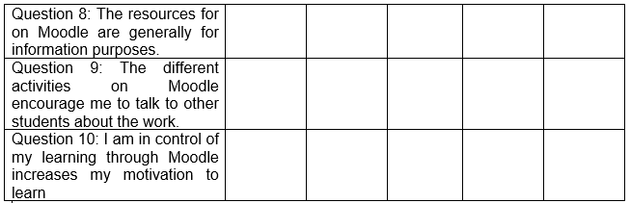

Appendix 2 (Results)

Table 1: Question 1: Which age group do you belong to?
Under 20 | 6
20 to 30 | 19
30 to 40 | 16
40 to 50 | 5
50 or more | 4
Total | 50
Table 2: Question 3: VLE & Moodle have a positive impact on my effectiveness in studying.
Strongly Disagree | 1
Disagree | 5
Neutral | 3
Agree | 16
Strongly Agree | 25
Total | 50
Table 3: Question 4: VLE &Moodle provides an essential help in my studies.
Strongly Disagree | 0
Disagree | 3
Neutral | 9
Agree | 17
Strongly Agree | 21
Total | 50
Table 4: Question 5: I am keen to learn more with Moodle than without it.
Strongly Disagree | 5
Disagree | 8
Neutral | 3
Agree | 23
Strongly Agree | 11
Total | 50
Table 5: Question 6: VLE & Moodle help me improve my quality of learning.
Strongly Disagree | 0
Disagree | 9
Neutral | 7
Agree | 29
Strongly Agree | 5
Total | 50
Table 6: Question 7: VLE & Moodle encourage me to learn independently at my own pace and place.
Strongly Disagree | 0
Disagree | 9
Neutral | 7
Agree | 29
Strongly Agree | 5
Total | 50
Table 7: Question 8: The resources for on Moodle are generally for information purposes.
Strongly Disagree | 5
Disagree | 2
Neutral | 1
Agree | 22
Strongly Agree | 20
Total | 50
Table 8: Question 9: The different activities on Moodle encourage me to talk to other students about the work.
Strongly Disagree | 4
Disagree | 3
Neutral | 4
Agree | 25
Strongly Agree | 14
Total | 50
Table 9: Question 10: I am in control of my learning through Moodle increases my motivation to learn
Strongly Disagree | 0
Disagree | 9
Neutral | 7
Agree | 29
Strongly Agree | 5
Total | 50

