BMSK5002 Developing Relationship and Workplace Achievement
Group 3
Easmin Khatoon
1711689
Doreen Nyaa Amundam

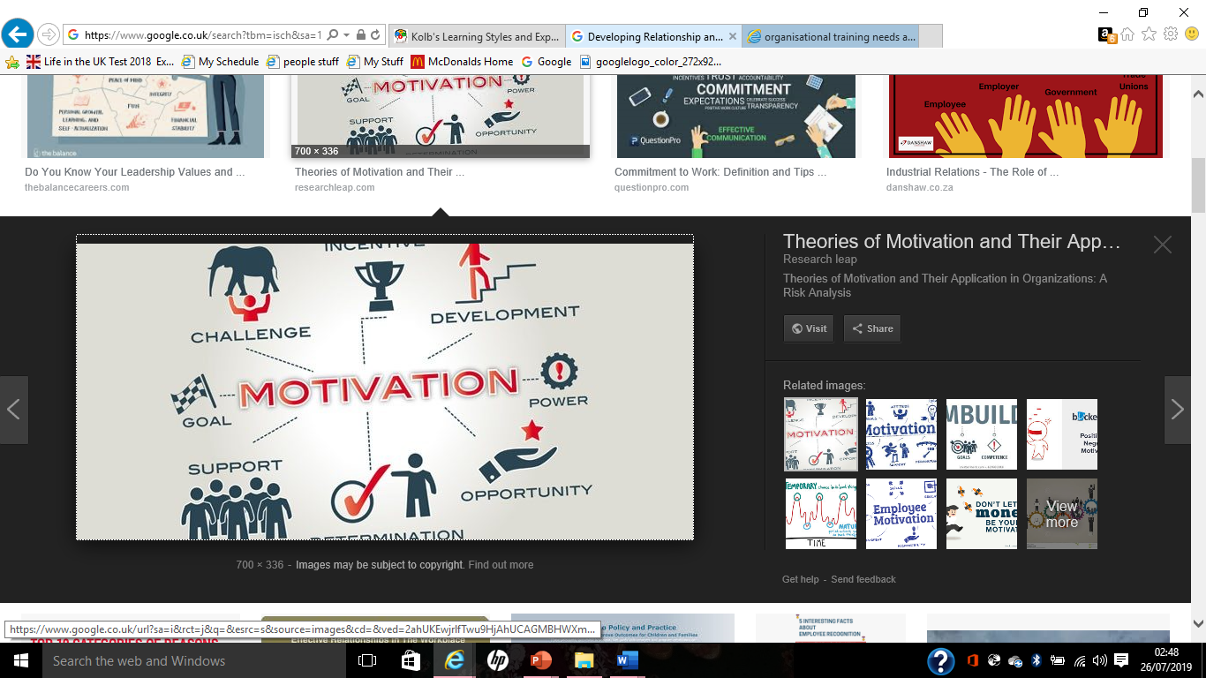

Contents
Introduction………………………………………………………………………….………………3
Task 1, Evaluation of three development vehicles……………………………………………3
a. Motivation…………………………………………………………………………………3
b. Employee engagement…………………………………………………………………6
c. Learning and development in the workplace……………………………………….8
Task 2, Assessing the potential benefits to the organisation and individuals………….11
Task 3, Developing a plan to meet the identified development needs and expectation.12
Conclusion………………………………………………………………………………................14
References………………………………………………………………………………................15

Introduction:
Employees are the most valuable resource of an organisation. Where a good relationship in the workplace is essential for the organisation’s success. That’s why it essential to place a development plan for employees to promote good relationship and motivate the employees to stay with the organisation and work efficiently. The employee’s development can be defined as a process of supporting the employees by the employer through various training to gain knowledge and skills, also motivating them by offering various rewards and benefits. According to the article in online journal Applied Psychology by Birdi, Kamal ,Allan, Catriona, Warr, Peter December 1997, four types of development activities was studied in a sample of manufacturing employees and found similar sets of variables are linked to the participation in three activities such as; training courses required in the work, work-based development activities and career planning activities in the work. To fulfil the requirement of the assignment this report will be based on three sections such as; Task 1, Evaluation of three development vehicles that are appropriate to the development needs of the individual. Task 2, Using Selfridges and Co. as organisational example to assess the potential benefits to the organisation and to the individual of using these development vehicles in the workplace. Task 3, Developing a plan using three examples to meet the identified development needs and expectations of an individuals.
Task 1, Evaluation of three development vehicles:
There are various vehicles that can be used for employee’s development process. Where different organisations use different kind of vehicles depending on the needs of the organisation and its employees. In here three development vehicles such as; Motivation, Employee engagement and Learning and development in the workplace will be discussed as these three vehicles are appropriate to the development needs of the individuals and are being used in my chosen organisation Selfridges and Co.
a. Motivation: The term motivation can be defined as a reason that the way an individual act or does something. The perception of the motivation differs by individuals and situation. There are some individuals who are motivated by their self by experiencing others behaviour and some individuals need motivation from others. According to David C. McClelland (1988) ‘from the point of view common-sense, motivation refers on one hand to conscious goals, to such inner feelings like I wish to be a doctor, or I am trying my best to solve this problem. On the other hand, motivation refers to inferences about conscious goals that we make by observing other behaviours.’ Now it is essential to find out what make an individual motivated in the workplace. Where the motivation can be divided in two types:
Intrinsic motivation: An individual is motivated from the engagement of the work or degree of involvement. Where responsibilities may be used as an example for managers to accomplish the task or an individual may be engaged with competition or teamwork cooperation.
Extrinsic motivation: An individual is motivated from things are placed by other to motivate him/her. Like bonus, pay rise, rewards, recognition, promotion etc. in the workplace.
However, both types of motivations are placed within an organisation. Where, on one hand an individual is motivated because of his/her job role to complete the certain task. On the other hand, the organisation taking actions to motivate the employees by providing competitive salary, performance related pay, bonus, incentives, rewards and recognition etc to maximise the performance and retain the employees too. But, in here I argue that extrinsic motivation is most important within an organisation. Because of the unlimited demands and needs of an individual. That’s why the question arise what can motivate an individual? To find the answer the motivational theories can be used and analyse. There are various motivational theories have been developed by various scholars to find the factors that motivate an individual in the workplace. To make this report comprehensive the one of the most famous motivational theories such as Maslow’s Hierarchy of Needs will be discussed.
According to Dr. N. Jerome (2013) Abraham Maslow anticipated a theory in psychology in his 1943 paper "A Theory of Human Motivation" which is known as Maslow’s hierarchy of needs, where lower order needs psychological and safety needs may be linked to the culture of an organization. Maslow’s hierarchy needs theory shows how needs and goals can motivate people. Where Maslow’s positioned the needs in hierarchy to make it clear which needs are linked to an organization and which needs are most needed to fulfil. According to McLeod, S. A. (2007) There are five stages in the model includes;
1.Biological and Physiological needs: are the basic needs that people want to fulfil before anything else. Like, air, food, cloths, shelter, sleep, sex etc.
2.Safety needs: Once the basic needs is fulfil a person wants to get protection, security, law, and stability etc.
3. Social Needs; At this stage a person wants to build relationship, friendship, family etc.
4. Self-esteem needs: In this stage a person wants to get independency, status, achievements, respect etc.
5. Self-Actualization needs: At the last stage a person realises his/her personal potential, pursue inner talent, gain experiences and look for personal growth.
Figure 1: Maslow’s hierarchy of needs.
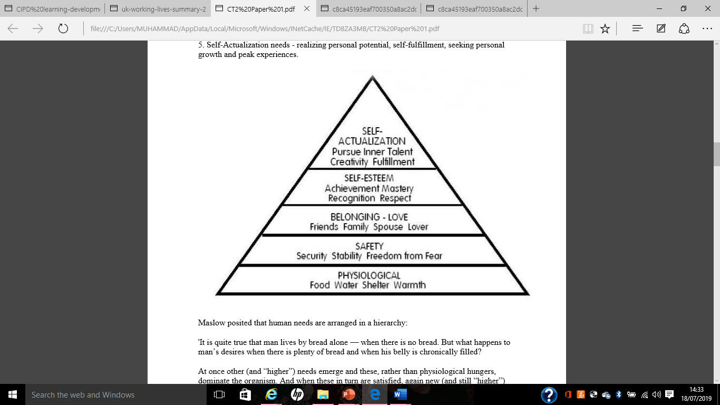
Source; McLeod, S. A. (2007).

Maslow (1943) stated that people are motivated to attain certain needs. When the first need is fulfilled a person pursues to achieve the next one, and so on.
Critical evaluation of Maslow’s hierarchy of needs:
The main limitation of Maslow’s hierarchy of needs theory is the methodology used in the model. Maslow used biographical data to characterised self-actualized individual where only few people been identified as self-actualized. But in realistic different group of people may have different characteristic around the world.
In this model the first level of needs must be attained to go to the next one, but there are some areas in the globe people are having family and getting love even their basic need food and shelter are not fulfilled.
It could be argued that several creative people like authors, artist living in the poverty but still they are well known in the world, meaning they have achieved the self-actualization.
The model based on assuming same culture of all the human beings but in realistic there are variety in culture around the globe.
b. Employee engagement:
The concept of employee engagement is for making the employees loyal to the organisation that they can do their best. An employee can go extra mile for the organisation when he/she feel valued in the organisation. Employee engagement can be defined as a basic concept to understand the connection or relationship between organisations and its employees. According to Sarah Cook (2008) ‘Employee engagement is more a psychological contract than a physical one. Where engagement is characterized by employees being committed to the organization, believing in what it stands for and being prepared to go above and beyond what is expected of them to deliver outstanding service to the customer.’ That’s why it has two aspects; when the employees find the job role is interesting, rewarding and enjoy doing it and other one, when the employees feel they are valued in the organisation and a great place to work. It is essential for an employer to ensure the employees are engaged to put the development process in the place. There are some models and theories to described how employee engagement can motivate employees to go extra miles for an organisation.
The employee engagement model by Armstrong, M, Brown, D, and Reilly, P 2010 shows the elements of engagement such as;
Commitment: Is a promise or obligatory duties of an employee that are identified and involved with the organisation. When a person is dedicated toward his/her commitment with the organisation he/she will go beyond the role and perform for the organisation.
Organisational citizenship: Is the behaviour or actions of an employee that he or she goes extra mile for organisation without any formal rewards. Rather this behaviour come form their self as realizing their involvement with the organisation.
Motivation: Is power that make an employee energetic to do something extra for the organisation’s success. In employee engagement the motivation is intrinsic or basic elements.
So, if the employees are engaged with the organisation there will be good relationship between employees and employer, there for the employees will not hesitate to take extra step to achieve the organisation’s goal even not being rewarded formally. The below figure of employee engagement shows clearly how these elements and engagement are attached.

Figure 2: IES model of Employee Engagement.
Engagement
Commitment
Organizational
Citizenship
Motivation

Source; Armstrong, M, Brown, D, and Reilly, P 2010.
According to research report at CIPD by Alfes, K, Soane, E.C, Rees, C 2010, ‘there are three core sides of engagement; Intellectual engagement or thinking hard about the job and how to do it better. Affective engagement or feeling positively about doing a good job. Social engagement or actively taking opportunities to discuss work-related improvements with others at work.’ They also found a range of positive out come of employee engagement like; batter performance by engaged employees, innovative than others who are engaged with organisation, rated high in performance appraisal, most likely to stay with organisation if the employees are engaged, and satisfied with personal well being etc. Also, engaged employees wants to do things batter way that can be beneficial for the organisation and they are can go extra mile for the organisation.
Critical evaluation of employee engagement;
The main limitation with employee engagement is not providing any formal reward rather thinking the job can be done with a strong engagement. Where, in a competitive market if the employees see other organisations providing batter pay, rewards and recognition formally they may go after that organisation and engagement will be failed in here.
Also, in engagement motivation is instinctive. But in realistic not many employees will be motivated by their self rather high salary, benefits, bonus, incentives, and learning and development opportunities play a vital roll for motivating the employees.
In employee engagement commitment is one of the core elements. But an employee may keep the commitment 100% at the beginning of the job, but after few months or years they will look for an increased in salary, bonus, rewards or promotion to keep the commitment.
Generally, an organisation will not share all the employees with everything rather the employees may be engaged with certain things depending on employee’s job role, length of service, previous record of the employees, and best employees etc. In this case not all the employees will perform batter because of engagement, rather conflict may arise because of pick and choose.
c. Learning and development in the workplace:
Learning and Development can be defined as a process of improving the knowledge, skills, capabilities of employees through a planned training to improve the performance of the employees and continue the organisation’s success. According to Hayden, D (2018), ‘learning and development in the workplace is a strategy outlines how an organization develops the capabilities, skills and competencies of its workforce to maintain the success, and it’s a vital part of the organization’s overall business plan and policies.’ The nature of learning in the workplace is mainly informal, where employees are given the opportunities took part in various training session, coaching, mentoring, and supporting activities etc. depending on the job role. Also, informal learning process may take place in the workplace as well as. Most of the workplace learnings are experiential learning, which is planned through a process and according to the training or experience need for an employee. The process involves self-managed and self-directed learning, which is improved by planned training, coaching, mentoring, and online learning.
In the process of learning an individual need to go through various stages to complete this learning. That’s why it’s can be presented in a cycle of learning. According to McLeod, S (2017) the experiential learning cycle was developed by Kolb, D, A in 1984. Which has four stages and a learner touches all the bases. These four stages where a learner go through; Having an existing experience, which followed by reflection and observation of that experience and leads to development of analysis and conclusion, which than use to test the future situation and resulting new experience.

Figure 3; Experiential learning cycle.

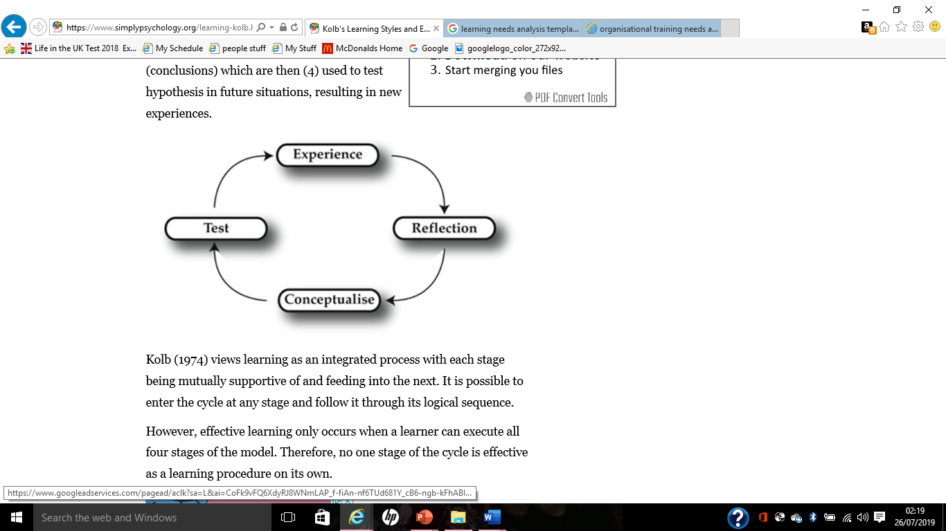

Source: McLeod, S (2017)

According to Kolb, D, A (2014) Experiential learning can be put as a process of linking the education, work and personal development. Which also presented by the model at below figure 4.

Figure 4: Experiential learning model.
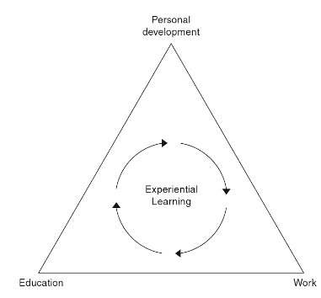
Source: Kolb, D, A (2014).
This model offers a system that describes the job demands that can be linked with educational background and works skills through personal development. In formal education variety of knowledge can be gained which could be the main requirement for a job role. But in realistic there are some training needed in the work to develop the skills to perform the job role. That’s why an organisation can develop individual’s development plan to identify the knowledge and skills need for an employee.
Self-managed and self-direct learning play a vital role for an individual’s personal development. An individual need to be self-managed and self-directed to gain the required skills and knowledge to progress further. In this digital world where most of things are getting done by one click in the computer and most of the people have smart electronic device with access to internet. That’s the organisation putting taking extra step to train their employee with the help of E-learning. Also, the main benefits of e-learning that an individual can complete it even from home where it will save time and money for the organisation.

Limitation of Learning and development:
The main limitation of learning and development process is the self-managed and self-directed individual. Where a person may find difficult to understand his/her learning needs and may find difficult to complete training for the experiential learning process. Individual may have certain education but not relevant to his job role, there for he/she may need to go for training to gain certain skills. Which could be time consuming if the person unable to pick up quick enough.
Not everyone can operate a computer or may not have access to electronic gadgets there for the E-learning process will not be useful for them. Also, introduction of E-learning that some organisation encourages people to complete it at home that may save organisation time and money for training. But people may not have access to the internet at home or may not have enough time to complete this.

Task 2, Assessing the potential benefits to the organisation and individuals;

The above described three development vehicles have potential benefits for the organisation and individuals. These are being used by various organisations and the Selfridges and Co. is one of them, which is beneficial for both employees and the company. The Gender pay gap report (2017) by the company shows following commitments:
- Offering individual’s opportunities to join retain apprentice program, which lead to develop management team.
- A clear career pathway, where the employee can see his/her future career.
- Reviewing the types of contract and working pattern that’s suit to individual needs.
- Easier for team member to search and apply for opportunities through an internal career portal.
- A weeklong career events and workshop to help team members to identify career paths and development opportunities.
- Educating the management team on unconscious bias that can make employee feel valued and not getting upset on any unexpected things.
Selfridges and Co. pays a competitive salary and bonus to its employees where the employees are highly motivated. If we look at Maslow’s hierarchy of needs. To fulfil the first level of needs an individual need enough money to buy food and find shelter. As Selfridges and Co. salary paid to employee are above UK’s minimum living wage. Average hourly pay by Selfridges is £9.03 (PayScale 2019) where national living age is £8.21 (GOV.UK 2019). Also, the job is secure for an employee where they don’t need worry for loosing the job. The bonus scheme and employee discount drive the employee’s motivation at high level. In here the employees of the company can clearly see what they are working for and what they will get by working for this company as a result the employees hierarchy needs explained by Maslow’s get fulfilled that are relevant to the organisation up to level of self-esteem. By putting this motivational vehicle in place, the company will reduce its staff turnover, high productivity and maximising the profit.
Selfridges & Co. engaged its employee to make a good relationship. According to the statement of Selfridges & Co. (2017) life at Selfridges is exciting, dynamic and always evolving. In here the IES model of employee engagement can be applied. The company is motivating the employees financially and socially. Making its employee royal to the organisation where they can go extra miles for the company. Also, its build a strong relationship between the company and employees. There for employees knows exactly what’s happening around them and can take extra steps to get things batter.
By looking at above commitments by the company its clearly shows that the employees can see their future career development through various training and development program. As we have seen in the experiential learning model only formal education can’t fulfil the learning gap or skills required for a job role. That’ why the company taking extra steps to educate its employees and providing training for required knowledge and skills needed to make them capable to perform a job. That’s why employees will find easier to perform the role efficiently and effectively and the company will get skill full and talented employees.

Task 3, Developing a plan to meet the identified development needs and expectation;

As we have identified the development needs and expectation for an employee such as: motivation, engagement and, learning and development, now it is essential to make a plan to meet these needs and which can be presented by below table.

Development  needs | Description | Time scale | Impact
Motivation | What kind of motivation needed?  Financial or non-financial | Time for measuring or observing | How it will impact on organisation or on employee.
Engagement | How this employee can be engaged with organisation.  Like: decision making, advised, suggestion or just providing the information | Time frame for engagement with certain information | What will be the impact?
Learning and development | What training needed | Time scale; like how long | What will be impacted for this training.

Figure 5: Individual development plan.
On above table on motivation development needs, a person may be demotivated for various things that’s why first of all it is urgent to find out the fact behind his/her demotivation. It could be financial for example: getting less pay than others, not getting pay on time, less bonus or no bonus etc. Non-financial could be conflicts with other employees or managers, family matters, not getting feedback or appraisal etc. These can be identified by talking to the individual person and put the correct action on the table, with a time framework and analyse who will be impacted for this action.
In engagement development needs not, all employees can be engaged with certain things in the organisation. Like, a lower level employee can’t be included in hierarchy or business strategy decision making process rather will be more appropriate to engage him/her with production related decision or suggestion. That’s why it is vital to know with which part of the business an individual can be engaged that he/she feel valued and for how long, and the impact for this engagement.
In learning and development, it is line manager responsibilities to identify his/her subordinates learning, knowledge and skills gap with the job role. Then arrange the necessary training by selecting and time frame. Also, it is important to know the impact during the training and after the training. For example, what will be the cost for undertaking the training. Also, it is essential to know if the person is ready or has the capabilities to complete the training.
Conclusion:
The above discussion made it clear that despite the purpose of a business organisation is to maximise the profits. But it is not possible without a strong and committed team. That’s why the organisation need to place a development process for its employees to continue with the success. Where, these three development vehicles can be used, also other development vehicles can be used by the organisation. Also, it is beneficial for both organisations and its employees. However, to motivate an individual I would suggest to study on that individual person that what can motivate him/her. Which can be done by individual’s team leader or line managers. At the end, if an employee is highly motivated his/her performance will be at peak there for beneficial for the organisation.

References:
- A. H. Maslow (1943), A Theory of Human Motivation, originally published on Psychological Review, 50, 370-396. Accessed on 18 July 2019 on http://psychclassics.yorku.ca/Maslow/motivation.htm.
- Armstrong, M, Brown, D, and Reilly,P 2010. Evidence-Based Reward Management: Creating Measurable Business Impact from Your Pay and Reward Practices. Kogan Page Publishers.
- Alfes, K, Soane, E.C, Rees, C 2010, Creating an engaged workforce – CIPD report 2010, https://engageforsuccess.org/creating-an-engaged-workforce-cipd-report-2010 updated 8th January 2013. Last access on 23 July 2019
- Birdi, Kamal,Allan, Catriona,Warr, Peter December 1997; Correlates and perceived outcomes of 4 types of employee development activity. Online Journal of Applied Psychology, Vol 82(6), Dec 1997, 845-857. https://psycnet.apa.org/doiLanding?doi=10.1037%2F0021-9010.82.6.845. Last access on 16 July 2019.
- David C. McClelland (1988), Human Motivation, Cambridge University Press 1988.
- Dr. N. Jerome (2013), Application of the Maslow’s hierarchy of need theory; impacts and implications on organizational culture, human resource and employee’s performance. International Journal of Business and Management Invention. www.ijbmi.org Volume 2 Issue 3 ǁ March. 2013ǁ PP.39-45.
- GOV.UK 2019, National Minimum Wage and National Living Wage rates, published 2019. https://www.gov.uk/national-minimum-wage-rates. Last access 25 July 2019.
- Gender pay gap report (2017), Selfridges & Co. https://images.selfridges.com/is/.../selfridges/.../Gender_Gap_Legislation_ack_10.pdf. Last access on 26 July 2019.
- Hayden, D (2018), Learning and development strategy and policy, fact sheets in CIPD. Published 25 October 2018, https://www.cipd.co.uk/knowledge/strategy/ development/factsheet. Last access on 24 July 2019.
- Kolb, D, A (2014), Experiential Learning: Experience as the Source of Learning and Development, 2nd edition. FT Press, 2014.
- McLeod, S. A. (2007), Maslow's Hierarchy of Needs, http://www.simplypsychology.org/maslow.html, published 2007, updated 2013, accessed 18 July 2019.
- McLeod, S (2017), Kolb's Learning Styles and Experiential Learning Cycle, Online journal, https://www.simplypsychology.org/learning-kolb.html. Last access on 26 July 2019.
- PayScale 2019, Average hourly rate for Selfridges employee. Published 2019, https://www.payscale.com/research/UK/Employer=Selfridges/Hourly_Rate. Last access on 25 July 2019.
- Sarah Cook (2008), The Essential Guide to Employee Engagement: Better Business Performance Through Staff Satisfaction, Kogan Page Publishers, 2008.

