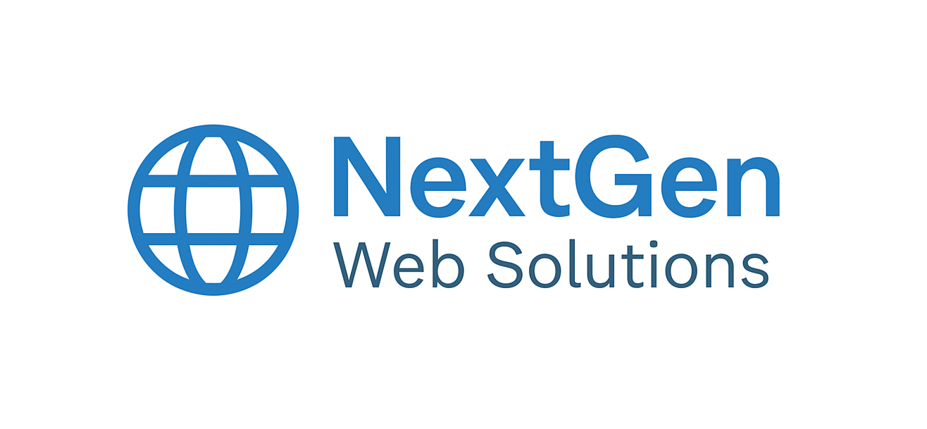

NextGen Web Solutions
  - E-Commerce Web and Mobile Application
Example (N-tier partitioned) Requirements Specification


Table of Contents
- Presentation Requirements
- Logic Requirements
- Database Requirements
- Hosting/Cloud Requirements
- Security Requirements

Presentation Requirements
ID | Title | Priority | Description
PR-001 | Responsive Design | High | The application must adapt seamlessly to different screen sizes (desktop, tablet, mobile).
PR-002 | Intuitive Navigation | High | Provide a clear menu structure and breadcrumb navigation for easy user flow.
PR-003 | Product Image Zoom | Medium | Users should be able to zoom in on product images for better detail.
PR-004 | Multi-Language Support | Medium | Enable language selection for global users.
PR-005 | Accessibility Compliance | High | Follow WCAG 2.1 standards for accessibility (e.g., alt text, keyboard navigation).

Logic Requirements
ID | Title | Priority | Description
LR-001 | User Authentication | High | Implement secure login and registration with email and social media options.
LR-002 | Shopping Cart | High | Allow users to add, remove, and update items in the cart.
LR-003 | Payment Gateway Integration | High | Support multiple payment methods (credit card, PayPal, etc.).
LR-004 | Order Tracking | Medium | Users can track order status from processing to delivery.
LR-005 | Recommendation Engine | Low | Suggest products based on user behavior and purchase history.

Database Requirements
ID | Title | Priority | Description
DB-001 | Product Catalog Schema | High | Maintain structured data for products including name, price, stock, and images.
DB-002 | User Profile Storage | High | Store user details securely with encryption for sensitive fields.
DB-003 | Transaction Logging | High | Record all transactions for auditing and reporting.
DB-004 | Inventory Management | Medium | Update stock levels automatically after purchase.
DB-005 | Backup and Recovery | High | Implement daily backups and disaster recovery protocols.

Hosting/Cloud Requirements
ID | Title | Priority | Description
HC-001 | Scalable Infrastructure | High | Use cloud services (e.g., AWS, Azure) to handle traffic spikes.
HC-002 | CDN Integration | Medium | Implement CDN for faster content delivery globally.
HC-003 | Load Balancing | High | Distribute traffic across multiple servers for performance.
HC-004 | Auto-Scaling | Medium | Automatically scale resources based on demand.
HC-005 | Monitoring & Alerts | High | Enable real-time monitoring and alerting for downtime or anomalies.

Security Requirements
ID | Title | Priority | Description
SR-001 | SSL/TLS Encryption | High | All data in transit must be encrypted using HTTPS.
SR-002 | Data Encryption at Rest | High | Sensitive data stored in the database must be encrypted.
SR-003 | Role-Based Access Control | Medium | Different user roles (admin, customer) should have appropriate permissions.
SR-004 | OWASP Compliance | High | Follow OWASP Top 10 guidelines to prevent common vulnerabilities.
SR-005 | Two-Factor Authentication | Medium | Provide optional 2FA for enhanced account security.

