

BA Business Management

LCBB5000

Data Handling and business intelligence

report

Student name: Carmen-Ioana Hodoroaba
Student ID: 2109656
Lecturer Name: DR. Eric Orsei

Table of Contents
Introduction 2
Discussion 3
Data warehousing and Business intelligence 3
The significance of the DW and BI with the DW architecture 3
Examples of the Tools of the BI used by the organizations 5
Effect of the BI and the DW on the modernized organization 5
Conclusion 7
References 8

Introduction
This report will talk about the importance of data warehousing and the business intelligence tools that have created a lot of impact on modern business nowadays. The use of the internet has uniquely transformed the whole world. The modernized organization has taken use of the ability of the internet for the creation of an extensive perception for their policies and growth. Both concepts play the role in the same section, but these are distinct from each other. The data storage and the organization intelligence include the information collection. But the process of the collection of the data, methods, and analysis is the major attention of the BI. On the other side, the data warehouse mainly introduces and the collection that kind of data that can help in supporting the BI tasks. The upkeeping and the distribution of the warehousing are important to the BI and they are majorly called the BIDW. Data analytics can provide support to the company so that it can react to the transformation faster way. The business can future predict schemes and the detection of modern opportunities in the best way. The leaders of the data-based organization know the advantages of the dependency on information perception so that they can move most easily. This documentation includes the data warehousing and the BI means, its significance with the architecture of the DW, the Modern instruments apparatus used by the business, and the effect of the BI and the DW on the organization.

Discussion

Data warehousing and Business intelligence
Storage of the data is the platform or the structure that collects the information from the organizational operation db. As well as from the outstanding references. Its structure is distinct from the working database as they collect ancient details, and helps the owner of the business for the analyzation of the info, on the particular interval of the timing. It also helps in the sorting of the details according to the distinct issue of the topics, like the consumers, items, or the task of the workplace. It includes the cleaning of the information, the integration of the data, and its consolidation. There is various kind of decision-supporting instruments and methods that will help in the utilization of the data that is present in data warehousing. All of these will help the execution of the usage of the storage in the fastest and the most effective manner (Vaisman and Zimányi, 2019).
The details that are collected can be taken into use in the following section-
1. Tune of the manufacturing policies: the strategies of the items can be well managed by the repositioning of the items and the handling of the portfolios by the comparison of the sales either in the quarter or in the year.
2. Analysis of the consumer: this is done by the analysis of the user's buying choice and preference, the time of the buying, and the wheel of the budget (Kunnathuvalappil Hariharan, 2019).
On the other hand, business intelligence merges the organization's analytics, data searching, visualization of the data, its tools, and architecture, and the best policies that will help the company for taking of the information-controlled settlement. It is the application that will help in the ingesting of the organization's details and make them available in user-friendly reviews like reporting, dashboards, charts, and pictorial presentations. Its tools make the user of the business for the accessing of a diverse amount of information- ancient or in-state, the third party, and the in-housing as well as the half-structure and the unorganized details example social media. The people can measure this data for the gaining of usefulness in the business performance (Vargas, 2021).

The significance of the DW and BI with the DW architecture
Data warehousing:
1. It helps in ensuring consistency. They are programs for the application of the informing format for all the collections of the information that make it easy for the corporate decision maker the analyzation and the sharing of information perception with the membrane across the world.
2. It will help in taking a good decision. It will increase the accuracy and the efficiency of the access to diverse kinds of info sets and make them ready which will help the business and the market policies that are easy to compete with.
3. Improvement in the down lining. Its structure will permit the owners of the business the rapidly access the business's past tasks and the evaluation of the steps that will succeed or succeed (Bhatia, 2019).
Business intelligence
1. Gaining of the modern consumer perception: the main reason the organization is investing their timing, worth, and skills in the BI is that it will provide them the high kind of capability for the observation and the analysis of the at present consumer purchasing trend.
2. Improving the visibility: The organization that is business intelligence has the best control over the process and the basic working structure because the capabilities of these functions is incremented by the system of the BI.
3. The action details: These also serve as the meaning for the identification of the basic organizational structure and the current trends (Božič and Dimovski, 2019).
The architecture of the DW
This is the process that defines the complete infrastructure of the information conversation process and the representation that will be at the client-end technology in the organization. Every type of data storage is diverse but all will be defined by the basic important elements. It involves its databases, Extraction, Transformation, Loading (ETL) tools, the Data within data, and its accessing tools. These all kinds of elements appear in a single layer that can be saw in the single-tier infrastructure or divided into the distinct layer that can be divided into the different layers that will be seen in the two and the three tiers (Jameel et al., 2022).
There are four different types of elements of the data warehouse:
1. Data warehousing databases
2. ELT tools
3. Metadata
4. Data warehousing accessing instruments
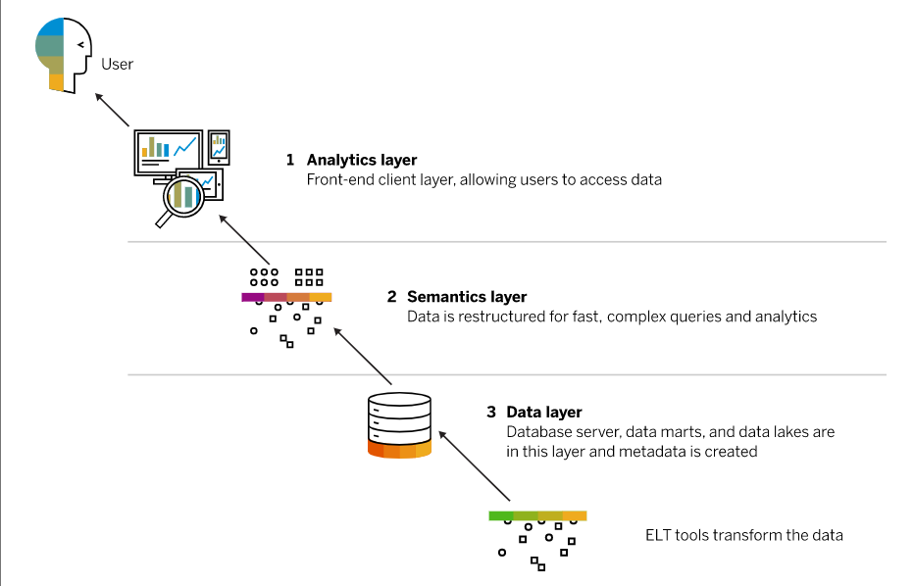
Figure 1:DW architecture
Source: (Sap.com, 2020)

Examples of the Tools of the BI used by the organizations
The tools of the BI are the app software that collects and process a bulk amount of information from both the inside and the outside of the business reference like books, articles, etc.
These are currently used:
1. Tableau
2. Sisense
3. Oracle BI suite
4. SAP

Effect of the BI and the DW on the modernized organization
Both concepts are essential for modern business as today most companies are competing in a far-bit manner on the base of the capability to grip the data that they had done before. Most of the 48% of the workplace take consideration of cloud BI as crucial or the most essential for their future product planning. There are different prospects of digitalized change that are closely linked when it talks about how the data is collected, secure, or used. It is the increment in the essentialness for the modern business to have the correct and clearer review of all the information to stay in the competition in which the tools of the BI come. Most of the 50% take into use these tools that show the continuous growth of the business. It provides several positive impacts
1. The clearer the data
2. Increase in the effectiveness
3. The user experience is best
4. The satisfaction of the worker is improving.
Advancements in technology are occurring constantly and accordingly, the DW is also appearing. The information lake, ELT, and the automation of data warehousing help shift the analysis of the data and the process. But the business needs more amount of DB consultant facilities for the analysis that needs organized information (Tripathi et al., 2020).

Conclusion
Both the concept of the data warehouse and the business intelligence are the two essential components for the survival of the organization. The trends of data warehousing is evolved due to the advance cloud base and data analytics tool. Data discovery and data security is the key trend of business intelligence. It gives information on the basic components like the ERP, Customer relationship management, the chain of the sell, and the consumers. The details of the current state of the company and the info on the present condition are given by the DW and the BI tools the techniques that will enable them for taking the required step and taking the best decision.

References
Bhatia, P., 2019. Data mining and data warehousing: principles and practical techniques. Cambridge University Press. https://books.google.com/books?hl=en&lr=&id=bF6NDwAAQBAJ&oi=fnd&pg=PR15&dq=importance+of+the+data+warehousing&ots=pNvDeAsyCk&sig=gpIEW0_jcZuocBklOlgbrwjvE0s
Božič, K. and Dimovski, V., 2019. Business intelligence and analytics for value creation: The role of absorptive capacity. International journal of information management, 46, pp.93-103. https://doi.org/10.1016/j.ijinfomgt.2018.11.020
Jameel, K., Adil, A. and Bahjat, M., 2022. Analyses the Performance of Data Warehouse Architecture Types. Journal of Soft Computing and Data Mining, 3(1), pp.45-57. https://doi.org/10.30880/jscdm. 2022.03.01.005
Kunnathuvalappil Hariharan, N., 2019. Trends in Data Warehousing Techniques. Naveen Kunnathuvalappil Hariharan.(2019). Trends in Data Warehousing Techniques. International Journal of Innovations in Engineering Research and Technology, 6(8), pp.7-14. https://papers.ssrn.com/sol3/papers.cfm?abstract_id=3914447
Tripathi, A., Bagga, T. and Aggarwal, R.K., 2020. The strategic impact of business intelligence: A review of literature. Prabandhan: Indian Journal of Management, 13(3), pp.35-48. https://www.researchgate.net/profile/Anuj-Tripathi-4/publication/339912127_Strategic_Impact_of_Business_Intelligence_A_Review_of_Literature/links/61440a4df4a9f7651162e3c6/Strategic-Impact-of-Business-Intelligence-A-Review-of-Literature.pdf
Vaisman, A. and Zimányi, E., 2019. Mobility data warehouses. ISPRS International Journal of Geo-Information, 8(4), p.170. 10.3390/ijgi8040170
Vargas, J., 2021. Business Intelligence. 10.20944/preprints202103.0579.v1

