Module Name: Learning In the Digital Era
Module Code: ACCA 4025

Student Name: Imran sharif
Student ID: 2538385
Group: 1
E-Portfolio Live Link- https://2538385.wixsite.com/my-site-1
Lecturer’s Name: Koushik Modak

Learning in The Digital Era Assignment 1

Table of Contents
-Learning in The Digital Era Assignment 1 0
Introduction 2
Main Body 2
Task 1: Essential Academic and Employment Skills for the future career Path 2
Task 1 (a): Report on Essential Academic and Employment Skills 2
Task 1 (b): Evaluation of Task 1 (a) based on Similarity report 3
Task 2: Collaborative Mind Map and Individual Poster 4
Mind Map (Collaborative) 4
Mind Map (Collaborative) 4
Poster (Individual) 5
Task 3: Virtual Collaboration and RefWorks 6
Report on Virtual Collaboration 6
Step-by-step process of using RefWorks with visuals 7
Task 4: E-Portfolio Creation and Evaluation 7
Task 4 (a): E-Portfolio Creation 7
Task 4 (b): Illustrative Review of E-Portfolio tool Selection 7
Conclusion 7
References 7
Task 1 References: 7
Task 3 References: 7
References 18
Task 1 References: 18
Task 3 References: 19

Introduction

We live in a progressively digital age, where possessing the ability to access, share, learn, communicate and work effectively in the digital world is more important than ever. This e-portfolio was created for the Learning in the Digital Era module completion by the University of Wales Trinity Saint David. The module consists of four tasks whose completion has allowed the learner to gain academic and professional skills. These include core academic and employment skills, team working and group work, using virtual communication tools, and even the design of this e-portfolio. An introduction to the digital and professional skills required in today’s working world that we develop useful software that people want.

Main Body

Task 1: Essential Academic and Employment Skills for the future career Path

Task 1 (a): Report on Essential Academic and Employment Skills
The skills mentioned in employability in cyber security jobs are very specific. Cybersecurity specialists should have both technical and soft or transferable skills sets. Employer priorities reveal a consistent trend, as evidenced by everything from everyday posts to industry analyses . [1]
A list of skills is here.
Network defence basics.
Resolving issues.
Conveying risks to non-technical management.
Focusing on details.
Lifelong learning.
Moral assessment
The fundamental technical skills are the entry point to capabilities (e.g. network security, threat identification, scripting). However, the most valuable differentiators between technically capable talent and market-ready talent lie in analytical skill and communication [2]. For instance, over three out of four Cybersecurity job advertisements state the need to critically assess a situation to identify its causes and consequences , and over two out of three do so to communicate technical risk to a nontechnical audience – a matter ignored by the cybersecurity newcomer focused only on technical certification [3]. To conclude, adaptability continues to be rated highly, as threats and security tools are evolving constantly employers will seek to reward ever more candidates who are proactive and continuous learners that pursue certification, participate in capture-the-flag (CTF) competitions, and run home lab environments rather than static credentials alone [4]. This is altogether consistent with increasingly common frameworks of competency such as NIST’s NICE Framework which links specific technical tasks directly with underlying areas of competency such as analysis and communication [5]. My movements in the future should include two alternate strands which make up the background. The things that always help are some basic tech skills like networking, system administration and scripting. Analytical and communication skills that pull technically sound but unprepared people up will be the second one.
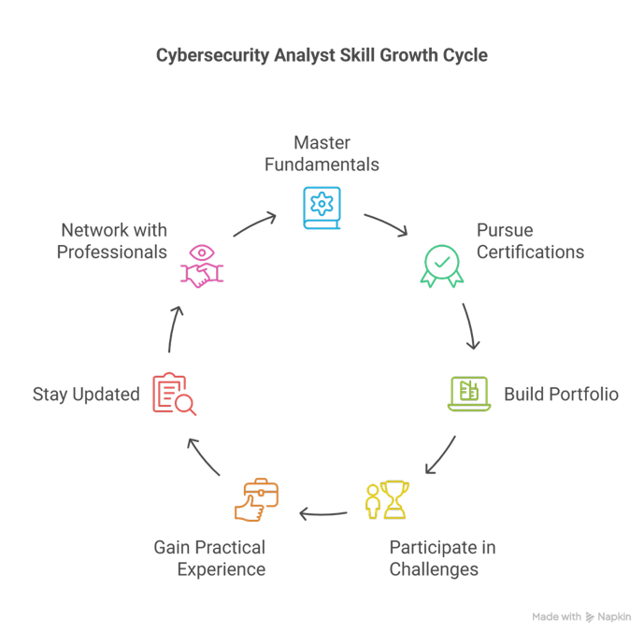

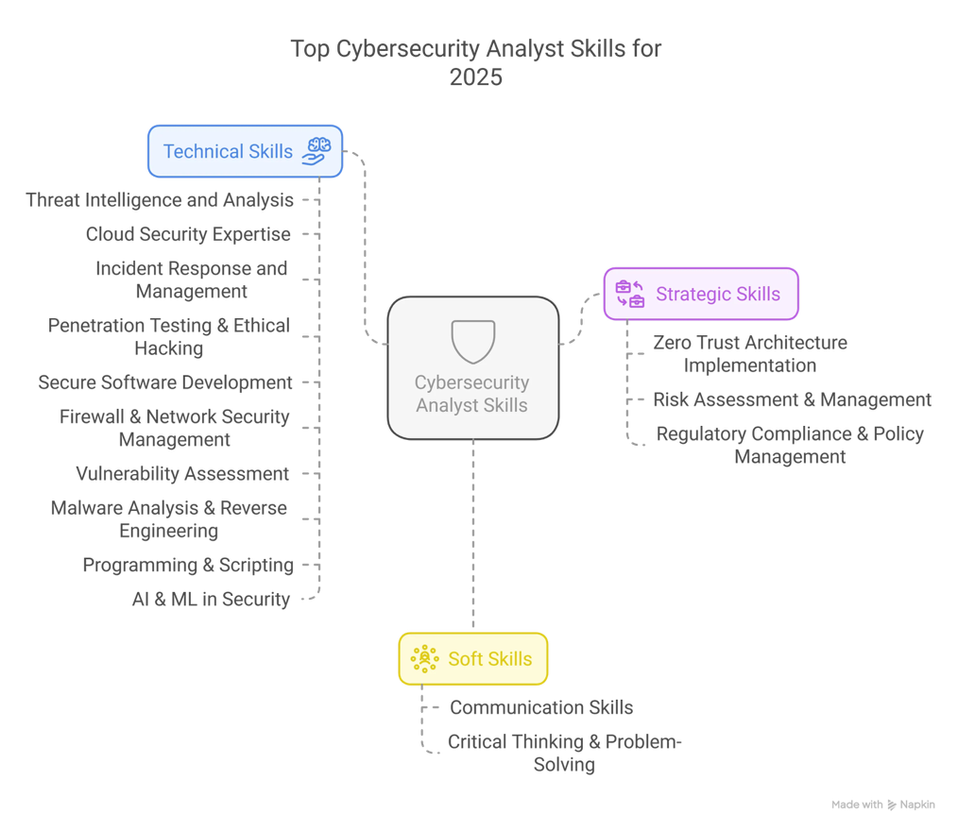
Figure 1: Cybersecurity analyst skills growth cycle [6].

Figure2 : Cybersecurity analyst skills [7]

Task 1 (b): Evaluation of Task 1 (a) based on Similarity report
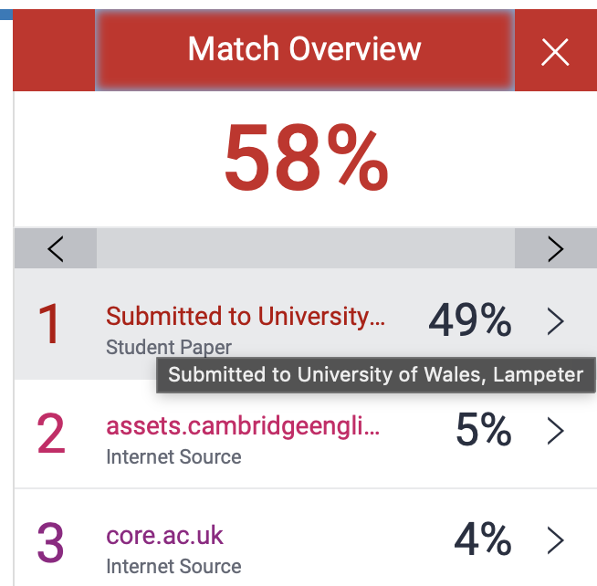

The 58% on the similarity section was due to the template that teacher provided. On the highlighted section it provided the bit that was similar. My work was not highlighted nor was my references. The other things that were highlighted was my research quote from the internet. Due to this outcome I need change a lot of my assignment task to see if I can reduce the high percentage of similarity. I need to also see if I can get lower 20%. I just to get better reference rather than copy and paste what I found on the internet. I also need to work on my research ability.
I believe I deserve 60% due to the amount of research I have done for this task. I did extensive research on google scholar, reference according to the Ieee format. Based on my assumptions I believe I have enough demonstrated the ability do research for the set requirement.

Task 2: Collaborative Mind Map and Individual Poster

Mind Map (Collaborative)

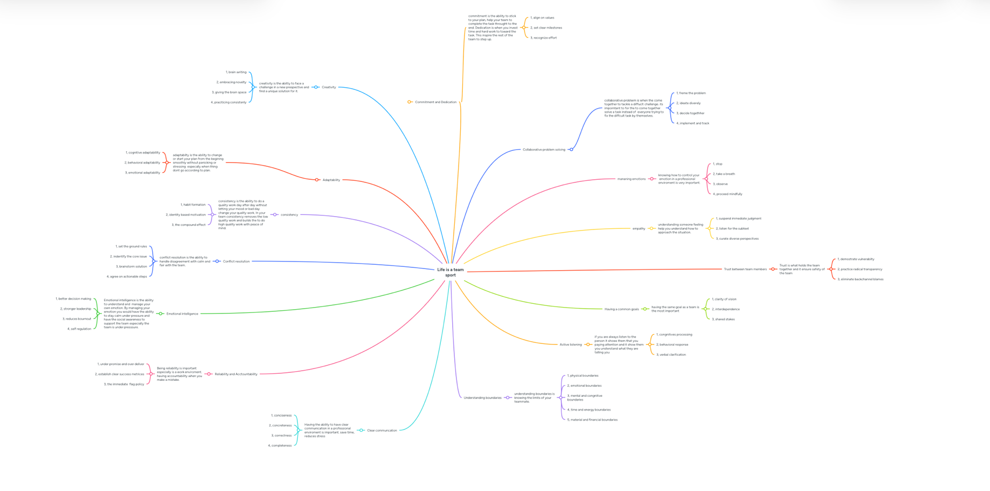
Mind Map (Collaborative)

Mind Map Link https://mm.tt/map/4030973602?t=1YKapSWIja

Poster (Individual)
Poster Link https://canva.link/hu20qo6wh6ll6lz

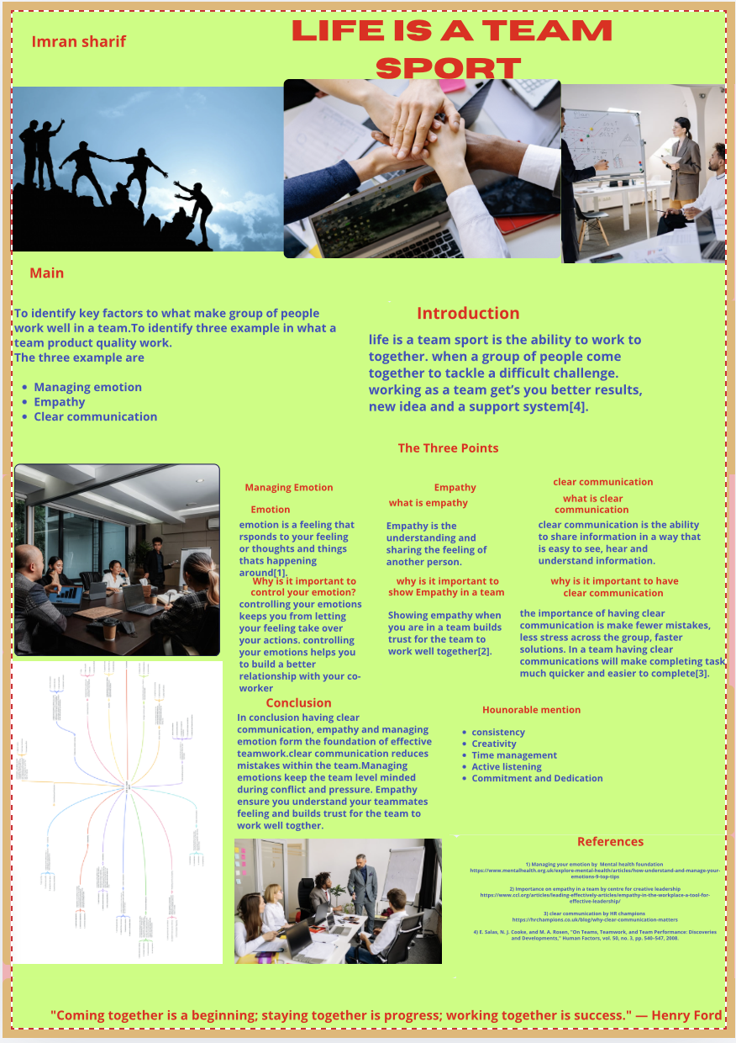

Task 3: Virtual Collaboration and RefWorks

Report on Virtual Collaboration
Put your Chosen topic here
Forming A Team
In building a great team, there are three indispensable steps: Trust in me, getting to know you, and we are forming.
- Trust.
Figure 1: Trust in teams [8]
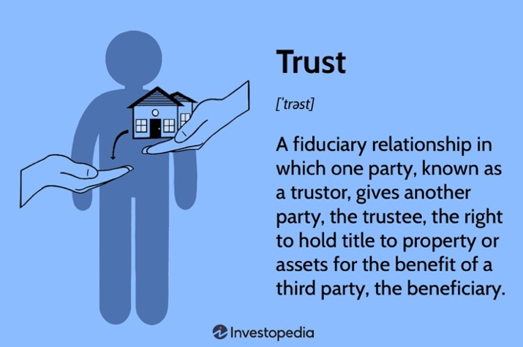

Team members must be confident about the honesty and reliability of their teammates if they want to work well in a team. As Lencioni [8] argues, the absence of trust is the most serious problem teams face as it does not allow people to be vulnerable and eventually accountable and committed. Teammates must first become vulnerable to themselves and one another before they can begin to trust. According to [9], trustworthiness refers to the ability, benevolence, and integrity of the person. At the point of trusting me a teammate shows their trusting by showing their competence by admitting when they are wrong or when they know something and their strength in turn the teammates will do the same in return by demonstrating their competence of being helpful. And showing their benevolence to only think of themselves when trying to help others instead of focusing on their own pride and ego. Keeping a promise to oneself and to another show’s integrity. If everyone does not establish their own reliable footing in a group it will be shallow, surface and weak.

- Getting to know you
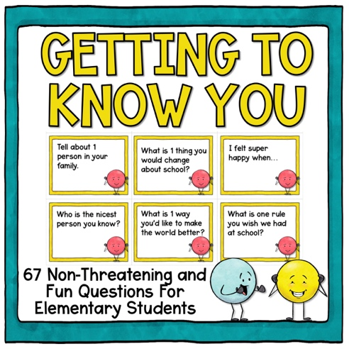
Figure 2: Getting to know you in teams [11].
After people learn to trust themselves and trust each other it is time to know each other as people and co-workers. Psychological safety in team a shared belief among team members that it is safe to take interpersonal risks exist in most high performing groups [10]. During the "getting to know you" phase, every team member will take the time and interest to see what everyone else's working styles and preferred methods of communication are so that each team member feels comfortable addressing work issues. Each team member feels comfortable talking about anything related to work, whether that will lead to conflict, as they know that all means are not harmful but helpful [11]. Through trust, communication develops and leads to innovation to solve issues the team is facing, and it is important that something like this takes place so that the members will eventually learn how to properly engage in a debate about an issue without getting hurt by other teammates.
- We Are Forming


Figure 3: We are forming [14]

The final level emphasizes a more collaborative and group-oriented approach; the first stage in Tuckman’s model reflects that beginning of the formation stage where the group will gain awareness of their group identity [11]. At this stage, it is necessary to build trust and interpersonal understanding to which a solid foundation can be constructed for the purpose of working towards the end goal and commitment. According to Lencioni [1], once team members become accountable and committed to one another in the forming stage, the team can start to ascend the pyramid. Without reaching the stage of team building, it’s still a disparate collection of individuals with whom they have acquired sufficient trust and may communicate with sufficient understanding, but who do not share a mutual feeling of being a team and will therefore never achieve their full potential.

Step-by-step process of using RefWorks with visuals

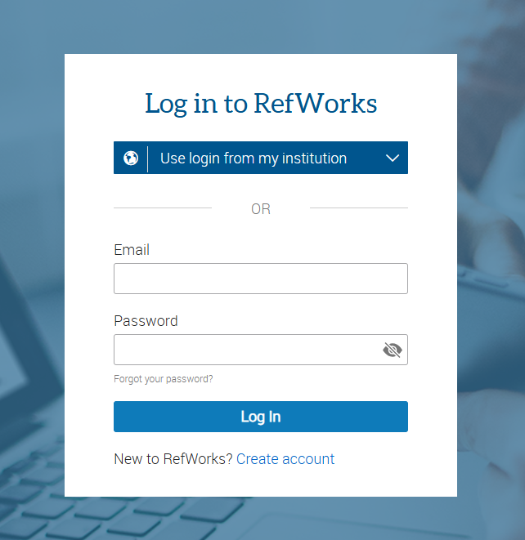

Figure 1
The beginning of reworks. To use RefWorks you need to sign up

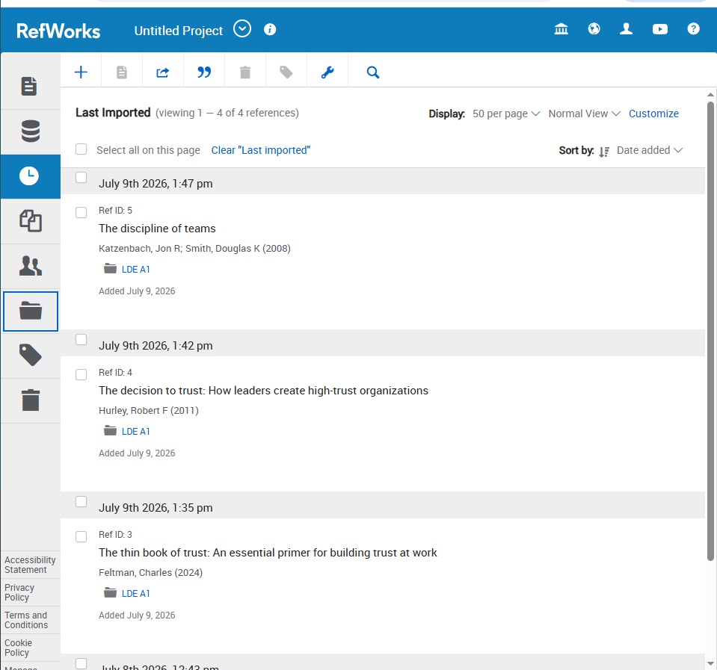

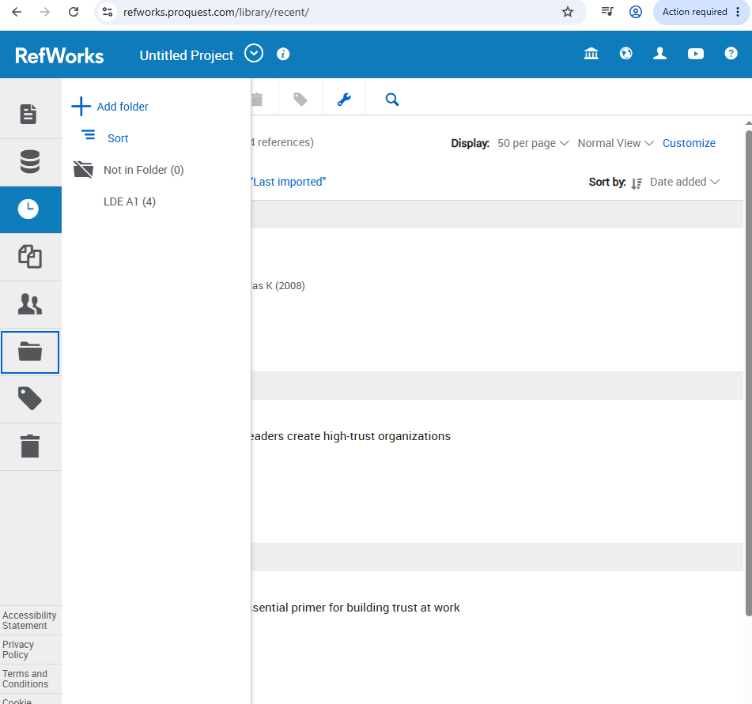
Figure 2
Once you sign up, it will take you to the main page. Once you are here you click on the folder that’s place on the left side on the page.

Figure 3
Once you click on the folder, click on the plus to add a folder

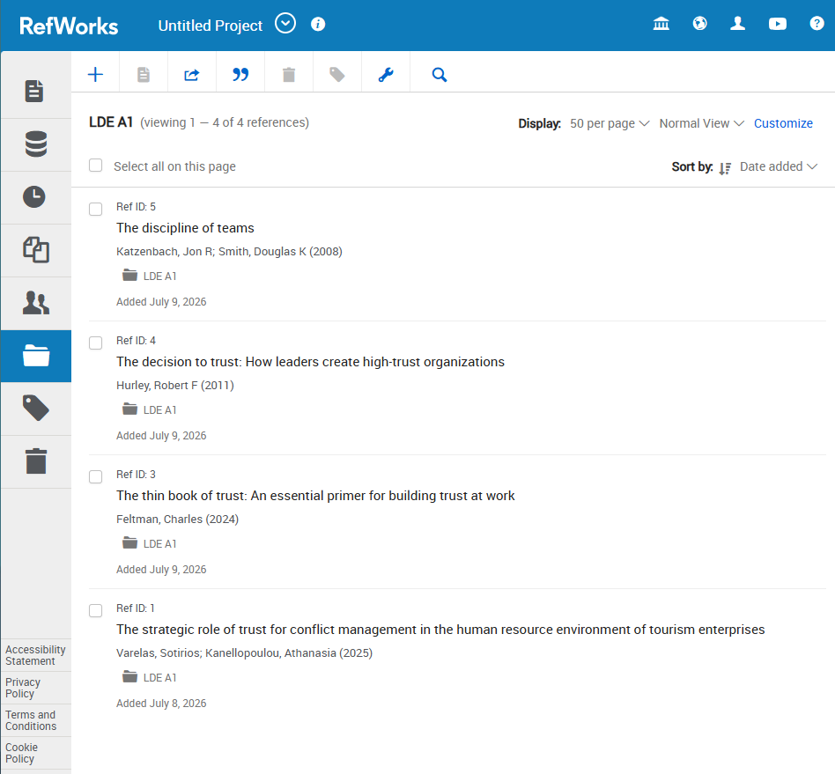
Figure 4
Name the folder LDE A1
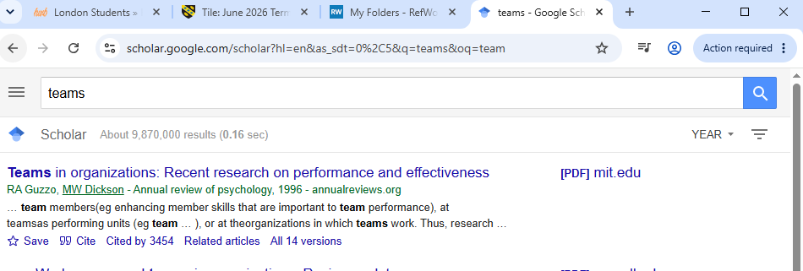
figure 5
when you find what you are looking for and you want to add the citation click the on cite button under the link.

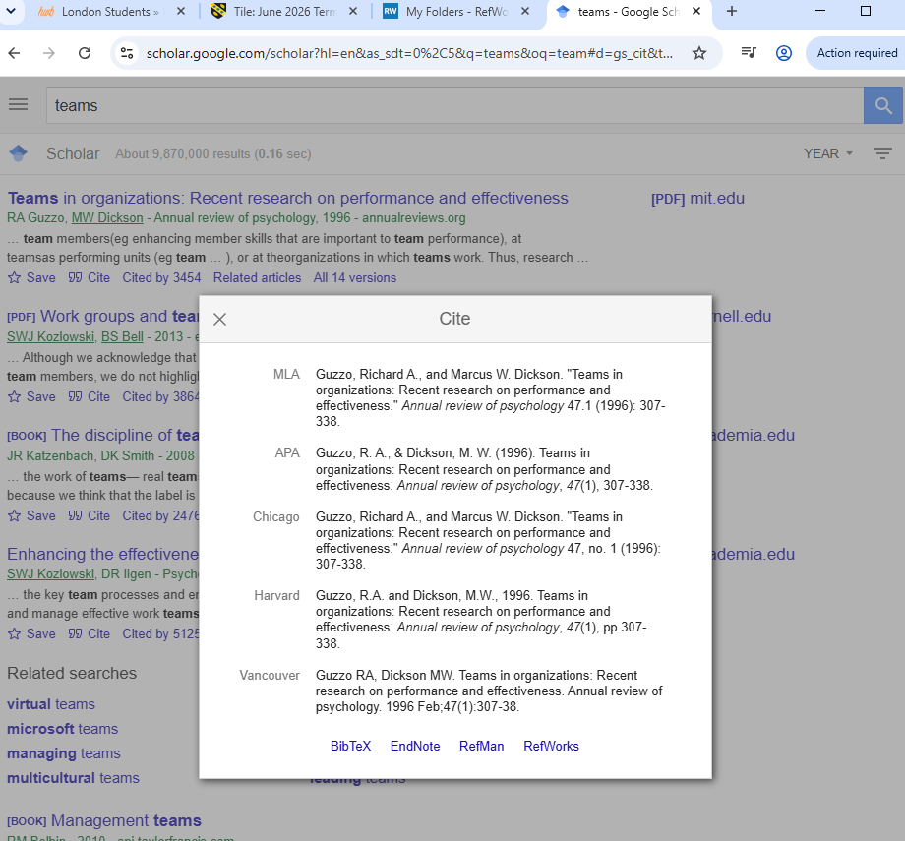

Figure 6
Once you click on the cite button you will see a small click on the RefWorks

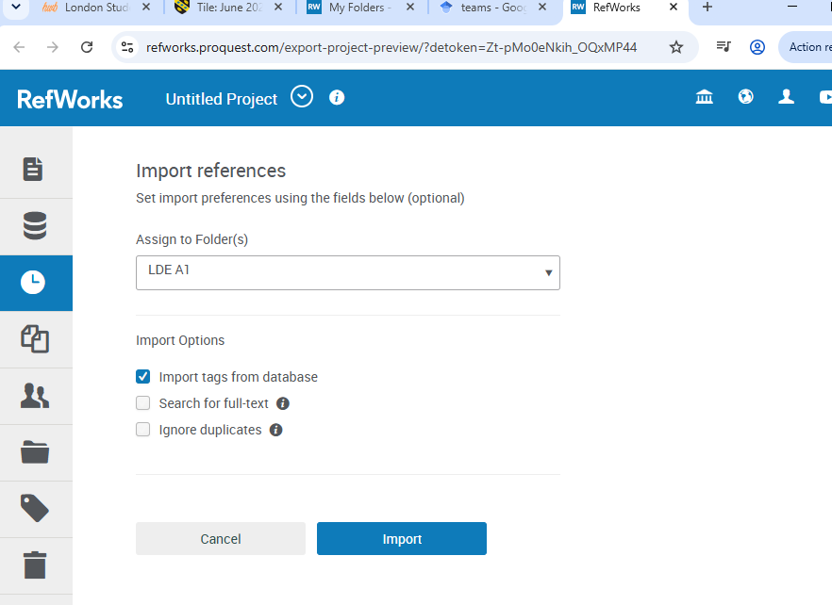

Figure 7
Once you clicked on the RefWorks, it will take you to a new tab where Its imports the references for you to the folder you created.

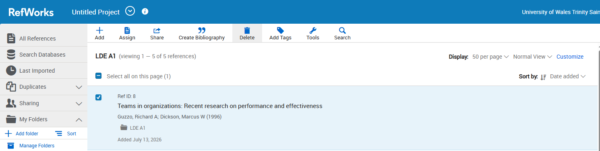
Figure 8
Once you click on import it will automatically save it on your named folder.

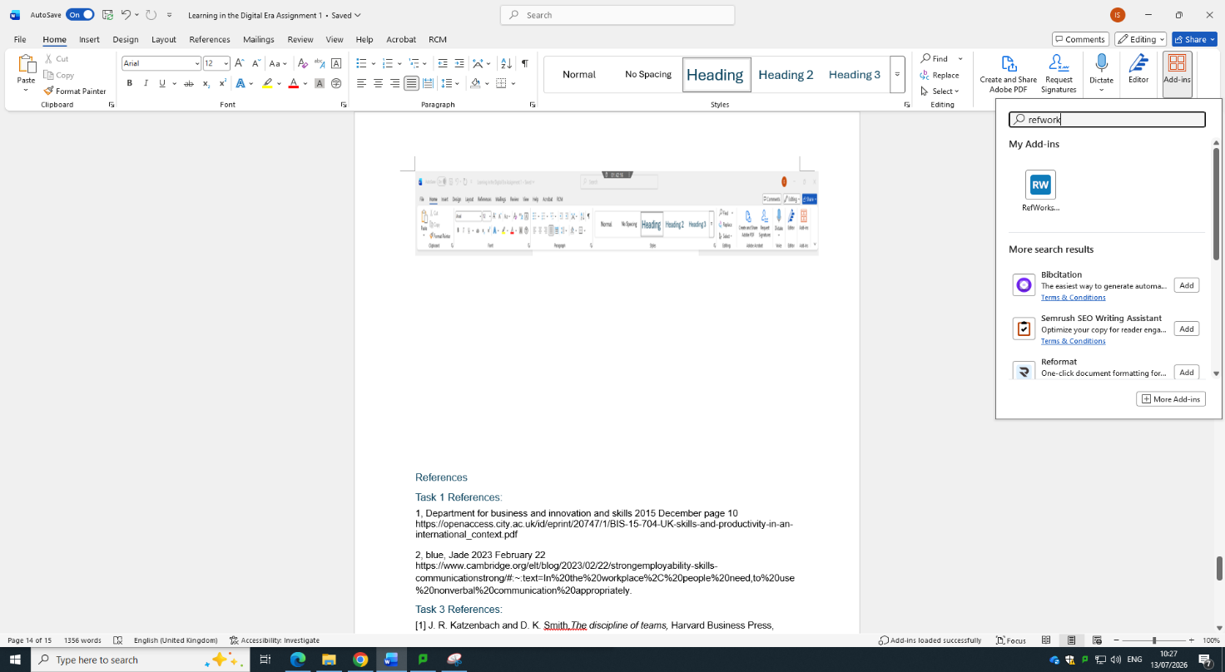
Figure 9
Once you import the reference head back to your word document and find the ADD-INS

Figure 10
Click on the add-ins and on the search, bar find RefWorks

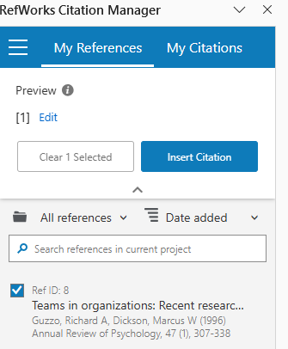

Figure 11
Once you click on the RefWorks it will pull up the saved references. However much references you save, you get the option to select whichever you want to use.

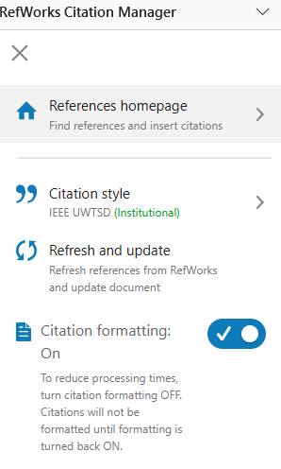
Based on my assignment requirement I had to use a specific citation style. I had to use the IEEE UWTSD.

Figure 12

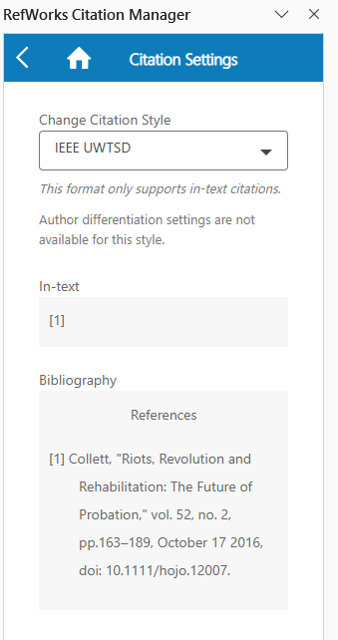

Figure 13
After selecting the right citation, it automatically shows me what style I choose.

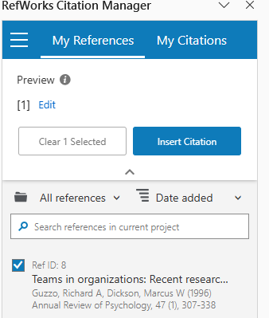

Figure 14
After that setting RefWorks properly I can save reference from google scholar, I can use it for assignment or documents.

Conclusion
By following these 14 steps outlined in the visual walk-through, you will learn how to organize all your references in a reference management software such as jabref [16], prevent miscalculations because of manual formatting in spreadsheets and produce your essay in an appropriate citation format like ieee for your project. By the end, you will also be able to reference efficiently, which will save you hours when working on essays [17]. Also, you will learn how to cite reference sources correctly for their original creators. The more involved the essays become over a longer span of time, the better manages your sources and avoids formatting errors is a skill that an academic needs to be capable of pulling off which leaves you more room to concentrate on your analysis and argument than where the date should go or how to format the citation.

Task 4: E-Portfolio Creation and Evaluation

Task 4 (a): E-Portfolio Creation
E-Portfolio - https://2538385.wixsite.com/my-site-1
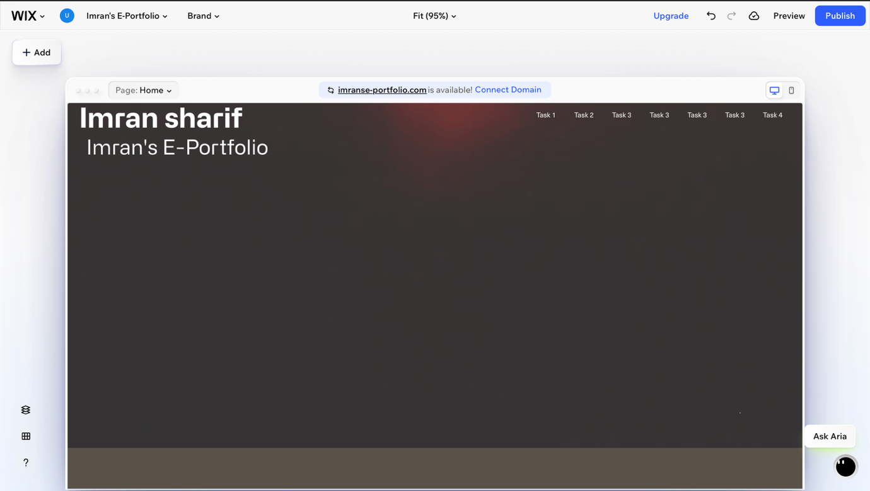
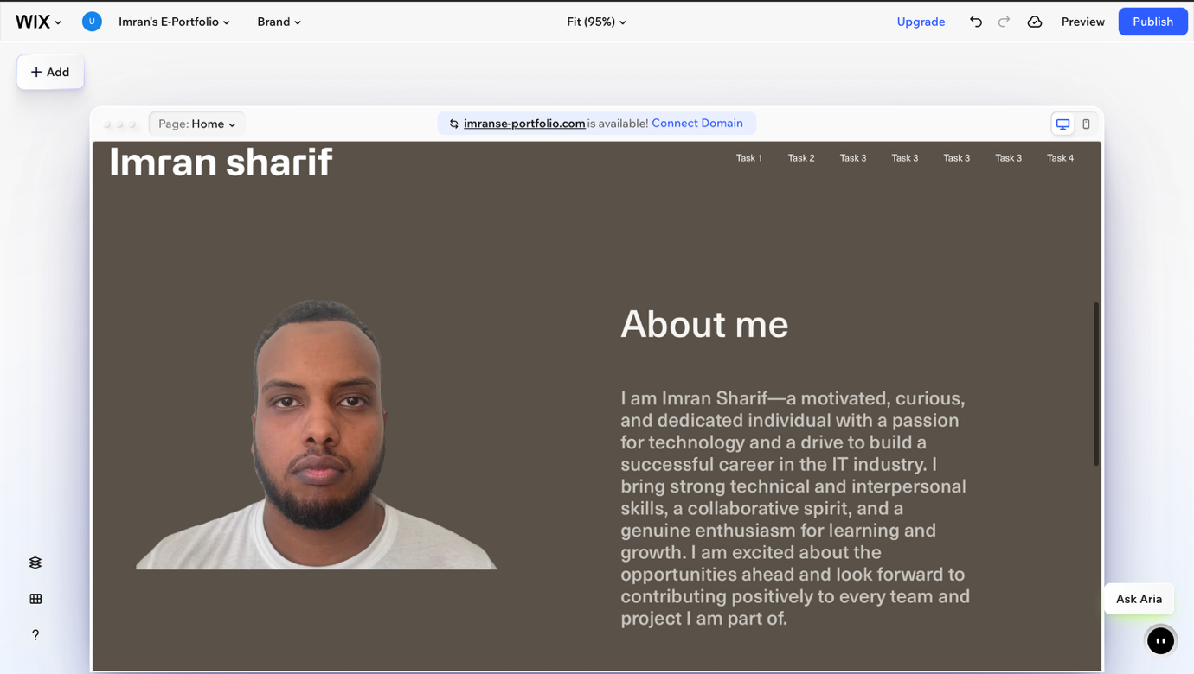
This is the home page of my E-portfolio
This is the about me section of the home page

Figure 1
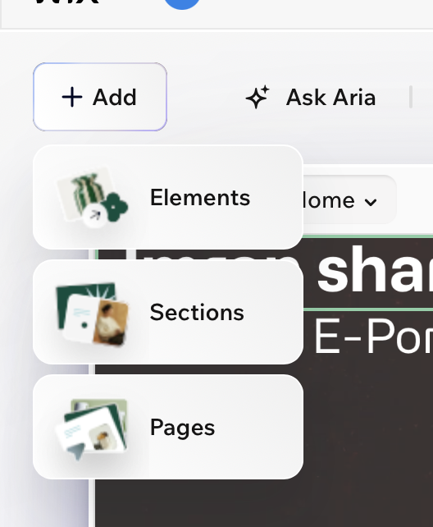
When I signed up to wix for my e-portfolio it took me a selection page, where I can pick from 1000 of templates. After selecting my e-portfolio template, I deleted the sections I didn’t want. I went to click on the add button, and I got a drop-down list. The two I used the most on my e-portfolio were Element and Pages.

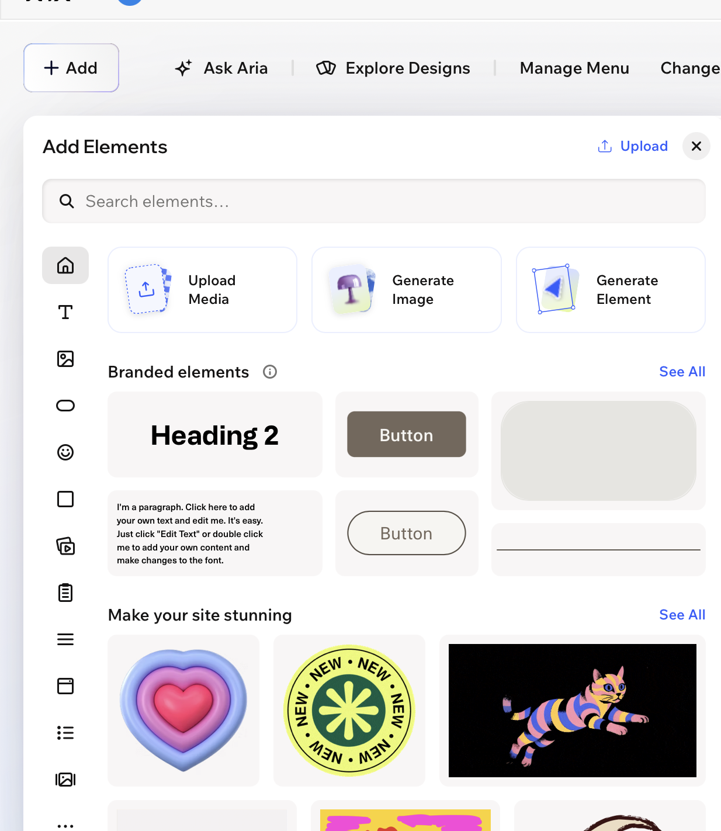
Figure 2
Textbox upload element

On the element section I used the following 2 elements the textbox and upload element.

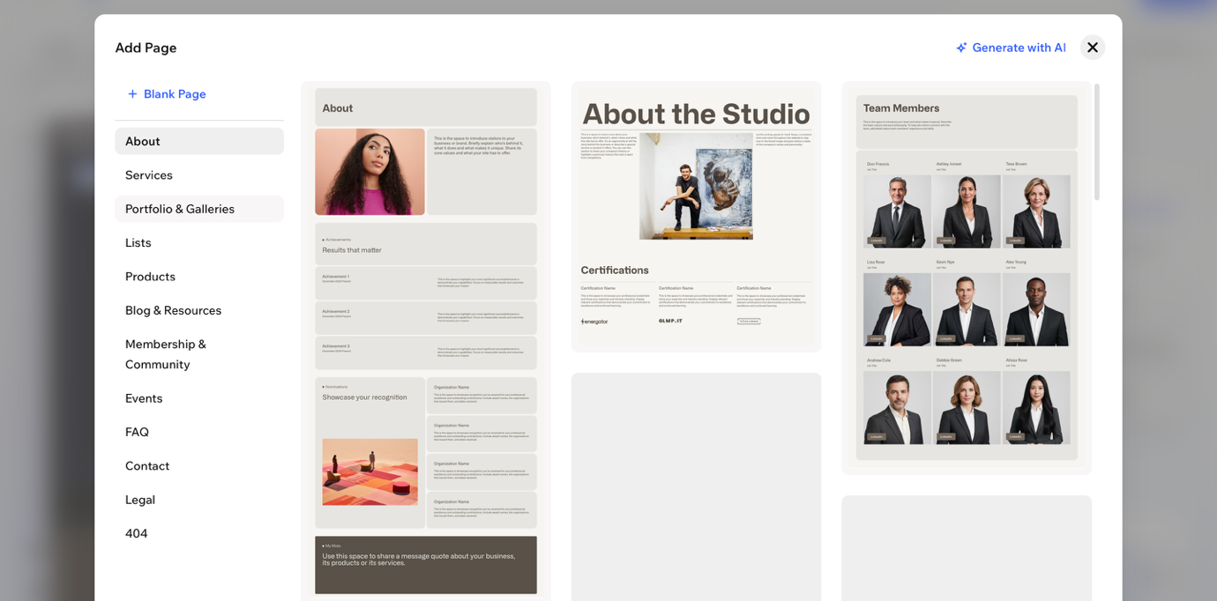
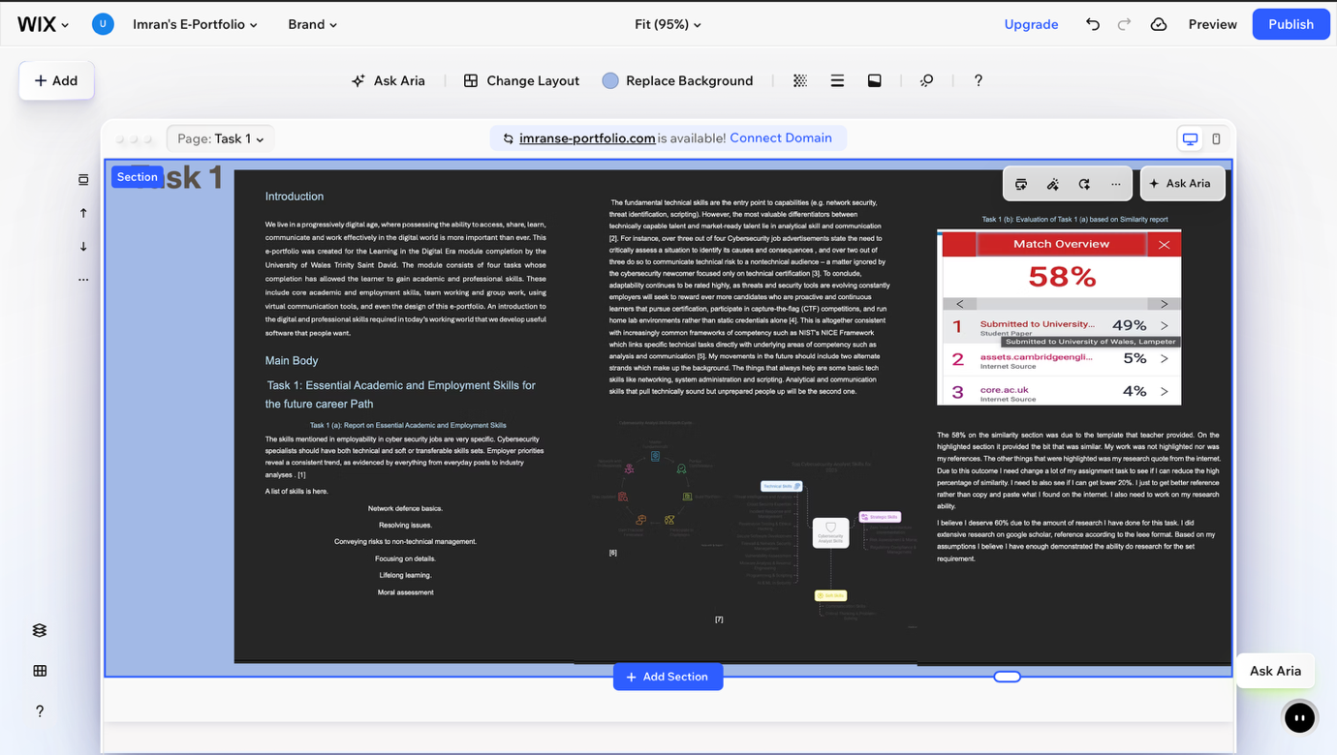
On the Add page element I used the blank page element to have the ability to create it the way I want it.

On the Task 1 page I changed the background colour and then used the textbox element. For the picture I screenshot my assignment and drag and dropped into the e-portfolio. For the rest of the e-portfolio I just repeated the same thing as the task1.

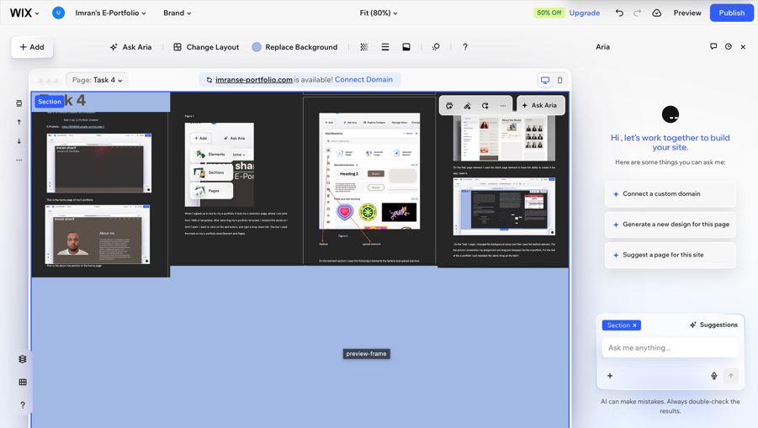
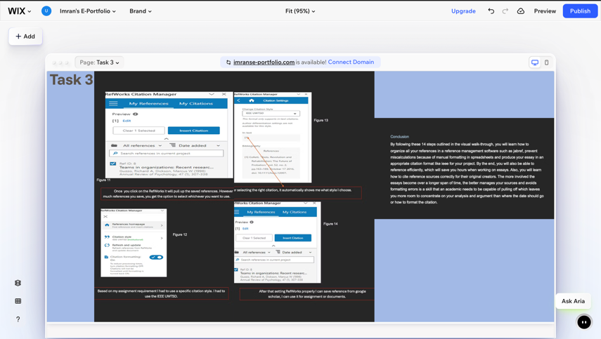
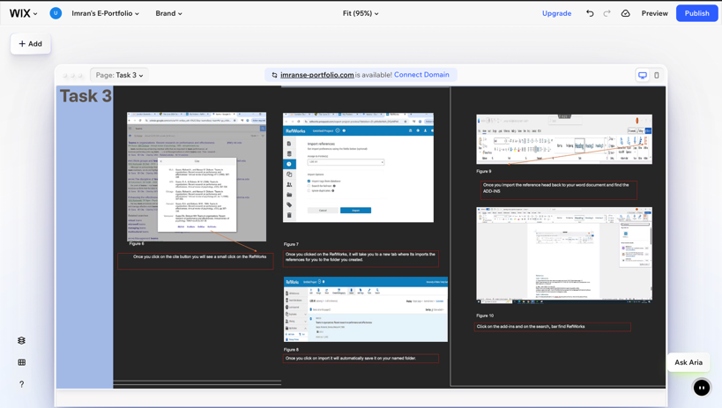
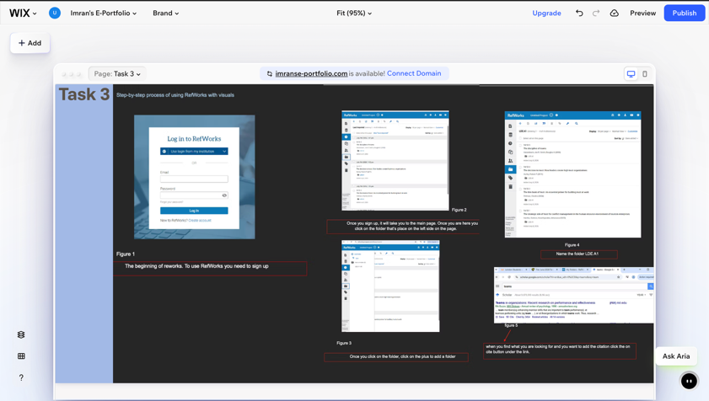
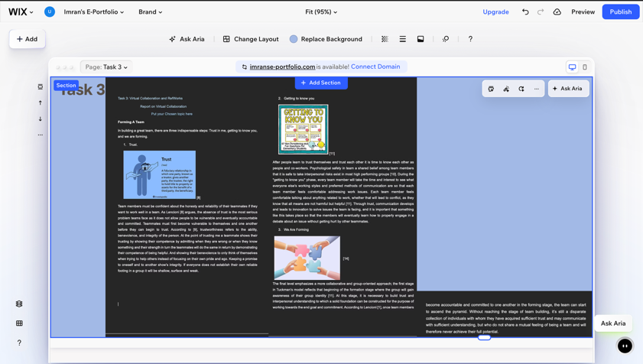
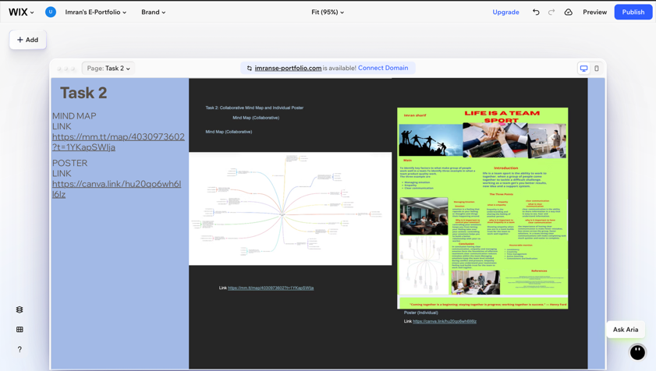

This is the rest of the pages on the E-portfolio. Every page rightly named, every screenshot rightly place on the right task page.

Task 4 (b): Illustrative Review of E-Portfolio tool Selection
The e-portfolio platform that I chose to utilize for my Learning in the Digital Era assignments is Wix. Since I was a complete beginner in creating a website, I chose Wix which is an easy-to-use website builder for beginners [16]. I use this website builder for my website. Wix provides me with professionally designed templates so I can save my time in designing my website and instead focus on the quality content [17] . It was good that Wix gave you a blank canvas meaning their designs don’t restrict you from displaying your academic feats. I can also create many pages for different classes which I can design as well as customize as I like.

Conclusion
To conclude, I have made the decision to create my e-portfolio in Wix as I find it easy to use, easy to create [20] and professional looking. As I didn’t have any prior website experience, I thought that as a free web-based tool to create your own website, Wix was the perfect place to start for my first ever e-portfolio [21] . The interface is simple ‘drag and drop’ tool to position content over several pages efficiently, which helps in finding answers to questions required for the reviewer with ease.
In conclusion, it can be recommended that students use Wix as a reliable tool to showcase an academic body of work as an e-portfolio.

References

Task 1 References:
1] (ISC), "Cybersecurity Workforce Study," (ISC)², 2023. Available: https://www.isc2.org/Insights/Workforce-Study
[2] CompTIA, "State of the Tech Workforce," CompTIA Research, 2023. Available: https://www.comptia.org/content/research
[3] World Economic Forum, "The Future of Jobs Report 2023," World Economic Forum, Geneva, Switzerland, 2023. Available: https://www.weforum.org/reports/the-future-of-jobs-report-2023
[4] LinkedIn, "Jobs on the Rise," LinkedIn Economic Graph, 2023. [Online]. Available: https://economicgraph.linkedin.com/research/jobs-on-the-rise
[5] National Institute of Standards and Technology, "Workforce Framework for Cybersecurity (NICE Framework)," NIST Special Publication 800-181, Rev. 1, Gaithersburg, MD, USA, 2020.. Available: https://doi.org/10.6028/NIST.SP.800-181r1

Task 3 References:
(8) [1] P. Lencioni, The Five Dysfunctions of a Team: A Leadership Fable. San Francisco, CA, USA: Jossey-Bass, 2002.
(9)[2] R. C. Mayer, J. H. Davis, and F. D. Schoorman, “An integrative model of organizational trust,” Acad. Manage. Rev., vol. 20, no. 3, pp. 709–734, Jul. 1995.
(10) [3] A. Edmondson, “Psychological safety and learning behaviour in work teams,” Adm. Sci. Q., vol. 44, no. 2, pp. 350–383, Jun. 1999.
(11) [4] B. W. Tuckman, “Developmental sequence in small groups,” Psychol. Bull., vol. 63, no. 6, pp. 384–399, 1965.
(12) [5] L. A. DeChurch and M. A. Marks, “Maximizing the benefits of task conflict: The role of conflict management,” Int. J. Confl. Manage., vol. 12, no. 1, pp. 4–22, 2001.

Task 3 conclusion reference

[1] H. K. Çelik, R. Çınar, and İ. Akıncı, "The role of citations in academic publications and reference management software," TOTBİD Derleme Dergisi, vol. 2025, no. 24, pp. 485–500, Aug. 2025, doi: 10.5578/totbid.derleme.dergisi.2025.71.
[2] C. Wadasinghe, "Adoption of Reference Management Software in academic writing among postgraduate medical professionals at the Postgraduate Institute of Medicine in Sri Lanka," J. Inf. Sci. Knowl. Manag., 2025.

Task 4 reference
[8] Wix, "Wix Website Builder," Wix.com, 2026. [Online]. Available: https://www.wix.com
[9] J. A. C. Gibbens, "A Review of E-Portfolio Platforms for Higher Education," Journal of Educational Technology, vol. 18, no. 2, pp. 45-58, 2025.

Task 4 conclusion reference
[1] "Wix for Educators," Prezi.com. [Online]. Available: https://prezi.com/p/ain_dnf48ptk/wix-for-educators/. [Accessed: Jul. 21, 2026].
[2] "Wix website builder review," Finder.com, May 12, 2026. [Online]. Available: https://www.finder.com/uk/business/business-software/wix-website-builder-review/. [Accessed: Jul. 21, 2026].

Task 1 picture reference
[6] and [7] Mukesh Kumar https://www.upgrad.com/blog/cybersecurity-analyst-skills/ July 07 2026

Task 3 picture reference

Kagan, Julia Investopedia https://www.investopedia.com/terms/t/trust.asp
28-02-2025

The responsive counsellor. https://shop.theresponsivecounselor.com/product/get-to-know-you-question-cards/
16-07-2025

chris zelt https://zelt.app/blog/5-proven-strategies-for-effective-remote-team-collaboration/
05-03-2024

