

RESULT

ASSIGNMENT DETAILS AND FEEDBACK

SOUTH WEST WALES CENTRE OF TEACHER EDUCATION

Sections marked with * should be completed by module lead
Student name: | Matthew Williams | Student number: | 1501396
Programme: | BA Primary Education with QTS
Module: * | Enterprising and Creative Teaching and Learning | Module Level (4, 5, 6): | 6
Module code: * | ECAD6004/C | Contribution to Overall  Module Assessment (%): * | 50%
Module Lead:* | Mr T. Cox
Start date:* | 3/10/17 | Assignment No (x of x):* | 1 of 1
Submission deadline:* | 15/12/17 | Return date of provisional marks & written feedback:* | 26/1/18
Assignment Title:* | Critically evaluate your creativity and enterprise dispositions in terms of the Entrecomp frame work and how you might develop these to the next level and demonstrate progression.

Referencing: | In the main body of your submission you must give credit to authors on whose research your work is based. Append to your submission a reference list that indicates the books, articles, etc. that you have read or quoted in order to complete this assignment (e.g. for books: surname of author and initials, year of publication, title of book, edition, publisher: place of publication).
Submission: | All assignments must be submitted to Turnitin unless otherwise instructed by the Lecturer.  Note: the Turnitin version is the primary submission and acts as a receipt for the student. Late submission of the electronic version of the assignment will result in a late penalty. Penalties for late submission: Up to one week late, maximum 40%. Over one week late will be recorded as a non-submission. Late submission penalties may be lifted only with the approval of the Extenuating Circumstances Panel. | Date: | 15/12/17

Module lead to tick to indicate if a hard copy version of the assignment must be submitted.* | YES
 | NO | X

Learning Outcomes tested*  (from module syllabus) | Assessment Criteria: To achieve each outcome a student must demonstrate the ability to:*
Upon the successful completion of this module, the student should be able to:  - Recognise, identify and select learning environments that support the development of creative learning and teaching.  - Critically reflect on strategies that impact on the distinctive role of the educator when developing creative and innovative pedagogies and environments.  - Critically reflect upon the educational potential of developing enterprise and creativity in the primary school.  - Demonstrate a critical awareness of the contribution of creativity and enterprise to educational practice. | In this assignment, markers will be looking for:  - The writing to include critical analysis and evaluation of wide, deep and appropriate background reading. Relevant synthesis of research and government documentation should be utilised to demonstrate knowledge and understanding of Creativity and Enterprise skills.  - A clear understanding of the importance of Creativity and Enterprise skills in education and the wider world.  - Appropriate knowledge and use of the Entrecomp Framework.  - Critical evaluation of personal creativity and Enterprise dispositions, linked to the Entrecomp Framework. Including examples and evidence of current level.  - Clear recommendations for future personal development with regards to identified areas.  - Critical reflection of reading and experience.  - Accurate referencing and academic writing skills  - Allocated word count.

TASK DESCRIPTION

Assessment Title

Critically evaluate your creativity and enterprise dispositions in terms of the Entrecomp frame work and how you might develop these to the next level and demonstrate progression.

Word Count - 2500 words

The essay should demonstrate critical self-evaluation. Also, analysis and evaluation of wide and appropriate background reading. Relevant reference to research, current pedagogy where appropriate, government documentation and school-based experience should be synthesised in the response.

So what might you include in your essay response?

- An outline of ‘why we should be developing creativity and enterprise skills within education’ (Highlighting benefits/ NC links/ initiatives/ current thinking/ Donaldson etc.)
- The importance of creativity and enterprise skills for the teacher.
- Knowledge of the Entrecomp Framework, the benefits/ uses/ limitations.
- Appropriate background research and knowledge for the competences identified. Supporting principles/ theories that underpin the discussion/ reflection and strategies proposed.
- Range of evidence to support the identification of competences discussed. Who agrees with the competency identified? What are the specific benefits/ challenges/ research base/ models or methods of progression? (Educational writers, case studies, wide research)
- Reference to key ‘Creativity’ and Enterprise skills researchers.
- Reference to, and understanding of, the fifteen competences of the Entrecomp Framework, with a clear focussed discussion on a limited number most appropriate to the development of teacher creativity and enterprise skills.
- A good understanding of not only the principles and theory but also the practical issues when implementing strategies to promote personal progression.
- A clear understanding and ability to identify where current level and awareness of proposed progression and continuity of personal development.
- Examples of proposed recommendations.
- Evidence of wide and deep background reading to support the reflection. Case studies, research, journals etc.
- A high level of professionalism in dialogue.
- Clear evidence of very good understanding of creativity and enterprise skills, no glaring errors.
- Critical analysis and evaluation of current performance and clearly identified reasons for recommendations, supported with a variety of data.

GUIDANCE FOR Students IN THE COMPLETION OF TASKS

NOTE: The guidance offered below is linked to the common assessment criteria overleaf.

- Subject Knowledge and Understanding (which includes using research-informed literature and knowledge and understanding of the subject)

Your work must be informed and supported by scholarly material that is relevant to and focused on the task(s) set. You should provide evidence that you have accessed a wide range of sources, which may be academic and/or governmental; these sources may include academic journal articles, textbooks, current news articles, organisational documents, and websites. You should consider the credibility of your sources; academic journals are normally highly credible sources while websites require careful consideration/selection and should be used sparingly. Any sources you use should be current and up-to-date, mostly published within the last five years or so, though seminal/important works in the field may be older. You must provide evidence of your research/own reading throughout your work, using in-text citations in the main body of your work and a reference list that is alphabetical at the end of your work. Please use the Harvard referencing system.

Your work must demonstrate the growing extent of your knowledge and understanding of concepts and underlying principles associated with the subject area. Knowledge relates to the facts, information and skills you have acquired through your learning. You demonstrate your understanding by interpreting the meaning of the facts and information (knowledge). This means that you need to select and include in your work the concepts, techniques, models, theories, etc. appropriate to the task(s) set. You should be able to explain the theories, concepts, etc. meaningfully to show your understanding. Your mark/grade will also depend upon the extent to which you demonstrate your knowledge and understanding; ideally each should be complete and detailed, with comprehensive coverage.

- Intellectual Skills (Analysis)

Your work must contain evidence of logical, analytical thinking, evaluation and synthesis. For example, to examine and break information down into parts, make inferences, compile, compare and contrast information. This means not just describing what! But also justifying: Why? How? When? Who? Where? At all times, you must provide justification for your arguments and judgements. Evidence that you have reflected upon the ideas of others within the subject area is crucial to you providing a reasoned and informed debate within your work. Furthermore, you should provide evidence that you are able to make sound judgements and convincing arguments using data and concepts. Sound, valid conclusions are necessary and must be derived from the content of your work. There should be no new information presented within your conclusion. Where relevant, alternative solutions and recommendations may be proposed.

- Pedagogic and Professional Applications (Practical Application and Deployment)

You should be able to demonstrate how the subject-related concepts and ideas relate to pedagogic situations or a particular education context. How do they work in practice? You will deploy models, methods, techniques, and/or theories, in that context, to assess current situations, perhaps to formulate plans or solutions to solve problems, some of which may be innovative and creative. This is likely to involve, for instance, the use of pedagogic examples and cases, the application of a model within relevant educational context. You should show awareness of the limitations of concepts and theories when applied in particular educational contexts. Your work must provide evidence of the attributes expected in professional practice. This includes demonstrating your individual initiative and/or collaborative working. Where relevant, you should show awareness of any ethical issues that relate to your discussion.

- Key Transferable Skills (Skills for Professional Practice)

You must communicate effectively in a suitable format, which includes written and oral presentation. Work should be coherent and well structured in presentation and organisation.

marking criteria and Student FEEDBACK

This section details the assessment criteria. The extent to which these are demonstrated by you determines your mark. The marks available for each criterion are shown. Lecturers will use the space provided to comment on the achievement of the task(s), including those areas in which you have performed well and areas that would benefit from development/improvement.

Common Assessment Criteria Applied | Marks available | Marks  awarded
1. Subject Knowledge and Understanding (which includes using research-informed literature and knowledge and understanding of the subject)  Extent of research and/or own reading, selection of credible sources, application of appropriate referencing conventions. Extent of knowledge and understanding of concepts and underlying principles associated with the discipline. | 30
2. Intellectual Skills (Analysis)  Analysis, evaluation and synthesis; logic, argument and judgement; analytical reflection; organisation of ideas and evidence | 30
3. Pedagogic and Professional Applications (Practical Application and Deployment)  Deployment of pedagogic methods, materials, tools and techniques; application of concepts; formulation of innovative and creative solutions to solve problems. Attributes in professional practice: individual and collaborative working | 30
4. Key Transferable Skills  Deployment of appropriate media; presentation and organisation. | 10

Assignment Mark (Assessment marks are subject to ratification at the Exam Board. These comments and marks are to give feedback on module work and are for guidance only until they are confirmed. ) | Late Submission Penalties (tick if appropriate) |  | %
 | Up to 1 week late | 40% Max | %
 | Over 1 week late | 0% | %
ASSESSMENT AND MARKING CRITERIA FOR ECAD5001/C ASSIGNMENT
Level 5 | Assessment Criteria Descriptors for BA Primary Education with QTS  This format emphasizes the holistic nature of judgements to be made by markers. Criteria weighting is adjusted for each module.
 | 0-39 (F) | 40-49 (P) | 50-59 (P) | 60-69 (P) | 70-79 (P) | 80-100 (P)
 | Poor / Weak F | Satisfactory 3rd | Good 2:2 | Very good 2:1 | Excellent 1st
Assessment Criteria | Poor, superficial, unsystematic, incomplete and/or inaccurate | Satisfactory understanding of main issues demonstrated | Good understanding demonstrated with some analysis | Very good understanding of basic principles and relevant evidence, with a coherent and logical argument | Thoughtful answer informed by wider reading, showing clarity of thought and personal insight | Outstanding answer, well written, highly structured and informed, showing striking personal insight and originality
Module Learning Outcomes matched to: | 0-11 | 12-14 | 15-17 | 18-20 | 21-23 | 24-30
Subject Knowledge and Understanding  (Conceptual)  (Reading) | Basic misunderstanding, misconceptions, misinterpretations and/or superficial knowledge in places | Outline knowledge of few key issues with evidence of understanding and application | Defined knowledge of some key issues and wider implications | Wider knowledge of most key issues, concepts and arguments | Clear understanding of the key issues under discussion with logical discussion | Excellent knowledge of key issues, concepts and arguments clearly discussed
Subject Knowledge and Understanding  (Conceptual)  (Reading) | Some inappropriate literature/material with limited reading range and lack of accuracy | Satisfactory range of reading drawn from the recommended list and other sources | Good range of reading drawn from the recommended list and other sources | Very good range of relevant literature from a variety of sources beyond recommended list | Evidence of well-considered thinking from a wide reading base using a variety of sources | Clear evidence of independent thinking informed by an excellent range of reading from a variety of sources
 | 0-11 | 12-14 | 15-17 | 18-20 | 21-23 | 24-30
Intellectual skills  (argument)  (presentation of findings/analysis)  (critical /reflective evaluation) | Argument is weak, little attempt to present differing viewpoints.  Generally too descriptive | The argument is beginning to be balanced with a growing awareness of other viewpoints | A balanced argument is presented while attempting to justify other viewpoints | A balanced argument is presented showing an understanding of different viewpoints and the reasoning behind them | A thoughtful argument is presented with appropriate consideration of viewpoints | A well- structured critical argument is presented with insightful consideration of viewpoints
 | Findings presented within incomplete descriptive framework and few or inaccurate conclusions are drawn | Findings are beginning to be presented in a developing framework with some analysis and reasonable conclusions | Findings are presented in a framework with some analysis and interpretation of data to form reasonable conclusions | Findings are presented in a framework with some analysis, interpretation and evaluation of data to form reasonable conclusions | Findings presented with some analysis and justified conclusions | Findings presented in a critical and analytical framework. Thoughtful conclusions, firmly based upon the evidence presented
 | Lack of evidence of evaluation and/or critical reflection | Evaluation and/or reflection are present but lacks depth | Good engagement with evaluation and reflection | Very good evidence of beginning to evaluate and critically reflect | Evidence of thoughtful critical engagement with evaluation and reflection | Effective and more in-depth critical engagement with evaluation and reflection
 | 0-11 | 12-14 | 15-17 | 18-20 | 21-23 | 24-30
Pedagogic and Professional applications  (linking theory to practice)  (professional reflection)  (ethical conduct where appropriate) | Superficial or lack of understanding of pedagogic and professional context(s) | Relates principles and concepts to underlying theoretical frameworks and approaches with respect to the pedagogic and professional context(s) | Identifies principles/ concepts underlying theoretical frameworks and begins to identify their strengths and weaknesses with respect to the pedagogic and professional context(s) | Evidence of the use of relevant research or developments to inform actions with respect to the pedagogic and professional context(s) | Clear evidence of integration of theory and practice with respect to the pedagogic and professional context(s) | Effective integration of theory and practice with respect to the pedagogic and professional context(s)
 | Little or no evidence of reflection | Reflection is evident | Evidence of good reflection | Beginning to critically reflect | Critical reflection is evident | Effective and in-depth logical and critical reflection is evident
 | Little or no awareness of ethical issues | Awareness of ethical issues | Awareness of ethical issues and able to discuss these in relation to personal beliefs and values | Ethical issues have been discussed showing an awareness of personal responsibility and professional codes of conduct | Ethical issues have been clearly discussed in the context of personal responsibility and professional codes of conduct | Ethical issues have been effectively addressed especially in the context of personal responsibility and professional codes of conduct
 | 0-3 | 4 | 5 | 6 | 7 | 8-10
Key/Transferable Skills  (Referencing techniques) | Weak presentation of written work | Satisfactory presentation of written work | Good presentation of written work | Very good presentation of written work | Effective presentation of written work | Outstanding presentation of written work
Key/Transferable Skills  (Referencing techniques) | A number of basic errors in spelling, punctuation or grammar | Some errors in spelling, punctuation or grammar | Few errors in spelling, punctuation or grammar | Very few errors in written language | Minor errors in written language | No errors in written language
Key/Transferable Skills  (Referencing techniques) | Weak structure with unclear writing style in parts | Satisfactory structure with a mostly coherent writing style | Good structure with a coherent writing style | Very good structure which supports the reader | Effective structure which supports the reader | Highly coherent and mature writing style which fully engages the reader
Key/Transferable Skills  (Referencing techniques) | Little or no use of protocols and conventions of Harvard referencing | Satisfactory use of Harvard referencing protocols and conventions | Good use of Harvard referencing protocols and conventions | Harvard system mainly used accurately, with some secondary sources | Harvard system used accurately including secondary sources | Harvard system used accurately, consistently and effectively with all sources

Student Self Evaluation Form

This section repeats in brief the common assessment criteria detailed on previous pages. The extent to which these are demonstrated by you determines your mark. Using these criteria, tick the box that best indicates the level of achievement you feel you have achieved with regard to each of them.

Common Assessment Criteria Applied | Level of Achievement
Common Assessment Criteria Applied | REFER |  | 3rd | 2:2 | 2:1 | 1st | 1st
 | OUTRIGHT FAIL | UNSATISFACTORY | SATISFACTORY | GOOD | VERY GOOD | EXCELLENT | EXCEPTIONAL
1. Subject Knowledge and Understanding (which includes using research-informed literature and knowledge and understanding of the subject) | 0-29% | 30-39% | 40-49% | 50-59% | 60-69% | 70-79% | 80-100%
 |  |  |  |  | X
2. Intellectual Skills (Analysis) | 0-29% | 30-39% | 40-49% | 50-59% | 60-69% | 70-79% | 80-100%
2. Intellectual Skills (Analysis) |  |  |  |  |  | X
3. Pedagogic and Professional Applications  (Practical Application and Deployment) | 0-29% | 30-39% | 40-49% | 50-59% | 60-69% | 70-79% | 80-100%
 |  |  |  |  |  | X
4. Key Transferable Skills | 0-29% | 30-39% | 40-49% | 50-59% | 60-69% | 70-79% | 80-100%
4. Key Transferable Skills |  |  |  |  | X
PLEASE COMMENT ON AREAS IN WHICH YOU FEEL THAT YOU HAVE PERFORMED WELL | PLEASE COMMENT ON AREAS you feel that you need TO DEVELOP
I feel I have accurately identified my strengths an weaknesses in accordance with the Framework and have identified steps for improvement well. | I could have done further background reading in order to further my knowledge on the EntreComp Framework.
Student’s Name | Matthew Williams | Date | 15/10/17
Student’s Signature

Critically evaluate your creativity and enterprise dispositions in terms of the Entrecomp frame work and how you might develop these to the next level and demonstrate progression.

Creativity is the act of coming up with imaginative and new ideas and turning them into a reality. Creativity in children is hugely important. It not only helps to develop cognitive skills such as thinking scientifically and mathematics, but it also helps to develop other skills such as using symbols which can help improve literacy skills in the future, imagination, communication, using scientific method, communication, physical dexterity and exertion, making interpretations and problem posing and solving problems. Sir Ken Robinson (2016) argued that all children are ‘born artists’ yet are educated out of this mindset as they age, with the educational system focusing more on the mind, particularly the left hand side of the brain, the ‘more logical’ side of the brain.

Enterprise learning is learning in a manner that allows the child to be creative, it is the process of equipping learners with an enhanced capacity to enable them to generate their own unique ideas and to help the learner develop the skills to enable the ideas to become a reality. Collingwood College (2017) states that through the use of enterprise education, learners will be benefited in their future lives as entrepreneurs, employees and citizens of the global community, showing that the individuals will not only be developing their entrepreneurial skills, but also life skills and employment skills.

A disposition is a psychological aspect of an individual, such as their attitude towards something or their nature. A disposition is something that can be developed, such as how a creative disposition can be developed within a learner. A disposition is developed based on experiences as well as common environments such as home or school or work and other people that the individual spends a lot of time with, possibly friends or family.

There are many benefits in teaching creatively for a teacher. Kaye Thorne (2007) completed research indicating that many of these benefits were intrinsic rewards, as can be seen with replies such as ‘the pride of being involved in the creative process’ or ‘Success. Knowing that you achieved something that was better and different to conventional paths’ being given as to why teachers enjoyed being creative. There are also external rewards to consider, by incorporating creative teaching into a set schedule, there can be a high level of interest generated in the students, with the learners experiencing something new and interesting there will likely be a higher level of engagement from them, resulting in a good lesson overall. There are, of course, also challenges to being a creative teacher. A lot of the time, if the whole staff are not onboard with your creative approach then an idea you present may be ignored due to it being impractical. In the same book as previously mentioned, Thorne states that often it is the creative teacher who is expected to produce something such as a fund raising event or a Christmas play, and whilst some may relish this chance it could also be a burden on top of an already busy schedule.

By teaching using enterprise education, a teacher is automatically able to become more creative due to the nature of enterprise education. The whole idea behind it is challenging the children to become imaginative and think outside the box in order to solve a problem. This is also a great way to get the most out of cross curricular learning as a practical style of teaching can be adopted. For example, a child may be tasked with making a new pencil pot for the classroom. Rather than having them just write about it, through cross curricular learning they are able to create it also, linking science with design and technology. It also allows the learners to be creative in the way they fashion the pot, which is the aim of enterprise education.

Throughout this essay, I as the author, will be comparing myself and my ow experiences against the EntreComp Framework. ‘EntreComp can be used as a reference for the design of curricula in the formal education and training sector. It can also be used for activities and programmes in nonformal learning contexts (for instance, to foster intrapreneurship with existing organizations). It aims to establish a bridge between the worlds of education and work as regards entrepreneurship as a competence.’ (Bacigalupo, et al, 2016). The EntreComp Framework, essentially, provides a framework with learning outcome descriptors. There are fifteen competencies that are able to be measured against and there are clear ‘levels’ to help indicate where an individual is currently performing at.

The first competency that I will be comparing myself against is ‘Creativity’ from the ‘Ideas and Opportunities’ competency area of the EntreComp framework. As previously discussed, creativity is a very important part of teaching. It allows a teacher to incorporate something different or unique into their lessons, meaning a raised level of interest from the learners. Creativity can be used as a form of communication, through the opportunity of group work or shared learning, something that can be very useful for a teacher as it allows for a different angle or approach to the planned lessons. The way the current curriculum is heading, all teachers must start becoming creative, with Donaldson’s six areas of learning and experience soon to come into fruition. Due to these areas of learning and experience, teachers are expected to teach almost completely in a cross curricular fashion, which is far easier to do with a creative disposition as the ideas flow in a smoother, easier manner. Through my own experiences, I have found that teaching with a creative mindset has allowed me to adapt the lesson should something not go to plan, such as the school not having enough clay due to a delivery not coming in, and so instead, the class made Lego people. Also, if a teacher has a creative disposition then the pupils may also develop the same, something that would be very beneficial to them for Enterprise education. I feel that I am currently at level 3 on the EntreComp Framework for creativity ‘I can experiment with different techniques to generate alternative solutions to problems, using available resources in an effective way.’ This can be backed up from my previous Lego incident. Also, ‘I can experiment with my skills and competences in situations that are new to me.’ As can be seen from appendix 1, I have taught a variety of subjects in a creative manner. In order for me to reach level 4 I must be able to ‘actively search for new solutions that meet my needs.’ I can do this by looking for more outside resources to use as a focus, this will encourage the learners’ curiosity and with the improved level if interest create a more engaging lesson. If I am to become a more creative teacher then I must be more accepting to out of the box ideas and be willing to work with more ‘random’ or ‘obscure’ resources.

The next competency I will be looking at is ‘Planning and Management’ from the ‘Into Action’ competency area of the EntreComp Framework. Planning and management is a very important part of teaching. Deciding what is taught, in what order and for what time frame are the basics of planning. Jensen (2001) states that a lesson plan ‘serves as a valuable resource when planning assessment measure such as quizzes and final exams’. A lesson plan can serve as a map to help guide the teacher through the lesson smoothly and aiding them in knowing what skills are being taught. With that being said, lesson plans are not set in stone, a teacher is free to change the lesson’s structure at any point during the lesson should it warrant a change. Lesson plans should guide but not dictate how a teacher should teach a lesson. Management in the classroom not only relates to classroom management strategies but also managing the other adults in the classroom such as teaching assistants. There is no point in not communicating as a team with the support staff in the classroom as nothing will be achieved and they will not know the layout of the lesson. It is important that lesson plans are shared with support staff so that they can maximise the help they are able to provide you, as the teacher. In relation to the EntreComp Framework, I feel I am currently working on a Level 4. This is because ‘I can set short-term goals that I can act on.’ as can be seen from Appendix 2. As well as this, with reference to the incident that I experienced with the clay and Lego I have demonstrated that ‘I can adapt my plans to achieve my goals in light of changes that are outside my control.’ Something that has been mentioned in my summative assessment is that my planning is quite poor, something that I am only ‘Adequate’ at doing. This is something I would agree with as I would often neglect sharing lesson plans with classroom staff or fail to organise my PTE file. I am aware that I must improve upon this in order to further my level in relation to EntreComp. Also, to further my level I must start setting long term goals to achieve, something that I feel will be more accessible to me when I qualify as a teacher and start full time work as it will be a necessity to plan for the foreseeable future when this is the case, as opposed to a few weeks ahead as is the case while on PTE placement.

The final competency that I will be comparing myself against is ‘Self Awareness and Self Efficacy’ from the ‘Resources’ competency area of the EntreComp Framework. This is very relatable to reflection, which is encouraged in teaching. Reflective teaching is something that can be used by teachers to evaluate and observe how they act and behave within their own classroom. It gives both the teacher and their colleagues the opportunity to collect information on what happened in the classroom and through analysis of the information, identify what went well and what did not go so well. With the current curriculum changing it is very important that a teacher utilises this kind of self awareness as they may need to change both what and how they teach. Bartlett (1990) indicates that asking ‘what and why’ questions give us a degree of power over our teaching. In reflecting on these kind of ‘what and why’ questions, the opportunity arises to transform your everyday classroom life. Overall, a reflective approach when teaching can help teachers to change their attitudes to aid their professional growth as teachers, as well as improve the support that is given to their students. It is something that may take up a large amount of time, however when reflection is partnered with experience, it can be a very powerful tool to aid teacher development. In line with the EntreComp Framework, I feel I am currently working at Level 2. I feel I am close to being on level 3 but am not quite there due to the fact that ‘I can describe my needs, wants, interests and goals’ but in order to be working on level 3 I need to commit to fulfilling these needs, wants, interests and goals. Also, ‘I can judge my strengths and weaknesses and those of others in relation to opportunities for creating value.’ as can be seen from Appendix 3, where I am able to identify that there needs to be differentiation within the class. This is a level 3 skill but is the only thread where I am currently working at that level. I am aware that to progress onto level 3 I must set aside time in order to commit to fulfilling all the needs and goals that I have set. I have completed ARC forms whilst on placement as can be seen from Appendix 4 but I must still try harder to act upon the goals that I set myself as a teacher.

To conclude, having evaluated myself against the EntreComp Framework, I feel that I am operating at Level 3 on the ‘Creativity’ competency, Level 4, on the ‘Planning and Management’ competency and Level 2 with elements of Level 3 on the ‘Self Awareness and Self Efficacy’ competency. I feel that through the use of the EntreComp Framework, I have been able to identify my next steps in order to become a better teacher. I also feel that using the EntreComp Framework will help me to teach life skills, as well as academically. This assignment has furthered my belief that creativity in school is very important. If all children are taught to be creative, then not only will they further their academic skills and knowledge but they will also be better prepared for life ahead as their life skills such as teamwork and problem solving will be more easily accessible. To teach creatively is to allow your pupils to experience things they have never seen before and may never see first hand, the goal of all lessons should be to get every child engaged and interested and ensure that they will remember it. As Ken Robinson (2009) said, ‘The fact is that given the challenges we face, education doesn't need to be reformed -- it needs to be transformed. The key to this transformation is not to standardise education, but to personalise it, to build achievement on discovering the individual talents of each child, to put students in an environment where they want to learn and where they can naturally discover their true passions.’

Word Count – 2262

References
Bacigalupo, M. K. P. P. Y. V. d. B. G., 2016. EntreComp: The Entrepreneurship Competence Framework, Luxemborg: European Union.
Bartlett, L., 1990. Teacher development through reflective teaching. In: J. Richards & N. D, eds. Second Language Teacher Education. New York: Cambridge University Press, p. 267.
Collingwood College, 2017. What is Enterprise Education?. [Online]
Available at: http://www.collingwoodcollege.com/page/?pid=525
[Accessed 10 December 2017].
Donaldson, G., 2015. Successful Futures: Independant Review of Curriculum and Assessment Arrangements in Wales, s.l.: s.n.
Jensen, L., 2001. Lesson Planning. Teaching English as a Second or Foreign Language, 5(4), p. 403.
Robinson, K., 2009. The Element: How Finding Your Passion Changes Everything. 1st ed. London: Penguin.
Robinson, K., 2016. Creative Schools: The Grassroots Revolution That’s Transforming Education. 1st ed. s.l.:Penguin.
Thorne, K., 2007. Essential Ceativity in the Classroom. Abingdon: Routledge.

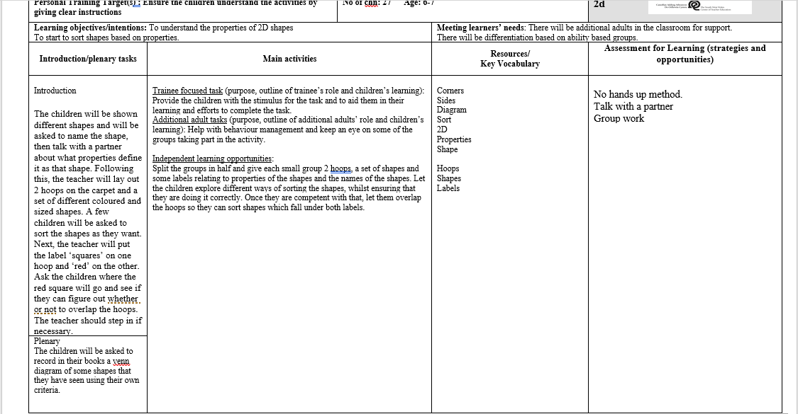
Appendices

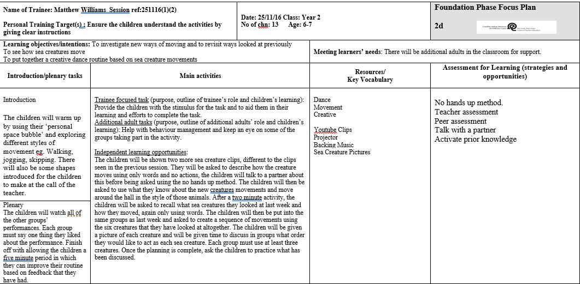

Appendix 1 – Evidence of teaching in a creative style.

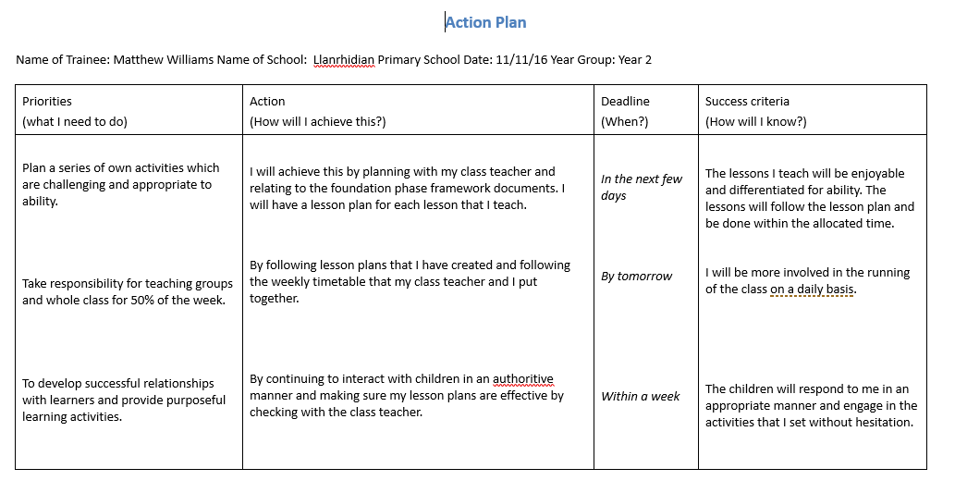
Appendix 2 – I Evidence I can make short term plans and act upon them

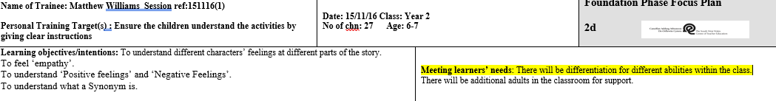
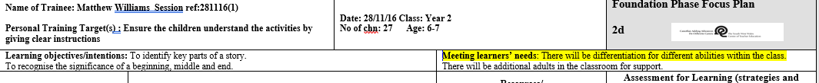

Appendix 3 – Evidence that I am aware that differentiation must be in the class

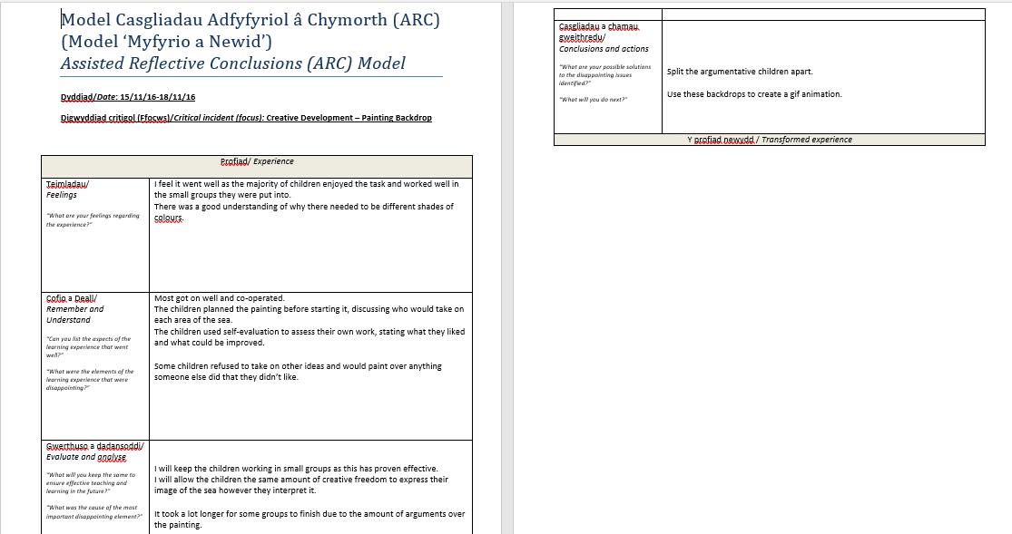
Appendix 4 – Evidence of a completed ARC Form to show Reflection

