Strategic Marketing
Title: Analysis IHG Hotels & Resorts’ current and future external and internal environments
Yangsenyun
18 March2022

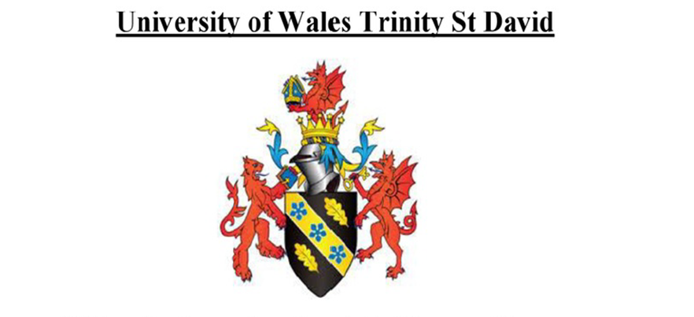

MOUDLE NAME | strategic marketing
MOUDLE CORE | BMBM6016
STUDENT NAME | YANGSENYUN
STUDENT NUMBER | 2100118

Executive Summary
Environment audit for hotels provides foundation in designing their marketing campaigns. The report analyses IHG Hotels & Resorts’ current and future external and internal environments by referring to the strategic analytical tools to figure out key issues that the corporation needs to consider when it is achieving the effective operations in the UK market. In environmental audit, Main findings are identified by using four strategic analytical models, which are PESTEL, SWOT, Porter’s Generic Value Chain, and Porter’s 5 Forces. The VIRO framework is used to audit the internal environment of IHG to suggest VIRO capabilities of the corporation as good operational practices with the interacted primary activities in the value chain well designed secondary activities in the value chain, and good reputation as one leading hotel related organization. Five key issues and findings facing IHG Hotels & Resorts are identified from the environmental audit: the challenges to meet the cultural diversified and dynamic requirements of the customers, Fierce competitions within the hotel industry, limited capabilities in combining profits and dealing with the covid-19 pandemics, good reputation as the intangible assets, physical hotels as tangible assets to support maximized functions of intangible assets for IHG. There are three recommendations proposed for IHG in the UK market when referring to marketing department of the corporation based on the five identified issues and findings from auditing the situations that IHG is facing: auditing customers by promoting customer engagement and using the customer relationship management system, adopting benchmark to perfect the marketing practices based on the successful marketing campaigns of the competitors, and branding the hotel by using social media advertising.

Table of Contents

Executive Summary 2
1. Introduction 4
2. Environment analysis 4
2.1 PESTEL 5
2.2 Porter’s Generic Value Chain 6
2.2.1 The VIRO framework 7
2.3 Porter’s 5 Forces 8
2.4 SWOT 9
3. Key issues and findings 10
3.1 Challenges to fit with customers’ requirements 11
3.2 Fierce competitions within the hotel industry 11
3.3 Limitations in gaining profits under impacts of the epidemic 11
3.4 Good reputation as the intangible assets 12
3.5 The requirements to combine tangible and intangible assets 12
4. Recommendations 12
5. Conclusions 13
References 15

Introduction
Hotels are facing the serious challenges raised by the covid-19 pandemic when there are reduced visits of the customers, as well as the reduced level of affordability that the customers could pay to support their accommodations and other activities in hotels. For the multinational hotels, such as IHG Hotels & Resorts, which have brands to support the operations, they are also facing serious challenges brought about by the covidi-19 pandemics, requiring the management auditing the environment before designing and implementing the certain marketing and promotional efforts toward the operational effectiveness. New management interventions, such as providing the manual to deal with the epidemic for all the visitors, requiring wearing masks or checking the track of the customers are required under some occasions, are required in operations of IHG in respond to the serious threats from the covid-19 pandemics. The managers are also facing additional challenges to appeal customers and achieving satisfaction of the customers under the new context when it is facing the serious threats from the epidemic. In this report, it analyses IHG Hotels & Resorts’ current and future external and internal environments by referring to the strategic analytical tools to figure out key issues that the corporation needs to consider when it is achieving the effective operations in the UK market. Main findings in this report are identified by using four strategic analytical models, which are PESTEL, SWOT, Porter’s Generic Value Chain, and Porter’s 5 Forces. Five key issues facing IHG Hotels & Resorts are identified from the environmental audit. InterContinental Hotels Group plc (IHG) is one British multinational hospitality business headquartered in Denham. It is also one of the FTSE100 companies, to have four categories of hotel brands, which are the luxury & lifestyle collection, the premium collection, the essentials collection, and the suites collection. Besides operations in the UK, IHG also shows its presence in more than 50 countries and districts across the world with its good reputation as one global leading hotel group.

Environment analysis
In environmental audit, Main findings are identified by using four strategic analytical models, which are PESTEL, SWOT, Porter’s Generic Value Chain, and Porter’s 5 Forces. The VIRO framework is used to audit the internal environment when evaluating internal capabilities of IHG under the value chain and the SWOT table.

PESTEL
IHG Hotels & Resorts’ current and future external and internal environments could be analysed by referring to PESTEL model, which identifies six dimensions that the organisation is facing in the operations as the political environment, the economic environment, the social environment, the technological conditions, the environmental situation and the legal conditions (Fernández, Cala, & Domecq, 2011). Table 1 summarizes PESTEL analyses about the external environment facing IHG in the UK market.

Table 1: PESTEL
Political factors | - Brexit referendum impacts, to mostly mean negative impacts on operations of IHG  - Macro external factors related to the industrial policies  - Potential restricts to deal with the covid-19 pandemic (Noel, 2022)
Economic factors | - Slowing growth and reduction in affordability of the consumers under the impacts of the epidemic (Sztorc, 2021)
Social factors | - IHG in the marketplace is facing the diversified cultural preferences of the many customers  - There are increases in travelling because of the changes in lifestyles and demographics  - Impacts of the covid-19 and the related additional measures or the reduction of accommodation in hotels (António, Rita, Citur- Universidade do Algarve, & Nova Information Management School, 2021)
Technological factors | - Digital booking growth  - Social media platforms and tools as the essential ways to support the marketing and promotions  - Big data available to analyse situations facing organisations before proposing the counterpart recommendations (Xuchao, Priyadarsini, & Siew Eang, 2010)
Environmental factors | - Sustainable business practices in requirements  - Water risk assessment by IHG (IHG, 2022)
Legal factors | - IHG in the operations is facing travel restrictions, which are leading to fewer visits of the customers  - Potential law suits related to data collection and use

Porter’s Generic Value Chain
Porter’s Generic Value Chain is one useful tool to analyse the business process of corporations with referring to the primary activities and the secondary activities that IHG is conducting toward the margins in the marketplace (Al-Aomar & Hussain, 2019). Figure 1 summarises analyses by referring to Porter’s Generic Value Chain when auditing operations of IHG in the global market.

Figure 1: Porter’s Generic Value Chain
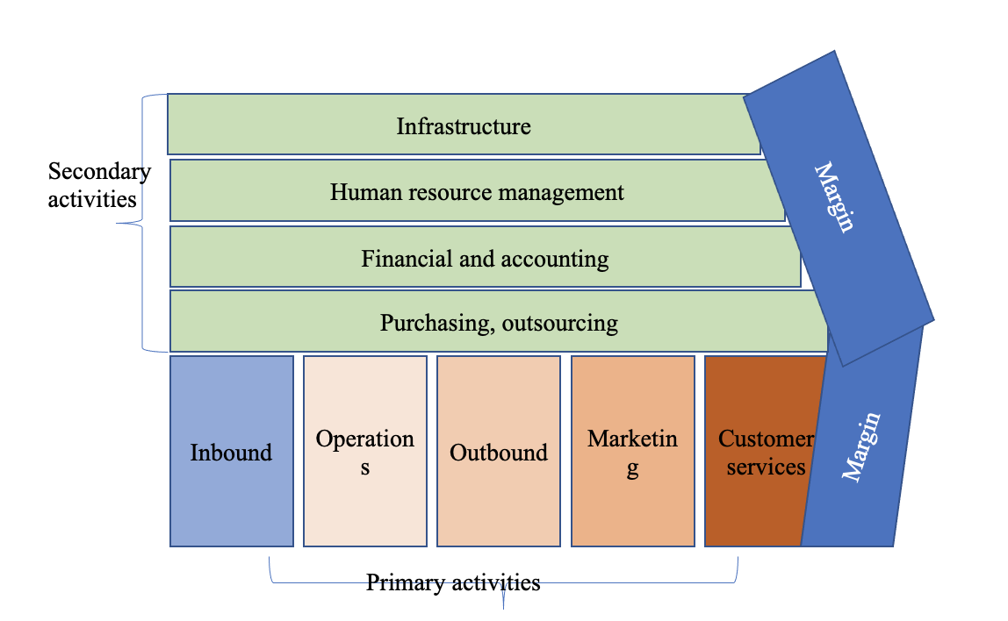

As illustrated in figure 1, IHG in the operations are having primary activities, such as inbound, operations, outbound, marketing, and customer services, as one hotel to serve the customers when the primary activities are directly resulted of margins in the operations (Chen, 2019). To support functions of the primary activities, there are also secondary activities, which are not directly contribute to margin in the operations (Chang & Sokol, 2022). The secondary activities include the purchasing and outsourcing related operations, the financial and accounting management practices, the human resource management practices and the infrastructure in the hotel (Thomas-Francois, Joppe, & von Massow, 2021). For example, the hall, along with the certain decoration are required to appeal and satisfy the target customers, who are visiting hotels of IHG.

2.2.1 The VIRO framework
The VIRO framework is used to audit the internal environment of IHG to suggest VIRO capabilities of the corporation as good operational practices with the interacted primary activities in the value chain well designed secondary activities in the value chain, and good reputation as one leading hotel related organization. Those identified capabilities within operations of IHG fits with each of the four criteria, which are valuable, difficult to intimate, rare and well organized, to support IHG’s gaining competitive advantages in the marketplace (Chang & Sokol, 2022).

Porter’s 5 Forces
Porter’s 5 Forces illustrates the industrial conditions that IHG is facing when the corporation intends to gain its competitiveness among all the hotels in the UK. Findings from Porter’s 5 Forces are summarized in figure 2, with referring to three levels of the powers from the five key powers that IHG is facing: the customers, the competitors, the suppliers, the substitutes and the potential entrants (Sztorc, 2021).

Figure 2: Porter’s 5 Forces
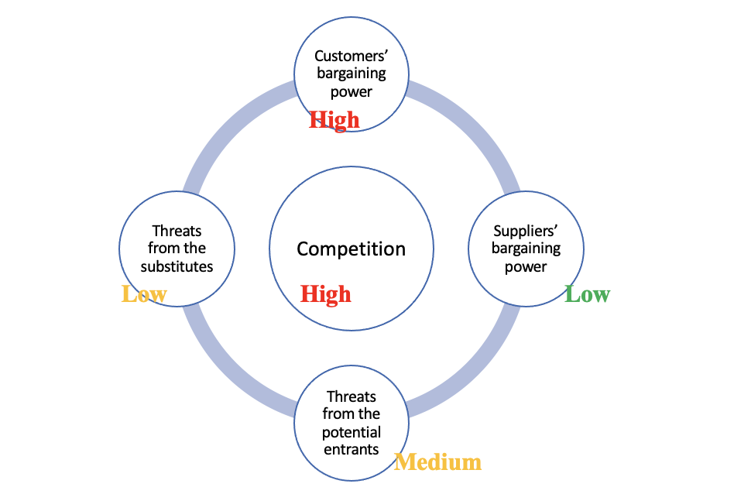

As illustrated by figure 2, the competition within the hotel industry facing IHG in the UK is high when there are many hotels operating in the industry, to fit with the changing situations related to technological advances and the threats from the covid-19 pandemic toward their operational effectiveness (Rotimi, Bahadori-Jahromi, Mylona, Godfrey, & Cook, 2017).

Threat of New Entrants is in the medium level when there are new entrants in the UK to bring about innovative services for the hotel industry while the hotels to achieve their expansion and services also need to have the financial resources and excellent experience in serving the customers (Debata, Patnaik, & Mishra, 2020).

Bargaining Power of Suppliers is in the low level because IHG could find many suppliers and the hotel could easily and cheaply transit from the previous suppliers to the other suppliers (Curtis, Smith, & Torriti, 2021).

Bargaining Power of Buyers is high because the customers of IHG have many choices and the development of the online vehicles are suggesting the reduced costs for the IHG to shift from the previous preferred hotels to new brands (Salem, Bahadori-Jahromi, Mylona, Godfrey, & Cook, 2020).

Threats from the substitutes are in the low level because the visitors need accommodation services from hotels and they have limited opportunities to achieve similar accommodation services besides hotels (Wang, Li, Li, & Zhang, 2016).

SWOT
SWOT analysis identifies and studies the external opportunities and threats, internal strengths and weaknesses based on the previous analyses, to summary situations facing IHG in the UK. Table 2 summarizes findings from the SWOT analyses.

Table 2: SWOT analysis
Opportunities | Threats
- There are increases in travelling because of the changes in lifestyles and demographics  - Digital booking growth  - Low threats from the suppliers  - Low threats from the substitutes | - Covid-19  - Brexit  - Slowing growth and reduction in affordability of the consumers under the impacts of the epidemic  - IHG in the marketplace is facing the diversified cultural preferences of the many customers  - IHG in the operations is facing travel restrictions  - Fierce competition  - High level of bargaining power from the customers
Strengths | Weaknesses
- Good operational practices with the interacted primary activities in the value chain  - Well designed secondary activities in the value chain  - Good reputation as one leading hotel related organization | - Limitations in cultural diversified items in catering  - Limitations in using outsourcing  - Weaknesses in cooperating different hotels and business units

Key issues and findings
Five key issues and findings facing IHG Hotels & Resorts are identified from the environmental audit. The five key issues in identification are the challenges to meet the cultural diversified and dynamic requirements of the customers, Fierce competitions within the hotel industry, limited capabilities in combining profits and dealing with the covid-19 pandemics, good reputation as the intangible assets, physical hotels as tangible assets to support maximized functions of intangible assets for IHG.

Challenges to fit with customers’ requirements
IHG in the operation is facing the challenges to fit with the customers’ requirements when considering the cultural diversified requirements of the customers and the dynamics in the customers preferences (Dubois & Dimanche, 2021). First, customers are from different countries and cultural backgrounds, to suggest their cultural diversified conditions. Second, customers are also having dynamic demands when they are having changes in their lifestyles and demographic conditions. For example, there are increasing number of customers to fulfill their requirements of accommodation by using online booking and they are paying increasing concerns on the covid-free rooms in their booking (Yan et al., 2021).

Fierce competitions within the hotel industry
IHG in the operation is facing fierce competition within the UK hotel industry when the corporation is competing with the many domestic and international hotel brands, which are providing diversified products and services toward customers’ satisfaction (Pham, Tučková, & Chiappetta Jabbour, 2019). For example, Airbnb is one competitor of IHG, especially by referring to the budget hotel services because Airbnb provides the mostly low prices of accommodation for the customers (Amirkhani, Bahadori-Jahromi, Mylona, Godfrey, & Cook, 2020). However, it is a challenge for IHG to ensure quality guaranteed services while the corporation intends to achieve lean practices in designing and conducting the operations.

Limitations in gaining profits under impacts of the epidemic
The covid-19 pandemic is one of the most essential situations facing the hotel industry to gain the sales and profits, suggesting limitations of IHG in the UK market to gain the growth in spite of the epidemic impacts. For example, IHG needs to stop the operations on some occasions when the corporation is facing business restricts by the local governments, leading to the reduced level of visitors and profits in the operations (Prakash, Rajendirabhabu, & Leelavathi, 2021). For example, sales and net profit in IHG in 2020 had declined by 41% and 55%, because of the low occupation of the hotel rooms (Majumdar, 2021).

Good reputation as the intangible assets
IHG has its good reputation as one international hotel group, listed on the London Stock Exchange as one FTSE100 company, to support its gaining operational effectiveness in the marketplace (Bahadori-Jahromi, Rotimi, Mylona, Godfrey, & Cook, 2017). The good reputation in IHG also suggest the VRIO resource because it fits with the four criteria in defining assets used in projects toward their competitive advantages. (Madai Boukar, Mbock, & Kilolo, 2021) suggested that VRIO capabilities contribute to competitive advantages of corporations while the model includes four pillars in evaluating capabilities of a hotel: being valuable, rare, difficult to intimate, and well organised. The intangible assets of IHG suggests the source of its competitive advantages because the intangible assets, such as the experience of catering high quality services to the customers, fit with the competitiveness development (Tan & Despotis, 2021).

The requirements to combine tangible and intangible assets
Besides good reputation as the form of intangible assets, IHG in the UK market is also facing various tangibles toward the customers’ satisfaction. The beautiful and high quality decoration of the IHG luxury hotels are suggesting ways of appealing the customers (Zhong, Verma, Wei, Morrsion, & Yang, 2022). However, it is difficult to gain competitive advantages with online the tangible items in catering, also requiring the use of intangible assets (Miao, Im, Fu, Kim, & Zhang, 2021).

Recommendations
There are three recommendations proposed for IHG in the UK market when referring to marketing department of the corporation based on the five identified issues and findings from auditing the situations that IHG is facing: auditing customers by promoting customer engagement and using the customer relationship management system, adopting benchmark to perfect the marketing practices based on the successful marketing campaigns of the competitors, and branding the hotel by using social media advertising. First, it is suggested that IHG in the UK market to audit customers by promoting customer engagement and using the customer relationship management system, which are essential ways of interacting with the customers, collecting and analysing big data, before gaining in-depth understanding on the customers and perfecting the marketing practices based on the customers’ requirements (Ozturk, Nusair, Okumus, & Hua, 2016).

Second, it is suggested that IHG in the UK market to perfect benchmark to perfect the marketing practices based on the successful marketing campaigns of the competitors. The recommendation is raised because IHG in the UK market are facing various successful marketing campaigns, to help audit its current marketing campaigns and to perfect the future campaigns design in the future (Arkhipova, Stepanova, Nikolaev, Bedyaeva, & Fomicheva, 2021). For example, the marketing campaign design for the luxury hotel business unit should learn from the successful experience of Four Seasons Hotel, which is one world leading luxury hotels.

Third, it is suggested that IHG in the UK market to brand the hotel by using social media advertising because social media are powerful while cheaper compared with the previous measures in appealing and satisfying the customers (Debata et al., 2020). However, it is still important for IHG to keep some traditional ways in marketing and promotional the products because of there are some customers failed to shift their ways of perceiving information from the traditional TV ads to the newly ways online.

Conclusions
The report analyses IHG Hotels & Resorts’ current and future external and internal environments by referring to the strategic analytical tools to figure out key issues that the corporation needs to consider when it is achieving the effective operations in the UK market. In environmental audit, Main findings are identified by using four strategic analytical models, which are PESTEL, SWOT, Porter’s Generic Value Chain, and Porter’s 5 Forces. The VIRO framework is used to audit the internal environment. Five key issues and findings facing IHG Hotels & Resorts are identified from the environmental audit: the challenges to meet the cultural diversified and dynamic requirements of the customers, Fierce competitions within the hotel industry, limited capabilities in combining profits and dealing with the covid-19 pandemics, good reputation as the intangible assets, physical hotels as tangible assets to support maximized functions of intangible assets for IHG. There are three recommendations proposed for IHG in the UK market when referring to marketing department of the corporation based on the five identified issues and findings from auditing the situations that IHG is facing: auditing customers by promoting customer engagement and using the customer relationship management system, adopting benchmark to perfect the marketing practices based on the successful marketing campaigns of the competitors, and branding the hotel by using social media advertising.

References
Al-Aomar, R., & Hussain, M. 2019. Exploration and prioritization of lean techniques in a hotel supply chain. International journal of lean six sigma, 10(1), pp.375-396. doi:10.1108/IJLSS-10-2017-0119
Amirkhani, S., Bahadori-Jahromi, A., Mylona, A., Godfrey, P., & Cook, D. 2020. Impact of Adding Comfort Cooling Systems on the Energy Consumption and EPC Rating of an Existing UK Hotel. Sustainability (Basel, Switzerland), 12(7), pp.2950. doi:10.3390/su12072950
António, N., Rita, P., Citur- Universidade do Algarve, F. P., & Nova Information Management School, U. N. d. L. L. P. 2021. COVID 19: The catalyst for digital transformation in the hospitality industry? Tourism & management studies, 17(2), pp.41-46. doi:10.18089/tms.2021.170204
Arkhipova, O., Stepanova, S., Nikolaev, A., Bedyaeva, T., & Fomicheva, N. 2021. Strategic development priorities of safety standards and business models of the hospitality industry in the conditions of restrictions and post-Covid period (by the example of St. Petersburg). E3S web of conferences, 296, pp.5007. doi:10.1051/e3sconf/202129605007
Bahadori-Jahromi, A., Rotimi, A., Mylona, A., Godfrey, P., & Cook, D. 2017. Impact of Window Films on the Overall Energy Consumption of Existing UK Hotel Buildings. Sustainability (Basel, Switzerland), 9(5), pp.731. doi:10.3390/su9050731
Chang, H. H., & Sokol, D. D. 2022. How incumbents respond to competition from innovative disruptors in the sharing economy—The impact of Airbnb on hotel performance. Strategic management journal, 43(3), pp.425-446. doi:10.1002/smj.3201
Chen, L.-F. 2019. Hotel chain affiliation as an environmental performance strategy for luxury hotels. International journal of hospitality management, 77, pp.1-6. doi:10.1016/j.ijhm.2018.08.021
Curtis, M., Smith, S. T., & Torriti, J. 2021. Development of a profile-based electricity demand response estimation method: An application based on UK hotel chillers. Energy and buildings, 246, pp.111071. doi:10.1016/j.enbuild.2021.111071
Debata, B., Patnaik, P., & Mishra, A. 2020. COVID‐19 pandemic! It's impact on people, economy, and environment. Journal of public affairs, 20(4), pp.n/a-n/a. doi:10.1002/pa.2372
Dubois, L.-E., & Dimanche, F. 2021. The futures of entertainment dependent cities in a post-COVID world. Journal of Tourism Futures, 7(3), pp.364-376. doi:10.1108/JTF-11-2020-0208
Fernández, J. I. P., Cala, A. S., & Domecq, C. F. 2011. Critical External Factors behind Hotels' Investments in Innovation and Technology in Emerging Urban Destinations. Tourism economics : the business and finance of tourism and recreation, 17(2), pp.339-357. doi:10.5367/te.2011.0033
IHG. (2022). Viewed 3 March 2022. Retrieved from: https://www.ihg.com/.
Madai Boukar, A., Mbock, O., & Kilolo, J. M. M. 2021. The impacts of the Covid‐19 pandemic on employment in Cameroon: A general equilibrium analysis. African development review, 33(S1), pp.S88-S101. doi:10.1111/1467-8268.12512
Majumdar, R. 2021. Surviving and growing in the post-Covid world: the case of Indian hotels. Worldwide hospitality and tourism themes, 13(5), pp.584-598. doi:10.1108/WHATT-05-2021-0064
Miao, L., Im, J., Fu, X., Kim, H., & Zhang, Y. E. 2021. Proximal and distal post-COVID travel behavior. Annals of tourism research, 88, pp.103159. doi:10.1016/j.annals.2021.103159
Noel, M. D. 2022. Competitive survival in a devastated industry: Evidence from hotels during COVID‐19. Journal of economics & management strategy, 31(1), pp.3-24. doi:10.1111/jems.12446
Ozturk, A. B., Nusair, K., Okumus, F., & Hua, N. 2016. The role of utilitarian and hedonic values on users’ continued usage intention in a mobile hotel booking environment. International journal of hospitality management, 57, pp.106-115. doi:10.1016/j.ijhm.2016.06.007
Pham, N. T., Tučková, Z., & Chiappetta Jabbour, C. J. 2019. Greening the hospitality industry: How do green human resource management practices influence organizational citizenship behavior in hotels? A mixed-methods study. Tourism management (1982), 72, pp.386-399. doi:10.1016/j.tourman.2018.12.008
Prakash, S., Rajendirabhabu, C., & Leelavathi, R. 2021. Impact of Power Loom Industry During Covid- 19 Pandemic Period Major District in Tamilnadu. Turkish journal of computer and mathematics education, 12(10), pp.2029-2035. Retrieved from https://go.exlibris.link/C4cMxpfg
Rotimi, A., Bahadori-Jahromi, A., Mylona, A., Godfrey, P., & Cook, D. 2017. Estimation and Validation of Energy Consumption in UK Existing Hotel Building Using Dynamic Simulation Software. Sustainability (Basel, Switzerland), 9(8), pp.1391. doi:10.3390/su9081391
Salem, R., Bahadori-Jahromi, A., Mylona, A., Godfrey, P., & Cook, D. 2020. Energy performance and cost analysis for the nZEB retrofit of a typical UK hotel. Journal of Building Engineering, 31, pp.101403. doi:10.1016/j.jobe.2020.101403
Sztorc, M. 2021. Autonomous Enterprise as a Model of Hotel Operation in the Aftermath of the COVID-19 Pandemic. Sustainability (Basel, Switzerland), 14(1), pp.97. doi:10.3390/su14010097
Tan, Y., & Despotis, D. 2021. Investigation of efficiency in the UK hotel industry: a network data envelopment analysis approach. International journal of contemporary hospitality management, 33(3), pp.1080-1104. doi:10.1108/IJCHM-07-2020-0641
Thomas-Francois, K., Joppe, M., & von Massow, M. 2021. The impact of customer engagement and service leadership on the local food value chain of hotels. Journal of Hospitality and Tourism Insights, 4(1), pp.35-58. doi:10.1108/JHTI-03-2020-0031
Wang, Y.-S., Li, H.-T., Li, C.-R., & Zhang, D.-Z. 2016. Factors affecting hotels' adoption of mobile reservation systems: A technology-organization-environment framework. Tourism management (1982), 53, pp.163-172. doi:10.1016/j.tourman.2015.09.021
Xuchao, W., Priyadarsini, R., & Siew Eang, L. 2010. Benchmarking energy use and greenhouse gas emissions in Singapore’s hotel industry. Energy policy, 38(8), pp.4520-4527. doi:10.1016/j.enpol.2010.04.006
Yan, J., Kim, S., Zhang, S. X., Foo, M.-D., Alvarez-Risco, A., Del-Aguila-Arcentales, S., & Yáñez, J. A. 2021. Hospitality workers’ COVID-19 risk perception and depression: A contingent model based on transactional theory of stress model. International journal of hospitality management, 95, pp.102935. doi:10.1016/j.ijhm.2021.102935
Zhong, L., Verma, R., Wei, W., Morrsion, A. M., & Yang, L. 2022. Multi-stakeholder perspectives on the impacts of service robots in urban hotel rooms. Technology in society, 68, pp.101846. doi:10.1016/j.techsoc.2021.101846

