
Sasha Cranfield
1703081
Professional Development

Contents
Part One - What is a professional? 4
what it means to be a professional? 4
Code of conduct 4
Part Two - Group Dynamics 5
Teamwork theories 5
Factors Affecting group performance 5
Group Conflict 5
Part Three - Project Management 7
Problem-solving 7
References 9
Appendix 1 11
Appendix 2 12
Appendix 3 13

Part One - What is a professional?

what it means to be a professional?
A professional is based on a body of knowledge, it uses expertise that people apply their own knowledge and judgement and is underpinned by a set of principles known as code of conduct, for example, a lawyer or a doctor. Human resource professionals will use the four centric circles. There are four things that professionals should have the ability to do. They are manage their self, group upwards so their senior managers and across the organisation their line managers (Certificate in Human Resource Management Program, no date).

Code of conduct
Code of conduct is a set of guidelines that is produced by professional organisations which set out ethical norms and standards which all professionals must follow. Code of conduct reflects what an organisation does daily so therefore every code is unique to the organisation. Professionals must be aware of these codes so that they know what is expected of them. Allowing employees to follow these guidelines will mean that discipline in the workplace will be maintained (Importance of Employee Code of Conduct, no date). The CIPD code of conduct for professionals cover the behaviour of professional’s ethics standards and integrity, representation and stewardship. Some examples of code of conduct would be inclusive, respect in the workplace and protection of workplace property. Codes of conduct should be visible and user friendly so that all employees are able to see and understand it.
The professional standards for a teacher which is the profession of my choice would be to create a safe environment for the pupils. Another standard is to plan and teach the correct curriculum, maintain high standards of ethics and finally understand their duties and responsibilities (Teachers’ Standards Guidance for school leaders, school staff and governing bodies, 2011).

Part Two - Group Dynamics

Professionals must work with other professionals in teams. There are different types of teams within organisations and for these teams to be successful they have to understand the importance and develop certain skills such as collaborative working (Buchanan and Huczynski, 2017). The difference between a good and a bad team is how well a team works together, the better you are at working with others the chances of having a successful team will be higher. Having good teamwork skills will boost your confidence, improve communication skills and will help you achieve your goals better (What Are Teamwork Skills | Build Skills For Life And Work | Young Professional - Youth Employment UK, no date).

Teamwork theories
Teams can only excel to its full potential when team roles within are balanced. For a team to function well a team needs roles fulfilled. There are a few teamwork theories that allow us to understand group dynamics. Meredith Belbin (2010) suggests that understanding your role within a team will help develop your strengths and improve your weaknesses as a member of a team, this will help you contribute to your team better (Belbin’s Team Roles - Leadership Training from MindTools.com, no date). Everyone discovers their role by doing a self-assessment which can be given by their managers.
Another teamwork theory is by Bruce Tuckerman (1965). He suggests that there are different stages to a group formation. The main aim of his concept is that teams must go through five stages in order to become functionally effective. He suggests that a well-established team functions well because they have established norms and trust. There are 5 stages in which teams should go through forming, storming, norming, performing and adoring (King Daniel, 2016).

Factors Affecting group performance
Group dynamics can be affected by several factors. One factor is communication, dynamics of groups will affect the decision making when team members seek to conform they all think alike which means that they lose their critical evaluation capabilities (French, Rayner and Rees, 2015). Another factor is leadership, groups tend to follow the person with leadership qualities, this might not necessarily be the leader and this could lead to loss of direction (Foltz, 2017)(Factors that Influence Group Dynamics | Actforlibraries.org, no date). Some groups will have very strong personalities and some team members will fight for power and this can cause clashes withing the group (Team Dynamics and Power | Applied Social Psychology (ASP), no date).

Group Conflict
Conflict can arise in teams when their roles are unclear, this will lead to performance problems. For a job to be done well team members need to know what is expected of them, conflict happens when these expectations are not met by any member of the group (French, 2011). There are other reasons to why conflict may arise such as role ambiguity, cultural and communication issues, power and diversity (Clegg, Kornberger and Pitsis, 2016). The Kilmann model was designed by two psychologists, it shows the different available options when handling a conflict which are competing, collaborating, compromising, avoiding and accommodating. It identifies two aspects when choosing a course of action and these are assertiveness which is to the extent of a person satisfying their own concerns and cooperativeness which is the extent where a person satisfies others concerns (Thompson and Kilmann, 2019).
Another conflict resolution method is PEACE. Hilary Cremin (2017) created this framework to tackle conflict and creating a culture of peace in schools. It was used to identify the conflict, pick the right strategy going forward, enable voices to be heard, attack the problems rather than the people create options and then evaluate the situation. In schools this can be used by peace keeping this can be done by the rules within schools also by peace making this can be done by conflict resolution techniques and finally by peace building (Cremin and Bevington, 2017).

Part Three - Project Management

I was involved in a small project in my first year of university, I was given the role as co leader. Our job was to help raise funds for a local school in Swansea that helped children with special needs. They needed help with funding for communication buttons. My role was to help the assigned leader. As a group, we went through five stages of project management. Projects are broken down into smaller parts so that the project can be successful. Project stages allows you to take parts of the project and organise it so that things are clear and progress can be made (Project Management Processes and Phases - ProjectManager.com, no date). The first stage we went through was project inanition, here we met and went over what our aims and objectives would be, we got to know each as a group more as we didn’t really know each other. The next stage we went to was project planning, here we created a Gantt chart to plan our project, we included all the tasks that had to be done and when they needed to be done by (see appendix 1) so that we could stick to a timeline and make sure that we were focused to get the work done on time. The third stage we went to was project execution, in this stage, we put all our ideas and plan into practise and made sure that what we set out to do was done correctly, for example, we carried out all our fundraising events. The fourth stage was project monitoring and control, in this stage we made sure that as a group we were working well together and that any issues was dealt with we also looked at our Gannt chart to make sure that all the work we needed to do was done. The final stage is project closure, here we made sure all tasks where completed and any necessary steps were taken before we finished, for example, give the school the money that we had raised.

Problem-solving
As a group, we had discussed a variety of different ways in which we could raise funds. We wanted to do something out the box and fun. We came up with a charity walk from the marina to mumbles, where we would all dress up as Christmas characters. We would ask family and friends to sponsor us and we would carry money tins so that we could collect funds on our route. we had the day and time all sorted but unfortunately, the uni said that we couldn’t do the walk due to safety reasons. So, we had less than a week to come up with a plan B. We had to use a problem-solving technique in order to find a solution to our problem (appendix 2). We brainstormed all the ideas that we could do instead. We also discussed the pros and cons for doing each event. Brainstorming was the quickest way for us to generate ideas.
Professionals sometimes have to influence others to bring about change. (Yemm, 2008) suggests that successful influencers have characteristics that include vision, friendliness and the ability to build relationships with others. Negotiation is the ability to reach a mutual agreement and influencing is having the ability to persuade and negotiate.

Part Four - Personal Development Plan (PDP)
Continuing professional development (CPD) is the tracking of both skills, knowledge, and experience. It helps professionals manage their own development (What is Continuing Professional Development (CPD)? - career-advice.jobs.ac.uk, no date). It is important for professionals to keep up to date with their skills and knowledge as the work environment is changing frequently. The CIPD professional map can help with identifying strengths and weaknesses. CPD enhances professionals’ abilities date). Some sources of CPD are vocational training, work shadowing, coaching and mentoring at work. The benefits of CPD are that it allows for regular focus on how people can become more effective professionals. It will increase confidence and capabilities. It will advance people career aspirations allows people to adapt to changes and shows clear self-development (CPD Explained | What Is Continuing Professional Development (CPD) | The CPD Certification Service, no date).
There are seven stages of Continued professional development which are identify, in this stage to try and understand where you have come from and where you would like to be in the future. The next stage is plan, in this stage, you plan how you going to get to the place you would like to be, you will track progress and have clear outcomes. The third stage is act, in this stage people will be open to. Th fourth stage is reflecting on expeirence. The fifth stage is apply and in this stage, learning will be put into practise. The sixth stage is share, in this stage people will get support from communities as they share there leaning expierences. The final stage is impact, in this stage overall impact of leaning will be measured (CIPD, 2019).
CIPD’s Profession Map (2018) sets out standards for professionals its designed to guide, plan and develop professionals’ careers. It focuses on the behaviour and knowledge that one needs to create value at work. One core knowledge that professionals need to have is been able to work digitally, this means the professionals should be able to apply technology and how it impacts people. One core behaviour is ethical practice, ethical values allow people to distinguish what is right and what is wrong, it’s a big part of decision making. Finally, a specialist knowledge need is reward, this is all about strategies that allow workers to be rewarded for their work within the organisation.
A personal development plan is a self-reflection of academic, personal or career based goals (Personal development planning: What you need to know | reed.co.uk, no date). It is important as it allows you to acknowledge your strengths and weaknesses. It’s a lifelong process which means it needs constant reviewing. The plan has four aspects to it, goals that are set out, how the goals will be met, resources that will be used and when will the goal be completed. This plan has definitely helped me out regards to planning my future (see appendix 3). There are certain skills that I must work on for me to be successful. For example, one skill I must work on is my leadership skills. Leadership skills is a powerful skill to have. Another skill I must improve is self-confidence, it allows you to push yourself to try new things. The final skill I must work on is being able to plan and be organised.

References
Belbin’s Team Roles - Leadership Training from MindTools.com (no date). Available at: https://www.mindtools.com/pages/article/newLDR_83.htm (Accessed: 30 December 2019).
Buchanan, D. and Huczynski, A. (2017) Organizational Behaviour. 10th edn. pearson.
Certificate in Human Resource Management Program (no date).
CIPD (2019) CPD Cycle Stages | CIPD, https://www.cipd.co.uk/learn/cpd/cycle. doi: 2019.
Clegg, S., Kornberger, M. and Pitsis, T. (2016) Managing and Organizations. 4th edn. SAGE.
CPD Explained | What Is Continuing Professional Development (CPD) | The CPD Certification Service (no date). Available at: https://cpduk.co.uk/explained (Accessed: 5 January 2020).
Cremin, H. and Bevington, T. (2017) Positive Peace in Schools, Positive Peace in Schools. Taylor and francis. doi: 10.4324/9781315304236.
Factors that Influence Group Dynamics | Actforlibraries.org (no date). Available at: http://www.actforlibraries.org/factors-that-influence-group-dynamics/ (Accessed: 5 January 2020).
Foltz, E. L. K. D. P. (2017) Skills for today: What We Know about Teaching and Assessing Collaboration, Executive Development. Available at: https://www.pearson.com/content/dam/one-dot-com/one-dot-com/global/Files/efficacy-and-research/he/Collaboration-White-Paper_FINAL.pdf%0Ahttps://www.pearson.com/content/dam/one-dot-com/one-dot-com/global/Files/efficacy-and-research/he/White-Paper-P21-Skill (Accessed: 14 November 2019).
French, R. (2011) Organiational Behaviour. 3rd edn. Wiley & Sons.
French, R., Rayner, C. and Rees, G. (2015) organizational Behaviour. Edited by 3rd. Wiley & Sons.
Importance of Employee Code of Conduct (no date). Available at: https://www.managementstudyguide.com/importance-of-employee-code-of-conduct.htm (Accessed: 6 January 2020).
King Daniel, L. S. (2016) Organization Behaviour. 2nd edn. oxford: Oxford University Press.
Personal development planning: What you need to know | reed.co.uk (no date). Available at: https://www.reed.co.uk/career-advice/personal-development-planning-what-you-need-to-know/ (Accessed: 6 January 2020).
Project Management Processes and Phases - ProjectManager.com (no date). Available at: https://www.projectmanager.com/blog/project-management-processes-phases (Accessed: 5 January 2020).
Teachers’ Standards Guidance for school leaders, school staff and governing bodies) 2 (2011).
Team Dynamics and Power | Applied Social Psychology (ASP) (no date). Available at: https://sites.psu.edu/aspsy/2017/02/27/team-dynamics-and-power/ (Accessed: 5 January 2020).
Thompson, K. and Kilmann, R. (2019) An Overview of the Thomas-Kilmann Conflict Mode Instrument (TKI) A long-term collaboration by Kenneth W. Thomas and Ralph H. Kilmann - Kilmann Diagnostics, killmandiagnostics. Available at: https://kilmanndiagnostics.com/overview-thomas-kilmann-conflict-mode-instrument-tki/ (Accessed: 1 January 2020).
What Are Teamwork Skills | Build Skills For Life And Work | Young Professional - Youth Employment UK (no date). Available at: https://www.youthemployment.org.uk/young-professional-training/teamwork-skills-young-professional/ (Accessed: 5 January 2020).
What is Continuing Professional Development (CPD)? - career-advice.jobs.ac.uk (no date). Available at: https://career-advice.jobs.ac.uk/career-development/what-is-continuing-professional-development-cpd/ (Accessed: 5 January 2020).
Yemm, G. (2008) ‘Influencing Others - a Key Skill for All’.

Appendix 1
Gannt chart- Evidence of project plan

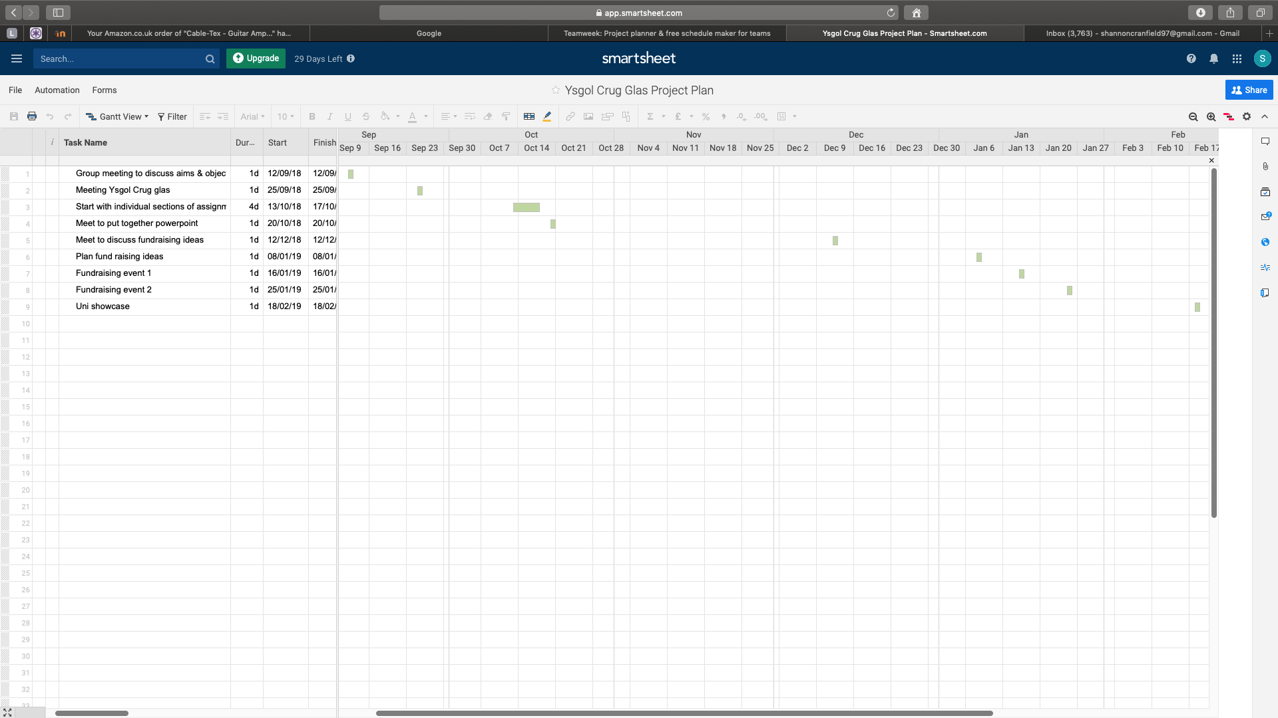

Appendix 2
Problem solving evidence
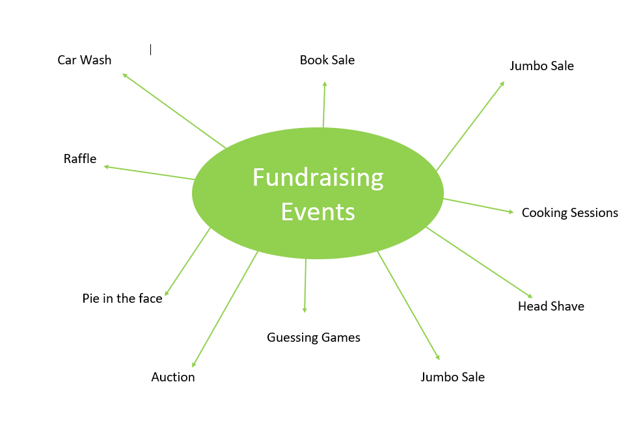

Appendix 3

Development Plan
NAME: | Sasha Cranfield | Student NUMBER: | 1703081
COVERING THE PERIOD FROM: | Jan 2020 | TO: | June 2020
Personal Development plan
What do I want/need to learn? | What will I do to achieve this? | What resources or support will I need? | What will my success criteria be? | Target dates for review and completion
Read more business books and journals | This will be achieved by inserting business reading into my daily routine | Books  Audio books | Having greater knowledge on my field of study. | Review: Feb
Improve on my transferable skills | To accomplish this, I will practise these skills as well as reading/researching ways in which to improve on these skills. | Blogs  articles  Websites  Personal stories  Time | To be able to perform these skills confidently. | Review: March
Achieve at least 2:1 on at least one of my modules | I will achieve this by using my time wisely leaving enough time to read/research, writing and fully proof-reading work, making good notes while in lectures and asking for help or advice when needed. Additionally, staying focused on assignments and not getting distracted. | Journals  Blogs  Articles  Lecturer | Being self-assured in the work I submit. | Review: June
Staying up to date with recent business developments | I will read newspapers and news websites, also listen to podcasts and videos. Moreover, I will network with local businesses and attend local events such as talks. | Newspapers  Podcasts | Getting regular notifications on my phone | Review: Feb

