
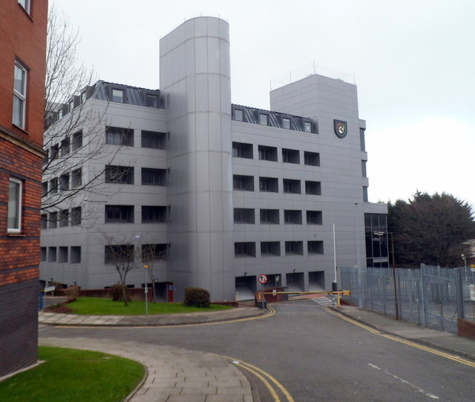

TY Bryn Glas is being renovated to be the new campus of Swansea Business School, which is part of the new University of Wales Trinity St David, Swansea Metropolitan. The campus will be open from January 2013.
TY BRYN GLAS, HIGH STREET, SWANSEA
HIGH STREET
SWANSEA
SA1 1PW

