

The impact of social media advertising on consumer buying behaviour

Student Name: Alina Mutoi
Student ID: 2028702
Module number: LCBB6000
Dissertation supervisor: Dr. Konstantina Mari

Table of content

- Introduction………………………………………………………………………..3
- Literature review…………………………………………………………………..5
  - From traditional to digital: Exploring the shift in marketing strategies………………………………………………………………………...5
  - Online vs. offline marketing: Pros and Cons…..………………………………..6
  - Buying process: factors that influence purchasing decision…………………….…………………………………………………….7
- Research methodology…………………………………………………………….. 9
  - Methodology……………………………………………………………………..9
  - Strategy and data collection…………………………………………………….10
  - Ethical considerations…………………………………………………………..11
- Data analysis and key results……………………………………………………..11
  - The sample……………………………………………………………………...11
  - General usage of social media…………………………………………………..13
  - Social media and product advertising…………………………………………...15
  - Online shopping vs traditional shopping………………………………………..17
  - Conclusion and limitations………………………………………………………18
- Conclusion and recommendations…………………………………………………22
  - Finding……………………………………………………………………………22
  - Limitations and suggestions for further research…………………………………………………………………………...22
  - Recommendations for businesses………………………………………………...22
- References and bibliography……………………………………………………….24
- Appendix…………………………………………………………………………….28
- Questionnaire…………………………………………………………………….28
- Participant consent form………………………………………………………….37
- Participant information sheet……………………………………………………..39

- Introduction

Internet has become an important source for businesses from all around the world to get more customers and profit. Statistics show that over 5 billion people worldwide use Internet and the number of purchases online is increasing year-by-year. In 2022, e-commerce sales have exceeded 5.7 trillion U.S. dollars globally and the figure is expected to increase next years (Statista, 2023).

Products marketed digitally are available to the consumers at all times and from any part of the world. Fast and secure shipping allows people to buy everything they want just by a click, even the product is not sold in their country. Covid-19 pandemic has also accelerated the transition from traditional shopping to the online one, with many benefits for the consumers and businesses owners, as well.

The term Digital Marketing was first used in the 1990s with the development of the Web 1.0 platform. It was a tool for finding information, but without allowing users to share it over the Internet. The first clickable banner, launched in 1993, has marked the beginning of the transition to the digital era. Next year, Yahoo has been created, hitting 1 million users straight away. More search engines and tools, like Google, HotBot, LookSmart, and Alexa have been launched at the end of 1990s.

The digital marketing had the first surge in 2006, when search engine traffic has grown to about 6.4 billion in a single month. Soon, MySpace was the first social networking site launched, followed by Facebook. Companies and organisations around the world have found the social media platforms as an opportunity to market their products and brands. Also, the later appearance of cookie tools has allowed businesses to easily track consumers habits and preferences in order to improve their activity (Simplilearn, 2023).

As digital marketing gains power over the traditional shopping, many businesses attempt to embrace online shopping channels to attract more and more customers and to give them a high level of satisfaction.

This dissertation is a study of the impact of social media on consumers buying behaviour. Purpose of the research is to identify how and why social media platforms, such as Facebook, Instagram, Twitter, etc. influence people’s attitude and behaviour about buying different products and services worldwide.

The dissertation will focus on identifying the most accessed social media platforms by population that are used for online advertisement by corporation and big companies. Also, it will find out the reasons customers prefer often buying online products that are advertised by social media. In conclusion, the study will try to find out the challenges faced by the digital marketing and to recommend certain strategies that can be applied to improve the quality of the social media promoting.

In line with the proposed objectives, the dissertation draws two hypothesis that needs to be proved by evidences and literature review:
- Digital marketing is preferred to traditional shopping.
- Social media marketing leads to increased sales and creates customer loyalty.

The research will focus on answering following questions:
- What is the digital marketing and what platforms are used by the businesses to promote their products and brands?
- How does online marketing impact consumers behaviour?
- What are the differences between traditional shopping and online shopping and what are the advantages and disadvantages of them?
- What are the challenges faced by online marketing?
- What future strategies of social media marketing can be applied to better relate to consumer behaviour?

The study of digital marketing gives information about the actual trends and tools in promoting the own business. The analysis of it teaches how to attract customers, build a strong brand online and engage with the audience. Digital marketing is also more cost-effective than traditional selling, offering flexibility with the funds and reducing the risk of wasting finances when not profitable (Future Learn, 2024).

The following chapter, Literature Review, will provide a full understanding of digital marketing and social media impact on purchasing behaviour. The section starts with definitions of the main terms and continues with a comparison between the traditional and online shopping. Also, it will analyse different papers and studies on the subject and will make a conclusion about how people decide on buying products and services online.

2. Literature review

2.1 From Traditional to Digital: Exploring the shift in marketing strategies.
Digital marketing, also called online marketing, is a form of advertising that uses Internet and digital technologies to connect with customers. It is a way of selling products and services online, through mobiles, computers, social media, search engines and other digital channels, wherever consumers spend most of the time. (Coursera, 2023).

In recent years, the shopping industry has been strongly impacted by the digitalization era. The progress of e-commerce and the increased use of digital technologies have transformed the way people shop as well. Many consumers have shifted from traditional, in-store shopping to the online one. Internet marketing provides convenience, more accessibility, and the possibility to compare products and prices from different retailers (LinkedIn, 2024). Covid-19 pandemic also had a significant impact on digital shopping surge. With lockdowns and people spending more time at home, there was a huge rise – about 129% - in online sales recorded by companies worldwide (Medium, 2023).

Nowadays, it is essential for businesses to have an online presence that allows to attract new potential customers and get wider audience. Therefore, digital marketing used by companies around the world is focused on different forms of online, such as websites, email, social media company pages, advertising videos on big platforms (such as YouTube), display adds, paid social ads etc. (Chaffey, Dave, 2019).

Particularly, social media platforms are effectively used to promote products and services, as it is accessed by different categories of consumers: from different countries, performing different types of activity and work, having different age etc. It includes a variety of technologies and applications (virtual networks and communities) that facilitate information and ideas sharing among their users.

According to the statistics, 62.3 percent of people worldwide access social media every day. The average usage of platforms is amounted to 143 minutes per day, which is about 2.5 hours. On the top of the most accessed social media networking sites are Facebook, Twitter, Pinterest, and Instagram (Statista 2024).

2.3 Online vs. offline marketing: Pros and Cons.
Online marketing has gained power and priority on the marketplace due to many advantages it comes with. It is easier and costless for companies and brands to attract more audience by creating virtual shops than to invest in physical stores, which require more employees and more finances. In the era of technology, most people prefer to save time doing online shopping instead of going to a crowded shop.

On the other hand, digital marketing has some setbacks as well. Online promotion highly depends on the Internet which sometimes may not be accessible in certain areas or there can be a poor connection. The brands competition is also high on online platforms. Some companies can be portrayed negatively due to a lot of frauds advertising appearing on websites, and, as a result, customers can lose trust in online shopping. Even an individual or a small group of people can harm the image of an established brand (Desai, 2019).

The table below presents the differences between online and offline marketings, including the advantages and disadvantages, as well.

 | Online marketing | Offline marketing
Cost | - It is very affordable, less costly. It does not require buildings for providing the activity, a lot of employees, physical maintenance etc. | More expensive to sell products in physical stores, as it requires businesses to rent/own buildings, shops, to pay maintenance bills, to hire more people to perform multiple jobs etc.
Trustworthiness | - It can be less trustworthy than real stores, especially for older generations. Number of scams performed through Internet has recently increased and some people can become afraid to buy products online (Balan, 2023). | More reliable, as customers can see and touch the products before buying them.
Target | - More consumers targeted than offline marketing. It can reach people from different geographic areas, different age, and lifestyles. More products can be displayed online because they do not require physical storage space. | - Less targeted customers than online marketing. Less products being displayed, as there is not so large space in stores to fit all company’s items.
Flexibility | - Online marketing campaigns can be easily changed and updated. People who order online get the products straight at home, thus saving time and money from going to physical stores. | - Campaigns difficult to change once have been launched.
Tangibility | - Some customers may prefer physically seeing and trying the product on before buying it rather than ordering it online. | People can see, touch, and try products on straight in the store. It is easier to decide right at place if you like the item or not, avoiding the hassle of returning products bought online (Balan, 2023)
Measurability | - Precise measurable. Online allows companies to track website traffic, and sales to see what works and what does not (Balan, 2023) | - Difficult to measure customers traffic, satisfaction, sales etc.
Table 1

  - Buying process: factors that influence consumers decision.
There are several factors that influence the customer decision when buying a product or a service. Different people take into consideration different aspects, such as price, quality, brand of the product, preferences, income level etc. Shared reviews and opinions, either friends’, family’s or online reviewers ones, also can have an impact on final purchasing decision of a consumer.

Consumer buying behaviour refers to the actions taken by the person before purchasing a product or a service. Waguespack (1993) defines it as “the process whereby individuals decide whether, what, when, where, how and from whom to purchase goods and services. The action includes both the mental and physical activity necessary for making decisions in the marketplace”.

An Indian study by Symbiosis International University emphasizes five phases of the customers buying process, called as the "EKB Model”:
- Recognition of requirements: Here, the customer analyses the gap between the true and the expected phase of purchasing. Interior or external stimulus cause the need. Smart phones, social media platforms, digital TV etc. trigger the necessity to buy a service or a new product.
2. Check for details: The buyer scans all information and details about the product. The knowledge is derived from external and internal memory outlets. Internal sources depend on the expertise and recollection of clients. Colleagues and acquaintances opinions, advertisers and commercial media come as a secondary source of information.
3. Alternative evaluation: After analysing important factors, such as price, cost, functionality, feedback and reviews of others, the customer assesses alternatives, as well.
4. Range and buying: A positive assessment of the option, plus other attitudes and unforeseen situational factors lead to the ultimate decision. Favorable actions by anyone and lack of an adverse circumstance may usually imply that the commodity will be bought.
5. Post buy behaviour: After buying the product, the consumer can feel pleased or unhappy. If buyer is happy, the customer can promote the brand to others and, if disappointed, may discourage others from buying it (Kumar, 2020).

Online influencers and celebrity branding, also known as celebrity endorsement or advertising, are another factor that influences consumer purchasing decision. Companies and brands worldwide use famous, well-known people image and status, such as actors, singers, political or sport personalities etc. in promoting their products and services. Social media influencers are encouraged and paid to share reviews on beauty and food products, lifestyle, travel and fashion. According to an UK independent survey, people trust them as an important source of information, after family and friends.
Consumers see online influencers as everyday human being, honest and close to reality, friendly and easy to interact with. It makes them reliable when it comes to buy certain product or service (Tebbatt, 2023).

The Similarity-Attraction Model (SAM) is a theory that explains the impact of the influencers on the decision-making process of consumers. The model says that ideas are transmitted through mass media or advertising to influencers, and from there, a reinterpreted message is then propagated to the public. It means that the process of developed in the public ideas is based on the perceptions and attitudes of an influencer. People like and are attracted to others who are similar to them, thus influencers who has a good impact on people will be able to promote certain brands and products more than others (Berscheid, Walster, 1969).

Next chapter of the dissertation, Research methodology, will provide a detailed information about the chosen for the study methods. It will describe the research enquiry paradigms, the adopted philosophy research, and data collection strategy.

- Research methodology
3.1 Methodology
The conduct of an academic study can be based on different methodology for collecting and analysing the information. It depends on the nature of the research subject and proposed questions.

According to Saunders theory, research methodology can be developed through four different types: ontological, epistemological, axiological and methodological. There are also three specific elements of paradigms: positivism, realism and interpretivism (Saunders, 2019). The understanding of the research philosophy is essential for conducting a scientific study, as it provides awareness of the available philosophical alternatives. It also offers “a general orientation about the world and the nature of the research that a researcher holds” (Creswell, 2009).

Research paradigms address three fundamental questions as a basic belief and value:
- The ontological question: What is the nature of the reality? Objective, subjective? What can be known in the world about it?
- The epistemological question: How do we know about this? What kind of the information and knowledge the research is looking for?
- The methodological question: How do we gain the knowledge? How can we find out what the information can be known? (Guba and Lincoln, 1998)

The research philosophy adopted for this study is epistemological, as it will gather and analyses empirical data and test hypothesis and theories. The chosen paradigm is positivism, focusing on quantitative, observable, and measurable facts – number and type of population making online purchases, type of online sales, tools and methods used by digital marketing to promote its products, and explanations of consumer-Internet relation etc.

3.2 Strategy and data collection
Data collection for the research is quantitative and the information was obtained by using a questionnaire. The survey is in electronic format, consists of 26 questions, demographic and related to the topic – about customers preferences regarding online purchasing. These were design to find out why, when, and how social media has an impact on buying decision.

The questionnaire was formatted on Google Forms platform, which is a free surveying web-based application, and was shared to the respondents by social media platforms (Facebook messages) and e-mail. It was estimated to take approximately few minutes for answering the survey.

The approach of this research will be deductive, as it will try to test facts and develop theories based on existing studies about digital marketing. There will be primary data to do the analysis and a random sampling of the participants to the survey. This means that the questioned people will be chosen randomly, regardless of their activity, religion, race, sexual orientation etc. The random sampling ensures that the samples are representative of the population.

A descriptive model will be used for data analysis and interpretation. Descriptive analysis shows, describes, and summarises data points in patterns, giving a statistical conclusion about the information distribution. It helps to identify similarities and differences among variables, keeping a high degree of objectivity and neutrality.

The data analysis will try to identify a relation between the age, gender, geographic location, income level, occupation of respondents and the influence that social media platforms have on their buying decision. The interpretation will also use infographics to visually present the results.

3.3 Ethical considerations

The study was carried out according to ethical principles. All personal details of the surveyed persons remain private and confident and will not be used for other purposes than the research ones. Any form of the manipulation in obtaining data has been avoided. The participants had the alternative to stop answering the questions of the survey anytime if they want to. The research respects the anonymity, integrity, promotes truthful statements, and will maintain data security.

- Data analysis and key results
  - The sample
The research questionnaire was shared in electronic format to 36 people between 18 and 54 age, living predominantly in the United Kingdom. Of these, 19 were female and 17 were male. The survey has purposely been distributed evenly between women and men respondents, in order to reach unbiased results and to avoid too many females or too any male answers.

Most of the respondents are full-time employed, earning a salary between £20.000 and £30.000 annually. 25% mentioned that their earnings are bellow £10.000 and about fifth part have jobs where the salary is £30.000-£50.000 yearly. Just 8% of the participants did not have a job at the moment of completing the questionnaire and another about 8 percents are students.

Approximately 75% of respondents of the survey are from cities or towns, while 27 percents live in village areas of the country. The background questions about the income level, occupation and geographic location were supposed to identify a link between financial, living stability and purchasing behaviour of the customers.

The graphic presentation of the questionnaire distribution is presented below:
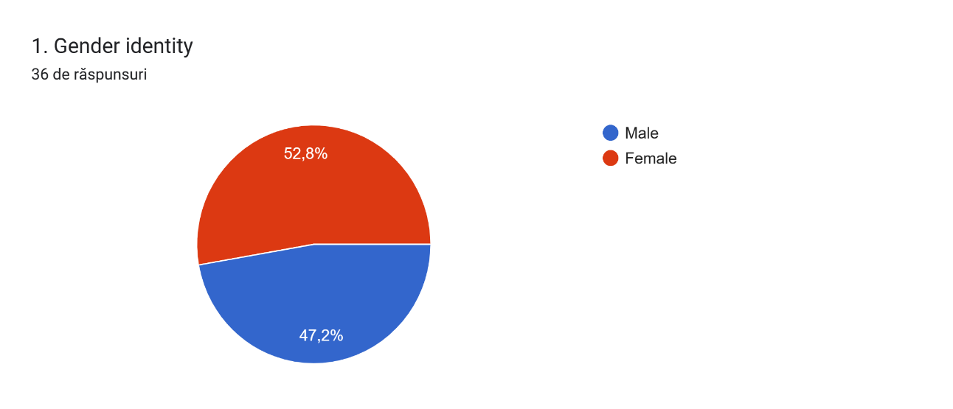
Graphic 1
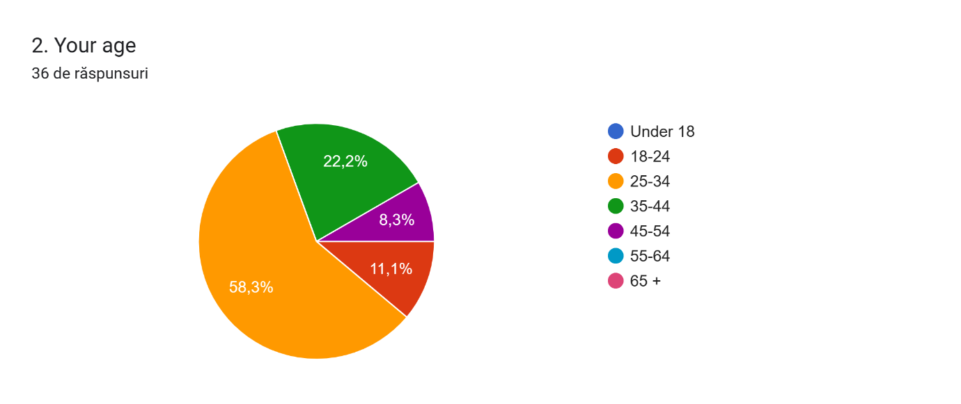
Graphic 2
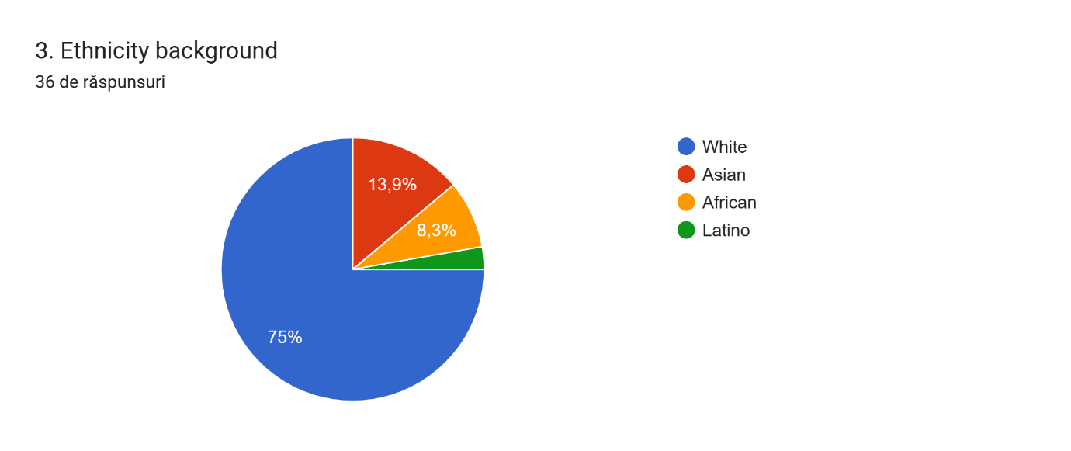
Graphic 3

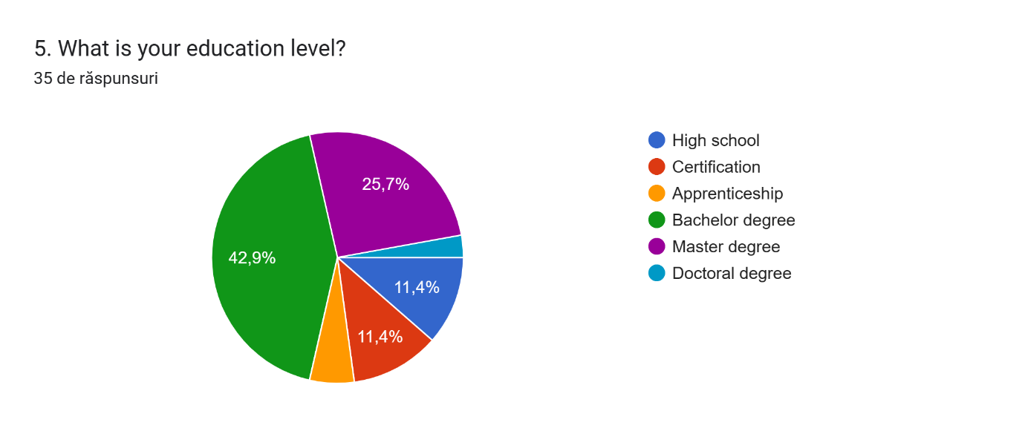
Graphic 4
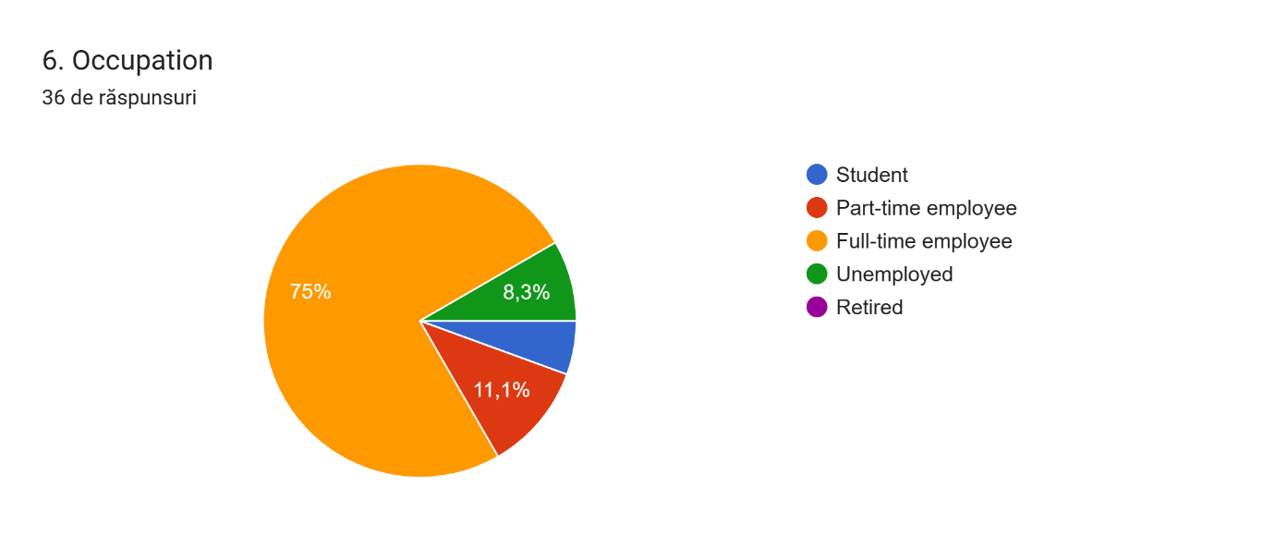
Graphic 5

  - General usage of social media
For a general information about the online consumption habits, the survey has included a couple of questions related to the usage of social media platforms.

More than 44 percents of the questioned people spend more than 2 hours a day on Internet platforms, followed by using social media. Only 8 percents have mentioned that they use online platforms less than 30 minutes daily.

The survey shows that Instagram is the most used social media platform by respondents, gaining more than half of the votes. On the second place is Facebook, with 37 percents, followed by Tik-Tok and Twitter with less than 10 percents each. According to the results, these platforms are not frequent enough to be considered within the study. Other social media platforms, such as LinkedIn or Pinterest, have not even been listed by the participants at the questionnaire.

Social media platforms are mostly accessed for socialising with friends and family and for entertainment and interesting content, according to 64 percents of the interviewed people. Other 20 percents access Internet accounts for worldwide news and for product and services branding. Sales and/or purchases online are not so popular activities among the survey participants. In fact, just 8 percents use social media platforms to buy or sell products or services.

The results of the questions can be visualised in Graphic 6 and Graphic 7:

Graphic 6

Graphic 7
  - Social media and product advertising
One of the present study objective has also been to find out the impact of the digital advertising on customer online buying decision. The questions from the questionnaire have helped to obtain information for analysing the effectiveness of marketing practices conducted by companies and brand on the online area. Also, it was important to identify if celebrities and online influencers that promote brand products and services can change people’s purchasing behaviour as well.
Firstly, the respondents were asked if they buy products online. The majority of them have mentioned that mostly they purchase clothing on brands web sites. 41.7 percents use Internet possibilities for buying cosmetic or hygienic products. Also, almost a third part of questioned people prefer to buy online electronic and accessories or houseware products. Other goods, as jewelry or food, are ordered through Internet web sites very rare – only by 1 percent of the survey respondents.

Most of the people (83%) take into consideration the quality, first, of the products or services purchased online. The price is also an important factor for choosing a certain product from Internet. Other respondents pay attention to the brand or how fast the product will be delivered to their house.

According to the study, around 70% of the participants have made an Internet purchase at least once being influenced by digital adds appearing on their social media accounts. Usually, people buy goods online several times monthly or less often than once a month. There are just 17 percents purchasing products from web sites several times a week. On average, more of the respondents spend online between £40 and £100 or more. A fifth part is ready to buy products from Internet amounted to £20 - £40 and 10% of the subjects spend £10 - £20 on it. Only 8 percents think to save up to £10 from their pocket for online purchasing.

This part of the questionnaire was also supposed to find out if the respondents follow any brands or companies on their social media accounts. A very high percentage has confirmed that they have at least one company profile on their following list. Product advertisements and endorsements can be seen daily by the respondents. However, the fifth part of the questioned people do not follow any brands online.

The respondents were asked if they think that celebrities and social media influencers who promote products online have an impact on their purchasing decisions. More than half agreed with that, while about 17 percents from the participants think that they cannot be influenced when they decide to buy something online. On the other hand, there were 20 percents of respondents who do not have a strong opinion about it.

The results of this part are illustrated in Graphic 8 and Graphic 9:

Graphic 8
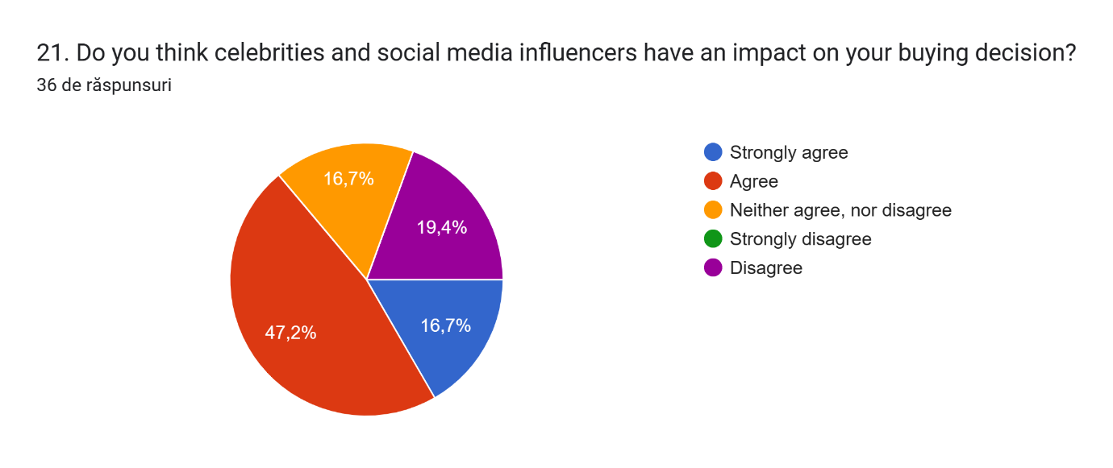
Graphic 9

Many people do not even trust social media platforms a lot when it comes to buying any products or services. According to the survey statistics, only 7% can make a purchase online with no fear of being scammed or disappointed regarding the products quality and characteristics. Moreover, 64 percents of them have been scammed at least once when buying products on social media platforms. Almost half of respondents (41,4%) have rated the trust for online platforms with 3 points on a 5 score-scale (see the graphic below).

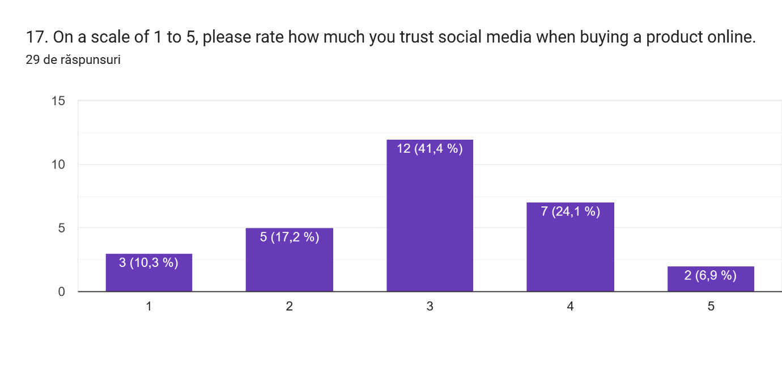
Graphic 10

Instagram has the highest influence (62%) on people’s purchase decisions, followed by Facebook (27.6%). Other social media platforms, such as Pinterest, Tik Tok, show a little interest for users when it comes to buy goods online.

Online reviews and comments on purchased products are essential for potential customers, as these provide information about the quality of the goods and share the experience of others who have bought and used them. It helps in buying decisions, either to do it or to change mind regarding the purchase.
Almost all participants at the research have mentioned that they read the reviews and opinions on the products before buying it. A vast part of them (almost 80%) feel that comments online definitely influence them to purchase or not a certain good or service. Just a small number of respondents are not sure about it or think they do not take into consideration online reviews.

  - Online shopping vs traditional shopping
Being asked what kind of purchasing they prefer, the opinions where shared proportionally between online shopping and in-store one. People opt for Internet purchases, as it saves time and money then going to a physical store. Also, according to the respondents, online shopping offers wider variety of products/services, deals and the possibility to compare models, prices much quicker or to see reviews on the goods.

The same number of participants prefer buying in stores instead. For them, it allows to test the quality of the product or to try it on straight away, without waiting for the delivery, thus avoiding hassle of returning and ordering again the proper product. On the other hand, there were a few participants who could not choose between online shopping and the traditional one. Both ways of shopping are comfortable for them, depending on the product they look for and on the circumstances at the time of purchasing. A third part of the respondents have not answered this question.

Half of the participants at the survey are strongly convinced that online shopping will replace the traditional shopping soon. According to their opinion, the world witnesses a high technological development which take over most of the routine activities. This, including online shopping as well, makes daily life easier, as it is more convenient to order goods and services on the Internet. A few respondents are not sure about it or think that it will not happen, and traditional shopping will be still popular, as people need to socialize, to go out and to try the quality of the products in reality.

4.6 Conclusions and limitations
The findings and conclusions presented in the research are only valid within the selected population and can not to be generalized due to the small number of participants (only 36 qualified respondents), differences in environmental factors and individual opinions of the respondents. With a large proportion of participants being in the age range from 25 to 34, there might be a gap of data from respondents of other age groups.

Due to the time limitations and geographic circumstances, the study could not have been done on a larger scale, which would have delivered more precise outcomes, more depth, and clearer visions. Representative cannot be guaranteed, as the research was limited to a specific period – March-April 2024, and to the members of population who were available and able to participate in study. To reach results that correspond all consumers social media behavior and how much impact social media has on consumer purchasing behavior, it would require wider research geographically and quantitatively.

However, considering the limited time and scope of this study, many theories related to the social media and consumer purchasing behavior were covered. As proposed study hypothesis, it is proved that digital marketing gains power over the traditional shopping. Most study participants prefer to shop online instead of going to a physical store. They are convinced that soon online shopping will replace the traditional going in-store, as it is more convenient, easier and save time and money. On the other hand, there are also people who still like going to a store to try products on, to see it in reality and to avoid hassle of returning things online if these are not suitable for them.

According to the implemented questionnaire, people tend to spend more time on Internet, socialising with friends or family, reading news, or making online purchases. Instagram and Facebook are on top of most used social media platforms, followed by Twitter and Pinterest.
People from villages access Internet less than citizens from cities or towns. Survey answers amount 80 percents of respondents living in village areas that use social media platforms, while all participants from cities confirmed that they have social media accounts and use it almost every day (see the graphic below). It can be explained as people living in villages have more house or outside activities (gardening, taking care of animals, going outside for a walk or talk with neighbors etc.) than people with higher pressure lifestyle coming from fast-paced environments as cities and towns. If the companies and brands want to get wider audience, including village population, another strategy might be necessary for promoting the businesses online or a plan how to attract more people to access social media platforms, thus accessing brand accounts, adds as well.

Graphic 11

Women seem to spend more time on Internet than men. The number of female respondents spending more than 2 hours per day on social media accounts is double than the number of men using Internet for the same period.

Graphic 12

The survey shows that there is also a difference between women and men preferences for products online. While female respondents opt for fashion good, as clothing, cosmetics and jewelry, men often buy electronics and accessories, houseware products or food. They purchase clothing as well at the same scale as women.
A graphic difference is shown below:

Graphic 13

When buying online, people focus on quality and price of the provided services, but also they prefer faster delivery time. However, the brand of the product is not so important, according to the respondents.

Brands digital adds on social media platforms seem to have a high influence on Internet users. About 70 percents of the interviewed people mentioned that they have made a purchase online after seeing an advertisement on their accounts. On average, they spend from £40 to £100 for online goods, several times a month. There are also people who prefer to spend less money on Internet purchasing – below £20 or even £10. This can be a consequence of lack of social media trustworthiness. As the questionnaire shows, a very small percentage of respondents trust Internet marketing very high. A medium rate of trustworthiness is given to social media brands accounts by just a half of participants. Also, a lot of people have been scammed at least once when buying online. It means that brands and companies selling their products online must better secure their Internet platforms to provide safer services to customers and to grow up loyalty.

Celebrity endorsement is also an efficient tool for businesses to promote their products online. Based on the questionnaire, more than half of respondents think that famous people influence them to buy certain products advertised online. Thus, brands can keep using this strategy to improve their profitability by reaching wider audience and loyalty from customers, as they trust celebrities in their purchasing decisions.

Almost all study participants read reviews and comments left online by other customers before buying a certain product or service. It provides them a valuable guidance and a true idea about the company and their goods from people who already used the service. People need reassurance that the product they want to buy is good and they will take the right decision.

- Conclusion and recommendations
  - Finding
The technology plays a significant role in our daily life. Social media platforms are used every day by millions of people worldwide to connect with others or to purchase goods and services. The research has shown that Internet has a very high impact on consumers purchasing behaviour. Development of technology allows companies and brands to promote their products online and to reach larger audience. Businesses use social media platforms, such as Instagram, Facebook, Tik-Tok, Pinterest etc., as an effective tool for their digital marketing. People follow brands and celebrities or online influencers on their social accounts, which through advertising different products, encourage users to buy it.

The study overall shows that digital marketing is preferred to the traditional one and, overtime, it can replace in-store shopping. Customers find online purchasing easier and more satisfying, saving time and money just with one click on Internet platforms. Digital marketing is also preferred by companies and brand, being more flexible, financially cheaper, and more measurable than a physical shop management. With such a vast information available on social media for free, businesses can improve their product offerings, their customer relationship, and the profitability.

5.2 Limitations and suggestions for further research
The amount of the research about the impact of social media on consumers behaviour is constantly growing. Digital marketing and social media impact on consumers behaviour are not a new aspect and these are always changing and evolving. The findings of the study are believed to add specific value to the digital marketing literature, even though is presented in a short and general manner.

Limitations are also unavoidable in a study, especially in quantitative research. Further analysis can be done in a longer period of time and on a larger and varied geographic location. As values and cultures varies from country to country, consumer’s behaviour may also be different. Research involving more parts and countries of the world is required to achieve more accurate results and findings.

5.3 Recommendations for businesses
According to the implemented analysis, in a modern and digitalized era, as consumers, people wait quality and trustworthiness from brands and companies they buy products from. Thus, businesses need to put accent on offering quality services that include good products, good web sites content, proper advertising, fast delivery time and affordable prices. Safety of their web sites and social media accounts is also an important aspect it has to be provided, as there is a high number of scammers using brands names in order to steal people’s money. Organisations need to invest in strong and latest cyber security systems to protect their data and customers base.

The study has identified that most customers read online reviews and opinions on the product before buying it from Internet and these have a high impact on their purchasing decision. Companies need to pay attention on the reviews they get from the customers and to plan strategies on gathering more positive opinions about their products. For example, they can encourage every customer to leave a comment after purchasing by offering a deal or a discount/voucher on their next purchase.

Despite many advantages that digitalization offers to the society, there are some negative effects as well. Addiction to phone and Internet usage lead to social disconnect, less contact between people and to a changed social and mental behaviour. Certain groups of people, such as old persons or people with mental health conditions, can be more exposed to loneliness, anxiety and depression associated with social isolation. These are aspects that can serve for a further research and analysis about another side of digitalisation era.

- References and bibliography

- Ahuja, V. (2019). Managing social media practices in the digital economy (V. Ahuja & S. Alavi, Eds.). IGI Global. https://doi.org/10.4018/978-1-7998-2185-4
- Al-Debei, M. M., Akroush, M. N., & Ashouri, M. I. (2015). Consumer attitudes towards online shopping: The effects of trust, perceived benefits, and perceived web quality. Internet Research, 25(5), 707–733. https://doi.org/10.1108/IntR-05-2014-0146
- Alexander, A. (2021). Marketing on Instagram. linkedin.com (Accessed on 6th of April 2024)
- Alexander, A. (2023). Marketing Tools: Social Media. linkedin.com (Accessed on 7th of April 2024)
- Alghamdi, E. A., & Bogari, N. (2020). The Impact of Social Media Platforms “Instagram” and “Snapchat” on the Purchasing Decision - Structural Equation Modelling Approach: Social Media Platforms. International Journal of Online Marketing, 10(1), 72–94. https://doi.org/10.4018/IJOM.2020010105
- Balan, A., 2023. Online marketing vs. offline marketing – which is better? Online Marketing vs. Offline Marketing - Which Is Better? (webdura.in)
- Berscheid, E., Walster, E.H., 1969. Rewards Others Provide: Similarity. In Interpersonal Attraction, 69-91. Reading, MA: Addison-Wesley.
- Chaffey, D., 2019. Digital marketing. 7th ed., Pearson Education, p.40
- Coles, L. (2018). Social media for business: foolproof tips to help you promote your business or your brand. John Wiley & Sons.
- Coursera, 2023. What is digital marketing? Types, skills and careers. What Is Digital Marketing? Types, Skills, and Careers | Coursera
- Creswell, J. W., 2009. Research design: qualitative, quantitative, and mixed method approaches. 3rd edition. London: Sage Publications.
- Di Virgilio, F. (2017). Social media for knowledge management applications in modern organizations (F. Di Virgilio, Ed.). IGI Global. https://doi.org/10.4018/978-1-5225-2897-5
- Desai, V., 2019. Digital marketing: A review. International Journal of Trend in Scientific Research and Development. DOI:10.31142/ijtsrd23100 (PDF) Digital Marketing: A Review (researchgate.net) pp.196-200
- Evans, M. (Martin J.), Foxall, G. R., & Jamal, A. (2006). Consumer behaviour. Wiley
- Fierro, I., Gavilanez, J., & Diego Alonso Cardona Arbelaez. (2017). Digital marketing. Pensamiento & Gestión, 43
- Flick, U. (2020). Introducing research methodology: thinking your way through your research project (Third edition.). SAGE
- Forghani, E., Sheikh, R., Hosseini, S. M. H., & Sana, S. S. (2022). The impact of digital marketing strategies on customer’s buying behavior in online shopping using the rough set theory. International Journal of System Assurance Engineering and Management, 13(2), 625–640. https://doi.org/10.1007/s13198-021-01315-4
- Future Learn, 2024. Why is digital marketing important for business? Why is digital marketing important for business? - FutureLearn (Accessed on 20th of March 2024)
- Guba, E. G. and Lincoln, Y. S., 1998. Competing paradigms in qualitative research. In: Denzin, N. K. and Lincoln, Y. S., eds. The Landscape of Qualitative Research: Theories and Issues. Thousand Oaks: Sage Publications, 195-220.
- I. Kalina. (2020). Digital marketing development trends. Naukovij Vìsnik Nacìonalʹnoï Akademìï Statistiki, Oblìku ta Auditu, 4, 92–100. https://doi.org/10.31767/nasoa.4.2019.09
- Keikhosrokiani, P. (Ed.). (2023). Handbook of research on consumer behavioral analytics in metaverse and the adoption of a virtual world (1st ed.). IGI Global, Engineering Science Reference
- Kumar, R. (2019). Research methodology: a step-by-step guide for beginners (Fifth edition.). SAGE
- Kumar, D, 2020. The study of significance of digital marketing tools in the promotion of E-commerce websites. Palarch’s Journal of Archaeology of Egypt/Egyptology 17(9)
- LinkedIn, 2024. The digitalisation of shopping: A revolution in consumer behaviour. The Digitalisation of Shopping: A Revolution in Consumer Behaviour (linkedin.com) (Accessed on 22nd of March 2024)
- Maurya, K. (2021). A Comparative study of Digital Marketing Vs Traditional Marketing. Sansmaran Research Journal, 11(1), 26–31
- Medium, 2023. The impact of Covid-19 on the surge in online shopping across the world. COVID-19 and the Rise of Online Shopping: A Global Trend | Data And Beyond (medium.com) (Accessed on 25th of March 2024)
- Meshko, N., & Savinova, A. (2020). Digital marketing strategy: companies experience during pandemic. VUZF Review, 5(4), 41–49. https://doi.org/10.38188/2534-9228.20.4.05
- Moriuchi, E. (2021). Cross-cultural social media marketing: bridging across cultural differences. Emerald Publishing Limited
- Munna, A., & Shaikh, M. S. I. (2023). Impact of Digital Marketing Tools and Methods on SMEs and Proposed Recommendations. IGI Global
- Noel, Hayden. (2018). Consumer behaviour (First ed.). AVA Publishing SA.
- Noor Aslinda Abu Seman, & Vicneswaran Segar (2023). The Impact of Digital Marketing Channels on Consumer Buying Decision. Journal of International Business, Economics and Entrepreneurship, 8(1), 42–53. https://doi.org/10.24191/jibe.v8i1.23145
- Nunan, D., & Di Domenico, M. (2019). Older Consumers, Digital Marketing, and Public Policy: A Review and Research Agenda. Journal of Public Policy & Marketing, 38(4), 469–483. https://doi.org/10.1177/0743915619858939
- O\’Connor, J., Galvin, Eamonn., & O\’Connor, J. (2001). Marketing in the digital age (2nd ed.). Financial Times Prentice Hall
- Olson, E. M., Olson, K. M., Czaplewski, A. J., & Key, T. M. (2021). Business strategy and the management of digital marketing. Business Horizons, 64(2), 285–293. https://doi.org/10.1016/j.bushor.2020.12.004
- Parkin, Godfrey. (2009). Digital marketing: strategies for online success. New Holland
- Research anthology on strategies for using social media as a service and tool in business. (2021). Business Science Reference. https://doi.org/10.4018/978-1-7998-9020-1
- Rogers, R., & Niederer, S. (2020). The Politics of Social Media Manipulation (1st ed.). Amsterdam University Press. https://doi.org/10.1515/9789048551675
- Simona Valentina Pascalau, & Ramona Mihaela Urziceanu. (2021). Traditional Marketing Versus Digital Marketing. Agora International Journal of Economical Sciences, 14. https://doi.org/10.15837/aijes.v14i0.4202
- Statista, 2024. Daily time spent on social networking by internet users worldwide from 2012 to 2024. Global daily social media usage 2024 | Statista (Accessed on 22nd of March 2024)
- Sue Scullin, S., Fjermestad, J., & Romano, N. C. (2004). E-relationship marketing: changes in traditional marketing as an outcome of electronic customer relationship management. Journal of Enterprise Information Management, 17(6), 410–415. https://doi.org/10.1108/17410390410566698
- Tarnanidis, T. (Ed.). (2023). Social media and online consumer decision making in the fashion industry. IGI Global
- Tarnanidis, T., Vlachopoulou, M., & Papathanasiou, J. (Eds.). (2023). Influences of social media on consumer decision-making processes in the food and grocery industry (1st ed.). Business Science Reference
- Tebbatt, M., 2023. Digital Marketing. University of Brighton blog. (Accessed on 21st of March 2024)
- Waguespack, B., Hyman, M., 1993. Consumer behaviour: Still normative after all these years. Advances in marketing, p.29-35
- Wamuyu, P. K. (2020). Analyzing global social media consumption (P. K. Wamuyu, Ed.). IGI Global. https://doi.org/10.4018/978-1-7998-4718-2
- Wolny, J. (2014). Marketing transformations: Re-thinking marketing, digital first. Journal of Direct, Data and Digital Marketing Practice, 16(2), 150–151. https://doi.org/10.1057/dddmp.2014.57

- Appendix

- Questionnaire
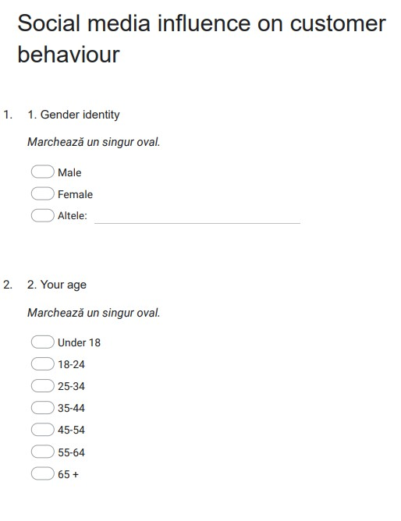

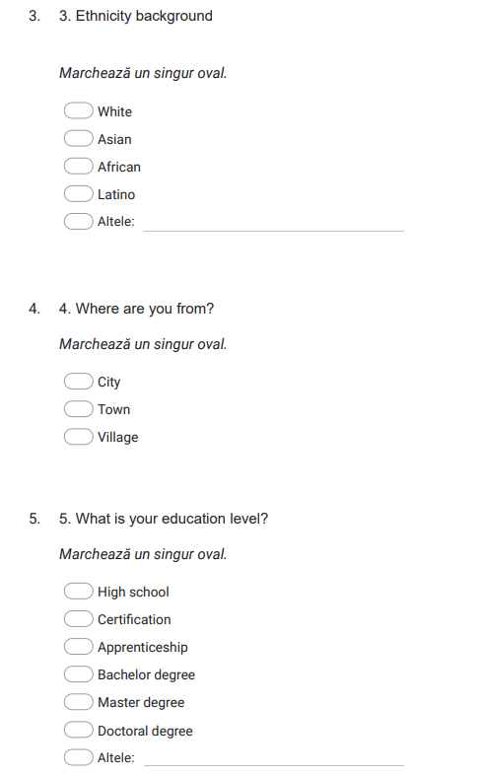

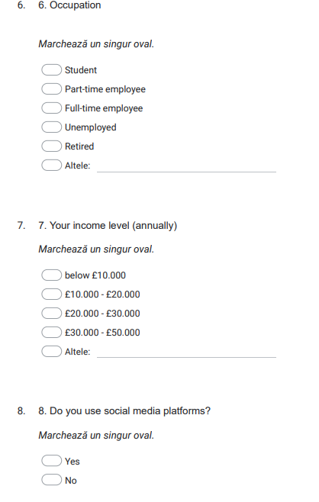

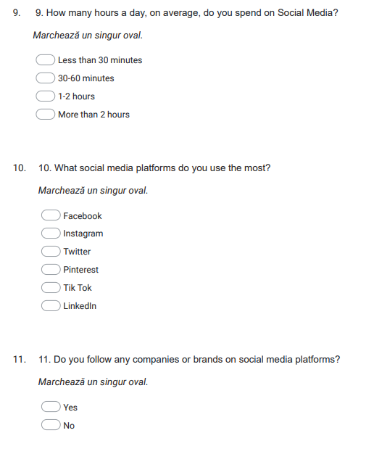

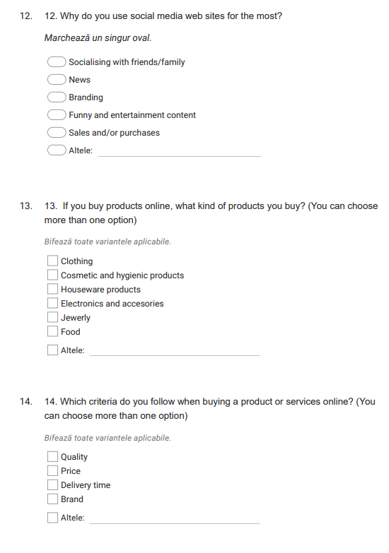
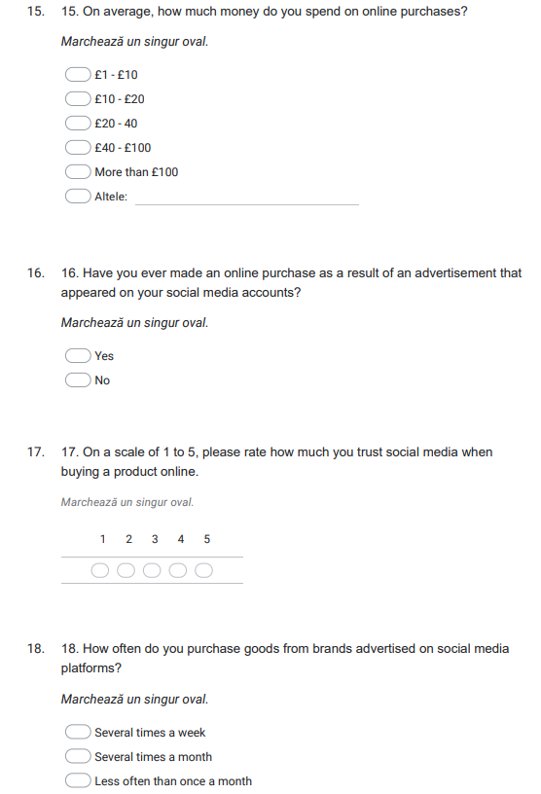
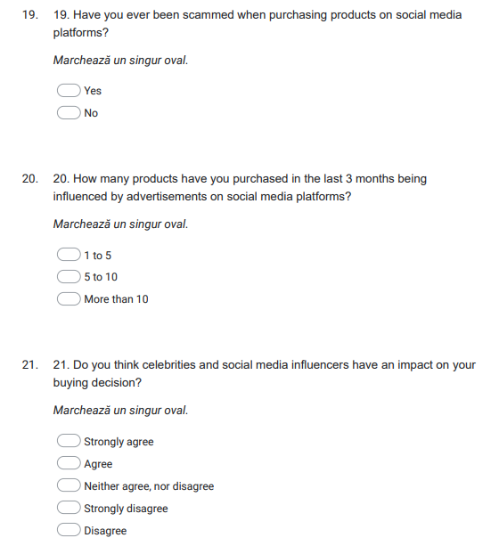
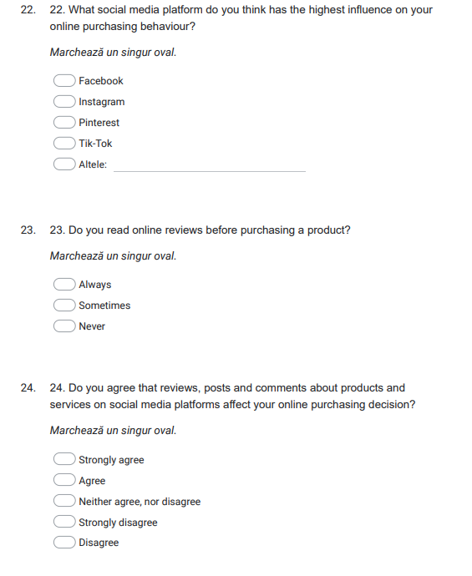
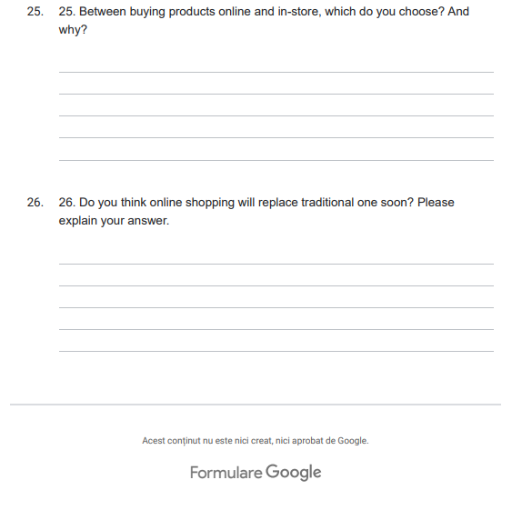

- Participant consent form

University of Wales Trinity Saint David (London Campus)
Winchester House
11 Cranmer Road
London – SW9 6EJ
Tel: +442075667600
Email: info.london@uwtsd.ac.uk
londonstudentservice@uwtsd.ac.uk



Rhif Adnabod Cyfranogwr:
Participant Identification Number:
FFURFLEN GANIATÂD CYFRANOGIAD | PARTICIPATION CONSENT FORM
Teitl Y Prosiect: / Project Title:
Enw'r Ymchwilydd / Name of Researcher:

1 | I confirm that I have read and understand the information sheet dated _________ for the above study. I have had the opportunity to consider the information, ask questions and have had these answered satisfactorily.
2 | I understand that my participation is voluntary and that I am free to withdraw at any time, without giving any reason.
3 | I understand that any information given by me may be used in future reports, articles or presentations by the research team.
4 | I understand that my name will not appear in any reports, articles or presentations.
5 | I agree to take part in the above study.
Name of Participant |  |  | Signature
Researcher |  |  | Signature

You may decline to participate in this study. You may end your participation in this study at any time. If you decide to remain anonymous, maintaining your anonymity will be a priority and every practical precaution will be taken to disguise your identity.
If you prefer anonymity, there will not be any identifying information on audiotapes or transcripts of this or any interview. No one will hear any audiotapes or see any transcripts without your prior consent. All materials generated from this or any interview will remain confidential.
When completed please return in the envelope provided. One copy will be given to you and the original to be kept on the file of the research team at:

NAME & ADDRESS OF RESEARCHER

University of Wales Trinity Saint David (London Campus)
Winchester House
11 Cranmer Road
London – SW9 6EJ
Tel: +442075667600
Email: info.london@uwtsd.ac.uk
: londonstudentservice@uwtsd.ac.uk

- Participant Information Sheet


Rhif Adnabod Cyfranogwr:
Participant Identification Number:
FFURFLEN GANIATÂD CYFRANOGIAD | SAMPLE PARTICIPANT INFORMATION SHEET
Teitl Y Prosiect: / Project Title:

Dear Sir/Madam,

My name is ………………………..and I am a ………………………..student in the School of Business, Finance and Management (London Campus), Faculty of Business and Management in University of Wales Trinity Saint David, United Kingdom. At present, I am conducting a research on………………………... The purpose of this research is to ………………………..

I would like to invite you to participate in my research project by answering the attached short questions developed by the researchers. Those questions will assess your opinions, experiences, knowledge, suggestions and views. Through your participation in the interviews, I hope to ascertain my research purpose to get the best opinion from you. I believe your opinion will be extremely helpful to me to carry out this research.

All questions will be kept strictly confidential to the researchers involved and at NO time will individual questions will be released to the general public. This gives you a chance to express your views on your programme a confidential and anonymous forum and still be able to make a difference. Your participation in this study is completely voluntary so you can withdraw from the questionnaire at any stage.

Please note, questionnaire should take no more than 30 minutes to complete but however, there is no time constraint. There are also no right or wrong answers. Attached to this letter along with the questionnaire there is a consent form where you will better understand researchers intension As this is a new project, your feedback is also important to me and I would be much obliged if you could also complete the feedback sheet along with the questionnaire. I understand that your time is at a premium, but your opinions are very valuable to me.

After careful and precise analysis of the data obtained from this questionnaires/interviews, I will be happy to provide you with a copy of the findings at your request. The results of this questionnaire will hopefully enhance my understanding of current level of knowledge and future findings. The results of the research will be feedback to Director of Studies, Supervisor, University and British Library.

I thank you in advance for your time and participation. If any questions do arise, feel free to contact me at your convenience.

NAME & ADDRESS OF RESEARCHER

University of Wales Trinity Saint David (London Campus)
Winchester House
11 Cranmer Road
London – SW9 6EJ
Tel: +442075667600
Email: info.london@tsd.ac.uk
londonstudentservice@tsd.ac.uk

